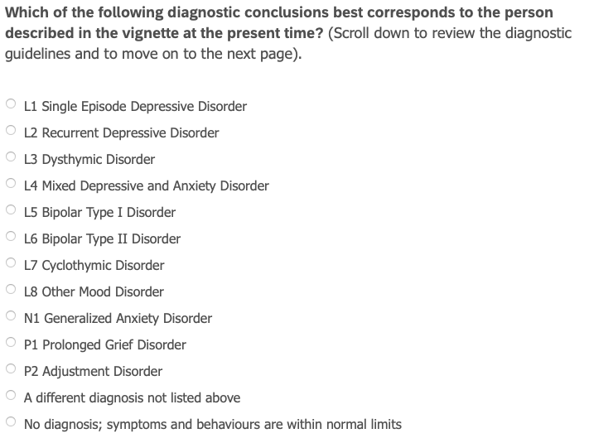
Mood
- Vignette is displayed
- Initial diagnostic impressions -> select disorder from List
- FU Q: L1,L2,L5, L6 -> specify severity, psychotic symptoms,
remission qualifier (select L1A, L1B,…)
- After selection: Additional Qualifiers L1A, L1B
  - Or Other mood discorder L8
  - Or N1, P1, P2
- After answering questions, still feel this is the most appropriate
diagnosis?
- Chance to select a different diagnosis
  - Do somewhat 3,4 again
- Diagnosis confidence + were the guidelines clear?
- Rational behind selecting different diagnosis

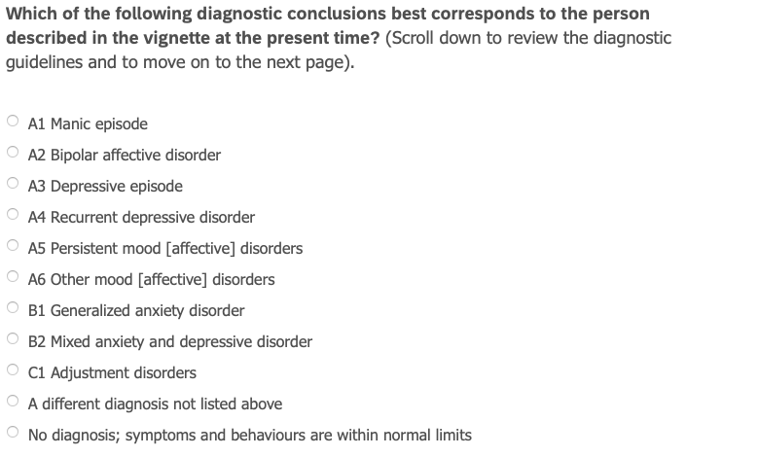
Mood
- Vignette is displayed
- Initial diagnostic impressions -> select disorder from List
- FU Q: A1, A2, A3, A4, A5, C1
- After selection: Additional Qualifiers L1A, L1B
  - Or Other mood discorder L8
  - Or B1, B2, C1

Please rate EASE OF USE of the diagnostic guidelines
Please rate GOOD OF FIT of the diagnostic guidelines

Vignette -

