Deep Learning Midterm Project
Breast Cancer Classification with an ANN and Clothing Classification with a CNN
Student: Muhammad Malhan
Registration Number: SP24-BBD-101
Course: Deep Learning

Introduction
This project presents two deep learning models on two different datasets. The first model is a feedforward artificial neural network (ANN) for breast cancer classification. The second is a convolutional neural network (CNN) for clothing image classification. Both models are trained, evaluated and compared.

Part 1: DNN - Breast Cancer Diagnosis

Problem Definition
Breast cancer diagnosis is based on measurements taken from a fine needle aspirate of a breast mass. The task is to classify each sample as malignant or benign. A false negative is more costly than a false positive, so the model should have high recall for malignant cases.

Dataset Description and Source
The Wisconsin Breast Cancer Diagnostic dataset contains 569 samples and 30 numerical features. There are 212 malignant and 357 benign samples. Source: UCI Machine Learning Repository. The data is loaded with sklearn.datasets.load_breast_cancer().

Proposed Solution
A small feed-forward ANN is trained on standardized features. The model outputs the probability of a sample being benign. Performance is measured with accuracy, precision, recall, F1-score and a confusion matrix.

Data Preprocessing
Missing values and class balance are checked first. The data is split into 80% training and 20% test sets with stratification. Features are standardized with StandardScaler, which is fit only on the training set.

Model Architecture
Layer | Details
Input | 30 features
Hidden layer 1 | 32 neurons, ReLU
Hidden layer 2 | 16 neurons, ReLU
Output | 1 neuron, sigmoid
Table 1. DNN architecture.
The model has 1,537 trainable parameters. It uses the Adam optimizer, binary cross-entropy, 40 epochs and a batch size of 16.

Training Results and Evaluation
The model reaches 96.5% test accuracy with a test loss of 0.0977. The confusion matrix shows that
41 of 42 malignant cases are detected and 3 benign cases are predicted as malignant. Training and validation accuracy are close to 100%, which suggests some overfitting on the small dataset. The trained model is saved as dnn_breast_cancer.joblib and reloaded for inference on five test samples.
Table 2. DNN classification report on the test set.
Class | Precision | Recall | F1-score | Support
Malignant | 0.93 | 0.98 | 0.95 | 42
Benign | 0.99 | 0.96 | 0.97 | 72
Accuracy |  |  | 0.96 | 114
Macro average | 0.96 | 0.97 | 0.96 | 114
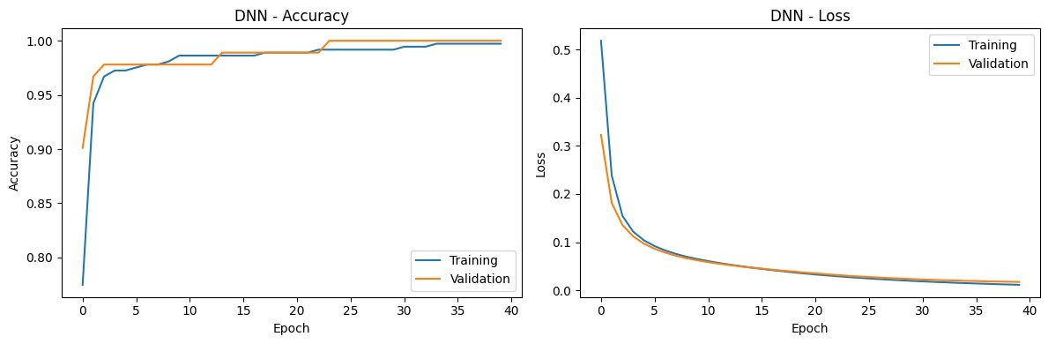
Figure 1. DNN training and validation curves.
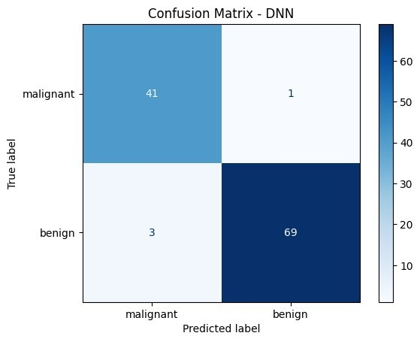
Figure 2. DNN confusion matrix.

Conclusion
The ANN provides a good baseline for breast cancer classification, with high malignant recall. The main limitation is the small dataset, so the result should be checked on a larger independent dataset.

Part 2: CNN - Clothing Image Classification

Problem Definition
Online clothing stores need to label large numbers of product images. The task is to classify each image into one of ten clothing categories. A CNN can learn visual features and support automatic tagging and inventory management.

Dataset Description and Source
Fashion-MNIST contains 70,000 grayscale 28x28 images in 10 classes. The dataset is split into 60,000 training and 10,000 test images, with 6,000 training images per class. Source: Fashion-MNIST. The data is loaded with keras.datasets.fashion_mnist.load_data().

Proposed Solution
A CNN with two convolution-pooling blocks is trained on normalized images. The model outputs a probability for each of the 10 classes. Performance is measured with accuracy, per-class precision/recall/F1 and a confusion matrix.

Data Preprocessing
Pixel values are scaled to the range [0, 1]. A channel dimension is added, giving an input shape of 28x28x1. Labels are kept as integers for sparse categorical cross-entropy.

Model Architecture
Layer | Details
Conv2D 1 | 32 filters, 3x3, ReLU
MaxPooling 1 | 2x2
Conv2D 2 | 64 filters, 3x3, ReLU
MaxPooling 2 | 2x2
Flatten | 1,600 features
Dense 1 | 128 neurons, ReLU
Dropout | 0.5
Output | 10 neurons, softmax
Table 3. CNN architecture.
The model has 225,034 trainable parameters. It uses the Adam optimizer, sparse categorical crossentropy, 10 epochs and a batch size of 64.

Training Results and Evaluation
The CNN reaches 90.8% test accuracy with a test loss of 0.2609. Trousers, bags, sandals and sneakers are classified well, with F1-scores between 0.96 and 0.99. Shirts are the weakest class: recall is 0.68, and many shirts are classified as T-shirts, pullovers or coats. The trained model is saved as cnn_fashion_mnist.joblib and reloaded for inference on five test images.
Table 4. CNN classification report on the test set.
Class | Precision | Recall | F1-score | Support
T-shirt/top | 0.86 | 0.86 | 0.86 | 1000
Trouser | 1.00 | 0.98 | 0.99 | 1000
Pullover | 0.82 | 0.88 | 0.85 | 1000
Dress | 0.90 | 0.92 | 0.91 | 1000
Coat | 0.83 | 0.87 | 0.85 | 1000
Sandal | 0.97 | 0.99 | 0.98 | 1000
Shirt | 0.77 | 0.68 | 0.72 | 1000
Sneaker | 0.95 | 0.97 | 0.96 | 1000
Bag | 0.99 | 0.97 | 0.98 | 1000
Ankle boot | 0.98 | 0.95 | 0.96 | 1000
Accuracy |  |  | 0.91 | 10000
Macro average | 0.91 | 0.91 | 0.91 | 10000
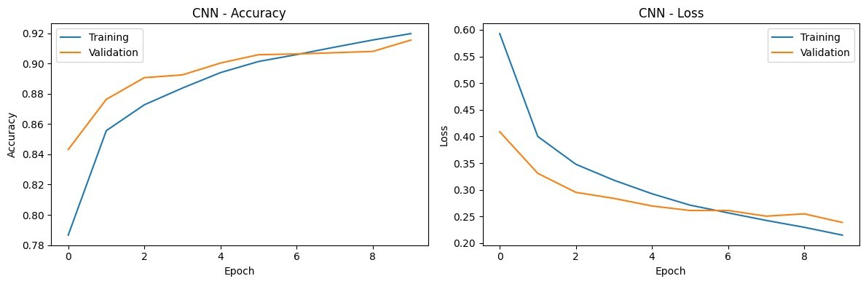
Figure 3. CNN training and validation curves.
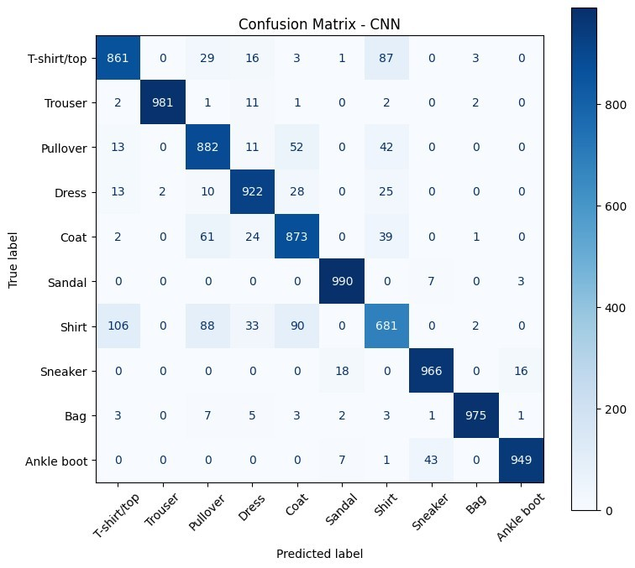
Figure 4. CNN confusion matrix.

Conclusion
The CNN works well for clear clothing categories. The main limitation is the low image resolution, which makes similar upper-body classes hard to separate.

Overall Conclusion
Table 5. Summary of results.
Model | Dataset | Test accuracy | Test loss
DNN | Breast Cancer Wisconsin | 96.5% | 0.0977
CNN | Fashion-MNIST | 90.8% | 0.2609
Both models met the project goal. The DNN reached 96.5% accuracy on tabular data, and the CNN reached 90.8% on images. Fully connected layers were sufficient for the numerical data, while convolution layers were better for images. A limitation of both experiments is the small or lowresolution data, so larger datasets could improve the results.

