Study on an existing working model of Kitchen Chimney:

**Chimneys** are ventilation channels that guide [smoke](https://energyeducation.ca/encyclopedia/Smoke) and other [gases](https://energyeducation.ca/encyclopedia/Gas) that are products of [combustion](https://energyeducation.ca/encyclopedia/Combustion) out from a fireplace through the roof of a [building](https://energyeducation.ca/encyclopedia/Building_envelope). Chimneys operate based on the principle that hot air is less [dense](https://energyeducation.ca/encyclopedia/Density) than cold air, and thus rises. When a chimney is filled with hot smoke or other gases, these gases rise up through the chimney. The hot, rising gas creates a [pressure](https://energyeducation.ca/encyclopedia/Pressure) difference known as a *draft* which pulls combustion gases out of the building.

Chimneys must be able to protect the structure of the home from the hot gases that pass through it, as well as being able to resist the high temperatures that could result from a chimney fire. On the outside chimneys must be able to resist weather effects and must be sealed to prevent leakage. Chimneys are essentially enclosed columns of warm air surrounded by colder outside air. When chimneys are not in use, they can allow cold backdraft back into the home since the house is full of warm air. The warm air can then leave the house through the chimney through the same process of rising that hot smoke does when wood is being burned. To prevent this, insulation of the chimney is important along with closing the flue when not in use.

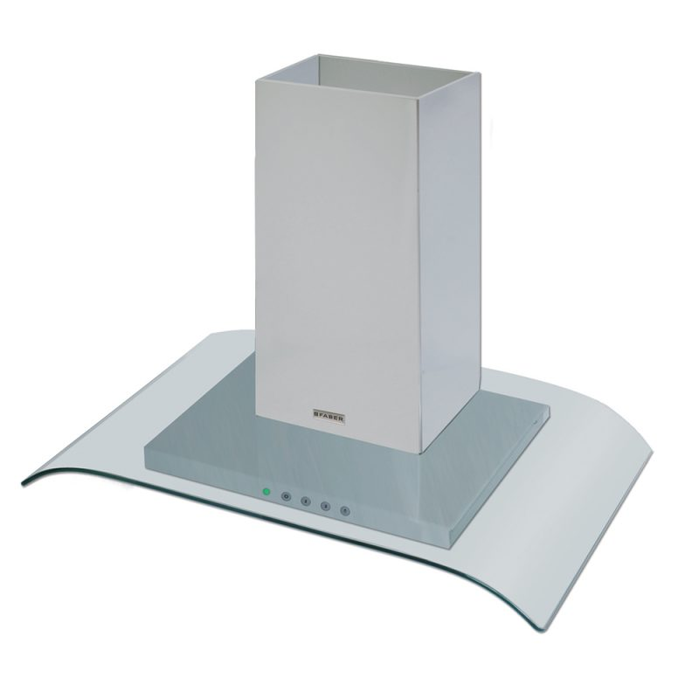

BLOCK DIAGRAM:

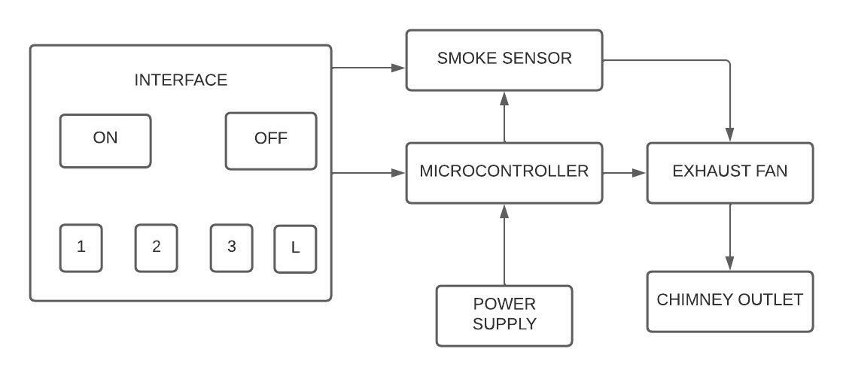

REQUIREMENTS:

**High level requirements Low level requirements**

1. Key board should be there. 1. Easily fixable.
2. Three modes of suction. 2. Easily washable.
3. Low noise. 3. LED light.
4. Emergency stop. 4. Compact size.
5. Cost less than Rs 10000.