Kitchen Chimney:

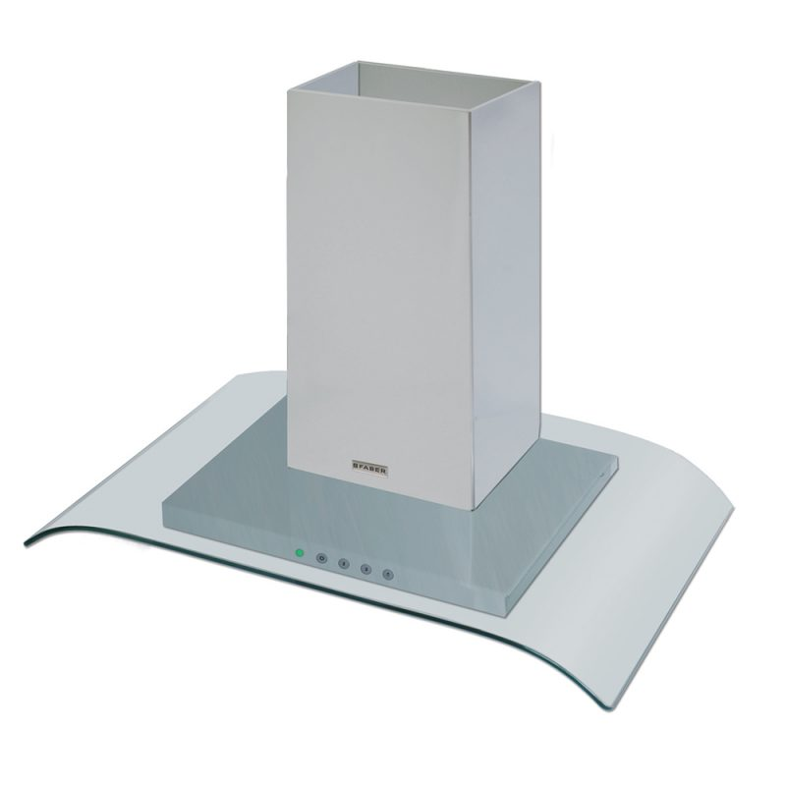

Table Of Content:

1. Abstract
2. Introduction
3. Requirements
4. Block diagram
5. Description of the components
6. Use case diagram
7. References

Abstract:

Removing out the smoke from kitchen is known as kitchen ventilation. The smoke which is produced in kitchen is harmful to human health. With help of Kitchen chimney we can remove smoke and the chimney is also used for domestic purpose for cleaning the residential areas, home, hotels & restaurants etc.

Introduction:

**Chimneys** are ventilation channels that guide [smoke](https://energyeducation.ca/encyclopedia/Smoke) and other [gases](https://energyeducation.ca/encyclopedia/Gas) that are products of [combustion](https://energyeducation.ca/encyclopedia/Combustion) out from a fireplace through the roof of a [building](https://energyeducation.ca/encyclopedia/Building_envelope). Chimneys operate based on the principle that hot air is less [dense](https://energyeducation.ca/encyclopedia/Density) than cold air, and thus rises. When a chimney is filled with hot smoke or other gases, these gases rise up through the chimney. The hot, rising gas creates a [pressure](https://energyeducation.ca/encyclopedia/Pressure) difference known as a *draft* which pulls combustion gases out of the building.

Chimneys must be able to protect the structure of the home from the hot gases that pass through it, as well as being able to resist the high temperatures that could result from a chimney fire. On the outside chimneys must be able to resist weather effects and must be sealed to prevent leakage. Chimneys are essentially enclosed columns of warm air surrounded by colder outside air. When chimneys are not in use, they can allow cold backdraft back into the home since the house is full of warm air. The warm air can then leave the house through the chimney through the same process of rising that hot smoke does when wood is being burned. To prevent this, insulation of the chimney is important along with closing the flue when not in use.

REQUIREMENTS:

HLR 1 - System shall have Interface.

LLR 1.1- LCD display shall be there.

LLR 1.2- Push button shall be there.

LLR 1.3- ON and OFF button shall be there.

HLR 2 - Automatic absorption of the smoke.

LLR 2.1 -There shall be three modes of suction.

LLR 2.2 - Low noise.

HLR 3 - System shall have emergency stop.

HLR 4 – System shall have LED light.

HLR 5 – Cost less than RS 10000.

BLOCK DIAGRAM: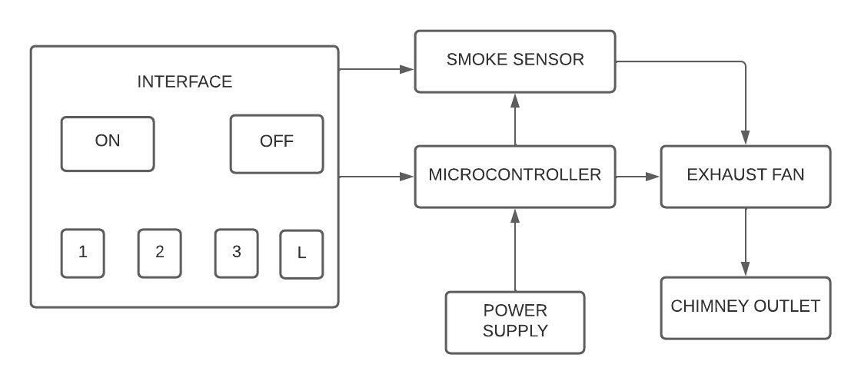

Microcontroller:

A **microcontroller** (**MCU** for *microcontroller unit*) is a small [computer](https://en.wikipedia.org/wiki/Computer) on a single [metal-oxide-semiconductor](https://en.wikipedia.org/wiki/MOSFET) (MOS) [integrated circuit](https://en.wikipedia.org/wiki/Integrated_circuit) (IC) chip. A microcontroller contains one or more [CPUs](https://en.wikipedia.org/wiki/Central_processing_unit) ([processor cores](https://en.wikipedia.org/wiki/Processor_core)) along with [memory](https://en.wikipedia.org/wiki/Computer_memory) and programmable [input/output](https://en.wikipedia.org/wiki/Input/output) peripherals. Program memory in the form of [ferroelectric RAM](https://en.wikipedia.org/wiki/Ferroelectric_RAM), [NOR flash](https://en.wikipedia.org/wiki/Flash_memory#NOR_flash) or [OTP ROM](https://en.wikipedia.org/wiki/Programmable_read-only_memory) is also often included on chip, as well as a small amount of [RAM](https://en.wikipedia.org/wiki/Random-access_memory). Microcontrollers are designed for [embedded](https://en.wikipedia.org/wiki/Embedded_system) applications, in contrast to the [microprocessors](https://en.wikipedia.org/wiki/Microprocessor) used in [personal computers](https://en.wikipedia.org/wiki/Personal_computer) or other general purpose applications consisting of various discrete chips.

* ATmega328:

The **ATmega328** is a single-[chip](https://en.wikipedia.org/wiki/Integrated_circuit) [microcontroller](https://en.wikipedia.org/wiki/Microcontroller) created by [Atmel](https://en.wikipedia.org/wiki/Atmel) in the [megaAVR](https://en.wikipedia.org/wiki/MegaAVR" \o "MegaAVR) family (later [Microchip Technology](https://en.wikipedia.org/wiki/Microchip_Technology) acquired Atmel in 2016). It has a [modified Harvard architecture](https://en.wikipedia.org/wiki/Modified_Harvard_architecture) [8-bit](https://en.wikipedia.org/wiki/8-bit) [RISC](https://en.wikipedia.org/wiki/Reduced_instruction_set_computer) processor core.

The Atmel [8-bit](https://en.wikipedia.org/wiki/8-bit) [AVR](https://en.wikipedia.org/wiki/Atmel_AVR) [RISC](https://en.wikipedia.org/wiki/Reduced_instruction_set_computing)-based microcontroller combines 32 KB [ISP](https://en.wikipedia.org/wiki/In-system_programming) [flash](https://en.wikipedia.org/wiki/Flash_memory) memory with read-while-write capabilities, 1 KB [EEPROM](https://en.wikipedia.org/wiki/EEPROM), 2 KB [SRAM](https://en.wikipedia.org/wiki/Static_random-access_memory), 23 general-purpose I/O lines, 32 general-purpose working [registers](https://en.wikipedia.org/wiki/Processor_register), 3 flexible timer/[counters](https://en.wikipedia.org/wiki/Counter_(digital)) with compare modes, internal and external [interrupts](https://en.wikipedia.org/wiki/Interrupt), serial programmable [USART](https://en.wikipedia.org/wiki/USART), a byte-oriented 2-wire serial interface, [SPI](https://en.wikipedia.org/wiki/Serial_Peripheral_Interface_Bus) serial port, 6-channel 10-bit [A/D converter](https://en.wikipedia.org/wiki/A/D_converter) (8 channels in [TQFP](https://en.wikipedia.org/wiki/Quad_Flat_Package) and [QFN](https://en.wikipedia.org/wiki/Quad_Flat_No-leads_package)/[MLF](https://en.wikipedia.org/wiki/Quad-flat_no-leads_package#Variants) packages), programmable [watchdog timer](https://en.wikipedia.org/wiki/Watchdog_timer) with internal [oscillator](https://en.wikipedia.org/wiki/Electronic_oscillator), and 5 software-selectable power-saving modes. The device operates between 1.8 and 5.5 volts. The device achieves throughput approaching 1 [MIPS](https://en.wikipedia.org/wiki/Million_instructions_per_second#Million_instructions_per_second)/MHz.

Smoke Sensor:

MQ2 gas sensor is an electronic sensor used for sensing the concentration of gases in air such as LPG, propane, methane, hydrogen, alcohol, smoke and carbon monoxide. This sensor works on 5v DC voltage. It can detect gases in the concentration of range 200 to 10000ppm. Smoke sensor sense the smoke coming from gas in kitchen and gives signal to the microcontroller.

Exhaust Fan:

Exhaust fans pull odors, fumes, and moisture from an area of the home, venting them outdoors for removal. The fan uses a motor to turn its blades, which function to pull air out of the space. The stale, humid, or contaminated air is propelled through the exhaust vent, exiting the home.

Use Case Diagram:

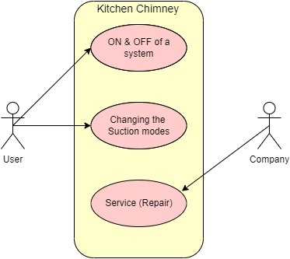

References:

<http://fabacademy.org/2020/labs/vigyanashram/students/nikhilkumar-more/my%20project.html>

<http://www.ijiere.com/FinalPaper/FinalPaperSOLAR%20POWERED%20KITCHEN%20CHIMNEY191489.pdf>

<https://en.wikipedia.org/wiki/Chimney>

<https://en.wikipedia.org/wiki/Smoke_detector>

<https://en.wikipedia.org/wiki/Fan_(machine)>