MINI PROJECT REPORT
Database Management System
CAR RENTAL MANAGEMENT SYSTEM
Java (Swing / NetBeans) with MySQL using JDBC
Submitted by
MALHAR SHAH
Name | Malhar Shah
Roll No. | E197
SAP ID | 60002250015
Division | E1
Branch | Electronics and Telecommunication Engineering (EXTC)
Year / Semester | Third Year (T.Y) / Semester V
Academic Year | 2026 – 2027
Department of Electronics and Telecommunication Engineering
Academic Year 2026 – 2027

1. Introduction
The Car Rental Management System is a desktop application that helps a car rental agency manage its day-to-day operations: registering cars and customers, issuing cars on rent, accepting returns and calculating late fines. The front end is built with Java Swing in the NetBeans IDE and the back end is a MySQL database named rentcar, connected through JDBC.

1.1 Objectives
- Replace manual registers with a centralised, searchable database.
- Track the availability of every car in real time (Yes / No).
- Record each rental with its fee, rent date and due date.
- Calculate the elapsed days and fine automatically when a car is returned.
- Restrict access to authorised administrators through a login screen.

1.2 Technology Stack
Component | Details
Language | Java (Swing GUI)
IDE | Apache NetBeans
Database | MySQL 5.x / 8.x, database name: rentcar
Connectivity | JDBC – MySQL Connector/J 5.1.48
Extra library | JCalendar 1.4 (date picker for rent and due dates)

1.3 Modules of the System
Module (Java class) | Function
Start_Page | Entry screen of the portal with Log In and Register buttons.
Admin_Register | Creates a new administrator account (INSERT into login).
Login | Validates username and password against the login table.
Main | Main menu: Car Registration, Customer Registration, Rental, Return, Logout.
CarRegistration | Add, edit and delete cars; auto-generates car numbers (C0001, C0002 …).
CustomerRegistration | Registers customers; auto-generates customer IDs (A0001, A0002 …).
Rent_a_car | Issues an available car to a customer and marks it as not available.
ReturnCar | Computes elapsed days and fine, stores the return and frees the car.

2. SQL CREATE Commands
Run the following script once in MySQL (Workbench or the command-line client) before starting the application. It creates the rentcar database and the five tables used by the project.
-- 1. Create and select the database
CREATE DATABASE IF NOT EXISTS rentcar;
USE rentcar;
-- 2. Cars
CREATE TABLE carregistration (
id INT(10) NOT NULL AUTO_INCREMENT,
car_no VARCHAR(255) NOT NULL,
make VARCHAR(255),
model VARCHAR(255),
available VARCHAR(255) DEFAULT 'Yes',
PRIMARY KEY (id),
UNIQUE KEY uq_car_no (car_no)
);
-- 3. Customers
CREATE TABLE customer (
id INT(10) NOT NULL AUTO_INCREMENT,
cust_id VARCHAR(255) NOT NULL,
name VARCHAR(255),
address TINYTEXT,
mobile BIGINT,
PRIMARY KEY (id),
UNIQUE KEY uq_cust_id (cust_id)
);
-- 4. Administrator login
CREATE TABLE login (
login_id INT(11) NOT NULL AUTO_INCREMENT,
username VARCHAR(255),
password VARCHAR(255),
PRIMARY KEY (login_id)
);
-- 5. Rentals
CREATE TABLE rental (
id INT(10) NOT NULL AUTO_INCREMENT,
car_id VARCHAR(255),
cust_id VARCHAR(255),
fee INT(11),
date VARCHAR(255),
due VARCHAR(255),
PRIMARY KEY (id),
FOREIGN KEY (car_id) REFERENCES carregistration(car_no),
FOREIGN KEY (cust_id) REFERENCES customer(cust_id)
);
-- 6. Returns
CREATE TABLE returncar (
id INT(10) NOT NULL AUTO_INCREMENT,
carid VARCHAR(255),
custid VARCHAR(255),
return_date VARCHAR(255),
elap INT(11),
fine INT(11),
PRIMARY KEY (id),
FOREIGN KEY (carid) REFERENCES carregistration(car_no),
FOREIGN KEY (custid) REFERENCES customer(cust_id)
);
Note: the project's README lists mobile as INT(13), which cannot hold a 10-digit number, so BIGINT is used here. UNIQUE keys on car_no and cust_id allow the foreign keys from rental and returncar.

3. Entity–Relationship (ER) Diagram
The ER diagram shows the entities of the system, their attributes (underlined = primary key) and the relationships between them.
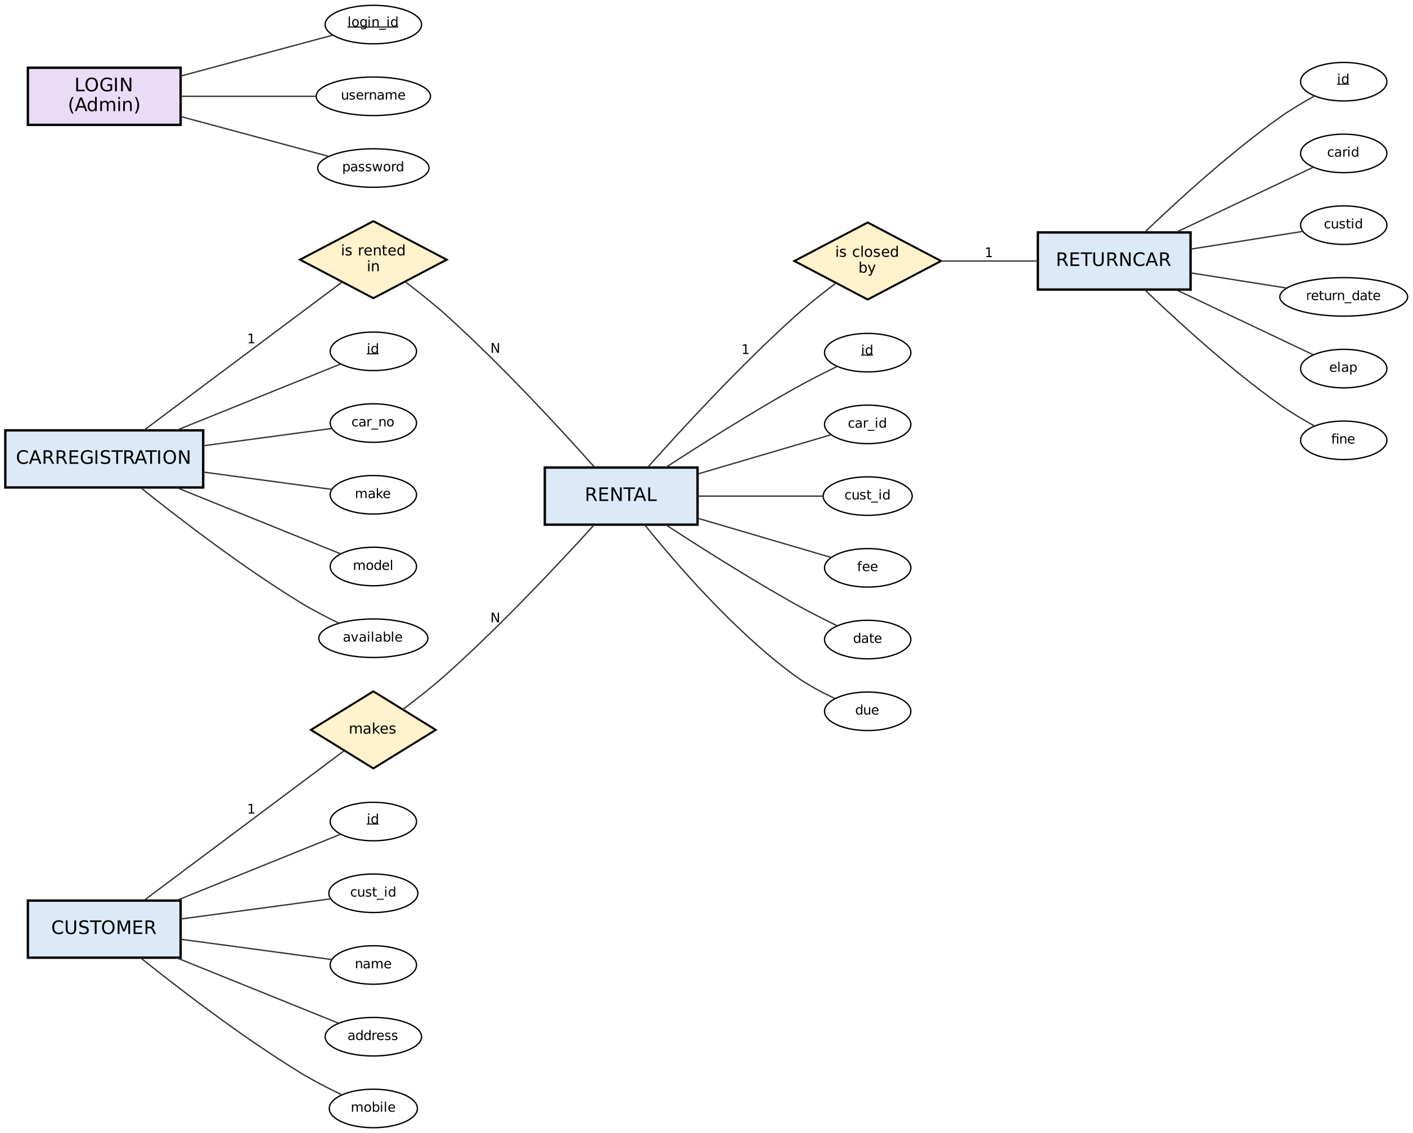
Figure 1: ER diagram of the Car Rental Management System
- One car can appear in many rentals, and one customer can make many rentals (1 : N).
- Each rental is closed by one return record (1 : 1), which stores elapsed days and fine.
- LOGIN is independent: it only stores administrator credentials.

4. Relational Schema
The ER diagram is mapped to five relations. Primary keys are underlined; arrows point from a foreign key to the key it references.
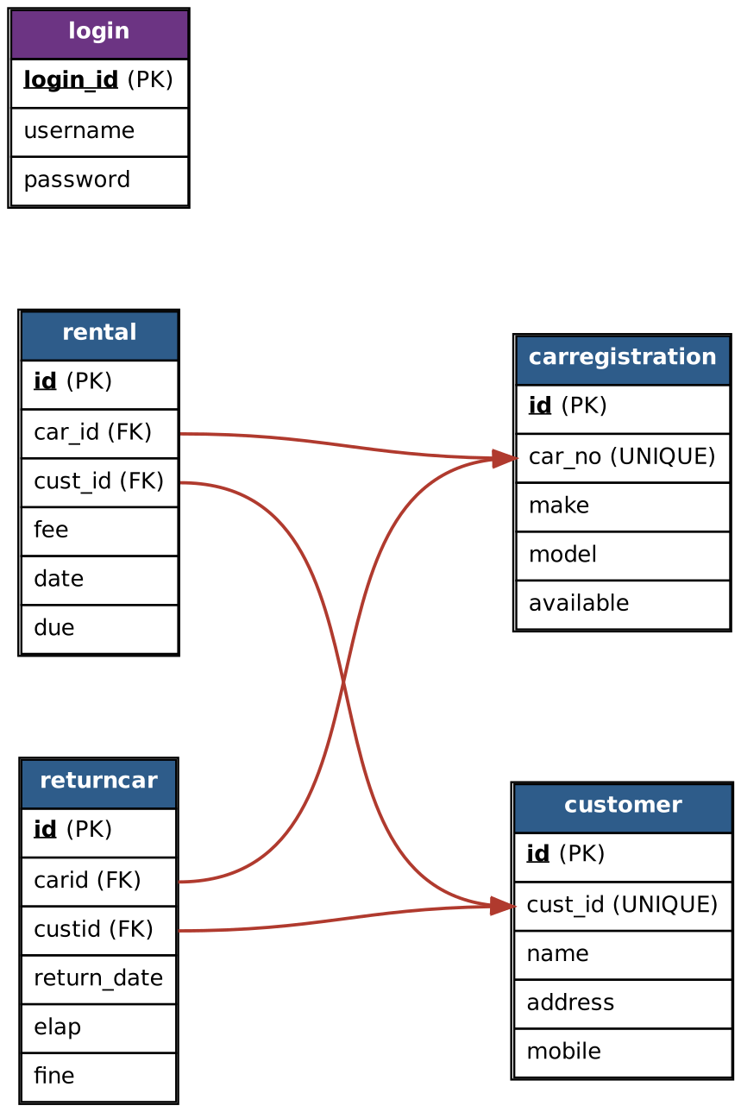
Figure 2: Relational schema with primary and foreign keys
Relation | Primary key | Foreign keys
carregistration | id | – (car_no is a unique business key)
customer | id | – (cust_id is a unique business key)
rental | id | car_id → carregistration.car_no; cust_id → customer.cust_id
returncar | id | carid → carregistration.car_no; custid → customer.cust_id
login | login_id | –

5. System Flow and Working
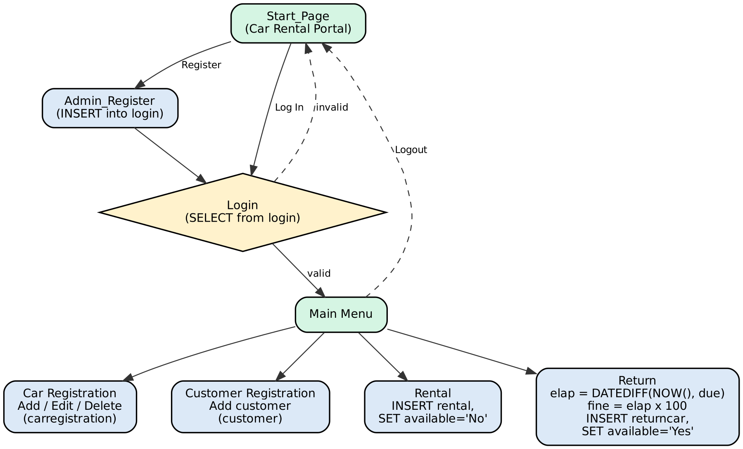
Figure 3: Navigation and database operations of the application

Key business logic
- Auto IDs: the next car number or customer ID is generated from the current maximum value in the table.
- Renting: a row is inserted into rental and the car's available flag is set to 'No'.
- Returning: elapsed days = DATEDIFF(NOW(), due). If elapsed > 0, fine = elapsed × ₹100, otherwise 0. A row is added to returncar and the car's available flag is set back to 'Yes'.
- Security: only administrators present in the login table can reach the main menu.

6. Steps to Run the Project
- Install JDK 8 or later, Apache NetBeans IDE and MySQL Server (with MySQL Workbench).
- Download the project ZIP (or git clone https://github.com/afrozchakure/Car-Rental-Java-DBMS-Project.git) and extract it.
- Open MySQL Workbench and run the SQL script from Section 2. Check that the rentcar database has five tables.
- Download mysql-connector-java-5.1.48.jar and jcalendar-1.4.jar.
- In NetBeans choose File → Open Project and select the extracted folder.
- Right-click the project → Properties → Libraries, remove the broken jar entries and add the two downloaded jars.
- The code connects with user root and password afroz123 on localhost:3306. Either set your MySQL root password to afroz123 or replace this password in the DriverManager.getConnection lines of each class (Find in Projects: Ctrl+Shift+F).
- Right-click Start_Page.java → Run File (the RentCar main class is empty, so run from Start_Page).
- Click Register to create an admin account, then Log In.
- From the Main Menu add cars and customers, then use Rental and Return to test the full cycle and the fine calculation.

7. Conclusion
The mini project shows how a normalised MySQL database can drive a complete Java desktop application: data entry, availability tracking, rentals, returns and automatic fine calculation. Possible enhancements are password hashing, DATE columns instead of VARCHAR, and reports for revenue and overdue cars.

