**The mid-term report of the project entitled**

**“ProManager”**

**Submitted in partial fulfillment of the requirements of**

**BACHELOR OF TECHNOLOGY**

**IN**

**COMPUTER SCIENCE & ENGINEERING**



**SUBMITTED TO: SUBMITTED BY:**

Mr. Tanveer Singh

( ) Roll no:- 2007037

**Ramgarhia Institute of Engineering and Technology(RIET)**

**(Phagwara)**

**INDEX**

**CONTENT PAGE_NO:**

Introduction 3

Problem Definition 4

Existing System 5

Proposed System 6

Project Detailed Analysis 7-8

Database Design 9-10

Feasibility Study 11-13

SRS 14-17

DFD 18-20

Technology 21-32

Hardware/Software Requirement 33

**Chapter - 1**

**Introduction**

ProManager is basically a task management system. This is truly beneficial for them who face many difficulties in managing and handling the work or tasks with their co-members. “ProManager” is a platform which provides the facility to admin to make the group of their employees and can invite their team-members/colleagues.

The admin can assign tasks to everyone in the group with task’s description, attachments and due dates. Admin can make announcements

The group member will get notification of their tasks and after the completion of their given tasks they can easily upload their completed work in ProManager and the admin will get the work from all the employees.

If there was any problem with anyone regarding a task or any other thing they can make conversation within the group, and if someone wants to talk to the admin (group leader) privately then that person can communicate privately within the group.

**1.1 Beneficial factors :-**

* Task Tracking and Assignment: Assign, monitor, and track tasks efficiently, ensuring accountability and visibility throughout the project lifecycle.
* Real-time Collaboration: Facilitate seamless communication and collaboration through integrated messaging, document sharing, and discussion forums within the platform.
* Project Dashboards: Provide comprehensive dashboards with real-time project metrics, progress indicators, and performance analytics for informed decision-making.
* Resource Management: Optimize resource allocation by tracking availability, skill sets, and workload to ensure a balanced distribution of tasks among team members.

**1.2 Problem Definition**

Nowadays handling and managing tasks are quite difficult, even if it is in a business field or in an educational field or any other field. The work of assigning tasks to your colleagues or team members separately and collecting the completed works from every member is so time consuming and difficult to manage.

There are many problems occurring in an organization between manager and employees for handling tasks and projects. Problems like :-

* Task Overload: Employees struggle to manage numerous tasks simultaneously.
* Lack of Clarity: Unclear task priorities, dependencies, and deadlines.
* Inefficient Communication: Difficulty in assigning, tracking, and updating tasks.
* Resource Allocation: Inefficient allocation of human and financial resources.
* Missed Deadlines: Tasks slipping through the cracks due to poor tracking.
* Inadequate Reporting: Lack of insights into task progress and bottlenecks.

**ProManager** is a task management website, which helps to manage and handle the tasks between the team leader and the team members. With this project the users will get a better way to assign and upload their work. Such a system plays a crucial role in ensuring efficient task execution and project management.

**Chapter - 2**

**Existing System**

In the existing system there are some problems that user are facing, some of the problem like:-

1. Complexity and Lack of User-Friendliness:

* Many task management systems are overly complex, leading to a steep learning curve for users.
* The interfaces may be cluttered, making it challenging for users to navigate and use the system efficiently.

1. Limited Collaboration Features:

* Some systems may lack robust collaboration features, hindering effective communication and coordination among team members.
* Limited real-time collaboration tools may impact productivity, especially in remote or distributed teams.

1. Inefficient Reporting and Analytics:

* Reporting and analytics capabilities may be insufficient, hindering the ability to gather insights into team performance, project progress, and resource allocation.

**Chapter - 3**

**Proposed System**

The new task management system aims to enhance user satisfaction, team collaboration, and overall productivity in a modern work environment.

Here are the features that are in proposed system :-

1. Intuitive and User-Friendly Interface:
   * The proposed system should prioritize an intuitive and user-friendly interface, reducing the learning curve for new users and enhancing overall usability.
2. Enhanced Collaboration Features:
   * Robust collaboration tools, such as real-time editing, commenting, and notification systems, should be integrated to improve communication and teamwork.
3. Advanced Reporting and Analytics:

* Implement powerful reporting and analytics features to provide users with insights into project progress, individual and team performance, and resource utilization. Customizable dashboards can offer a comprehensive overview.

**Detailed analysis of project**

My project (ProManager) is specifically designed for a company or an organization. In this the admin can perform no. things like assign tasks and projects to their employees, can make their team for project work, can track their work progress, can make announcements.

As both admin and employees are assigned with Username and Password for login.

Admin Panel can be used by only one person, so no one other can use or login that admin panel. But there are a number of employees in a company so the employee panels have access for multiple users. Employees can easily login by its username and password and can start their word, without login employees can do or see anything.

Admin can decide which employee will join or if admin wants to remove someone then admin can remove the specific employee from the group.

Let's discuss these two panels briefly, their goals ,objectives..

**Admin Panel**

In the admin panel there is only one person who has all access. Admin can add or remove the user(employee)

The main objectives of admin are :-

* Admin can add the employees , check all the present employees , change and remove the employees.
* Admin can assign the task to all their employees by describing the task and attachments. Admin can also read all the task that it has assigned and if admin wants to make the changes in the assigned tasks then it can do , and all the employees will notified about the updation made in the tasks

And for any reason admin wants to delete the task so admin can easily remove the task

* Projects are also assigned by the admin. Admin can assign projects with the project title, project description, attachments,client’s name, technology and deadline.

Now projects are done in a team not by a single person , so the admin can make the team of employees who will make those projects and assign them.

Admin can also see all the projects that are assigned, makes updates in the projects and can delete the projects.

* In our project we have rewards and warnings that can be used with ‘Coin System’. If the admin wants to give rewards to an employee then it will give a coin to the employee as a reward and when the warning is given to the employee , one coin will be deducted from the user.

Apart from that, the admin can track the progress of employees to whom the project or tasks are assigned. Admin can see whose work is completed , whose work is going on and who has not completed their work even after the deadline.

**Employee Panel**

In employee’s panel there are multiple uses , so employees whose has access of login by admin or have its login username and password and easily login and can do their works, otherwise it can do and see anything

Objectives of Employees are :-

* Employees will login and see its works , tasks ,and projects assigned. Employees can read all the tasks or project details provided by the admin.
* Once employees have completed their work , they can submit to that group. And for any reason if there was a mistake in their work and want to make changes , then they can resubmit it after making the changes and the admin will be notified of updates made by which employee.
* Employees have to give the progress report to the admin, so that admin has knowledge about work.

**DATABASE DESIGN**

Database design can be generally defined as a collection of tasks or processes that enhance the designing, development, implementation, and maintenance of enterprise data management systems. Designing a proper database reduces the maintenance cost thereby improving data consistency and the cost-effective measures are greatly influenced in terms of disk storage space. Therefore, there has to be a brilliant concept of designing a database. The designer should follow the constraints and decide how the elements correlate and what kind of data must be stored.

**Managing user’s database :** To manage the user data with their information

|  |  |
| --- | --- |
| **Key’s** | **Description** |
| _id | It is automatically generated Primary key |
| autoId | It is auto incremented id number |
| Name | It is the name of the user |
| Email | User’s email |
| Password | User’s password |
| userType | Identify the user - is it the admin or employee |
| createdAt | It is the time stamp. Tell the exact time when the  user is added in database |
| Status | Status for the user (true or false) |

**Managing projects :** It stores and manages the project that the admin added and assigned to employees.

|  |  |
| --- | --- |
| Key’s | Description |
| _id | It is an automatically generated primary key. |
| autoId | It is an auto incremented id number. |
| Name | To add the name of the project. |
| Description | To tell a description about the project. Explanation of the assigned project so employees can understand. |
| Attachment | It can be image, document, file, zip, video.. |
| Client | Name of the client who’s project it is. |
| Technology | Name of the technology by which the project will be made. |
| createdAt | Time stamp tells when the project is created. |
| Status | Status of the added project (true or false) |

**Chapter - 4**

**Feasibility Study**

Nowadays handling and managing tasks are quite difficult, even if it is in a business field or in an educational field or any other field. The work of assigning tasks to your colleagues or team members separately and collecting the completed works from every member is so time consuming and difficult to manage.

ProManager is a task management website, which helps to manage and handle the tasks between the team leader and the team members. With this project the users will get a better way to assign and upload their work.

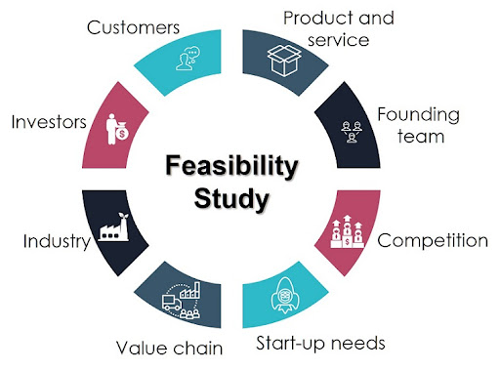

Fig no. 4.1

## **Types of Feasibility Study**

A feasibility analysis evaluates the project’s potential for success; therefore, perceived objectivity is an essential factor in the credibility of the study for potential investors and lending institutions. There are five types of feasibility study—separate areas that a feasibility study examines, described below.

### 1. **Technical Feasibility**

This assessment focuses on the technical resources available to the organization. It helps organizations determine whether the technical resources meet capacity and whether the technical team is capable of converting the ideas into working systems. Technical feasibility also involves the evaluation of the hardware, software, and other technical requirements of the proposed system. As an exaggerated example, an organization wouldn’t want to try to put Star Trek’s transporters in their building—currently, this project is not technically feasible.

### 2. **Economic Feasibility**

This assessment typically involves a cost/ benefits analysis of the project, helping organizations determine the viability, cost, and benefits associated with a project before financial resources are allocated. It also serves as an independent project assessment and enhances project credibility—helping decision-makers determine the positive economic benefits to the organization that the proposed project will provide.

### 3. **Operational Feasibility**

This assessment involves undertaking a study to analyze and determine whether—and how well—the organization’s needs can be met by completing the project. Operational feasibility studies also examine how a project plan satisfies the requirements identified in the requirements analysis phase of system development

## **Importance of Feasibility Study :-**

The importance of a feasibility study is based on organizational desire to “get it right” before committing resources, time, or budget. A feasibility study might uncover new ideas that could completely change a project’s scope. It’s best to make these determinations in advance, rather than to jump in and to learn that the project won’t work. Conducting a feasibility study is always beneficial to the project as it gives you and other stakeholders a clear picture of the proposed project.

Below are some key benefits of conducting a feasibility study:

* Improves project teams’ focus
* Identifies new opportunities
* Provides valuable information for a “go/no-go” decision
* Narrows the business alternatives
* Identifies a valid reason to undertake the project
* Enhances the success rate by evaluating multiple parameters
* Aids decision-making on the project

**Chapter - 5**

**SRS (Software Requirement Specification)**

The production of the requirements stage of the software development process is Software Requirements Specifications (SRS) (also called a requirements document). This report lays a foundation for software engineering activities and is constructed when entire requirements are elicited and analyzed. SRS is a formal report, which acts as a representation of software that enables the customers to review whether it (SRS) is according to their requirements. Also, it comprises user requirements for a system as well as detailed specifications of the system requirements.

The SRS is a specification for a specific software product, program, or set of applications that perform particular functions in a specific environment. It serves several goals depending on who is writing it. First, the SRS could be written by the client of a system. Second, the SRS could be written by a developer of the system. The two methods create entirely various situations and establish different purposes for the document altogether. The first case, SRS, is used to define the needs and expectations of the users. The second case, SRS, is written for various purposes and serves as a contract document between customer and developer

## Qualities of SRS:

* Correct
* Complete
* Consistent
* Verifiable
* Modifiable
* Traceable

## Characteristics of good SRS :-

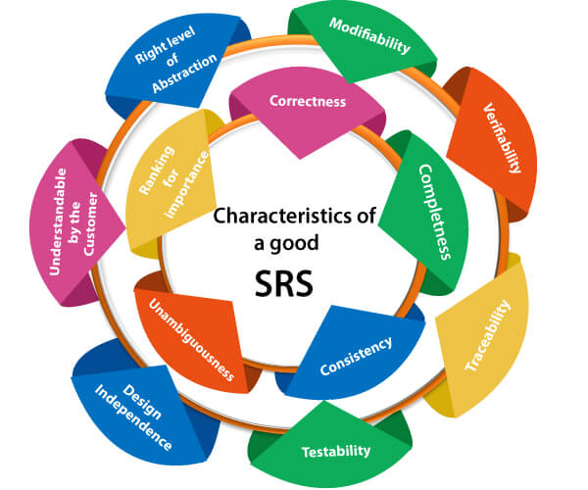

Fig no. 5.1

**1. Correctness:** User review is used to provide the accuracy of requirements stated in the SRS. SRS is said to be perfect if it covers all the needs that are truly expected from the system.

**2. Completeness:** The SRS is complete if, and only if, it includes the following elements:

* All essential requirements, whether relating to functionality, performance, design, constraints, attributes, or external interfaces.
* Definition of their responses of the software to all realizable classes of input data in all available categories of situations.
* Full labels and references to all figures, tables, and diagrams in the SRS and definitions of all terms and units of measure.

**3. Consistency:** The SRS is consistent if, and only if, no subset of individual requirements described in its conflict. There are three types of possible conflict in the SRS:

* The specified characteristics of real-world objects may conflict. For example,

1. The format of an output report may be described in one requirement as tabular but in another as textual.
2. One condition may state that all lights shall be green while another states that all lights shall be blue.

* There may be a reasonable or temporal conflict between the two specified actions. For example,

1. One requirement may determine that the program will add two inputs, and another may determine that the program will multiply them.
2. One condition may state that "A" must always follow "B," while another requires that "A and B" co-occurs.

* Two or more requirements may define the same real-world object but use different terms for that object. For example, a program's request for user input may be called a "prompt" in one requirement and a "cue" in another. The use of standard terminology and descriptions promotes consistency.

**4. Unambiguousness:** SRS is unambiguous when every fixed requirement has only one interpretation. This suggests that each element is uniquely interpreted. In case there is a method used with multiple definitions, the requirements report should determine the implications in the SRS so that it is clear and simple to understand.

**5. Ranking for importance and stability:** The SRS is ranked for importance and stability if each requirement in it has an identifier to indicate either the significance or stability of that particular requirement.

Typically, all requirements are not equally important. Some prerequisites may be essential, especially for life-critical applications, while others may be desirable. Each element should be identified to make these differences clear and explicit. Another way to rank requirements is to distinguish classes of items as essential, conditional, and optional.

**6. Modifiability:** SRS should be made as modifiable as likely and should be capable of quickly obtaining changes to the system to some extent. Modifications should be perfectly indexed and cross-referenced.

**7. Verifiability:** SRS is correct when the specified requirements can be verified with a cost-effective system to check whether the final software meets those requirements. The requirements are verified with the help of reviews.

**8. Traceability:** The SRS is traceable if the origin of each of the requirements is clear and if it facilitates the referencing of each condition in future development or enhancement documentation.

**DFD (Data Flow Diagrams)**

DFD is the abbreviation for Data Flow Diagram. The flow of data of a system or a process is represented by DFD. It also gives insight into the inputs and outputs of each entity and the process itself. DFD does not have control flow and no loops or decision rules are present. Specific operations depending on the type of data can be explained by a flowchart.

**Level 0**



**Admin panel DFD:**

**Level 1**

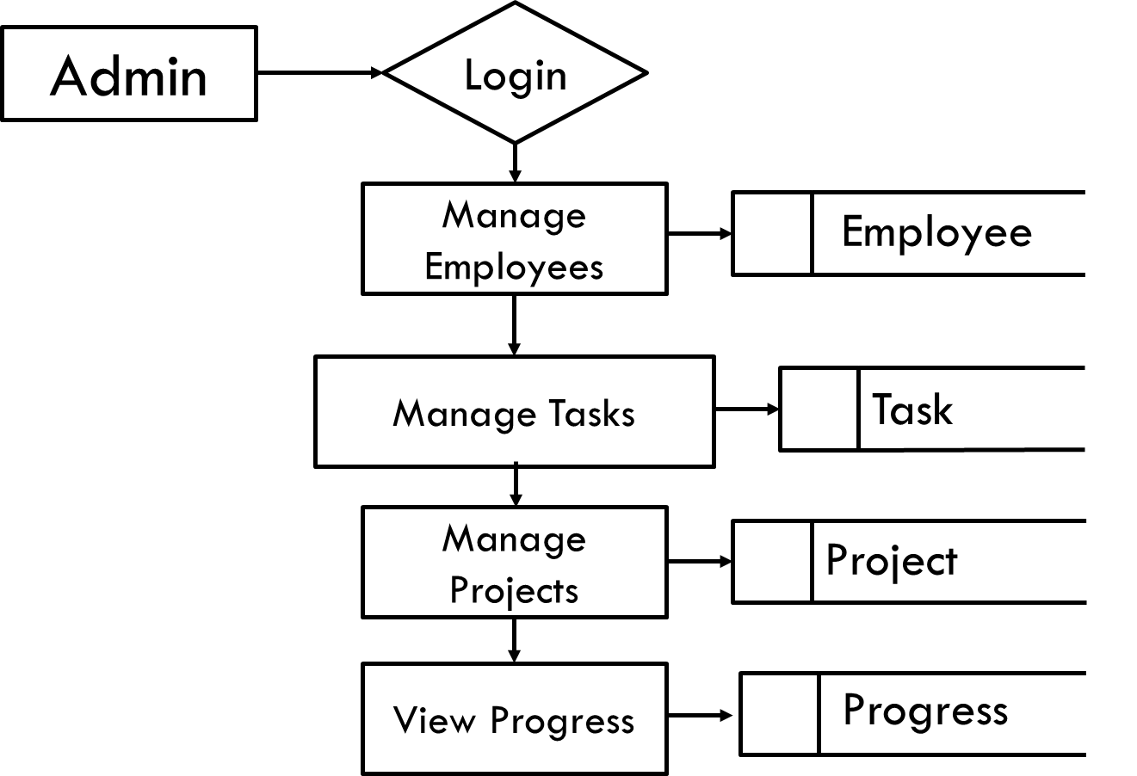

**Employee Panel DFD:**

**Level 2**

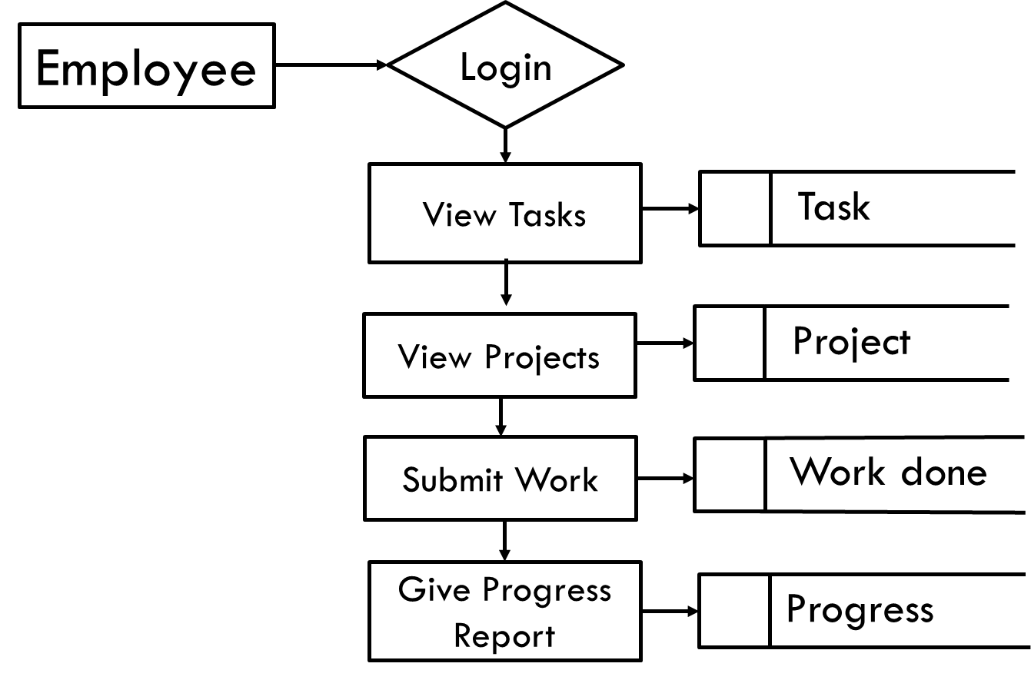

**Chapter - 6**

**Technology**

**Front End :-**

**HTML :-**Fig no. 6.1


HTML is an acronym which stands for Hyper Text Markup Language which is used for creating web pages and web applications. Let's see what is meant by Hypertext Markup Language, and Web page.

HyperText: HyperText simply means "Text within Text." A text has a link within it, is a hypertext. Whenever you click on a link which brings you to a new webpage, you have clicked on a hypertext. HyperText is a way to link two or more web pages (HTML documents) with each other. Fig no. 6.1

Markup language: A markup language is a computer language that is used to apply layout and formatting conventions to a text document. Markup language makes text more interactive and dynamic. It can turn text into images, tables, links, etc.

Web Page: A web page is a document which is commonly written in HTML and translated by a web browser. A web page can be identified by entering an URL. A Web page can be of the static or dynamic type. With the help of HTML only, we can create static web pages.

* It is a very easy and simple language. It can be easily understood and modified.
* It is very easy to make an effective presentation with HTML because it has a lot of formatting tags.
* It is a markup language, so it provides a flexible way to design web pages along with the text.

**CSS :-**



CSS (Cascading Style Sheets) is a simply designed language intended to simplify the process of making web pages presentable. CSS allows you to apply styles to HTML documents. It describes how a web page should look. It prescribes colors, fonts, spacing, etc. In short, you can make your website look however you want. CSS lets developers and designers define how it behaves, including how elements are positioned in the browser.

Fig no. 6.2

HTML uses tags and CSS uses rulesets. CSS styles are applied to the HTML element using selectors. CSS is easy to learn and understand, but it provides powerful control over the presentation of an HTML document.

CSS comprises style rules that are interpreted by the browser and then applied to the corresponding elements in your document. A style rule set consists of a selector and declaration block.

* **Selector**: A selector in CSS is used to target and select specific HTML elements to apply styles.
* **Declaration**: A declaration in CSS is a combination of a property and its corresponding value.

The current version of css is CSS3

**BOOTSTRAP :-**

Bootstrap is a free and open-source tool collection for creating responsive websites and web applications. It is the most popular HTML, CSS, and JavaScript framework for developing responsive, mobile-first websites. Nowadays, the websites are perfect for all browsers (IE, Firefox, and Chrome) and for all sizes of screens (Desktop, Tablets, Phablets, and Phones). All thanks to Bootstrap developers – Fig no. 6.3

Mark Otto and Jacob Thornton of Twitter, though it was later declared to be an open-source project.

By using this framework we can easily manipulate the styling of any web page, like font style, text color, background color, flex, grid system, etc. Bootstrap Version 4 & Version 5 are the most popular versions. There are lots of other CSS frameworks like Tailwind CSS, Bulma, and Foundation but among them, this framework is the most popular because of below mentioned features:

* It is a Faster and Easier way for Web-Development.
* It creates Platform-independent web-pages.
* It creates Responsive Web-pages.
* It designs responsive web pages for mobile devices too.
* It is a free and open-source framework available on www.getbootstrap.com

Applications of Bootstrap

* **Responsive Web Design**: Bootstrap empowers developers to create websites that seamlessly adapt to different screen sizes and devices, providing a consistent and optimal user experience.
* **Mobile-First Development**: Bootstrap’s mobile-first approach ensures that websites are designed and optimized for mobile devices, catering to the increasing usage of smartphones and tablets.
* **Efficient Prototyping**: With its extensive collection of pre-designed components and templates, Bootstrap facilitates rapid prototyping, enabling developers to quickly create functional website layouts and UIs.
* **Consistent Cross-Browser Compatibility**: Bootstrap’s standardized CSS and JavaScript codebase ensures consistent rendering and functionality across various web browsers, saving developers time and effort in browser-specific troubleshooting.
* **Customizable Themes and Styling**: Bootstrap offers a wide range of customizable themes and styles, allowing developers to create visually appealing and unique designs that align with their brand or project requirements.
* **Time and Cost Efficiency**: By leveraging the power of Bootstrap, developers can save significant time and effort in front-end development, resulting in faster project delivery and cost savings.

**JAVASCRIPT :-**



JavaScript (JS) is the top programming language for web development, used for both Client-Side and Server-Side purposes. It is also known as a scripting language for web pages.It is commonly used to create dynamic and interactive content on websites. JS plays a crucial role in modern web browsers, enabling client-side scripting to modify web page content in real-time, enhancing user experience.

JavaScript is the most popular and hence the most loved language around the globe. Apart from this, there are abundant reasons to become the most demanding. Here’s why: Fig no. 6.4

* Used both Client and Server Side: Earlier JavaScript was used to build client-side applications only, but with the evolution of its frameworks namely Node.js and Express.js, it is now widely used for building server-side applications too.
* Helps to build a complete solution: As we saw, JavaScript is widely used in both client and server-side applications, therefore it helps us to build an end-to-end solution to a given problem.
* Used everywhere: JavaScript is so loved because it can be used anywhere. It can be used to develop websites, games or mobile apps, etc.
* JavaScript is constantly evolving with new features and standards.
* Huge community support: JavaScript has a huge community of users and mentors who love this language and take its legacy forward.

**REACT JS :-** 

React is a library for building composable user interfaces. It encourages the creation of reusable UI components, which present data that changes over time. Lots of people use React as the V in MVC. React abstracts away the DOM from you, offering a simpler programming model and better performance. React can also render on the server using Node, and it can power native apps using React Native. React implements one-way reactive data flow, which Fig no. 6.5

reduces the boilerplate and is easier to reason about than traditional data binding.

**React Features**:

* JSX − JSX is a JavaScript syntax extension. It isn't necessary to use JSX in React development, but it is recommended.
* Components − React is all about components. You need to think of everything as a component. This will help you maintain the code when working on larger scale projects.
* Unidirectional data flow and Flux − React implements one-way data flow which makes it easy to reason about your app. Flux is a pattern that helps keep your data unidirectional.
* License − React is licensed under Facebook Inc. Documentation is licensed under CC BY 4.0.

**React Advantages:**

* Uses virtual DOM which is a JavaScript object. This will improve apps performance, since JavaScript virtual DOM is faster than the regular DOM.
* Can be used on client and server side as well as with other frameworks.
* Component and data patterns improve readability, which helps to maintain larger apps.

**BACKEND:-**

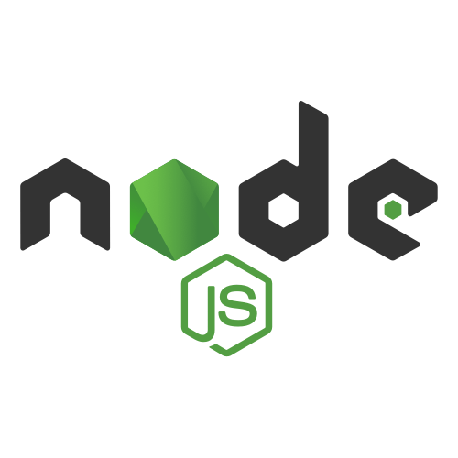

**NODE JS:**

NodeJS or Node.js is one of the powerful open-source and cross-platform runtime environments built on Chrome’s V8 JavaScript engine for executing JavaScript code outside of a browser. It provides an event-driven, non-blocking (asynchronous) I/O and cross-platform runtime environment for building highly scalable server-side applications using JavaScript. Fig no. 6.6

It was developed by Ryan Dahi in the year 2009 and v20.9 is the latest version of Node.js. Because it is cross-platform one can easily run on Windows, Linux, Unix, macOS and more.

Node Advantages:

* **Easy Scalability**: Node JS is built upon Chrome V8’s engine powered by Google. It allows Node to provide a server-side runtime environment that compiles and executes JavaScript at lightning speeds.
* **Real-time web apps**: Today the web has become much more about interaction. Users want to interact with each other in real-time. Chat, gaming, constant social media updates, collaboration tools, eCommerce websites, real-time tracking apps, marketplace- each of these features requires real-time communication between users, clients, and servers across the web.
* **Fast Suite**: As we have discussed, Node is highly scalable and lightweight that’s why it’s a heavy favorite for microservice architectures. In a nutshell, microservice architectures mean breaking down the application into isolated and independent services.
* **Easy to learn and code**: No matter what language you are using for the backend application you’re gonna need JavaScript for front-end anyway so instead of spending your time learning a server-side language such as Php, Java or Ruby on Rails, you can spend all your efforts in learning JS and mastering in it.
* **Data Streaming**: Node comes to the rescue since it’s good at handling such an I/O process which allows users to transcode media files simultaneously while they are being uploaded. It takes less time compared to other data processing methods for processing data.
* **Non Blocking Event-Driven Architecture** : Unlike other traditional web servers that wait for one request to finish before handling another, Node.js uses an event-driven architecture and this makes it effective for handling many concurrent requests.
* **Corporate Support**: It’s an independent community aimed at facilitating the development of Node core tools. The foundation of Node was formed to speed up the development of Node, and it was intended to allow broad adoption of it.

**SERVER :-**



**EXPRESS:**

Express JS is a small framework that works on top of Node web server functionality to simplify its APIs and add helpful new features. It makes it easier to organize your application’s functionality with middleware and routing. It adds helpful utilities to Node HTTP objects and facilitates the rendering of dynamic HTTP objects.

Fig no. 6.7

Express makes the development of Node applications very easy and it is very simple to use. It provides a simple and efficient way to build web applications and APIs using JavaScript. It helps Node to handle routes, requests, and responses, making it easier for you to create robust and scalable applications. As it is very flexible, lightweight and easy to learn and contains a ton of middleware options making it an excellent choice to learn and use Express in your application.

* Express was created to make APIs and web applications with ease,
* It saves a lot of coding time almost by half and still makes web and
* Mobile applications are efficient.
* Another reason for using express is that it is written in javascript as javascript is an easy language even if you don't have a previous
* knowledge of any language. Express lets so many new developers enter the field of web development.

The reason behind creating an express framework for node js is:

* Time-efficient
* Fast
* Economical
* Easy to learn
* Asynchronous

Express Advantages:

* Simplicity and Minimalism: Express JS has a very simple design that makes it easy to learn and use. With its simple structure you can quickly set up a server, define routes, and handle HTTP requests which makes it an excellent choice for building web applications efficiently.
* Flexibility and Customization: Express JS is a flexible framework that allows you to structure the application based on your preferences. It does have a strict application architecture so you can organize your code according to your preference.
* Middleware Ecosystem: Express JS has a large number of middleware that can be easily integrated into applications. Middleware functions increase the functionality of Express by allowing you to handle various tasks such as authentication, logging, and error handling.
* Scalability: Express JS is designed to be lightweight and scalable, which makes it suitable for building both small projects and large-scale applications. It is asynchronous and has event-driven architecture which allows you to handle a large number of requests.
* Active Community Support: Express JS has a large active community who contribute to its growth and improvement. Because of them the framework is regularly updated and well-documented.

**DATABASE**

**mongoDB:-**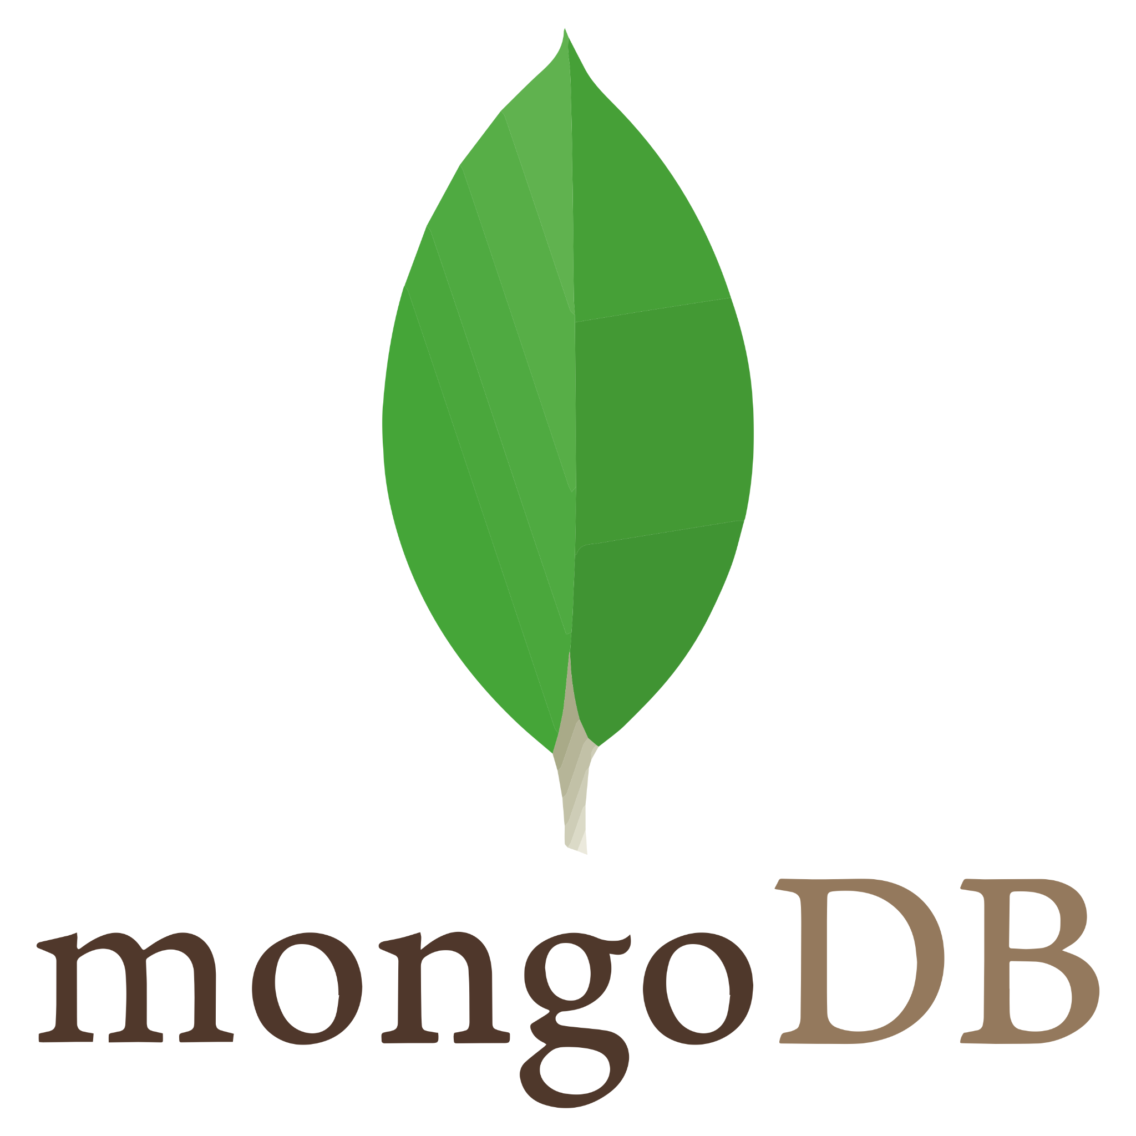

MongoDB is an open source NoSQL database management program. NoSQL (Not only SQL) is used as an alternative to traditional relational databases. NoSQL databases are quite useful for working with large sets of distributed data. MongoDB is a tool that can manage document-oriented information, store or retrieve information.

Fig no. 6.8

MongoDB is used for high-volume data storage, helping organizations store large amounts of data while still performing rapidly. Organizations also use MongoDB for its ad-hoc queries, indexing, load balancing, aggregation, server-side JavaScript execution and other features.

Structured Query Language (SQL) is a standardized programming language that is used to manage relational databases. SQL normalized data as schemas and tables, and every table has a fixed structure.

Instead of using tables and rows as in relational databases, as a NoSQL database, the MongoDB architecture is made up of collections and documents. Documents are made up of Key-value pairs -- MongoDB's basic unit of data. Collections, the equivalent of SQL tables, contain document sets. MongoDB offers support for many programming languages, such as C, C++, C#, Go, Java, Python, Ruby and Swift.

An organization might want to use MongoDB for the following:

* Storage. MongoDB can store large structured and unstructured data volumes and is scalable vertically and horizontally. Indexes are used to improve search performance. Searches are also done by field, range and expression queries.
* Data integration. This integrates data for applications, including for hybrid and multi-cloud applications.
* Complex data structures descriptions. Document databases enable the embedding of documents to describe nested structures (a structure within a structure) and can tolerate variations in data.
* Load balancing. MongoDB can be used to run over multiple servers.

**Advantages of MongoDB:**

MongoDB offers several potential benefits:

* **Schema-less**: Like other NoSQL databases, MongoDB doesn't require predefined schemas. It stores any type of data. This gives users the flexibility to create any number of fields in a document, making it easier to scale MongoDB databases compared to relational databases.
* **Document-oriented**: One of the advantages of using documents is that these objects map to native data types in several programming languages., Having embedded documents also reduces the need for database joins, which can lower costs.
* **Scalability**: A core function of MongoDB is its horizontal scalability, which makes it a useful database for companies running big data applications. In addition, sharding lets the database distribute data across a cluster of machines. MongoDB also supports the creation of zones of data based on a shared key.
* **Third-party support**: MongoDB supports several storage engines and provides pluggable storage engine APIs that let third parties develop their own storage engines for MongoDB.
* **Aggregation**: The DBMS also has built-in aggregation capabilities, which lets users run MapReduce code directly on the database rather than running MapReduce on Hadoop. MongoDB also includes its own file system called GridFS, akin to the Hadoop Distributed File System. The use of the file system is primarily for storing files larger than BSON's size limit of 16 MB per document.

**Chapter - 7**

**Hardware Requirement**

Processor : Intel core i3

RAM : 8 GB

SSD : 256GB

Hard Disk : 512 GB or more

Monitor : 15”CRT or LCD monitor

Keyboard : Normal or Multimedia

Mouse : Compatible Mouse

**Software Requirement**

Front End : React

Web Server : Express Server 8.0.0 (or Above)

DB Tool : MongoDB

Browser : Mozilla Firefox/Chrome/Edge

OS : Windows Operating System/Linux

Text Editor : Visual Studio

Environment : NodeJS