Q. Create a Letter informing student of your class about their sessional exam schedule. Accordingly, Demonstrate various steps of mail merge with the examples.

Solution-

STEP1-First open the MS-Word and then go to the “Mailing” tab .

STEP2-Then click on the mail merge option and then click on the “step by step mail merge wizard”.

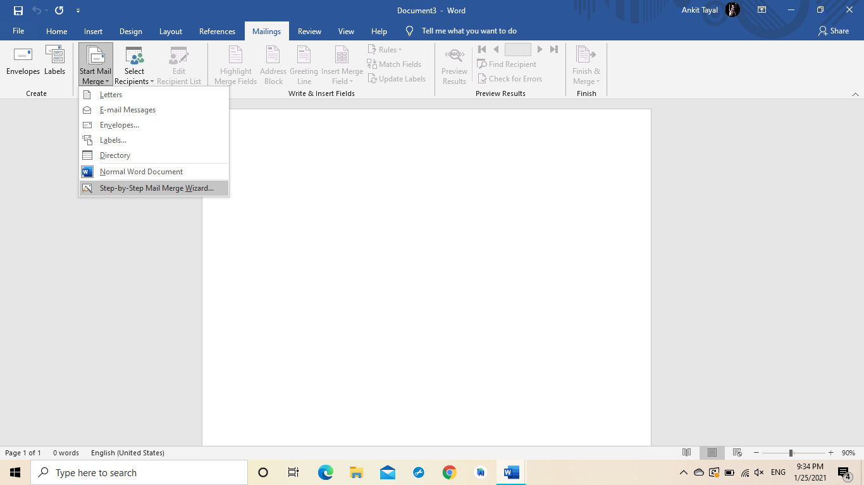

STEP3-An option to the right side will appear on the right screen of the computer.

STEP4- Now select it and then go to the step on the right screen and then move till the last step.

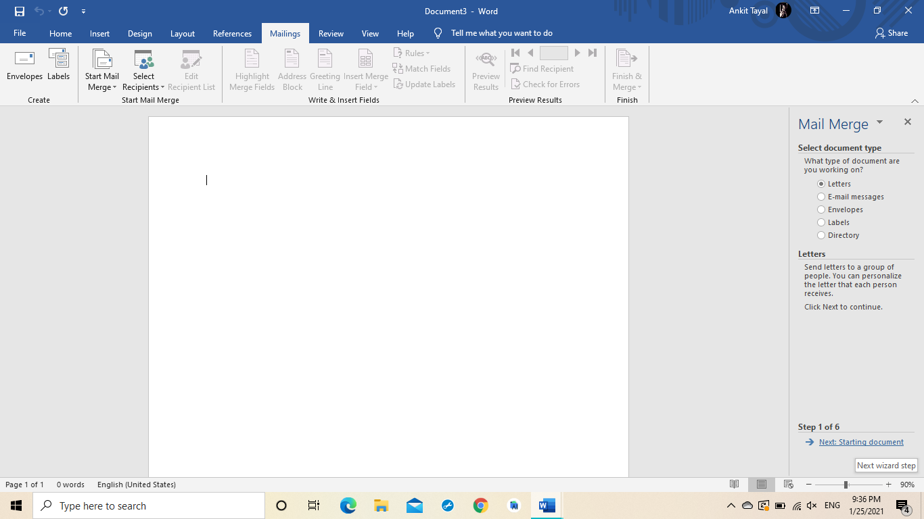

STEP5-Now from the third step on the right screen go to the “Address List “ and then Write the name of the people to whom the mail is send .

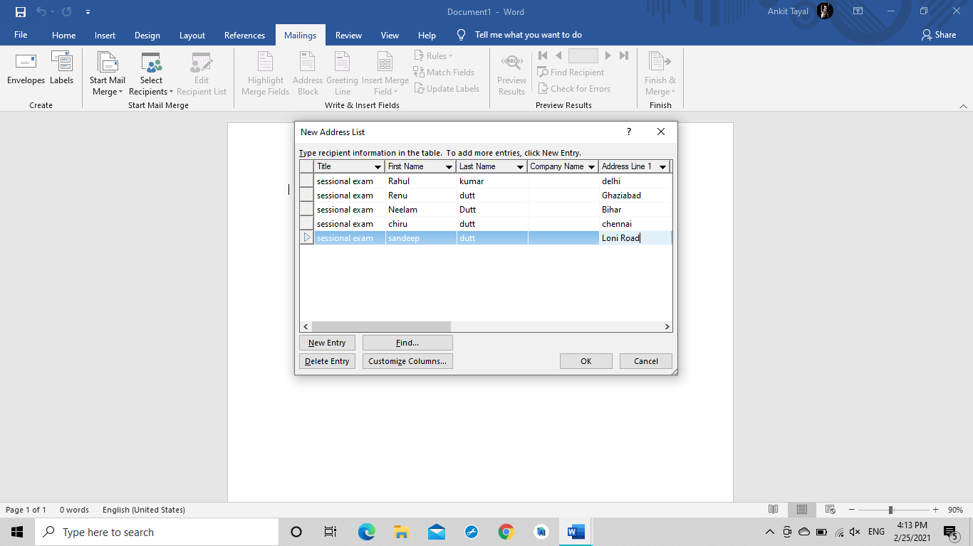

STEP6-Now go back to the main ms-word and then with the use of “tab” make the cursor in the centre.

STEP7-Now from the mailing option select the title .

STEP8-Now then select the new line and then go the mailing option and then add the name of the recipient .

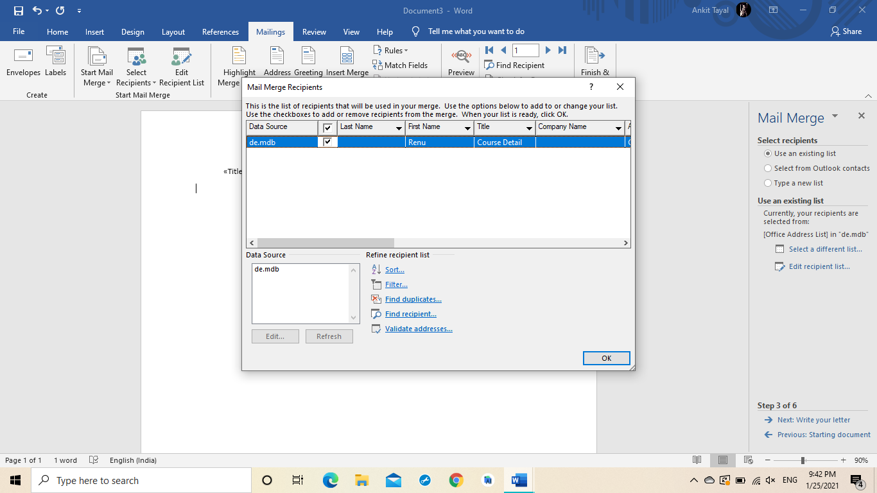

STEP9-Now add the “Address line “ from the “Mailing Option “ .

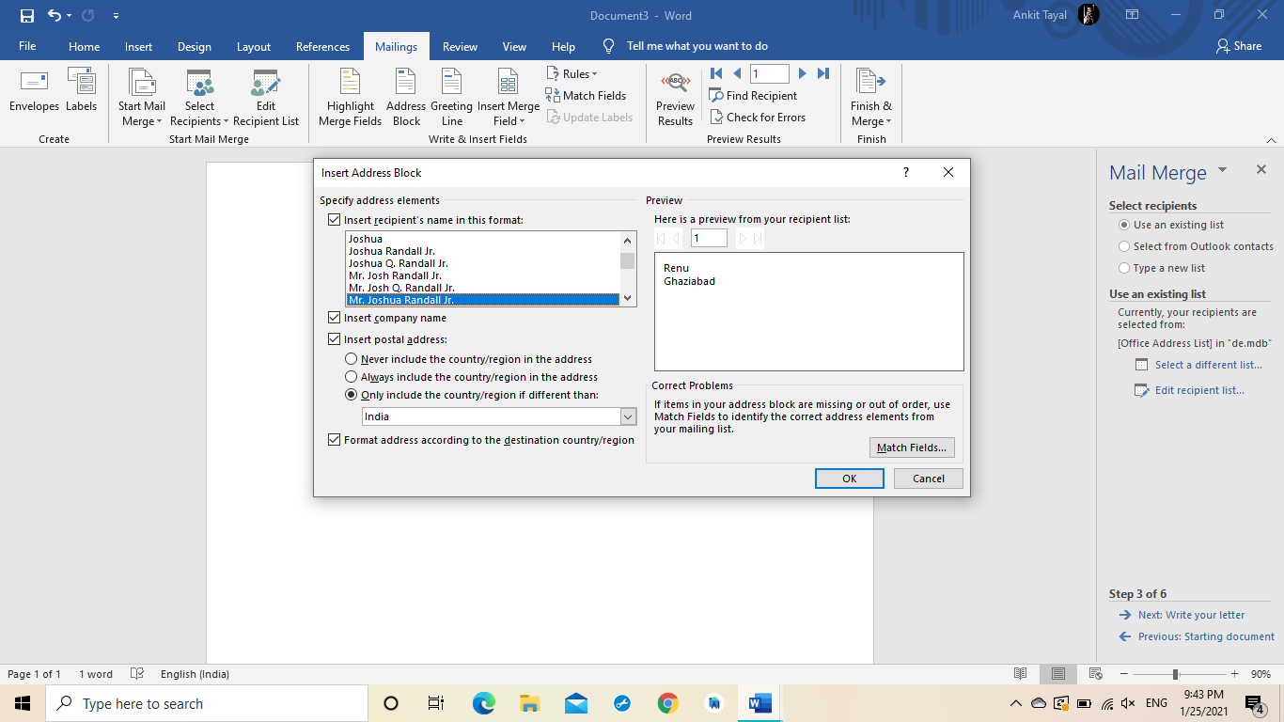

STEP10-Now insert the “Greeting Line “ after the “Address Line ” from the “mailing option”.

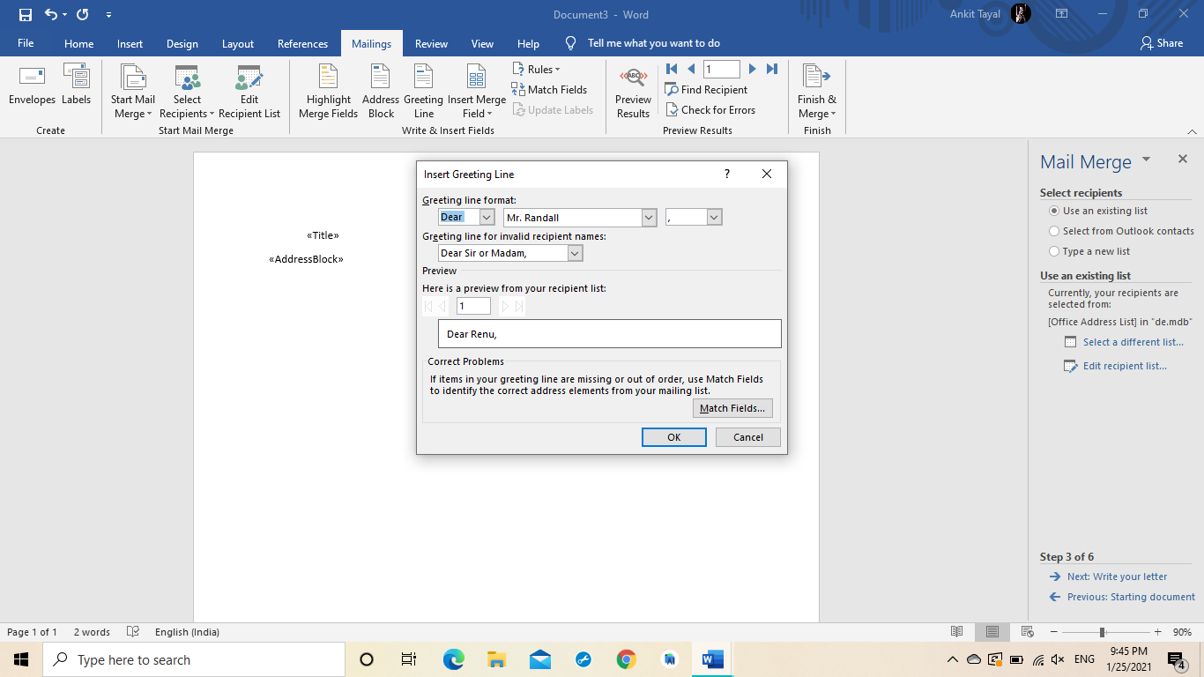

STEP11-Now write the body of the letter with the regards to the person to whom the message is sent.

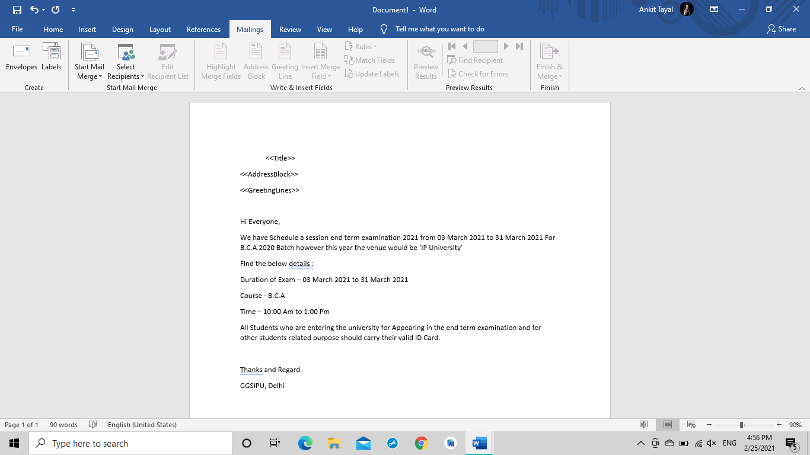

STEP12-Now the letter is typed and is ready to dispatch .

STEP13-Before sending the letter to it’s destination we have to review it from the option “Mailing” and the select the “Preview Results”.

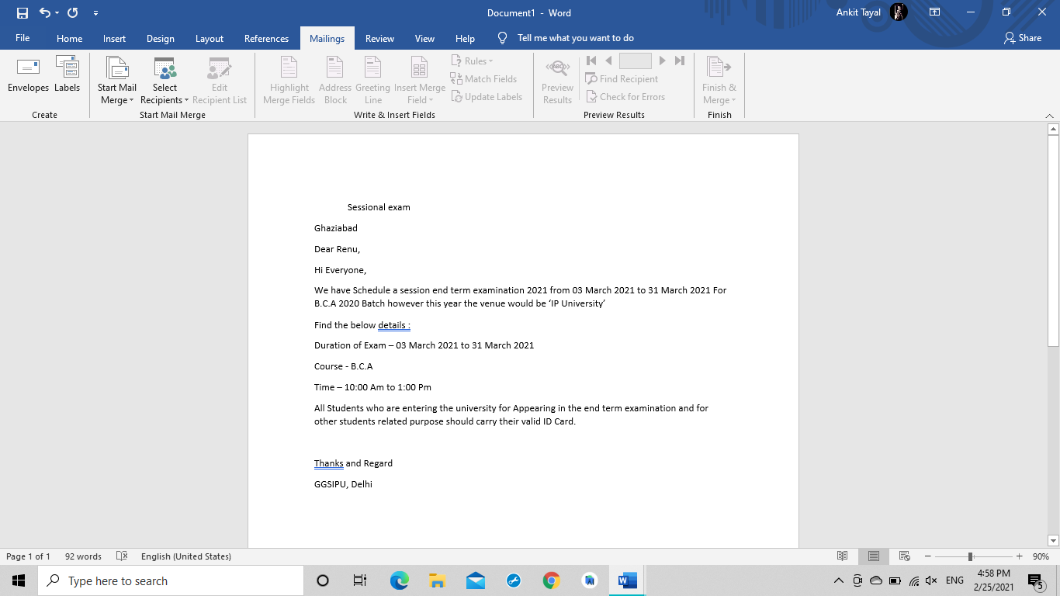

STEP14- Now again go to the option of “Mailing” and then select option “Mail Merge”.

STEP15-All the mails will be merged.

STEP16-All mails are now ready to dispatch.