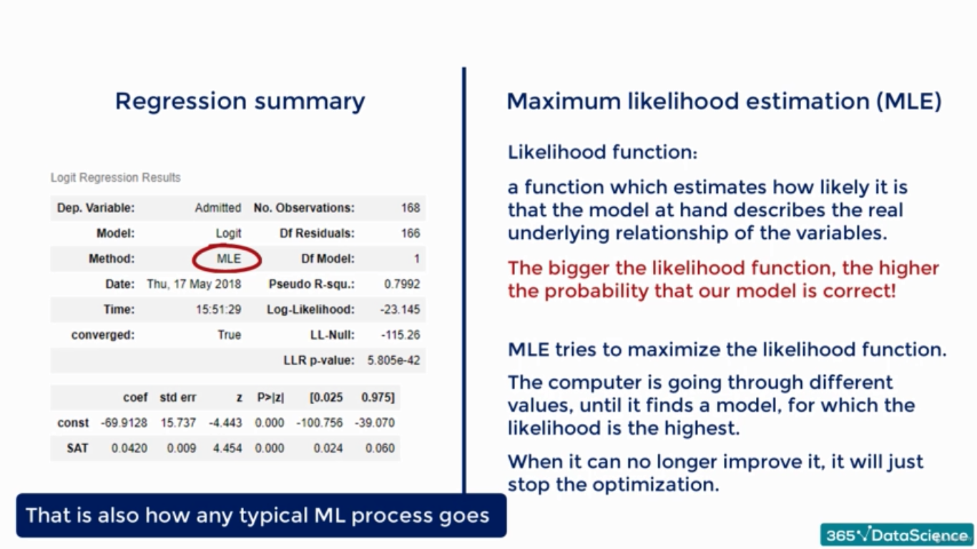

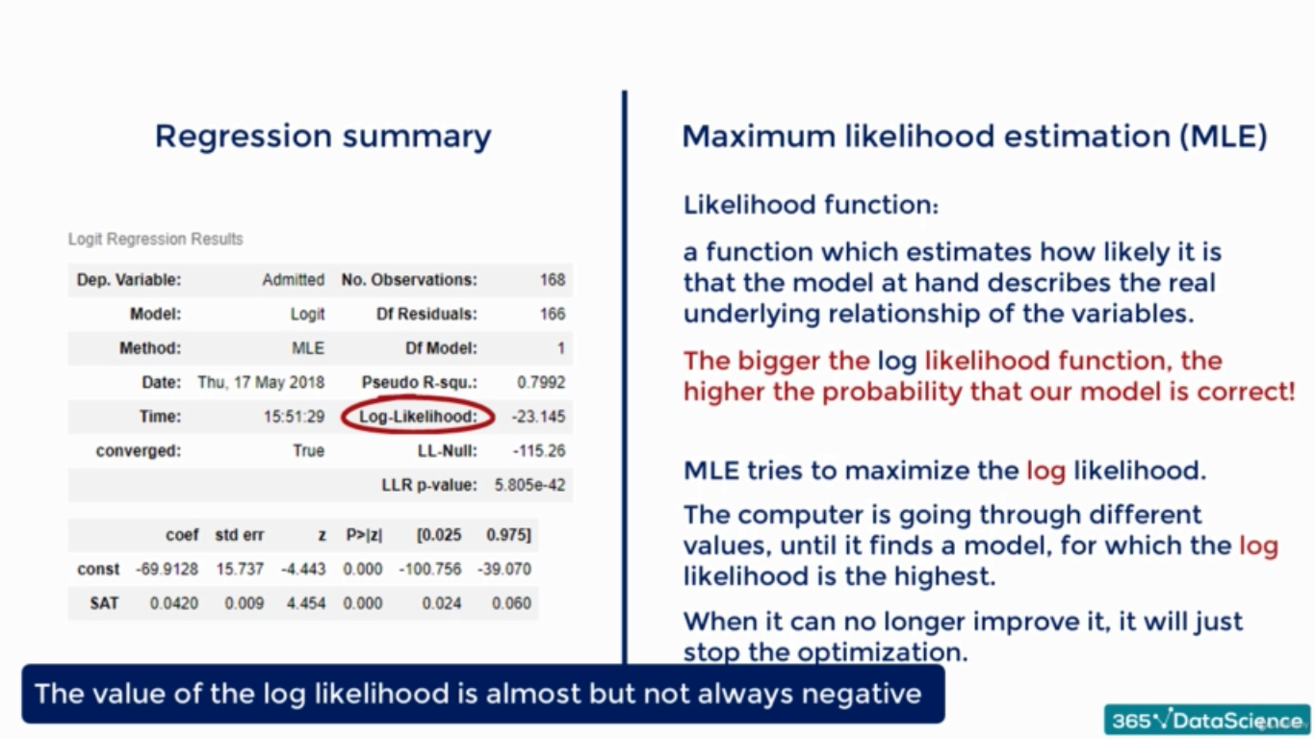  
The bigger the value of Log-likelihood the better it is.

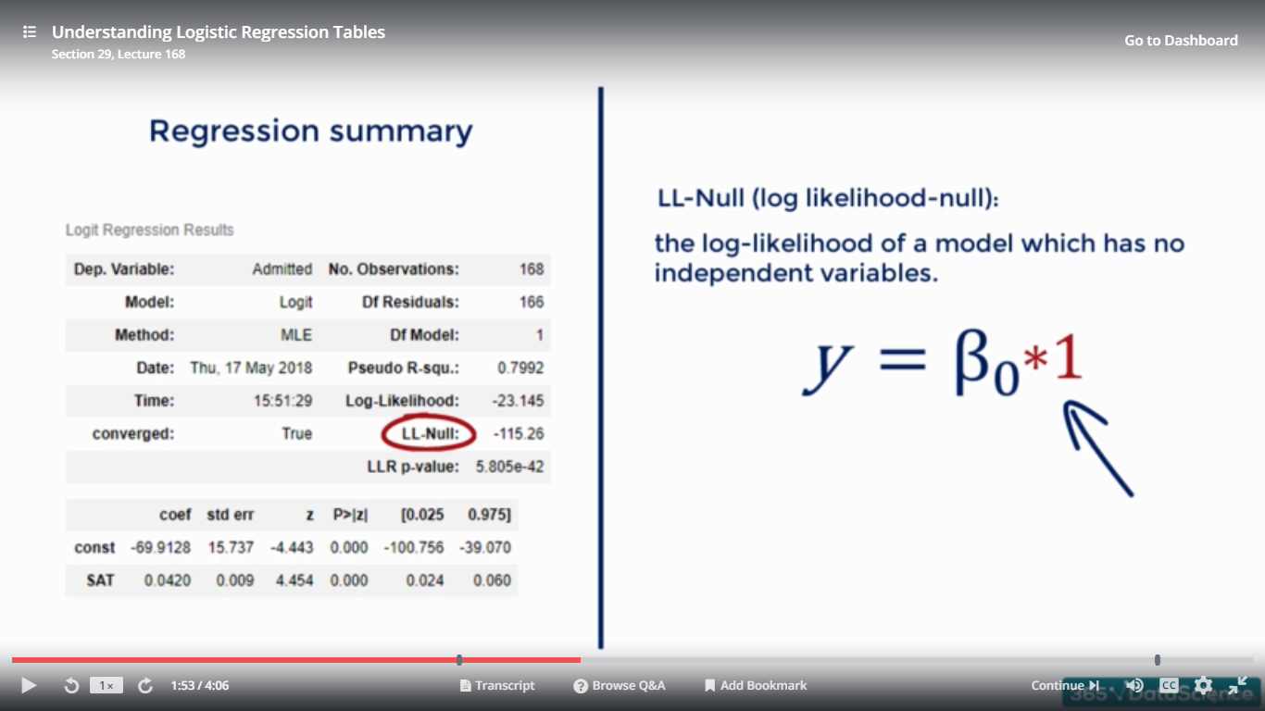

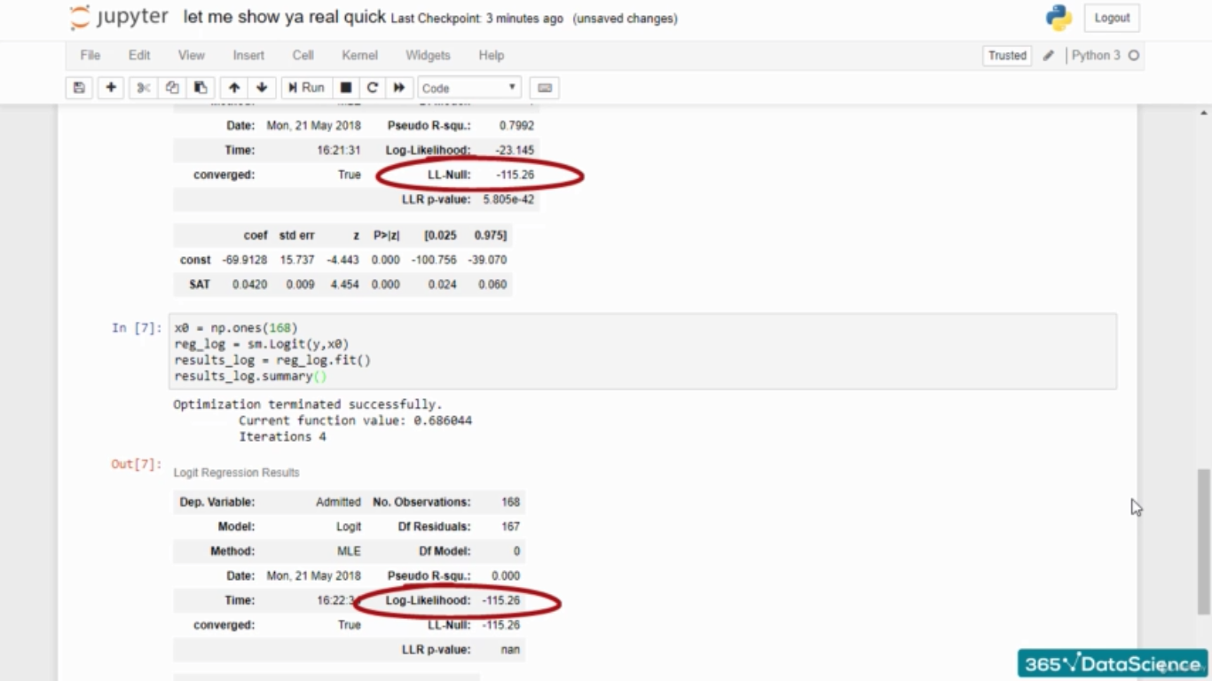

  
We had F test for the Linear regression….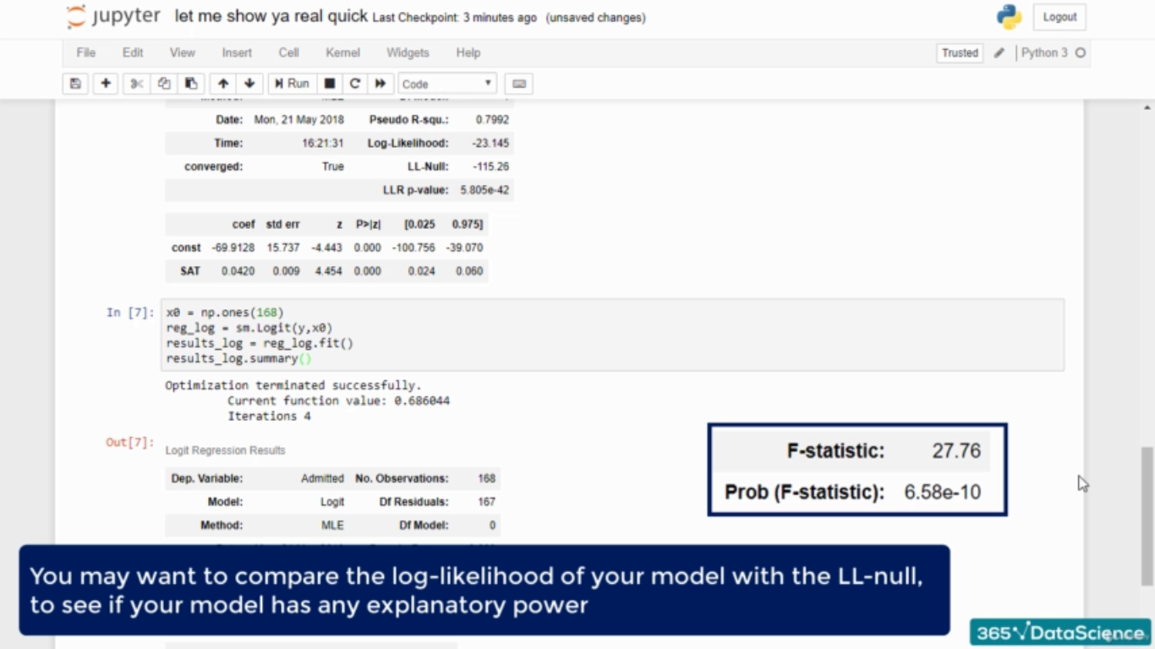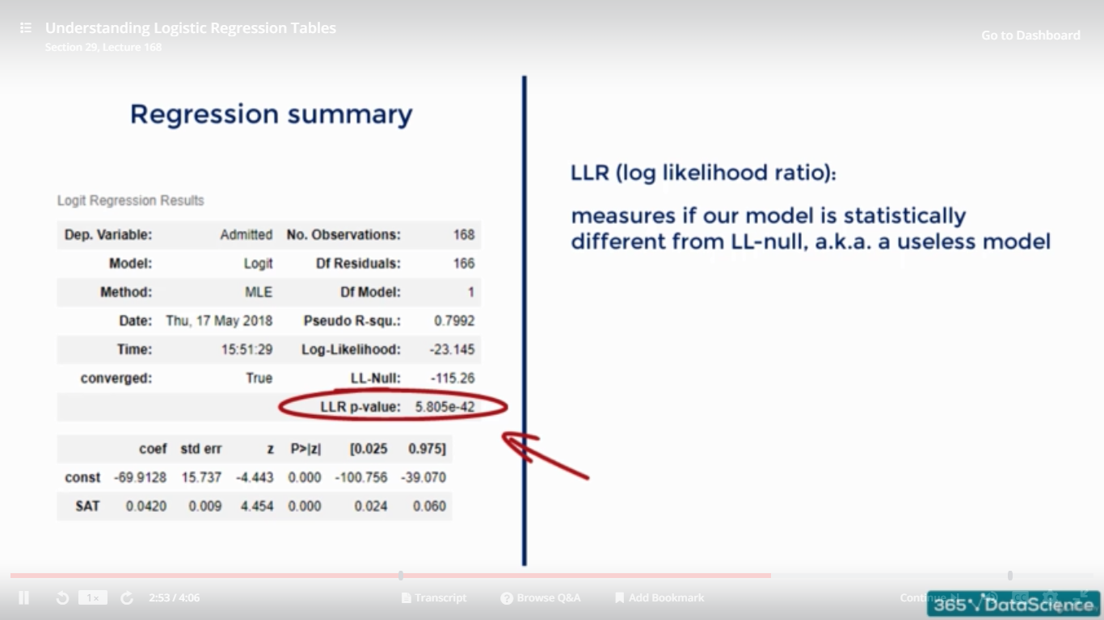  
LLR p value is the measure wghich will tell if our model is significant or not ….its value is very close to zero, that’s why our model is significant…..

Unlike linear regression , there is nothing like …R square… We have pseudo R square..

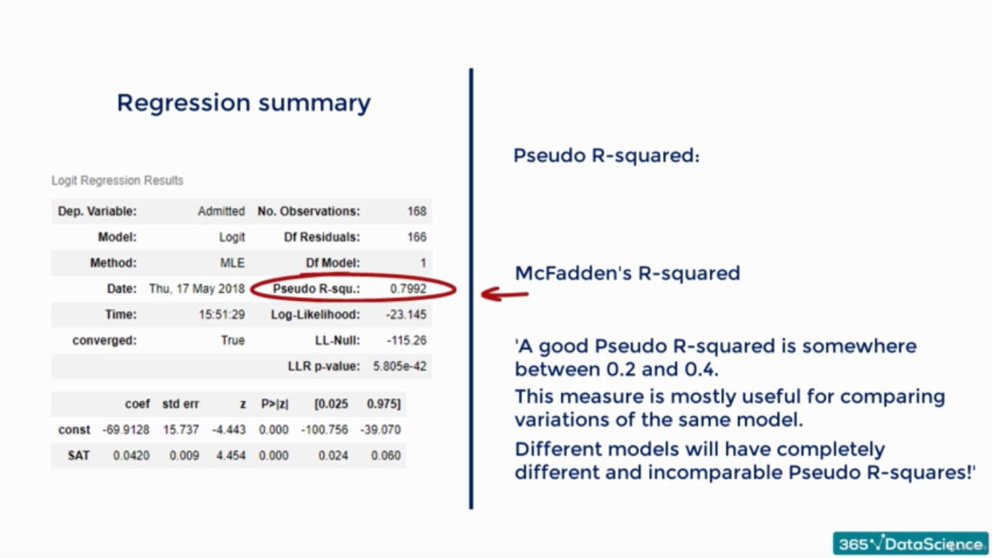

**So  
For relevance of a model LLR p value….  
For comparing two model over a same data set pseudo R square is to be considered…**