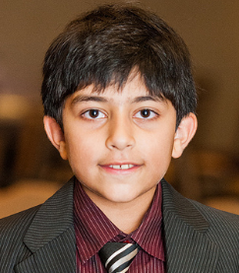Farhan Shahid

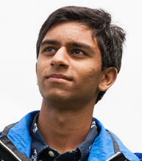

Bilal Mahmood

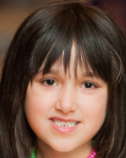

Nadia Mumtaz Khan

Ammar Khan

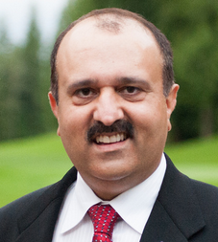Muhammad Ali

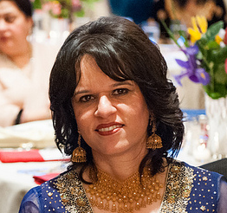Fatima Sadia

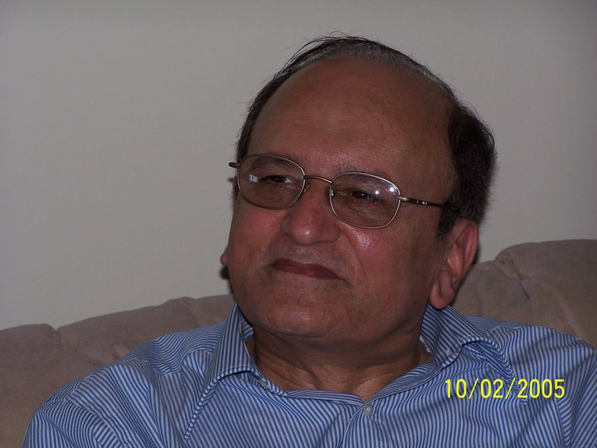Said Ahmad Khan

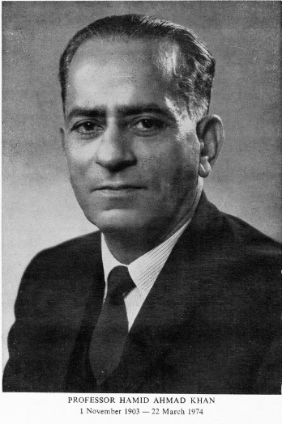

Hamid Ahmad Khan

(1 Nov 1903-22 Mar 1974)

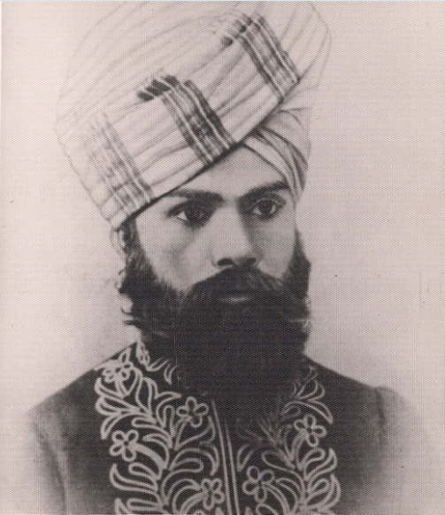Sirajuddin Ahmad Khan

(21 Jan 1850-6 Dec 1909)

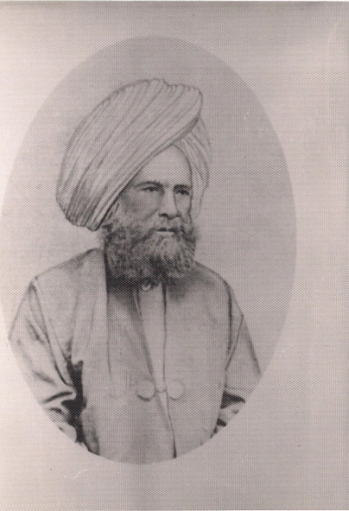

Karam Elahie Khan (d. 1890)