DBMS Lab Assignment – 2

**Title:** Introduction to DDL commands and its execution.

## Problem Statement:

**Section- 1:** DDL Commands

**Section- 2:** DML Command execution

## Theory:

Data definition language defines the schema for the database by specifying entities and the relationship among them. In addition to this, DDL even defines certain security constraints. The execution of DDL statements results in new tables which are stored in “system catalogue” also called data dictionary or data directory.

Data Manipulation Language is a language that provides a set of operations to support the basic data manipulation operations on the data held in the databases. It allows users to insert, update, delete and retrieve data from the database. Data manipulations are applied at internal, conceptual, and external levels of schemas. However, the level of complexity at each schema level varies from one another.

Data Control Language statements control access to data and the database using statements such as GRANT and REVOKE. A privilege can be granted to a User with the help of GRANT statement. The privileges assigned can be SELECT, ALTER, DELETE, EXECUTE, INSERT, INDEX etc. In addition to granting of privileges, you can also revoke (taken back) it by using REVOKE command.

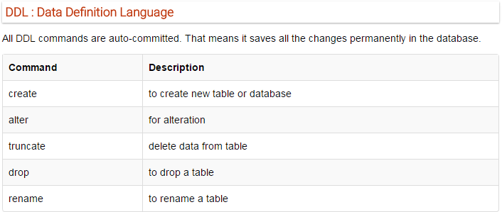

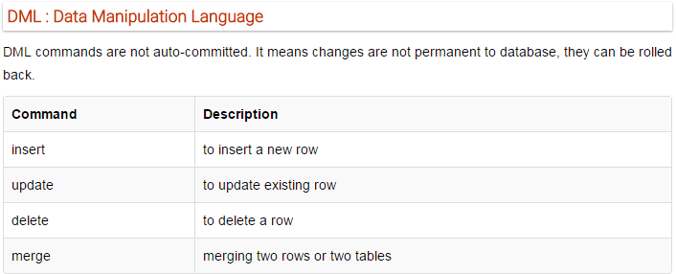

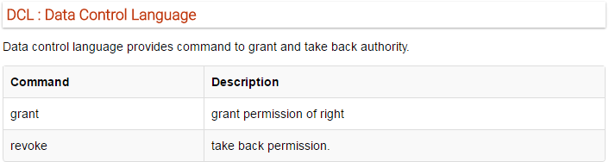

# Section 1

## Theory Questions:

**Q1. Explain DDL commands and their syntax.**

**Ans**. Data Definition Language(DDL) is a subset of SQL and a part of DBMS(Database Management System). DDL consist of Commands to commands like CREATE, ALTER, TRUNCATE and DROP. These commands are used to create or modify the tables in SQL.

### CREATE :

This command is used to create a new table in SQL. The user must give information like table name, column names, and their datatypes.

Syntax –

*CREATE TABLE table_name( column_1 datatype, column_2 datatype, column_3 datatype,*

*....);*

### ALTER :

This command is used to add, delete, or change columns in the existing table. The user needs to know the existing table name and can do add, delete, or modify tasks easily.

Syntax –

Syntax to add a column to an existing table:

*ALTER TABLE table_name ADD column_name datatype;*

### TRUNCATE :

This command is used to remove all rows from the table, but the structure of the table still exists.

Syntax to remove an existing table:

*TRUNCATE TABLE table_name;*

### DROP :

This command is used to remove an existing table along with its structure from the Database. Syntax to drop an existing table:

*DROP TABLE table_name;*

### RENAME:

It is possible to change name of table with or without data in it using simple RENAME command.

We can rename any table object at any point of time. Syntax –

*RENAME TABLE <Table Name> To <New_Table_Name>;*

**Q2. Create tables for the following relational model of library management. Apply constraints on the columns and alter the structure according to your requirements.**

1. **VULIBRARY** (Slid,lname,location,noofbranches)

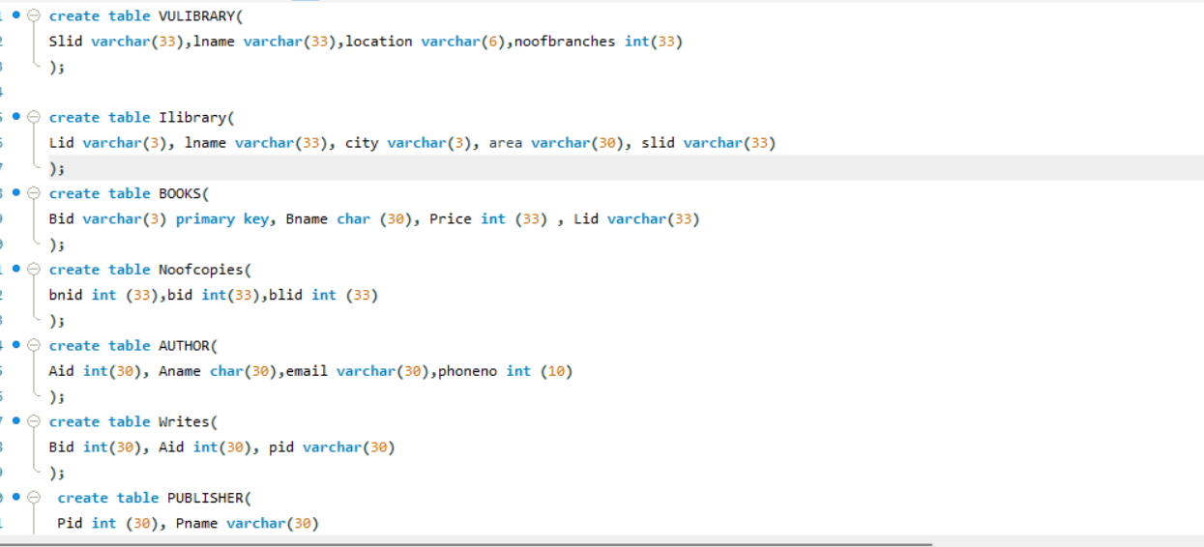

1. **Ilibrary**(Lid, lname, city, area, slid)



1. **BOOKS**(Bid, Bname, Price , Lid)



1. **Noofcopies**(bnid,bid,blid)

1. **AUTHOR**(Aid, Aname,email,phoneno)



1. **Writes**(Bid, Aid, pid)



1. **PUBLISHER**(Pid, Pname)

1. **SELLER**(Sid, slname, city)

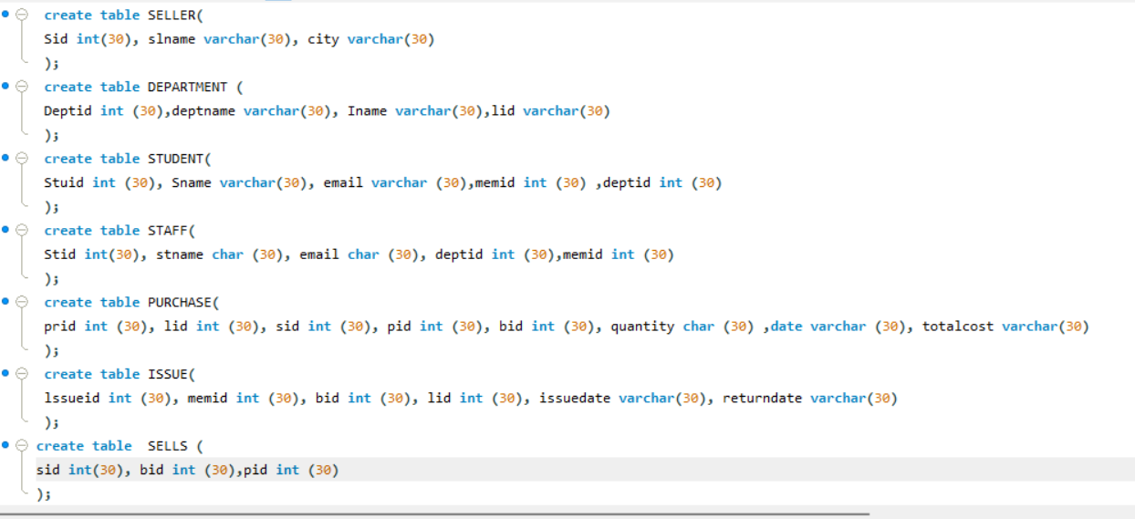

1. **DEPARTMENT** (Deptid,deptname, Iname,lid)

1. **STUDENT**(Stuid, Sname, email,memid deptid) A screenshot of a computer program

   Description automatically generated
2. **STAFF**(Stid, stname, email, deptid,memid)

1. **PURCHASE**(prid , lid, sid, pid, bid, quantity ,date, totalcost)

1. **ISSUE**(lssueid, memid, bid, lid, issuedate, returndate)



1. **SELLS** (sid, bid,pid)



1. **Employee**(eid,empname,email,salary,lid)

1. **A_specialization**(spec_id,spec_name,Aid)

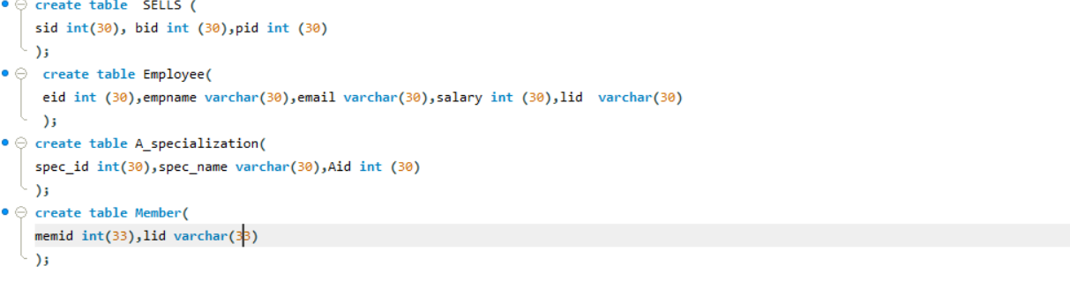

1. **Member**(memid,lid)



# ``Section 2

## Theory Questions:

**Q-1. Explain DML commands and their syntax.**

**Ans.** Data Manipulation Language (DML) is a subset of SQL commands used for adding (inserting), deleting, and modifying (updating) data in a database. DML commands are crucial for managing the data within the tables of a database. The primary DML commands in SQL include:

**INSERT**: This command is used to add new rows (records) to a table.

Syntax: INSERT INTO table_name (column1, column2, column3, ...) VALUES (value1, value2, value3, ...);

**UPDATE**: This command is used to modify the existing records in a table.

Syntax: UPDATE table_name SET column1 = value1, column2 = value2, ... WHERE condition;

The WHERE clause specifies which records should be updated. Without it, all records in the table will be updated.

**DELETE**: This command is used to remove one or more rows from a table. Syntax: DELETE FROM table_name WHERE condition;

Like with UPDATE, the WHERE clause specifies which rows should be deleted. Omitting the WHERE clause will result in all rows being deleted.

**SELECT**: Although often categorized separately, the SELECT command is sometimes considered part of DML as it is used to retrieve data from the database.

Syntax: SELECT column1, column2, ... FROM table_name WHERE condition;

The SELECT statement is used to query and extract data from a table, which can then be used for various purposes.

**Q-2. Insert 5 tuples in each of the created tables. Vulibrary:**

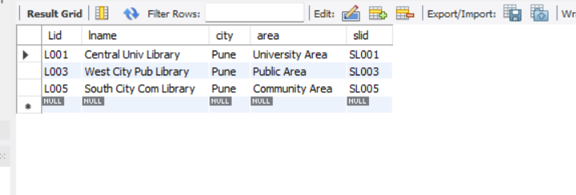

**Ilibrary:**

**Books:**

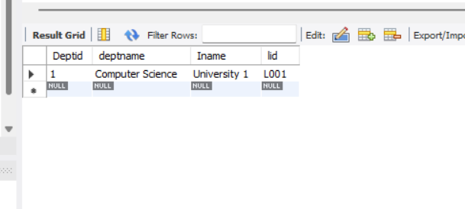



**Noofcopies:**

**Author:**

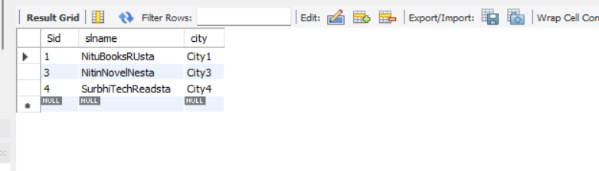

**Writes:**

**Publisher:**

**Seller:**

**Department:**

**Student:**

**Q3. Execute following queries on the library database.**

1. Which institute libraries are located in Pune city?

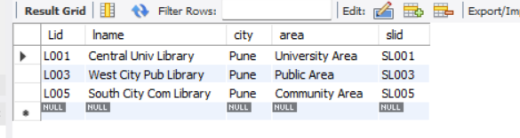

1. To which institute CS department belongs to?

1. Find all the books whose price is between 800 to 12000?

1. Find out such employees whose salaries are not greater than 50,000/-.

1. Find out such sellers who’s name end with “ta”.

1. Find out such institute libraries where their area information is missing

1. Find out such staff members whose name doesn’t starts with “A”.

1. Find out such VU libraries which have institute libraries located in Bangalore.

1. Which students belong to civil department?

1. Find out books which are written by “shruti” and published by McGraw hill.

**Conclusion:** While performing this practical, we have learnt about Data Definition Language(DDL) and Data Manipulation Language(DML) in SQL. We looked into the different commands within them and learned about their syntax and implementation.