|  |  |
| --- | --- |
| Name: Muhammad Ali Ahmad | EE-272L Digital Systems Design |
| Reg. No.: 2023-EE-029 | Marks Obtained: ____________ |

**Lab Manual**

|  |  |  |  |  |  |
| --- | --- | --- | --- | --- | --- |
| **DSD Lab Manual Evaluation Rubrics** | | | | | |
|  |  |  |  |  |  |
| **Assessment** | **Total Marks** | **Marks Obtained** | **0-30%** | **30-60%** | **70-100%** |
| Code Organization (CLO1) | 3 |  | No Proper Indentation and descriptive naming, no code organization.  Zero to Some understanding but not working | Proper Indentation or descriptive naming or code organization.  Mild to Complete understanding but not working | Proper Indentation and descriptive naming, code organization.  Complete understanding, and proper working |
| Simulation (CLO2) | 5 |  | Simulation not done or incorrect, without any understanding of waveforms | Working simulation with errors, don't cares's(x) and high impedance(z), partial understanding of waveforms | Working simulation without any errors, etc and complete understanding of waveforms |
| FPGA (CLO2) | 2 |  | Not implemented on FPGA and questions related to synthesis and implementation not answered. | Correctly Implemented on FPGA or questions related to synthesis and implementation answered. | Correctly Implemented on FPGA and questions related to synthesis and implementation answered. |

**Experiment 1: MOSFET as an Inverter**

1. Task 1

When we implement this circuit on breadboard and supply 10 V to the source and then it act as a NOT Gate. Following is the implemented circuit:

Fig: A MOSFET acting as a NOT Gate in a circuit.

When we apply voltage, the LED does not glow and gives 0.24 volts at B.

1. Task 2

When we do not apply voltage on A the LED glows and gives 1.96V at B.

1. Task 3

When we apply a sinusoidal on a and connect an oscilloscope at A and B to observe the wave forms we get following wave forms:

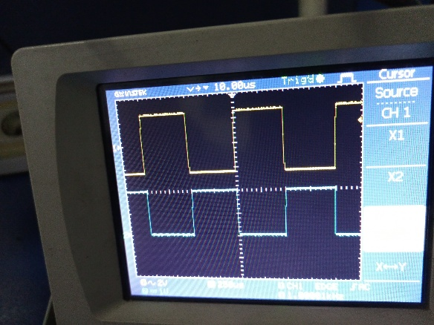

1K Frequency and 5V peak to peak

Now if we will Zoom on the output wave which is in Yellow colour it will have some propagation delay as shown bellow:

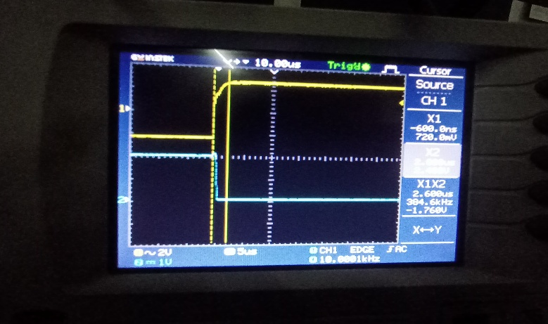

In above picture it can be seen that the propagation delay in Low to High is 2.6 micro sec.

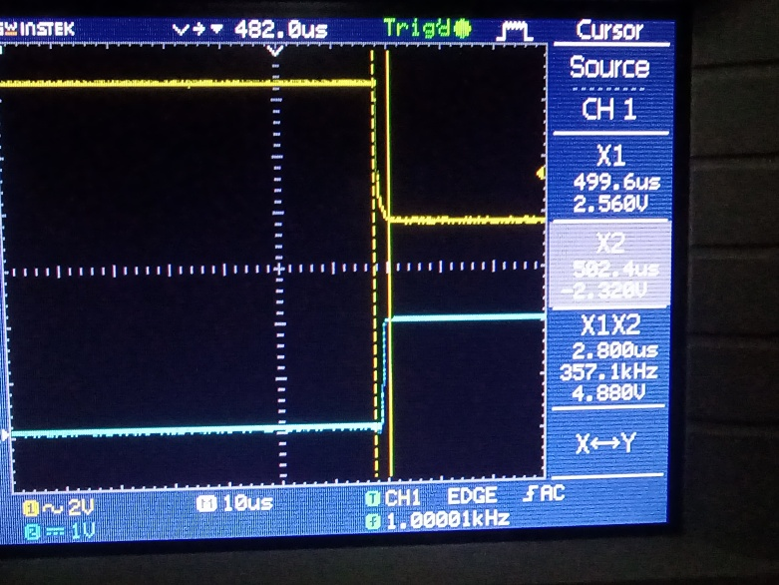

In High to Low Case the delay is 2.8 micro sec

1. Task 4:

When we apply 100kHz frequency following measurements are taken:

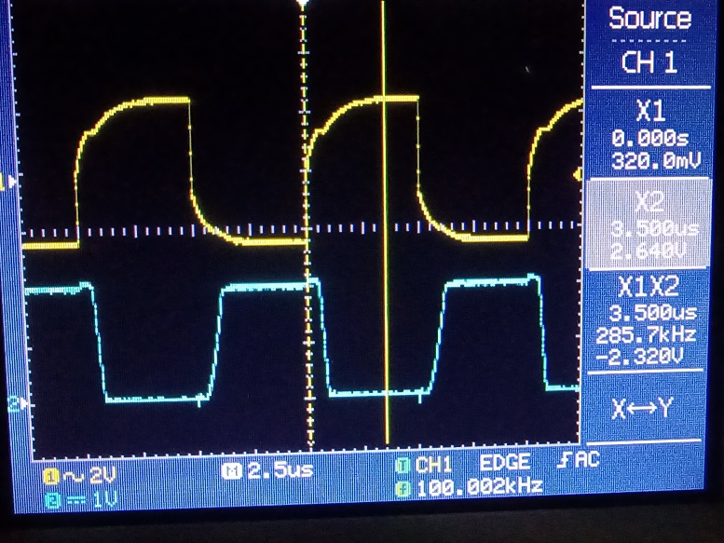

We can see that the delay has now increased up to 3.5 micro sec when we go from Low to High.

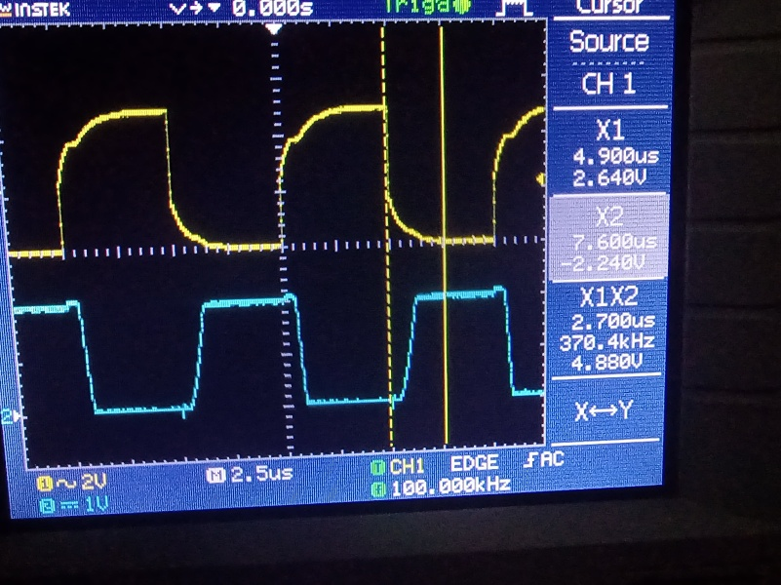

Now when we see the High to Low delay it is around 2.7 micro sec.

1. Task 5:

When we use high frequency it pushes the transistor closer to it’s limits which affects it’s overall performance and also the time it takes to propagate through the circuit.