|  |  |
| --- | --- |
| Name: Muhammad Ali Ahmad | EE-272L Digital Systems Design |
| Reg. No.: 2023-EE-029 | Marks Obtained: ____________ |

**Lab Manual 4**

|  |  |  |  |  |  |
| --- | --- | --- | --- | --- | --- |
| **DSD Lab Manual Evaluation Rubrics** | | | | | |
|  |  |  |  |  |  |
| **Assessment** | **Total Marks** | **Marks Obtained** | **0-30%** | **30-60%** | **70-100%** |
| Code Organization (CLO1) | 3 |  | No Proper Indentation and descriptive naming, no code organization.  Zero to Some understanding but not working | Proper Indentation or descriptive naming or code organization.  Mild to Complete understanding but not working | Proper Indentation and descriptive naming, code organization.  Complete understanding, and proper working |
| Simulation (CLO2) | 5 |  | Simulation not done or incorrect, without any understanding of waveforms | Working simulation with errors, don't cares's(x) and high impedance(z), partial understanding of waveforms | Working simulation without any errors, etc and complete understanding of waveforms |
| FPGA (CLO2) | 2 |  | Not implemented on FPGA and questions related to synthesis and implementation not answered. | Correctly Implemented on FPGA or questions related to synthesis and implementation answered. | Correctly Implemented on FPGA and questions related to synthesis and implementation answered. |

Task 1:

|  |  |  |  |  |  |  |  |  |  |  |  |
| --- | --- | --- | --- | --- | --- | --- | --- | --- | --- | --- | --- |
| **A** | **B** | **C** | **D** | **a** | **b** | **Purple** | **Yellow** | **Cyan** | **R** | **G** | **B** |
| 0 | 0 | 0 | 0 | 0 | 0 | 0 | 1 | 0 | 1 | 1 | 0 |
| 0 | 0 | 0 | 1 | 0 | 1 | 0 | 0 | 1 | 0 | 1 | 1 |
| 0 | 0 | 1 | 0 | 0 | 2 | 0 | 0 | 1 | 0 | 1 | 1 |
| 0 | 0 | 1 | 1 | 0 | 3 | 0 | 0 | 1 | 0 | 1 | 1 |
| 0 | 1 | 0 | 0 | 1 | 0 | 1 | 0 | 0 | 1 | 0 | 1 |
| 0 | 1 | 0 | 1 | 1 | 1 | 0 | 1 | 0 | 1 | 1 | 0 |
| 0 | 1 | 1 | 0 | 1 | 2 | 0 | 0 | 1 | 0 | 1 | 1 |
| 0 | 1 | 1 | 1 | 1 | 3 | 0 | 0 | 1 | 0 | 1 | 1 |
| 1 | 0 | 0 | 0 | 2 | 0 | 1 | 0 | 0 | 1 | 0 | 1 |
| 1 | 0 | 0 | 1 | 2 | 1 | 1 | 0 | 0 | 1 | 0 | 1 |
| 1 | 0 | 1 | 0 | 2 | 2 | 0 | 1 | 0 | 1 | 1 | 0 |
| 1 | 0 | 1 | 1 | 2 | 3 | 0 | 0 | 1 | 0 | 1 | 1 |
| 1 | 1 | 0 | 0 | 3 | 0 | 1 | 0 | 0 | 1 | 0 | 1 |
| 1 | 1 | 0 | 1 | 3 | 1 | 1 | 0 | 0 | 1 | 0 | 1 |
| 1 | 1 | 1 | 0 | 3 | 2 | 1 | 0 | 0 | 1 | 0 | 1 |
| 1 | 1 | 1 | 1 | 3 | 3 | 0 | 1 | 0 | 1 | 1 | 0 |

Task 2:

For Red light: (~b [0]) &(~b[1])| (a[1]&(~b[0]))| (a[0]&(~b[0]))| (a[0]&(~b[1])| (a[0]& a[1])

For Green Light: (~a [0]) &(~a[1])| (b[1]&(~a[0]))| (b[0]&(~a[0]))| (b[0]&(~a[1]))| (b[0]& b[1])

For Blue Light: (b[1] &(~a[1]))|(b[0]&(~a[0]))|(a[1]&(~b[1]))| (a[0]&(~b[0]))

Task 3:

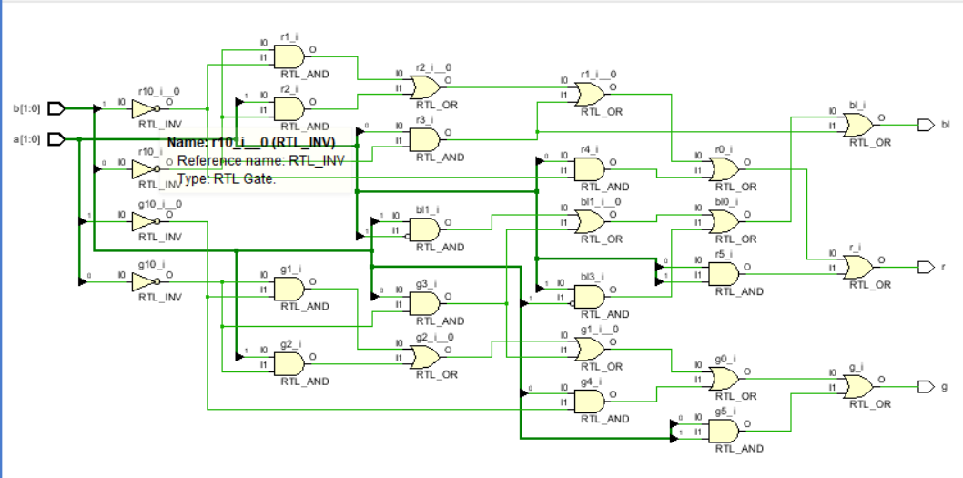

Task 4:

The maximum delay is as follows:



Task 5:

