### **Inf 117 – Spring 2016**

### **Requirements Document**

##### **Team Members: Ali Aijaz, Sara Dadafshar, Henry Hoang, Natalie Kassir, Chirag Samtani**

|  |  |  |
| --- | --- | --- |
| Awarded Points | Maximum Points | Document Aspect |
|  | 15 | Clarity of writing (spelling, grammar, sentence construction) and Clarity of expression (flow, structure, making logical arguments). Roughly 7.5 each. |
|  | 7.5 | Introduction / Executive Summary (can be different sections or combined into one) |
|  | 7.5 | Application Context / Environmental Constraints (can be different sections or combined into one) |
|  | 7.5 | Use Cases |
|  | 32.5 | Functional Requirements Specification |
|  | 7.5 | Software Qualities and Non-functional Requirements |
|  | 7.5 | Other Requirements |
|  | 7.5 | Assumptions / Risks (can be different sections or combined into one) |
|  | 7.5 | Priorities / Implementation Phases; Future Directions and Expected Changes |
|  | **100** | **TOTAL** |

ZotFeed System Requirements

###### April 04, 2016

|  |  |
| --- | --- |
| Ali Aijaz  Sara Dadafshar  Henry Hoang  Natalie Kassir  Chirag Samtani | 82181685 69513464 77097458 14591873 63279154 |

##### Table of Contents

1. Introduction ………………………………………………………………………… 4

1. Intended Audience
2. Purpose

2. Overview / Executive Summary …………………………………………………… 5

1. Scope
2. Major Features

3. Application Context/Environmental Constraints …………………………………… 7

1. Application Context
2. Constraints

4. Use Cases …………………………………………………………………………… 8

5. User Stories …………………………………………………………………………. 9

6. System Requirements Documentation ………………………………………………10

1. Application Structure
2. Main Menu and Side Menu
3. Option I: KUCI
4. Option II: New University
5. Option III: Anteater TV

7. Software Qualities and Non-Functional Requirements …………………………….. 17

8. Other Requirements ………………………………………………………………… 18

1. Glossary of Terms
2. UML Diagrams
   1. KUCI
   2. New University
   3. Anteater TV
   4. ZotFeed App

9. Assumptions and Risks ………………………………………………………………24

1. Assumptions
2. Risks

10. Priorities / Implementation Phases ………………………………………………… 25

1. KUCI
2. New University
3. Anteater TV

11. Future Direction and Expected Change …………………………………………… 26

1. KUCI
2. New University
3. Anteater TV

##### **Introduction**

This document’s intent is to articulate a detailed description of the ZotFeed Mobile Application. This project has been requested by the needs of our three main stakeholders: KUCI, New University, and Anteater TV for use in the upcoming Fall quarter by any audience who wants to associate themselves with UC Irvine related news.

1. **Intended Audience**

The main audience of this system are UC Irvine students, however, this application is to be used by anyone associated with UC Irvine, whether it be students, teachers, alumnus, or other faculty and staff.

1. **Purpose**

This document will explain and rationalize the various features that are implemented within the mobile application, ZotFeed. It will also go over some system constraints including hardware, software and even environmental. This document will also discuss the application’s user interface. The document is intended for the stakeholder as a reference and is to be approved by the stakeholder.

##### **Overview / Executive Summary**

1. **Scope**

ZotFeed is a mobile application that is catered to anyone associated with UC Irvine. The ultimate goal of this system is to provide both a convenient and mobile platform for students, or other users, to be able to actively connect with what is going on on campus with regards to the newspaper, the campus radio, and also the campus TV station. This will lessen the need to constantly be checking up on three separate websites to access information regarding any of the three on-campus media organizations. All this information will be available on one application on a handheld device for immediate use. The basic application would need to be ready for publishing by the end of Spring quarter in order to market it to incoming freshman for Fall 2016. This application will also be perfected in future quarters, so documentation of code is a necessity.

1. **Major Features**

The major feature is of course to centralize different sources of media that delivers content created by UC Irvine and about anything UC Irvine related. The sources of media include: New University, KUCI and Anteater TV.

The proposed mobile application merges all the various sources of content deliver disjoint contents. The user will be able to select an option that corresponds to a certain media source and different software features will be implemented for different media source.

1. **New University**

By selecting the New University option, users will see a feed of articles displayed by a picture and a title for each article. By clicking the picture and title, the user will be led to a page within the app where they can view the full article. News articles will also be categorized by different genres. Users will be able to choose which genre they would like to categorize by.

*Business Rationale:*

This allows quick filtering of articles - that is users who are interested in reading the New University only to update themselves of the Men’s Volleyball scores can view it instantaneously on their phones rather than going to the hassle of finding a copy somewhere on campus.

1. **Anteater TV**

By selecting the AnteaterTV option, users can view the latest videos fed from the YouTube channel within the app. The benefits of having this on a mobile application is the application categorizes videos under certain genres such as arts, comedy, sports or events.

*Business Rationale:*

Similar to New University’s feature rationales, this supports quicker search of videos when it pertains to user’s preferences. Feeding videos from YouTube on an independent mobile application gives more flexibility on the presentation, as well as the ability to feature trending videos from the main page of AnteaterTV on the mobile-app.

1. **KUCI**

Clicking the KUCI option gives a page that allows users to either view the schedule for shows that are currently going on at KUCI or listen to the KUCI live stream with the click of a button. The user can also search what shows are on on a certain time/date in the future.

*Business Rationale:*

This feature computes schedule for the radio shows accordingly to allow for better accuracy (so users don’t have to guess when a show comes on)

##### **Application Context / Environmental Constraints**

1. **Application Context**

The application will be run on a mobile platform on iOS and Android OS phones. The minimum API for Android will be API 14. This system may require frequent updates on both platforms and are available for download on the Google Play Store for Android and the App Store for iOS users. Internet connectivity will be required however no other internal hardware (GPS, Camera or any other sensors) will be required for the application to run.

1. **Constraints**

**Environmental Constraints**: The focus of the application is accurate synchronization with KUCI’s live stream with no streaming issues (this also concerns Anteater TV). Creating an easy to use interface is also crucial but also a constraint as different people have different learning curves. For example, users who are new to either iPhones or Androids, the devices which we plan to optimize our design for, may have a harder learning curve at learning how to use the application than those who are familiar with using iPhones or Android phones.

**User Interface/Design Constraint:** The user interface will follow a standard mobile-based interface with a menu icon that triggers a navigation drawer on the side displaying all the options.The layout of the application will be simple and not be too cluttered by icons and buttons with the focus of the screen being the content (articles, videos) as it pertains to New University or Anteater TV. Other types of design contraints would be usability issues. For example, certain users may not be able to see certain pieces of text on the app if it is too small. Therefore, we must consider adding in a zoom in option for making the text large enough for the user to see but small enough that its size doesn’t take up too much space on the screen.

**Software Constraints:** Because we plan to develop a cross-platform application, it’d be necessary to learn both Java for Android and Swift for iOS to build both of the applications. However, there are frameworks that allow us to build a cross-platform application easily. This is where Meteor comes in. The primary language we will be using is Javascript and we may be using the open source platform called Meteor to deploy the app in both iOS and Android with just minor differences. We may also need to use XML, HTML, CSS to support the design of the user interface.

##### Use Cases

**Actor:** New U Administrator/Content Provider

1. Provide a means of separating articles into genres using tags

**Actor:** Anteater TV Administrator/Content Provider

1. Provide a means of separating videos into genres using tags

**Actor:** Students/Alumni

1. Listen to KUCI stream (KUCI Option)
2. Look at schedules of radio shows (KUCI Option)
3. Read news articles from New U (New U Option)
4. Search for articles from New U (New U Option)
5. Search for videos from Anteater TV (Anteater TV Option)
6. Search for shows from KUCI (KUCI Option)
7. Pick articles according to genre preference (New U Option)
8. Watch videos uploaded by Anteater TV (Anteater TV Option)

##### 

##### 

##### 

##### 

##### 

##### 

##### 

##### 

##### 

##### 

##### 

##### 

##### 

##### 

##### 

##### 

##### 

##### 

##### 

##### 

##### User Stories

|  |  |  |  |
| --- | --- | --- | --- |
|  | **As a. . .** | **I want to. . .** | **So that. . .** |
| KUCI | Student or Alumni | look at schedules of KUCI’s radio shows | I can make sure I don’t miss any of my favorite shows and time my schedule accordingly so I can listen to that show. |
| KUCI | Student or Alumni | listen to KUCI’s live stream on the app | I can listen to the show that’s currently being broadcasted on the station anytime and anyhwere. |
| KUCI | Student or Alumni | listen to KUCI’s live stream on the website | I can listen to the stream via KUCI’s website if there’s any interference or issues with the stream from the KUCI app. |
| New University | Student or Alumni | Read news articles from New University through an app | I can update myself of any news or events that are correlated to UCI anywhere and anytime with a mobile phone. |
| New University | Student or Alumni | Pick articles according to a specific genre | I can view stories according to my preferred section without having to view articles that don’t match my interest. |
| New University | Student or Alumni | Search for articles | I can quickly retrieve and view articles that I remembered or were suggested by someone else. |
| Anteater TV | Student or Alumni | Pick videos according to a specific genre | I can quickly filter out videos that don’t necessarily match my interest and only view all videos that match my preference. |
| Anteater TV | Student or Alumni | Search for videos | I can instantaneously view the video that I was looking for through a search-box |
| Anteater TV | Student or Alumni | View Videos | I can watch videos uploaded by AnteaterTV’s Youtube Channel quickly |
| Anteater TV | Student or Alumni | Sort Videos | I can filter videos according to some sorting parameter - maybe I want to view videos that are most recent or videos that have higher rating |

##### **System Requirements Specification**

The following section describes the full functionality of ZotFeed. We will create a system that will allow users of the application to be more connected with the three media platforms on campus: KUCI, New U, and Anteater TV.

The ZotFeed application will need no credential processing in other words there’s no login process, as soon as a user clicks on the application that user will be brought to the main screen of the application which shows three buttons each corresponding to the type of media they want to use (KUCI, New U or Anteater TV).

1. **Application Structure**



*Figure 1: Application Structure*

The figure above (Figure 1) shows the underlying structure of the mobile application. The circle indicates a screen and the arrows indicate navigation between screens. Bidirectional arrows indicate that the user can navigate between the two screens back and forth.

Users can navigate to KUCI, New University and Anteater TV screen through the Main screen by selecting a button that correspodns to either KUCI, New University or Anteater TV. Similarly, whenever a user is in a screen below the Main Screen (KUCI, New U or Anteater TV) they can navigate back to the Main Screen by simply clicking the back button provided on their phones.

Some features are only limited to a certain screen. A user cannot access the live stream feature that is correlated with the KUCI aspect of the application whilst still being active on the New University screen, they would have to navigate to the KUCI screen either by going back to the main screen or through a side menu that’s provided on the application. Every screen will be explained in more detail below.

**II. Main Screen and Side Menu**

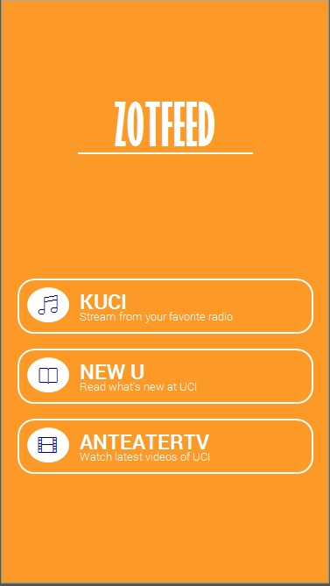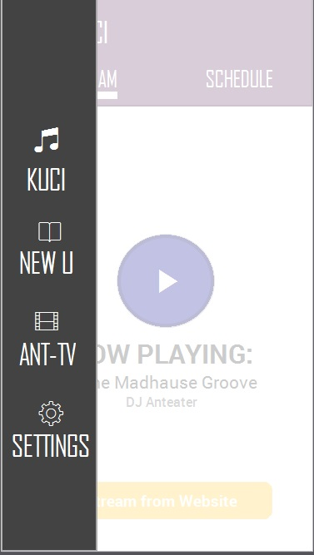

*Figure A: Main Screen Prototype Figure A2: Side Menu Prototype*

Asforementioned, the main screen is the first screen that the user sees after launching the ZotFeed application. The user will be able to select which of the three by selecting the buttons shown (See Figure A). By selecting an option, they will be able to experience features that related to a certain option. For example, KUCI will have the Live Stream feature and View Schedule Feature and so on.



The side menu can be triggered by clicking the hamburger icon ( ) which is labeled as three lines underneath each other. The icon is available on every screen except the main screen and when clicked it opens up a drawer filled with icons that the user can click to navigate between the KUCI, New University or Anteater TV screen.

**III. Option 1: KUCI**

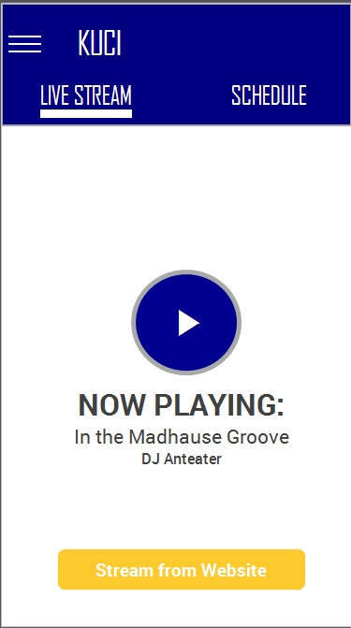

*Figure B: KUCI Feature Prototype*

ZotFeed has two main features that correlates with KUCI, the live steram and the show schedule features both of which will be explained in more detail by relating each feature to their corresponding use case.

**Use Case - Listen to Live Stream (Live Stream Feature)**

**Prerequisite:**

User has selected the KUCI button in the main screen (See Figure A) or in the side menu (See Figure A2) and is on the Live Stream Tab (Figure B)

**Basic Path:**

1. The user clicks on the Play Button on as shown on (Figure B)

2. Application start playing the stream on the phone that’s feeded from the radio station.

3. If there’s nothing playing on the station, the play button will not trigger any sound and instead will pop-up a window saying radio stations has signed off.

**Alternative Path:**

1. The user clicks on Stream from Website button. (Figure B)

2. Application will prompt the mobile to switch to their default web browser and display the KUCI website where they can listen to the radio station using the website’s tools.

**Result:** User listens to the KUCI radio show.

**Use Case - View Schedule Shows (View Schedule Feature)**

**Prerequisite:**

User has selected the KUCI button in the main screen (See Figure A )or in the side menu (See Figure A2) and is on the Schedule tab (Figure B)

**Basic Path:**

1. Application displays a table that shows a row of show names and show timings.

2. User will be able to select an option of inputting a date and time.

3. Application will display all the shows given the corresponding date and time inputted by the user.

**Result:** User sees all shows currently going on or sees shows given a specific timing.

**IV. Option 2: New University**

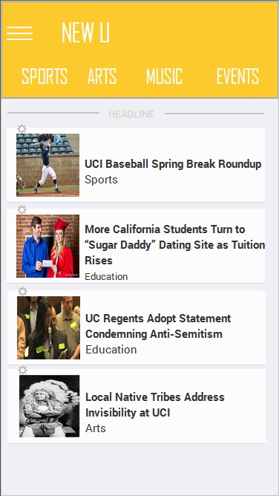

*Figure C: New University Feature Prototype*

ZotFeed will allow the user to read the article inside the application or in their web browser of their choosing. Another key feature that ZotFeed provides is subsetting the articles into their respective categories so user can view articles that pertains to their interest.

**Use Case - Read Article on Application or Browser (Basic Feature)**

**Prerequisite:**

User has selected the New U button in the main screen (See Figure A) or in the side menu (See Figure A2)

**Basic Path:**

1. The user clicks on any article on the list (shown in Figure C as an example)

2. Application will display a pop-up asking the user if they would want to view the article in a webview (inside ZotFeed) or via their mobile web browser.

3. If the user chooses webview (inside ZotFeed) the application displays a view of the article inside the application.

4. If the user chooses their browser, the application will open their browser and opens the webpage inside the browser automatically.

**Result:** Users would be able to read the article that they selected.

**Use Case - Choose Articles By Category**

**Prerequisite:**

User has selected the New U button in the main screen (See Figure A) or in the side menu (See Figure A2)

**Basic Path:**

1. The user clicks on any of the tabs that pertains to their category of interest (See Figure C), could be sports for example.

2. Application displays all articles related to the category selected in Step 1.

3. User clicks on the article to read it (See Use Case A2)

**Alternative Path:**

1. The user clicks on another tab that pertains to another category.

2. Application displays all articles that is related to that category.

**Result:** Users would be able to see all articles that is related to a certain category.

**Use Case - Search Articles**

**Prerequisite:**

User has selected the Search Icon on the New U Option.

**Basic Path:**

1. Application will pop-up a small text-box below the search icon.

2. User enters the article they want to search for inside the text-box

3. Application returns all the articles that matches the text that the user specified in another screen internal to the application.

**Result:** Users would be able to see all articles that matches a certain search text.

**V. Option 3: New University**

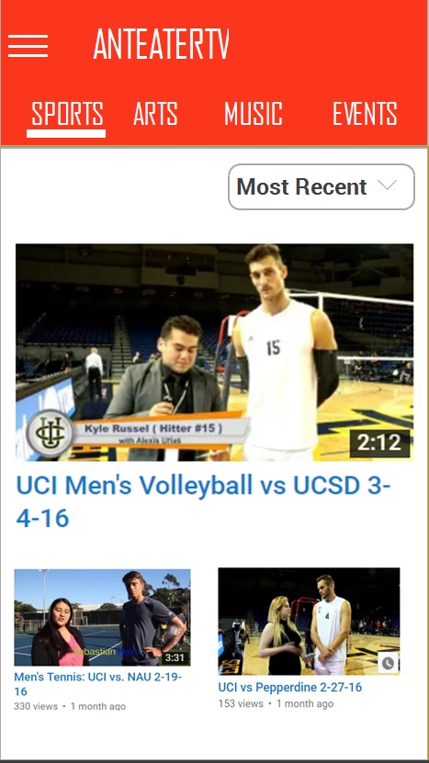

*Figure D: Anteater TV Feature Prototype*

ZotFeed will allow the user to view videos that are uploaded from the Anteater TV’s Youtube channel and view the videos in Youtube themselves. Videos are also categorized by a certain category that’s related to the context of the video

**Use Case - View Videos on Youtube (Basic Feature)**

**Prerequisite:**

User has selected the AnteaterTV button in the main screen (See Figure A) or in the side menu (See Figure A2).

**Basic Path:**

1. The user clicks on any video shown in the screen (See Figure D)

2. Application will open a Youtube window outside the application and displaying the video (unplayed) straight away.

3. User will be able to use Youtube features to play the video.

**Result:** Users would be able to watch the videos listed on the application.

**Use Case - Choose Videos By Category**

**Prerequisite:**

User has selected the New U button in the main screen (See Figure A) or in the side menu (See Figure A2).

**Basic Path:**

1. The user clicks on any of the tabs that pertains to their category of interest (See Figure D).

2. Application displays all videos related to the category selected in Step 1.

3. User clicks on the video and the application opens up an external Youtube window.

4. Application shows the video on Youtube automatically (unplayed)

**Alternative Path:**

1. The user clicks on another tab that pertains to another category.

2. Application displays all videos that is related to that category.

**Result:** Users would be able to see all videos that corresponds to a certain category.

**Use Case - Search Videos**

**Prerequisite:**

User has selected the Search Icon on the Anteater TV option.

**Basic Path:**

1. Application will pop-up a small text-box below the search icon.

2. User enters the video name that they want to search for.

3. Application returns all the videos that aligns to the video that the user was looking for.

**Result:** Users would be able to see all articles that matches a certain search text.

**Use Case - Sort Videos**

**Prerequisite:**

User has selected the New U button in the main screen (See Figure A) or in the side menu (See Figure A2).

**Basic Path:**

1. User has clicked the drop-down list that sorts the videos by a certain filters (labelled by ‘Most Recent’ in Figure D). By default, the application sorts the videos by the ones that are recently uplodaed.

2. Application shows the list of filters that are parameters from Youtube’s sorting filters - “Most Viewed”, “Relevance”, “View Count” and ‘Rating”.

3. Application returns all the videos given the sorting filter chosen in Step 2.

**Result:** Users would be able to sort videos given a certain filter that they chose.

##### **Software Qualities and Non-functional Requirements**

**Non-functional Requirements:**

**Implementation Bias**

Content in the New University and Anteater TV section of the application should be viewed in a grid-list view, with a photo or screenshot related to the content and the content header/title itself.

**Performance**

Application must be interactive; therefore performace must be efficient and delays must be limited. When accessing Anteater TV and New Univeristy content, the system must be able to quickly retrieve and display the content within a few seconds. When accessing the KUCI stream, the system should consistently connect to the audio stream and reconnect within a few seconds if the connection is interrupted.

**Safety**

Information transmitted between the server and client must be secure and and information must remained unchanged during transmission.

**Reliability**

The mean times between failures of the application should be greater than one week. A failure in the application is defined as the unable to retrieve and display content from the servers, and unable to connect to and maintain the KUCI audio stream. If a failure occurs, the system should provide the proper tools or text that ensures proper operation.

**Software Qualities:**

**Aesthetics**

The color scheme of each section of the application should correspond to the brand colors of the respected organizations (or of UC Irvine), i.e., the Anteater TV section of the application should have the same color scheme as the logo colors, etc.

**Availability**

The system should, ideally, be availabe 99% of its uptime. If an Internet source is disconnected while sending/retrieving information from the servers, then the information can be sent/retrieved again for verification.

**Extensibility**

In the future, the app will support notifications and allow users to save/bookmark favorite content. The system should be build to be able to accomodate these features in the future.

**Platform Constraints**

The application will be developed under multiple platforms, namely iOS and Android.

**Portability**

Application will be supported under mutiple platforms, Application will work the same across all platforms, with minor visual differences.

**Usability**

Application should be simple to use. When a user opens Zotfeed for the first time, the user should be able learn how to navigate through the app quickly and easily. Returning users should be able open Zotfeed and immediately be familiar with navigating the application. In addition, the system responds as the user expects with the least amount of delay. If unexpected handling or delay occurs, the system should react accordingly and quickly transition between states.

##### **Other Requirements**

1. Glossary of Terms
   1. KUCI: UCI’s on-campus nonprofit radio station, streamed online and locally on 88.9FM.
   2. New University: UCI’s official campus newspaper, with content available through print (on campus) and online on their website.
   3. Anteater TV: UCI’s first digital journalism organization, creating a broadcast program focused on bringing media news, promotions, and opportunities to UCI students, with content available online on their website and YouTube channel.
   4. API (Application Program Interface): set of protocols for building software applications; specifies how software components should interact. (Beal - API)
   5. Meteor: software that allows you to build web and mobile apps using just JavaScript from a single code base.
   6. Webview: A View that displays a webpage inside a mobile application without the use of an external web browser
   7. Main Screen**:** The main screen in this case is similar to a homepage which contains the top directory of all the features of a system.
   8. Browser or Web Browser**:** A browser is a software that's created for the usage of picturing images, texts on different WebPages available on the huge array of the web. (Beal - Web Browser)
   9. Navigation Drawer: The navigation drawer is a panel that displays the app’s main navigation options on the left edge of the screen. It is hidden most of the time, but is revealed when at the top level of the app, the user touches the app icon in the action bar. (“Creating a Navigation Drawer”)
2. References

Beal, Vanige. "Web Browser (browser)." What Is Web Browser (Browser)? Webopedia. Webopedia, n.d. Web. 28 Oct. 2014.

Beal, Vangie. "API - Application Program Interface." What Is Application Program Interface (API)? Webopedia Definition. Webopedia, n.d. Web. 12 Apr. 2016.

"Creating a Navigation Drawer." Creating a Navigation Drawer. Android Developers, n.d. Web. 11 Apr. 2016.

1. **UML Diagrams**
   1. KUCI

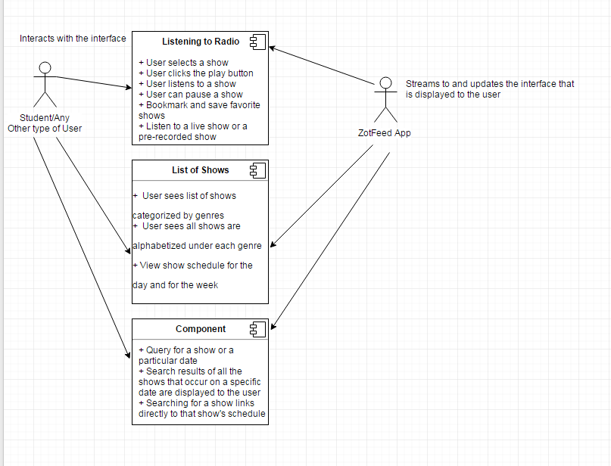

* 1. New University



* 1. Anteater TV

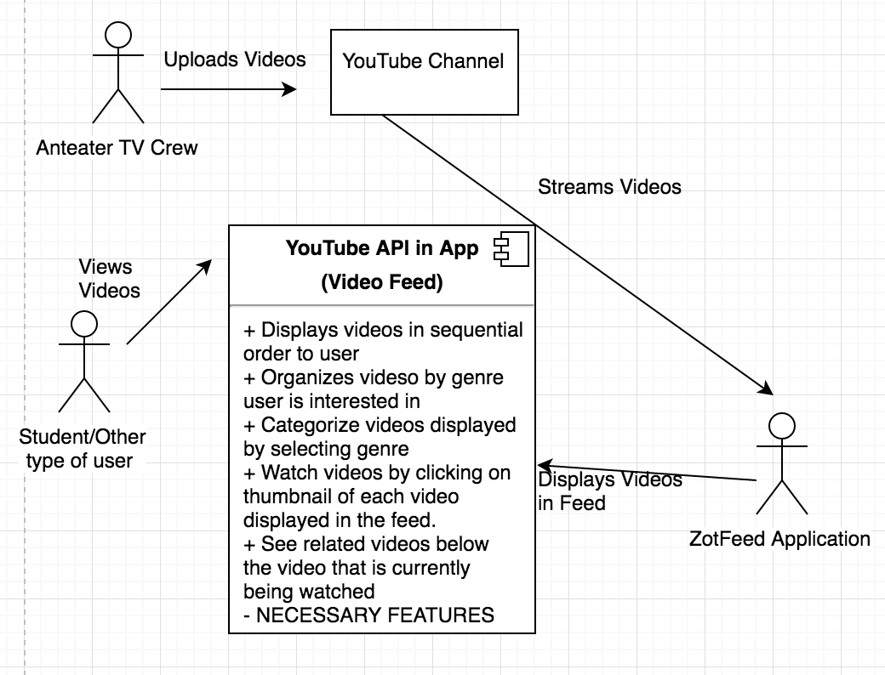

* 1. ZotFeed Application Architecture

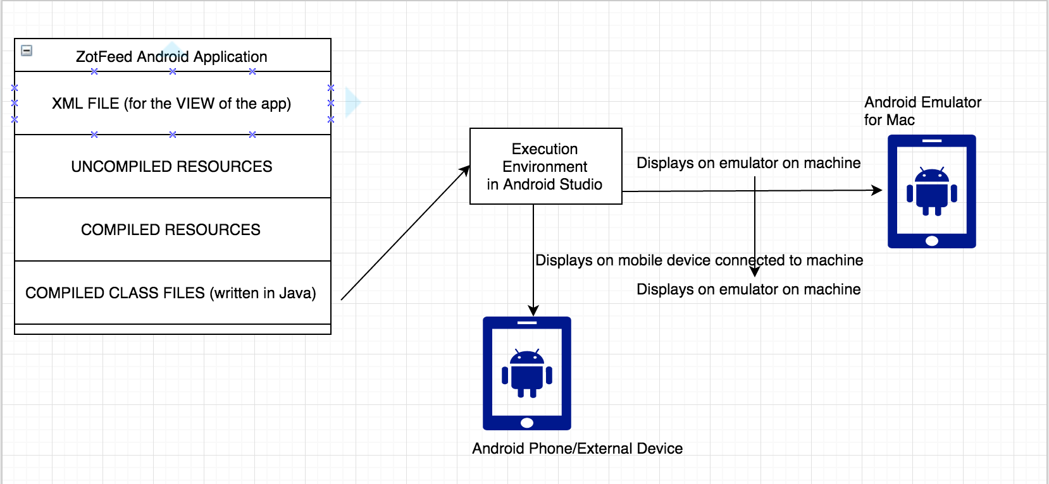

##### **Assumptions / Risks**

1. **Assumptions**

It is assumed that every user of this system has a good functioning knowledge of mobile phones and applications. It is also assumed that the system users are aware of the existence of these media platforms (KUCI, New U, Anteater TV) that exist on UC Irvine’s campus today

Another assumption is that users are familiar with the commonplace icons used in both iOS and Android such as the triple lines (hamburger icon) which denotes a menu icon. Another assumption is that users are aware that ZotFeed will be switching between applications such as ZotFeed and Youtube when viewing a video.

1. **Risks**

Project and Developmental Risks:

* + Scheduling, pertaining to delays in the different sprints within application development, needing more time for a particular sprint to complete a system feature.
  + Overcoming certain technical issues that arise with relation to getting media to sync in with our software from the website.
  + Learning new APIs, MVC architecture or languages that we may be unfamiliar with

##### **Priorities / Implementation Phases**

1. KUCI
   1. Must Have
      1. Listen to KUCI now feature
      2. Schedules of the shows
   2. Should Have
      1. User should be allowed to search for shows and dates (to see the shows that are playing on that specific date)
   3. Nice To Have
      1. A blurb about the shows, available via the schedule
      2. Links to show blogs
      3. Bookmark / Save shows to listen later
      4. Links to KUCI social media platforms
      5. Notification to users when favorite show is on
2. New University
   1. Must Have
      1. Article titles and image thumbnails
         1. can click this if user wants to view full article
      2. Articles must be separated by genre
   2. Should Have
      1. User should be allowed to search for articles
   3. Nice To Have
      1. Bookmark/Save articles to read later
      2. Links to New University social media platforms
3. Anteater TV
   1. Must Have
      1. YouTube videos must be separated by genre
      2. YouTube video thumbnails will be displayed from most recently uploaded
   2. Should Have
      1. User should be allowed to search for videos
   3. Nice To Have
      1. Bookmark/Save videos to watch later
      2. Links to AnteaterTV social media platforms
      3. Notification to user when new video is uploaded

##### **Future Directions and Expected Changes**

1. KUCI
   1. Create a section that keeps a blurb about all the radio shows available for viewing via the schedule on the application
   2. Have a feature that allows the user to rate certain shows
   3. Have a feature that allows the user to see the setlist of a specific show they are listening to live
   4. Have a feature that allows the user to see past setlists of specific shows
   5. Have a link to each show’s blog available under the blurb
   6. Have links to KUCI’s social media platforms that redirect the user to those pages
   7. Notify the user when their favorite shows are on
2. New U
   1. Have a feature that allows the user to favorite certain articles
   2. Have a feature that allows the user to rate certain articles
   3. Have a feature that allows the user to bookmark certain articles to read later
   4. Have links to the New University’s social media platforms that redirect the user to those pages
3. Anteater TV
   1. Have a feature that allows the user to favorite certain videos
   2. Have a feature that allows the user to rate videos (through YouTube API)
   3. Have a feature that allows the user to bookmark or queue certain videos to watch later
   4. Have links to Anteater TV’s social media platforms that redirect the user to those pages
   5. Notify the user when a new video is uploaded onto the channel