

Bilkent University CS 319 Object-Oriented

Software Engineering

Summer 2017

Design Report Project Name: Hotel Reservation System

Group #1

Mehmet Ali Altuntaş 21401004

Damla Eda Bıçakcı 21402130

Murat Süerdem 21401107

İrem Yurdakul 21400299

**Index**

**1.Introduction**

1.1.  Purpose of The System

1.2. Design Goals

1.3 Definitions, Acronyms and Abbreviations

1.4. References

1.5. Overview

**2.Software Architecture**

2.1.Overview

2.2. Subsystem Decompositon

2.3. Hardware/ Software Mapping

2.4. Persistent Data Management

2.5. Access Control and Security

2.6. Boundry Conditions

**3. Subsystem Services**

3.1. Model Subsystems

3.2. User Interface Subsystems

3.3. Control Subsystems

## 1. INTRODUCTION

## 1.1 Purpose of the system

The Hotel ReservationSystem is a reservationsystemwhichaimtooffereasyandwelldesigntocustomertomakereservationandofferdetailedinformationaboutroomsandreservationstomanagertochecksystem. Program is easytounderstand, customersmaketheirbookingwithpleasureandeasyway, andmanager can accessroomdetailspracticallywiththeiraccesscode.

Main advantages of thesystem is choosingfeatures of theroomwhilemakingreservation. Ifcustomerchoosejusttostay in theroomwithbasic form of it, customer paylessandcustomerdoes not havetochoosefixedfeatures, customer can decidewhichfeature is importantforhimlikelaundry, breakfastortv.

## 1.2 Design Goals

### Performance:

Forthesystem, it is importantto how quicklythesystemreactstouserinputbecausethissituation can causetodistractcustomers’ interestandcomfort. Our system can response quickly at each step (1 second), because the main purpose is to make reservation quickly and efficiently.

### Adaptability:

The hotel reservationsystem is codedwith Java. Java provideusertouse program withall JRE installedplatforms.

### Extensibility:

In software engineering, reusability and extendibility are two importance concepts. Hotel Reservation System suitable to be extended and re-used for future works because separation of controller, view and model classes offer to change or add new features without modifying anything in other classes.

### Usability:

Easy use of program is important functionality because it makes system more charming. Our program provideuserwitheasyandclearinterfacetounderstandandmaketheirbookingswiftly. Especially focus on the plainness of the program, sousers can use program without priorty knowledge.

### Reliability:

The system should not demonstrate with unexpected crashes due to software bugs, soseparatetests will be practiced ,andexceptionsandboundaryconditionswill be performedsocarefully in ordertoavoidunconsideredconditions.

## 1.3 Definitions, acronyms, and abbreviations

Abbreviations:

MVC: Model View Controller

2. **SOFTWARE ARCHITECTURE**

## 2.1 Overview

Hotel Reservationsystemconsists of severalsubsystems. Weuse MVC structureandoursystem is decomposedbased on thisstructertype. Bydividingthesystemtosubsystems, ourgoal is tomanagethesystemmoreeasily. Andalso it enables us codereusability. We can makechangeseasily.

## 2.2 Subsystem Decomposition

For a goodorganization, it is essentialtoseperatesytemintosubsystems. Therefore, ur subsystemsarebasicallybased on models, viewsandcontrollers.

## 2.3 Hardware / Software Mapping

Our Hotel ReservationSystemwill be coded in Java programminglanguageandusejavaruntimeenvironment. Mouse andkeyboardwill be usedtointeractwiththe program, userswilldeterminereservationdetailsbyusingkeyboardandmouse. A standardcomputerwithoperatingsystemandjavacompilerwill be neededtorun program. Hotel Reservation Program does not require internet connection, it is desktop program. The program willkeep data byusing .txtbasedstructureswhichcompose of details of theeveryseparatereservation.

## 2.4 Persistent Data Management

Inoursystem, weusetext file tostorethe data. Our data is aboutbasicallycustomer, managerandreservations. Wekeepcustomer’sinfowhicare name, surnameandforthemanageralsowekeeps name, surnameandID forthesystementerance.

## 2.5. Access Control and Security

Inoursystem, there is noneedtoconnectany network, our program works on thedesktop. Therefore, Hotel ReservationSystemperformswithoutanycontrolforaccess. However, wekeepsinformationaboutourcustomers, alsomanagers. Therefore, security is an significantissuetoconsider it.

## 2.6 BoundaryConditions

**Initialization**

Ourprogram does not requireanyinstallization. It can be opnedby a simple .jar file.

**Termination**

User can exitthe program simplybyclickingexitbuttonand in the program thereareseveralbuttonstoreturnthebackpage.

**Error**

If an erroroccurduringtheinformationenterenceorbeforethestorage, allinformationkeptbythesytem, can disapperedunfortunately.Otherthanthat. someerrorshappensduringthe program works, sousermust be closethe program and he or she can start the program again.

3. SUBSYSTEM SERVICES

3.1. Model Subsystems

3.2. User Interface Subsystems

User interface subsystem provides our software system with graphical system components.

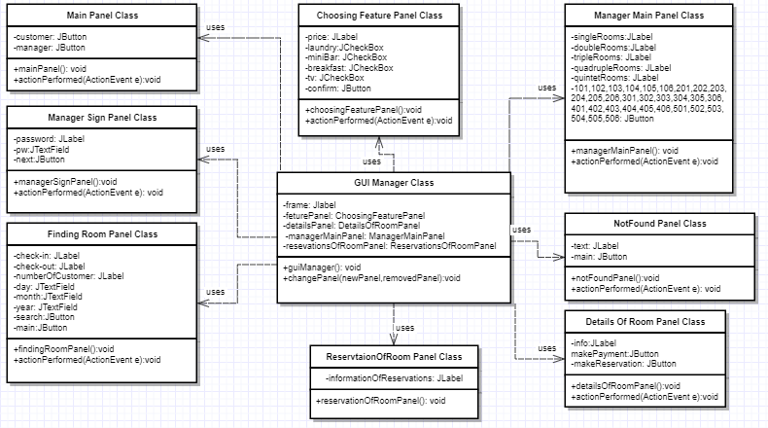

Main Panel Class

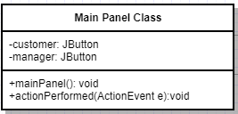

Attributes:

**private JButton customer**:When the user first enter the system by the help of this button user can indicate that he is a customer.

**private JButton manager:** When the user first enter the system by the help of this button user can indicate that he is a manager.

Constructor:

**public mainPanel():** This method initializes the first interface sttaing two buttons in the system which indicates the user is a customer or a manager.

Methods:

**public void actionPerformed(ActionEvent e):** This method determines what is going to happen when customer selects “customer” button or “manager” button.

Manager Sign Panel Class

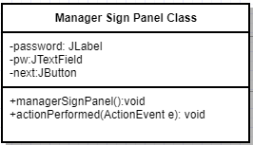

Attributes:

**private JLabel password:** This label shows just a text that in the next JTextField user should enter his password.

**private JTextField pw:** This text field helps manager to enter his password to take action in the system.

**private JButton next**: This button evaluate the trueness of the password, and if its true pass the manager to the next page.

Constructor:

public managerSignPanel(): This panel shows the password text place and the informative text inside.

Methods:

public void actionPerformed(ActionEvent e): This method determines what is going to happen when customer selects “next” button after writiring the password correctly.

Finding Room Panel Class

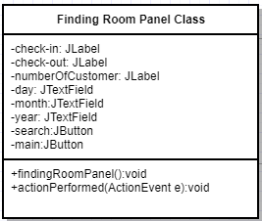

Attributes:

**private JLabel checkin:** This label shows just a text that in the next JTextField user should enter his check-in day, month and year.

**private JLabel checkout:** This label shows just a text that in the next JTextField user should enter his check-out day, month and year.

**private JLabel numberOfCustomer:** This label shows just a text that in the next JTextField user should enter his number of customer that is going to accommodate in the room.

**private JTextField day:** This text field offer to the user to sekect the day that isgoing to check-in/out in the hotel.

**private JTextField month:** This text field offer to the user to select the month that isgoing to check-in/out in the hotel.

**private JTextField year:** This text field offer to the user to select the year that isgoing to check-in/out in the hotel.

**private JButton search:** When the user complete all the check-in/out and number of customer information this button starts the search process.

**private JButton main:**When the user complete or does not complete the seacrh criterias he can turn back to main menu by the help of this buton.

Consturctor:

**public findingRoomPanel():** This panel shows the criterias and the selection options to the user to ask.

Methods:

**public void actionPerformed(ActionEvent e):** This method determines what is going to happen when customer selects “next” button after writiring the password correctly.

NotFound Panel Class

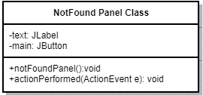

Attributes:

**private JLabel text**: This label includes necessary information about the the search process.

**private JButton main:** This button helps user the turn bak to main menu after the search process competed unsuccesfully.

**Consturctor:**

**public notFoundPanel():** This panel holds the information in the text to inform the user and holds a button insace the user wants to turn back to menu.

Methods:

**public void actionPerformed(ActionEvent e):** This method determines what is going to happen when customer selects “main” buttonthe seacrh process completed unsuccesfully.

### ChoosingFeturePanel Class

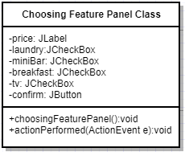

#### Attributes:

**private JLabel price:** This label shows the specified room price and while customer is determining features of the room, price change.

**private JCheckBox laundry :** This check box is to get the user input to determine feature of the room whether there is laundry service for customer.

**private JCheckBox mini bar :** This check box is to get the user input to determine feature of the room whether there will be tv in the room or not.

**private JCheckBox breakfast :** This check box is to get the user input to determine feature of the room whether hotel will offer breakfast for the customer or not.

**private JCheckBox tv :** This check box is to get the user input to determine feature of the room whether there will be tv in the room or not.

**private JButton confirm:** This button confirms features and provide customer to pass the other page.

#### Constructors:

**public choosingFeaturePanel:**This is to initialize and add attributes to panel.

#### Methods:

**public void actionPerformed(ActionEvent e):**  This method determine what will happen when customer selects “confirm” button.

### DetailsOfRoomPanel Class

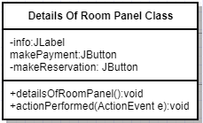

#### Attributes:

**private JLabel ınfo:** This label shows the specified room features before make reservation.

**private JButton makePayment:** If customer wants to make payment of the reservation, customer selects this button, his or her reservation is registered and payment page is opened.

**private JButton makeReservation:** If customer wants to make reservation without making payment of the reservation, customer selects this button, his or her reservation is registered and system shows the reservation code.

#### Constructors:

**public detailsOfRoomPanel:**This is to initialize and add attributes to panel.

#### Methods:

**public void actionPerformed(ActionEvent e):**  This method determine which button is selected and what will happen.

### ManagerMainPanel Class

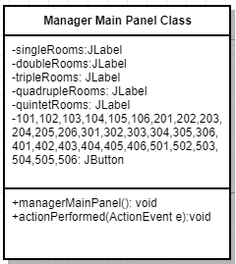

#### Attributes:

**private JLabel 1st Floor(single rooms) :** This label give information about floor of the room to make clear interface.

**private JLabel 2nd Floor(double rooms) :** This label give information about floor of the room to make clear interface.

**private JLabel 3rd Floor(triple rooms) :** This label give information about floor of the room to make clear interface.

**private JLabel 4th Floor(quadruple rooms) :** This label give information about floor of the room to make clear interface.

**private JLabel 5th Floor(quintet rooms) :** This label give information about floor of the room to make clear interface.

**private JButton 101,102,103,104,105,106,201,202,203,204,205,206,301,302,303,304,305,306,401,402,403,404,405,406,501,502,503,504,505,506 :** If manager selects this button, the other page is opened where all reservations of the specified room with its all details are showed..

#### Constructors:

**public managerMainPanel :**This is to initialize and add attributes to panel.

#### Methods:

**public void actionPerformed(ActionEvent e):**  This method determine which button is selected and what will happen.

### ReservationsOfRoomPanel Class

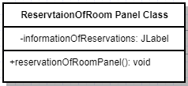

#### Attributes:

**private JLabel informationOfReservations:** This label shows all reservations with its all details which are belong to specified room.

#### Constructors:

**public reservationOfRoomPanel:**This is to initialize and add attributes to panel.

### GUİManager Class

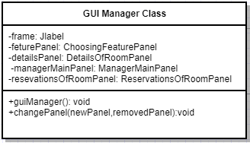

#### Attributes:

**private JFrame frame:** This is the main frame where we display specified panel

**private ChoosingFeaturePanel featurePanel:** This JPanel is to show choosing feature menu on the screen .

**private DetailsOfRoomPanel detailsPanel:** This JPanel is to show details of specified room details menu on the screen .

**private ManagerMainPanel managerMainPanel:** This JPanel is to show rooms menu on the screen .

**private ReservationsOfRoomPanel reservationsOfRoomPanel:** This JPanel is to show rooms’ reservations on the screen .

#### Constructors:

**public guiManager:**This is to initialize and add attributes to panel.

#### Methods:

**public void changePanel(newPanel,removedPanel):** It changes the panel on frame according to commands of controllers.