
CS 319 - Object-Oriented Software Engineering
Analysis Report
Crazy Ball
Group 2-C
Cem Oğuz Yücel
Ekin Öcalan
İstemi Rahman Bahçeci
Mustafa Özkıdık
Özge Karaman

Table of Contents
1. Introduction 2

2. Overview 2
2.1. Gameplay 3
2.2. Levelling 3
2.3. Ball & Paddle 3
2.4. Brick Types 3
2.5. Power-ups 4

3. Requirement Specificaiton 5
3.1. Functional Requirements 5
3.1.1. Play Game 5
3.1.2. Change Settings 5
3.1.3. High Scores 6
3.1.4. Pause Game 6
3.1.5. View Help 6
3.1.6. View Credits 7
3.2. Non-Functional Requirements 7
3.2.1. Game Performance 7
3.2.2. Graphical Smoothness 7
3.2.3. User-Friendly Interface 7
3.2.4. Extendibility 7

4. System Model 8
4.1. Use Case Model 8
4.1.1. View High Scores 9
4.1.2. View Credits 10
4.1.3. Play Game 11
4.1.4. Change Settings 13
4.1.5. View Help 14
4.2. Dynamic Models 15
4.2.1. Sequence Diagrams 15
4.2.1.1. Start Game 15
4.2.1.2. Power up Management 17
4.2.1.3. Change Settings 19
4.2.2. Activity Diagram 21
4.3. Object and Class Model 23

5. User Interface 26
5.1. Navigational Path 26
5.2. Screen Mock-ups 27
5.2.1. Main Menu 27
5.2.2. Pause Menu 31
5.2.3. Power Ups 32
5.2.4. Bricks 34

6. Important Decisions in overall Analysis 35

7. Conclusion 36

8. References 38

Introduction
Crazy Ball is a basic javanoid type video game we decided to develop. There are lots of javanoid type video games in market that have different type of features. The main purpose of javanoid type games is destroying a all bricks with certain number of balls by using a paddle. The game we influenced by is following.
Javanoid
http://ww7.freearcade.com/Javanoid.jav/Javanoid.html?s=popular
We plan to develop our game with different features. In Crazy Ball, we are going to use new features including new bonuses and new maps.
The purpose of Crazy Ball will be similar to classic type of javanoid games. The player will try to destroy all the bricks by using your paddle to throw balls. Since our game will consist of a number of different levels, one following another, after destroying all bricks in a certain level, the player will be able to play next level.
The game will be a desktop application and will be controlled by a mouse.

Overview
Crazy Ball is a ball-and-paddle arcade game such as Javanoid or DX-Ball. Like its ancestors, it is quite easy to play and fun at the same time. Basically there is a wall on the air which is formed by different kinds of bricks and the player tries to destroy the wall by sending a ball through the help of a paddle at the bottom. Every hit from the ball either destroys a brick or just crack it depending on the type of the brick or/and the ball. If the player destroys all the bricks on the wall, he deserves to see a completely new design of wall with one ball and a paddle at the initial state. The goal is to see all the levels and to finish them successfully.

Gameplay
The player will just need a mouse to play the game. Some extra actions can be fulfilled by using specific buttons at the keyboard. As usual, the player will move the paddle in the horizontal line at the bottom of the screen by using his mouse and he will use the buttons on the mouse if the paddle has gathered some related power-ups. Keyboard will be needed if the player wants to pause and then continue the game. Also, the menu of the game will be accessible through the keyboard buttons.

Levelling
There are 10 different levels in the first version of Crazy Ball. The levels are in difficulty order, so any time when the player passes a level, the game will come up with a wall which is harder to destroy. Also the walls are getting more enjoyable as much as they are getting harder while the level goes up; because the player will encounter with new types of bricks and he will have to spend a little bit more time to explore how to destroy that specific brick. The good point about the leveling is that the game allows to add new walls to the game easily (as easy as editing a simple notepad file), thus if the player gets used to all 10 levels, he would create a whole new level and add it to the game easily.

Ball & Paddle
The paddle is the only tool that the player can control; so the its size and usage are important to take control over the game. While a short kind of paddle would lose the ball to the ground, a long kind of paddle might have to catch power-downs; so the player must know that the size matters. Also the player might catch some power-ups that effect the paddle to destroy the bricks by its own. The size and the usage of the ball is also important. While a small kind of ball would make you cannot see the ball, a fired one might destroy more than one brick at the same time.

Brick Types
Bricks are designed to be fun to crack or destroy, so the animations behind destroying the bricks are as garish as possible. The different kinds of bricks will come up in each new level and they will seem as in somehow order like they compose a meaningful picture. There are 4 types of bricks and some of them are cracking different than the others. While covering the whole wall, the player will encounter random power-ups and power-downs sometimes when he hits a brick. The bricks are:

Normal ones: It is destroyed with one single hit.
Exploding ones: It destroys the adjacent ones when it is destroyed.
Invisible ones: It appears with one hit, then it is destroyed with another hit.
Hard ones: It is destroyed with three hits.

Power-ups
The power-ups and power-downs are the essential part of the game to make it so fun. The player will never know if there is a coming power-up or a power-down when the ball hits a brick. Also the player cannot know exactly what type of power-up or power-down coming. Some of them would be rare and not be coming as much as the other ones and that makes this kind of power-ups interesting. The power-ups and the power-downs are:

Expand paddle: It expands the paddle.
Shrink paddle: It shrinks the paddle.
Extra life: It gives one extra life to the player.
Explode explosive bricks: If there is at least one explosive brick on the wall, it explodes.
Accelerate ball: It accelerates the ball.
Decelerate ball: It decelerates the ball.
Level warp: The game moves up one level.
Instant death: It takes one life from the player.
Piercing ball: It makes the collision off and the ball goes through the bricks.
Magnet: The paddle keeps the ball every time it catches.
Laser paddle: The paddle gains a skill to shoot the bricks.
Small ball: The ball gets smaller.
Mega ball: The ball gets bigger.
Clone ball: The ball splits into two balls.
Eight ball: The ball splits into eight balls.
Riot ball: When the ball hit to a brick, it destroys any type of bricks with adjacent ones.
Random power-up: It gives a random power-up/down.
Crazy ball: It consist of piercing ball and eight ball power-ups.
Drunk paddle: Paddle goes to opposite direction, when you move it to right or left.

Requirement Specificaiton

Functional Requirements

Play Game
Crazy Ball is a basic type of javanoid game. The main purpose of game is destroying all bricks by using a paddle and ball. In the beginning of the game, Player starts with 3 lives. If Player cannot catch the ball with paddle , he losts one of his lives. When Player loses all of his lives, the game is over. If Player destroyes all bricks in a level, he will have access to the next level. To win the game, Player has to complete 10 levels which have different walls with different shapes and brick combinations.
Player will see different types of power ups and power downs which show up from destroyed bricks. These extra features makes game much more challenging and enjoyable. However, having good time is not only positive effect of this game. Crazy ball also increases hand-eye coordination of a person.
Change Settings

Change Settings
Besides the default game settings provided to Player by the System, Player can change some of the game settings according to his own demands. The settings that can be changed by the Player are listed below:
- Sound On/Off
- Background Picture
- Paddle Type

Player can turn off or turn on game sounds from Change Settings. In addition, System provides Player with several choices for paddle type and background picture. Player can select paddle type and background picture during gameplay or before starting game from Change Settings. If player wants to undo all changes he made in game settings, he can use default settings provided by system.

High Scores
Player can see highest 10 scores of all time are recorded in the High Score List with ranked player names. This list makes game more challenging by encouraging Players to be in ranked list. Therefore, Player will have an urge to play the game to get the highest score.

Pause Game
The game can be paused during gameplay and Player can continue game from where he paused. When game is paused, closing application will cause any game progress to be lost.

View Help
Player can get all kind of information about the game as an instructive explanation.
This instructive explanation contains the information about:
- Rules and main purpose of the game.
- Player controls.
- Brick types.
- Power ups and power downs that can be gained by Player during game.

This help document mainly provides Player a chance to learn rules and game controls. Besides, this document also aims to increase the enjoyment of game by explaining details of brick types, power ups and power downs to Player. When Player learned and used all these information during game, he will have much more fun.

View Credits
Player can reach contact information of the game developers which included in View Credits in order to give Player a chance to communicate with designers and help the development of the game by sharing his own ideas and suggestions.

Non-Functional Requirements

Game Performance
We plan to make Crazy Ball work with high performance. Since There will be sound and some dynamic displays such as exploding brick, we want these features not to effect speed of the game. Also, we will try to keep system requirements as low as we can since it is an old fashioned game and it should work in every standard computers in these days.

Graphical Smoothness
Since we will develop a video-game it is important to have at least decent animations and good looking graphics. We will try to make our game work good and look good. We plan to use some smooth dynamic animations such as exploding brick. Keeping these animations and graphics smooth is one of our goal during development of Crazy Ball.

User-Friendly Interface
The game will consist of a user-friendly interface which Player will be able to play the game easily. This feature of the game is important to make Player feel comfortable while playing the game. As a group we are aware of, what difference a program with user-friendly interface can make. We will try to make Crazy Ball user-friendly.

Extendibility
In software engineering, reusability and extendibility are two importance concepts. We plan to make Crazy Ball suitable to be extended and re-used for future works.

System Model

Use Case Model
This section provides information about the main use case model of Crazy Ball game, detailed use case explanations are included below.
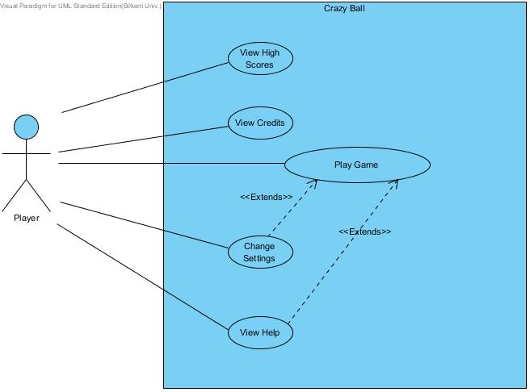

Figure 4.1 – Illustrates the use case model of Crazy Ball

View High Scores

Use Case Name: View High Scores
Primary Actor: Player
Stakeholders and Interests:
-Player wants to see top ten scores with player names.
-System shows the list containing top ten scores with player names.
Pre-conditions: System keeps records of top ten scores.
Post-condition: -
Entry Condition: Player selects “View High Scores” from Main Menu.
Exit Condition: Player selects “Back” to return Main Menu.
Success Scenario Event Flow:
1.System displays top ten scores with player names.
Alternative Flows:
A. If player desires to return main menu at any time:
A.1. Player selects “Return to Main Menu” button to return main menu.
A.2. System displays Main Menu.

View Credits

Use Case Name: View Credits
Primary Actor: Player
Stakeholders and Interests:
- Player wants to learn names of people and their contact information created Crazy Ball.
- System displays contact information of software developers with their names.
Pre-conditions: Player should be in Main Menu.
Post-condition: -
Entry Condition: Player selects “View Credits” from main menu.
Exit Condition: Player selects “Back” to return previous menu.
Success Scenario Event Flow:
1.System displays contact information and names of people who developed Crazy Ball.
Alternative Flows:
A. If player desires to return main menu at any time:
A.1. Player selects “Return to Main Menu” button to return main menu.
A.2. System displays Main Menu.

Play Game

Use Case Name: Play Game
Primary Actor: Player
Stakeholders and Interests:
-Player aims to complete all levels and make highest score.
-System keeps the score of the Player.
Pre-condition: For first running, game settings are set as default. If Player changes game settings, adjusted settings will be saved and used by System.
Post-condition: If Player gets a score which is high enough to be in high score list, high score list will be updated by System.
Entry Condition: Player selects “Play Game” button from Main Menu.
Exit Condition: Player selects “Return to Main Menu” from Pause Menu.
Success Scenario Event Flow:
1.Game is started by System.
2.Player starts playing from first level.
3.Player plays the level until all bricks are destroyed.
4.System grants access to next level.
5.Player starts playing next level.
Player repeats the steps 3 – 5 until all levels are completed or Player loses all lives.
6.System record Player’s score to High Score List, if Player score is higher than the lowest score
in high score list and displays the High Score List.
7.System returns to Main Menu.
Player repeats the steps 1 – 7 if he wants to play game again.
Alternative Flows:
3A. Player tries to destroy all bricks to complete the level:
3A.1. Player throws the ball from paddle by mouse.
3A.2. Ball collides with brick(s) in the screen.
3A.3. Ball bounces from the collided bricks.
3A.4. Collided bricks are removed from screen by System, if they are not destroyed by one collision.
3A.5. System updates the Player’s score according to the destroyed brick type, active power up features.
3A.6. Player prevents the ball falling from the screen by his/her paddle via mouse.
3A.7. Ball bounces from the paddle.
- Player follows steps 3A.1 – 3A.7 to destroy all the bricks.
3A.8. Player completes the level.

3B. Player collects the power ups during game:
3B.1. Ball collides with brick(s).
3B.2. System removes collided brick(s) from screen.
3B.2. One or more power up pop up from collided brick(s).
3B.3. Player tries collects power up(s) by using his paddle.
3B.4. System removes the power up, whether user collects it or power up falls from screen.
3B.5. If user collects power up(s) System makes necessary changes to apply the feature of
power up(s) and System updates score of the Player according to power up.
- Whenever a power up occurs during the game, steps 3B1-3B5 are applied.

- If player requests to pause the game at any time during the game:
A.1. Player presses proper key from keyboard to pause the game.
A.2. System pauses the game.
A.3. System shows the pause menu.
A.3.1. If Player selects resume game from pause menu, System resumes the game.
A.3.2. If Player selects “Return to Main Menu” from pause menu, System directs Player
to Main Menu.
A.3.3.If Player selects “Change Game Settings” Change Game Settings use case is applied.
A.3.4. If Player selects “View Help”, View Help use case is applied.
A.3.5. If Player selects “Return to Main Menu”, System displays Main Menu.
A.3.6. If Player selects “Exit Game”, System closes the game and returns to desktop.

Change Settings

Use Case Name: Change Settings
Primary Actor: Player
Stakeholders and Interests:
-Player desires to change game settings: disabling game sounds or enabling game sound, changing
the background, changing the paddle type.
-System updates the settings which are changed by player.
Pre-condition: For first running, game settings will be set as default. If Player changes game
settings, adjusted settings will be saved and used by system.
Post-condition: Game settings are updated.
Entry Condition: Player selects “Change Settings” button from menu.
Exit Condition: Player selects “Back” to return menu.
Success Scenario Event Flow:
1. Player presses “Change Settings” button to make changes about game settings.
2. Game settings are displayed to Player in “Change Settings” screen by System.
3. Player adjusts settings according to his desire.
4. System updates game settings successfully.
Alternative Flows:
A. If Player desires to use default settings at any time:
A.1. Player selects “Default Settings” button from “Change Settings” screen.
A.2. Default game settings are updated by System.
B. If Player requests to return previous menu at any time:
B.1. Player selects “Back” button from “Change Settings” screen.
B.2. Game settings are updated by System.
B.3. Player returns previous menu.

View Help

Use Case Name: View Help
Primary Actor: Player
Stakeholders and Interests:
- Player wants to learn purpose of game and how to play it.
- System shows a text document explaining purpose of game, player controls, power ups and brick types.
Pre-conditions: Player should be in Main Menu or Pause Menu.
Post-condition: -
Entry Condition: Player selects “View Help” from Main Menu or Pause Menu.
Exit Condition: Player selects “Back” to return previous menu.
Success Scenario:
1.Player selects “View Help” from Menu.
2. System displays help document giving instructions about main purpose of game, game
controls and power ups and brick types.
Alternative Flows:
B. If Player requests to return previous menu at any time:
B.1. Player selects “Back” button from “View Help” screen.
B.2. Player returns previous menu.

Dynamic Models
This section provides detailed information about the Crazy Ball game by illustrating some crucial scenarios of the game in sequence diagrams. Since the ball and the paddle objects are two crucial objects of the game, states of these particular objects are also described in state diagrams. Besides, activities of the system during the gameplay are also stated in activity diagram in this section.

Sequence Diagrams

Start Game
Following sequence Diagram illustrates the scenario explained below:
Scenario: Player Cengiz requests to start game by pressing proper button from Main Menu. After that System initializes a full screen window and get graphics object to draw on the screen. System then loads current map by reading its object distribution from a text file, which just consists paddle, brick, ball objects ( one per each ), system then creates these objects and places them to desired locations which described in a text file that system is responsible for reading it. Lastly, system enters the game loop in order to continuously update the game.
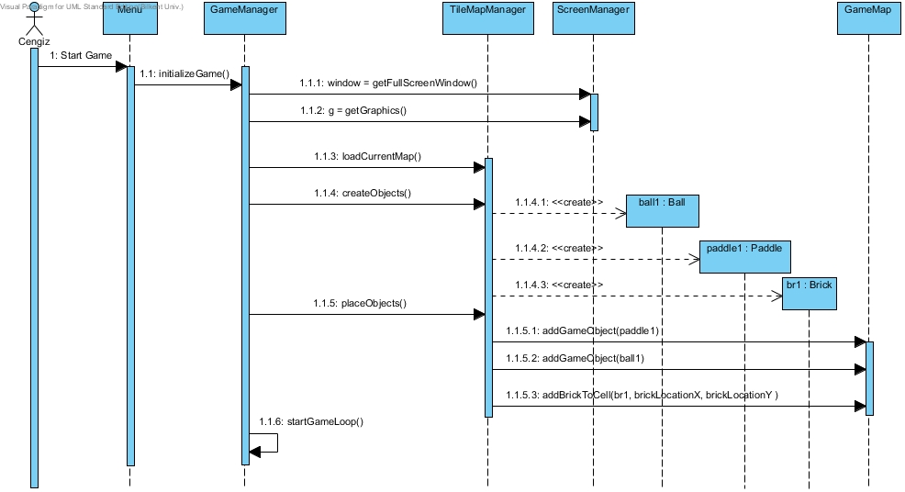
Figure 4.2.1.1 shows the sequence diagram which explains start game scenario

Here MainMenu is a boundary object by which user can perform some activities like starting game, viewing credits, changing settings. In addition, ScreenManager handles creating full screen window and graphics issues. The locations of the game objects are stored in GameMap class, GameMapManager is responsible for the organization of the GameMap. Hence, System enters a game loop in order to continuously update the game.

Power up Management
Following sequence Diagram illustrates the scenario explained below:
Scenario: Player Cengiz requests to start game by pressing proper button from Main Menu. Assuming that the steps on the previous sequence diagram are performed, System enters a game loop which manages the whole game dynamics. Assuming that user moves the paddle in order to reflect the ball by colliding with paddle and the ball. System checks if the ball and the paddle are collided, if they are collided System reflects the ball. System then checks that if ball collides with a brick, if yes System locates this brick and removes it from screen, then system also updates the score of Cengiz. System then determines that if a power up should occur, if yes system generates a random power up. In this scenario shrink paddle power up is created Then assuming that user moves the paddle to pick up the power up. System checks the collision between the power up and the paddle, if there is a collision, System applies the power up which is represented by an specific id, after that system updates the score of player.

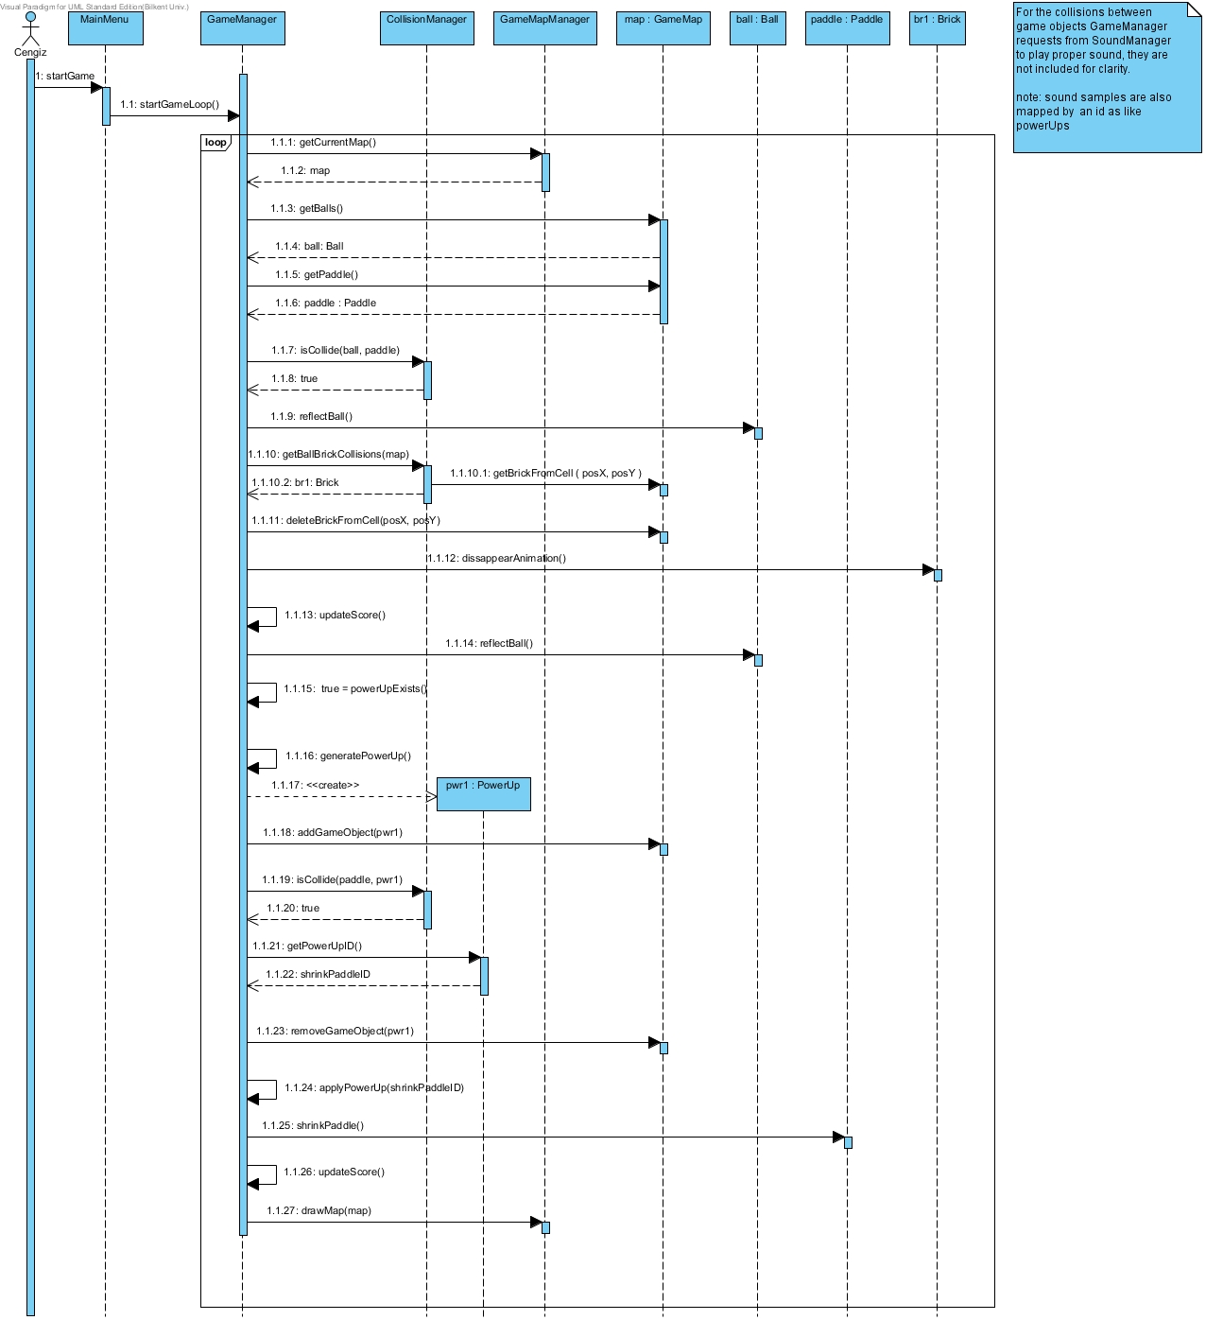 Figure-4.2.1.2 shows the sequence diagram which explains power up management
As illustrated above, GameManager manages the actual game dynamics by interacting with other control objects of the System. Moreover, CollisionManager handles all collision issues in the game and communicates with GameManager

Change Settings
Following sequence diagram illustrates the scenario explained below:
Scenario 1: Cengiz desires to change the game settings. He presses change settings button from a menu object (since both PauseMenu and MainMenu provides this functionality), System displays settings, and Cengiz changes the settings according to his desire. After that, when Cengiz presses back button, System updates new settings by GameManager.

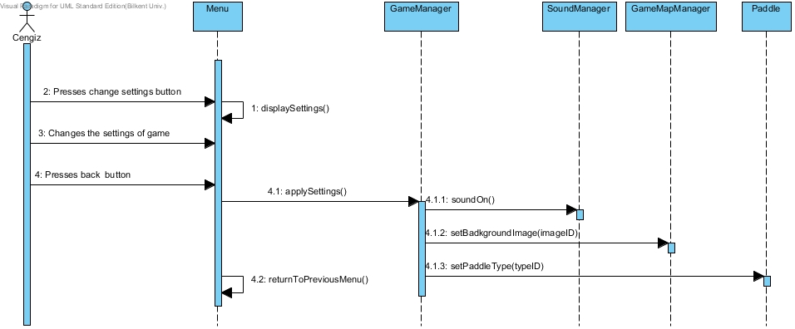
Figure-4.2.1.3 illustrates the change settings sequence diagram

Here, GameManager sends paddle type ( which is a common property for all paddle objects ) to Paddle class. GameManager also sends the desired background image which is chosen by user and represented by an id, to GameMapManager to apply. New sound settings are sent to SoundManager to apply, by GameManager again.
Following sequence diagram illustrates the scenario explained below:
Scenario 2: Assuming that Cengiz changed the game settings previously, as in the Scenario 1. Cengiz desires to use the default game settings which are set automatically at the startup of game. In this respect Cengiz presses change settings from a Menu object. System displays settings of the game. Cengiz presses return to default settings button. System applies the original game settings and displays the new view of changed settings.
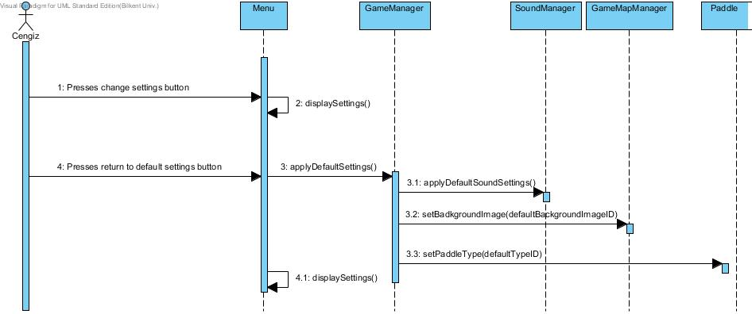
Figure-4.2.1.3 (Alternative) illustrates the alternative change settings scenario

Activity Diagram
This diagram shows how system maintains gameplay.
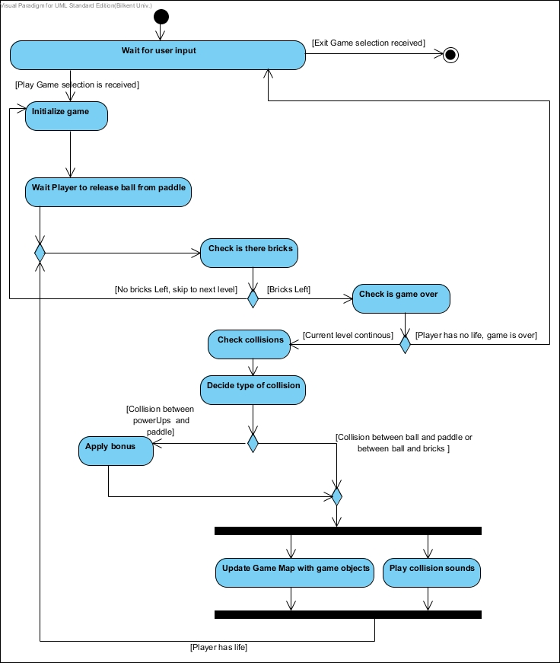
Figure 4.2.2 Illustrates Activity Diagram of Gameplay Maintenance
When user selected Play Game selection system initialize game by instantiating game objects and creating game map. When this preparation process is finished system waits user to interact with mouse to release ball from paddle. When player releases ball from paddle firstly system checks are there any bricks on game map. If there is any number of bricks on game map, system checks the number of Player’s lives to make a decision between two alternatives which are continuing game and ending game. If Player has no life, game is over. If Player has life, system checks for any collision on game map. When a collision is detected, the system decides next operation according to type of collision. If detected collision is between game window and ball, system repeats all performed operations from the time when ball released from paddle.
If detected collision is between game paddle and power ups system applies bonus features to game objects. In other cases which are sourced by collisions between paddle and ball, ball and power up, bullet and brick or ball and brick, system simultaneously updates game objects with game map and plays collision sounds according to colliding game objects. After this point, system checks number of lives of player and number of bricks on game map. If player still has life and there is at least one brick on game map, system maintains game loop and look for next collision. If player still has life and there is no brick on game map system provides access to the next level.

Object and Class Model
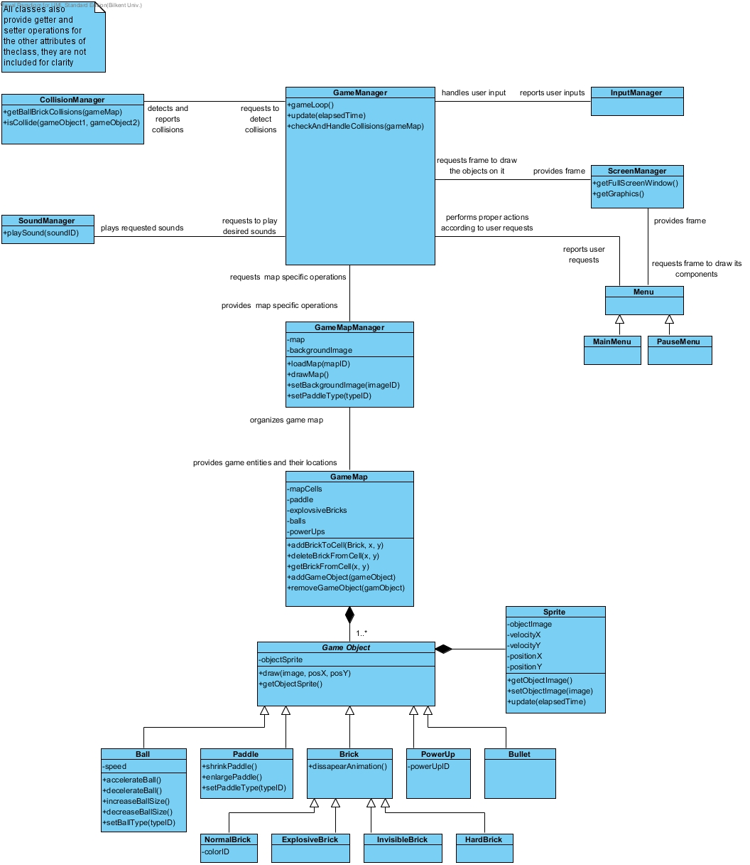
Figure-4.3 Class diagram of Crazy Ball game

The object model of the Crazy Ball game is illustrated above. Class Diagram of Crazy Ball consist of 19 classes.
First of all Menu class, is a parent class to MainMenu and PauseMenu classes. These Menu class basically is for creating and managing pause menu and the main menu of the game.

More importantly, manager classes of our System carries out the task of organization of the whole game. These classes explained briefly below.

- GameManager class is where we actually organize and manage the game dynamics by corporating with other manager classes. This class is Façade class of our System.

- CollisionManager class is basically reports the collision issues of game objects to the game manager when needed.

- ScreenManager class provides the full screen window and graphics objects to the GameManager. This class also handles the double buffering issues. Briefly, this class provide us the actual game window.

- InputManager class handles all controls of the game.

- SoundManager class handles all sound issues of the game

- GameMapManager organizes the positions and the numbers of the game objects on the game map. This class provides functionalities to find the location of the game objects easily. Also this class places all objects in their places on the map.

We have GameMap class, which consists of GameObjects. GameMap basically holds the bricks in a 2-D array, other dynamic game objects like paddle, ball, powerUps are stored seperately from bricks for fast access. By this way we can easily place our bricks on the screen. GameMapManager basically divides the screen into small, equal sized, rectangular areas and performs map specific operations like drawing whole map, loading and interpreting a map from text file.

Moreover, we have a class named Sprite. This class is basically for moving image objects on the screen. In this respect this class has an image, its x and y positions and its x and y direction speeds as properties. Hence, All game objects of our System consists of one or more sprites.

For the remaining part, we have our entity objects which inherit from a base class called GameObject. Also, we have 4 different brick classes, which also inherits from Brick class. As a reult for our game objects we tried to benefit from inheritance as much as possible to get a neat and tidy structure.

User Interface

Navigational Path

View Help
View Credits
Change Settings

Exit Game
View High Scores
Play Game
Pause Menu
Main Menu
Return to Main Menu
Game

Figure 5.1 Illustrates the Navigational Path of Crazy Ball

Screen Mock-ups

Main Menu
When application begins to run, Player will see main menu screen. Main menu screen shows six options to Player which are play game, change settings, view high scores, credits, help, and exit game. (Figure 5.2.1)

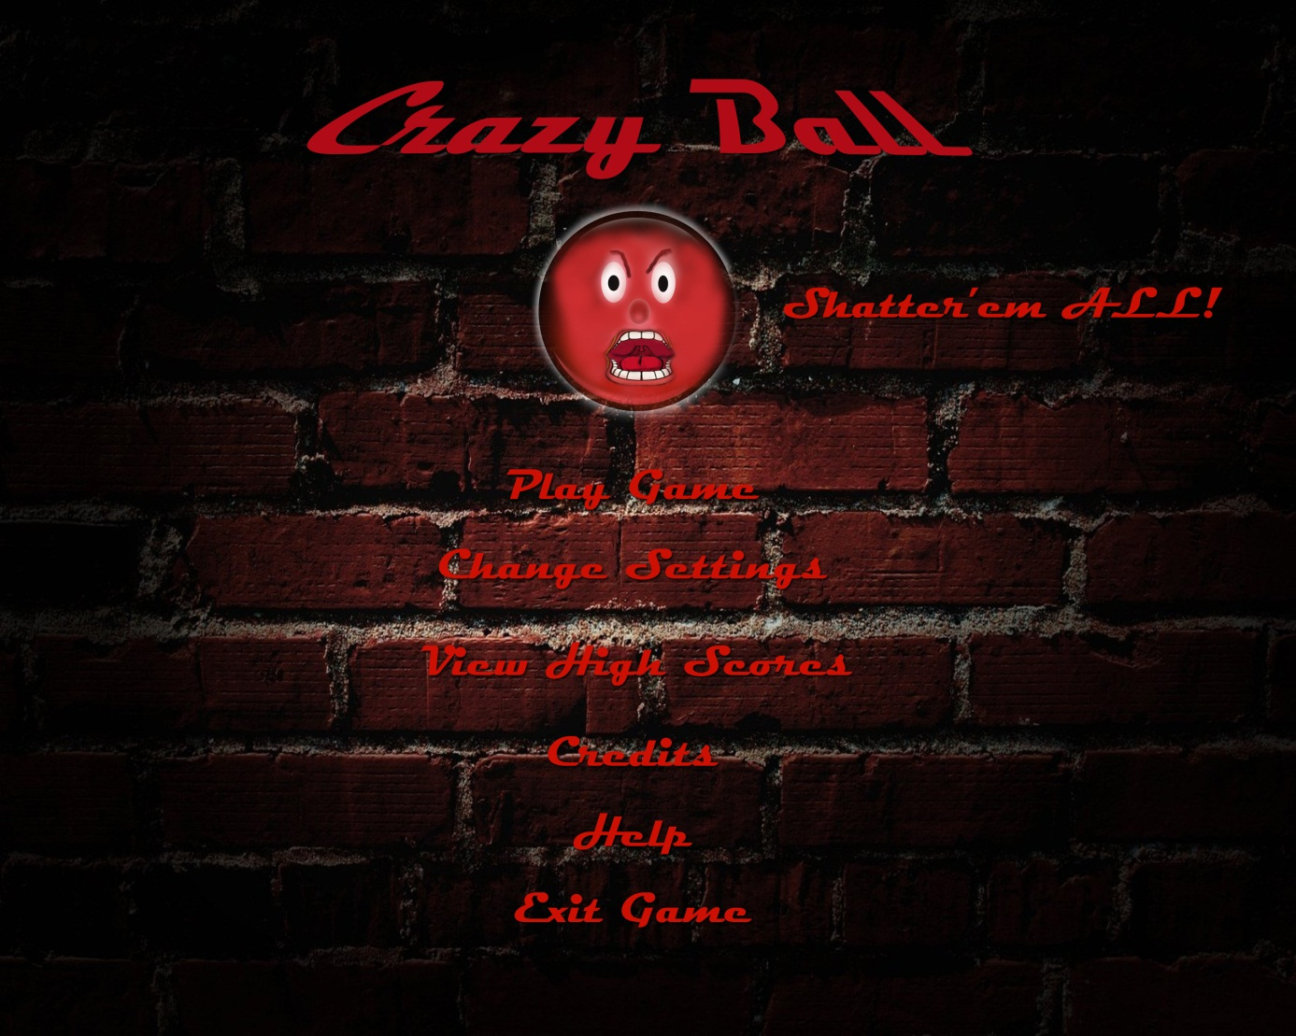
Figure 5.2.1 Screen shot of Main Menu

-Play Game: If Player selects Play Game, game starts with current game settings. Figure 5.2.1.1 is a screen shot from gameplay.

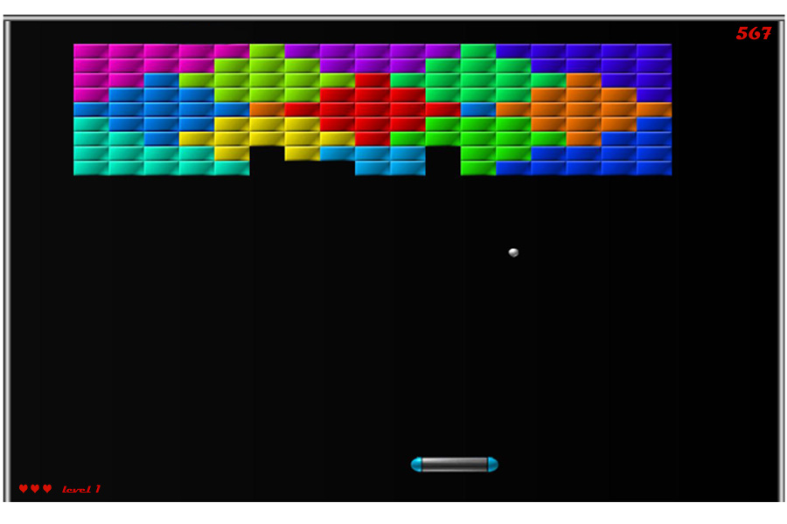
Figure 5.2.1.1 Screen shot of gameplay

-Change Settings: When change settings button is pressed a list of options are shown on screen. These settings can be changed by Player manually. If Player does not make any change in settings, default settings are set and used by system. (Figure 5.2.1.2) Player can on/off game sounds change background images and paddle type by the red arrows in figure. If player wants to use default settings he should only click on “Default Settings”.
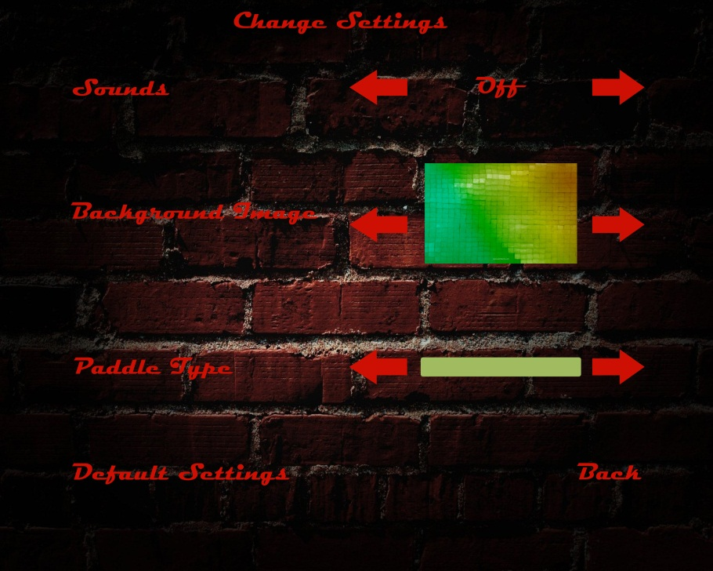
Figure 5.2.1.2 Screen shot of Change Settings

-View High Scores: When high scores button is pressed, system will show the list of top ten scores with player names. If player can make a score which is higher than the 10th score, his score is displayed at this list and he will enter his name to high scores list. (Figure 5.2.1.3)
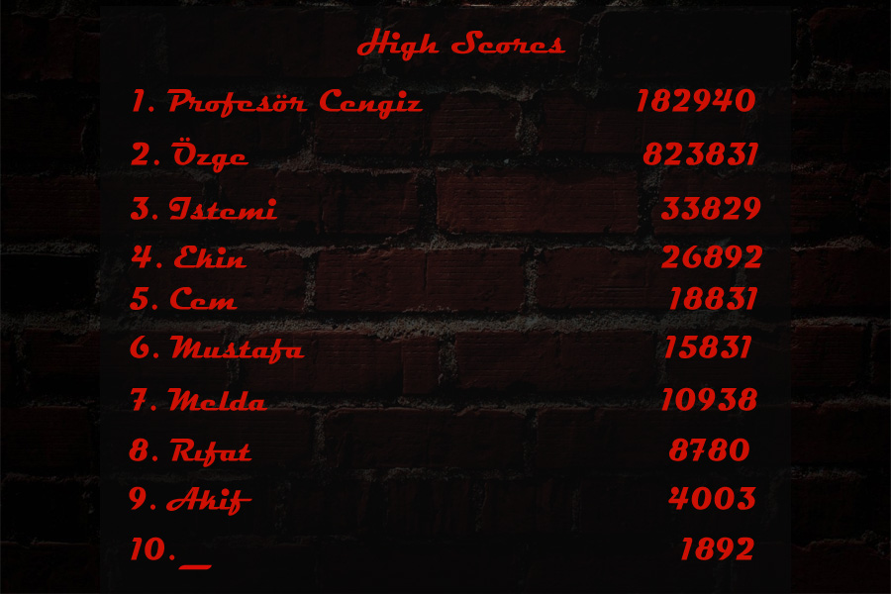
Figure 5.2.1.3 Screen shot of View High Scores

-Help: If player chooses help, a text is shown on screen containing instructions about game and explanations of power ups. Player can return to pervious menu by clicking “Back”. (Figure 5.2.1.4)
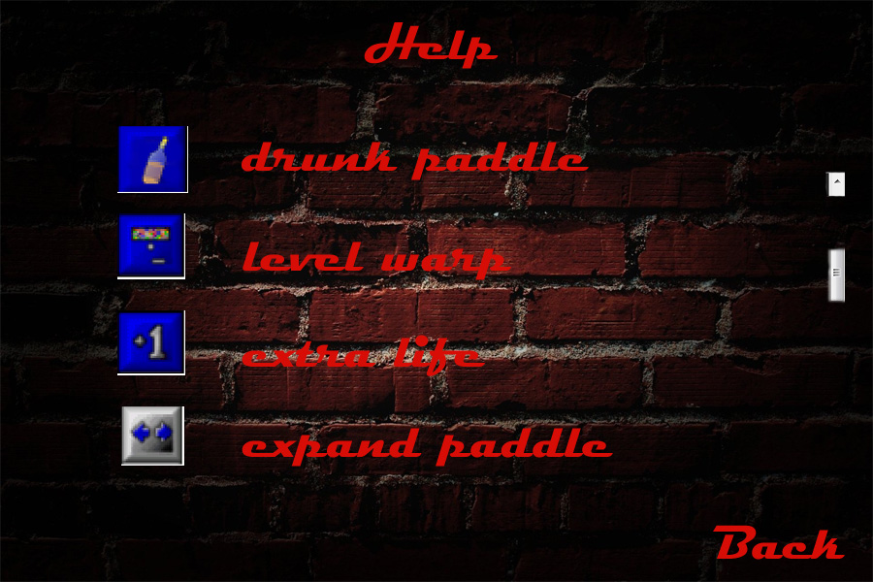
Figure 5.2.1.4 Screen shot of Help

-Credits: When Player selects Credits, contact information and names of game developers are shown on screen. Player can return to previous menu by clicking “Back”. (Figure 5.2.1.5)

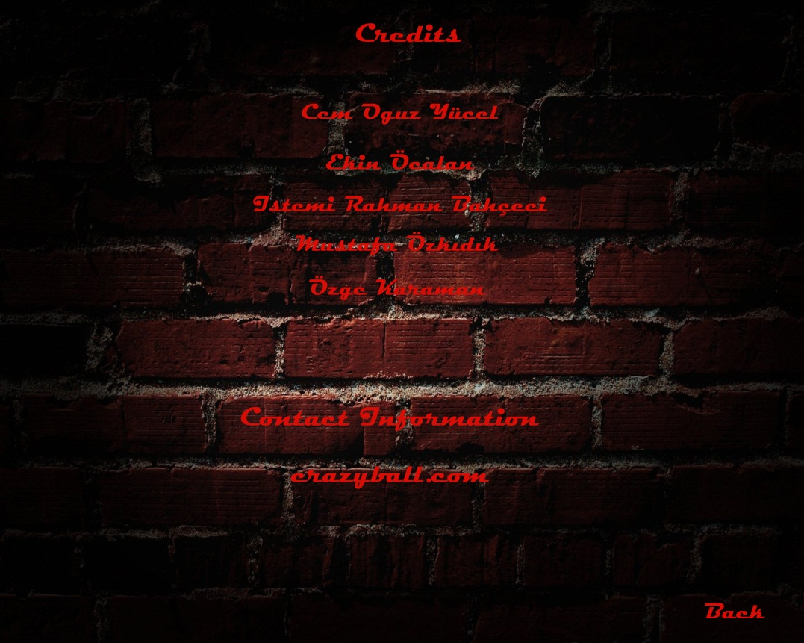
Figure 5.2.1.5 Screen shot of Credits

-Exit Game: When player selects exit game, application stops running and game window is closed.

Pause Menu
When Player pauses game by pressing “ESC” on keyboard, pause menu will be shown on screen. Content of Pause menu is similar with main menu. However, exit game option is not in pause menu. Therefore; if player wants to exit game, he should select “Return to Main Menu” then he can exit game. (Figure 5.2.2)
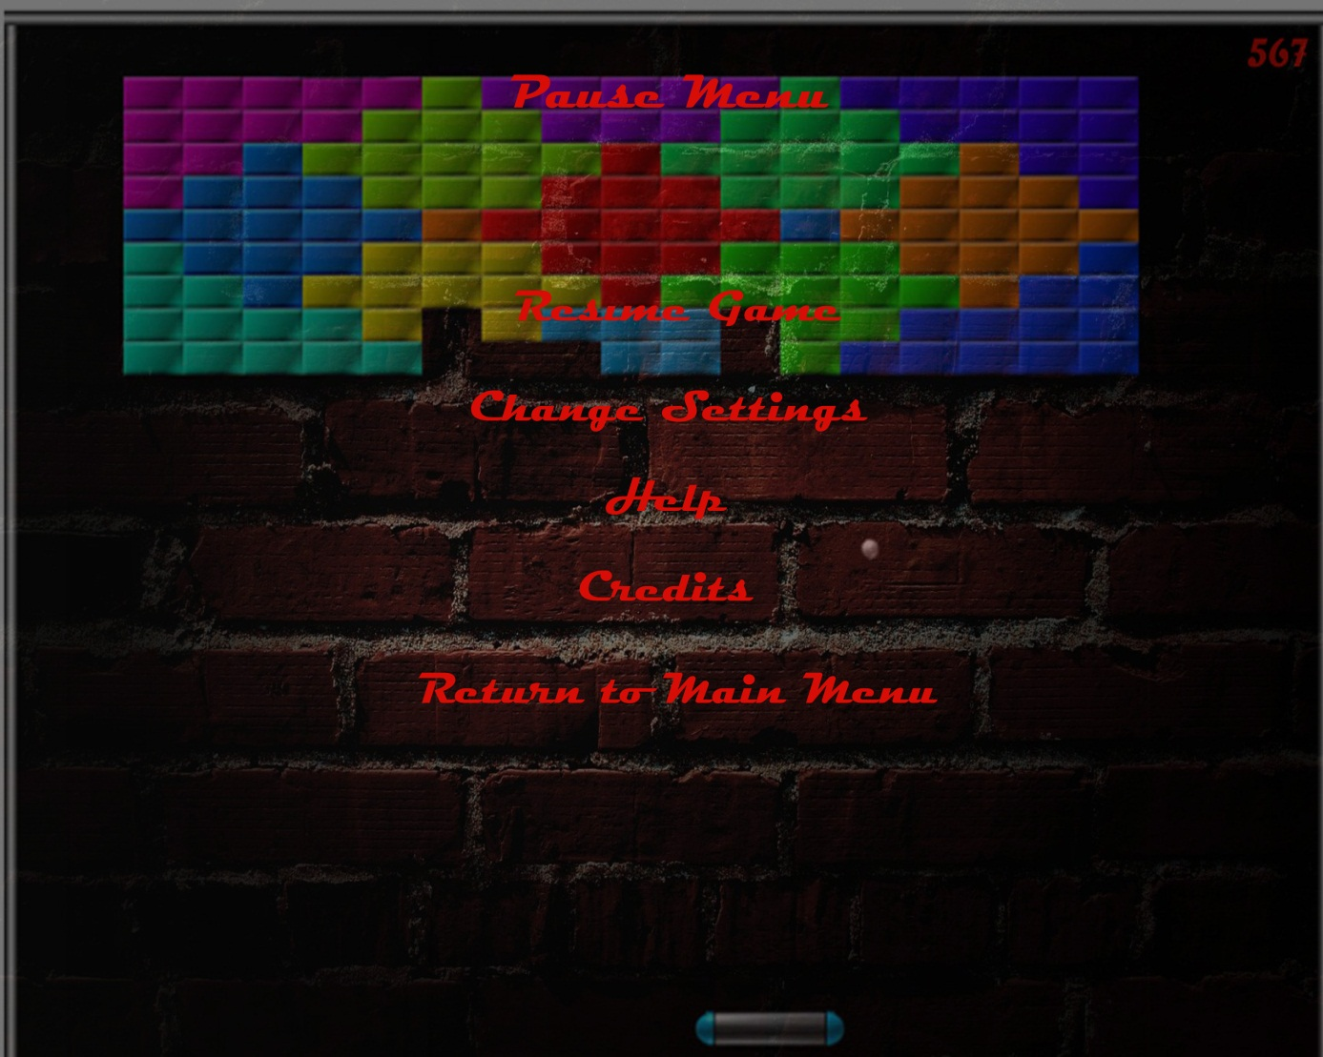
Figure 5.2.2 Screen shot of Pause Menu

Power Ups
Power ups are listed below with their corresponding images;

 Expand paddle*
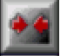 Shrink paddle*
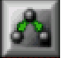 Clone ball*
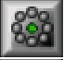 Eight ball*
 Mega ball*
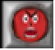 Crazy ball
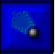 Decelerate ball*
 Riot ball*
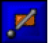 Piercing ball*
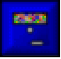 Level warp*
 Random power-up
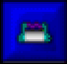 Magnet*
 Extra life*
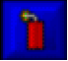 Explode explosive bricks*
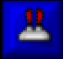 Laser paddle*
 Drunk paddle
 Small ball*
 Instant death*
 Accelerate ball*

Images of some power ups are taken from DXBall game.

Bricks
There are 4 types of bricks.
-Normal Bricks: Normal bricks are destroyed by one hit. (Figure 5.2.4.1)

Figure 5.2.4.1 Normal Bricks

-Invisible Bricks: Invisible bricks are not shown on game map. When ball hits them, they become visible. They can be destroyed with second hit. (Figure 5.2.4.2)

Figure 5.2.4.2 Screen shot of invisible bricks after first hit
-Exploding Bricks: When you hit an exploding brick it is destroyed with adjacent bricks.
(Figure 5.2.4.3)

Figure 5.2.4.3 Exploding brick

-Hard Bricks: Hard bricks are destroyed with 3 hits. For each hit hard bricks changes its apperance.

Figure 5.2.4.4.1 Illustrates hard brick before first hit


Figure 5.2.4.4.2 Illustrates hard brick after first hit


Figure 5.2.4.4.2 Illustrates hard brick after second hit

Important Decisions in overall Analysis

- We decided to have a big manager class which actually organizes the game by cooperating with other manager classes. We thought that this would simplify the complexity of our game in implementation.

- We aimed to benefit from inheritance as much as possible to get a hierarchical structure in our System. In this respect we inherited all game objects from a class called GameObject.

- For the further stages, we are planning to apply singleton and façade design patterns to our System therefore, we decided constructing our class model according to this desire.

Conclusion

In this report , we created our analysis report in order to design and implement a brick breaker type game, called “Crazy Ball”. Our analysis report consists of two main parts. First main part is basically requirement specification. Second main part is our System model.
For requirement specification part, we tried to examine all possible requirements which a player could perform in a brick breaker game. This was our principle while we had for both functional and non-functional requirements. In our project design, we plan to fulfill all of these requirements. Since we are aware of importance of requirement specification part, we spent enough time to specify them. After deciding which requirements which a player seeks, we were ready for our system model.
Our system model, which is second main part of our analysis report, consist of four sections which are following :
1.Use case model
2. Dynamic models
3. Class model
4. User interface
To decide what use cases we have, we spent some time on thinking about them to identify which uses we should indicate for our project. At this point, we tried to specify which requirements, which actions are actual use cases.
Our Dynamic model includes sequence diagrams, state diagrams and activity diagrams. We tried to show possible actions that will constitue the crucial parts of our game and interactions between player and the System by sequence diagrams. We have two state diagrams. One is for paddle’s states , one is for ball’s states. We tried to identify all possible states in our state diagrams. Our activity diagram indicates our game play basically. It has activities of ball and paddle. In our class diagram, we tried to form a perfect class model since we know that in implementation and design process this model would constitute a crucial part. We spent so much time about thinking possible classes and connections between them.
Fourth part of our analysis report is user interface and navigational path diagram. We tried to keep user interface mock-ups simpler and fancy as much as we can, since we plan to have a user friendly interface. And we created a navigational path with using our use cases.
To sum up we tried to create a perfect analysis report since it will guide us in our design and implementation process. We do not want to deal with problems in future, so this is why we took serious on analysis report.

References
* http://www.blitwise.com/superdxb.html

