**4.1. Use Case Model**

This part provides information about use case model of Hotel Rezervation System, detailed use case descriptions are included below.

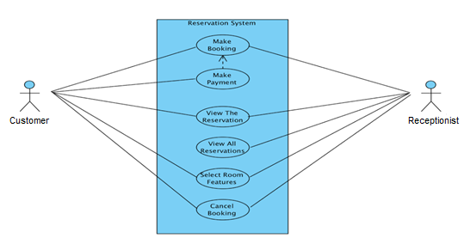

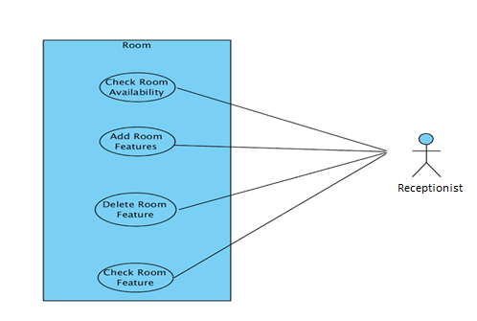

**4.1.1**

***Use case name*** makeBooking

***Participating Actor*** Initiated by customer

***Entry condition*** 1. Customer selects “make booking” button from main menu.

***Flow of Events*** 2. Customer selects number of rooms to book

3. Customer selects check-in and check-out dates, number of

people for each rom and rooms’ features.

4. Customer selects “show availabity of rooms and their prices”

button below the page.

5. System show the rooms information and prices.

6. If prices are suitable for the customer, he can selects

“confirm booking” button.

7. Customer can make payment by selecting “make payment” button, or

customer can make payment when he/she go to the hotel to host by

selecting “make payment in the hotel”.

***Exit condition*** 8. System displays the rezervation code.

**4.1.2**

***Use case name*** viewTheRezervation

***Participating Actor*** customer and receptionist

***Entry condition*** 1. Customer or receptionist selects “view the rezervation” button

from main menu.

***Flow of Events*** 2. Customer or receptionist write the rezervation code.

***Exit condition*** 3. Customer and receptionist see the rezervation information(check-

İn,check-out dates,room features,number of room,number of people,

room price).

**4.1.3**

***Use case name*** viewAllRezervations

***Participating Actor*** Initiated by receptionist

***Entry condition*** 1. Receptionist selects “view all rezervation” button from main menu.

***Flow of Events*** 2. Receptionist enter the his/her password and selects “sign in” button.

3. Receptionist can choose any room button to see its all rezervations.

For example, if receptionist select the “105” button, he/she can

see the all rezervations for room 105.

***Exit condition*** 4.Receptionist selects “back to main menu” button.

.

**4.1.4**

***Use case name*** cancelBooking

***Participating Actor*** customer and receptionist

***Entry condition*** 1. Customer or receptionist selects “cancel booking” button from main menu.

***Flow of Events*** 2. Customer or receptionist enter the rezervation code

and selects “cancel” button.

***Exit condition*** 3. System give information about whether canceling booking canceled

succefully or not.

**4.1.5**

***Use case name*** addRoomFeatures

***Participating Actor*** Initiated by receptionist

***Entry condition*** 1. Receptionist selects “add room feature” button from main menu.

***Flow of Events*** 2. Receptionist enter the his/her password and selects “sign in” button.

3. Receptionist selects the room to activate any feature of it.

4. Receptionist tick up to add feature to specified room by

activating it.

***Exit condition*** 5. Receptionist selects “ save changes” button and system give information

about whether changes applied succesfully or not.

. **4.1.6**

***Use case name*** deleteRoomFeatures

***Participating Actor*** Initiated by receptionist

***Entry condition*** 1. Receptionist selects “delete room feature” button from main menu.

***Flow of Events*** 2. Receptionist enter the his/her password and selects “sign in” button.

3. Receptionist selects the room to inactivate any feature of it.

4. Receptionist remove tick to delete feature of specified room by

inactivating it.

***Exit condition*** 5. Receptionist selects “ save changes” button and system give information

about whether changes applied succesfully or not.

.

**4.1.7**

***Use case name*** checkRoomFeatures

***Participating Actor*** Initiated by receptionist

***Entry condition*** 1. Receptionist selects “check room feature” button from main menu.

***Flow of Events*** 2. Receptionist enter the his/her password and selects “sign in” button.

***Exit condition*** 3. Receptionist selects the room to see any feature of it.

.