University Name: Bilkent Unıversity
Department Name: Computer Science
Course Code : 223
Course Name : Digital Design

Mine Sweeper Game
Onur KOCAHAN 21402013 - Section 05
Mehmet Ali ALTUNTAŞ 214001004 -Section 05

Date of Submission: 16.04.2017
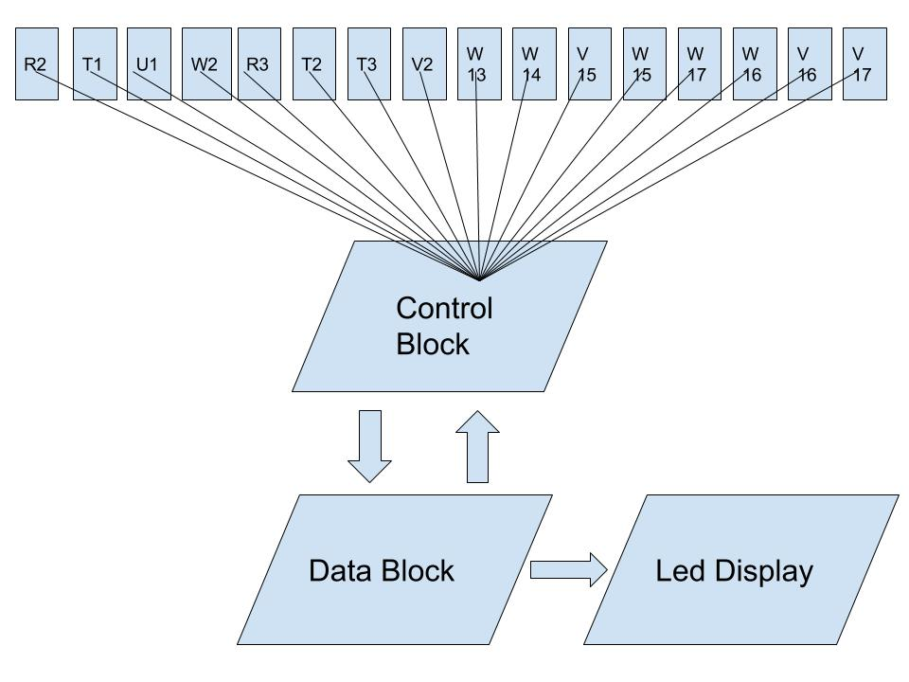

Explanation:
In this project, the user gives input from 16 switches and each switch corresponds to one 2 x 2 area on the led display. Each input is given into the control block where the the input is corresponded to areas on the led. The Control and data block seeks both ,back and forth checking where the boom could be and if the boom is on this area, it will be triggered. The last state of the table is transferring the info to the led will be displayed on.

Control  Block | This block controls the switches that have turned on
8*8 led | Shows the related switches’ assigned for bomb or continuing the game
Data Block | This block generates and assignes a switch of the boom randomly
Led Display | This block turns the led on which is assigned in control block

Implementation so far:

// random class: https://verificationacademy.com/forums/systemverilog/random-clock-generator

module 8x8Matrix(input logic [15:0] switches, output logic [15:0] sel);

logic a;
logic[15:0] boom;
keepBoom boomer(boom);
always_comb
begin
case(switches)
16’b1000000000000000 begin: sel = 16’b1100000011000000; a<=a+1;;
16’b0100000000000000: begin sel = 16’b1100000000110000; a<=a+1;;
16’b0010000000000000: begin sel = 16’b1100000000001100; a<=a+1;;
16’b0001000000000000: begin sel = 16’b1100000000000011; a<=a+1;;
16’b0000100000000000: begin sel = 16’b0011000011000000; a<=a+1;;
16’b0000010000000000: begin sel = 16’b0011000000110000; a<=a+1;;
16’b0000001000000000: begin sel = 16’b0011000000001100; a<=a+1;;
16’b0000000100000000: begin sel = 16’b0011000000000011; a<=a+1;;
16’b0000000010000000: begin sel = 16’b0000110011000000; a<=a+1;;
16’b0000000001000000: begin sel = 16’b0000110000110000; a<=a+1;;
16’b0000000000100000: begin sel = 16’b0000110000001100; a<=a+1;;
16’b0000000000010000: begin sel = 16’b0000110000000011; a<=a+1;;
16’b0000000000001000: sel = 16’b0000001111000000; a<=a+1;;
16’b0000000000000100: sel = 16’b0000001100110000; a<=a+1;;
16’b0000000000000010: sel = 16’b0000001100001100; a<=a+1;;
16’b0000000000000001: sel = 16’b0000001100000011; a<=a+1;;
endcase
end

always_comb
begin
if (a >= 15) // win
sevenSeg w(1,0,000000,000000);
else if(sel = boom)
sevenSeg l(0,1,000000,000000);
end
endmodule

module sevenSegment(input logic win, lost,
output logic [6:0] sevSeg1,sevSeg2 );

if(win)
sevSeg1 = 0111110;
sevSeg2 = 0111000;
else if (lost)
sevSeg1 = 0001110;
sevSeg2 = 0000000;
endmodule

module Boom(output logic [15:0] boom);

rand int numOfBoom = $urandom_range(0,15);
case(numOfBoom)
0: boom = 16’b1100000011000000;
1: boom = 16’b1100000000110000;
2: boom = 16’b1100000000001100;
3: boom = 16’b1100000000000011;
4: boom = 16’b0011000011000000;
5: boom = 16’b0011000000110000;
6: boom = 16’b0011000000001100;
7: boom = 16’b0011000000000011;
8: boom = 16’b0000110011000000;
9: boom = 16’b0000110000110000;
10: boom =16’b0000110000001100;
11: boom =16’b0000110000000011;
12: boom =16’b0000001111000000;
13: boom =16’b0000001100110000;
14: boom =16’b0000001100001100;
15: boom =16’b0000001100000011;
endcase
endmodule

sevenSegment Block has implemented in SystemVerilog on BASYS 3, 7 segment display
8x8Matrix Block has implemented in SystemVerilog on 8*8 Led which is purchased from amazon.com

