面

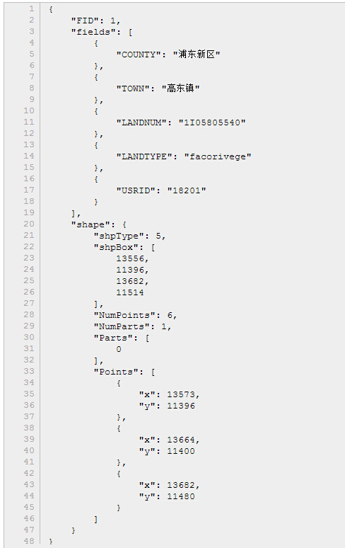
点
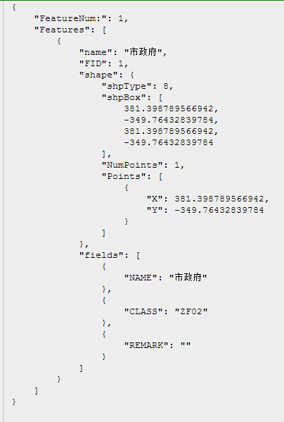

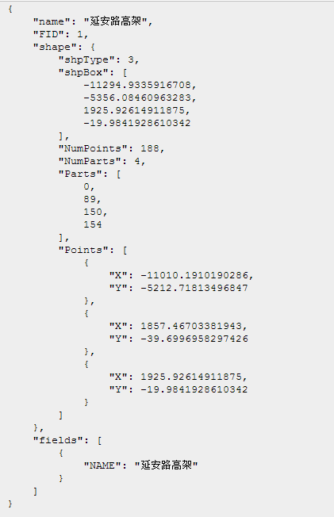
stNull = 0;
stPoint = 1;
stPolyline = 3;
stPolygon = 5;
stRectangle = 6; // Customize Def
stEllipse = 7; // Customize Def
stMultiPoint = 8; //

