Natural Language Processing: Group Assignment

Public Sentiment to the Federal Reserve’s Rate Cuts in 2024

Ben Belhassen Mohamed Ali, Ciampana Lorenzo, Filesi Gianluca, Tibi Gad

**Team 1**

February 13, 2025

**Contents**

1. Research question 2
2. Data collection and processing 2
   1. Data sources 2
   2. Data Pre-processing 2
3. Methodology 3
   1. Bag-of-Word and Word vector 3
   2. Word Cloud 3
   3. Word Frequency 4
      1. Bigram Analysis 5
      2. Trigram Analysis 7
   4. Topic Modeling 8
      1. Best number of topics 8
      2. Topic division 8
   5. Sentiment Analysis 9
4. Results 10
5. What happened in 2022? 11
   1. Wordcloud 11
   2. Word Frequency 12
   3. Sentiment Analysis 12

# Research question

**Public Sentiment to the Federal Reserve’s Rate Cuts in 2024.**

For this project, we will gather data by scraping comments from YouTube. These platforms offer valuable insights into public sentiment regarding the Federal Reserve’s 2024 rate cuts, capturing reactions from both general users and financially informed individuals. Our goal is to analyze discussions, opinions, and emotional responses to better understand how people perceive and react to these significant financial policy changes.

# Data collection and processing

## Data sources

We web-scrapped comments under three videos from three YouTube television news chan- nels: [Federal reserve cuts interest rates by 0.5%](https://www.youtube.com/watch?v=pBOWeEyFYlw) by NBC news, [How Fed Rate Cuts Affect](https://www.youtube.com/watch?v=rVDE5Q74EhM) [The Global Economy](https://www.youtube.com/watch?v=rVDE5Q74EhM) by CNBC and [Federal Reserve Chair Powell speaks after Fed low-](https://www.youtube.com/watch?v=seEoCB97cds) [ers interest rates by half point - 9/18/2024](https://www.youtube.com/watch?v=seEoCB97cds) by CNBC television. The first one has 152 comments, the second one 720 and the last one 248.

## Data Pre-processing

The code begins by ensuring that all rows in the DataFrame contain valid text data by removing any entries where the text column is missing. After this initial cleaning, it defines a function whose purpose is to convert part-of-speech tags from the format pro- vided by the NLTK tagging function into a format that the WordNet lemmatizer can use. This conversion is based on examining the first letter of each tag and mapping adjectives, verbs, nouns, and adverbs to their corresponding WordNet categories, defaulting to noun if no match is found. Next, a comprehensive text preprocessing function is defined. The function first standardizes the text by converting it all to lowercase. It then removes any URLs present in the text, followed by eliminating numbers, punctuation, and any remain- ing special characters. Additionally, the function removes standalone single characters, which are often not useful for further analysis.

1

def preprocess_text ( text):

text = text. lower ()

text = re. sub ( r’ http \ S+| www \.\ S+’, ’’, text) text = re. sub ( r’\ d+’, ’’, text)

text = text. translate ( str. maketrans(’’, ’’, string . punctuation )) text = re. sub ( r’[^\ w\ s]’, ’’, text)

text = re. sub ( r’\ b\ w\ b’, ’’, text)

2

3

4

5

6

7

Once the basic cleaning is complete, the text is broken down into individual words using tokenization. Each token is then assigned a part-of-speech tag, which is essential for the subsequent lemmatization step. Using these tags, the lemmatizer reduces each word to its base or dictionary form. This step is crucial because it consolidates different forms of the same word into one, making later analysis more consistent.

1

# Tokenize text so that we can lemmatize each token

tokens = word_tokenize ( text) # POS tagging for each token

tagged_tokens = pos_tag ( tokens)

# Initialize lemmatizer and lemmatize each token using its POS tag lemmatizer = Word NetLemmatizer ()

lemmatized_tokens = [ lemmatizer. lemmatize ( word , get_wordnet_pos ( pos)) for word , pos in tagged_tokens ]

2

3

4

5

6

7

After the text has been lemmatized, the function proceeds to remove words that do not contribute significantly to the analysis. It does this by filtering out standard English stopwords, as defined by NLTK, and then further extends this list with custom stopwords that are considered irrelevant for the particular analysis. Once the unnecessary words have been filtered out, the remaining tokens are joined back together into a single string that represents the cleaned version of the original text.

1

stop_words = set( stopwords. words(’ english ’))

# Include any custom stopwords you want to remove

custom_stopwords = stop_words. union ({’ like ’, ’ just ’, ’ really ’, ’ video ’, ’ watch ’, ’ know ’, ’ youd ’, ’ dont ’, ’ good ’, ’ non ’, ’ appreciate ’,’ thank ’, ’

channel ’, ’ people ’, ’ thanks ’, ’ lol’, ’ time ’, ’ name ’, ’ im ’, ’ maga ’, ’

would ’,’ one ’, ’u’, ’ get’, " rate ",’ know ’, ’ want ’, ’ make ’, ’ go ’, ’ ive ’, ’ cut’, ’ tear ’, ’ dollar ’})

filtered_tokens = [ token for token in lemmatized_tokens if token not in custom_stopwords ]

2

3

4

# Methodology

## Bag-of-Word and Word vector

After text data cleaning and preprocessing, we transformed the corpus into numeric fea- tures through two conventional vectorization methods: TF-IDF and Bag-of-Words (BoW). In the TF-IDF approach, the importance of each token is weighted by its frequency in a given document (term frequency) and the inverse of its frequency in all documents (inverse document frequency). This helps to downscale very frequent words and upscale more dis- criminative words. TfidfVectorizer was utilized with parameters like max_df=0.95 and min_df=5, meaning to ignore tokens that are too frequent (appearing in more than 95% of documents) or not enough frequent (appearing in fewer than 5 documents). Furthermore, standard English stop words were ignored to avoid words with little semantic content. For comparison, a CountVectorizer, also known as Bag-of-Words, was also employed, which simply counts how often each token appears in a document.

1

vectorizer_tfidf = TfidfVectorizer ( max_df =0.95 , min_df =5 , stop_words=’ english ’)

X_tfidf = vectorizer_tfidf . fit_transform ( df[’ cleaned_text ’])

vectorizer_bow = CountVectorizer ( max_df =0.95 , min_df =5 , stop_words=’ english ’) X_bow = vectorizer_bow . fit_transform ( df[’ cleaned_text ’])

2

3

4

5

This yields a sparse matrix representation with the columns as the unique vocabulary terms and the rows as the term counts by document. Comparing both Bag-of-Words and TF-IDF, we observe how weighting schemes compare to simple counts, and we decides to use BoW as representation of the text for subsequent modeling.

## Word Cloud

To visualize the general vocabulary distribution of our cleaned text collection, we started off by gathering all non-null values of the cleaned_text column and appending them into one continuous string. This concatenated string was then passed through the WordCloud library, which implements algorithms to display an image of most frequent words in pro- portion to their respective frequencies. It creates a clear and concise visual composition of the most dominant terms of the dataset. (Figure 1).

Looking at this wordcloud, we can observe the strong emphasis on macroeconomic concerns like inflation, interest rates, and market reactions. The dominance of “inflation” and

“fed” suggests that people are highly engaged in discussions about monetary policy and its broader impact.

Interestingly, words like “portfolio,” “investment,” and “advisor” indicate that many com- ments are from investors or finance enthusiasts trying to strategize around the rate cut. The presence of “government,” “election,” and “Trump/Biden” also hints at a debate on the political implications of Fed decisions.

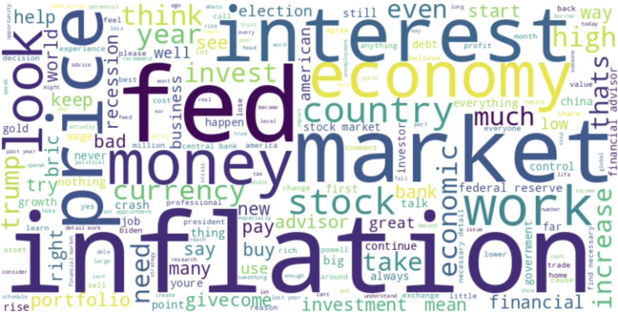

Figure 1: Unique Wordcloud for the Dataset

## Word Frequency

To gain a deeper understanding of the public discourse surrounding the Federal Reserve’s rate cut, we conducted a word frequency analysis on the comments. This method allows us to identify the most commonly used terms, providing insights into the key themes, concerns, and sentiments expressed by the audience. (Figure 2).

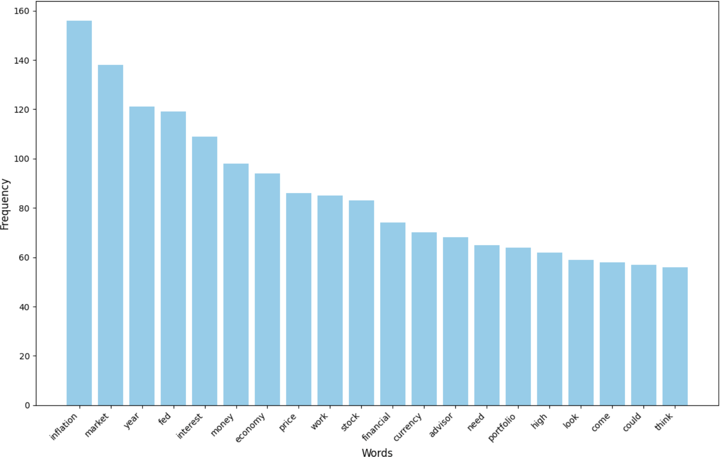

Figure 2: Top 20 Most Frequent Words

Words such as “Inflation,” “market,” “year,” “Fed,” and “interest” are the most mentioned

ones, reinforcing that commenters are primarily concerned with macroeconomic impacts and financial planning. The strong presence of “money,” “economy,” “price,” “stock,” and “financial” suggests that many discussions revolve around investment strategies and economic expectations. Additionally, words like “advisor,” “portfolio,” and “currency” indicate that some commenters are actively considering how to adjust their financial de- cisions based on the Fed’s actions.

Interestingly, more general terms like “need,” “look,” “come,” and “think” appear, which might suggest uncertainty or speculation about what the Fed’s decision means for the broader economy. A deeper sentiment analysis could reveal whether discussions are opti- mistic, pessimistic, or mixed regarding the rate cut’s impact.

However, we noticed that certain words appeared too frequently since they are core to the topic. Their dominance limited our ability to uncover more nuanced discussions. To address this, we removed words with a frequency higher than 80, allowing us to highlight less dominant but still relevant discussions, as shown in figure 3.

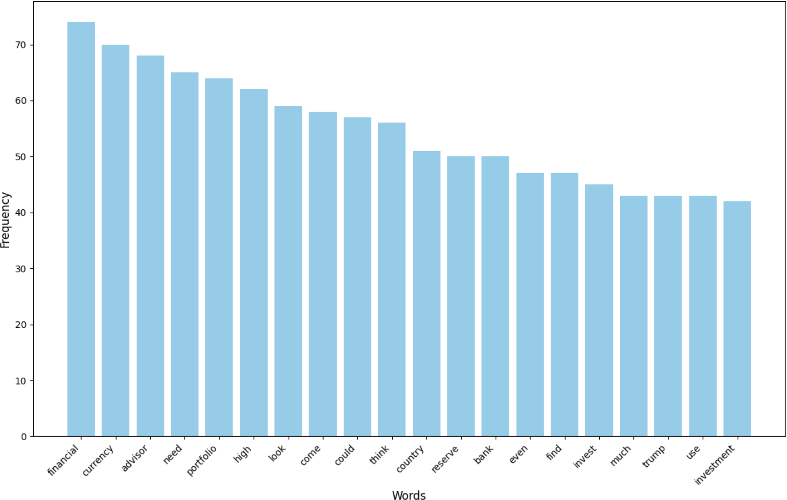

Figure 3: Top 20 Most Frequent Words

Here, we can see that words like “country,” “reserve,” and “bank” indicate ongoing discus- sions about central banking policies and their broader economic impact. The presence of “even,” “find,” and “much” suggests users are debating the extent of the Fed’s influence, while “Trump” signals political connections to the discussion.

### Bigram Analysis

By analyzing bigrams, we aimed to uncover how commenters frame their thoughts on the rate cuts, whether their tone leans positive or negative, and what specific issues they emphasize.

With the following prompt, we managed to exctract bigrams from the text:

1

def extract_bigrams ( text):

tokens = text. split ()

return list( ngrams( tokens , 2))

df[’ bigrams ’] = df[’ cleaned_text ’]. apply( extract_bigrams )

2

3

4

5

all_bigrams = [ bigram for bigrams_list in df[’ bigrams ’] for bigram in

bigrams_list ]

bigram_counts = Counter( all_bigrams) print(’ Top 10 most common bigrams:’)

for bigram , count in bigram_counts . most_common (10): print( f’{ bigram }: { count}’)

6

7

8

9

This bigram analysis gives us a clearer picture of how people are talking about the Fed rate cut. Not surprisingly, phrases like “federal reserve,” “stock market,” and “central bank” dominate, reinforcing that the discussion is centered on monetary policy and its impact on financial markets.

What’s interesting is the presence of “financial advisor” and “financial market,” which suggest that many people are thinking about how to navigate these changes, possibly looking for guidance or adjusting their investment strategies. Meanwhile, “middle class” and “global economy” hint at broader concerns about how these decisions affect everyday people and the economy as a whole.

Some less expected phrases, like “find necessary” and “set appointment,” might indicate that people are actively researching, planning, or even seeking expert advice in response to the rate cut. Overall, this analysis helps us move beyond individual words and see the bigger picture of what’s driving the conversation. (Figure 4).

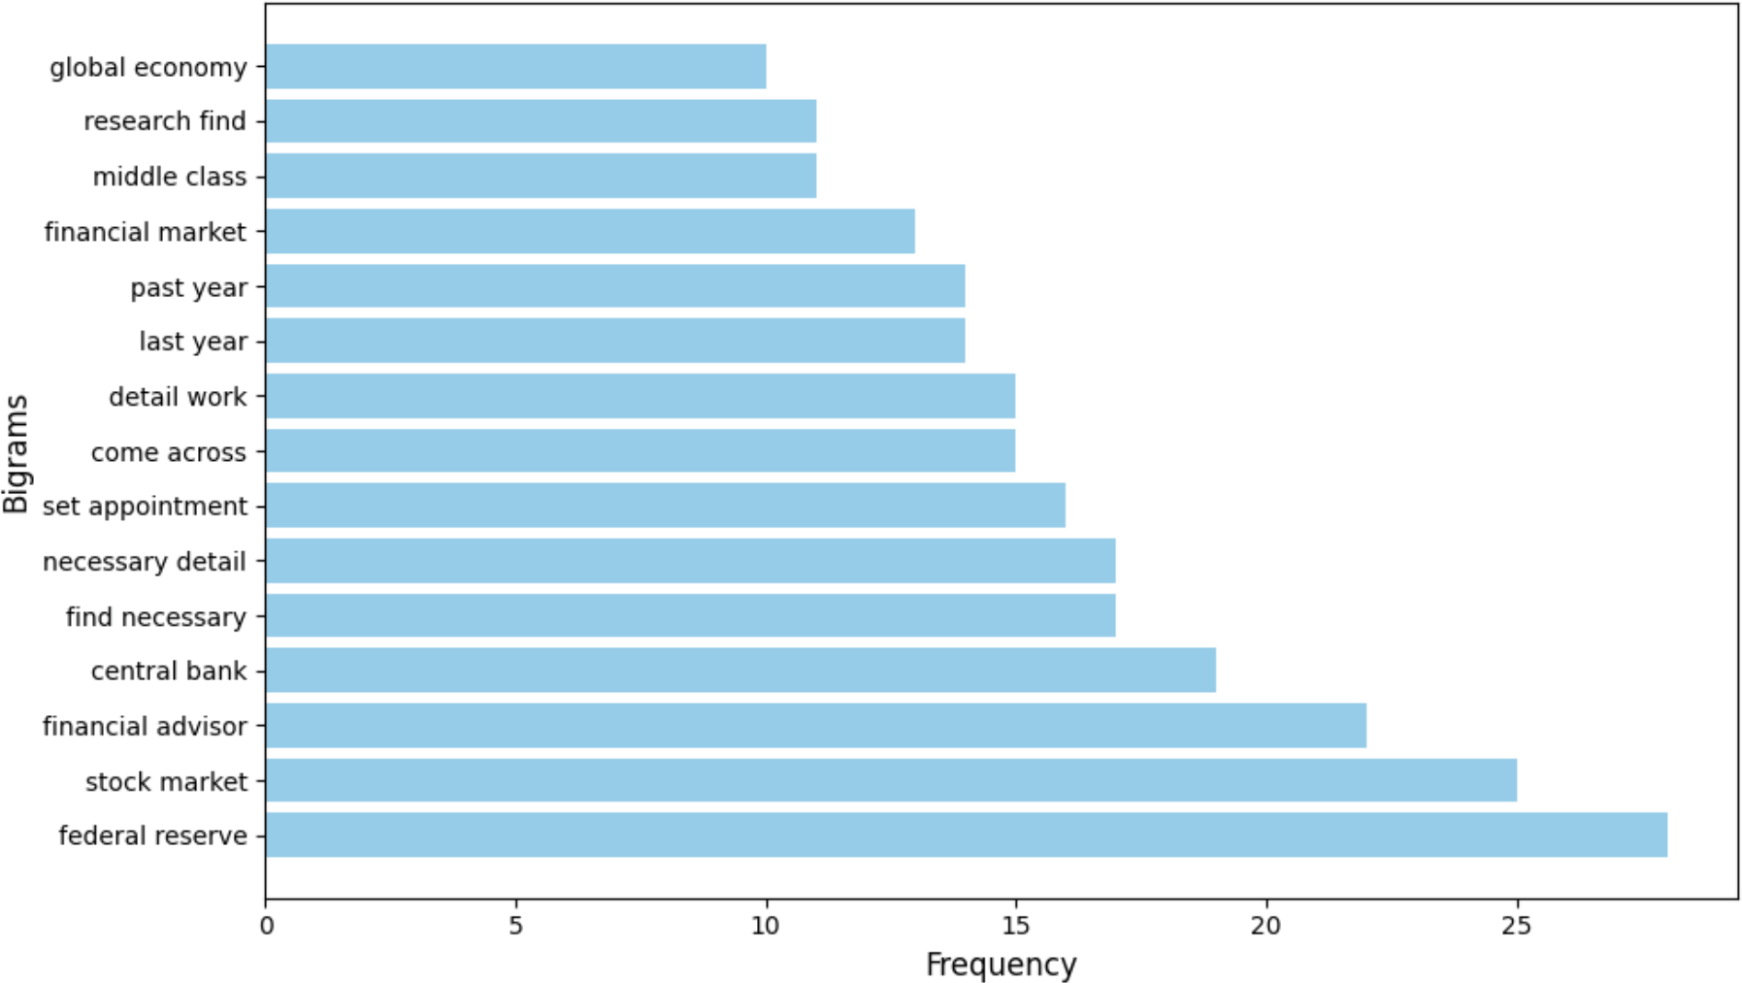

Figure 4: Top 15 Bigrams

To get a better understanding of how people were actually reacting and what else they were discussing, we decided to remove the bigrams with the highest frequencies and focus on the less expected ones. So, we decided to apply the same mechanism as with the Word Frequency: integrating a frequency limit, as shown in figure 5.

1

freq_limit = 25

filtered_bigram_counts = Counter ({ bigram : count for bigram , count in bigram_counts . items () if count <= freq_limit })

top_bigrams = filtered_bigram_counts . most_common (15) bigrams , counts = zip (* top_bigrams)

bigrams_str = [’ ’. join ( bigram ) for bigram in bigrams]

2

3

4

5

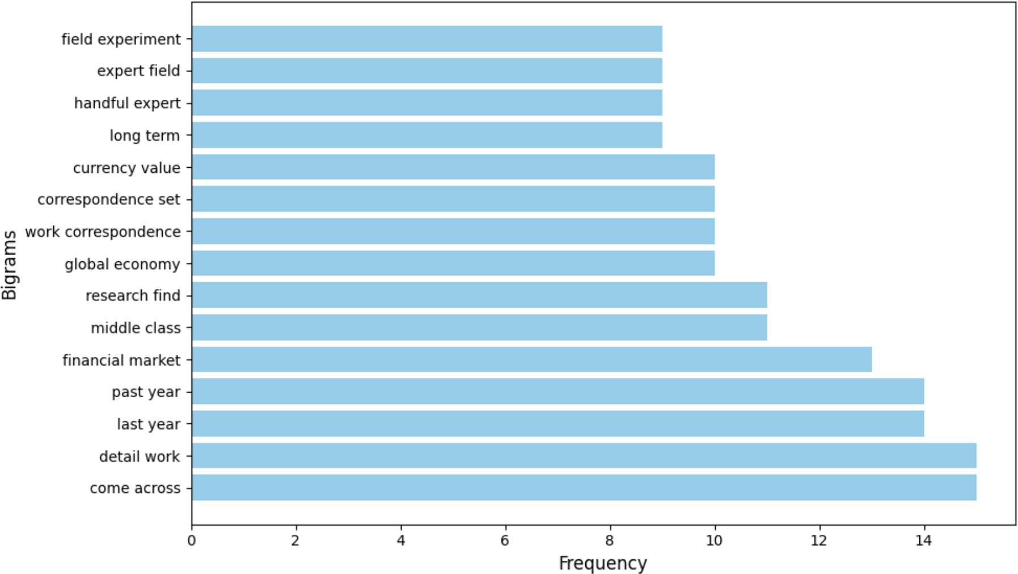

Figure 5: Top 15 Bigrams (Frequency *≤* 15)

### Trigram Analysis

For this project, trigram analysis was explored to see if it could provide deeper insights into the discussion around the Fed rate cut. While bigrams highlighted key themes, trigrams may help capture more specific phrases and patterns offering a clearer understanding of common narratives and financial concerns. (Figure 6).

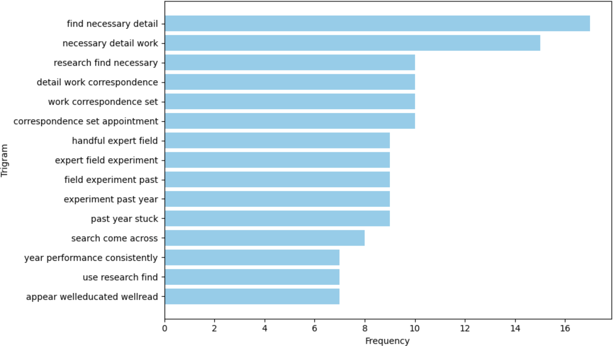

Figure 6: Top 15 Trigrams

## Topic Modeling

### Best number of topics

We first tokenize the text in each row of the cleaned_text column and hence obtain a list of tokenized documents. Tokens are then transformed into a dictionary object, which maps each distinct word to a unique id, along with a corpus recording the occurrence of each token ID in each document, via Gensim’s ‘Dictionary’ and ‘doc2bow’ methods. We then iteratively go through a specified list of numbers of topics (2, 3, 4, 5) to create a range of Latent Dirichlet Allocation (LDA) models, each modeling a different number of topics. For each of the models, we try out a coherence score, a measure of coherence of topics, using the CoherenceModel model. By looking at coherence values for various topic counts, we determine the number of topics with the highest coherence. This approach gives us a systematic method of selecting the most appropriate LDA model for the data.

1

for num_topics in topic_range :

lda_model= Lda Model( corpus=corpus , id 2word = dictionary , num_topics= num_topics , random_state =42)

coherence_model_lda = Coherence Model ( model= lda_model , texts=texts , dictionary = dictionary , coherence =’ c_v ’)

coherence_score = coherence_model_lda . get_coherence () print( f" Topics: { num_topics}, Coherence Score : { coherence_score }")

if coherence_score > best_score : best_score = coherence_score best_num_topics = num_topics

print( f" Best number of topics: { best_num_topics }")

2

3

4

5

6

7

8

9

10

11

### Topic division

Using the previously determined optimal number of topics, the LDA model was used on the BoW representation to generate a set of latent topics. A function was implemented to extract and show the top 10 words per topic so that there can be a deeper understanding of the primary subjects determined by the model. The function iterates over all the topics in the components of the model and pulls out the most relevant words from their weighted contribution to the topic.

Having extracted topics, we converted the BoW matrix to find the distribution of topics for each document. Using the topic with the largest probability for each document, we labeled each entry in the dataset with a dominant topic. This yields an organized overview of how various comments map to specific themes, thereby enhancing subsequent activities such as clustering or classification by topic.

At the end, we displayed a word cloud for each topic, to give a clear and concise visual composition of each group. (Figure 7).

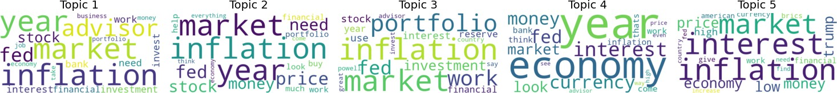

Figure 7: Topic wordclouds

Consistent with our expectations, given the very specific nature of our research question, the identified topics do not differ significantly from one another. In fact, each topic includes

recurring terms such as “inflation,” “market,” and “interest,” which are closely tied to the core theme of the Federal Reserve’s interest rate cuts. However, it is significant to note the emergence of two main sub-themes.

The first sub-theme revolves around personal finance, with words like “stock,” “need,” “invest,” and “advisor,” indicating that many comments focus on individual financial planning and strategies in response to the rate cuts. This suggests a strong interest among users in understanding how these monetary policy decisions affect their personal investments and portfolios. The second sub-theme highlights a broader, national-level perspective, featuring terms such as “Trump,” “economy,” and “bank.” These words reveal a discussion centered on the political and economic context of the Federal Reserve’s actions, with users debating their implications on national policies and the overall economic outlook.

This division between personal financial concerns and national economic discourse provides a richer understanding of the public’s reaction. It underscores how the same event can be perceived from multiple angles, blending individual financial strategies with broader political and economic reflections. Such a distinction is essential for tailoring communica- tion strategies or policy explanations to address the varying concerns of different audience segments.

## Sentiment Analysis

For sentiment analysis, we employed the VADER (Valence Aware Dictionary and sEn- timent Reasoner) sentiment analyzer, which is suited to social media and informal text analysis since it is rule-based and includes a pre-trained lexicon.

We created an instance of the SentimentIntensityAnalyzer and applied it to each entry in the cleaned_text column, extracting the compound score that represents the overall sentiment on a *−*1 (very negative) to +1 (very positive) scale.

Based on the compound score, every comment was placed in one of three categories: “positive” (compound score *>* 0*.*05), “negative” (compound score *< −*0*.*05), or “neutral” (compound score between *−*0*.*05 and 0*.*05). The sentiment label was then tagged in a new column named sentiment_label.

To get a sense of the sentiment distribution in our dataset, we counted the occurrences of each sentiment label and plotted the findings in a bar chart. The graphical illustration, shown in figure 8, provides the relative number of positive, negative, and neutral comments, thereby giving us insightful information on the overall emotional tone in the dataset.

The sentiment distribution indicates an overwhelming number of positive comments, in- dicating that the majority of users perceive the Federal Reserve rate cuts in a positive light, probably because of anticipated personal financial gains. This remark is consistent with the sub-theme that was identified using topic modeling, in which terms like “stock,” “invest,” and “advisor” were frequently used, indicating a concern with personal financial planning. The large percentage of neutral comments suggests a high degree of fact-based input or less emotive discussions, which means that the majority of users tackle the topic from an analytical perspective without having strong opinions.

The lesser but notable percentage of negative comments might appears to result from two general viewpoints. There might be discontent among some users, citing an anticipation of an earlier implementation of a rate cut and considering the move by the Federal Reserve as tardy. Some others may consider the decision to cut rates as premature, possibly indicating concern about its long-term impact on the economy. This division of opinion in the negative sentiment sphere indicates the multifaceted nature of public reactions,

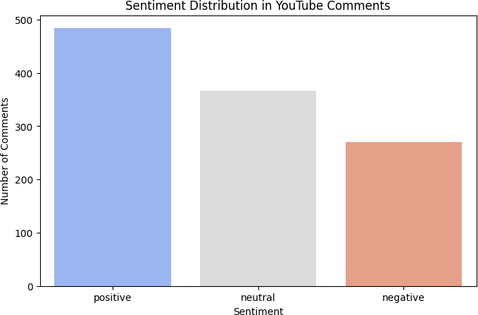

Figure 8: Sentiment analysis results barplot

with people arguing about both the timing of the intervention and its overall impact on economic conditions.

This sentiment analysis is consistent with a balanced public response; while some point to the short-term profit-making prospects, others are more negative about the timing and consequences of Federal Reserve action.

# Results

The analysis revealed detailed insights into how the public perceives the Federal Reserve’s 2024 rate cuts, based on YouTube comments extracted from videos related to the policy change. By employing various NLP techniques – word frequency analysis, collocation analysis, topic modeling, and sentiment analysis – we were able to identify key themes, recurring patterns, and the overall emotional tone of the conversation.

The word frequency analysis highlighted a clear emphasis on macroeconomic concerns. Terms such as “inflation,” “market,” “interest,” and financial were among the most fre- quently used, suggesting that the public’s attention is strongly focused on the economic ramifications of the rate cuts. These results were reinforced by collocation analysis, where common bigrams such as “federal reserve,” “stock market,” and “financial advisor” in- dicated that much of the discourse revolves around financial markets, monetary policy, and personal financial planning. Broader societal and global economic concerns were also present in bigrams like middle class and global economy, suggesting a mix of personal and national-level reflections.

In an effort to capture deeper insights, we applied topic modeling. This process revealed two main sub-themes in the dataset. The first sub-theme focuses on personal finance, where words such as “stock,” “invest,” and “advisor” indicate that many comments re- late to individual financial strategies in response to the policy change. Users appear to be analyzing how the rate cuts might impact their investments, portfolios, and broader

financial plans. The second sub-theme reflects a more national-level perspective, with frequent terms such as “Trump,” “economy,” and “bank” pointing to discussions on the political and economic context of the Federal Reserve’s actions. These comments often involve debates about the policy’s long-term implications on national economic stability and political agendas.

Sentiment analysis provided further clarity on how users emotionally responded to the Federal Reserve’s decision. Using VADER, we classified comments into three categories: positive, neutral, and negative. The majority of comments fell into the positive category, which suggests that many users viewed the rate cuts favorably, likely anticipating personal financial benefits. Neutral comments were also prevalent, reflecting fact-based discussions or a more analytical approach to the policy change. Negative comments, though less frequent, might offer two contrasting perspectives: some users might have expressed frus- tration at the timing of the cuts, criticizing them as either delayed or premature, while others could have voiced concerns about the potential long-term economic consequences. This divergence of opinion may highlight the multifaceted nature of the public reaction. Overall, the results illustrate a complex and layered response to the FED’s rate cuts. While many individuals see the decision as a financial opportunity and are eager to adjust their personal investment strategies, others remain cautious, concerned about the broader impact on the national economy. This blend of optimism, careful analysis, and skepticism reflects the diverse nature of public sentiment, offering valuable insights into how large- scale financial policy decisions resonate with the public.

# What happened in 2022?

In 2022, the Federal Reserve aggressively raised interest rates in response to surging in- flation, marking one of the fastest rate hike cycles in decades. Starting in March, the Fed increased the benchmark rate from near zero, implementing multiple hikes throughout the year. By December, rates had climbed to a target range of 4.25%–4.50%, significantly tightening financial conditions. This policy shift aimed to curb inflationary pressures but also heightened recession concerns and market volatility.

Our intention was to analyze how people reacted to these rate hikes and compare their responses to the 2024 rate cuts, assessing shifts in consumer sentiment, market behavior, and economic expectations.

## Wordcloud

First, to get a general overview of our dataset, we wanted to plot a word cloud to un- derstand the most frequently occurring words and key themes in the text. This visual representation helps us quickly identify dominant topics, common sentiments, and poten- tial patterns in language use. By highlighting the most prominent terms, a word cloud provides an intuitive snapshot of the dataset, guiding us toward deeper analysis and help- ing us spot trends that might not be immediately obvious through raw text review.

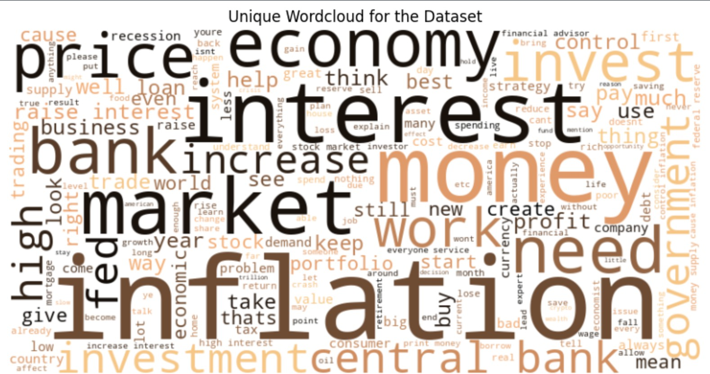

Figure 9: Unique Wordcloud for the Dataset

## Word Frequency

The word cloud highlights key themes like inflation, interest, market, bank, and economy, reflecting concerns about financial markets, investment strategies, and borrowing costs. Words related to employment, debt, and policy suggest broader economic anxiety. Inter- estingly, the 2024 word cloud showed similar terms, indicating that discussions around interest rate changes remained focused on the same core issues despite shifting from hikes to cuts.

## Sentiment Analysis

We conducted sentiment analysis to understand how people emotionally reacted to inter- est rate changes and to identify shifts in public perception over time. By categorizing comments as positive, neutral, or negative, we can gauge overall sentiment trends and detect whether discussions leaned toward optimism, concern, or indifference. This analy- sis is especially useful for tracking how economic decisions impact consumer and investor confidence, providing deeper insights than simple word frequency alone. By comparing sentiment from 2022 rate hikes to 2024 rate cuts, we can assess whether reactions became more positive, negative, or remained stable, helping us understand broader economic sen- timent shifts.

The sentiment distribution shows that the majority of comments were positive outnumber- ing both neutral and negative sentiments. This suggests that discussions around the topic were not overwhelmingly pessimistic, despite potential economic concerns. The neutral and negative sentiments, while present, are considerably lower, indicating that while some users expressed skepticism or concern the overall reaction leaned more toward optimism or constructive discussion. Comparing this with 2024 sentiment data will help determine whether public perception shifted following the rate cuts.

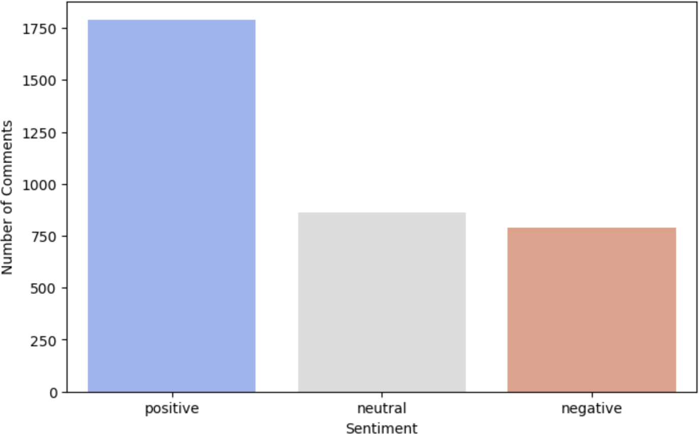

Figure 10: Unique Wordcloud for the Dataset

# Individual Contributions

**Ben Belhassen Mohamed Ali**

My contribution to the project involved the development of the preprocessing of the dataset to clean and structure the text data for analysis, working on the bigrams and trigrams analysis and writing some sections of the report and powerpoint.

**Ciampana Lorenzo**

My contribution involved looking for a way to scrape the data and arraning a DataFrame to work with, defining the optimal number of topics based on coherence score in the Topic Modeling part, and implementing Sentiment Analysis. I have also arranged the presentation.

**Filesi Gianluca**

My contribution to the project involved ensuring the harmonization of the code across its various parts to maintain consistency and readability, bug fixing and improvements. I also carried out a general review of the project, identifying areas for further development and ensuring the overall coherence of the work. Additionally, I wrote some sections of the project report.

**Tibi Gad**

My contribution to the projecy involved working on the Data pre-processing code, TD- IDF vectorization and BoW vectorization and Topic modeling. I also worked on the presentation.

**Generative AI usage**

Generative AI has been used extensively for this project. However, besides the web- scraping function that has been entirely written by AI, in all the other parts of this project, we have used AI as a support to refine code and sentences, to explore new possibilities and to reason about our results. In all the processes, AI has been monitored and adjusted by our intervention, using it as a tool for our purposes.