Table of Contents
Table of Contents 2
1. Rationale 2
1.1 Problem Description 2
1.2 Background 2
1.3 Community Impact 2
1.4 Proposed Solution 2
1.5 Computational Thinking Process 2
1.6 Algorithm Design 2
1.7 SDG Alignment 2
1.8 Open Source Justification 2
1.9 Digital Public Goods Justification 2
2. Algorithm 2
2.1 Data Dictionary 2
3. Pseudocode 2
4. Flowcharts 2
4.1 Flowchart Index 2
5. Functional Modules 2
6. Expected Outputs 2
Scenario 1: High priority report, crew available 2
Scenario 2: Low priority report 2
Scenario 3: High priority report, all crews full 2
Scenario 4: Invalid input 2
Scenario 5: Resolving a job releases a crew for the queue 2
Scenario 6: Statistics (after Scenarios 1 to 5) 2
7. GitHub Evidence 2
8. References 2

1. Rationale

1.1 Problem Description
Waste in Freetown and other urban centres of Sierra Leone is not collected, tracked or prioritised in a coordinated way. Residents dump refuse in drains, gutters and open spaces because collection is irregular, and the authorities have no simple shared record of where waste is piling up. The people affected include residents of dense and informal settlements such as Kroo Bay, market traders, school children, and the council staff and collection crews who work without up-to-date information.
The problem exists for four main reasons: (1) collection capacity has not kept pace with rapid urban growth; (2) hilly terrain and settlements without roads are hard for crews to reach; (3) residents have limited ways to report a dump site, and no shared record exists; and (4) crews are often sent by habit rather than by urgency or distance. CleanSalone addresses this by letting residents report a dump site, ranking every report with clear rules, and assigning the nearest free crew to the most urgent site first.

1.2 Background
Freetown City Council describes sanitation, including solid waste management, as probably the city's biggest challenge, and notes that waste thrown into drains and watercourses causes flooding and standing water, which help spread malaria and cholera (Freetown City Council, n.d.). Concern Worldwide (n.d.) reports that Freetown has two authorised disposal sites, Kingtom and Granville Brook, no formal waste-sorting facilities, and links weak drainage and poor waste management to flood disasters, including the 2017 flash floods.
In 2024 the council identified 72 flooding flashpoints and employed youth groups to clear silt and garbage from drains (Sierra Leone Telegraph, 2024). In 2025 the Mayor acknowledged that waste from hard-to-reach communities ends up in illegal dumps or waterways, and that clean-up campaigns are only a temporary fix (Awoko Newspaper, 2025). The problem is therefore recognised; what is missing is a lightweight tool that connects residents' reports to crews' decisions.

1.3 Community Impact
Problem and impact: CleanSalone tackles uncollected waste that blocks drains, causes flooding and spreads disease. It is expected to give faster response to the most dangerous sites (near drains, markets and schools, or holding hazardous waste), fewer blocked drains before the rainy season, a visible record of every report, and fairer use of limited crews.
Beneficiaries and sustainability: residents of flood-prone and informal communities, traders, schools, council sanitation officers, crews and volunteer youth groups. The design uses simple rules that officers can read and adjust, needs only low-cost technology, and can be maintained by local developers and students because it is open source. Its statistics help the council plan budgets and crew numbers.

1.4 Proposed Solution
CleanSalone is a logical system design with six modules: Main Program, Report Intake, Priority Checker, Crew Assignment, Status Update and Statistics Report. A resident or volunteer reports a dump site (location, waste type, size, nearness to a drain or market, days unresolved). The system validates the input, decides HIGH, MEDIUM or LOW priority, and assigns the nearest crew that holds fewer than three jobs. If every crew is full the report is QUEUED and is assigned automatically, highest priority first, when a crew finishes a job. As the brief requires, this report presents the design only; no source code is written.

1.5 Computational Thinking Process
Concept | How it is applied in CleanSalone
Decomposition | The large problem of "managing community waste" is broken into six smaller modules: main menu, report intake, priority checking, crew assignment, status updating and statistics. Each can be designed and tested on its own.
Pattern recognition | Every report has the same fields and goes through the same steps. Input validation repeats the same "ask, check, re-ask" loop for waste type, site size, Yes/No answers and days. Crew selection repeats the same check for every crew.
Abstraction | Details that do not affect the decision are ignored (road maps, truck models, exact weight of waste). Only essential data is kept: location, waste type, site size, nearness to a drain or market, days unresolved, crew distance and crew load.
Algorithm design | The steps are written as clear rules: a priority rule using Boolean logic, a nearest-free-crew search using a loop, and a queue rule that serves HIGH reports before MEDIUM and LOW.

1.6 Algorithm Design
The algorithm follows an input, processing and output structure, summarised below. The full step-by-step algorithm, pseudocode and flowcharts follow in Sections 2 to 4.
Stage | Items | Description
Input | location, wasteType, siteSize, nearDrain, nearMarket, daysUnresolved, reportID, menu choice | Collected from the user and validated before use.
Processing | validation, priority rule, crew search, queue handling, counters | Decision structures choose the priority and status. Repetition structures validate input and search the crews.
Output | confirmation, priority, assigned crew, status, statistics | Messages and summary figures shown to the user and the council.

Logic structures used. Decision structures (IF, ELSE IF, ELSE) set priority and status. Boolean logic combines conditions with AND, OR and comparison operators. Repetition structures (WHILE, REPEAT UNTIL, FOR, FOR EACH) run the menu, validate input and scan crews and reports. Functions and modules keep each task separate and reusable.

1.7 SDG Alignment
SDG 11 (primary), Sustainable Cities and Communities: target 11.6 aims to reduce the adverse environmental impact of cities, including municipal waste management; CleanSalone makes sure the most harmful sites are collected first. SDG 12, Responsible Consumption and Production: target 12.5 aims to reduce waste generation; waste-type records show what is most common, supporting reduction and recycling. SDG 3, Good Health and Well-being: cleaner drains and streets reduce standing water and diseases such as malaria and cholera, and the HIGH rule for hazardous waste protects residents and crews (United Nations, n.d.).

1.8 Open Source Justification
Why open source: public waste services are community-funded, so the logic that decides who is served first should be visible and checkable. It also avoids licence fees and vendor lock-in. Benefits for Sierra Leone: no licence cost for councils and schools, a learning resource for local students and developers, easy adaptation for Bo, Kenema, Makeni and other towns, and a local community that can keep it alive. Community contributions: Krio and other local-language translation, new waste types, SMS and USSD reporting, map integration, better priority rules from sanitation officers, bug reports and documentation, through GitHub issues and pull requests under an OSI-approved licence such as Apache 2.0 (Open Source Initiative, n.d.).

1.9 Digital Public Goods Justification
CleanSalone could become a Digital Public Good by meeting the DPG Standard (Digital Public Goods Alliance, n.d.): SDG relevance, an approved open licence, clear ownership, platform independence, documentation, data extraction, privacy and legal compliance, adherence to best practices, and do-no-harm by design. Reporters would not need to give personal details. It promotes accessibility through low-data and SMS channels and local languages, openness through public rules and data formats other councils can reuse, and public benefit because its purpose is better shared sanitation and public health, not profit.

2. Algorithm
The step-by-step algorithm below describes the whole CleanSalone system in plain language.
- Start the system and call InitialiseSystem to set all counters and crew loads to 0.
- Set running to TRUE.
- While running is TRUE, display the menu (1 Report, 2 Update, 3 Statistics, 4 Exit) and read the choice.
- If the choice is 1, perform steps 5 to 14 (Submit Report).
- Add 1 to totalReports and create a new reportID.
- Read the location of the dump site.
- Repeat until the waste type is Household, Plastic, Market or Hazardous; show an error each time it is not.
- Repeat until the site size is Small, Medium or Large; show an error each time it is not.
- Ask whether the site is near a drain and near a market or school, and store each answer as TRUE or FALSE.
- Repeat until daysUnresolved is 0 or more.
- Determine priority: if the waste is Hazardous, or the site is near a drain or market, or days are 3 or more, the priority is HIGH. Otherwise, if the size is Large or days are 2 or more, it is MEDIUM. Otherwise it is LOW.
- Search the crews: for each crew with fewer than 3 jobs, calculate its distance to the site and remember the nearest one.
- If a crew was found, add 1 to its load and set the status to ASSIGNED. If not, set the status to QUEUED.
- Save the report, update the priority counter and display the confirmation.
- If the choice is 2, read a reportID. If it is not found, or is already RESOLVED, show a message and return to the menu.
- Otherwise mark the report RESOLVED, add 1 to totalResolved and reduce the assigned crew's load by 1.
- Assign queued reports to free crews, HIGH first, then MEDIUM, then LOW.
- If the choice is 3, count the queued reports, calculate the resolution rate (resolved divided by total, times 100) and display all statistics.
- If the choice is 4, set running to FALSE. For any other choice, display "Invalid choice".
- Return to step 3. When running is FALSE, display a goodbye message and stop.

2.1 Data Dictionary
Constants, variables and data types. Constants hold fixed rules so they can be changed in one place. Variables hold data that changes while the system runs.
Name | Type | Purpose
HIGH_PRIORITY_DAYS = 3 | Constant, Integer | Days unresolved after which a report becomes HIGH priority
MEDIUM_PRIORITY_DAYS = 2 | Constant, Integer | Days unresolved after which a report becomes at least MEDIUM
MAX_CREW_LOAD = 3 | Constant, Integer | Maximum jobs a crew can hold at one time
MAX_CREWS = 5 | Constant, Integer | Number of collection crews
reportID, location, wasteType, siteSize | Variable, String | Identify and describe a reported site
nearDrain, nearMarket, running | Variable, Boolean | TRUE or FALSE conditions used in decisions and loops
daysUnresolved, totalReports, totalResolved | Variable, Integer | Counters and ages
crewLoad[1..5] | Variable, Integer array | Current number of jobs held by each crew
shortest, d | Variable, Real | Distance in kilometres from a crew to a site
priority, status | Variable, String | HIGH/MEDIUM/LOW and QUEUED/ASSIGNED/RESOLVED

3. Pseudocode
Keywords are shown in bold. Indentation shows the structure of each decision and loop.
ALGORITHM CleanSalone
CONSTANT HIGH_PRIORITY_DAYS = 3
CONSTANT MEDIUM_PRIORITY_DAYS = 2
CONSTANT MAX_CREW_LOAD = 3
CONSTANT MAX_CREWS = 5
DECLARE totalReports, totalResolved, highCount, mediumCount, lowCount AS Integer
DECLARE crewLoad[1..MAX_CREWS] AS Integer array
DECLARE reports AS List of Report records
DECLARE running AS Boolean
MODULE 1: MAIN PROGRAM
START
CALL InitialiseSystem()
SET running = TRUE
WHILE running = TRUE DO
DISPLAY "1 Report waste site | 2 Update job status | 3 View statistics | 4 Exit"
INPUT choice
IF choice = 1 THEN
CALL SubmitReport()
ELSE IF choice = 2 THEN
CALL UpdateStatus()
ELSE IF choice = 3 THEN
CALL GenerateStatistics()
ELSE IF choice = 4 THEN
SET running = FALSE
ELSE
DISPLAY "Invalid choice. Enter 1 to 4."
END IF
END WHILE
DISPLAY "Thank you for keeping Salone clean."
END
FUNCTION InitialiseSystem()
SET totalReports = 0
SET totalResolved = 0
SET highCount = 0, mediumCount = 0, lowCount = 0
FOR i = 1 TO MAX_CREWS DO
SET crewLoad[i] = 0
END FOR
END FUNCTION
MODULE 2: REPORT INTAKE
FUNCTION SubmitReport()
SET totalReports = totalReports + 1
SET reportID = "R" + FormatNumber(totalReports)
INPUT location
SET wasteType = GetValidWasteType()
SET siteSize = GetValidSiteSize()
SET nearDrain = GetYesNo("Is the site near a drain or gutter?")
SET nearMarket = GetYesNo("Is the site near a market or school?")
SET daysUnresolved = GetDays()
SET priority = DeterminePriority(wasteType, siteSize, nearDrain, nearMarket, daysUnresolved)
SET crew = AssignCrew(location)
IF crew = 0 THEN
SET status = "QUEUED"
ELSE
SET status = "ASSIGNED"
END IF
SAVE new Report(reportID, location, wasteType, siteSize, priority, crew, status)
IF priority = "HIGH" THEN
SET highCount = highCount + 1
ELSE IF priority = "MEDIUM" THEN
SET mediumCount = mediumCount + 1
ELSE
SET lowCount = lowCount + 1
END IF
DISPLAY reportID, priority, crew, status
END FUNCTION
FUNCTION GetValidWasteType() RETURNS String
REPEAT
INPUT wasteType (Household, Plastic, Market or Hazardous)
SET valid = (wasteType = "Household" OR wasteType = "Plastic" OR wasteType = "Market" OR wasteType = "Hazardous")
IF valid = FALSE THEN
DISPLAY "Invalid waste type. Try again."
END IF
UNTIL valid = TRUE
RETURN wasteType
END FUNCTION
FUNCTION GetValidSiteSize() RETURNS String
REPEAT
INPUT siteSize (Small, Medium or Large)
SET valid = (siteSize = "Small" OR siteSize = "Medium" OR siteSize = "Large")
IF valid = FALSE THEN
DISPLAY "Invalid size. Enter Small, Medium or Large."
END IF
UNTIL valid = TRUE
RETURN siteSize
END FUNCTION
FUNCTION GetYesNo(question) RETURNS Boolean
REPEAT
INPUT answer (Y or N)
UNTIL answer = "Y" OR answer = "N"
RETURN (answer = "Y")
END FUNCTION
FUNCTION GetDays() RETURNS Integer
REPEAT
INPUT days
IF days < 0 THEN
DISPLAY "Days cannot be negative."
END IF
UNTIL days >= 0
RETURN days
END FUNCTION
MODULE 3: PRIORITY CHECKER
FUNCTION DeterminePriority(wasteType, siteSize, nearDrain, nearMarket, days) RETURNS String
IF wasteType = "Hazardous" OR nearDrain = TRUE OR nearMarket = TRUE OR days >= HIGH_PRIORITY_DAYS THEN
RETURN "HIGH"
ELSE IF siteSize = "Large" OR days >= MEDIUM_PRIORITY_DAYS THEN
RETURN "MEDIUM"
ELSE
RETURN "LOW"
END IF
END FUNCTION
MODULE 4: CREW ASSIGNMENT
FUNCTION AssignCrew(location) RETURNS Integer
SET bestCrew = 0
SET shortest = 9999
FOR i = 1 TO MAX_CREWS DO
IF crewLoad[i] < MAX_CREW_LOAD THEN
SET d = CalculateDistance(i, location)
IF d < shortest THEN
SET shortest = d
SET bestCrew = i
END IF
END IF
END FOR
IF bestCrew <> 0 THEN
SET crewLoad[bestCrew] = crewLoad[bestCrew] + 1
END IF
RETURN bestCrew
END FUNCTION
MODULE 5: STATUS UPDATE
FUNCTION UpdateStatus()
INPUT reportID
SET report = FindReport(reportID)
IF report = NOTHING THEN
DISPLAY "Report not found."
ELSE IF report.status = "RESOLVED" THEN
DISPLAY "Report already resolved."
ELSE
SET report.status = "RESOLVED"
SET totalResolved = totalResolved + 1
IF report.crew <> 0 THEN
SET crewLoad[report.crew] = crewLoad[report.crew] - 1
END IF
CALL AssignQueuedReports()
DISPLAY "Report marked as resolved."
END IF
END FUNCTION
FUNCTION AssignQueuedReports()
FOR EACH level IN ["HIGH", "MEDIUM", "LOW"] DO
FOR EACH r IN reports DO
IF r.status = "QUEUED" AND r.priority = level THEN
SET crew = AssignCrew(r.location)
IF crew <> 0 THEN
SET r.crew = crew
SET r.status = "ASSIGNED"
END IF
END IF
END FOR
END FOR
END FUNCTION
MODULE 6: STATISTICS REPORT
FUNCTION GenerateStatistics()
SET queued = 0
FOR EACH r IN reports DO
IF r.status = "QUEUED" THEN
SET queued = queued + 1
END IF
END FOR
IF totalReports > 0 THEN
SET rate = (totalResolved / totalReports) * 100
ELSE
SET rate = 0
END IF
DISPLAY totalReports, highCount, mediumCount, lowCount, queued, totalResolved, rate
END FUNCTION

4. Flowcharts
The flowcharts were drawn with Graphviz using standard symbols. A rounded dark box is a start or end terminator, a rectangle is a process, a diamond is a decision, a parallelogram is input or output, and a double-bordered rectangle is a call to another module or function. Figures 1 to 5 follow.

4.1 Flowchart Index
Figure | Flowchart | Module
Figure 1 | Main program | Module 1: Main Program
Figure 2 | Submit report | Module 2: Report Intake
Figure 3 | Determine priority | Module 3: Priority Checker
Figure 4 | Assign crew | Module 4: Crew Assignment
Figure 5 | Update status | Module 5: Status Update
Figure 1: Main program flowchart (Module 1)
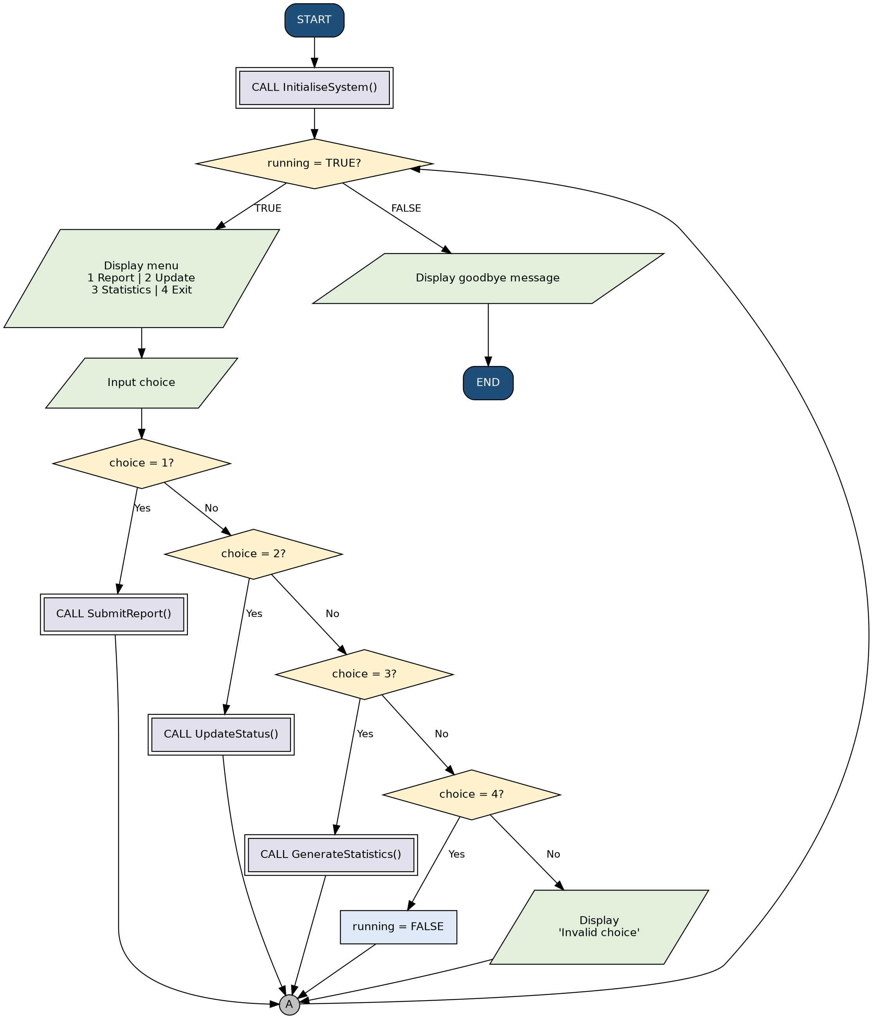
Figure 2: Submit report flowchart (Module 2)
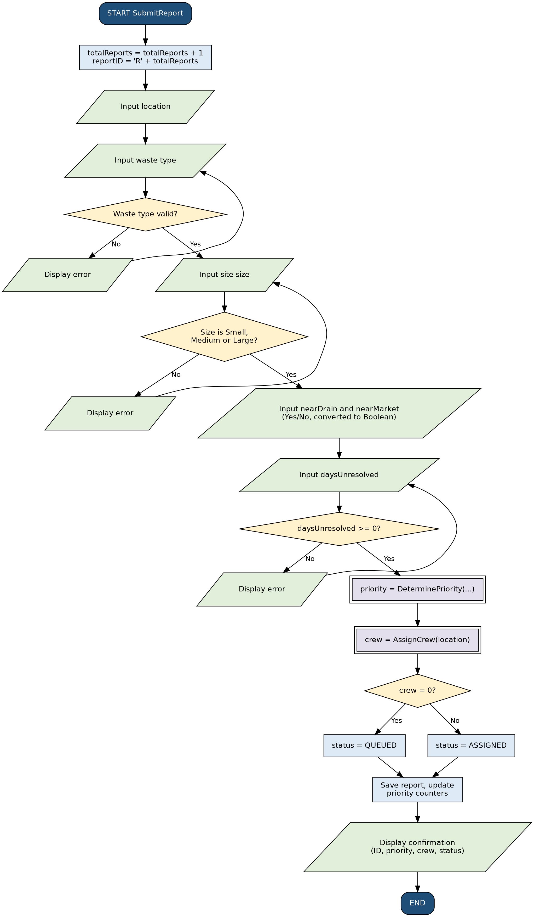
Figure 3: Determine priority flowchart (Module 3)
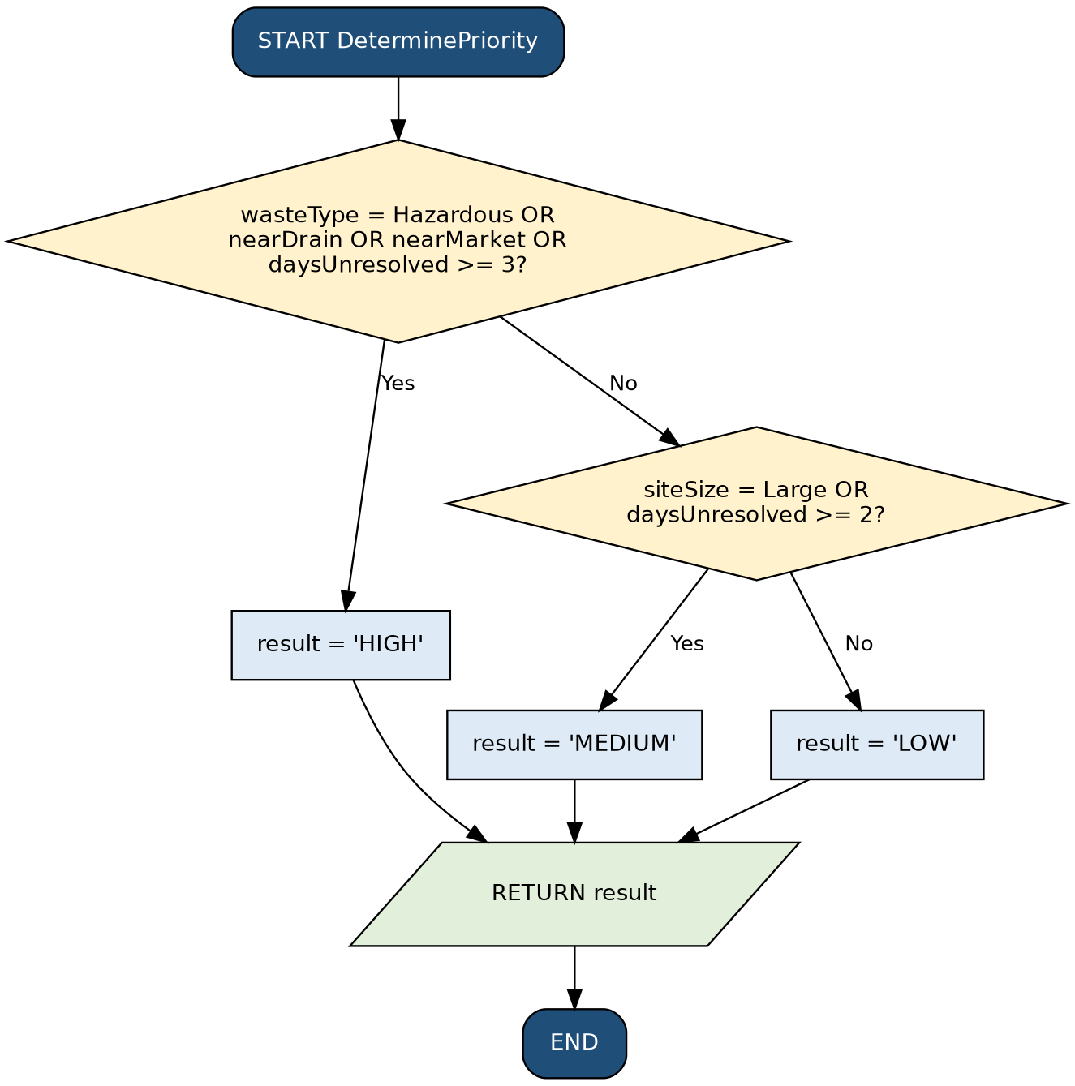
Figure 4: Assign crew flowchart (Module 4)
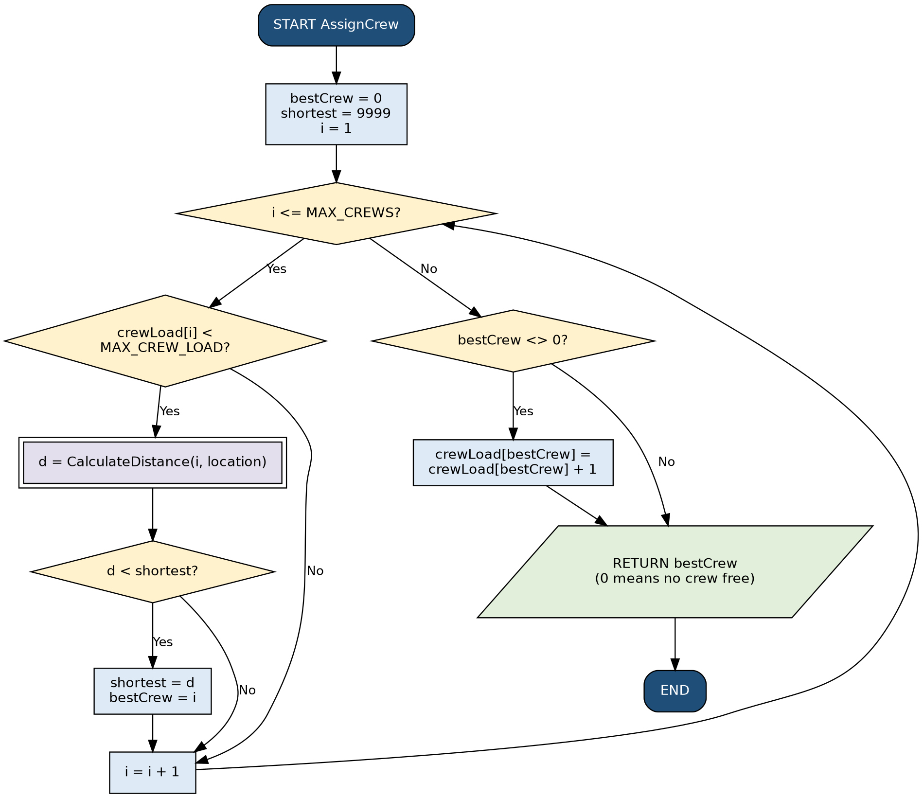
Figure 5: Update status flowchart (Module 5)
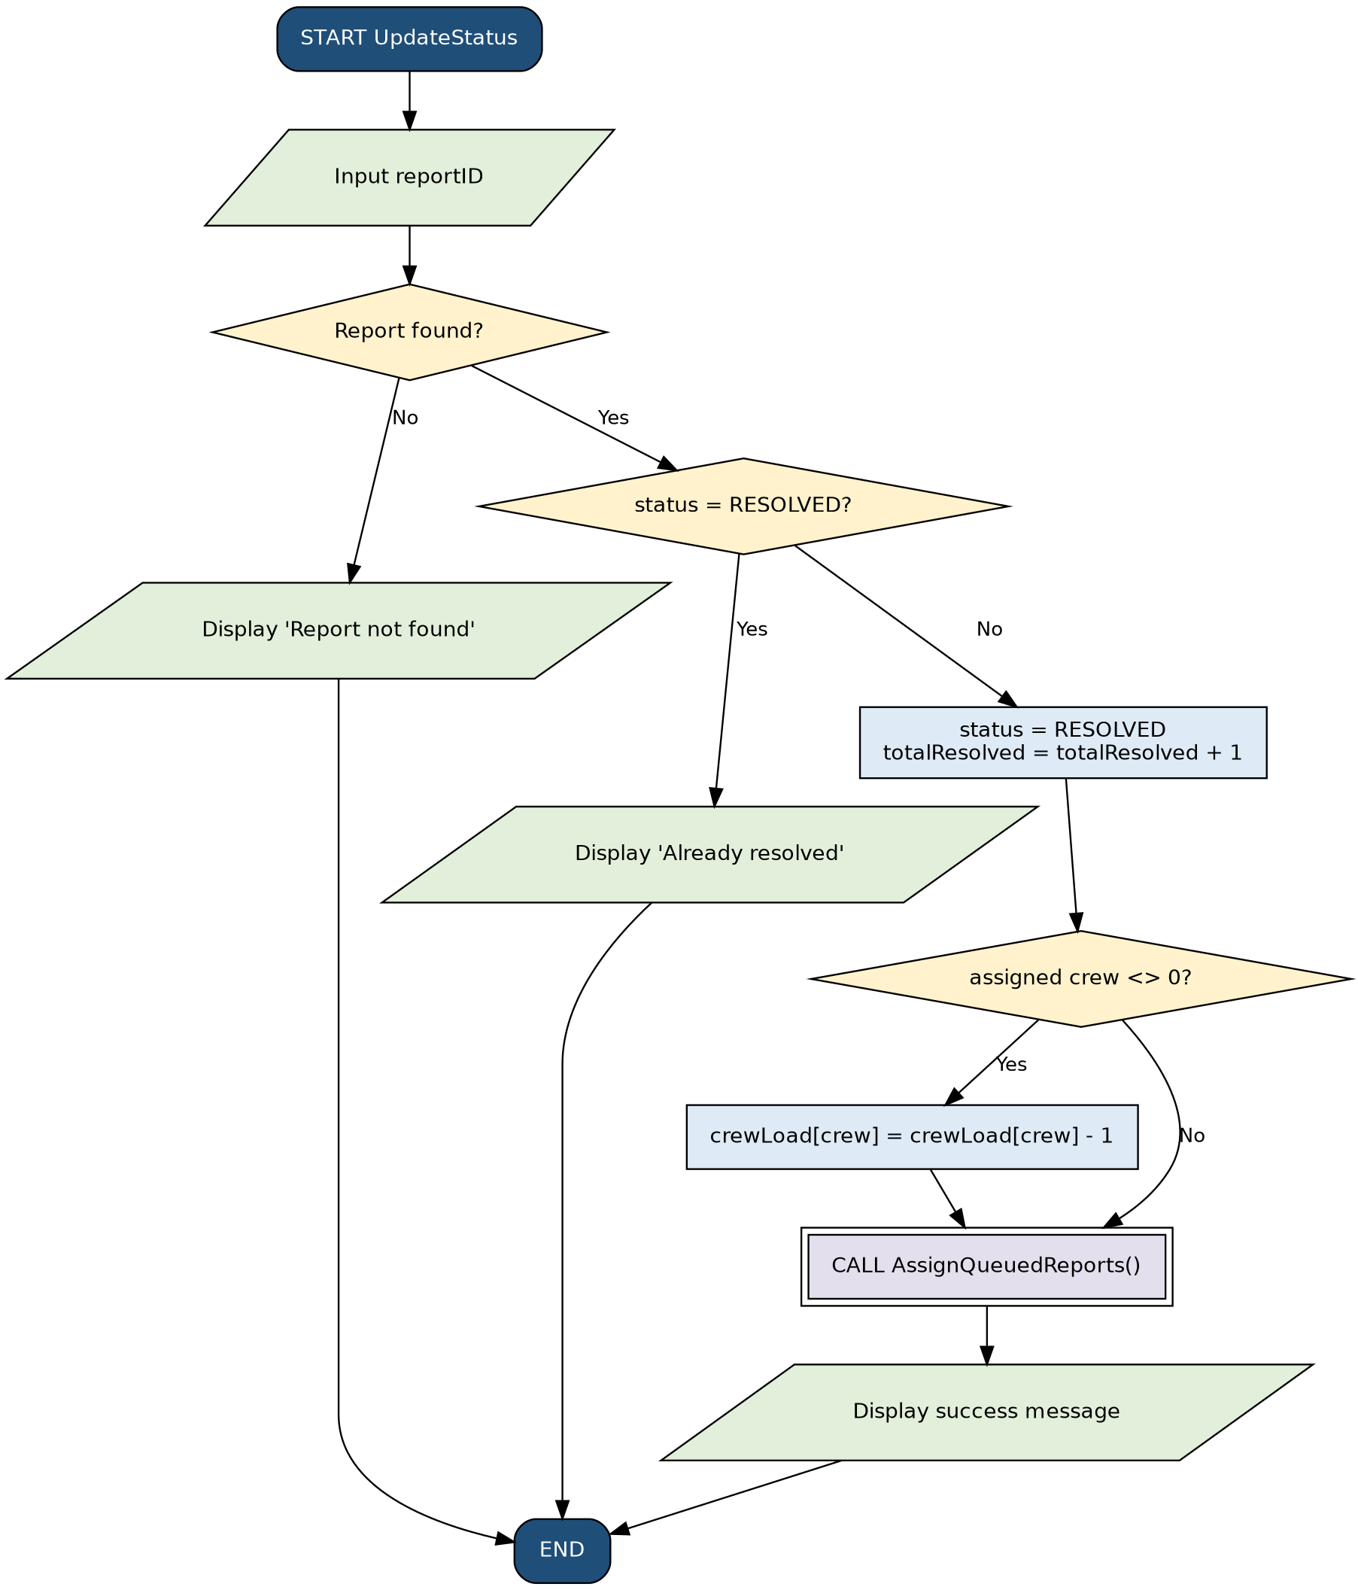

5. Functional Modules
The problem is decomposed into six modules. Each module has one job and communicates with the others through function calls and returned values.
Module | Purpose | Functions | Input and output
1. Main Program | Run the menu loop and call the other modules | InitialiseSystem() | In: menu choice. Out: calls to modules, goodbye message
2. Report Intake | Collect and validate a report and save it | SubmitReport(), GetValidWasteType(), GetValidSiteSize(), GetYesNo(), GetDays() | In: location, waste type, size, nearDrain, nearMarket, days. Out: saved report and confirmation
3. Priority Checker | Decide HIGH, MEDIUM or LOW | DeterminePriority() | In: waste type, size, Booleans, days. Out: priority string
4. Crew Assignment | Find the nearest crew with free capacity | AssignCrew(), CalculateDistance() | In: location, crew loads. Out: crew number or 0
5. Status Update | Mark jobs resolved and serve the queue | UpdateStatus(), AssignQueuedReports() | In: reportID. Out: updated status and crew load
6. Statistics Report | Summarise performance | GenerateStatistics() | In: counters and report list. Out: totals and resolution rate

6. Expected Outputs
The scenarios below demonstrate the expected outputs. Assume five crews and the following distances from each crew base to each site.
Site | Crew 1 | Crew 2 | Crew 3 | Crew 4 | Crew 5
Kissy Market | 5.4 km | 2.1 km | 3.8 km | 6.0 km | 4.5 km
Wellington | 1.2 km | 4.0 km | 5.1 km | 3.3 km | 2.9 km
Aberdeen drain | 3.0 km | 2.6 km | 1.8 km | 4.2 km | 3.5 km

Scenario 1: High priority report, crew available
Input | Expected output
Location: Kissy Market  Waste type: Market  Site size: Large  Near drain: N  Near market: Y  Days unresolved: 1 | Report R001 received.  Priority: HIGH (near a market)  Assigned to Crew 2 (2.1 km, nearest free crew)  Status: ASSIGNED

Scenario 2: Low priority report
Input | Expected output
Location: Wellington  Waste type: Plastic  Site size: Small  Near drain: N  Near market: N  Days unresolved: 0 | Report R002 received.  Priority: LOW  Assigned to Crew 1 (1.2 km)  Status: ASSIGNED

Scenario 3: High priority report, all crews full
Assume all five crews already hold 3 jobs (peak rainy season).
Input | Expected output
Location: Aberdeen drain  Waste type: Household  Site size: Medium  Near drain: Y  Near market: N  Days unresolved: 2 | Report R003 received.  Priority: HIGH (near a drain)  No crew is free.  Status: QUEUED

Scenario 4: Invalid input
Input | Expected output
Site size: Huge | Invalid size. Enter Small, Medium or Large.  (the system asks for the site size again)

Scenario 5: Resolving a job releases a crew for the queue
Input | Expected output
Menu choice: 2  Report ID: R001 | Report marked as resolved.  Crew 2 load reduced by 1.  Queued report R003 (HIGH) assigned to Crew 2.  R003 status: ASSIGNED

Scenario 6: Statistics (after Scenarios 1 to 5)
Input | Expected output
Menu choice: 3 | Total reports: 3  HIGH: 2 | MEDIUM: 0 | LOW: 1  Queued: 0  Resolved: 1  Resolution rate: 33.3%

7. GitHub Evidence
The evidence from the GitHub repository is shown below.
Item | Evidence
GitHub repository | Name: PROG101_Assignment1_MaligiePapahKamara_905006179
Repository URL | https://github.com/maligiekamara94-svg/PROG101_Assignment1_MaligiePapahKamara_905006179
Files uploaded | Report, flowcharts, pseudocode, README.md

Git commit history
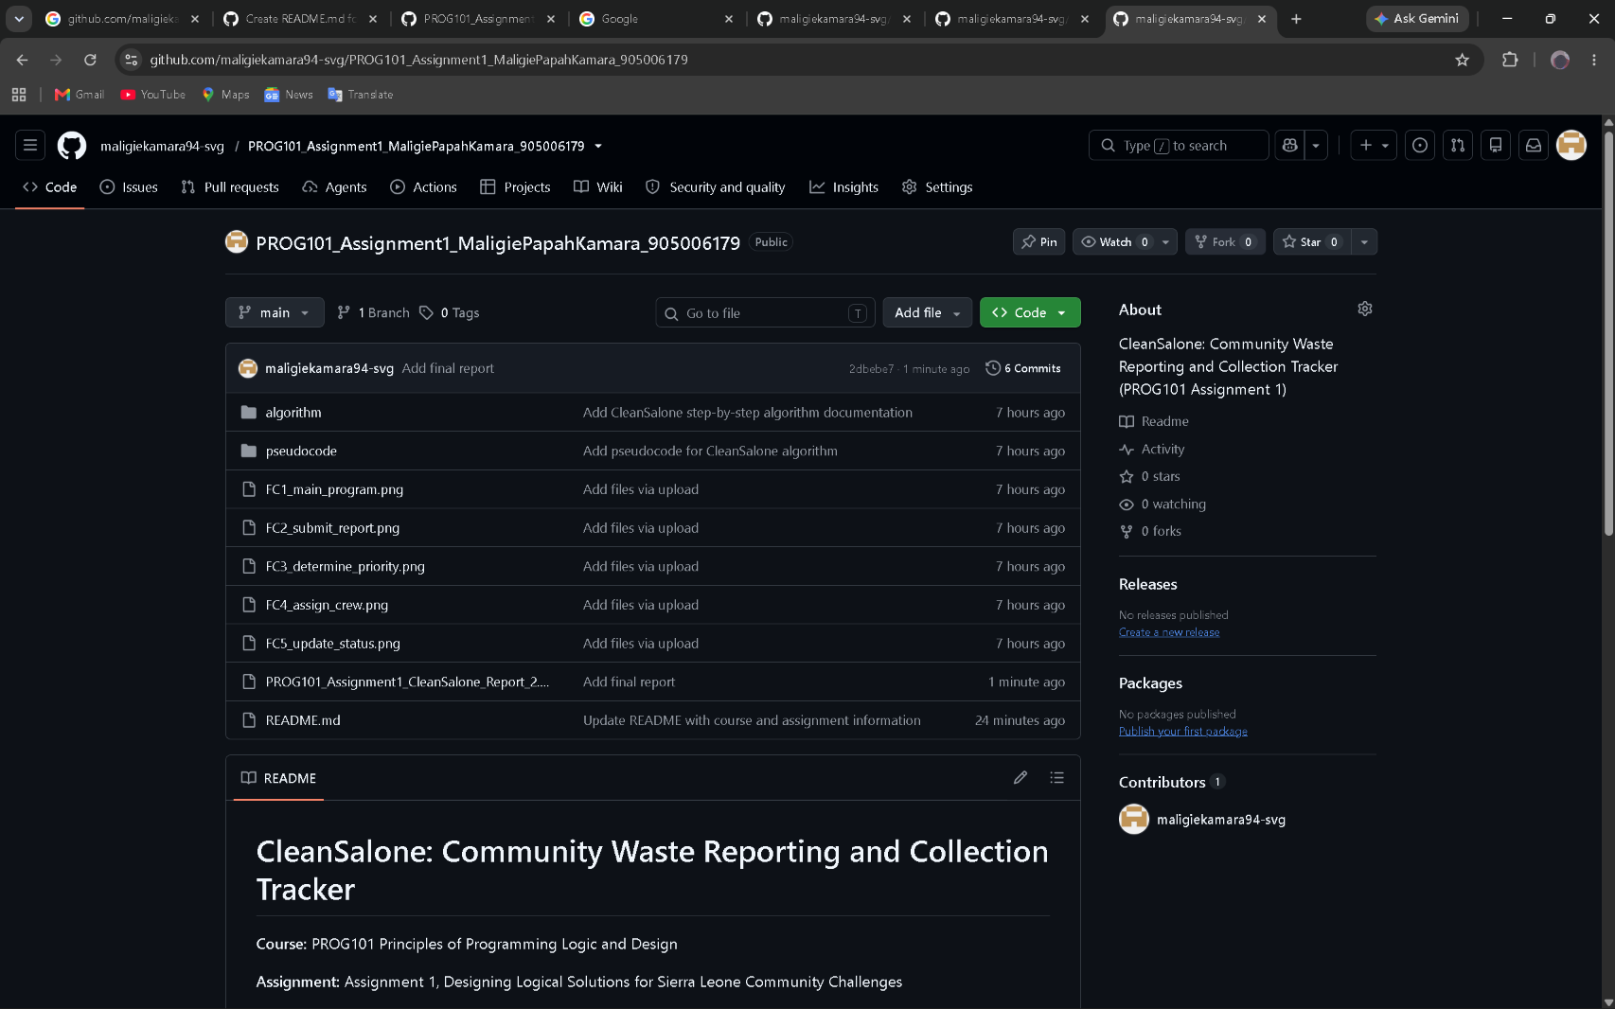

README.md
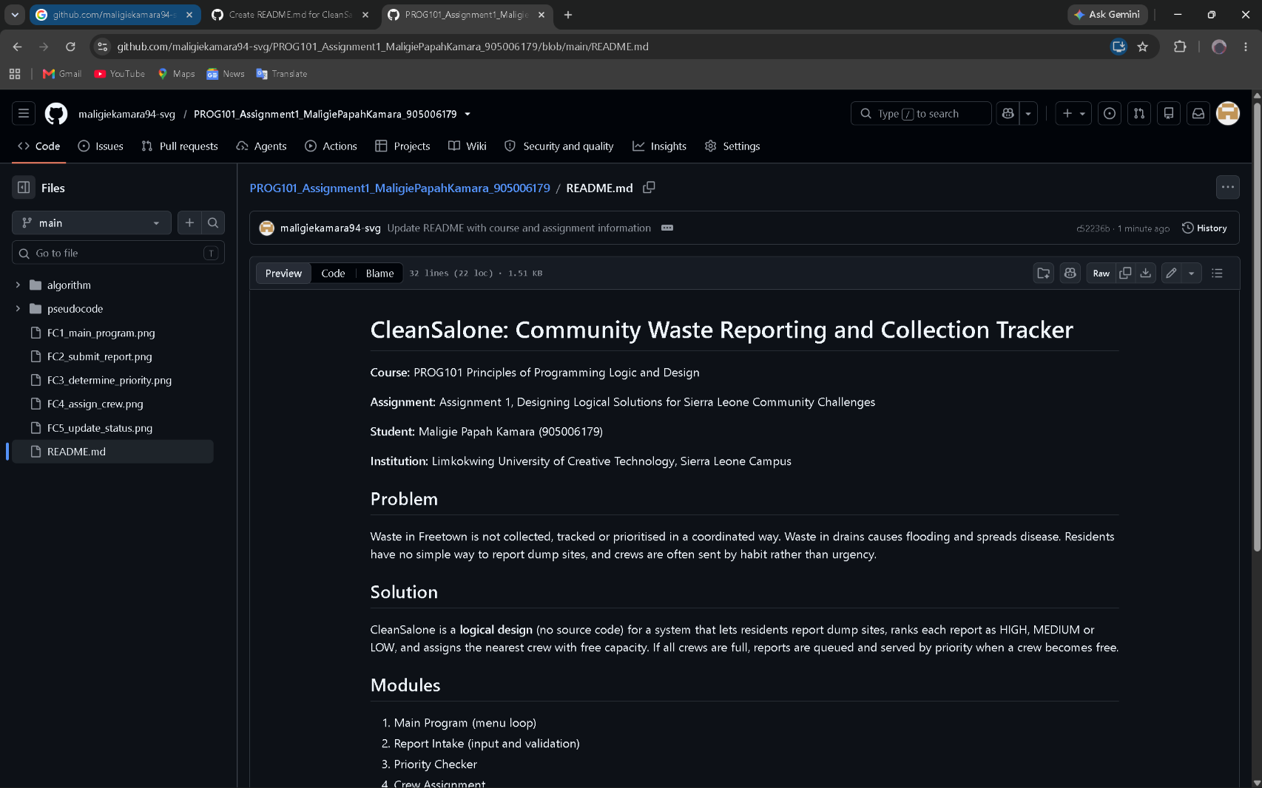

Repository screenshot
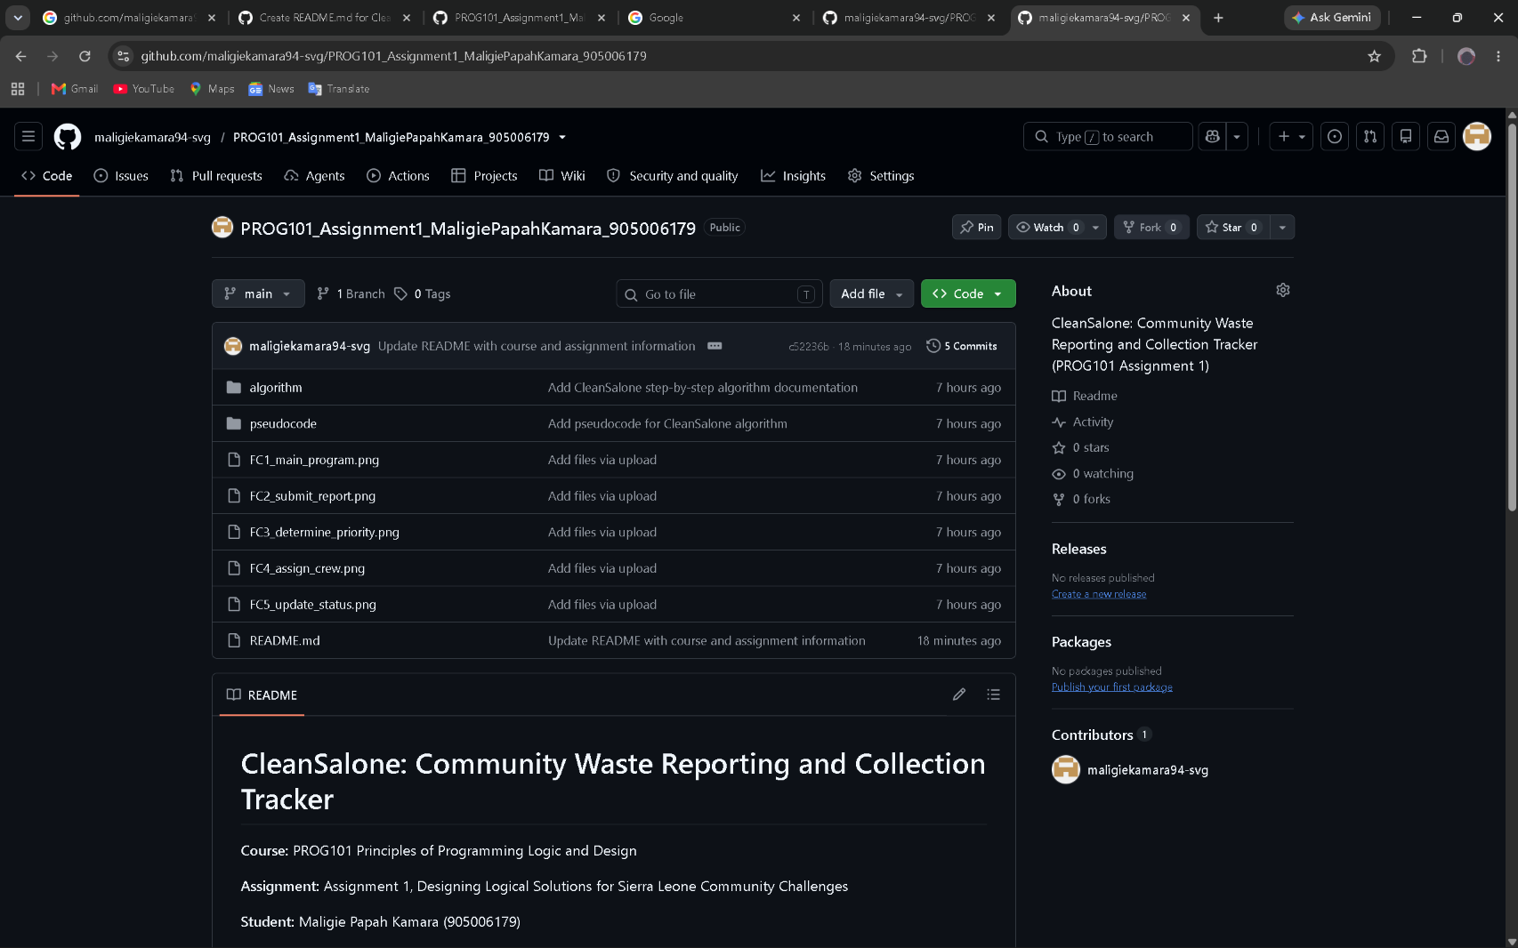

8.References
Awoko Newspaper (2025) Mayor Aki-Sawyer admits flood efforts fall short of tackling Freetown's deeper crisis, 27 July. Available at: https://awokonewspapersl.com/mayor-aki-sawyer-admits-flood-efforts-fall-short-of-tackling-freetowns-deeper-crisis/
Concern Worldwide (n.d.) Sierra Leone's waste and flooding crisis. Available at: https://concern.net/news/sierra-leones-waste-and-flooding-crisis
Digital Public Goods Alliance (n.d.) The DPG Standard. Available at: https://digitalpublicgoods.net/standard/
Freetown City Council (n.d.) Sanitation achievements. Available at: https://fcc.gov.sl/first-100-days/sanitation-achievements/
Open Source Initiative (n.d.) The Open Source Definition. Available at: https://opensource.org/osd
Sierra Leone Telegraph (2024) Freetown City Council engages over 1000 youths in citywide flood mitigation activities, 12 June. Available at: https://thesierraleonetelegraph.com/?p=42955
United Nations (n.d.) The 17 Sustainable Development Goals. Available at: https://sdgs.un.org/goals

