Maps
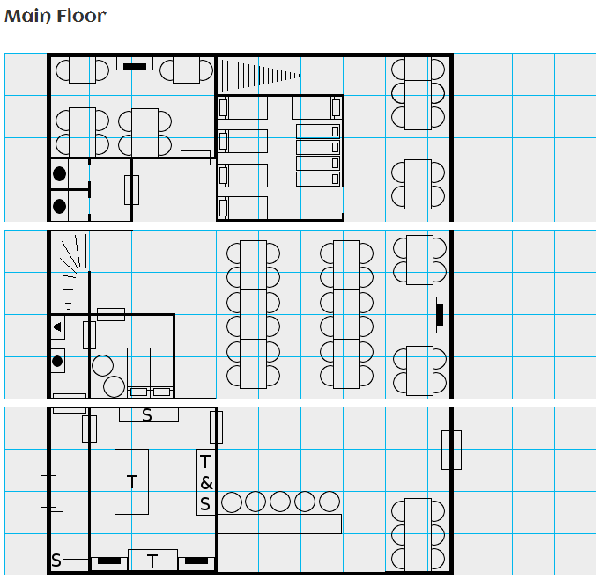

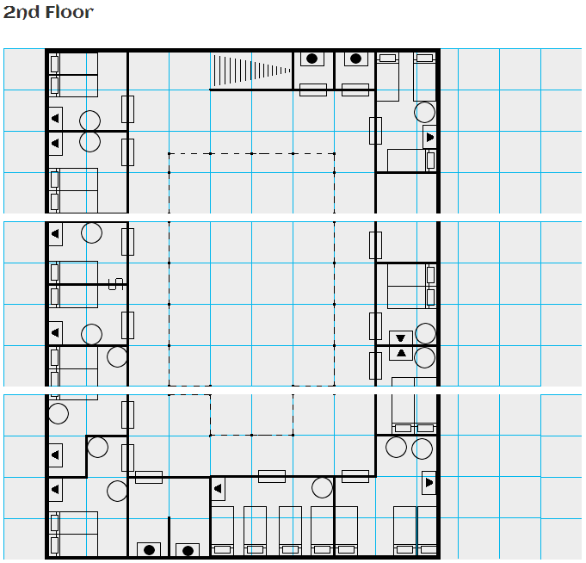

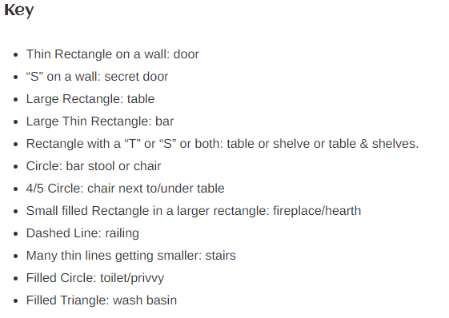

Menu
- Roast Stuffed Leg of Lamb with Mint Sauce: 5sp
- Cheese rolls with a filling of nuts, honey and vegetables: 4cp
- Roast Beef Served with Cranberry Sauce: 6sp
- Honey Glazed Carrots and Parsnips: 1sp
- Smoked Salmon Salad: 4sp
- Braised Oxtails with Mushrooms: 6sp
- Garlic and Basil Leg of Lamb: 4sp
- Grilled Fillet of Salmon: 3sp
- Beef in Ginger & Cinnamon: 5sp
- Mutton, Lettuce and Tomato: 5sp
- Breaded Breast of Chicken, Whiskey & Mushroom Sauce: 3sp
- Chicken Liver Pate and Bread: 4sp
- Roast Goose strewn with Caraway seeds: 3sp
- Pork Knuckle Roasted in Beer: 4sp
- Heron Wine: 5cp
- Kharukan (dwarven) Ale: 7cp
- Yanusa Wine: 2cp
- Dwarven Spirits: 6cp
- Ervanic Lager: 4cp
- Thanuk (heavy) Ale: 4cp
- Rum: 6cp
- Finnell (pale) Ale: 3cp
- Fallan (elven) Wine: 7cp
- Whiskey: 6cp
- Quillin (elven) Wine: 9cp

Random Rumors
Some of these are tongue-in-cheek, some tell the questioner to stop asking, some add details that have no plot hooks, some can be turned into plot hooks if you desire, and most should give you a seed for a conversation.
- That medicine Benton the Magnificent was selling last week didn't do a bit of good. He said he was going to Thistleton this week. I've got a good mind to go there and confront him.
- Bramty over there in the corner--No! Don't Look--is said to be unhappy with the Duke.
- Keep an eye on Anninia sleeves if you ever play cards.
- The dry weather is going to lead to a small crop this harvest.
- The general store clerk Jafyssa hasn't been acting herself lately.
- You seem like a fine fellow. If you need anything from the Melyssa's general store, tell them Arrok sent you. They'll give you my discount.
- Rodents of unusual size? I don't believe they exist.
- Roton's sister went missing last night. They found her and she's ok, but she's not talking about it.
- Ale! Ale! I'll tell you anything you want for another ale, and some of it may even be true.
- If you want any special attention from any of the girls upstairs, ask for Danielle. She's better than any of the others.

Peoples

Name (M/F) | Race | Class | Level | Weapon | Armor | Other Possessions | Alignment | Background | Notes
Bartender(s)
Perbur (M) | Gnome | Bard | 9 | Spear, Shortbow | Leather, Shield | Armor is +1; 3 potions of healing; 3 500gp gems; | True Neutral | Injury Discharged Soldier | Ugly; Clean
Vinfield (M) | Human | Commoner |  |  |  |  | Neutral Evil | Farmer | Rich; Funny
Wait Staff
Elduwa (F) | Human | Sorceress | 2 | Bastard Sword, Dagger, Shortbow | Scale Mail, Shield |  | True Neutral | Guardsman | irresponsible; Plain
Azimaze (M) | Gnome | Cleric | 1 | Quaterstaff, Sling | Leather |  | True Neutral | Explorer | Armorsmith; Thoughtful
Kerok (M) | Human | Commoner |  |  |  |  | Neutral Evil | Maid | Tactful
Barstools
Virgea (F) | Human | Commoner |  |  |  |  | True Neutral | Weaponsmith | Sneaky; irresponsible
Bramfield (M) | Gnome | Commoner |  |  |  |  | True Neutral | Farmer | Combative; Miserly
Benstan (M)Gnome | Gnome | Commoner |  |  |  |  | Neutral Evil | Logger | Helpful; Angry
Aziris (M) | Gnome | Commoner |  |  |  |  | Lawful Neutral | Weaponsmith | Condescending; Shallow
Lamcy (M) | Human | Commoner |  |  |  |  | True Neutral | Laborer | Shallow; Shy
Table 1 just right of front door
Stenten (M) | Gnome | Commoner |  |  |  |  | Lawful Neutral | Fisherman | Gloomy; Creepy
Aduwa (F) | Human | Commoner |  |  |  |  | True Neutral | Farmer | Quarrelsome; Immodest
Virgea (F) | Gnome | Commoner |  |  |  |  | Lawful Good | Miller | Energetic; Eccentric
Table 2, just left of the front door
Jafissa (F) | Elf | Monk | 1 | Kama, Light Crossbow | Splint Mail |  | True Neutral | Retired Soldier | Domineering; Combative; Focused
Jafine (F) | Gnome | Ranger | 1 | Bastard Sword, Dagger, Shortbow | Hide |  | True Neutral | Cutpurse | Nimble; Rugged; Boastful
Longtable 1, not farthest from the front door but also not in front
Perfield (M) | Gnome | Bard | 1 | Rapier, Darts(5) | Leather |  | Chaotic Good | Pirate | Immodest; Abrasive
Karella (F) | Human | Paladin | 1 | Greatsword, Mace, Longbow | Full plate, Shield |  | True Neutral | Explorer | Disciplined; Homeless
Arvin (M) | Gnome | Druid | 1 | Sickle, Sling | Hide |  | Chaotic Neutral | Retired Soldier | Argumentative
Wilten (M) | Human | Cleric | 1 | Shortspear, Light Crossbow | Scale Mail |  | Lawful Neutral | Off-Duty Mercenary | Beautiful
Teyealie (F) | Gnome | Fighter | 1 | Rapier, Morning Star, Heavy Crossbow | Scale Mail |  | Neutral Good | Guardsman | Graceful
In the private room
Jaflyn (F) | Human | Commoner |  |  |  |  | Chaotic Neutral | Beggar | Brazen; Ostentatious
Maxivyn (M) | Human | Commoner |  |  |  |  | True Neutral | General Blacksmith | Aloof; Sadistic
Smalltable to right of entrance, nearer the stairs
Floralie (F) | Gnome | Commoner |  |  |  |  | True Neutral | Armorsmith | Determined; Sly; Poor
Azirok (M) | Human | Commoner |  |  |  |  | Lawful Neutral | Baker | Verbose; Immature; Scruffy
Table 5, in SE corner, left of the front door
Eldera (F) | Gnome | Commoner |  |  |  |  | Chaotic Good | Fisherman | Succinct; Inventive; Patriotic
Ameth (F) | Human | Commoner |  |  |  |  | True Neutral | Miller | Reflective; Cynical; Boisterous
Corinia (F) | Human | Commoner |  |  |  |  | Neutral Good | Maid | Indiscrete; Shallow
Mororma (F) | Gnome | Commoner |  |  |  |  | Chaotic Neutral | Laborer | Withdrawn
Teyea (F) | Gnome | Commoner |  |  |  |  | Lawful Evil | General Blacksmith | Bratty
Agyssa (F) | Gnome | Commoner |  |  |  |  | Lawful Neutral | Beggar | Dumb; Studious
Table 6, in NE corner, near the stairs
Tuniwain (M) | Human | Commoner |  |  |  |  | Neutral Good | Fisherman | Rich; Timid
Deninia (F) | Human | Commoner |  |  |  |  | Chaotic Good | Fisherman | Irritating; Contrarian
Wilbur (M) | Gnome | Commoner |  |  |  |  | Lawful Evil | Fisherman | Brainy
Danea (F) | Gnome | Commoner |  |  |  |  | Neutral Evil | Laborer | Judgmental
Danera (F) | Gnome | Commoner |  |  |  |  | Neutral Evil | Maid | Lunatic; Eloquent
Jafuwa (F) | Gnome | Commoner |  |  |  |  | True Neutral | Weaponsmith | Hot-headed; Sullen; Discerning
Longtable2 in center of the room, farthest from the front door, nearest the cellar
Annorma (F) | Human | Cleric | 1 | Dagger, Sling | Splint Mail |  | True Neutral | Cutpurse | Respectful; Secretive
Wilty (M) | Human | Paladin | 1 | Long Sword, Dagger, Longbow | Banded Mail |  | Neutral Good | Guardsman | Forgetful; Inventive
Nararia (F) | Gnome | Fighter | 1 | Long Sword, BattleAxe, Daggers(3) | Chain Shirt |  | True Neutral | Off-Duty Mercenary | Hot-headed; Graceful
Lamrok (M) | Human | Rogue | 1 | Greataxe, Quarterstaff, Longbow | Studded Leather, Shield |  | Lawful Neutral | Injury Discharged Soldier | Dull; Brilliant
Azistan (M) | Human | Paladin | 1 | Bastard Sword, Morning Star, Daggers(3) | Banded Mail |  | Lawful Neutral | Guardsman | Diplomatic; Carefree

