**LAB 5 TableJoin**

* First downloaded the files
* Then copy the zip file to the location of your choice
* Uncompress the zip file

**sudo tar -xvf MapReduceJoin.tar.gz**

* Start Hadoop **start-all.sh**
* and **start-yarn.sh**
* These file needs to be copied to HDFS using below command.

**$HADOOP_HOME/bin/hdfs dfs -copyFromLocal DeptStrength.txt DeptName.txt /**

* Run the following command.

**$HADOOP_HOME/bin/hadoop jar MapReduceJoin.jar MapReduceJoin/JoinDriver/DeptStrength.txt /DeptName.txt /output_mapreducejoin**

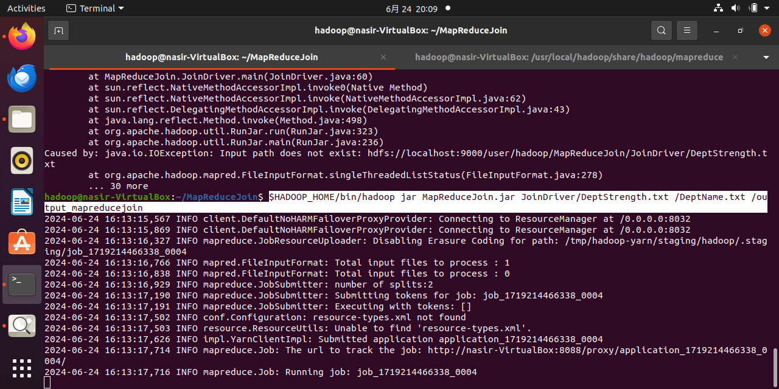

**Note: it get stuck here I have waited for it for 3 hours but still it is not executing, I have 8gb Ram so I think it is the reason.**

* After executing the above command the output file named (‘part-0000’) will be stored on /output-mapreducer on HDFS.
* Result can be seen using the following command.

**$HADOOP_HOME/bin/hdfs dfs -cat /output_mapreducejoin/part-00000**

