
UNIVERSITY OF SARGODHA
Computer Science
PROJECT REPORT
Student Data Analytics
A Menu-Based Python System for Academic Performance Analysis
ADVANCE PROGRAMMING LAB APL
Name | MUHAMMAD ALI HAMZA
Roll No | BSCS51F25S016
Class | BSCS SS1 3RD
Submitted To | ABU BAKAR UBAID
Date | 19/10/26

1. Project Title
Student Data Analytics: A Menu-Based Python System for Academic Performance Analysis
Student Data Analytics is a menu-based Python program that reads university student records, cleans and combines them, and lets the user explore academic performance, attendance and fee status by choosing options from a simple menu. The program uses the Pandas library for all data processing, so a user does not need any programming knowledge to get meaningful reports out of the data.

2. Problem Statement
Every university keeps a large amount of student data, such as personal details, course marks, attendance and fee records. In most cases this data is stored in separate files or sheets, with different formats and many errors like missing values, duplicate entries and inconsistent spellings. Because of this, simple questions become slow and difficult to answer: Which students are performing poorly? Which department has the best results? How does low attendance affect marks? Which students have pending fees?
Checking this information by hand takes a lot of time and is prone to mistakes. As a result, students who are at academic risk are often noticed too late, and decision-makers do not have clear, data-based information to support them.

3. Objective
The main objective of this project is to build an easy-to-use, menu-driven program that turns raw student data into clear and useful information. The project aims to:
- Import student datasets (students, courses, marks, attendance, fees and activities) from CSV/Excel files.
- Clean the data by handling missing values, duplicates, wrong data types and invalid entries.
- Combine the separate datasets into one master dataset using merge/join operations.
- Analyse academic performance, attendance and fee status using selection, filtering, sorting, aggregation and grouping.
- Identify top performers and students who are at academic risk.
- Provide results through a simple menu so that any user can search and view reports easily, and export them to Excel/CSV.

4. Dataset
Item | Details
Source | Dummy Datasets for Implementation
Format | CSV / Excel (multiple files or sheets)
Total Records | 15
Description | Student-related academic data covering student profiles, courses, marks, attendance, fee payments and extra-curricular activities.

Dataset Files and Columns
Dataset | Description | Columns
Students | Basic profile of each student | ID,NAME,SEMESTER….
Courses | Courses offered by each department | ID,COURSE CODE,….
Marks | Marks obtained by students in each course | MID,FINAL,QUIZ….
Attendance | Attendance record of students per course | ID,COURSE ID,…
Fees | Fee amount, paid amount and fee status | ID,TOTAL FEE,DUE DATE…
Activities | Extra-curricular activities of students | ID,ACTIVITY TYPE….

5. Data Cleaning
Before analysis, the raw data was checked for quality problems. The following issues were found and handled using Pandas:
Issue | Method Used
Missing values | Checked with isnull().sum(); filled with mean/median/default value or removed with dropna()
Duplicate records | Detected with duplicated() and removed with drop_duplicates()
Wrong data types | Converted using astype(), to_numeric() and to_datetime()
Inconsistent text | Fixed spaces and letter case using str.strip() and str.title()
Invalid values | Filtered out values such as marks above 100 or attendance above 100%
After cleaning, the final dataset contained 15 records and was ready for analysis.

6. Data Analysis
The analysis is performed through the program menu. Each menu option runs one analysis task on the cleaned master dataset.

6.1 Selection and Filtering
- Searching a single student by roll number or name.
- Filtering students of a particular department or semester.
- Selecting students who failed, or whose attendance is below 75%.

6.2 Sorting
- Listing top students by percentage/CGPA in descending order.
- Sorting students by attendance to find the most irregular students.
- Ranking departments by overall performance.

6.3 Aggregation and Grouping
- Department-wise average marks, highest marks and student count using groupby().
- Course-wise average marks and pass percentage.
- Attendance summary and total pending fees per department.

Program Menu
Option | Menu Item | Operation
1 | Data Inspection | Inspect Datasets
2 | Data Filtering | Filter data on conditions & Save
3 | Data Refining | Clean or Refine datasets
4 | CRUD | Allow ADD,Delete,Update datasets
5 | Data Analysis | Analyse datasets
6 | Data Merging | Merge Data & Join Data
7 | Export / Save | Save results to Excel/CSV
8 | Close Application | Close the program
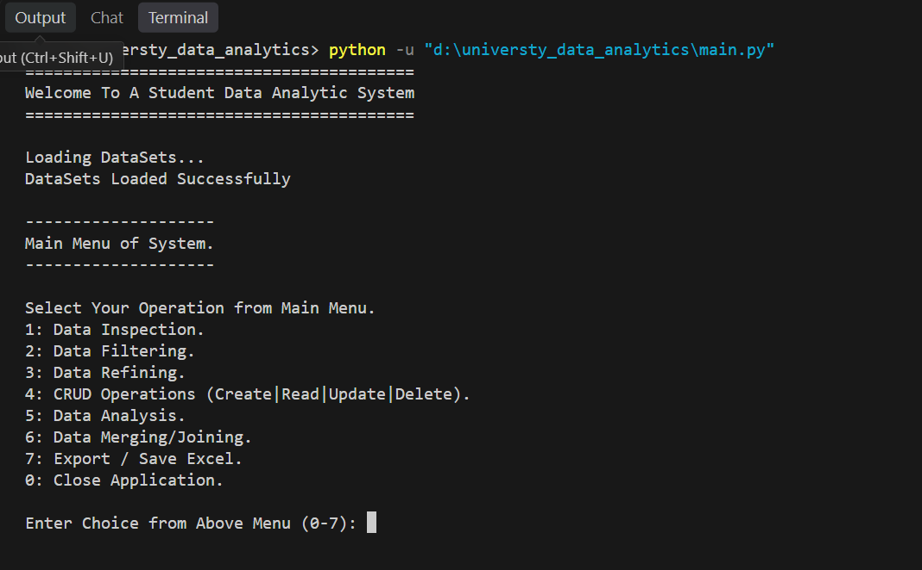

7. Data Combination
The datasets were stored separately, so they were combined into one master dataset to allow complete analysis of each student.
- Merge: the students dataset was merged with marks, attendance, fees and activities using the common key column Student ID (merge() with a left join).
- Concatenation: records of different semesters/sheets with the same structure were stacked together using concat().
- Verification: the number of rows before and after merging was compared to make sure no student was lost or duplicated.
The final master dataset has 30 rows and 12 columns.

8. Findings
The following insights were obtained from the analysis. Replace the highlighted values with the actual results from your program output.
- Department distribution: Information Technology and Data Science have the most students, with 5 records each (33.33% of all rows), while Computer Science has 3 records (20.00%). Together, IT and Data Science make up two-thirds of the dataset.
- Gender distribution: Male students form the majority with 10 records (66.67%), compared to 3 female records (20.00%), so there are more than three times as many male students as female students.
- Duplicate records: The dataset has 15 rows but only 12 unique Student IDs. STU0003, STU0004 and STU0006 each appear twice (13.33% of all rows each), which shows that 3 duplicate entries exist and must be removed during data cleaning.
- Missing values: The Department and Gender columns have values in only 13 of 15 rows (86.67%), meaning 2 rows (13.33%) are missing in each column. These gaps need to be handled before department-wise or gender-wise analysis.
- Unique identifier: Names are not reliable for identifying students because the same first name is shared by several students (for example Usman Malik, Usman Khan and Usman Hussain). Student_ID should therefore be used as the key for searching and merging data.

9. Conclusion
This project shows that a simple menu-based Python program built on Pandas can turn scattered student records into clear and useful information. Cleaning and combining the datasets made it possible to analyse performance, attendance and fees together, which would be slow and error-prone if done manually.
The analysis showed that the student dataset contains data-quality problems, such as 3 duplicate records and 2 missing values each in the Department and Gender columns, which must be cleaned before any reliable analysis can be done. It also showed that Information Technology and Data Science make up two-thirds of the students, and that Student_ID, not name, should be used as the key to identify students. Early identification of such problems, and of at-risk students, can help the university support them in time. In the future, the system can be extended with charts, a graphical interface and prediction of student performance.

Output Snapshots

Starting Menu
Chose Your Operation from menu

Data Set selection Menu
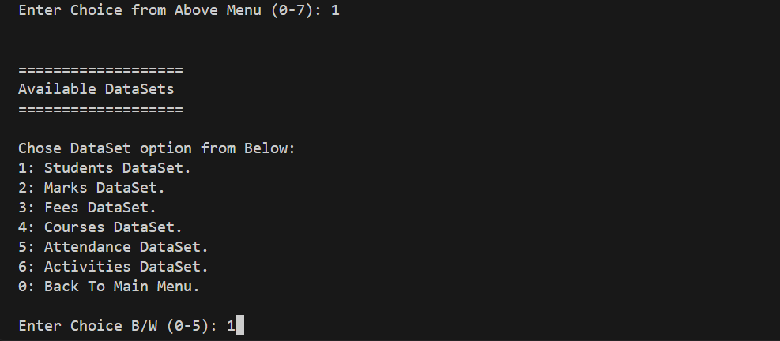
Chose Datasets for your selected operation

Selected Operation Available options
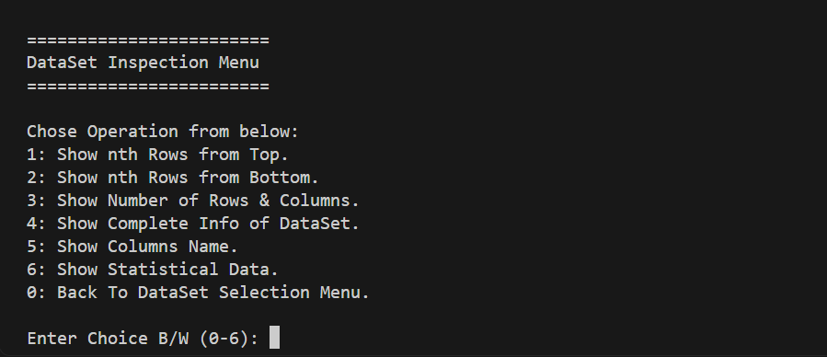
You can apply any option for your inspection of dataset

Info of selected Dataset
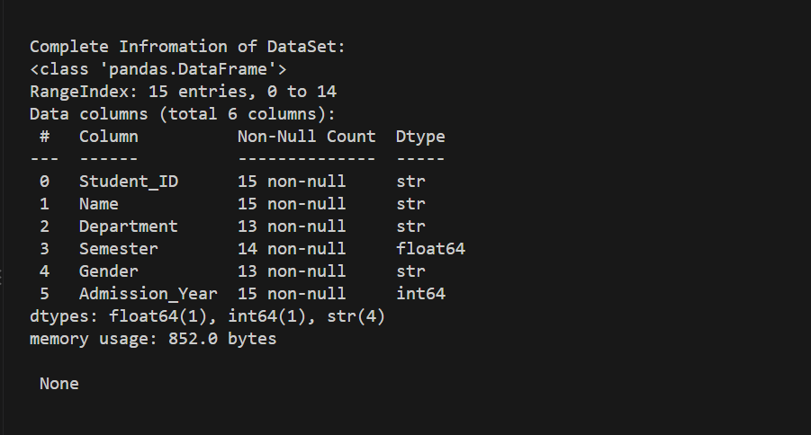
Shows the information of the selected dataset

Data Filtering
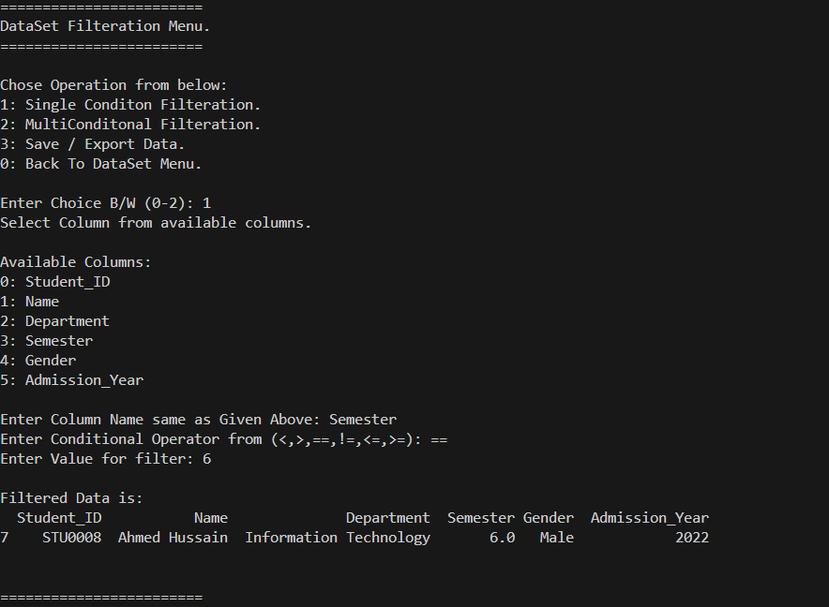
Filter data on conditions and save the result

Data Refining / Cleaning
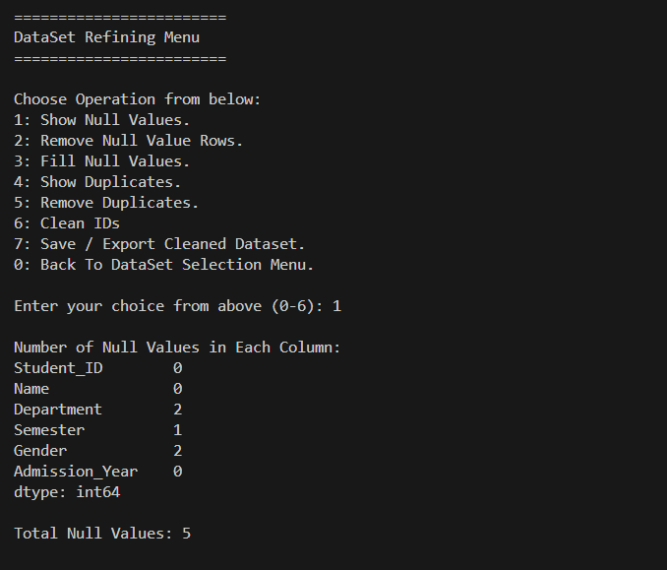
Clean or refine the selected dataset

Delete Duplication
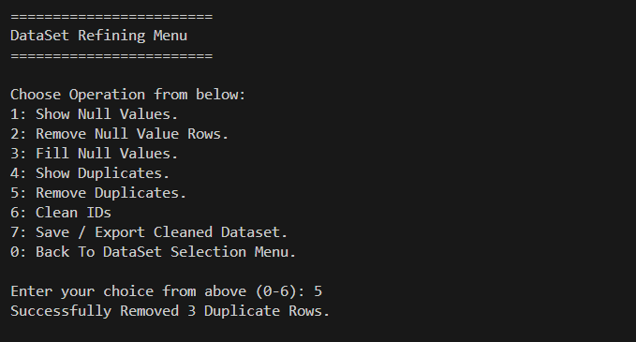
3 Duplicated rows deleted.

Data Analysis
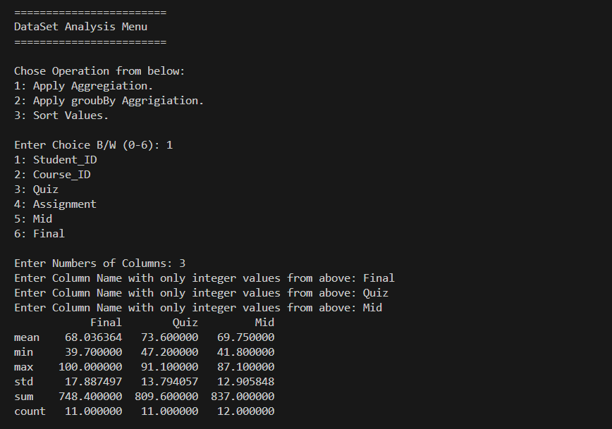
Show analysis of the selected dataset

Data Sorting
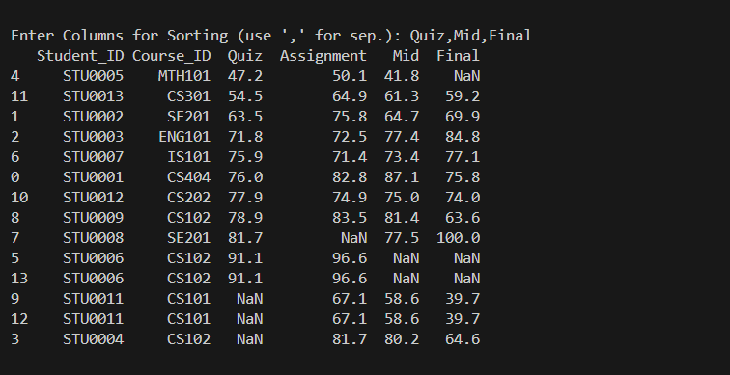
Sort data of columns

Data Merging / Joining
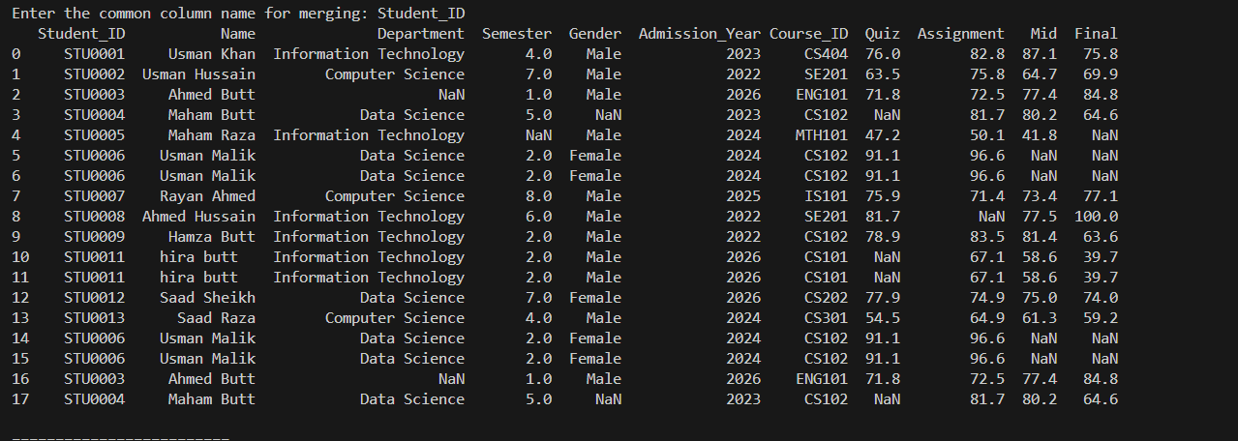
Merge data on the basis of option (inner & outer etc.)

Summary
These are the sample output structure and formats of whole program. Program is based on Pure Human thinking,creativity,architecture,ideas and Workflow. Ai use in this project is just for documentation or little bit speed up the process in the deadline

