**Airbnb**

April 1, 2020

Maliha Wahab and Daniel Lopez

|  |
| --- |
|  |
| To Airbnb or To Airbnb |
|  |
| Executive Summary |

To Airbnb or To Airbnb

Executive Summary

This database stores information about vacation rental properties available to guests for vacations and beyond. Multiple queries are provided which allow a user to enter in values regarding the location of their stay as well as what days they want to check in and check out. In order to make the use of this database easy, a switchboard is also present so that tables, forms, queries and reports are more easily to view. This database will be implemented using MySQL.

The database will contain four tables which will provide information regarding what days guests want to check in and out as well as the number of children and adults. The tables comprise of the following: ***Location, Check-In and*** ***Check-Out, Number of Guests, Rental Properties and Pick your Comfort.*** These tables all relate to one another allowing for a meaningful output of a guest’s ideal Airbnb.

The information in the ***Rental Properties*** table contains city, state, ZIP, country, the type of property, number of bedrooms, safety information, and price per night. The ***Check-In and Out*** table has information regarding the day, month and year of check-in and the day, month, and year of check-out, how many days they will be staying, and the total price. The ***Guests*** table includes information such as their names, address, city, country, ZIP, phone, email and how many adults, kids, and pets there are. The ***Owner Info*** table has information on the owner’s name, phone, email, and which property they rent out. The ***Pick your Comfort*** table has options of amenities and nearby activities. Amenities comprise of pool, kitchen, hot tub, TV, laundry machines, outdoor grill/BBQ and air conditioning. Nearby activities include watersports, fishing, hiking, golfing, shopping and the location options may include beach, beachfront, lake, oceanfront and waterfront.

This database is a simplistic layout that allows a user to retrieve their perfect stay for their vacation and/or destination. The user can easily input information such as their city, state and/or country and making bookings depending on where they want to stay and how many rooms they need. Once a user enters in their information, available properties for rent as well as the cost per night will be retrieved. All in all, this database will serve as a life-changing and great enhancement to the firm by providing information rapidly and at a convenience.

To Airbnb or To Airbnb

RENTALPROPERTIES (LocNum, City, State, ZIP, Country, TypeOfProp, BedroomNum, SafetyInfo, PricePerNight, *OwnerNum*);

FK OwnerNum 🡪 OWNERINFO

CHECKIN_OUT (*LocNum*, DateIn, DateOut, NumberOfDays, TotalPrice, *GuestNum*);

FK LocNum🡪 RENTALPROPERTIES

FK GuestNum🡪 GUEST

GUEST (GuestNum, FirstName, LastName, Address, City, Country, ZIP, Phone, Email, NumOfAdults, NumOfChildren);

OWNERINFO (OwnerNum, FirstName, LastName, Phone, Email);

PICKYOURCOMFORT (*LocNum*, PYCNum, Amenities, Activities, Location);

FK LocNum🡪 RENTALPROPERTIES

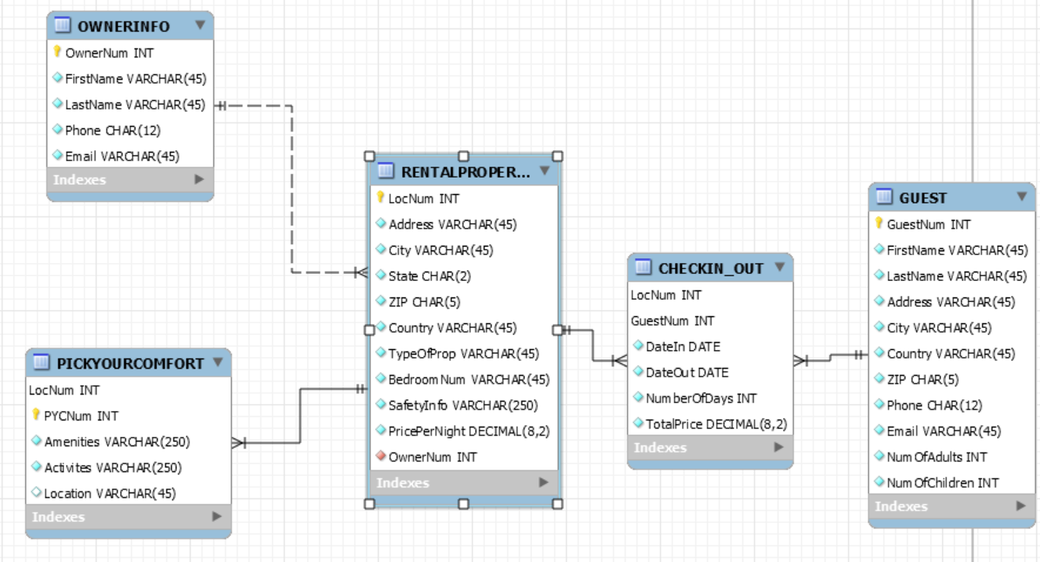

The relationship between Owner and RentalProperties is 1:M because one owner can own multiple properties to rent out. RentalProperties and PickYourComfort is a 1:M because multiple properties can have the same amenities but different activities and vice-versa. It’s an identifying relationship because amenities and activities can’t exist without being linked to a property. RentalProperties and Guest have a M:N since multiple guests can rent multiple properties.

To Airbnb or To Airbnb

Table and Query Implementation (Deliverable 2)

### Query 1

* 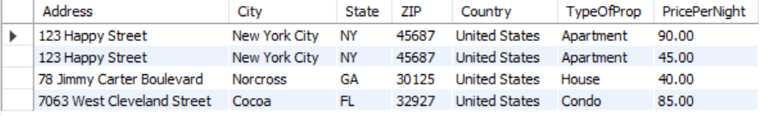Show address, city, state, ZIP, country, the type of property, and price per night of properties that are wheelchair accessible property and costs less than $90

### Query 2

* Show name, phone, and email of customers that rented in 2019

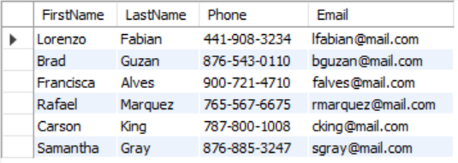

### Query 3

* Show name, phone, email, and location number of owners who own property that have more than 3 bedrooms

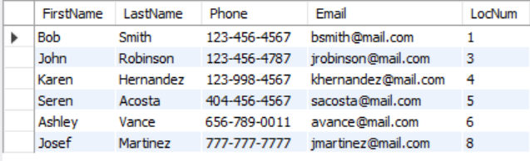

### Query 4

* Show location number, address, city, state, ZIP, and price per night of all properties that have been rented in 2020

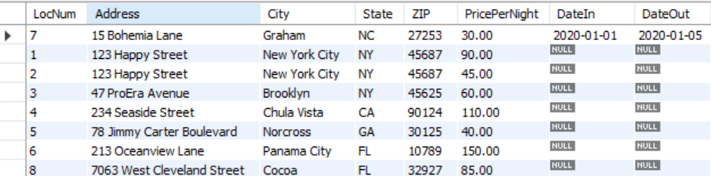

### Query 5

* 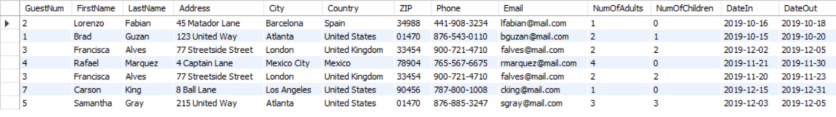Create a view of all customers’ information that rented in 2019

### Query 6

* Show how many customers from each country

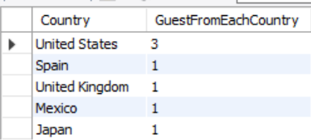

### Query 7

* 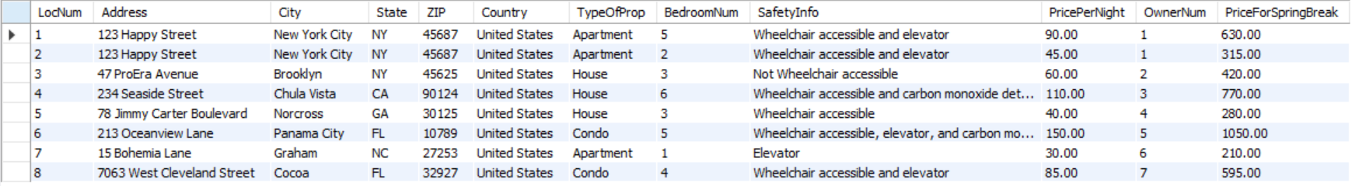Show all rental property information and the cost of renting for Spring Break (7 days)