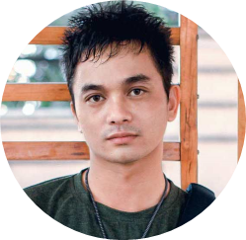
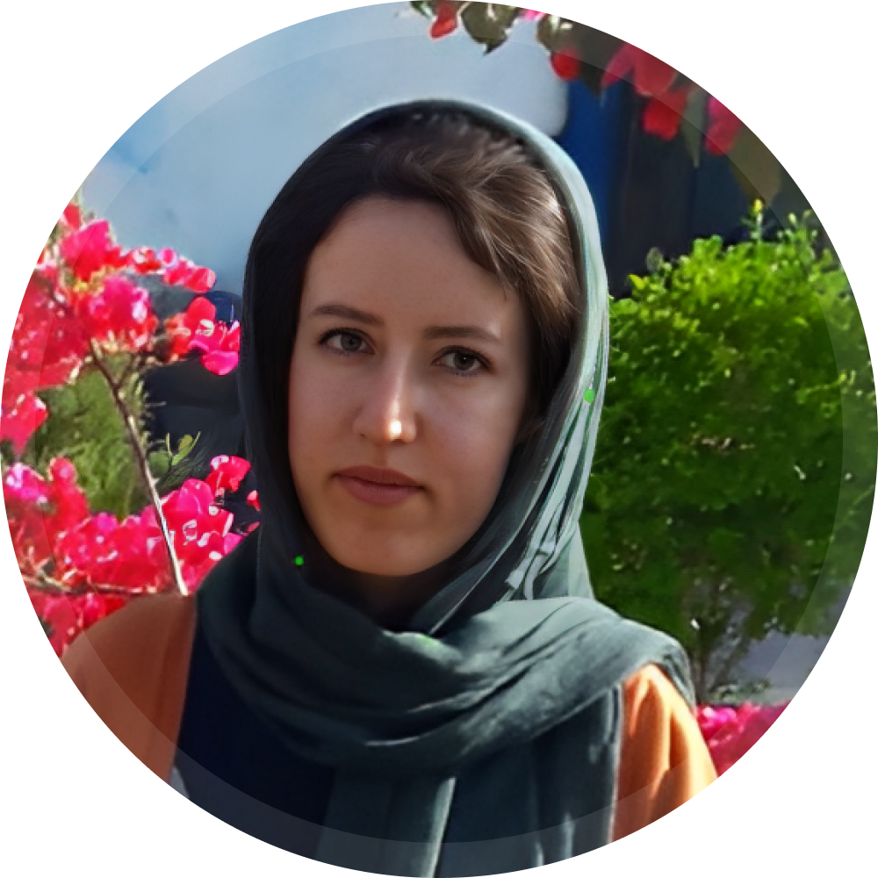
Android Developer
“Curious, motivated and determined”
Malihe Moradi
+989178327703
www.linkedin.com/in/malihemoradi
m.moradi.ps@gmail.com
About me. Creative, focused, motivated, and caring developer with more than 7 years of hands-on experience in Android development. I have experience in solution providing, architecture, team management and team support. Develop cutting-edge Android apps in industries such as fintech, tourism, threading, e-commerce, and transportation with over 7 million downloads.

SKILLS
- Android, SDK
- Kotlin
- Java
- Compose
- Clean Architecture
- MVP - MVVM - MVI
- Solid, OOP
- RxJava
- Coroutine, Flow
- Dagger, Hilt, Koin
- Git, CI / CD
- UI, UX

EDUCATION
Technical University of the Enghelab
Bachelor Degree in Software Computer
2015 - 2018
Iran

EXPERIENCE
- Donec turpis mauris, auctor vitae sollicitudin in, elementum efficitur tellus.
- Aenean nec turpis tortor. Ut placerat varius vivera vestibulum eu dictum purus.
- Ut lacinia commodo erat id vulputate. Orci varius natoque penatibus et magnis dis parturient montes, nascetur ridiculus mus.
Senior Android Developer
Jun. 2019 – March. 2022
Shiraz, Iran

- Donec turpis mauris, auctor vitae sollicitudin in, elementum efficitur tellus.
- Aenean nec turpis tortor. Ut placerat varius vivera vestibulum eu dictum purus.
- Ut lacinia commodo erat id vulputate. Orci varius natoque penatibus et magnis dis parturient montes, nascetur ridiculus mus.
Android Developer
HivaTech
Atishahr

Jan. 2019 – May. 2019
Shiraz, Iran

- Donec turpis mauris, auctor vitae sollicitudin in, elementum efficitur tellus.
- Aenean nec turpis tortor. Ut placerat varius vivera vestibulum eu dictum purus.
- Ut lacinia commodo erat id vulputate. Orci varius natoque penatibus et magnis dis parturient montes, nascetur ridiculus mus.
Senior Android Developer
Aug. 2018 – May. 2019
Shiraz, Iran

- Donec turpis mauris, auctor vitae sollicitudin in, elementum efficitur tellus.
- Aenean nec turpis tortor. Ut placerat varius vivera vestibulum eu dictum purus.
- Ut lacinia commodo erat id vulputate. Orci varius natoque penatibus et magnis dis parturient montes, nascetur ridiculus mus.
Co-Founder and Android Developer
AriaSmart
Rohamweb

Apr. 2017 – Jul. 2018
Shiraz, Iran

- Donec turpis mauris, auctor vitae sollicitudin in, elementum efficitur tellus.
- Aenean nec turpis tortor. Ut placerat varius vivera vestibulum eu dictum purus.
- Ut lacinia commodo erat id vulputate. Orci varius natoque penatibus et

- magnis dis parturient montes, nascetur ridiculus mus.
Senior Android Developer
Jun. 2016 – May. 2017
Shiraz, Iran

ShirazIT

Language
Persian
Native
English
Professional

