**TBI GEU**

**SDE ASSISTANT INTERN**

**Vishwas Malik**

**Month 1**

**Topics covered:**

* **HTML**
* **CSS**
* **JavaScript**
* **MySQL**
* **NodeJS**
* **MongoDB**

**Week 1**

* **HTML concepts learned**
* **Simple HTML project topic i.e., personal portfolio website**
* **CSS styling techniques**
* **CSS styles to HTML project**

**Week 2**

* **JavaScript concepts learned**
* **Simple JavaScript project (e.g.- form, timetable, calculator, etc.)**
* **JavaScript in the HTML + CSS project**
* **Notes on JavaScript features and concepts**

**Week 3**

* **Node.js concepts learned**
* **concepts of MySQL.**

**Week 4**

* **Implementing Node.js, such as building a RESTful API**
* **MongoDB concepts and queries**
* **Implementation of all the MongoDB operations learned**

Started with the basics of HTML and ended month 1 with some understanding of databases. Learned a lot, and explored a lot.

The basics of web development were focused on in the first month and a little touch on databases.

Main projects:

* Portfolio site
* CRUD operations using NodeJS and MongoDB

Total 14 submissions.

**Portfolio (HTML, CSS, JavaScript)**

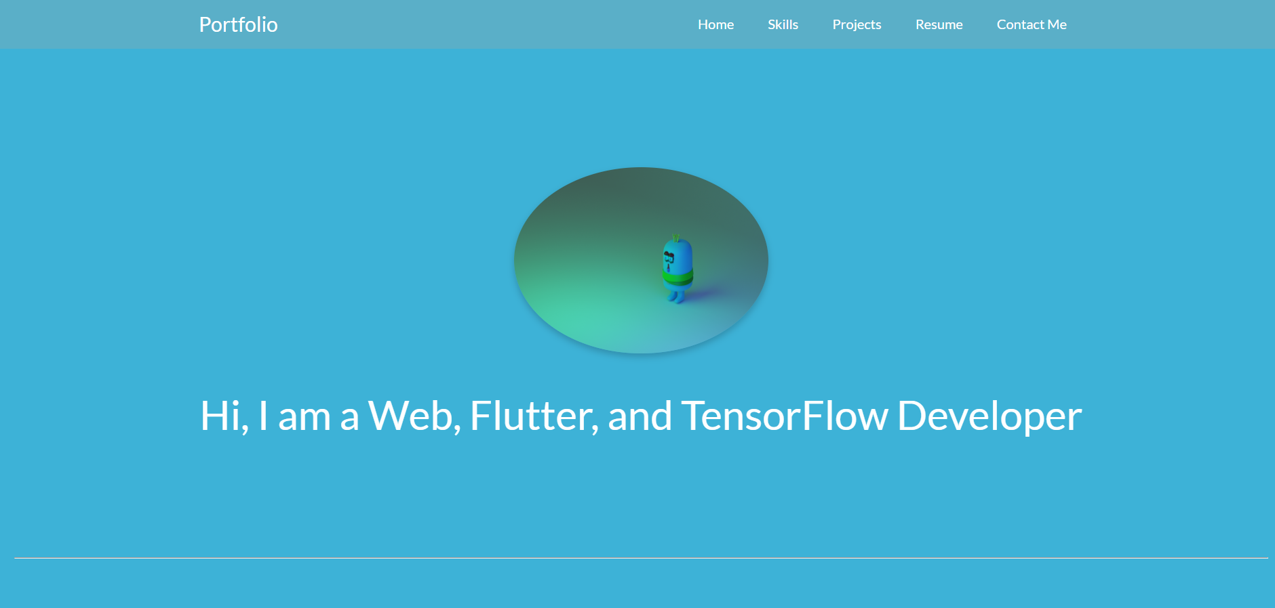

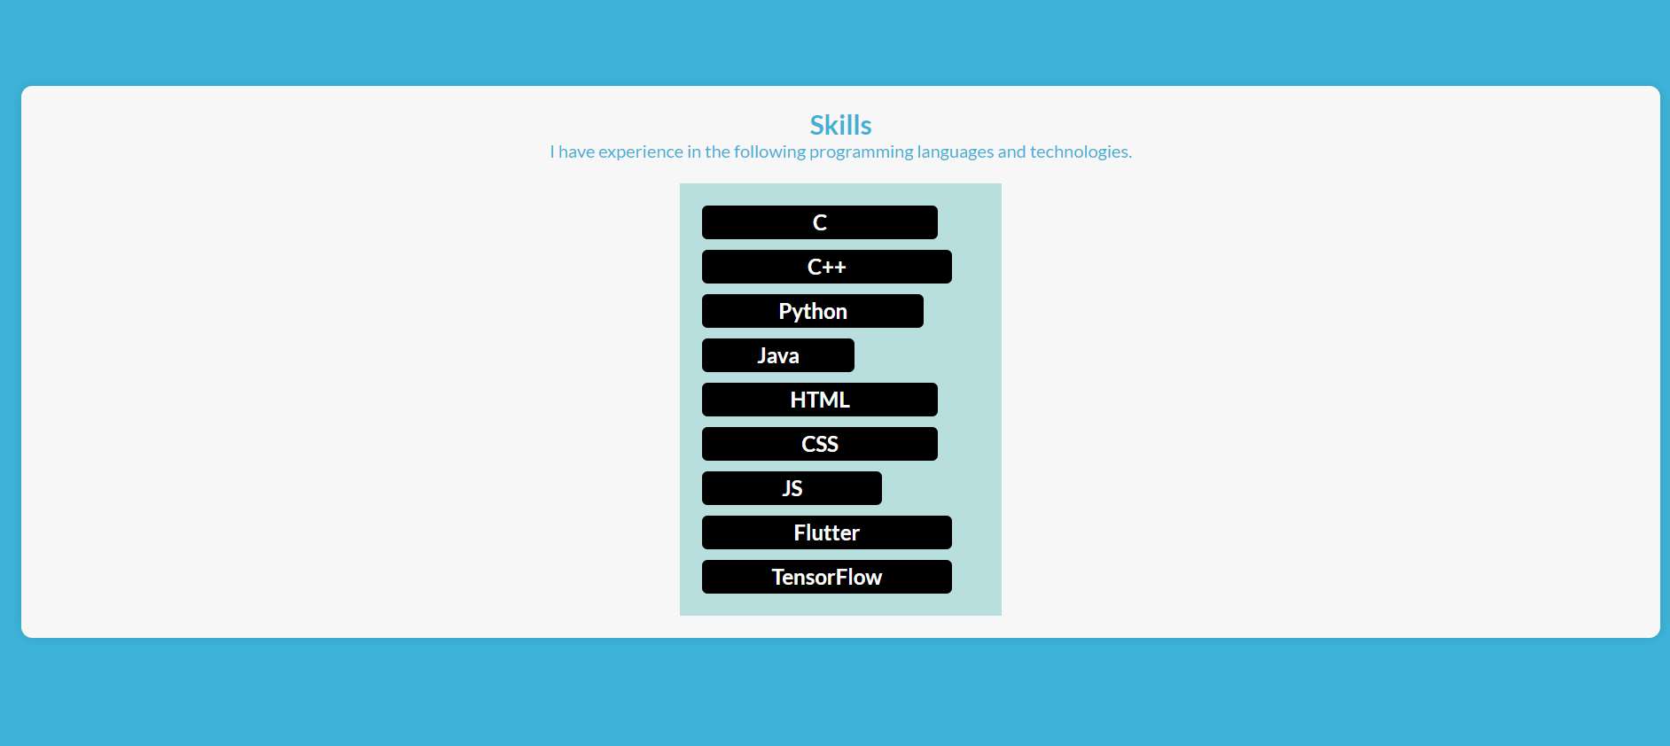

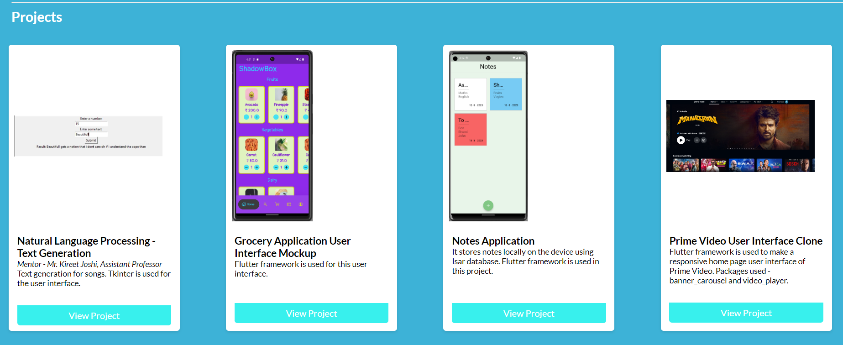

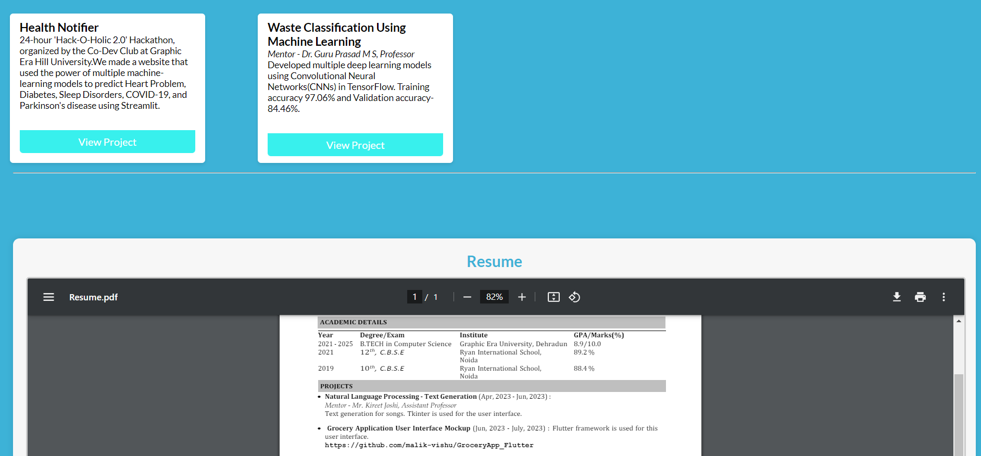



**Calculator(HTML, JavaScript)**

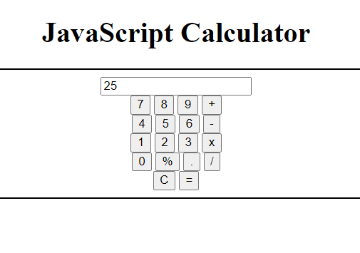

**Handling data (Restful API, MongoDB, NodeJS)**

