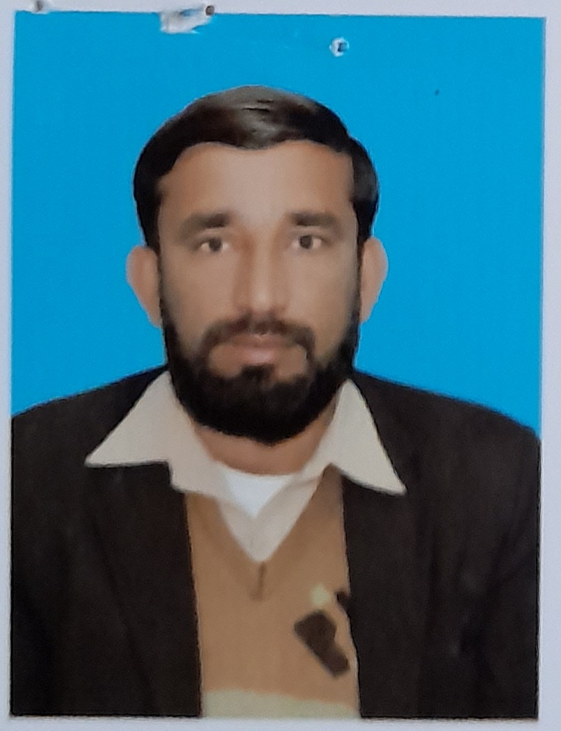

|  |  |  |  |  |  |  |  |  |  |  |  |  |  |  |  |
| --- | --- | --- | --- | --- | --- | --- | --- | --- | --- | --- | --- | --- | --- | --- | --- |
| **Personal Details بيانات صاحب الطلب** | | | | | | | | | | | | **Position Applied:** | **DRIVER** | **الوظيفة** | |
| Full Name : | | | | **ASIF HUSSAIN** | | | | | | الإســـــم بالكامل : | | Monthly Salary : | **1500+200** | الراتب : | |
| Nationality : | | | | **PAKISTANI** | | | | | | الجنسية : | | Contract Period : | **2 YEARS** | مدة العقد : | |
| Religion : | | | | **ISLAM** | | | | | | الديانة : | | Passport No. : | **WB6890862** | رقم الجواز : | |
| Date of Birth : | | | | **02-JUL-1986** | | | | | | تاريخ الميلاد: | |  | | | |
| Age : | | | | **35** | | | | | | العمر: | |
| Place of Birth : | | | | **SARGODHA** | | | | | | مكان الميلاد : | |
| Home Address : | | | | **SARGODHA,PAK** | | | | | | مكان السكن : | |  | | | |
| Marital Status : | | | | **MARRIED** | | | | | | الحالة الإجتماعية : | |
| No. of Children : | | | | **N/A** | | | | | | عدد الأطفال : | |
| Educational Background : | | | | **MATRIC** | | | | | | المستوى التعليمي : | |
| **Previous Employment (Abroad):الخبرة السابقة خارج البلد :** | | | | | | | | | | | |
| Country: | SAUDIA | | | |  | | | |  | | |
| Period : | 3 YEARS | | | |  | | | |  | | |
| **Work Experience(s) :خبرات العمل :** | | | | | | | | | | | |
| **DRIVER** | | | PAKISTAN | | | | 06 YEARS | | | | |
|  | | | | | | | |
| **Languages you can Speak or Write : إجــادة اللغــــات : / ARABIC / URDU / ENGLISH** | | | | | | | | | | | |  | | | |
|  | | Fluent ممتاز | | | | Fair متوسط | | | | | Poor لا شي | Weight : 65 | **KG** | الوزن |
| English | |  | | | |  | | | | | **🗸** | Height :5’6 |  | الطول |
| Arabic | |  | | | | **🗸** | | | | |  | Complexion : |  | اللون |
| **NOTE; EX-ABROAD** AND WILLING TO WORK AS ALL AROUND HOUSE DRIVER | | | | | | | | | | | | | | | |

I hereby declare that the above particulars furnished by me are true and accurate to the best of my knowledge.

