Student Result Analysis System – By Kajal (24bcy70214)

1. Executive Summary
This document presents a detailed proposal for a Student Result Analysis System built using a microservices-based architecture. The system securely manages academic data, computes deterministic and explainable analytics, and provides role-based dashboards for administrators, teachers, and students. The design emphasizes scalability, maintainability, and real-world engineering practices.

2. Technology Stack
Frontend: Next.js (TypeScript), Tailwind CSS, Recharts
Backend: Spring Boot, Spring Security, Spring Data MongoDB
Database: MongoDB Atlas
API Gateway: Spring Cloud Gateway
Deployment: Vercel (Frontend), Render (Backend)

3. High Level Design (HLD)
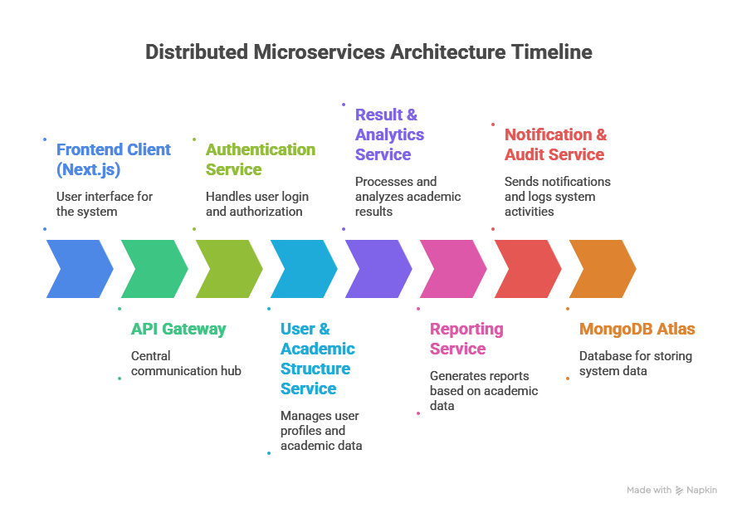
The system follows a distributed microservices architecture. A single frontend application communicates with backend services through an API Gateway. Each backend service is independently deployable and responsible for a specific business capability.

High Level Components:
1. Frontend Client (Next.js)
2. API Gateway
3. Authentication Service
4. User & Academic Structure Service
5. Result & Analytics Service
6. Reporting Service
7. Notification & Audit Service
8. MongoDB Atlas

All requests from the frontend pass through the API Gateway, which handles routing, authentication validation, and rate limiting.

4. Microservices Architecture
Each microservice is designed around a single responsibility and communicates via REST APIs.

Authentication & Authorization Service:
- Manages user registration, login, JWT issuance, and role validation.

User & Academic Structure Management Service:
- Handles CRUD operations for students, teachers, classes, subjects, and exams.

Result Processing & Analytics Service:
- Stores results and performs all academic computations such as totals, percentages, grades, trends, projections, and rankings.

Reporting & Insights Service:
- Generates consolidated academic reports and downloadable exports.

Notification & Audit Service:
- Sends notifications and maintains audit logs for critical operations.

Services are stateless and horizontally scalable. MongoDB Atlas is used as the persistent data store.

5. Frontend Modules Overview
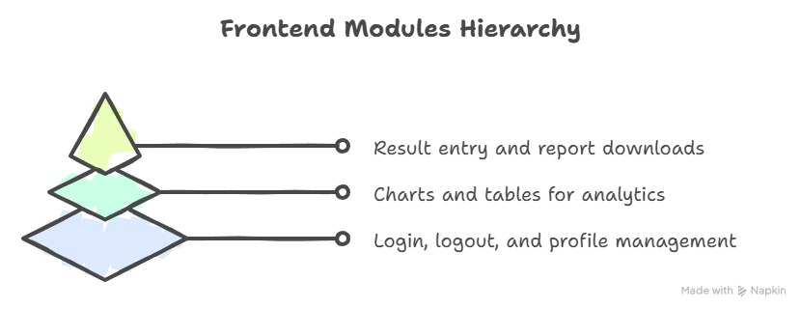
F1. User Authentication & Interface Module:
- Login, logout, role-based dashboards, and profile management.

F2. Student Performance Visualization Module:
- Charts and tables displaying backend-computed analytics.

F3. Result Management & Reporting Module:
- Interfaces for result entry, academic data management, and report downloads.

6. Low Level Design (LLD)
The backend services are designed using a layered architectural pattern, which ensures separation of concerns, maintainability, and testability. Each layer has a clearly defined responsibility and communicates only with its adjacent layers.
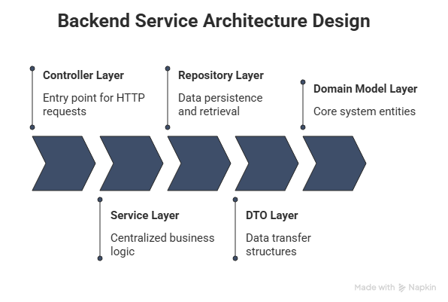
Controller Layer:
- The Controller layer acts as the entry point for all HTTP requests. It is responsible for receiving client requests, performing basic request validation, and returning appropriate HTTP responses. This layer does not contain any business logic.
Service Layer:
- The Service layer contains the complete business logic of the application. It is responsible for processing requests, applying validation rules, performing result calculations, computing analytics such as trends and projections, and coordinating interactions between repositories. All academic computation and decision-making logic is centralized in this layer.
Repository Layer:
- The Repository layer handles data persistence and retrieval. It interacts directly with the MongoDB database using Spring Data MongoDB repositories. This layer abstracts database operations from the business logic.
DTO Layer:
- The Data Transfer Object (DTO) layer is used to define request and response structures exchanged between the client and the server. DTOs prevent direct exposure of internal domain models and enable controlled data flow across layers.
No business logic is implemented in controllers. Analytics calculations are centralized in the service layer.
Domain Model Layer:
This layer defines the core entities of the system such as Student, Subject, Exam, and Result. These models represent the structure of data stored in the database.

7. Functional Requirements
• Secure authentication and authorization
• CRUD operations for academic entities
• Result entry and validation
• Automatic computation of totals, percentages, and grades
• Performance trend analysis and projections
• Risk identification
• Report generation and notifications

8. Non-Functional Requirements
• Scalability and high availability
• Secure data handling
• Low latency API responses
• Maintainable and modular codebase
• Fault tolerance and observability

9. Conclusion
This proposal outlines an enterprise-grade Student Result Analysis System suitable for academic submission and real-world deployment. The architecture and design decisions ensure correctness, scalability, and long-term maintainability.

