**Use Case Diagram**

All the use cases are defined for the population information system, the following diagram defines the functional and necessary use cases for the system. System must have functionality of CRUD operations for population information, Login System, Reports, and different views of the population by country, region, continent, city and language. Use cases are performed by the two-stake holder, one organizational admin who has all the permissions and second a user who can view all the information about population for now. Both the stake holders require a login session in order to perform operations.

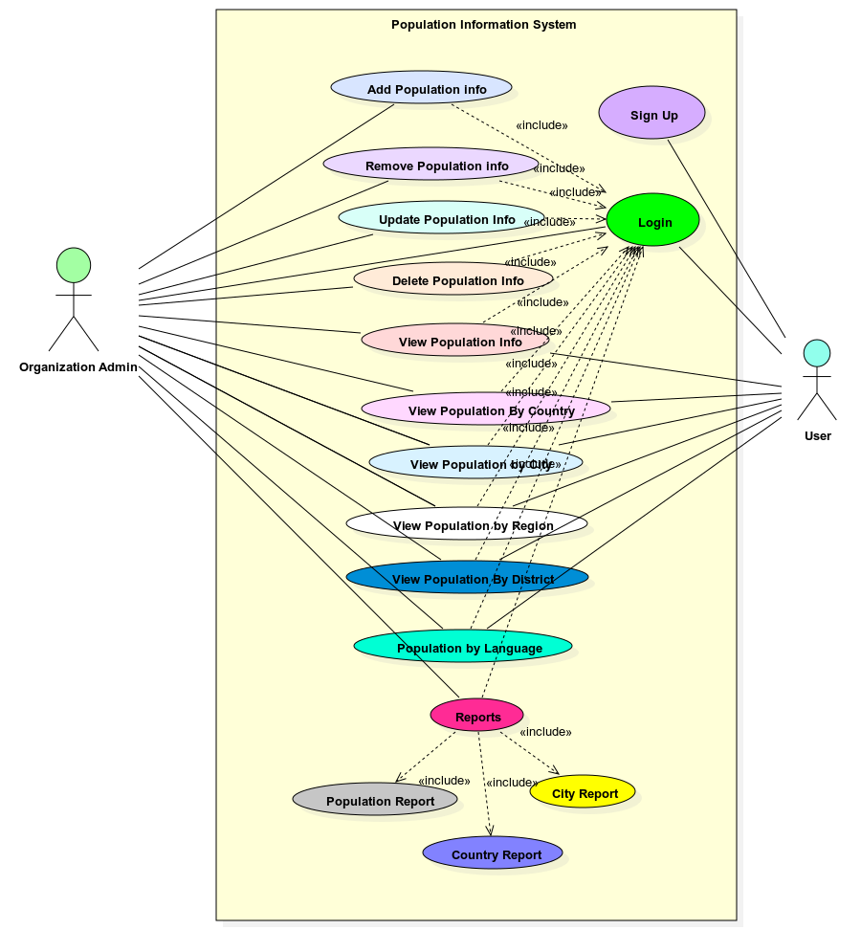

**Class Diagram**

Below is a UML class diagram of the basic system. More classes could be added as the system grows in development but the following classes are necessary in order for the system to work.

* City – class is an object mapping from table ‘city’ and useful in ‘object’ mapping in the system, database and relationships.
* Country Language – similarly, country language is an object mapping from table ‘countrylanguage’ and useful in object mapping in the system, database and relationships
* Country – It is also an object mapping from table ‘country’ and is helpful in the system for object mapping and relationship.
* DBHelper – This class manages the connection to database and has all the functions for crud operations on database tables. It is helpful in generating reports and different views.

