

**Index Number:**

|  |  |  |  |  |
| --- | --- | --- | --- | --- |
| **Student Name:** | | **Malika Bakhtiyorova** | | |
| **Student ID:** | | **B1903177** | | |
| **Course:** | | **Bachelor of Science (Hons) in Computer Information Systems for Business** | | |
| **Module Code and Title:** | | **ICP-1026 Web Technologies** | | |
| **Module Leader:** | | **Mr Lau Chong Teck Jackson** | | |
| **Module Tutor:** | | **Mr Castro Eugene** | | |
| **Assessment:** | | **Assignment (Main)** | | |
| **Due Date:** | **25 January 2021** | | **Date Submitted:** | **23 January 2021** |
| **Weighting within Module:** | | **50 %** | | |
| **ALL MARKS ARE PROVISIONAL AND ARE SUBJECT TO CHANGE UNTIL CONFIRMED BY THE EXTERNAL EXAM BOARD** | | | | |
| **Comments from Internal Examiner (Name):** | | | | |
| **Strengths:** | | | | |
| **Weaknesses:** | | | | |
| **Areas of Improvement:** | | | | |
| **Provisional Mark out of 100:** | | |  | |
| **ALL MARKS ARE PROVISIONAL AND ARE SUBJECT TO CHANGE UNTIL CONFIRMED BY THE EXTERNAL EXAM BOARD** | | | | |

**NAME: __Malika Bakhtiyorova_**

**Student ID: ___b1903177_____**

**Date of Submission: ___23th January___**

**Testing Report**

**1st Step. Creating Appropriate Folders.**

Here is a link to the website

[*https://b1903177-webtech-assignment.netlify.app/*](https://b1903177-webtech-assignment.netlify.app/)

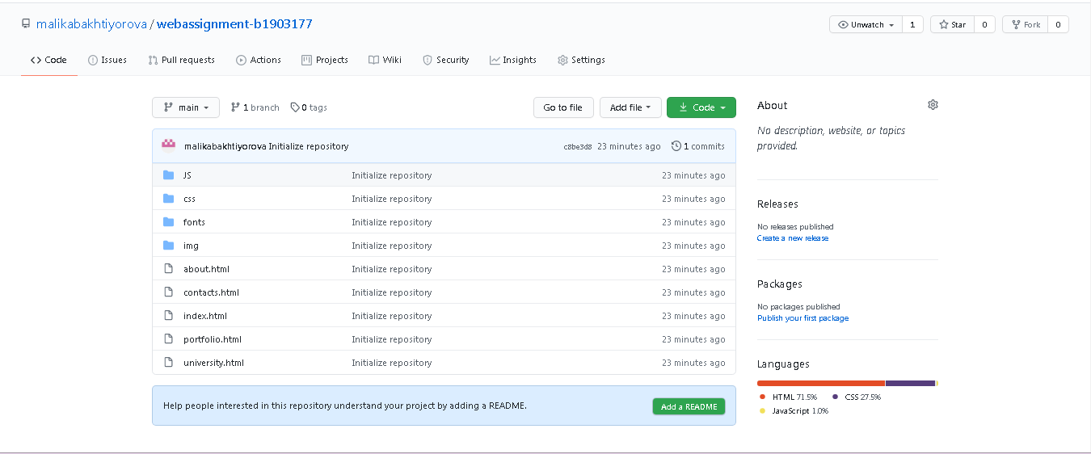

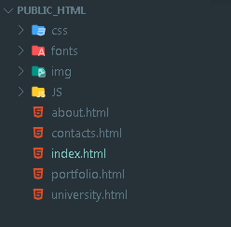

**Website has 5 html files and separate img, JavaScript, fonts and css folders.**

**2nd Step. Part of the Website**

**Explanation**

Figure below shows the header and hero section of the main page:



For the header division:

HtML part:

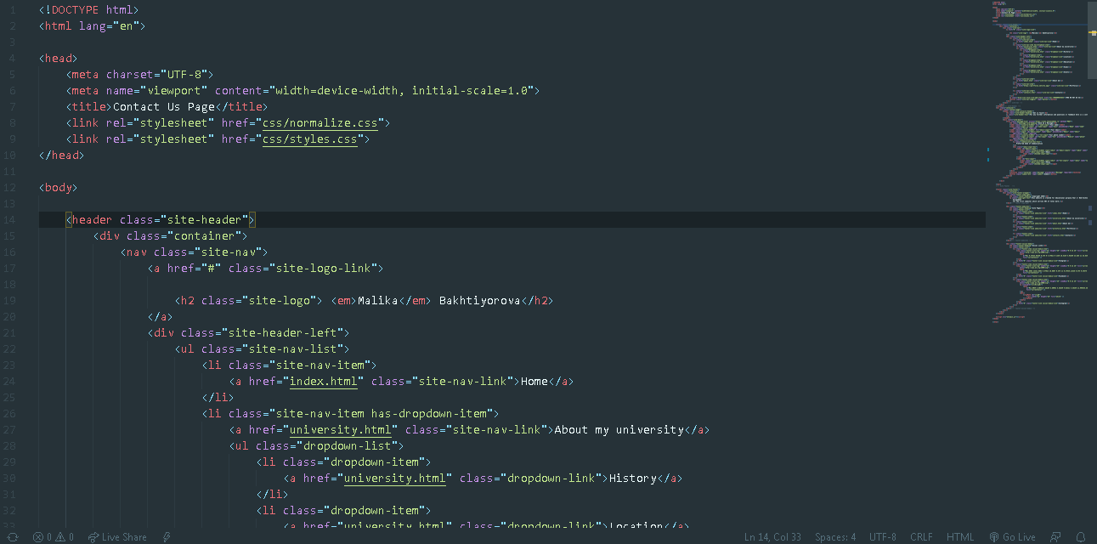

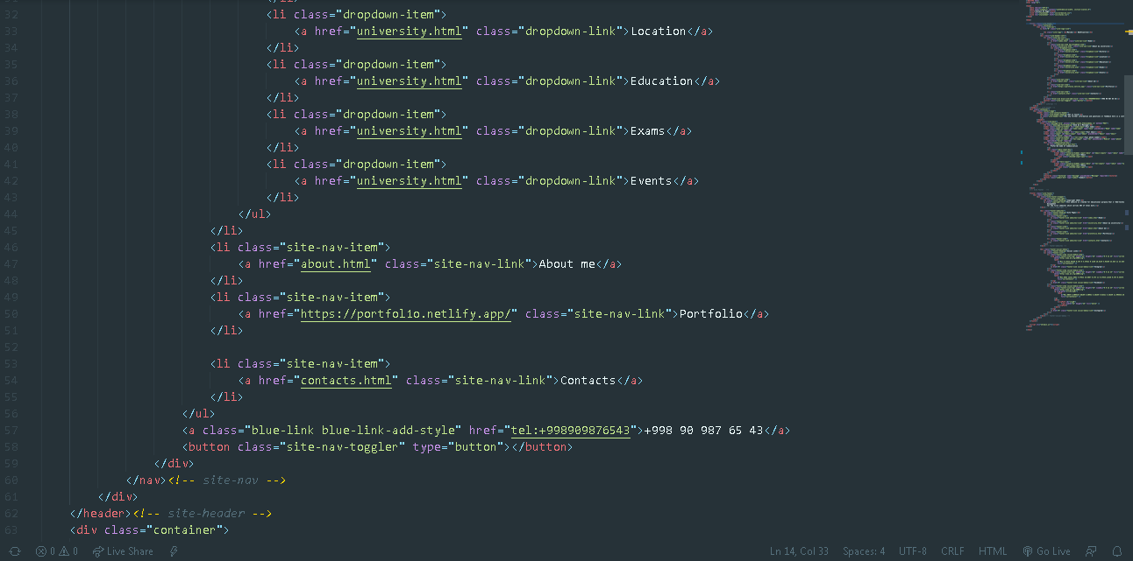

**Header part css:**

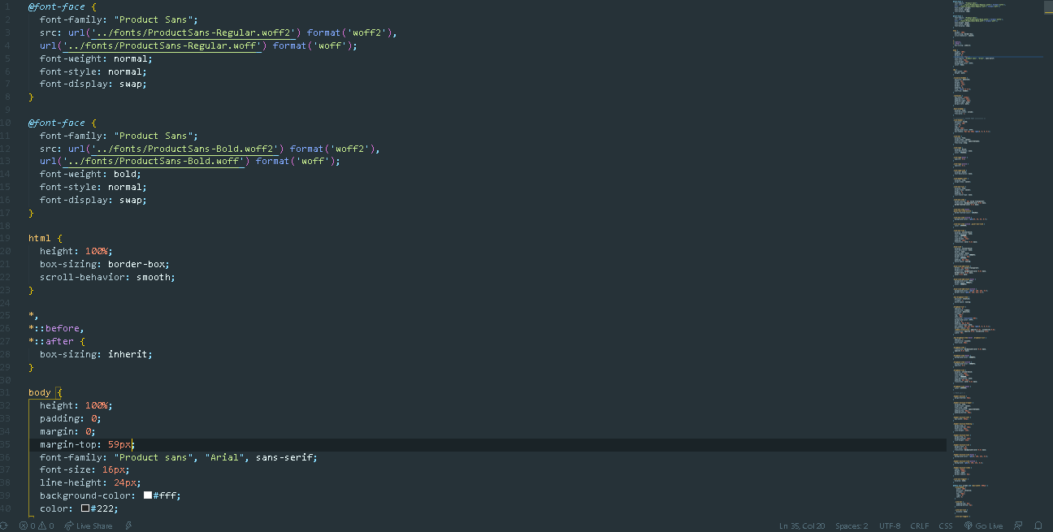

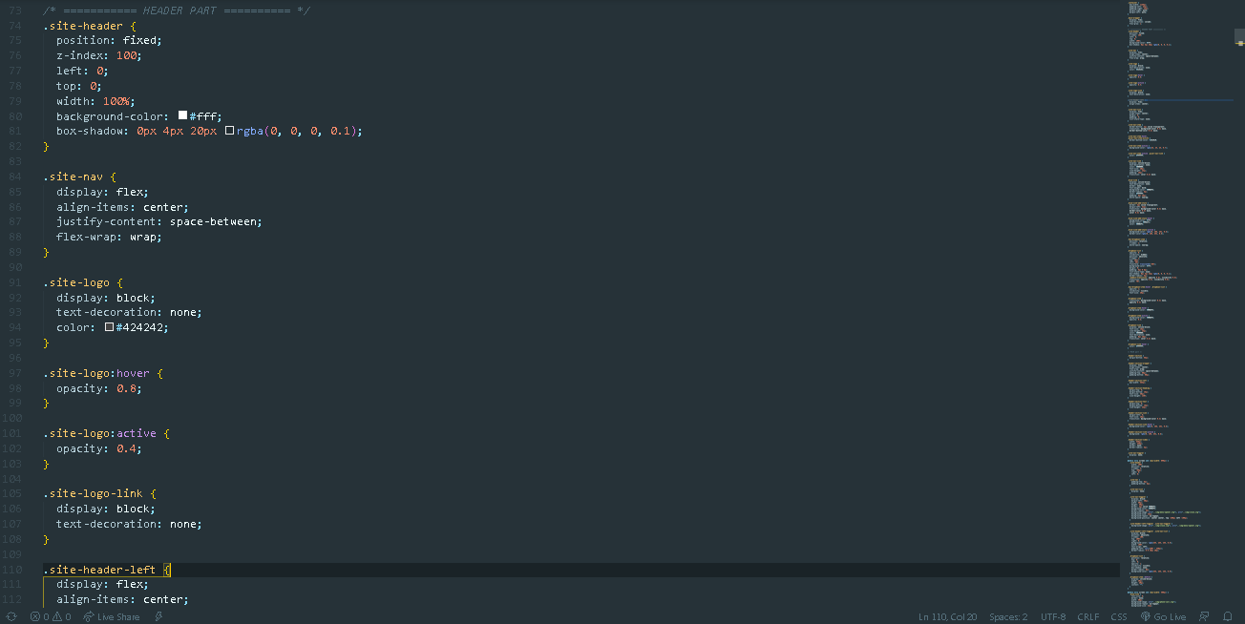

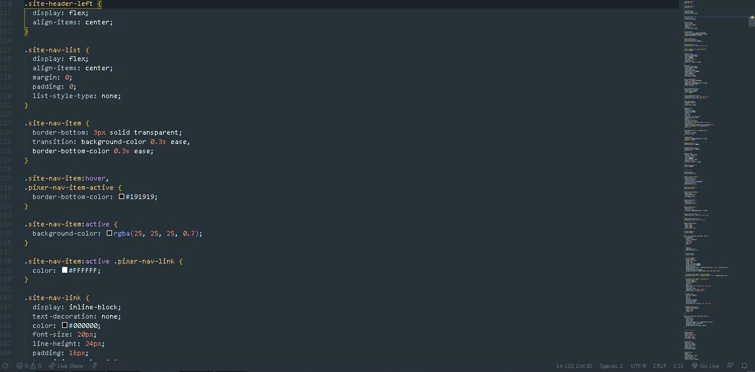

**Hero section HtML**

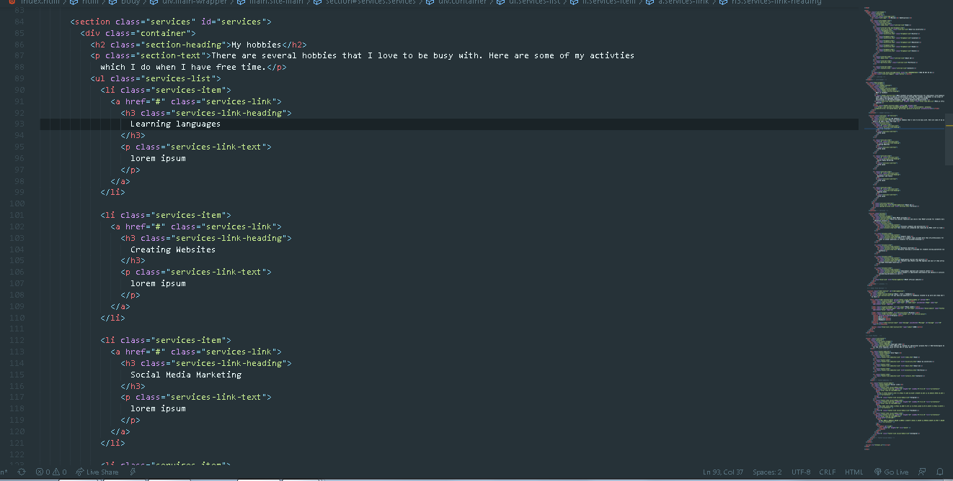

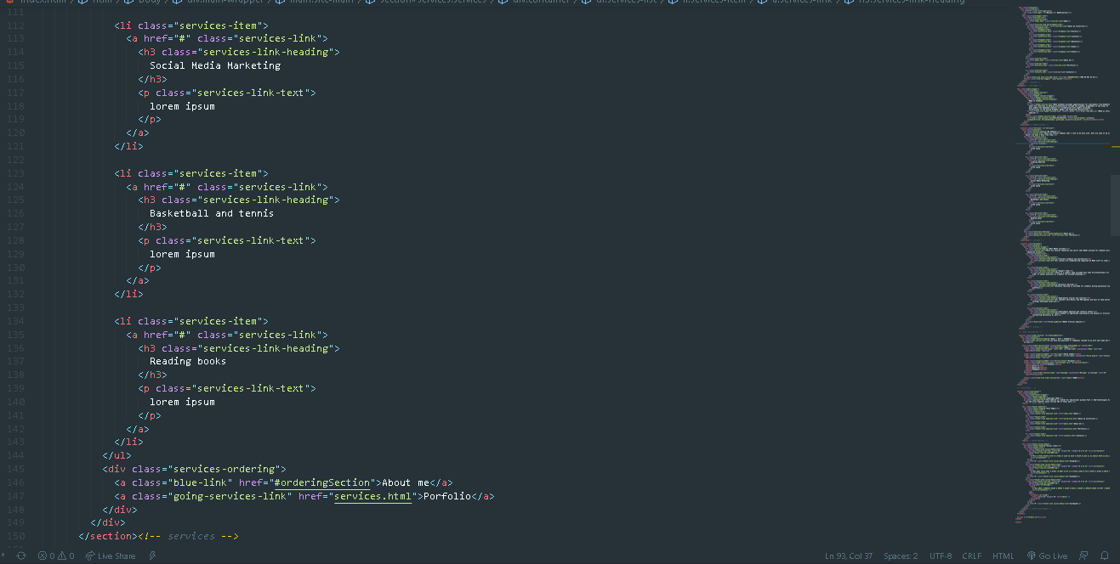

**Hobbies and MDIST webpage**

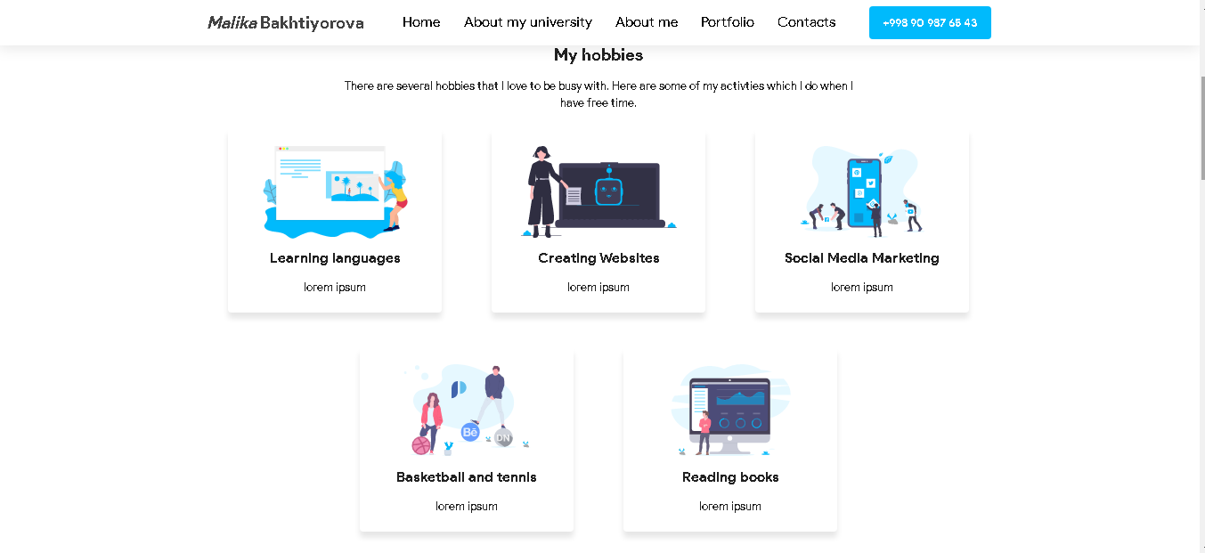

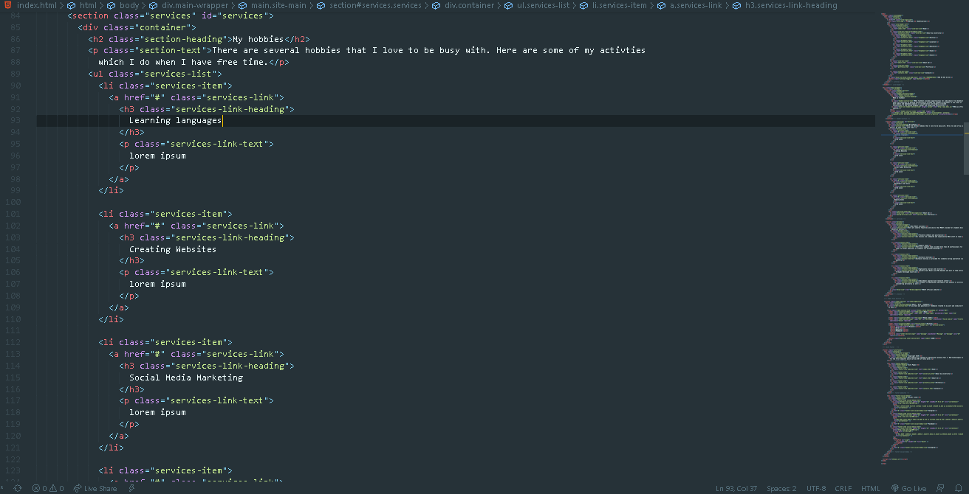

**CSS**

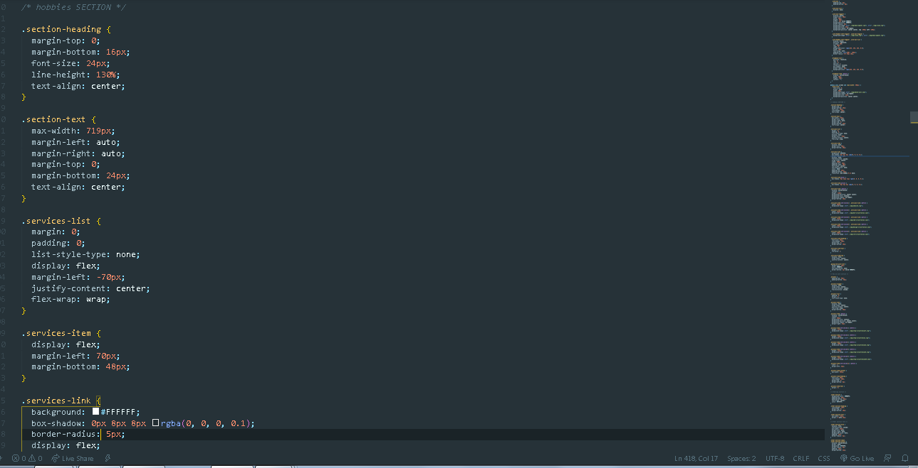

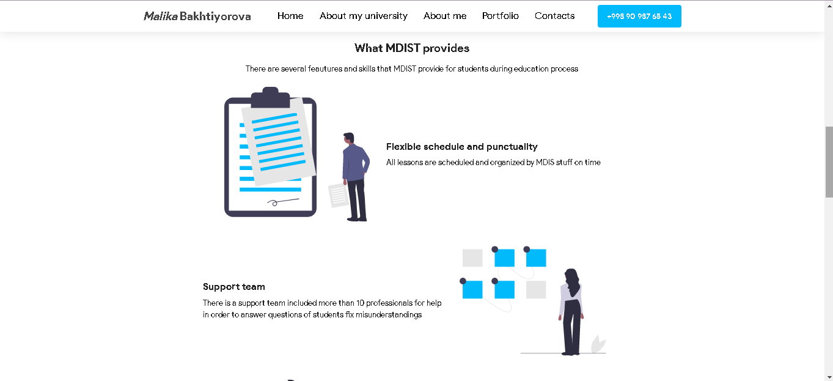

**Feautures Html**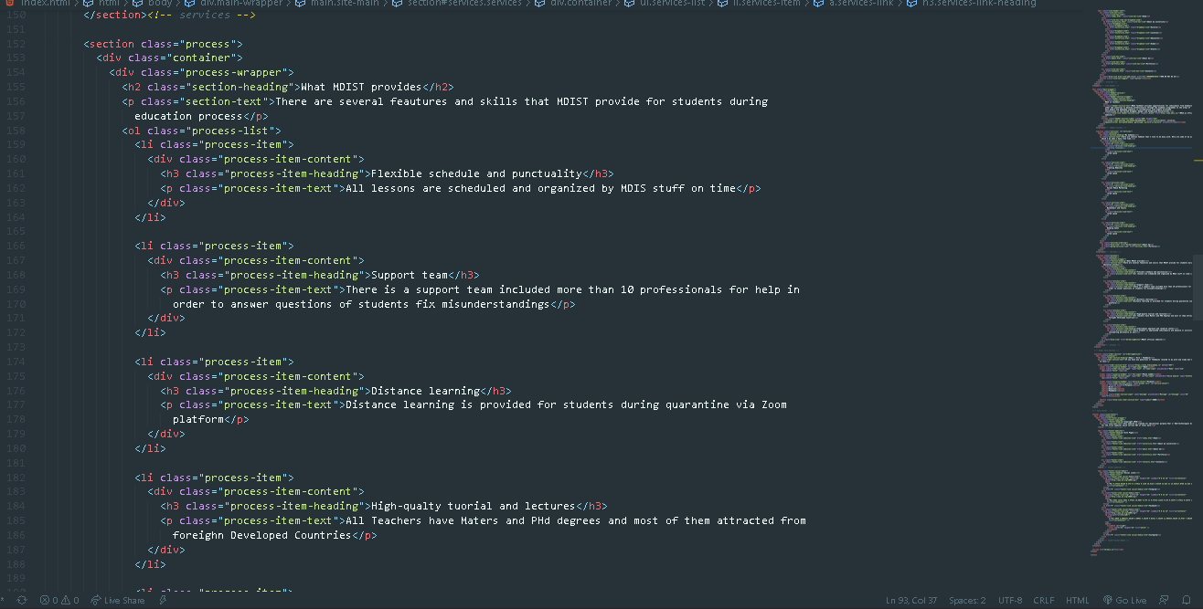

**Css**

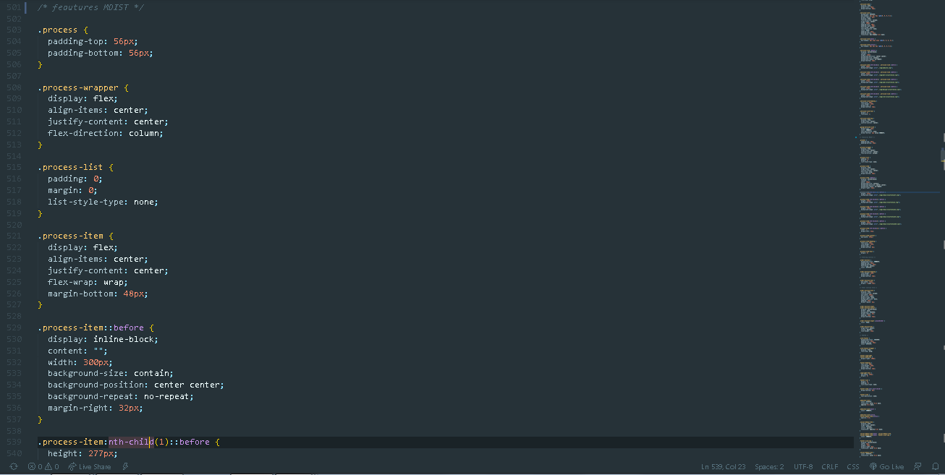

**Form**

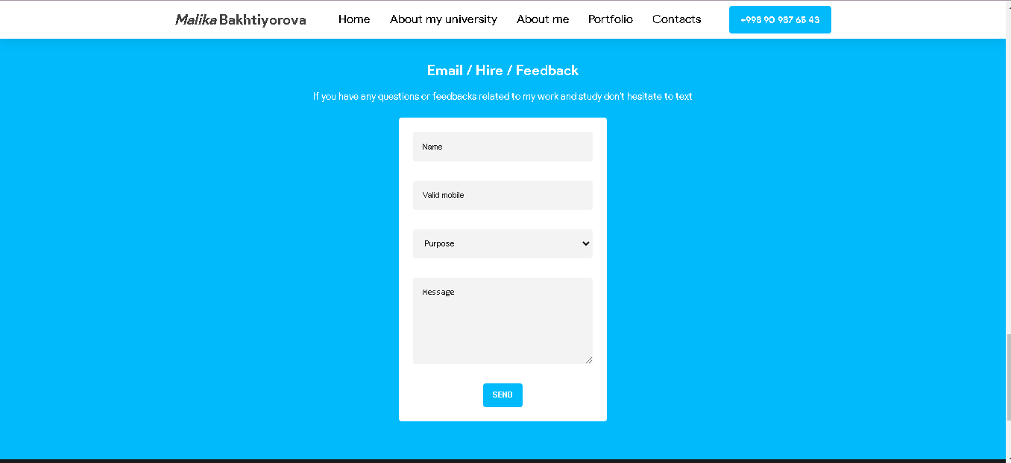

**Form section Html**

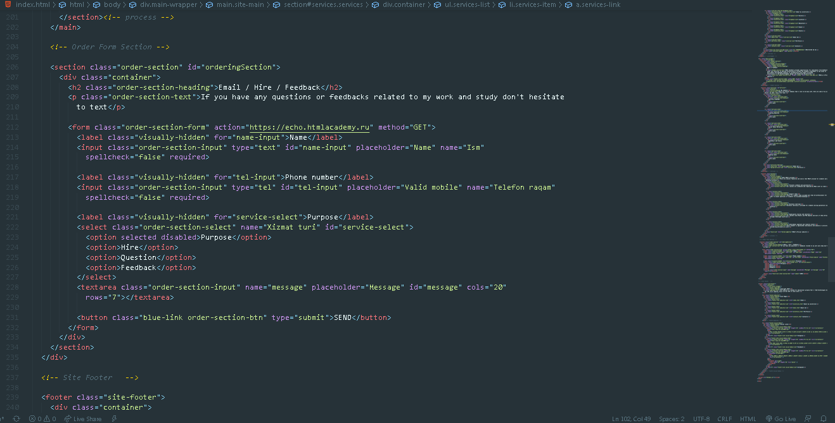

**Css**

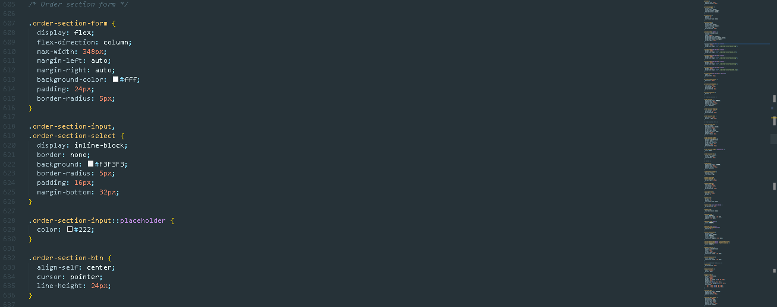

**Footer section**

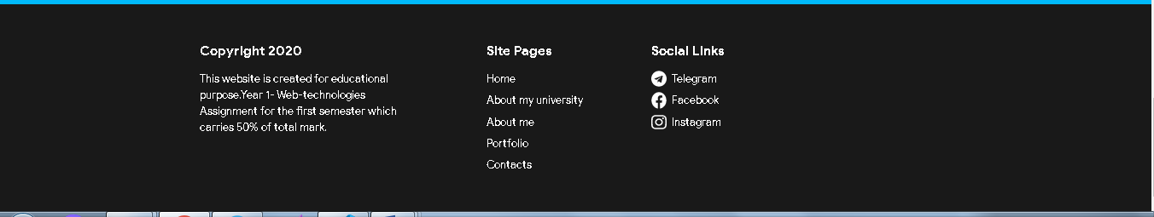

**Footer websites**

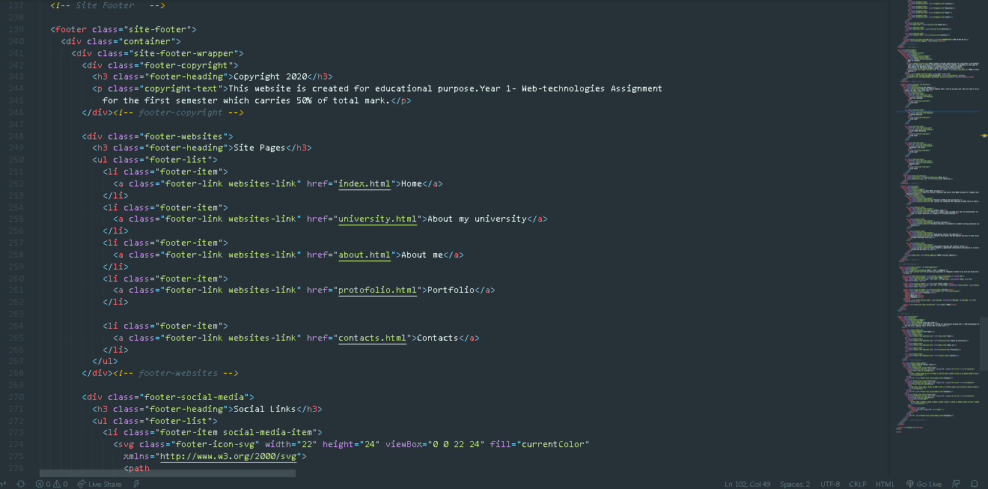

**css**

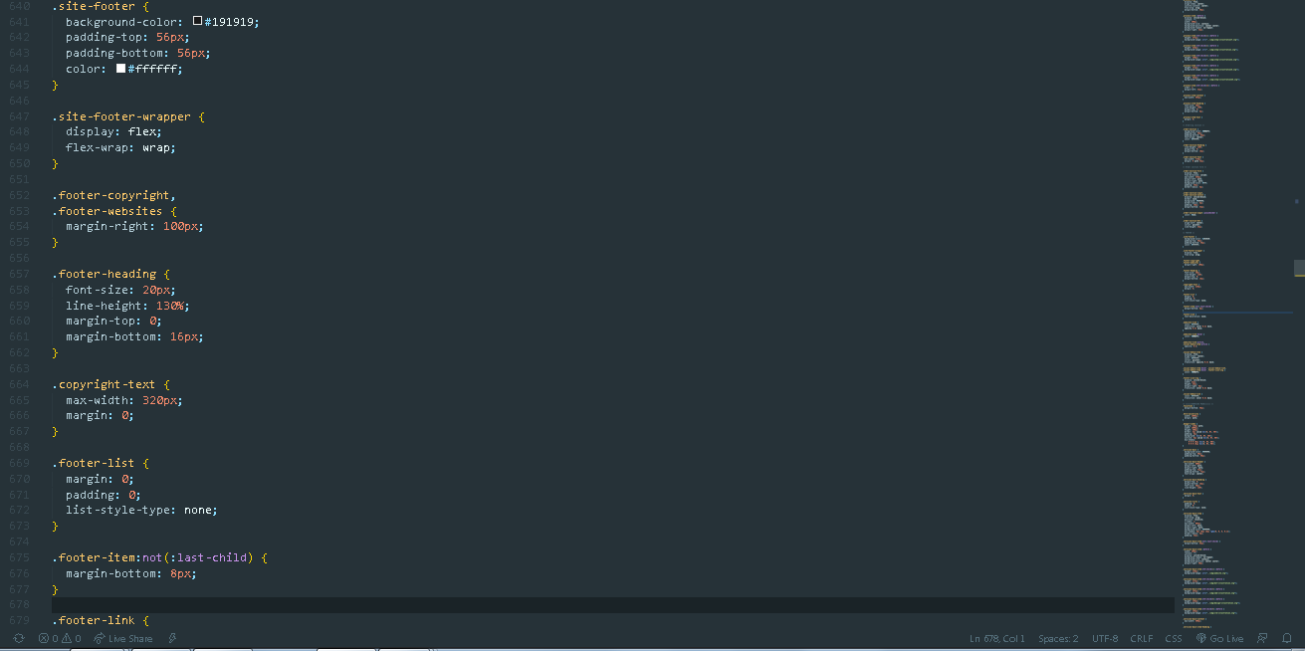

**3rd Step. Adding a Google analytics snippet**

In the 3rd step, finished Webpage has been added to Google analytics by adding the google analytic snippets on the head section of the main page “index.html”

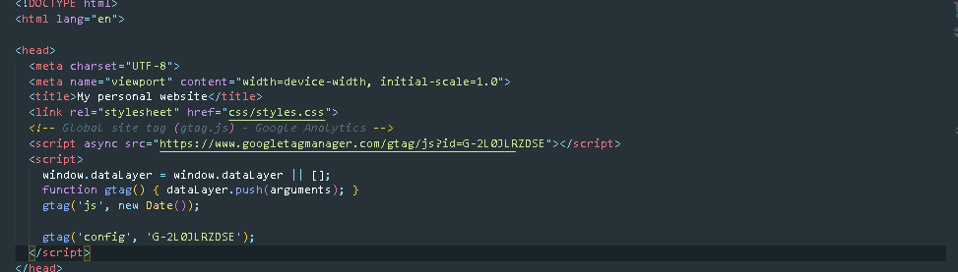

This is the summary of report in Google Analytics:

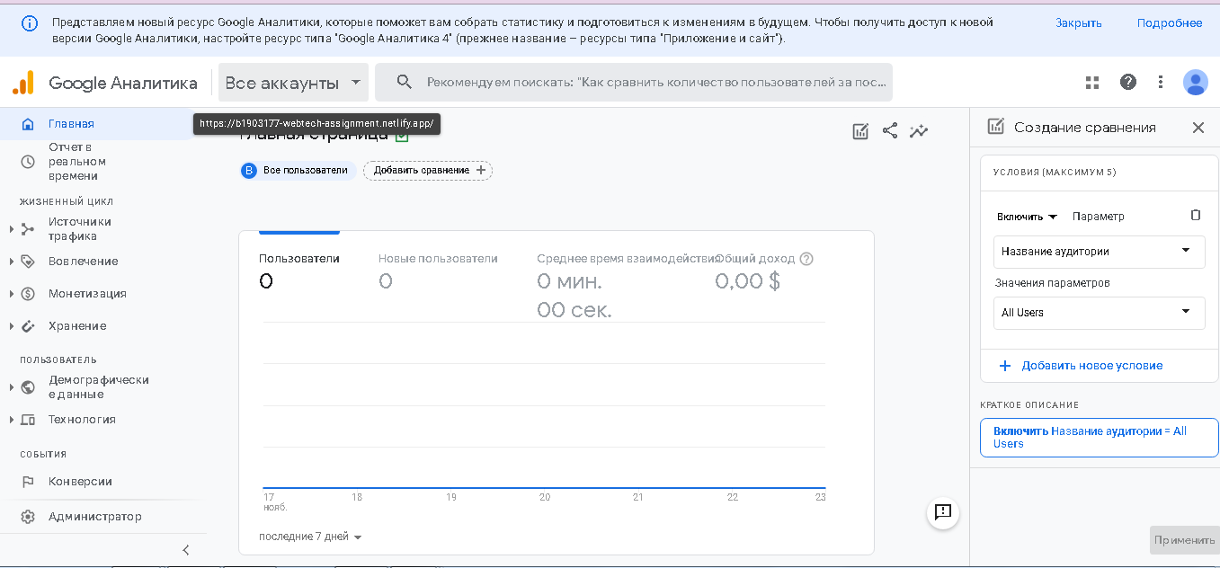

**4th Step. W3C Validation:**

**Validation**

