GYM MEMBERSHIP MANAGEMENT SYSTEM
A PROJECT REPORT
submitted in partial fulfilment of the requirements of the course
BCSE302L Database Systems
by
Student name | Register number
Liz Alex | 24BCE2978
Malika Balaji | 24BAI0114
Nehaa Prabhu | 24BAI0130

Under the guidance of
Prof. Lydia Jane G

School of Computer Science and Engineering (SCOPE)
Vellore Institute of Technology, Vellore 632014, Tamil Nadu, India
Fall Semester 2026-27 | October 2026
Source code: https://github.com/malikabalaji/gym-membership-db

Abstract

Gyms and fitness centres manage tightly linked data about members, trainers, workout plans, group classes, attendance and payments, yet many small and mid-sized gyms still keep these records in registers and disconnected spreadsheets. The result is overbooked classes, missed or untracked dues, and no reliable view of member engagement or revenue. This project designs and implements the Gym Membership Management System, a database solution built on MongoDB 8, a document-oriented NoSQL database management system.
The design followed the full database life cycle: requirements analysis, an Enhanced Entity Relationship model with a USER generalization, a relational schema normalized to third normal form, and a document model that embeds bounded, always-read-together data such as workout exercises and class rosters while referencing unbounded data such as attendance and payments. The implemented database has seven collections protected by $jsonSchema validators, nineteen secondary indexes, one read-only view, two multi-document ACID transactions and two change-stream triggers. A Python application layer of 36 CRUD functions enforces ten referential integrity rules. A reproducible dataset of 1,016 documents was loaded.
Fifteen representative queries covering selection, joins, grouping, subqueries and set operations, eight analytical aggregation pipelines and a recursive $graphLookup over the member referral network were executed on a live MongoDB 8.3 replica set. Indexing reduced a member's attendance history query from 200,000 documents examined in 80.5 ms to 105 documents in 2.1 ms, and a partial index served the dues report at one tenth of the size of a full index. Transaction tests confirmed complete rollback on failure, and all six automated tests passed.
The project shows that a carefully designed document database can provide the integrity guarantees usually associated with relational systems while giving a gym the flexible schema, fast dashboard reads and built-in analytics it needs.
Keywords: MongoDB, NoSQL, document database, data modelling, aggregation pipeline, indexing, ACID transactions, gym management.

Table of Contents

Abstract i
Table of Contents ii
List of Figures v
List of Tables vi
Part B: Main Report 1
Chapter 1: Introduction 1
1.1 Background of the Study 1
1.2 Motivation 1
1.3 Problem Statement 1
1.4 Aim and Objectives 1
1.5 Scope of the Project 2
1.6 Limitations 2
1.7 Methodology Overview 2
Chapter 2: Literature Review 3
2.1 Overview of the Application Domain and Its Data Needs 3
2.2 Review of Data Models 3
2.3 Review of Existing Systems and Related Work 4
2.4 Comparison of DBMS Platforms and Tools 4
2.5 Standards and Best Practices 4
2.6 Gap Identified 5
2.7 How This Project Addresses the Gap 5
2.8 Summary of the Chapter 5
Chapter 3: System Analysis and Requirements 6
3.1 Existing System and Its Drawbacks 6
3.2 Proposed System and Its Advantages 6
3.3 Feasibility Study 6
3.3.1 Technical Feasibility 6
3.3.2 Economic Feasibility 6
3.3.3 Operational Feasibility 6
3.4 Users, Roles and Access Needs 7
3.5 Requirements Specification 7
3.5.1 Functional Requirements 7
3.5.2 Data Requirements 7
3.5.3 Non-Functional Requirements 8
3.5.4 Hardware Requirements 8
3.5.5 Software Requirements 8
3.6 Business Rules and Constraints 9
Chapter 4: Database Design 10
4.1 Design Approach and Principles 10
4.2 System Architecture Diagram 10
4.3 Data Flow Diagram 11
4.4 Conceptual Design: ER / EER Diagram 12
4.4.1 Entities and Attributes 13
4.4.2 Relationships, Cardinality and Participation 13
4.4.3 Keys 13
4.4.4 Generalization and Specialization 14
4.5 Logical Design 14
4.6 Normalization 16
4.6.1 Functional Dependencies 16
4.6.3 Justified Denormalization 17
4.7 Physical Design 17
4.7.1 Data Types and Storage 17
4.7.2 Indexing Strategy 18
4.7.3 Partitioning 18
4.8 Integrity Constraints 18
Chapter 5: Implementation 19
5.1 Development Environment and Setup 19
5.2 DBMS, Tools and Libraries Used 19
5.5 Views and Indexes Created 19
5.7 Application Connectivity 20
5.8 Version Control and Project Repository 20
5.9 Challenges Faced and Solutions Adopted 20
Chapter 6: Query Design and Performance Tuning 21
6.1 Representative Queries 21
6.1.1 Selection 21
6.1.2 Joins 21
6.1.3 Grouping and Aggregation 22
6.1.4 Subqueries 23
6.1.5 Set Operations 24
6.1.6 Analytical Reports and Graph Query 25
6.2 Performance Tuning 25
6.2.1 Execution Plans with explain() 25
6.2.2 Benchmark at Scale 25
6.2.3 Other Tuning Measures 26
Chapter 7: Results and Discussion 27
7.1 Output Screenshots and Sample Reports 27
7.2 Evaluation Against Objectives 29
7.3 Comparison with the Existing System 29
7.4 Discussion of Findings 30
7.5 Limitations Observed 30
Chapter 8: Conclusion and Future Work 31
8.1 Summary of the Work 31
8.2 Key Contributions 31
8.3 Future Enhancements 31
8.4 Concluding Remarks 31
Part C: References and Appendices 32
References 32
Appendix A: Complete DDL Scripts 34
Appendix B: Sample Data and DML Scripts 38
B.1 Sample Documents 38
B.2 DML: Key CRUD Operations 41
Appendix C: Stored Procedures, Functions and Triggers (Full Code) 43
C.1 Transactions (transactions.py) 43
C.2 Triggers (triggers.py) 44
C.3 Sample Report Pipeline: Revenue by Month and Tier (A1) 45
Appendix D: Complete Query Set with Outputs 47
D.1 Outputs of the Query Set on MongoDB 8.3.7 (query_output.txt) 47
D.2 Output of the Index Benchmark (benchmark_output.txt) 50
Appendix E: Full-Size ER Diagram and Relational Schema 51
Appendix F: Application Screenshots 53
Appendix G: User Manual 58
G.1 Installation 58
G.2 Running the System 58
G.3 Everyday Tasks 58
G.4 Backup and Restore 58
G.5 Troubleshooting 59

List of Figures

Figure 4.1: Layered system architecture 10
Figure 4.2: Context diagram (level 0 DFD) 11
Figure 4.3: Level 1 data flow diagram 11
Figure 4.4: Enhanced Entity Relationship diagram (Chen notation, key attributes shown) 12
Figure 4.5: Relational schema in third normal form (12 relations) 14
Figure 4.6: MongoDB document model (orange arrows are ObjectId references) 15
Figure 6.1: Median query time with and without indexes at 200,000 documents 25
Figure 7.1: Collected revenue by month and membership tier (pipeline A1) 27
Figure 7.2: Attendance rate and fill rate by class (pipeline A2) 28
Figure E.1: Complete EER diagram with all attributes 51
Figure E.2: Full-size relational schema (3NF) 52
Figure F.1: Validator rejecting a member with an invalid tier 53
Figure F.2: Collections created and 1,016 sample documents loaded 53
Figure F.3: CRUD demonstration, create and read operations 53
Figure F.4: CRUD demonstration, update, delete and authentication 54
Figure F.5: Aggregation reports A1 to A5 54
Figure F.6: Aggregation reports A6 to A8 and the member_dashboard view 55
Figure F.7: Referral network with $graphLookup 55
Figure F.8: Indexes, explain() comparison and text search 56
Figure F.9: Transactions T1 and T2, commit and rollback 56
Figure F.10: Set operations Q13 to Q15 56
Figure F.11: Index benchmark at 200,000 documents 57
Figure F.12: Change-stream triggers TR1 and TR2 57

List of Tables

Table 1.1: Database life cycle followed in this project 2
Table 2.1: Comparison of data models for the gym domain 3
Table 2.2: Existing gym management systems 4
Table 2.3: DBMS platforms considered 4
Table 3.1: Cost estimate 6
Table 3.2: Users, roles and access rights 7
Table 3.3: Functional requirements 7
Table 3.4: Data requirements: entities, sources, volume and growth 7
Table 3.5: Non-functional requirements 8
Table 3.6: Hardware requirements 8
Table 3.7: Software requirements 8
Table 3.8: Business rules and how they are enforced 9
Table 4.1: Entities and their attributes 13
Table 4.2: Relationships, cardinality and participation 13
Table 4.3: Logical design of the seven collections 16
Table 4.4: Functional dependencies and normal form of each relation 16
Table 4.5: Denormalization decisions 17
Table 4.6: Indexes created 18
Table 4.7: Integrity constraints and their MongoDB implementation 18
Table 5.1: DBMS, tools and libraries 19
Table 5.2: Challenges and solutions 20
Table 6.1: Output of Q4 (first 4 rows) 22
Table 6.2: Output of Q7 22
Table 6.3: Output of Q9 23
Table 6.4: Report pipelines and graph queries 25
Table 6.5: Execution plans for the member attendance history query (sample data) 25
Table 6.6: Benchmark results 26
Table 7.1: Sample data loaded 27
Table 7.2: Class popularity report (A2) 28
Table 7.3: Members at risk (A3) and top dues (A4) 28
Table 7.4: Results of integrity, transaction and trigger tests 29
Table 7.5: Evaluation against the objectives of Section 1.4 29
Table 7.6: Existing manual system compared with the proposed system 29
Table G.1: Commands 58
Table G.2: Common problems 59

PART B: MAIN REPORT
CHAPTER 1

INTRODUCTION

1.1 Background of the Study
A modern gym offers tiered memberships, personal training, group classes and monthly billing. This data is interlinked: a member is coached by a trainer, follows that trainer's workout plan, enrols in classes, attends sessions and pays a tier-based fee. A DBMS stores such data once, enforces rules on it and answers questions efficiently [3], [4]. Relational systems [1] were long the default, but document databases such as MongoDB are now mainstream for nested, evolving data [5], [9], [10]. This project applies the course's design principles to this domain on MongoDB.

1.2 Motivation
Gyms near our campus use a paper register, a fee spreadsheet and a messaging group. Three problems recur:
- Revenue leakage: nobody sees which members owe money or for how long.
- Poor class planning: some classes are overbooked while others run half empty.
- Weak retention: members who stop attending are noticed only when they fail to renew.
Commercial software exists but is closed and subscription-priced, so we built an open system covering every stage of the database life cycle.

1.3 Problem Statement
Design and implement a database for a single gym that stores members, trainers, workout plans, classes, enrolment, attendance and payments; enforces the business rules that keep this data consistent; supports role-based access for administrators, trainers and members; produces revenue, popularity, dues and retention reports; and stays fast as history grows.

1.4 Aim and Objectives
Aim: build a reliable, well-designed and efficient gym database on MongoDB that meets real functional and non-functional requirements. The objectives (evaluated in Section 7.2) are:
- O1. Derive a document schema from a formal EER model.
- O2. Implement full CRUD for all core entities with referential integrity.
- O3. Enforce data quality in the database through validation, unique keys and constraints.
- O4. Provide analytics (revenue, popularity, attendance, dues, workload) through aggregation pipelines.
- O5. Provide authentication and role-based access for Administrator, Trainer and Member.
- O6. Ensure performance through evidence-based indexing.
- O7. Guarantee consistency of multi-document operations through transactions and triggers.
- O8. Deliver a reproducible, version-controlled implementation with data, tests and documentation.

1.5 Scope of the Project
In scope: single-gym member registration with Basic, Premium and VIP tiers; trainer profiles and personalised workout plans; class schedules, sessions and capacity-controlled enrolment; attendance; monthly billing with overdue flagging; analytical reports, a referral network, audit triggers and role-based login.
Out of scope: biometric or IoT check-in, online payment gateways, multi-branch support and a production web front end (planned as future work).

1.6 Limitations
- The sample data is synthetic, generated by a seeded script.
- One gym only; sharding was not implemented.
- The interface is command-line and mongosh; role-based screens are designed but not built.
- Referential integrity lives in the application layer because MongoDB has no foreign keys.
- Performance was measured on a single machine.

1.7 Methodology Overview
The project followed the database life cycle [3], [4] across three course reviews (Table 1.1).
Table 1.1: Database life cycle followed in this project
Phase | Outputs | Section
Requirements | User roles, 8 functional and 5 non-functional requirements, 12 business rules | Chapter 3
Conceptual design | EER diagram: 9 entities, 11 relationships, USER generalization | 4.4
Logical design | 3NF relational schema (12 relations), mapped to 7 collections | 4.5, 4.6
Physical design | BSON types, 19 indexes, validators, replica set | 4.7, 4.8
Implementation | gym_db package, mongosh DDL, data, view, transactions, triggers | Chapter 5
Testing | 6 tests, 15 queries, explain plans, benchmark | Chapters 6, 7
Maintenance | Git repository, JSON export, user manual | 5.8, Appendix G

CHAPTER 2

LITERATURE REVIEW

2.1 Overview of the Application Domain and Its Data Needs
Gym data has four characteristics that drive the database choice:
- Strong relationships: almost every record refers to a member, trainer or class.
- Hierarchical data read together: a plan with its exercises, a class with its schedule and roster.
- Fast-growing history: attendance and payments grow every week and dominate storage.
- Analytics: owners need revenue, attendance and dues aggregates, not single records.
Member contact and payment details are personal data under India's DPDP Act, 2023 [23], so passwords must be hashed and access restricted.

2.2 Review of Data Models
Table 2.1: Comparison of data models for the gym domain
Model | Strengths for a gym | Weaknesses for a gym
Relational [1], [3] | Foreign keys, checks, mature SQL | Nested data needs extra tables and joins; migrations for schema changes
Object-relational [24] | SQL plus arrays and JSON columns | Nesting is secondary; JSON weakly validated
Document [10] | Matches hierarchical data; flexible schema; rich aggregation; multi-document ACID [13] | No foreign keys; design needs discipline
Key-value | Very fast caching | No querying by attribute
Column-family [26] | Massive write throughput | Query patterns fixed in advance; no joins
Graph | Natural for referral networks | Poor fit for billing and reports
NewSQL [6], [27] | Distributed ACID SQL | Far more complexity than one gym needs

Reasons for the model chosen. The document model on MongoDB was selected because:
- Exercises, schedules and rosters are stored with their owner and read in one operation.
- Integrity is still achievable: $jsonSchema validators [11], unique indexes and multi-document transactions [13].
- The aggregation framework provides joins, faceted reports and recursive graph traversal [12], [15] without a second database.
- New fields, such as referred_by added after Review 1, need no migration.
- MongoDB is the most widely used document database [22] and is covered in the syllabus.
The relational model was still used as the rigorous intermediate design (Section 4.5), and the document model is a justified denormalization of it (Section 4.6.3).

2.3 Review of Existing Systems and Related Work
Commercial platforms such as Mindbody [21a], Glofox [21b], Zen Planner [21c] and Gymdesk [21d] offer billing, booking, check-in and reports as subscriptions [21e].
Table 2.2: Existing gym management systems
System type | Provides | Limitation
Register and spreadsheets | Zero cost, familiar | No integrity, concurrency or analytics
Commercial SaaS | Billing, booking, check-in, apps | Recurring fee; closed data model; vendor holds the data
Academic gym projects | Relational CRUD screens | Rarely include analytics, index evidence or transactions

Cattell [5] and Stonebraker [8] frame the integrity versus flexibility trade-off, Brewer [7] explains the CAP balance and Pavlo and Aslett [6] describe NewSQL. Kleppmann [9] and MongoDB's modelling guide [10] give the rule used here: embed tree-like data loaded together, reference unbounded and many-to-many data.

2.4 Comparison of DBMS Platforms and Tools
Table 2.3: DBMS platforms considered
Criterion | MySQL 8 | PostgreSQL 16 | MongoDB 8 | Cassandra 5
Data model | Relational | Object-relational | Document (BSON) | Wide column
Nested data | Separate tables | Arrays, JSONB | Native embedding | Collections
Joins | SQL | SQL | $lookup, $graphLookup | None
Transactions | ACID | ACID | Multi-document ACID | Per partition
Analytics | GROUP BY, windows | SQL plus extensions | Aggregation pipeline | Limited
Cost | Free | Free | Free Community Server | Free
Fit | Good, nesting awkward | Good | Best fit | Poor

Tools: PyMongo driver [29], mongosh and Compass, bcrypt [17], pytest with mongomock, and Git/GitHub.

2.5 Standards and Best Practices
- Design: Chen's ER model [2] and EER [3]; normalize to 3NF before denormalizing.
- Queries: an ISO SQL [20] equivalent is given for every query in Chapter 6.
- Document modelling: embed bounded data, reference unbounded data, extended reference pattern [10], [25].
- Data quality: $jsonSchema with strict validation and error action [11].
- Security: salted bcrypt hashes per OWASP [18] and NIST SP 800-63B [19]; hashes never returned.
- Performance: indexes verified with explain("executionStats") [16]; partial indexes [14].
- Reliability: replica set, majority write concern [13], mongodump backups.

2.6 Gap Identified
- Commercial systems do not let owners run custom analytics on their own data.
- Spreadsheets give no integrity, concurrency control or history.
- Academic projects stop at relational CRUD, without design justification, index measurements or transactions.
- Few student works show relational-grade integrity on a document database.

2.7 How This Project Addresses the Gap
- An open design that goes from EER to 3NF to a justified document model.
- Relational-grade integrity on MongoDB: validators, unique keys, referential actions, atomic updates, transactions.
- Analytics inside the database: 8 pipelines, a view and a recursive referral query.
- Measured performance with explain plans and a 200,000-document benchmark.
- A public repository with seeded data and tests so every result can be reproduced.

2.8 Summary of the Chapter
Gym data is related, hierarchical, fast-growing and analytical. After comparing data models, MongoDB's document model was chosen for its fit, validation, transactions, aggregation and zero cost. The project fills the gap of an open, measured and integrity-focused NoSQL design.

CHAPTER 3

SYSTEM ANALYSIS AND REQUIREMENTS

3.1 Existing System and Its Drawbacks
The existing system is a front-desk register, a fee spreadsheet, paper class lists and trainers' notebooks. Its drawbacks: duplicate and inconsistent member records; nothing prevents overbooking, double payments or deleting members with dues; concurrent edits overwrite each other; no audit trail; reports take hours; and personal data is exposed.

3.2 Proposed System and Its Advantages
One MongoDB database of seven collections, used through a Python layer and mongosh scripts, giving:
- Consistency: validators, unique keys and ten referential rules.
- Safe concurrency: atomic updates and transactions prevent lost updates and overbooking.
- Instant reports: eight pipelines run in milliseconds.
- Auditability and security: a change-stream audit log, bcrypt hashes and role-based access.
- Scalability: indexes, replica set and a shard-ready design.

3.3 Feasibility Study

3.3.1 Technical Feasibility
MongoDB 8, Python and PyMongo are mature, free and run on macOS, Windows and Linux. The only special need, a replica set for transactions, is met by a single-node replica set on a laptop. The team had the required skills. Feasible.

3.3.2 Economic Feasibility
Table 3.1: Cost estimate
Item | Development | Yearly running
MongoDB, Python, PyMongo, mongosh, Compass | INR 0 | INR 0
Hosting on the gym PC or Atlas free tier | INR 0 | INR 0
Commercial gym SaaS (for comparison) | Not applicable | Monthly fee per location

No licence cost; feasible.

3.3.3 Operational Feasibility
Staff need three daily tasks (register members, record payments, mark attendance), each a single function. Trainers already plan workouts and take roll calls, so the system digitises existing habits. Feasible.

3.4 Users, Roles and Access Needs
Table 3.2: Users, roles and access rights
Role | Main tasks | Access
Administrator | Manage members, trainers, classes, sessions, payments; run reports | Full CRUD on all collections
Trainer | Create and update plans; take attendance; view rosters | Own members, classes and plans
Member | View profile, plan, schedule, attendance, dues; enrol | Own data through member_dashboard
System | Overdue sweep, audit log, reactivation | payments, members, audit_log

3.5 Requirements Specification

3.5.1 Functional Requirements
Table 3.3: Functional requirements
ID | Requirement | Implemented by
FR1 | Admin CRUD on members, trainers, classes, payments | crud.py
FR2 | Trainers manage personalised workout plans | create_workout_plan, add_exercise
FR3 | Members view profile, plan, schedule, attendance, dues | member_dashboard view
FR4 | Class scheduling with capacity limits and enrolment | create_class, enroll_member
FR5 | Attendance per member per session | mark_attendance, T2
FR6 | Payment tracking; overdue bills flagged | record_payment, flag_overdue
FR7 | Revenue, popularity, attendance and workload reports | Pipelines A1 to A8
FR8 | Email and password login with roles | authenticate (bcrypt)

3.5.2 Data Requirements
Table 3.4: Data requirements: entities, sources, volume and growth
Entity | Source | Sample | Expected growth
Member | Registration form | 60 | About 20 per month
Trainer | HR records | 8 | A few per year
Workout plan | Trainer | 76 | About 1.3 per member per year
Class | Administrator | 8 | Rarely changes
Class session | Schedule | 64 | About 16 per week
Attendance | Roll call | 580 | About 240 per week (12,000 per year)
Payment | Front desk | 220 | 1 per member per month

Attendance and payments are unbounded, so they are kept in their own collections.

3.5.3 Non-Functional Requirements
Table 3.5: Non-functional requirements
ID | Category | Requirement and how it is met
NFR1 | Performance | Dashboard queries under 100 ms; member history 2.1 ms on 200,000 rows (Section 6.2)
NFR2 | Concurrency | No lost updates: atomic conditional updates and snapshot-isolated transactions
NFR3 | Security | bcrypt hashes never returned; role-based access; audit trail
NFR4 | Usability, availability | Simple commands; replica set failover when run with three nodes
NFR5 | Consistency, backup | Validators, keys, transactions, journaling, mongodump and JSON export

3.5.4 Hardware Requirements
Table 3.6: Hardware requirements
Component | Minimum | Used
Processor | 64-bit dual core | Apple M-series, x86-64 Linux
Memory | 4 GB | 8 GB and above
Storage | 2 GB free | SSD

3.5.5 Software Requirements
Table 3.7: Software requirements
Software | Version | Purpose
MongoDB Community Server | 8.0+ (tested 8.3.7, 8.3.11) | DBMS, replica set rs0
mongosh | 2.x | DDL and query scripts
Python, PyMongo, bcrypt | 3.10+, 4.x, 4.x | Application layer
pytest, mongomock | 8.x, 4.x | Tests
Git | 2.x | Version control

3.6 Business Rules and Constraints
Table 3.8: Business rules and how they are enforced
No. | Rule | Enforced by
BR1 | One tier (Basic, Premium, VIP) and one status (active, expired, frozen) per member | Validator enum
BR2 | Monthly fee: Basic 1,500, Premium 2,500, VIP 4,000 INR | create_invoice
BR3 | Emails are unique | Unique indexes
BR4 | At most one trainer per member, and it must exist | create_member
BR5 | Plans come from the assigned trainer; one active plan per member | create_workout_plan
BR6 | Only active members enrol; never above capacity; no duplicates | Atomic enroll_member
BR7 | One attendance record per member per session | uq_session_member
BR8 | Pending bills past due become overdue | flag_overdue
BR9 | Paid bills cannot change | record_payment, delete_payment
BR10 | No deleting members with dues or trainers with members or classes | delete_member, delete_trainer
BR11 | Renewal records payment and new end date together or not at all | Transaction T1
BR12 | Paying a bill reactivates an expired membership | Trigger TR2

CHAPTER 4

DATABASE DESIGN

4.1 Design Approach and Principles
The design went from a technology-independent EER model (4.4) to a 3NF relational schema (4.5, 4.6) and then, by documented denormalization, to a MongoDB document model (4.6.3). Principles:
- Model for the queries: each main screen needs one document read.
- Embed bounded, reference unbounded [9], [10].
- Integrity first: every rule in Section 3.6 is enforced by the database or one application function.
- Evidence for performance: every index serves a named query and is verified (Section 6.2).

4.2 System Architecture Diagram
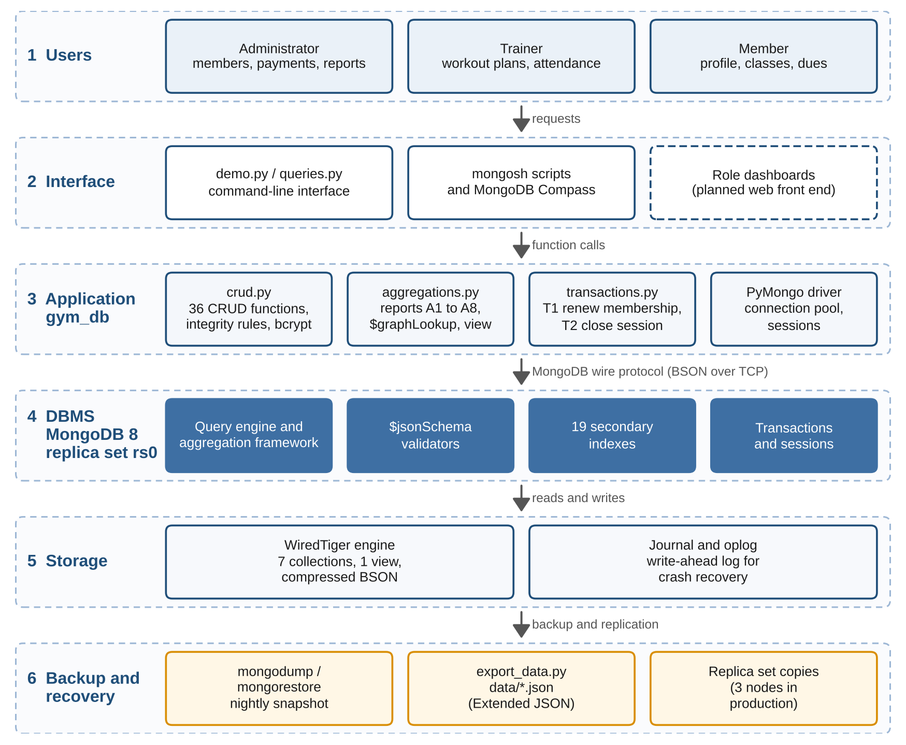
Figure 4.1: Layered system architecture
Users (administrator, trainer, member) work through the interface layer (demo.py, queries.py, mongosh, Compass). The application layer, the gym_db package, holds CRUD, reports, transactions and triggers and talks to MongoDB 8 (replica set rs0) through PyMongo. WiredTiger stores compressed BSON with a journal and oplog, and mongodump plus JSON export provide backups.

4.3 Data Flow Diagram
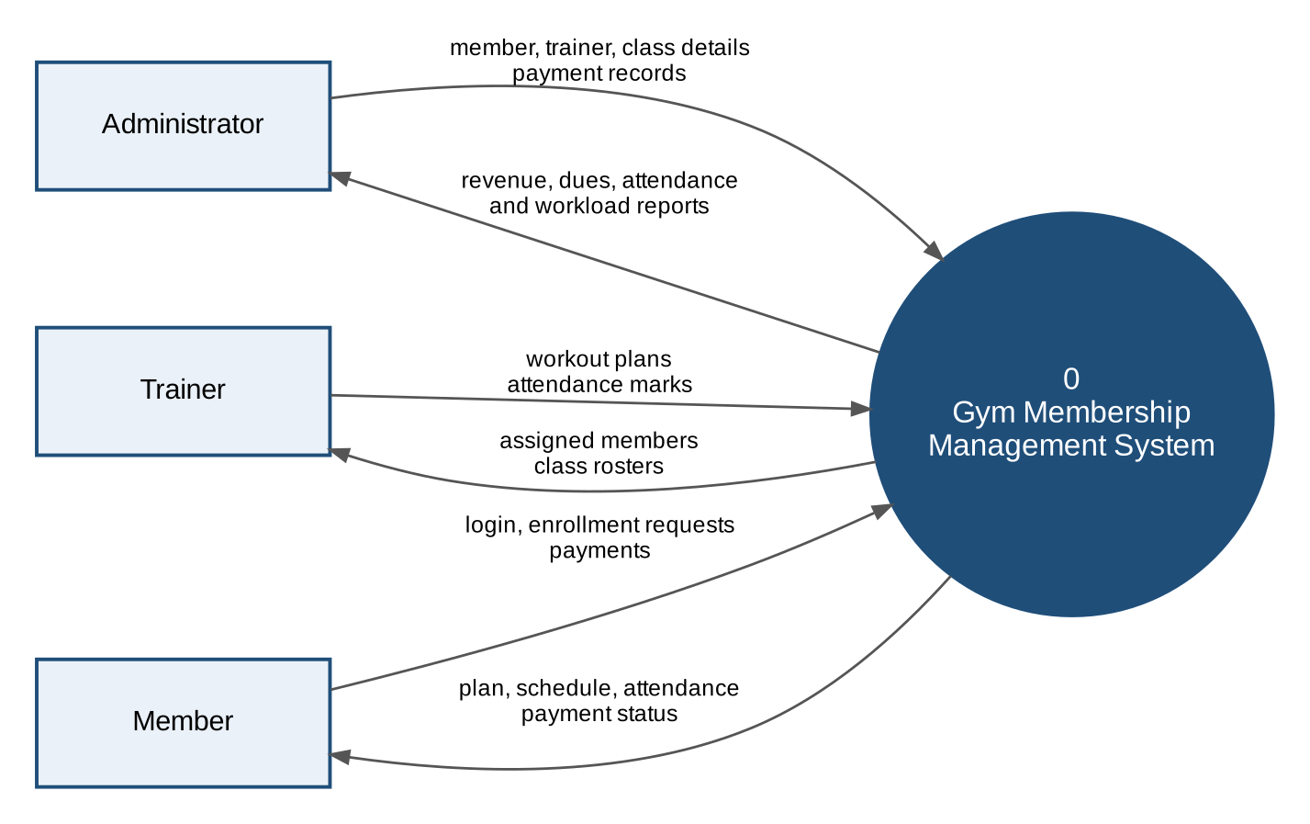
Figure 4.2: Context diagram (level 0 DFD)
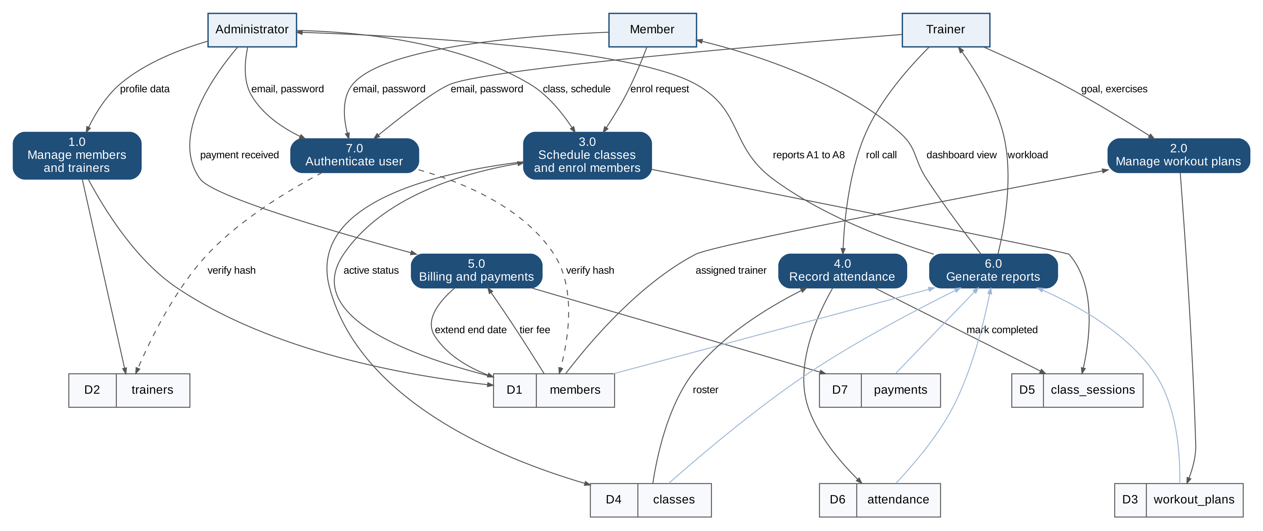
Figure 4.3: Level 1 data flow diagram
The level 1 DFD splits the system into seven processes (members and trainers, plans, classes and enrolment, attendance, billing, reporting, authentication). Data stores D1 to D7 are the seven collections.

4.4 Conceptual Design: ER / EER Diagram
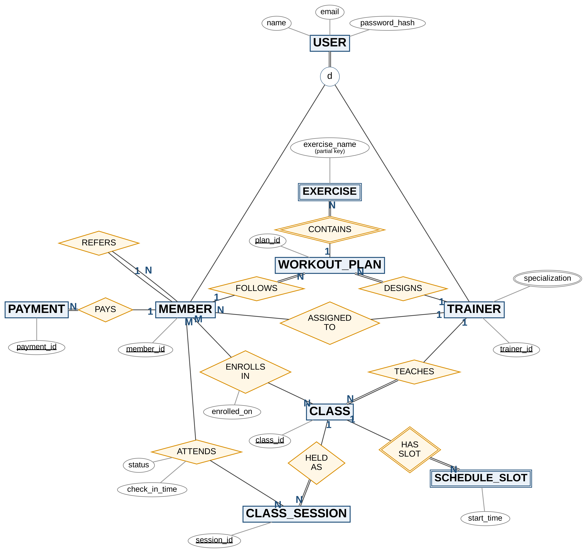
Figure 4.4: Enhanced Entity Relationship diagram (Chen notation, key attributes shown)
Chen notation: double rectangles are weak entities, double diamonds identifying relationships, double lines total participation and the circle d a disjoint specialization. The complete diagram is Figure E.1.

4.4.1 Entities and Attributes
Table 4.1: Entities and their attributes
Entity | Type | Attributes
USER | Superclass | name, email, phone, password_hash, role
MEMBER | Subclass | member_id (key), dob, gender, membership (type, status, start, end), address, emergency_contact
TRAINER | Subclass | trainer_id (key), certification, experience_years, specialization (multivalued), availability (multivalued)
WORKOUT_PLAN | Strong | plan_id (key), goal, duration_weeks, status, created_at, updated_at
EXERCISE | Weak | exercise_name (partial key), day, sets, reps, weight_kg, notes
CLASS | Strong | class_id (key), class_name, category, capacity
SCHEDULE_SLOT | Weak | day_of_week, start_time (partial key), end_time, room
CLASS_SESSION | Strong | session_id (key), date, start_time, end_time, status
PAYMENT | Strong | payment_id (key), amount, currency, mode, status, billing period, payment_date, due_date

4.4.2 Relationships, Cardinality and Participation
Table 4.2: Relationships, cardinality and participation
Relationship | Entities | Cardinality | Total participation
ASSIGNED_TO | TRAINER, MEMBER | 1 : N | None
REFERS (recursive) | MEMBER, MEMBER | 1 : N | None
FOLLOWS / DESIGNS | MEMBER / TRAINER, WORKOUT_PLAN | 1 : N | WORKOUT_PLAN
CONTAINS (identifying) | WORKOUT_PLAN, EXERCISE | 1 : N | EXERCISE
TEACHES | TRAINER, CLASS | 1 : N | CLASS
ENROLLS_IN (enrolled_on) | MEMBER, CLASS | M : N | None
HAS_SLOT (identifying) | CLASS, SCHEDULE_SLOT | 1 : N | SCHEDULE_SLOT
HELD_AS | CLASS, CLASS_SESSION | 1 : N | CLASS_SESSION
ATTENDS (status, check_in_time) | MEMBER, CLASS_SESSION | M : N | None
PAYS | MEMBER, PAYMENT | 1 : N | PAYMENT

4.4.3 Keys
- Primary keys: _id (ObjectId) on every document; readable business keys (MEM1001, TRN01, WP5001, CLS01, SES9001, PAY7001).
- Candidate key: email for MEMBER and TRAINER (unique index).
- Partial keys: EXERCISE by plan plus exercise_name; SCHEDULE_SLOT by class plus day and start time.
- Relationship key: ATTENDS by (session, member), unique index uq_session_member.
- Foreign keys: ObjectId references checked by the application (Section 4.8).

4.4.4 Generalization and Specialization
MEMBER and TRAINER specialise USER. The specialization is disjoint and total, mapped as one collection per subclass [3] because the two are always queried separately. The role field marks the subclass and login searches both collections.

4.5 Logical Design
The EER model was mapped to 12 relations in 3NF (Figure 4.5) with the standard algorithm [3]: weak entities and multivalued attributes became relations, the M:N relationships became ENROLLMENT and ATTENDANCE, and 1:N relationships became foreign keys.
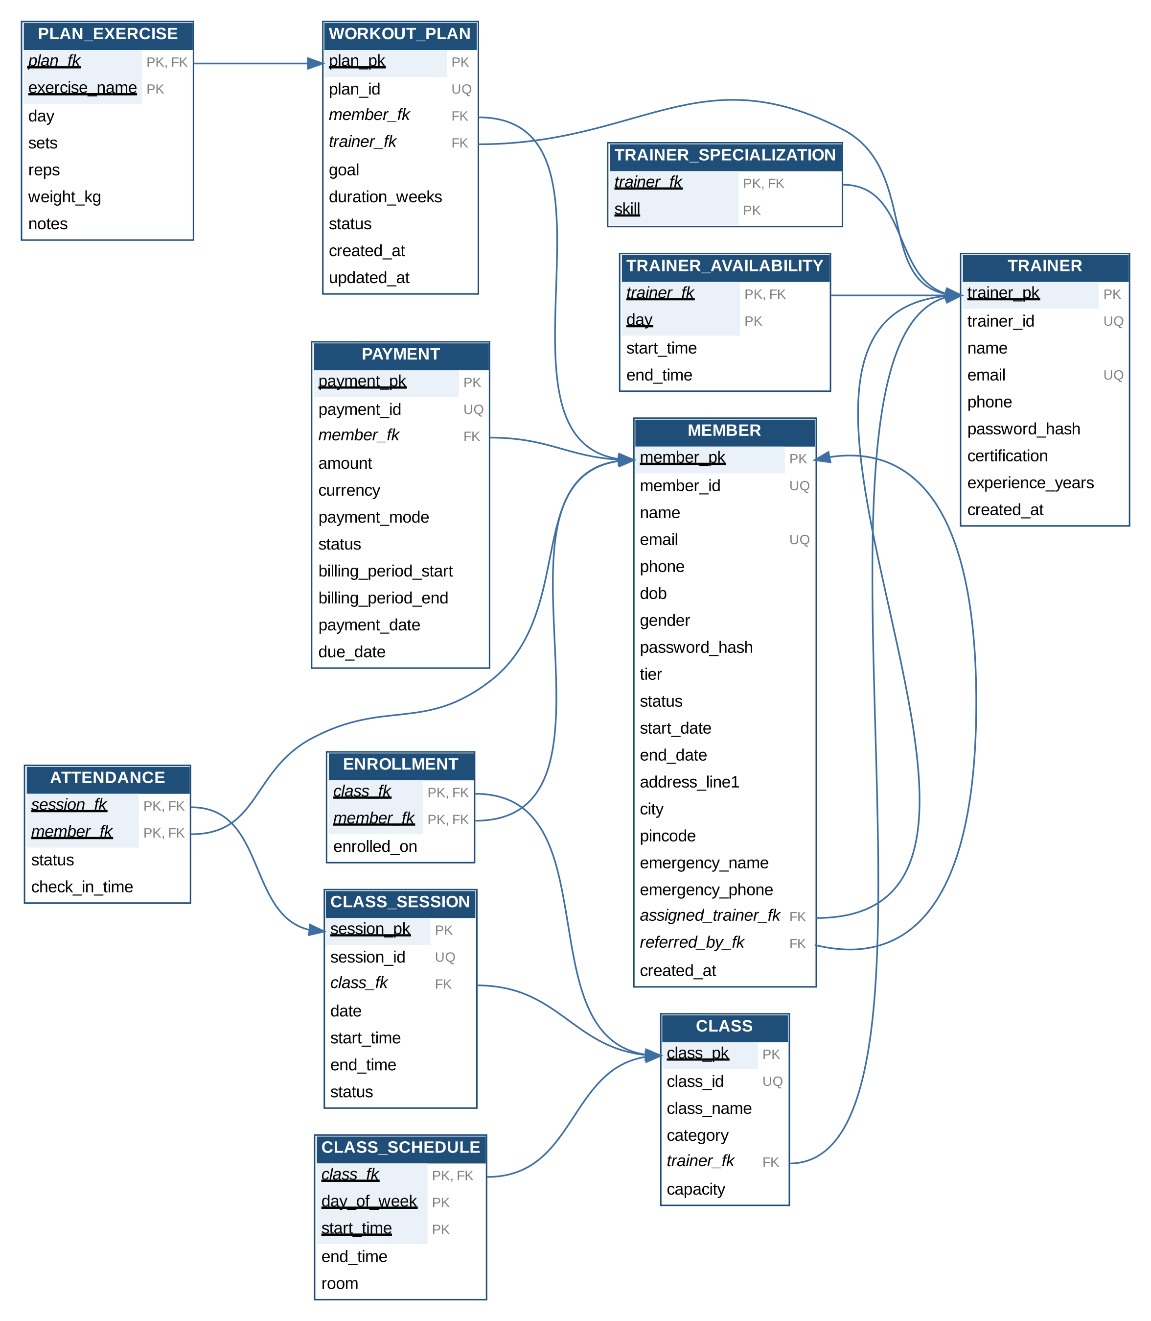
Figure 4.5: Relational schema in third normal form (12 relations)
Five relations were then embedded into their owners (specializations and availability into trainers, exercises into workout_plans, schedule and enrollment into classes), giving seven collections (Figure 4.6).
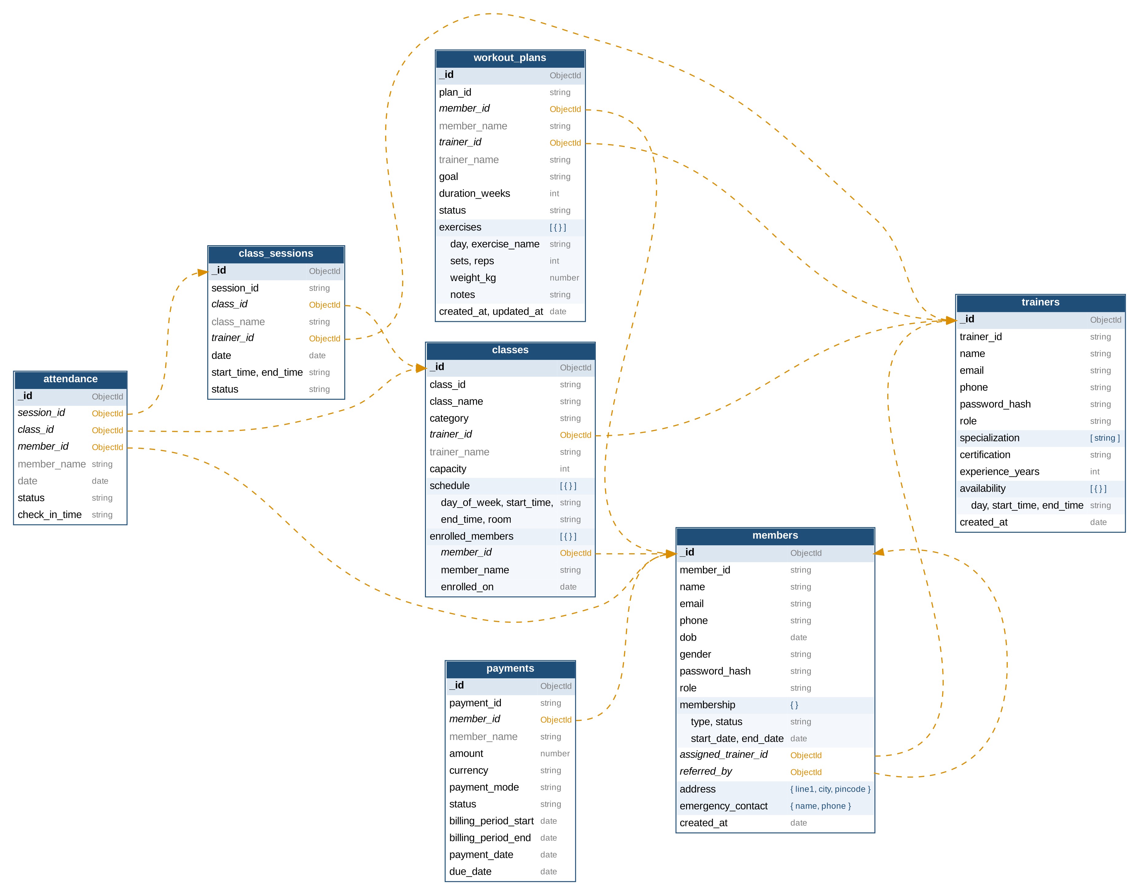
Figure 4.6: MongoDB document model (orange arrows are ObjectId references)
Table 4.3 gives the logical design of every collection (all have _id ObjectId as primary key; "ref" marks an ObjectId reference).
Table 4.3: Logical design of the seven collections
Collection | Fields and types | Key constraints
members | member_id, name, email, phone, password_hash, role (string); dob, created_at (date); membership {type, status, start_date, end_date}; assigned_trainer_id, referred_by (ref or null); address, emergency_contact (object) | member_id ^MEM[0-9]{4}$ and email unique; tier and status enums; phone 10 digits
trainers | trainer_id, name, email, phone, password_hash, certification (string); experience_years (int); specialization (array of string); availability (array of {day, start_time, end_time}) | trainer_id ^TRN[0-9]{2}$ and email unique; experience at least 0
workout_plans | plan_id, goal, status (string); member_id, trainer_id (ref); member_name, trainer_name (copies); duration_weeks (int); exercises (array of {day, exercise_name, sets, reps, weight_kg, notes}) | duration 1 to 52; at least 1 exercise; sets and reps at least 1; status active or completed
classes | class_id, class_name, category (string); trainer_id (ref), trainer_name; capacity (int); schedule (array); enrolled_members (array of {member_id ref, member_name, enrolled_on}) | capacity 1 to 50; roster never exceeds capacity
class_sessions | session_id, class_name, start_time, end_time, status (string); class_id, trainer_id (ref); date (date) | status scheduled, completed or cancelled
attendance | session_id, class_id, member_id (ref); member_name; date (date); status; check_in_time (HH:MM or null) | (session_id, member_id) unique; status present, late or absent
payments | payment_id, member_name, currency, payment_mode, status; member_id (ref); amount (double); billing_period_start, billing_period_end, payment_date, due_date (date) | amount at least 0; mode cash, card, UPI or null; status paid, pending or overdue

4.6 Normalization

4.6.1 Functional Dependencies
Table 4.4: Functional dependencies and normal form of each relation
Relation | Functional dependencies | Normal form
MEMBER, TRAINER | pk → all; business id → pk; email → pk | BCNF
TRAINER_SPECIALIZATION | (trainer, skill) is the whole key | BCNF
TRAINER_AVAILABILITY | (trainer, day) → start_time, end_time | BCNF
WORKOUT_PLAN | plan_pk → member, trainer, goal, duration, status | BCNF
PLAN_EXERCISE | (plan, exercise_name) → day, sets, reps, weight_kg | BCNF
CLASS | class_pk → name, category, trainer, capacity | BCNF
CLASS_SCHEDULE | (class, day, start_time) → end_time, room | BCNF
ENROLLMENT | (class, member) → enrolled_on | BCNF
CLASS_SESSION | session_pk → class, date, times, status | BCNF
ATTENDANCE | (session, member) → status, check_in_time | BCNF
PAYMENT | payment_pk → member, amount, mode, status, dates | 3NF

- 1NF: multivalued attributes, repeating groups and rosters moved to their own relations; composites flattened.
- 2NF: in every composite-key relation (PLAN_EXERCISE, ATTENDANCE, ENROLLMENT) non-key attributes depend on the whole key.
- 3NF: no transitive dependencies, for example trainer name is not stored in CLASS. Every determinant is a key, so the relations are also BCNF.
- PAYMENT: amount comes from the tier at billing time and must not change if the tier changes later, so storing it is correct.

4.6.3 Justified Denormalization
Table 4.5: Denormalization decisions
Decision | Reason | Consistency kept by
Embed exercises in workout_plans | Always read together; bounded | Atomic $push, $inc, $pull
Embed specializations and availability in trainers | Small lists read with profile | $addToSet
Embed schedule and roster in classes | Shown together; roster at most 50 | Capacity check in update filter
Copy member, trainer and class names | Avoid a $lookup per row | update_member propagates renames
Store class_id and date in attendance | Reports without joining sessions | Copied at insert; sessions never move
Keep attendance and payments separate | Unbounded growth, 16 MB document limit | References plus indexes

4.7 Physical Design

4.7.1 Data Types and Storage
BSON types: ObjectId (12 bytes) for keys and references, string for codes and enums, int for counts, double for money and weights, date (8 bytes, UTC) for dates; times of day are HH:MM strings. WiredTiger compresses collections (Snappy) and indexes (prefix compression) and uses a journal for crash recovery. The largest document (a full class) is under 10 KB against the 16 MB limit [10].

4.7.2 Indexing Strategy
Table 4.6: Indexes created
Collection | Index | Keys (type) | Query served
members | uq_email, uq_member_id | email; member_id (unique) | Login, lookup
members | ix_trainer, ix_referred_by | assigned_trainer_id; referred_by | Workload; $graphLookup
members | ix_tier_status | membership.type, status (compound) | Member filters
trainers | uq_email, uq_trainer_id | email; trainer_id (unique) | Login, lookup
workout_plans | ix_member_status, ix_trainer | member_id, status; trainer_id | Active plan; trainer's plans
classes | ix_trainer | trainer_id | Workload, delete checks
classes | ix_enrolled_member | enrolled_members.member_id (multikey) | Member's classes
classes | tx_class_search | class_name, category (text) | Class search
class_sessions | ix_class_date | class_id, date | Timetable
attendance | ix_member_date | member_id, date desc | Member history
attendance | uq_session_member | session_id, member_id (unique) | One mark per session
attendance | ix_class_status | class_id, status | Popularity, absentees
payments | ix_member_status, ix_due_date | member_id, status; due_date | Dues; overdue sweep
payments | px_unpaid_dues | status, due_date (partial: unpaid) | Dues reports

Compound indexes follow the equality, sort, range rule, so member history needs no in-memory sort. The partial index stores only unpaid bills and stays small as paid history grows.

4.7.3 Partitioning
Not needed for one gym. For multiple branches, attendance and payments could be sharded on a hashed member_id (or branch_id, member_id). Replication (rs0) is used for availability.

4.8 Integrity Constraints
Table 4.7: Integrity constraints and their MongoDB implementation
Constraint | Implementation
Primary key, unique | _id; unique indexes on email, member_id, trainer_id, (session_id, member_id)
Not null, check | Validator required, enum, pattern, minimum/maximum, minItems
Default | Application defaults: status active, currency INR, created_at now
Foreign key | References checked before every insert and update (_require)
RESTRICT | Members with unpaid bills; trainers with members or classes
CASCADE | Deleting a member removes plans and roster entries; deleting a class removes future sessions
SET NULL | Deleting a member clears referred_by of members they referred
Cascade update | A rename updates every copied member_name
Cross-document rules | Atomic capacity check; transactions T1, T2; triggers TR1, TR2

CHAPTER 5

IMPLEMENTATION

5.1 Development Environment and Setup
Developed on macOS (Homebrew, MongoDB 8.3.11) and Linux (MongoDB 8.3.7), each as a single-node replica set for transactions and change streams. Full steps are in Appendix G.
brew install mongodb-community # add replication: replSetName: rs0 to mongod.conf
brew services restart mongodb-community && mongosh --eval "rs.initiate()"
git clone https://github.com/malikabalaji/gym-membership-db.git && cd gym-membership-db
python3 -m venv .venv && source .venv/bin/activate && pip install -r requirements.txt
python demo.py # build, seed, demonstrate

5.2 DBMS, Tools and Libraries Used
Table 5.1: DBMS, tools and libraries
Component | Version | Role
MongoDB Community Server | 8.3.7, 8.3.11 | Server, replica set rs0
mongosh | 2.14 | ddl.js, queries.js
Python, PyMongo | 3.12, 4.x | Application layer and driver
bcrypt | 4.x | Password hashing
pytest, mongomock | 8.x, 4.x | Offline tests
Git, GitHub | Latest | Version control

Repository layout: gym_db/ (config, schema, indexes, seed, crud, aggregations, transactions, triggers), demo.py, queries.py, benchmark.py, mongosh/ (DDL and queries), data/ (JSON export), tests/ and docs/.

5.5 Views and Indexes Created
View. member_dashboard joins each member's trainer name and payments, totals unpaid bills and hides the password hash (FR3):
MEMBER_DASHBOARD_PIPELINE = [
{"$lookup": {"from": "trainers", "localField": "assigned_trainer_id", "foreignField": "_id",
"as": "t"}},
{"$lookup": {"from": "payments", "localField": "_id", "foreignField": "member_id", "as": "p"}},
{"$project": {"_id": 0, "member_id": 1, "name": 1, "tier": "$membership.type",
"status": "$membership.status", "trainer": {"$first": "$t.name"},
"unpaid_amount": {"$sum": {"$map": {
"input": {"$filter": {"input": "$p", "as": "x", "cond": {"$ne": ["$$x.status",
"paid"]}}},
"as": "u", "in": "$$u.amount"}}}}},
]

Indexes. The 19 indexes of Table 4.6 are created by indexes.py and mongosh/ddl.js (Appendix A), for example:
db.attendance.createIndex({ member_id: 1, date: -1 }, { name: "ix_member_date" });
db.payments.createIndex({ status: 1, due_date: 1 },
{ name: "px_unpaid_dues", partialFilterExpression: { status: { $in: ["pending",
"overdue"] } } });
Validators, transactions and triggers. Each collection has a $jsonSchema validator; a member with tier "Gold" is rejected with error 121 (Figure F.1). Transactions T1 (renew membership) and T2 (close a session) and triggers TR1 (audit) and TR2 (reactivation) are in Appendix C.

5.7 Application Connectivity
PyMongo, the official driver, plays the role of JDBC or ODBC [29]. One pooled MongoClient is created from the MONGO_URI environment variable. start_session() with with_transaction() gives ACID transactions with majority write concern and automatic retry; db.watch() opens the change streams for triggers; documents map directly to Python dictionaries, so no ORM is needed; and get_db(mock=True) runs everything offline on mongomock.

5.8 Version Control and Project Repository
All code, data, outputs, reports and screenshots are on GitHub at https://github.com/malikabalaji/gym-membership-db, with a README covering every command. Each review stage was committed separately.

5.9 Challenges Faced and Solutions Adopted
Table 5.2: Challenges and solutions
Challenge | Solution
No foreign keys in MongoDB | Ten referential rules in the application layer
Two members booking the last place at once | Capacity check inside the update filter ($expr, $size), one atomic operation
Transactions fail on a standalone server | Single-node replica set (rs.initiate())
Homebrew rejected the untrusted tap | brew trust mongodb/brew
Keeping copied names consistent | update_member propagates renames, including inside arrays
Testing without a server | mongomock with a $round shim; server-only features verified live
Row order varied between runs | Tie-break sort keys
Index timings were 0 ms on 580 rows | benchmark.py with 200,000 documents

CHAPTER 6

QUERY DESIGN AND PERFORMANCE TUNING

6.1 Representative Queries
Fifteen queries cover selection, joins, grouping, subqueries and set operations. Each is shown in MongoDB syntax with its SQL equivalent and its output on the live MongoDB 8.3.7 replica set. Full outputs are in Appendix D.

6.1.1 Selection
Q1. Active VIP members in Chennai.
db.members.find({ "membership.type": "VIP", "membership.status": "active",
"address.city": "Chennai" },
{ _id: 0, member_id: 1, name: 1,
"membership.end_date": 1 }).sort({ member_id: 1 })
-- SQL: SELECT member_id, name, end_date FROM members
-- WHERE tier='VIP' AND status='active' AND city='Chennai' ORDER BY member_id;
Output: MEM1014 Divya Das (ends 2026-12-31), MEM1043 Gautham Nair (2027-05-31), MEM1046 Nandini Menon (2027-02-28).
Q2. Trainers of Yoga or CrossFit with at least 6 years of experience.
db.trainers.find({ specialization: { $in: ["Yoga", "CrossFit"] },
experience_years: { $gte: 6 } },
{ _id: 0, trainer_id: 1, name: 1,
experience_years: 1 }).sort({ experience_years: -1 })
-- SQL: SELECT DISTINCT t.trainer_id, t.name, t.experience_years FROM trainers t
-- JOIN trainer_specializations s ON s.trainer_id = t.trainer_id
-- WHERE s.skill IN ('Yoga','CrossFit') AND t.experience_years >= 6 ORDER BY 3 DESC;
Output: Deepa Krishnan (9), Vivek Nair (8), Kavitha Reddy (7), Priya Menon (6).
Q3. Unpaid bills past their due date, oldest first.
db.payments.find({ status: { $in: ["pending", "overdue"] },
due_date: { $lt: ISODate("2026-09-24") } },
{ _id: 0, payment_id: 1, member_name: 1, amount: 1, due_date: 1 })
.sort({ due_date: 1, payment_id: 1 }).limit(8)
-- SQL: SELECT ... FROM payments WHERE status IN ('pending','overdue')
-- AND due_date < DATE '2026-09-24' ORDER BY due_date, payment_id LIMIT 8;
Output: 17 bills match; the oldest is PAY7054 (Divya Menon, INR 1,500, due 2026-08-05), followed by sixteen bills due 2026-09-05.

6.1.2 Joins
Q4. Inner join: active VIP members with their trainer. $unwind drops non-matches, as an inner join does.
db.members.aggregate([
{ $match: { "membership.type": "VIP", "membership.status": "active" } },
{ $lookup: { from: "trainers", localField: "assigned_trainer_id", foreignField: "_id",
as: "t" } },
{ $unwind: "$t" },
{ $project: { _id: 0, member_id: 1, name: 1, trainer: "$t.name" } },
{ $sort: { member_id: 1 } } ])
-- SQL: SELECT m.member_id, m.name, t.name FROM members m JOIN trainers t
-- ON t.trainer_pk = m.assigned_trainer_id WHERE m.tier='VIP' AND m.status='active';
Table 6.1: Output of Q4 (first 4 rows)
member_id | name | trainer
MEM1001 | Harish Kumar | Priya Menon
MEM1012 | Isha Das | Sanjay Pillai
MEM1014 | Divya Das | Rohit Sharma
MEM1018 | Aishwarya Das | Kavitha Reddy

Q5. Three-way join: attendance history of MEM1001 with class and session time.
db.members.aggregate([ { $match: { member_id: "MEM1001" } },
{ $lookup: { from: "attendance", localField: "_id", foreignField: "member_id", as: "a" } },
{ $unwind: "$a" },
{ $lookup: { from: "class_sessions", localField: "a.session_id", foreignField: "_id",
as: "s" } }, { $unwind: "$s" },
{ $lookup: { from: "classes", localField: "a.class_id", foreignField: "_id", as: "c" } },
{ $unwind: "$c" },
{ $project: { _id: 0, date: "$s.date", class_name: "$c.class_name", status: "$a.status" } },
{ $sort: { date: -1 } } ])
-- SQL: SELECT s.date, c.class_name, a.status FROM members m
-- JOIN attendance a ON ... JOIN class_sessions s ON ... JOIN classes c ON ...
-- WHERE m.member_id = 'MEM1001' ORDER BY s.date DESC;
Output: five Evening Yoga sessions from 2026-09-09 to 2026-09-23, all present.
Q6. Left outer join: every trainer with the number of classes taught. $lookup without $unwind keeps trainers with no match.
db.trainers.aggregate([
{ $lookup: { from: "classes", localField: "_id", foreignField: "trainer_id", as: "c" } },
{ $project: { _id: 0, trainer_id: 1, name: 1, classes: { $size: "$c" } } },
{ $sort: { classes: -1, trainer_id: 1 } } ])
-- SQL: SELECT t.trainer_id, t.name, COUNT(c.class_id) FROM trainers t
-- LEFT OUTER JOIN classes c ON c.trainer_id = t.trainer_pk GROUP BY t.trainer_id, t.name;
Output: Deepa Krishnan teaches 2 classes, six trainers teach 1, and Priya Menon teaches 0 (kept by the outer join).

6.1.3 Grouping and Aggregation
Q7. Money collected by payment mode.
db.payments.aggregate([ { $match: { status: "paid" } },
{ $group: { _id: "$payment_mode", payments: { $sum: 1 }, total: { $sum: "$amount" },
average: { $avg: "$amount" } } },
{ $sort: { total: -1 } } ])
-- SQL: SELECT payment_mode, COUNT(*), SUM(amount), AVG(amount) FROM payments
-- WHERE status='paid' GROUP BY payment_mode ORDER BY 3 DESC;
Table 6.2: Output of Q7
payment_mode | payments | total (INR) | average (INR)
UPI | 101 | 237,500 | 2,351
card | 37 | 97,000 | 2,622
cash | 15 | 37,500 | 2,500

The total of INR 372,000 matches the revenue report A1 (Figure 7.1).
Q8. HAVING: cities with more than 10 members, by tier.
db.members.aggregate([
{ $group: { _id: "$address.city", members: { $sum: 1 },
vip: { $sum: { $cond: [{ $eq: ["$membership.type", "VIP"] }, 1, 0] } } } }, // basic,
premium alike
{ $match: { members: { $gt: 10 } } }, { $sort: { members: -1 } } ]) // HAVING
-- SQL: SELECT city, COUNT(*), SUM(CASE WHEN tier='VIP' THEN 1 ELSE 0 END)
-- FROM members GROUP BY city HAVING COUNT(*) > 10;
Output (members: Basic, Premium, VIP): Chennai 16 (6, 6, 4), Bengaluru 13 (6, 5, 2), Hosur 12 (4, 2, 6).
Q9. Attendance outcome by class category (join, then conditional sums).
db.attendance.aggregate([
{ $lookup: { from: "classes", localField: "class_id", foreignField: "_id", as: "c" } },
{ $unwind: "$c" },
{ $group: { _id: "$c.category", marked: { $sum: 1 },
absent: { $sum: { $cond: [{ $eq: ["$status", "absent"] }, 1, 0] } } } }, // present,
late alike
{ $sort: { marked: -1 } } ])
-- SQL: SELECT c.category, COUNT(*), SUM(CASE WHEN a.status='absent' THEN 1 ELSE 0 END)
-- FROM attendance a JOIN classes c ON c.class_pk = a.class_id GROUP BY c.category;
Table 6.3: Output of Q9
category | marked | present | late | absent
Yoga | 160 | 103 | 8 | 49
Zumba | 95 | 69 | 8 | 18
CrossFit | 75 | 51 | 10 | 14
Strength | 70 | 46 | 7 | 17
HIIT | 68 | 46 | 8 | 14
Pilates | 60 | 46 | 5 | 9
Cardio | 52 | 36 | 4 | 12

6.1.4 Subqueries
Q10. Scalar subquery: members below the gym-wide attendance rate. $facet computes the average and per-member rates in one pass.
db.attendance.aggregate([
{ $addFields: { attended: { $cond: [{ $eq: ["$status", "absent"] }, 0, 100] } } },
{ $facet: { overall: [ { $group: { _id: null, avg: { $avg: "$attended" } } } ],
per_member: [ { $group: { _id: "$member_name",
rate: { $avg: "$attended" } } } ] } },
{ $unwind: "$overall" }, { $unwind: "$per_member" },
{ $match: { $expr: { $lt: ["$per_member.rate", "$overall.avg"] } } } ])
-- SQL: SELECT member_id, AVG(...) AS rate FROM attendance GROUP BY member_id
-- HAVING rate < (SELECT AVG(...) FROM attendance);
Output: the gym average is 77.1%; the lowest rates are Isha Nair 20%, Keerthana Iyer 40% and Meera Varma 45.8%.
Q11. Correlated subquery: members with more than one unpaid bill. $lookup with let and pipeline runs an inner query per member.
db.members.aggregate([
{ $lookup: { from: "payments", let: { mid: "$_id" }, as: "unpaid",
pipeline: [ { $match: { $expr: { $and: [ { $eq: ["$member_id", "$$mid"] },
{ $in: ["$status", ["pending",
"overdue"]] } ] } } } ] } },
{ $match: { $expr: { $gt: [{ $size: "$unpaid" }, 1] } } },
{ $project: { _id: 0, member_id: 1, name: 1, amount_due: { $sum: "$unpaid.amount" } } } ])
-- SQL: SELECT m.member_id, m.name FROM members m WHERE (SELECT COUNT(*) FROM payments p
-- WHERE p.member_id = m.member_pk AND p.status IN ('pending','overdue')) > 1;
Output: 17 members, each with two unpaid bills, for example MEM1008 Isha Joshi (INR 3,000) and MEM1014 Divya Das (INR 8,000).
Q12. EXISTS: classes taught by trainers who coach more than 8 members.
db.classes.aggregate([
{ $lookup: { from: "members", localField: "trainer_id", foreignField: "assigned_trainer_id",
as: "m" } },
{ $match: { $expr: { $gt: [{ $size: "$m" }, 8] } } },
{ $project: { _id: 0, class_name: 1, trainer_name: 1, trainer_members: { $size: "$m" } } } ])
-- SQL: SELECT class_name FROM classes c WHERE EXISTS (SELECT 1 FROM members m
-- WHERE m.assigned_trainer_id = c.trainer_id GROUP BY 1 HAVING COUNT(*) > 8);
Output: Morning Yoga and Pilates Core (Deepa Krishnan, 12 members), Spin Cycle (Farhan Ali, 10), Strength 101 (Sanjay Pillai, 10).

6.1.5 Set Operations
$setUnion, $setIntersection and $setDifference work on arrays, so each operand is a class roster produced by $facet.
db.classes.aggregate([
{ $facet: { a: [ { $match: { class_name: "Morning Yoga" } },
{ $project: { n: "$enrolled_members.member_name" } } ],
b: [ { $match: { class_name: "Evening Yoga" } },
{ $project: { n: "$enrolled_members.member_name" } } ] } },
{ $project: { result: { $setUnion: [ { $arrayElemAt: ["$a.n", 0] }, { $arrayElemAt: ["$b.n",
0] } ] } } } ])
-- SQL: SELECT member_name FROM enrollments WHERE class_name='Morning Yoga'
-- UNION SELECT member_name FROM enrollments WHERE class_name='Evening Yoga';
- Q13 UNION: Morning Yoga (13) and Evening Yoga (19) give 27 distinct members, so 5 attend both.
- Q14 INTERSECT ($setIntersection): 5 members are in both CrossFit Burn and Strength 101.
- Q15 EXCEPT ($setDifference, SQL EXCEPT): 3 of 50 active members are in no class (Ashwin Krishnan, Rahul Sharma, Swathi Varma), natural targets for a promotion.

6.1.6 Analytical Reports and Graph Query
Table 6.4: Report pipelines and graph queries
ID | Report | Main operators
A1 | Monthly revenue by tier | $match, $lookup, two $group, $dateToString
A2 | Class popularity | $group, $cond, $addToSet, $lookup, $round
A3 | Members at risk (below 60%) | $group, $addFields, $match
A4 | Outstanding dues with priority | Date arithmetic, $floor, nested $cond
A5 | Trainer workload | Three $lookup, $filter, $size
A6 | Membership overview | $facet with four sub-pipelines, $bucket
A7 | Most prescribed exercises | $unwind on embedded array, $avg
A8 | Peak check-in hours | $substr, $group
G1, G2 | Referral network, top referrers | Recursive $graphLookup

6.2 Performance Tuning

6.2.1 Execution Plans with explain()
Table 6.5: Execution plans for the member attendance history query (sample data)
Plan | Stage | Docs examined | Returned | In-memory sort
Collection scan | COLLSCAN | 580 | 5 | Yes
ix_member_date | IXSCAN | 5 | 5 | No

The index cuts documents examined from 580 to 5 and returns them already sorted.

6.2.2 Benchmark at Scale
benchmark.py measures three queries on 200,000 attendance and 60,000 payment documents (median of 5 runs, MongoDB 8.3.7).
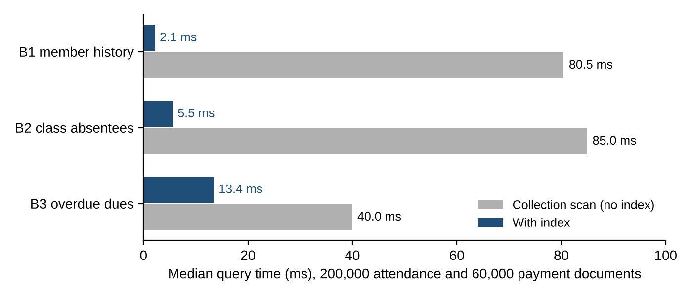
Figure 6.1: Median query time with and without indexes at 200,000 documents
Table 6.6: Benchmark results
Query | Plan | Docs examined | Median time
B1 member history | COLLSCAN | 200,000 | 80.46 ms
B1 member history | ix_member_date | 105 | 2.10 ms
B2 class absentees | COLLSCAN | 200,000 | 84.97 ms
B2 class absentees | ix_class_status | 998 | 5.53 ms
B3 overdue dues | COLLSCAN | 60,000 | 39.95 ms
B3 overdue dues | px_unpaid_dues (partial) | 2,965 | 13.38 ms
B3 overdue dues | Full index | 2,965 | 12.78 ms

Member history became 38 times faster and class absentees 15 times faster. The partial index matched the full index in speed at 60 KB instead of 604 KB.

6.2.3 Other Tuning Measures
- Projections return only needed fields and never the password hash.
- Every pipeline starts with $match so it can use an index.
- Copied names remove a $lookup from most list screens.
- Lists are paginated (sort, skip, limit).
- Enrolment, attendance and the overdue sweep are single atomic server-side updates.

CHAPTER 7

RESULTS AND DISCUSSION

7.1 Output Screenshots and Sample Reports
All results come from a live replica set: screenshots on macOS with MongoDB 8.3.11, query, benchmark and trigger outputs on 8.3.7. All screenshots are in Appendix F.
Table 7.1: Sample data loaded
Collection | Docs | Contents
trainers | 8 | Skills, certifications, availability
members | 60 | 24 Basic, 22 Premium, 14 VIP; 50 active, 6 expired, 4 frozen
workout_plans | 76 | 60 active, 16 completed; 4 exercises each
classes | 8 | Seven categories, 2 weekly slots each
class_sessions | 64 | 7 September to 3 October 2026
attendance | 580 | Present, late or absent per enrolled member
payments | 220 | July to October 2026 bills
Total | 1,016 | All pass the validators

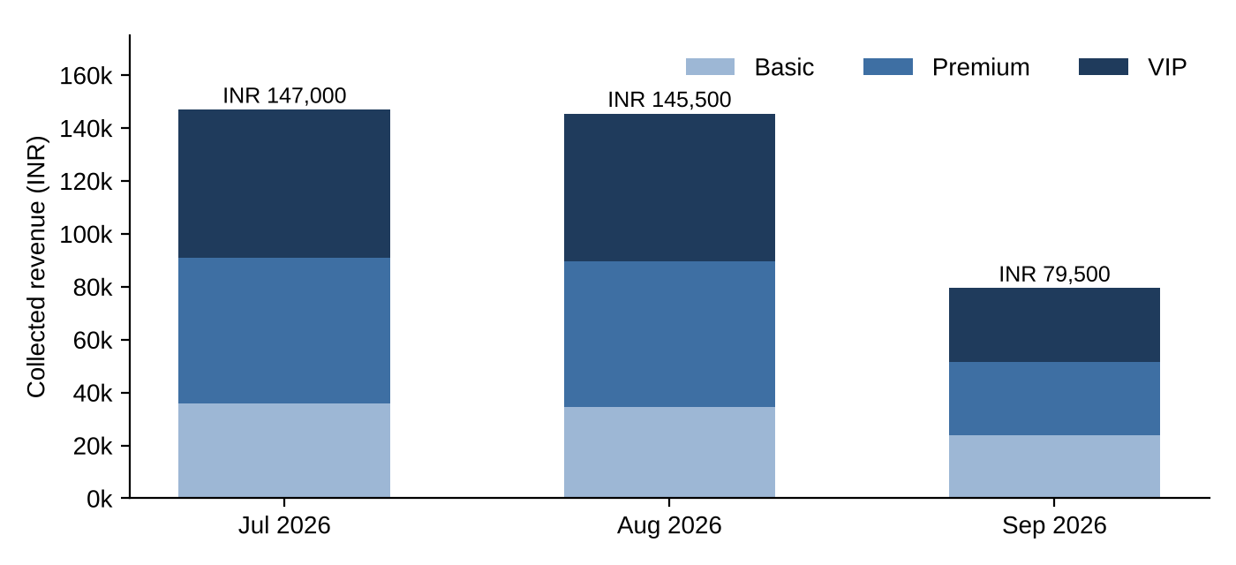
Figure 7.1: Collected revenue by month and membership tier (pipeline A1)
Revenue (A1): INR 147,000 in July, 145,500 in August and 79,500 in September; the drop comes from six memberships expiring on 31 August, four frozen and sixteen unpaid September bills. VIP members (14 of 60) produced 38% of July revenue.
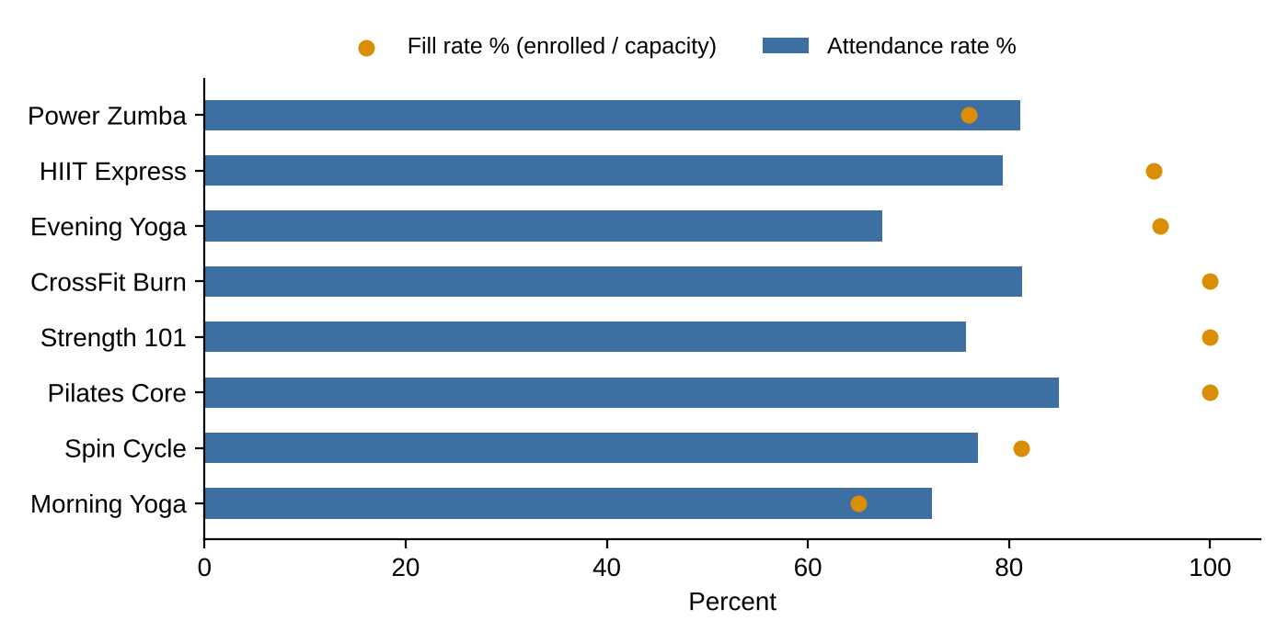
Figure 7.2: Attendance rate and fill rate by class (pipeline A2)
Table 7.2: Class popularity report (A2)
Class | Trainer | Enrolled / capacity | Avg turnout | Attendance %
Power Zumba | Meenakshi Iyer | 19 / 25 | 15.4 | 81.1
HIIT Express | Rohit Sharma | 17 / 18 | 13.5 | 79.4
Evening Yoga | Kavitha Reddy | 19 / 20 | 12.8 | 67.4
CrossFit Burn | Vivek Nair | 15 / 15 | 12.2 | 81.3
Strength 101 | Sanjay Pillai | 14 / 14 | 10.6 | 75.7
Pilates Core | Deepa Krishnan | 12 / 12 | 10.2 | 85.0
Spin Cycle | Farhan Ali | 13 / 16 | 10.0 | 76.9
Morning Yoga | Deepa Krishnan | 13 / 20 | 9.4 | 72.3

Table 7.3: Members at risk (A3) and top dues (A4)
At risk: attendance below 60% (A3) | Highest priority dues (A4)
Isha Nair 20.0%, Keerthana Iyer 40.0%, Meera Varma 45.8%, Isha Joshi, Siddharth Varma, Gautham Joshi, Karthik Krishnan 50.0% (7 members) | Divya Menon INR 3,000, 50 days overdue; Divya Das, Aishwarya Das, Nandini Das, Nandini Menon INR 8,000 each, 19 days (all HIGH)

Other reports. Trainer workload (A5) ranges from Deepa Krishnan (12 members, 2 classes) to Meenakshi Iyer (2 members). The overview (A6) shows Chennai as the largest city (16) and 35 to 44 as the largest age band (22). Plank is the most prescribed exercise (A7, 23 plans) and 18:00 the busiest check-in hour (A8, 115). The referral query (G1, G2) shows that Lakshmi Bhat referred one member directly but five joined through her over three levels.
Table 7.4: Results of integrity, transaction and trigger tests
Test | Result on the live server
Member with tier "Gold"; duplicate email | Rejected: error 121; DuplicateKeyError
Member for missing trainer TRN77 | Rejected: IntegrityError
Three enrolments in a class of capacity 2 | Third blocked atomically
Rename a member | Name updated in all copies
Delete a member with unpaid bills | Blocked (RESTRICT)
T1 renewal with simulated failure | Rolled back: payments 221 to 221, end date unchanged
T1 renew MEM1010 for 3 months | Committed: INR 4,500; end date 31 Mar to 30 Jun 2027
T2 close SES9006 / with an invalid member | Committed 3 rows / rolled back, attendance 583 to 583
TR2 bill paid by expired MEM1004; TR1 audit | Membership reactivated; all changes logged
Automated tests | 6 passed

Figures F.9 and F.13 show the transaction and trigger runs.

7.2 Evaluation Against Objectives
Table 7.5: Evaluation against the objectives of Section 1.4
ID | Evidence | Status
O1 | EER, 3NF and document model (Figures 4.4 to 4.6) | Met
O2 | 36 CRUD functions, 10 referential rules (Table 7.4) | Met
O3 | 7 validators, unique indexes, rejection test (Figure F.1) | Met
O4 | Q1 to Q15, A1 to A8, G1, G2 | Met
O5 | bcrypt login, roles, member_dashboard view | Met (web screens planned)
O6 | 19 indexes; 38 times faster; partial index 10 times smaller | Met
O7 | T1, T2 commit and rollback; TR1, TR2 | Met
O8 | Public repository, seeded data, 6 tests, user manual | Met

7.3 Comparison with the Existing System
Table 7.6: Existing manual system compared with the proposed system
Aspect | Existing | Proposed
Integrity | None | Validators, keys, 10 referential rules
Overbooking | Possible | Prevented atomically
Dues | Manual, late | Overdue sweep and priority worklist
Reports | Hours of work | Milliseconds
Concurrency | Last edit wins | Atomic updates, transactions
Audit and security | None | Audit trigger, bcrypt, roles
Backup | Single copy | Journal, replica set, mongodump

7.4 Discussion of Findings
- The document model fitted the domain: the main screens each need one read, versus two to four joins in 3NF.
- NoSQL integrity must be designed: validators handle NOT NULL and CHECK; foreign keys need code; the capacity check in the update filter removes the race condition without locks.
- Analytics are actionable: Pilates Core is full with 85% attendance, while Morning Yoga is 65% full with the lowest turnout and could move to a new slot. Yoga has the most absences (31%). Two at-risk members (Isha Nair, Isha Joshi) also owe money, so retention and dues reports should be read together.
- Revenue concentration: UPI dominates (66% of paid bills) and VIP members matter most.
- Indexes matter at scale: no difference at 580 documents, 15 to 38 times faster at 200,000.

7.5 Limitations Observed
- Writes that bypass the application can skip referential rules (validators still apply).
- Copied names must be kept in sync.
- $lookup is slower than SQL joins on very large collections.
- Transactions and change streams need a replica set.
- Data is synthetic; concurrent real users were not tested.
- Roles are enforced in the application, not with MongoDB RBAC users.

CHAPTER 8

CONCLUSION AND FUTURE WORK

8.1 Summary of the Work
Following the full life cycle, the project captured 8 functional and 5 non-functional requirements and 12 business rules; built an EER model (9 entities, 11 relationships, USER generalization); normalized it to 12 relations in 3NF; and denormalized it into 7 MongoDB collections with 19 indexes and validators. The implementation has 36 CRUD functions, 8 pipelines, a referral query, a view, 2 transactions and 2 triggers over 1,016 documents. Fifteen queries, explain plans and a benchmark confirmed correctness and performance; all objectives were met.

8.2 Key Contributions
- A documented path from EER to 3NF to a justified document model.
- Relational-grade integrity on MongoDB.
- Fifteen queries mapping every SQL category, including set operations, to MongoDB.
- Measured evidence for each index, including a partial index.
- An open, reproducible repository.

8.3 Future Enhancements
- Web dashboard (Flask or React) on the existing gym_db layer.
- MongoDB RBAC users, field-level encryption and TLS.
- UPI or card payment gateway with transactional webhooks.
- SMS or email alerts for dues and at-risk members via change streams.
- Multi-branch support with sharding on a hashed member key.
- Churn prediction and class demand forecasting.

8.4 Concluding Remarks
Relational versus NoSQL is not a choice between integrity and flexibility. Starting from a rigorous relational design and denormalizing only where queries justify it, a document database gives a gym consistent, secure and fast data management with built-in analytics.

PART C: REFERENCES AND APPENDICES

References

[1] E. F. Codd, "A relational model of data for large shared data banks," Communications of the ACM, vol. 13, no. 6, pp. 377 to 387, 1970.
[2] P. P. Chen, "The entity-relationship model: Toward a unified view of data," ACM Transactions on Database Systems, vol. 1, no. 1, pp. 9 to 36, 1976.
[3] R. Elmasri and S. B. Navathe, Fundamentals of Database Systems, 7th ed. Boston, MA, USA: Pearson, 2016.
[4] A. Silberschatz, H. F. Korth and S. Sudarshan, Database System Concepts, 7th ed. New York, NY, USA: McGraw-Hill, 2019.
[5] R. Cattell, "Scalable SQL and NoSQL data stores," ACM SIGMOD Record, vol. 39, no. 4, pp. 12 to 27, 2011.
[6] A. Pavlo and M. Aslett, "What's really new with NewSQL?," ACM SIGMOD Record, vol. 45, no. 2, pp. 45 to 55, 2016.
[7] E. Brewer, "CAP twelve years later: How the 'rules' have changed," Computer, vol. 45, no. 2, pp. 23 to 29, 2012.
[8] M. Stonebraker, "SQL databases v. NoSQL databases," Communications of the ACM, vol. 53, no. 4, pp. 10 to 11, 2010.
[9] M. Kleppmann, Designing Data-Intensive Applications. Sebastopol, CA, USA: O'Reilly Media, 2017.
[10] MongoDB, Inc., "Data modeling," MongoDB Manual. [Online]. Available: https://www.mongodb.com/docs/manual/data-modeling/
[11] MongoDB, Inc., "Schema validation," MongoDB Manual. [Online]. Available: https://www.mongodb.com/docs/manual/core/schema-validation/
[12] MongoDB, Inc., "Aggregation operations," MongoDB Manual. [Online]. Available: https://www.mongodb.com/docs/manual/aggregation/
[13] MongoDB, Inc., "Transactions," MongoDB Manual. [Online]. Available: https://www.mongodb.com/docs/manual/core/transactions/
[14] MongoDB, Inc., "Partial indexes," MongoDB Manual. [Online]. Available: https://www.mongodb.com/docs/manual/core/index-partial/
[15] MongoDB, Inc., "$graphLookup (aggregation stage)," MongoDB Manual. [Online]. Available: https://www.mongodb.com/docs/manual/reference/operator/aggregation/graphLookup/
[16] MongoDB, Inc., "Explain results," MongoDB Manual. [Online]. Available: https://www.mongodb.com/docs/manual/reference/explain-results/
[17] N. Provos and D. Mazières, "A future-adaptable password scheme," in Proc. USENIX Annual Technical Conference, FREENIX Track, Monterey, CA, USA, 1999, pp. 81 to 91.
[18] OWASP Foundation, "Password storage cheat sheet," OWASP Cheat Sheet Series. [Online]. Available: https://cheatsheetseries.owasp.org/cheatsheets/Password_Storage_Cheat_Sheet.html
[19] P. A. Grassi et al., "Digital identity guidelines: Authentication and lifecycle management," National Institute of Standards and Technology, Gaithersburg, MD, USA, NIST SP 800-63B, 2017.
[20] Information technology: Database languages SQL, Part 1: Framework (SQL/Framework), ISO/IEC 9075-1:2023, International Organization for Standardization, 2023.
[21a] Mindbody, "Fitness studio and gym software." [Online]. Available: https://www.mindbodyonline.com
[21b] Glofox, "Gym management software." [Online]. Available: https://www.glofox.com
[21c] Zen Planner, "Gym management software." [Online]. Available: https://zenplanner.com
[21d] Gymdesk, "Gym management software." [Online]. Available: https://gymdesk.com
[21e] Wodify, "Best fitness studio management software for 2026: 7 platforms compared." [Online]. Available: https://www.wodify.com/blog/best-fitness-studio-software
[22] solid IT GmbH, "DB-Engines ranking." [Online]. Available: https://db-engines.com/en/ranking
[23] Government of India, The Digital Personal Data Protection Act, 2023, Act No. 22 of 2023, Ministry of Law and Justice, 2023.
[24] The PostgreSQL Global Development Group, "JSON types," PostgreSQL Documentation. [Online]. Available: https://www.postgresql.org/docs/current/datatype-json.html
[25] K. Banker, P. Bakkum, S. Verch, D. Garrett and T. Hawkins, MongoDB in Action, 2nd ed. Shelter Island, NY, USA: Manning, 2016.
[26] A. Lakshman and P. Malik, "Cassandra: A decentralized structured storage system," ACM SIGOPS Operating Systems Review, vol. 44, no. 2, pp. 35 to 40, 2010.
[27] R. Taft et al., "CockroachDB: The resilient geo-distributed SQL database," in Proc. ACM SIGMOD International Conference on Management of Data, 2020, pp. 1493 to 1509.
[28] MongoDB, Inc., "Change streams," MongoDB Manual. [Online]. Available: https://www.mongodb.com/docs/manual/changeStreams/
[29] MongoDB, Inc., "PyMongo documentation." [Online]. Available: https://pymongo.readthedocs.io/

Appendix A: Complete DDL Scripts

mongosh/ddl.js creates the seven collections with $jsonSchema validators, the nineteen indexes and the view. It is generated from the same definitions as gym_db/schema.py, so the two always agree.
// Generated by queries.py --export-js. Creates EMPTY collections (drops existing ones), then indexes.
// Load data afterwards with mongoimport (data/*.json) or use python demo.py, which does all of this.
// mongosh "mongodb://localhost:27017/?directConnection=true" mongosh/ddl.js

// Data definition for gym_db: 7 collections with $jsonSchema validators, then 19 indexes.
db = db.getSiblingDB("gym_db");

db.getCollection("members").drop();
db.createCollection("members", {
validator: { $jsonSchema: {
bsonType: "object",
required: ["member_id", "name", "email", "password_hash", "role", "membership"],
properties: {
member_id: { bsonType: "string", pattern: "^MEM[0-9]{4}$" },
name: { bsonType: "string", minLength: 2 },
email: { bsonType: "string", pattern: "^.+@.+\\..+$" },
phone: { bsonType: "string", pattern: "^[0-9]{10}$" },
gender: { enum: ["Male", "Female", "Other"] },
role: { enum: ["member"] },
membership: {
bsonType: "object",
required: ["type", "status", "start_date", "end_date"],
properties: {
type: { enum: ["Basic", "Premium", "VIP"] },
status: { enum: ["active", "expired", "frozen"] },
start_date: { bsonType: "date" },
end_date: { bsonType: "date" }
}
},
assigned_trainer_id: { bsonType: ["objectId", "null"] },
referred_by: { bsonType: ["objectId", "null"] }
}
} },
validationLevel: "strict",
validationAction: "error"
});

db.getCollection("trainers").drop();
db.createCollection("trainers", {
validator: { $jsonSchema: {
bsonType: "object",
required: ["trainer_id", "name", "email", "password_hash", "role"],
properties: {
trainer_id: { bsonType: "string", pattern: "^TRN[0-9]{2}$" },
role: { enum: ["trainer"] },
specialization: { bsonType: "array", items: { bsonType: "string" } },
experience_years: { bsonType: ["int", "long", "double"], minimum: 0 },
availability: {
bsonType: "array",
items: { bsonType: "object", required: ["day", "start_time", "end_time"] }
}
}
} },
validationLevel: "strict",
validationAction: "error"
});

db.getCollection("workout_plans").drop();
db.createCollection("workout_plans", {
validator: { $jsonSchema: {
bsonType: "object",
required: ["plan_id", "member_id", "trainer_id", "goal", "status", "exercises"],
properties: {
member_id: { bsonType: "objectId" },
trainer_id: { bsonType: "objectId" },
duration_weeks: { bsonType: ["int", "long"], minimum: 1, maximum: 52 },
status: { enum: ["active", "completed"] },
exercises: {
bsonType: "array",
minItems: 1,
items: {
bsonType: "object",
required: ["day", "exercise_name", "sets", "reps"],
properties: {
sets: { bsonType: ["int", "long"], minimum: 1 },
reps: { bsonType: ["int", "long"], minimum: 1 }
}
}
}
}
} },
validationLevel: "strict",
validationAction: "error"
});

db.getCollection("classes").drop();
db.createCollection("classes", {
validator: { $jsonSchema: {
bsonType: "object",
required: ["class_id", "class_name", "category", "trainer_id", "capacity"],
properties: {
trainer_id: { bsonType: "objectId" },
capacity: { bsonType: ["int", "long"], minimum: 1, maximum: 50 },
schedule: { bsonType: "array" },
enrolled_members: { bsonType: "array" }
}
} },
validationLevel: "strict",
validationAction: "error"
});

db.getCollection("class_sessions").drop();
db.createCollection("class_sessions", {
validator: { $jsonSchema: {
bsonType: "object",
required: ["session_id", "class_id", "date", "status"],
properties: {
class_id: { bsonType: "objectId" },
date: { bsonType: "date" },
status: { enum: ["scheduled", "completed", "cancelled"] }
}
} },
validationLevel: "strict",
validationAction: "error"
});

db.getCollection("attendance").drop();
db.createCollection("attendance", {
validator: { $jsonSchema: {
bsonType: "object",
required: ["session_id", "class_id", "member_id", "date", "status"],
properties: {
session_id: { bsonType: "objectId" },
member_id: { bsonType: "objectId" },
status: { enum: ["present", "absent", "late"] }
}
} },
validationLevel: "strict",
validationAction: "error"
});

db.getCollection("payments").drop();
db.createCollection("payments", {
validator: { $jsonSchema: {
bsonType: "object",
required: ["payment_id", "member_id", "amount", "status", "due_date"],
properties: {
member_id: { bsonType: "objectId" },
amount: { bsonType: ["int", "long", "double"], minimum: 0 },
currency: { enum: ["INR"] },
payment_mode: { enum: ["cash", "card", "UPI", null] },
status: { enum: ["paid", "pending", "overdue"] },
due_date: { bsonType: "date" }
}
} },
validationLevel: "strict",
validationAction: "error"
});

db.members.createIndex({ email: 1 }, { unique: true, name: "uq_email" });
db.members.createIndex({ member_id: 1 }, { unique: true, name: "uq_member_id" });
db.members.createIndex({ assigned_trainer_id: 1 }, { name: "ix_trainer" });
db.members.createIndex({ "membership.type": 1, "membership.status": 1 }, { name: "ix_tier_status" });
db.members.createIndex({ referred_by: 1 }, { name: "ix_referred_by" });
db.trainers.createIndex({ email: 1 }, { unique: true, name: "uq_email" });
db.trainers.createIndex({ trainer_id: 1 }, { unique: true, name: "uq_trainer_id" });
db.workout_plans.createIndex({ member_id: 1, status: 1 }, { name: "ix_member_status" });
db.workout_plans.createIndex({ trainer_id: 1 }, { name: "ix_trainer" });
db.classes.createIndex({ trainer_id: 1 }, { name: "ix_trainer" });
db.classes.createIndex({ "enrolled_members.member_id": 1 }, { name: "ix_enrolled_member" });
db.classes.createIndex({ class_name: "text", category: "text" }, { name: "tx_class_search" });
db.class_sessions.createIndex({ class_id: 1, date: 1 }, { name: "ix_class_date" });
db.attendance.createIndex({ member_id: 1, date: -1 }, { name: "ix_member_date" });
db.attendance.createIndex({ session_id: 1, member_id: 1 }, { unique: true, name: "uq_session_member" });
db.attendance.createIndex({ class_id: 1, status: 1 }, { name: "ix_class_status" });
db.payments.createIndex({ member_id: 1, status: 1 }, { name: "ix_member_status" });
db.payments.createIndex({ due_date: 1 }, { name: "ix_due_date" });
db.payments.createIndex({ status: 1, due_date: 1 }, {
name: "px_unpaid_dues",
partialFilterExpression: { status: { "$in": ["pending", "overdue"] } }
});

// Read-only view used by the member dashboard (hides password_hash).
db.getCollection("member_dashboard").drop();
db.createView("member_dashboard", "members", [
{
"$lookup": { from: "trainers", localField: "assigned_trainer_id", foreignField: "_id", as: "t" }
},
{ "$lookup": { from: "payments", localField: "_id", foreignField: "member_id", as: "p" } },
{
"$project": {
_id: 0,
member_id: 1,
name: 1,
tier: "$membership.type",
status: "$membership.status",
trainer: { "$first": "$t.name" },
unpaid_amount: {
"$sum": {
"$map": {
input: { "$filter": { input: "$p", as: "x", cond: { "$ne": ["$$x.status", "paid"] } } },
as: "u",
in: "$$u.amount"
}
}
}
}
}
]);

print("gym_db created: " + db.getCollectionNames().sort().join(", "));

Appendix B: Sample Data and DML Scripts

B.1 Sample Documents
One document per collection (Extended JSON). The full dataset is in data/*.json (load with mongoimport --jsonArray); the generator is gym_db/seed.py (fixed seed).
members
{
"_id": {
"$oid": "6ae07293995dced28d294f9c"
},
"member_id": "MEM1001",
"name": "Harish Kumar",
"email": "harish.kumar1@example.com",
"phone": "9952304698",
"dob": {
"$date": "1987-04-04T00:00:00Z"
},
"gender": "Male",
"password_hash": "$2b$04$/zukbpdrHdQvDWSJSJ7LB.h77zHVCrIdcDUy8dQziLg22wwXkUJkm",
"role": "member",
"membership": {
"type": "VIP",
"status": "active",
"start_date": {
"$date": "2026-01-01T00:00:00Z"
},
"end_date": {
"$date": "2026-12-31T00:00:00Z"
}
},
"assigned_trainer_id": {
"$oid": "6ae07293995dced28d294f94"
},
"referred_by": null,
"address": {
"line1": "193 Katpadi Main Road",
"city": "Bengaluru",
"pincode": "560034"
},
"emergency_contact": {
"name": "Aishwarya Kumar",
"phone": "9817771848"
},
"created_at": {
"$date": "2025-12-19T00:00:00Z"
}
}
workout_plans
{
"_id": {
"$oid": "6ae07293995dced28d294fd8"
},
"plan_id": "WP5001",
"member_id": {
"$oid": "6ae07293995dced28d294f9c"
},
"member_name": "Harish Kumar",
"trainer_id": {
"$oid": "6ae07293995dced28d294f94"
},
"trainer_name": "Priya Menon",
"goal": "Flexibility",
"duration_weeks": 10,
"status": "active",
"exercises": [
{
"day": "Mon",
"exercise_name": "Plank",
"sets": 4,
"reps": 8,
"weight_kg": 0,
"notes": ""
},
{
"day": "Tue",
"exercise_name": "Sun Salutation",
"sets": 4,
"reps": 10,
"weight_kg": 0,
"notes": ""
},
{
"day": "Wed",
"exercise_name": "Cat-Cow Stretch",
"sets": 3,
"reps": 10,
"weight_kg": 0,
"notes": ""
},
{
"day": "Fri",
"exercise_name": "Hip Opener Flow",
"sets": 5,
"reps": 8,
"weight_kg": 0,
"notes": ""
}
],
"created_at": {
"$date": "2026-01-01T00:00:00Z"
},
"updated_at": {
"$date": "2026-01-01T00:00:00Z"
}
}
classes (roster shortened)
{
"_id": {
"$oid": "6ae07293995dced28d295029"
},
"class_id": "CLS06",
"class_name": "Pilates Core",
"category": "Pilates",
"trainer_id": {
"$oid": "6ae07293995dced28d294f96"
},
"trainer_name": "Deepa Krishnan",
"capacity": 12,
"schedule": [
{
"day_of_week": "Tue",
"start_time": "10:00",
"end_time": "11:00",
"room": "A2"
},
{
"day_of_week": "Thu",
"start_time": "10:00",
"end_time": "11:00",
"room": "A2"
}
],
"enrolled_members": [
{
"member_id": {
"$oid": "6ae07293995dced28d294fa4"
},
"member_name": "Gautham Bhat",
"enrolled_on": {
"$date": "2026-07-11T00:00:00Z"
}
},
{
"member_id": {
"$oid": "6ae07293995dced28d294fa3"
},
"member_name": "Isha Joshi",
"enrolled_on": {
"$date": "2026-07-12T00:00:00Z"
}
},
{
"...": "10 more"
}
]
}
attendance
{
"_id": {
"$oid": "6ae07293995dced28d29506c"
},
"session_id": {
"$oid": "6ae07293995dced28d29502c"
},
"class_id": {
"$oid": "6ae07293995dced28d295024"
},
"member_id": {
"$oid": "6ae07293995dced28d294fa8"
},
"member_name": "Manoj Shetty",
"date": {
"$date": "2026-09-07T00:00:00Z"
},
"status": "present",
"check_in_time": "06:50"
}
payments
{
"_id": {
"$oid": "6ae07293995dced28d2952b0"
},
"payment_id": "PAY7001",
"member_id": {
"$oid": "6ae07293995dced28d294f9c"
},
"member_name": "Harish Kumar",
"amount": 4000,
"currency": "INR",
"payment_mode": "card",
"status": "paid",
"billing_period_start": {
"$date": "2026-07-01T00:00:00Z"
},
"billing_period_end": {
"$date": "2026-07-31T00:00:00Z"
},
"payment_date": {
"$date": "2026-07-08T00:00:00Z"
},
"due_date": {
"$date": "2026-07-05T00:00:00Z"
}
}

B.2 DML: Key CRUD Operations
Excerpts from gym_db/crud.py (36 functions in the repository): insert with reference checks, rename with cascade update, delete with RESTRICT, CASCADE and SET NULL, atomic capacity-checked enrolment and attendance upsert.
def create_member(db, name, email, phone, dob, gender, password, tier="Basic",
trainer_id=None, referred_by=None, city="Vellore", pincode="632014"):
trainer_oid = None
if trainer_id:
trainer_oid = db.trainers.find_one({"trainer_id": trainer_id}, {"_id": 1})
if not trainer_oid:
raise IntegrityError(f"Trainer {trainer_id} not found")
trainer_oid = trainer_oid["_id"]
ref_oid = _member_oid(db, referred_by) if referred_by else None
start = REFERENCE_DATE.replace(day=1)
doc = {
"member_id": _next_code(db.members, "member_id", "MEM", 4),
"name": name, "email": email.lower(), "phone": phone, "dob": dob, "gender": gender,
"password_hash": bcrypt.hashpw(password.encode(), bcrypt.gensalt()).decode(),
"role": "member",
"membership": {"type": tier, "status": "active", "start_date": start,
"end_date": datetime(start.year + 1, start.month, 1)},
"assigned_trainer_id": trainer_oid, "referred_by": ref_oid,
"address": {"line1": "", "city": city, "pincode": pincode},
"emergency_contact": {"name": "", "phone": ""},
"created_at": REFERENCE_DATE,
}
db.members.insert_one(doc)
return doc["member_id"]

def update_member(db, member_id, **fields):
"""Update profile fields. A name change is propagated to every denormalized copy."""
allowed = {"name", "phone", "email", "address", "emergency_contact"}
bad = set(fields) - allowed
if bad:
raise ValueError(f"Cannot update {bad} here")
doc = db.members.find_one_and_update({"member_id": member_id}, {"$set": fields},
projection=SAFE, return_document=ReturnDocument.AFTER)
if doc and "name" in fields:
oid, name = doc["_id"], fields["name"]
for coll in ("workout_plans", "attendance", "payments"):
db[coll].update_many({"member_id": oid}, {"$set": {"member_name": name}})
db.classes.update_many({"enrolled_members.member_id": oid},
{"$set": {"enrolled_members.$.member_name": name}}) # positional $
return doc

def delete_member(db, member_id):
"""Blocked if dues are outstanding; otherwise cascades to plans and class rosters.
Attendance and payment history are kept as the gym's audit trail."""
oid = _member_oid(db, member_id)
dues = db.payments.count_documents({"member_id": oid, "status": {"$in": ["pending", "overdue"]}})
if dues:
raise IntegrityError(f"{member_id} has {dues} unpaid bill(s); settle before deleting")
plans = db.workout_plans.delete_many({"member_id": oid}).deleted_count
rosters = db.classes.update_many({}, {"$pull": {"enrolled_members": {"member_id": oid}}}).modified_count
db.members.update_many({"referred_by": oid}, {"$set": {"referred_by": None}})
db.members.delete_one({"_id": oid})
return {"plans_deleted": plans, "classes_updated": rosters}

def enroll_member(db, class_id, member_id):
"""FR4. Atomic single-document update: the filter itself checks capacity and duplicates,
so two simultaneous requests can never overbook the class."""
m = db.members.find_one({"member_id": member_id, "membership.status": "active"})
if not m:
raise IntegrityError(f"{member_id} not found or membership not active")
res = db.classes.update_one(
{"class_id": class_id,
"enrolled_members.member_id": {"$ne": m["_id"]},
"$expr": {"$lt": [{"$size": "$enrolled_members"}, "$capacity"]}},
{"$push": {"enrolled_members": {"member_id": m["_id"], "member_name": m["name"],
"enrolled_on": REFERENCE_DATE}}})
if res.modified_count == 0:
raise IntegrityError(f"Cannot enroll {member_id} in {class_id}: class full or already enrolled")
return True

def mark_attendance(db, session_id, member_id, status, check_in_time=None):
"""FR5. Upsert keyed on (session, member): re-marking corrects the record, never duplicates it."""
s = db.class_sessions.find_one({"session_id": session_id})
if not s:
raise IntegrityError(f"Session {session_id} not found")
m = db.members.find_one({"member_id": member_id})
if not m:
raise IntegrityError(f"Member {member_id} not found")
return db.attendance.update_one(
{"session_id": s["_id"], "member_id": m["_id"]},
{"$set": {"status": status, "check_in_time": check_in_time},
"$setOnInsert": {"class_id": s["class_id"], "member_name": m["name"], "date": s["date"]}},
upsert=True)

Appendix C: Stored Procedures, Functions and Triggers (Full Code)

MongoDB has no SQL stored procedures. Their roles are played by multi-document transactions (a procedure inside BEGIN and COMMIT), server-side aggregation pipelines, and change-stream triggers [28], the supported equivalent of CREATE TRIGGER. Transactions and triggers are given in full; the eight report pipelines are in gym_db/aggregations.py (the view is in Section 5.5).

C.1 Transactions (transactions.py)
"""Step 6: multi-document ACID transactions.

Transactions need a replica set (a single-node replica set is enough; see README).
Two business operations touch several collections and must be all-or-nothing:

T1 renew_membership: insert a paid payment AND extend the member's end date.
T2 close_session: insert attendance rows for a session AND mark it completed.
"""
from datetime import timedelta

from pymongo import ReadPreference
from pymongo.read_concern import ReadConcern
from pymongo.write_concern import WriteConcern

from .config import REFERENCE_DATE, TIER_FEES, get_client, is_mock

class TransactionAborted(Exception):
pass

def _run(db, fn):
"""Run fn(session) inside a transaction, with automatic retry on transient errors.
Under mongomock (no transaction support) fn runs without a session."""
if is_mock():
return fn(None)
client = get_client()
with client.start_session() as s:
return s.with_transaction(
fn,
read_concern=ReadConcern("snapshot"),
write_concern=WriteConcern("majority"),
read_preference=ReadPreference.PRIMARY,
)

def renew_membership(db, member_id, months, mode="UPI", fail_midway=False):
"""T1. fail_midway=True raises after the payment insert to prove the rollback."""
def txn(s):
m = db.members.find_one({"member_id": member_id}, session=s)
if not m:
raise TransactionAborted(f"{member_id} not found")
fee = TIER_FEES[m["membership"]["type"]] * months
old_end = m["membership"]["end_date"]
start = max(old_end, REFERENCE_DATE) + timedelta(days=1)
new_end = start + timedelta(days=30 * months)
last = db.payments.find_one({}, sort=[("payment_id", -1)], projection={"payment_id": 1}, session=s)
pid = f"PAY{int(last['payment_id'][3:]) + 1}"
db.payments.insert_one({
"payment_id": pid, "member_id": m["_id"], "member_name": m["name"], "amount": fee,
"currency": "INR", "payment_mode": mode, "status": "paid",
"billing_period_start": start, "billing_period_end": new_end,
"payment_date": REFERENCE_DATE, "due_date": REFERENCE_DATE}, session=s)
if fail_midway:
raise TransactionAborted("Simulated failure after payment insert")
db.members.update_one({"_id": m["_id"]},
{"$set": {"membership.end_date": new_end, "membership.status": "active"}},
session=s)
return {"payment_id": pid, "amount": fee, "new_end_date": new_end.date().isoformat()}
return _run(db, txn)

def close_session(db, session_id, marks):
"""T2. marks = {member_id: (status, check_in_time)}. Everything commits together."""
def txn(s):
sess = db.class_sessions.find_one({"session_id": session_id, "status": "scheduled"}, session=s)
if not sess:
raise TransactionAborted(f"{session_id} is not an open session")
cls = db.classes.find_one({"_id": sess["class_id"]}, session=s)
roster = {e["member_id"]: e["member_name"] for e in cls["enrolled_members"]}
ids = {d["member_id"]: d["_id"] for d in
db.members.find({"member_id": {"$in": list(marks)}}, {"member_id": 1}, session=s)}
db.class_sessions.update_one({"_id": sess["_id"]}, {"$set": {"status": "completed"}}, session=s)
rows = 0
for mid, (status, t) in marks.items():
oid = ids.get(mid)
if oid not in roster: # fails AFTER earlier writes: the rollback undoes them all
raise TransactionAborted(f"{mid} is not enrolled in {cls['class_name']}")
db.attendance.insert_one({"session_id": sess["_id"], "class_id": sess["class_id"],
"member_id": oid, "member_name": roster[oid], "date": sess["date"],
"status": status, "check_in_time": t}, session=s)
rows += 1
return {"session_id": session_id, "attendance_rows": rows}
return _run(db, txn)

C.2 Triggers (triggers.py)
"""Database triggers implemented with MongoDB change streams.

MongoDB has no CREATE TRIGGER statement. The supported equivalent is a change stream:
the server pushes every insert, update, replace and delete on a collection to a listening
client, which reacts to it. Change streams need a replica set, which this project uses.

Trigger TR1 (audit trail): every change to members and payments is written to the
audit_log collection with the operation, the business key, the fields that changed and
the time. This gives the administrator a tamper-evident history of who paid what and
when a membership changed (NFR3 security, NFR5 consistency).

Trigger TR2 (membership reactivation): when a payment changes to status "paid" for a
member whose membership is "expired", the member is set back to "active".

python -m gym_db.triggers # run the triggers until Ctrl+C
"""
import threading
from datetime import datetime, timezone

WATCHED = ["members", "payments"]

def _business_key(db, coll, event):
doc = event.get("fullDocument") or {}
key = doc.get("member_id") if coll == "members" else doc.get("payment_id")
if key is None and coll == "payments" and isinstance(doc.get("member_id"), str):
key = doc["member_id"]
return key or str(event["documentKey"]["_id"])

def handle_event(db, event):
"""Apply both triggers to one change event."""
coll = event["ns"]["coll"]
op = event["operationType"]
changed = None
if op == "update":
desc = event.get("updateDescription", {})
changed = sorted(list(desc.get("updatedFields", {}).keys()) + desc.get("removedFields", []))
# TR1 audit trail
db.audit_log.insert_one({
"collection": coll, "operation": op, "key": _business_key(db, coll, event),
"changed_fields": changed, "at": datetime.now(timezone.utc),
})
# TR2 reactivate an expired membership once a bill is paid
doc = event.get("fullDocument") or {}
if coll == "payments" and op in ("update", "replace") and doc.get("status") == "paid":
res = db.members.update_one({"_id": doc["member_id"], "membership.status": "expired"},
{"$set": {"membership.status": "active"}})
if res.modified_count:
member = db.members.find_one({"_id": doc["member_id"]}, {"member_id": 1})
db.audit_log.insert_one({"collection": "members", "operation": "trigger:reactivate",
"key": member["member_id"], "changed_fields": ["membership.status"],
"at": datetime.now(timezone.utc)})

def watch(db, stop_event=None, ready_event=None):
"""Listen to members and payments until stop_event is set."""
pipeline = [{"$match": {"ns.coll": {"$in": WATCHED}}}]
with db.watch(pipeline, full_document="updateLookup", max_await_time_ms=200) as stream:
if ready_event:
ready_event.set()
while stop_event is None or not stop_event.is_set():
event = stream.try_next()
if event is not None:
handle_event(db, event)

def start_in_background(db):
"""Start the triggers on a daemon thread; returns the stop event."""
stop, ready = threading.Event(), threading.Event()
threading.Thread(target=watch, args=(db, stop, ready), daemon=True).start()
ready.wait(5)
return stop

if __name__ == "__main__":
from gym_db.config import get_db
print("Triggers TR1 (audit trail) and TR2 (reactivation) are running. Press Ctrl+C to stop.")
try:
watch(get_db())
except KeyboardInterrupt:
pass

C.3 Sample Report Pipeline: Revenue by Month and Tier (A1)
def revenue_trend(db):
return list(db.payments.aggregate([
{"$match": {"status": "paid"}},
{"$lookup": {"from": "members", "localField": "member_id", "foreignField": "_id", "as": "m"}},
{"$unwind": "$m"},
{"$group": {
"_id": {"month": {"$dateToString": {"format": "%Y-%m", "date": "$billing_period_start"}},
"tier": "$m.membership.type"},
"revenue": {"$sum": "$amount"}, "payments": {"$sum": 1}}},
{"$group": {"_id": "$_id.month",
"total_revenue": {"$sum": "$revenue"},
"payments": {"$sum": "$payments"},
"by_tier": {"$push": {"tier": "$_id.tier", "revenue": "$revenue"}}}},
{"$sort": {"_id": 1}},
{"$project": {"_id": 0, "month": "$_id", "total_revenue": 1, "payments": 1, "by_tier": 1}},
]))

# A2. Class popularity: attendance rate, average turnout and fill rate per class

Appendix D: Complete Query Set with Outputs

The MongoDB and SQL text of all fifteen queries is in Section 6.1 (mongosh version: mongosh/queries.js). Below is the complete output of the live run.

D.1 Outputs of the Query Set on MongoDB 8.3.7 (query_output.txt)
Connected to MongoDB; database 'gym_db' recreated and seeded; reference date 2026-09-24

==============================================================================
Q1 [Selection] Active VIP members living in Chennai
==============================================================================
member_id name membership.end_date
--------- ------------- -------------------
MEM1014 Divya Das 2026-12-31
MEM1043 Gautham Nair 2027-05-31
MEM1046 Nandini Menon 2027-02-28
(3 matching documents)

==============================================================================
Q2 [Selection] Trainers who teach Yoga or CrossFit with at least 6 years of experience
==============================================================================
trainer_id name specialization experience_years
---------- -------------- --------------------------- ----------------
TRN03 Deepa Krishnan Yoga, Pilates 9
TRN08 Vivek Nair CrossFit, Olympic Lifting 8
TRN07 Kavitha Reddy Yoga, Mobility 7
TRN01 Priya Menon Strength Training, CrossFit 6
(4 matching documents)

==============================================================================
Q3 [Selection] Unpaid bills already past their due date (oldest first)
==============================================================================
payment_id member_name amount status due_date
---------- -------------- ------ ------- ----------
PAY7054 Divya Menon 1500 overdue 2026-08-05
PAY7023 Isha Joshi 1500 pending 2026-09-05
PAY7027 Gautham Bhat 2500 pending 2026-09-05
PAY7047 Divya Das 4000 pending 2026-09-05
PAY7061 Aishwarya Das 4000 pending 2026-09-05
PAY7073 Karthik Sharma 2500 pending 2026-09-05
PAY7085 Ananya Das 2500 pending 2026-09-05
PAY7089 Vikram Kumar 1500 pending 2026-09-05
(17 matching documents, first 8 shown)

==============================================================================
Q4 [Join (inner)] Active VIP members with their assigned trainer
==============================================================================
member_id name trainer certification
--------- ---------------- ------------- -------------
MEM1001 Harish Kumar Priya Menon ACE-CPT
MEM1012 Isha Das Sanjay Pillai ISSA-CPT
MEM1014 Divya Das Rohit Sharma NASM-CPT
MEM1018 Aishwarya Das Kavitha Reddy RYT-200
MEM1028 Lakshmi Krishnan Rohit Sharma NASM-CPT
MEM1033 Rahul Sharma Vivek Nair CF-L2
MEM1035 Dev Varma Vivek Nair CF-L2
MEM1038 Nandini Das Farhan Ali ACSM-EP
(8 matching documents)

==============================================================================
Q5 [Join (three tables)] Attendance history of MEM1001 with class name and session time
==============================================================================
date class_name start_time status check_in_time
---------- ------------ ---------- ------- -------------
2026-09-23 Evening Yoga 19:00 present 18:52
2026-09-19 Evening Yoga 17:00 present 16:51
2026-09-16 Evening Yoga 19:00 present 18:50
2026-09-12 Evening Yoga 17:00 present 16:57
2026-09-09 Evening Yoga 19:00 present 19:00
(5 matching documents)

==============================================================================
Q6 [Join (left outer)] Every trainer with the number of classes they teach, including trainers with none
==============================================================================
trainer_id name classes class_names
---------- -------------- ------- --------------------------
TRN03 Deepa Krishnan 2 Morning Yoga, Pilates Core
TRN02 Rohit Sharma 1 HIIT Express
TRN04 Sanjay Pillai 1 Strength 101
TRN05 Meenakshi Iyer 1 Power Zumba
TRN06 Farhan Ali 1 Spin Cycle
TRN07 Kavitha Reddy 1 Evening Yoga
TRN08 Vivek Nair 1 CrossFit Burn
TRN01 Priya Menon 0
(8 matching documents)

==============================================================================
Q7 [Grouping and aggregation] Money collected by payment mode (COUNT, SUM, AVG)
==============================================================================
payment_mode payments total average
------------ -------- ------ -------
UPI 101 237500 2351
card 37 97000 2622
cash 15 37500 2500
(3 matching documents)

==============================================================================
Q8 [Grouping with HAVING] Cities with more than 10 members, split by tier
==============================================================================
city members basic premium vip
--------- ------- ----- ------- ---
Chennai 16 6 6 4
Bengaluru 13 6 5 2
Hosur 12 4 2 6
(3 matching documents)

==============================================================================
Q9 [Grouping and aggregation] Attendance outcome by class category
==============================================================================
category marked present late absent
-------- ------ ------- ---- ------
Yoga 160 103 8 49
Zumba 95 69 8 18
CrossFit 75 51 10 14
Strength 70 46 7 17
HIIT 68 46 8 14
Pilates 60 46 5 9
Cardio 52 36 4 12
(7 matching documents)

==============================================================================
Q10 [Subquery (scalar)] Members whose attendance rate is below the gym-wide average
==============================================================================
name marked rate_pct gym_average_pct
---------------- ------ -------- ---------------
Isha Nair 5 20 77.1
Keerthana Iyer 10 40 77.1
Meera Varma 24 45.8 77.1
Gautham Joshi 14 50 77.1
Isha Joshi 10 50 77.1
Karthik Krishnan 8 50 77.1
Siddharth Varma 24 50 77.1
Nandini Menon 10 60 77.1
(8 matching documents)

==============================================================================
Q11 [Subquery (correlated)] Members with more than one unpaid bill
==============================================================================
member_id name tier unpaid_bills amount_due
--------- ------------------ ------- ------------ ----------
MEM1008 Isha Joshi Basic 2 3000
MEM1009 Gautham Bhat Premium 2 5000
MEM1014 Divya Das VIP 2 8000
MEM1016 Divya Menon Basic 2 3000
MEM1018 Aishwarya Das VIP 2 8000
MEM1021 Karthik Sharma Premium 2 5000
MEM1024 Ananya Das Premium 2 5000
MEM1025 Vikram Kumar Basic 2 3000
MEM1038 Nandini Das VIP 2 8000
MEM1044 Kavya Kumar Premium 2 5000
MEM1045 Siddharth Pillai Basic 2 3000
MEM1046 Nandini Menon VIP 2 8000
MEM1047 Varun Das Basic 2 3000
MEM1049 Ashwin Krishnan Premium 2 5000
MEM1051 Karthik Shetty Premium 2 5000
MEM1052 Isha Nair Premium 2 5000
MEM1054 Keerthana Krishnan Premium 2 5000
(17 matching documents)

==============================================================================
Q12 [Subquery (EXISTS)] Classes taught by trainers who coach more than 8 members
==============================================================================
class_name trainer_name trainer_members
------------ -------------- ---------------
Morning Yoga Deepa Krishnan 12
Pilates Core Deepa Krishnan 12
Spin Cycle Farhan Ali 10
Strength 101 Sanjay Pillai 10
(4 matching documents)

==============================================================================
Q13 [Set operation (UNION)] Members enrolled in Morning Yoga or Evening Yoga (each counted once)
==============================================================================
morning_yoga: 13 evening_yoga: 19 union_size: 27
result: Aditya Reddy, Dev Varma, Divya Das, Gautham Joshi, Gautham Subramanian, Harish Kumar, Harish Subramanian,
Isha Das, Isha Joshi, Isha Nair, Karthik Sharma, Karthik Shetty, Keerthana Iyer, Keerthana Krishnan, Lakshmi Bhat,
Lakshmi Krishnan, Manoj Shetty, Meera Varma, Nandini Das, Pranav Varma, Rahul Reddy, Shreya Iyer, Siddharth Pillai,
Siddharth Sharma, Siddharth Varma, Sneha Kumar, Varun Das

==============================================================================
Q14 [Set operation (INTERSECT)] Members enrolled in both CrossFit Burn and Strength 101
==============================================================================
intersect_size: 5
result: Dev Varma, Divya Menon, Meera Varma, Rahul Reddy, Siddharth Sharma

==============================================================================
Q15 [Set operation (EXCEPT)] Active members who are not enrolled in any class
==============================================================================
active_members: 50 enrolled_somewhere: 47 except_size: 3
result: Ashwin Krishnan, Rahul Sharma, Swathi Varma

D.2 Output of the Index Benchmark (benchmark_output.txt)
MongoDB 8.3.7: building gym_bench with 200,000 attendance and 60,000 payment documents ...

query plan docs_examined keys_examined returned median_ms
B1 member attendance history COLLSCAN 200,000 0 105 80.46
B1 member attendance history ix_member_date 105 105 105 2.1
B2 absentees of one class COLLSCAN 200,000 0 998 84.97
B2 absentees of one class ix_class_status 998 998 998 5.53
B3 overdue dues report COLLSCAN 60,000 0 2,965 39.95
B3 overdue dues report px_unpaid_dues (partial) 2,965 2,966 2,965 13.38
B3 overdue dues report full index 2,965 2,967 2,965 12.78

Index size: px_unpaid_dues 60.0 KB vs full index 604.0 KB

Appendix E: Full-Size ER Diagram and Relational Schema

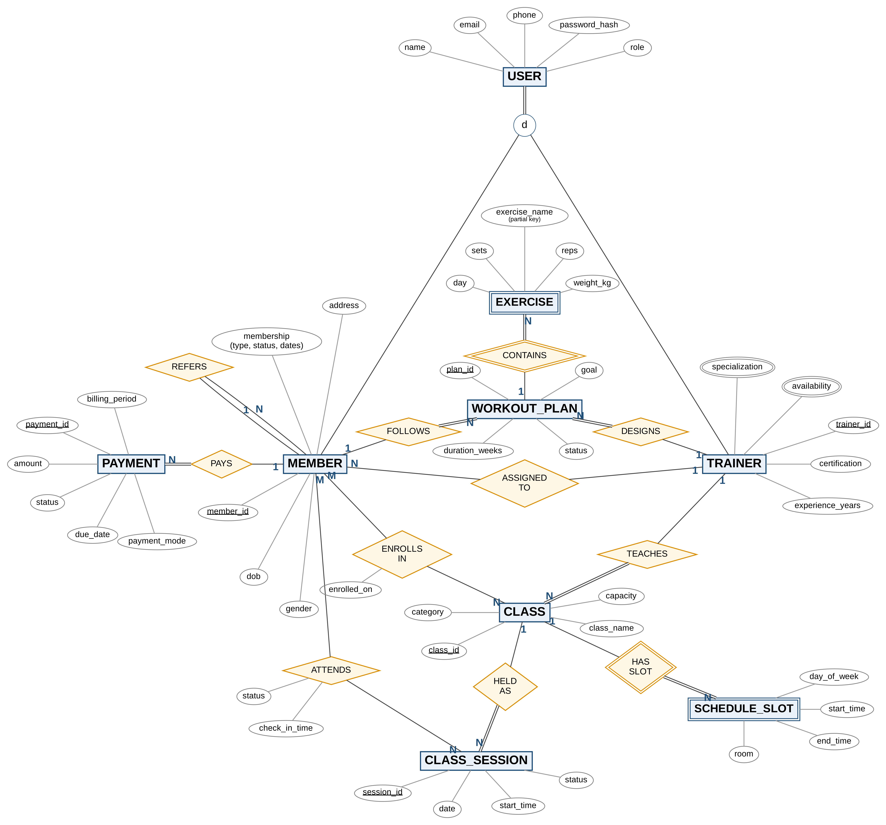
Figure E.1: Complete EER diagram with all attributes

Figure E.2: Full-size relational schema (3NF)

Appendix F: Application Screenshots

Figures F.1 to F.9 are terminal screenshots of the live run on macOS with MongoDB 8.3.11; F.10 to F.12 are from the run on MongoDB 8.3.7.
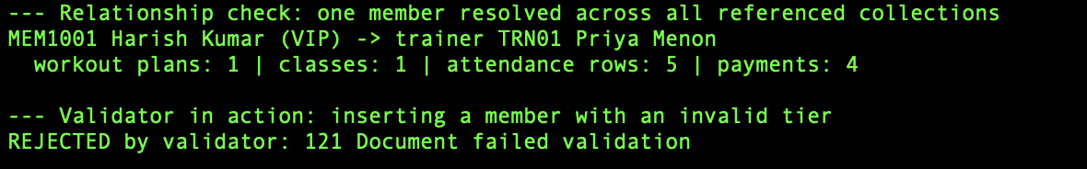
Figure F.1: Validator rejecting a member with an invalid tier
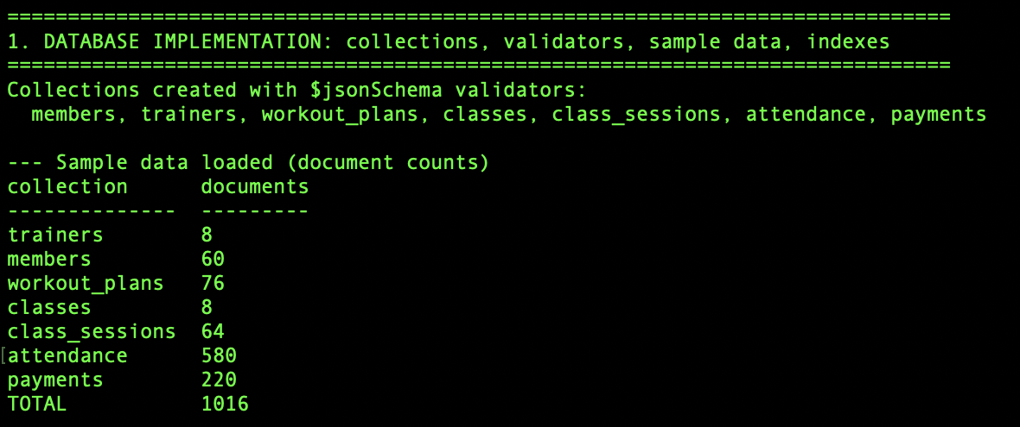
Figure F.2: Collections created and 1,016 sample documents loaded
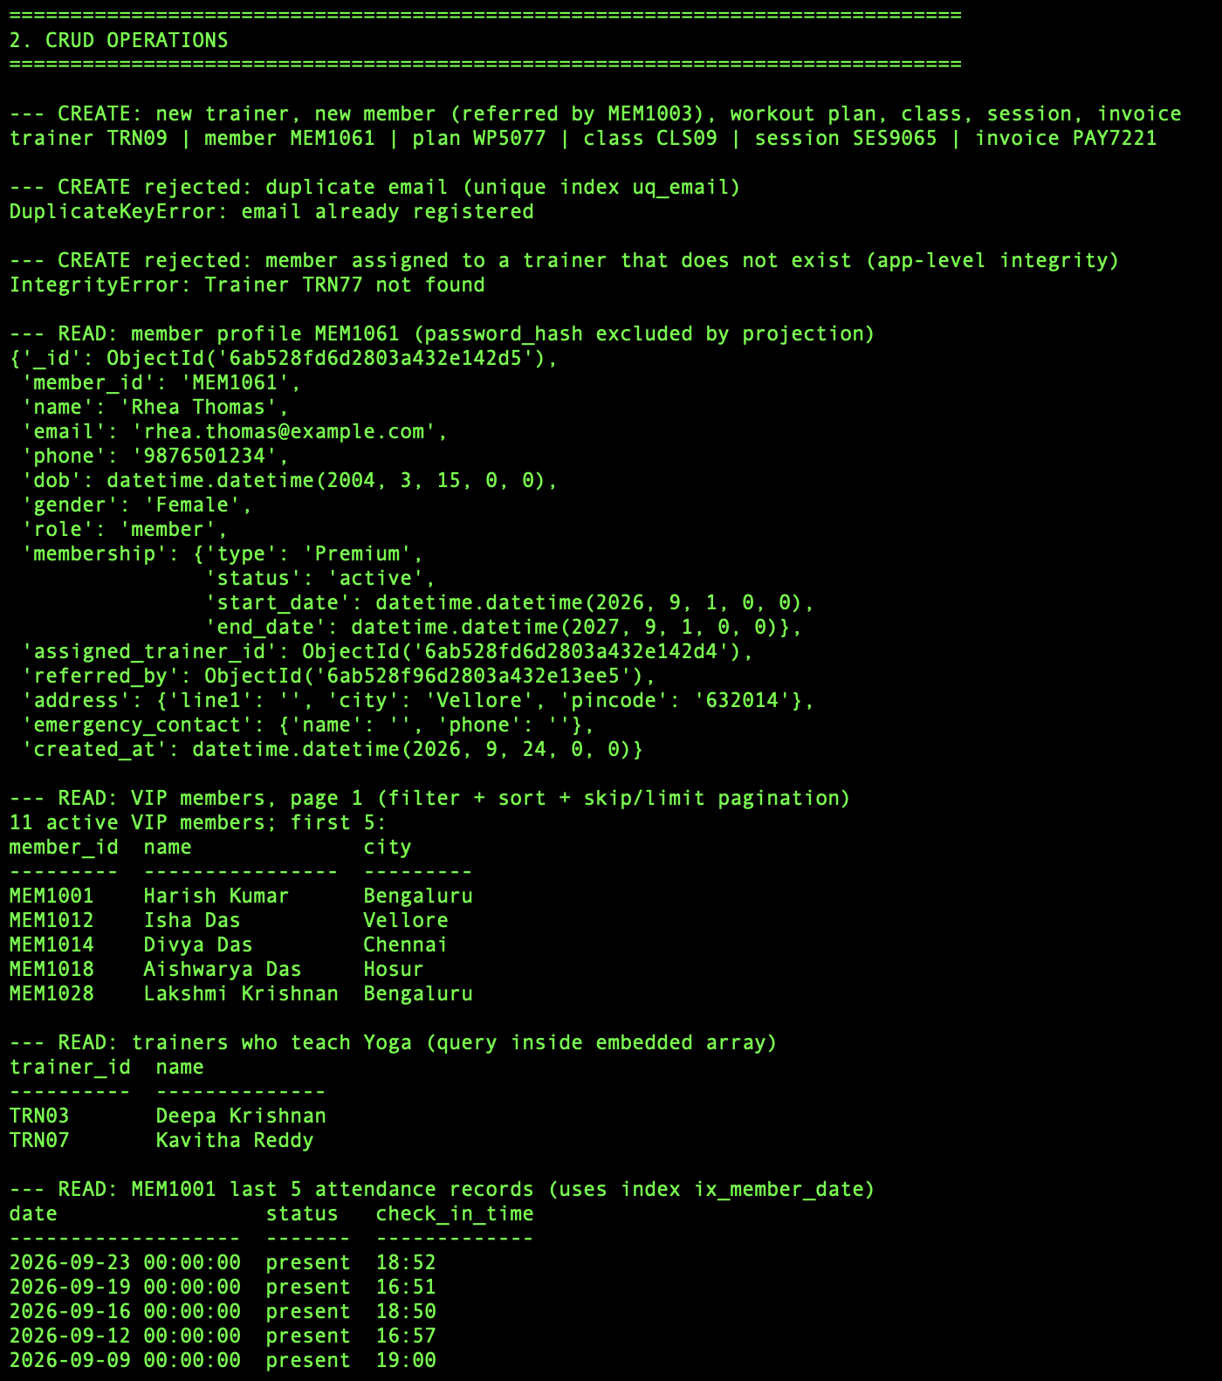
Figure F.3: CRUD demonstration, create and read operations
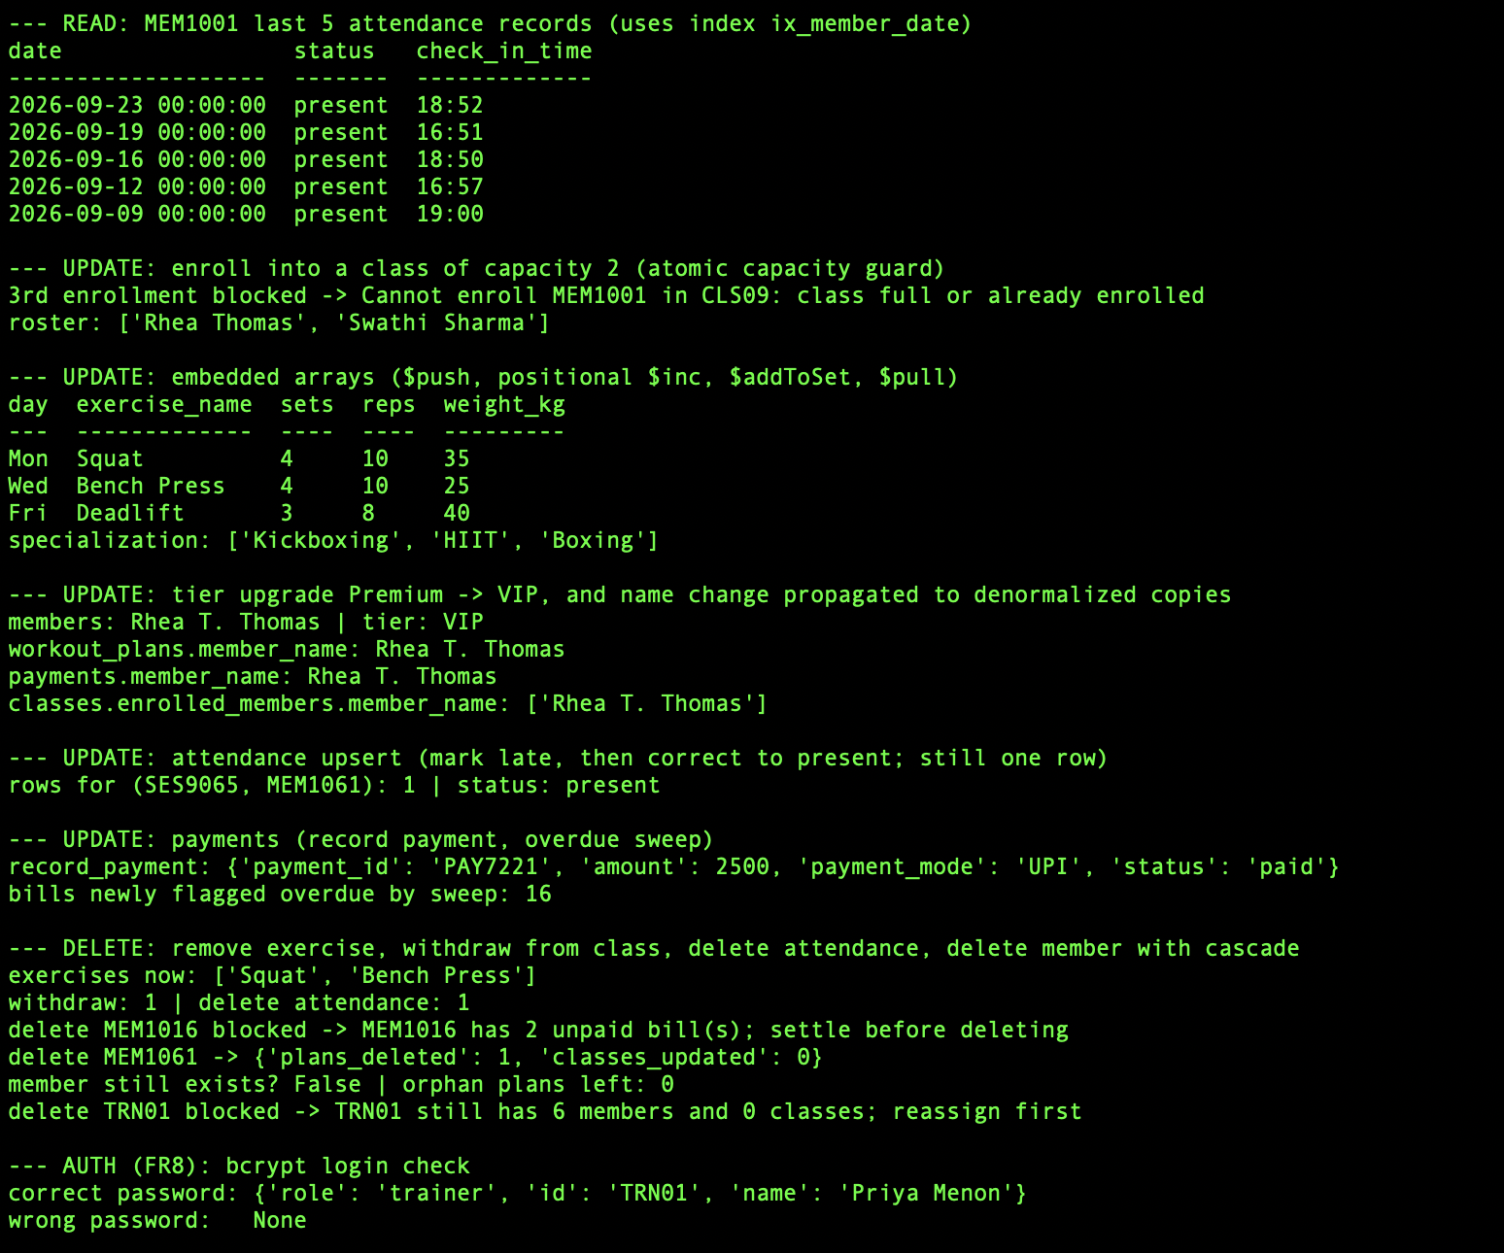
Figure F.4: CRUD demonstration, update, delete and authentication
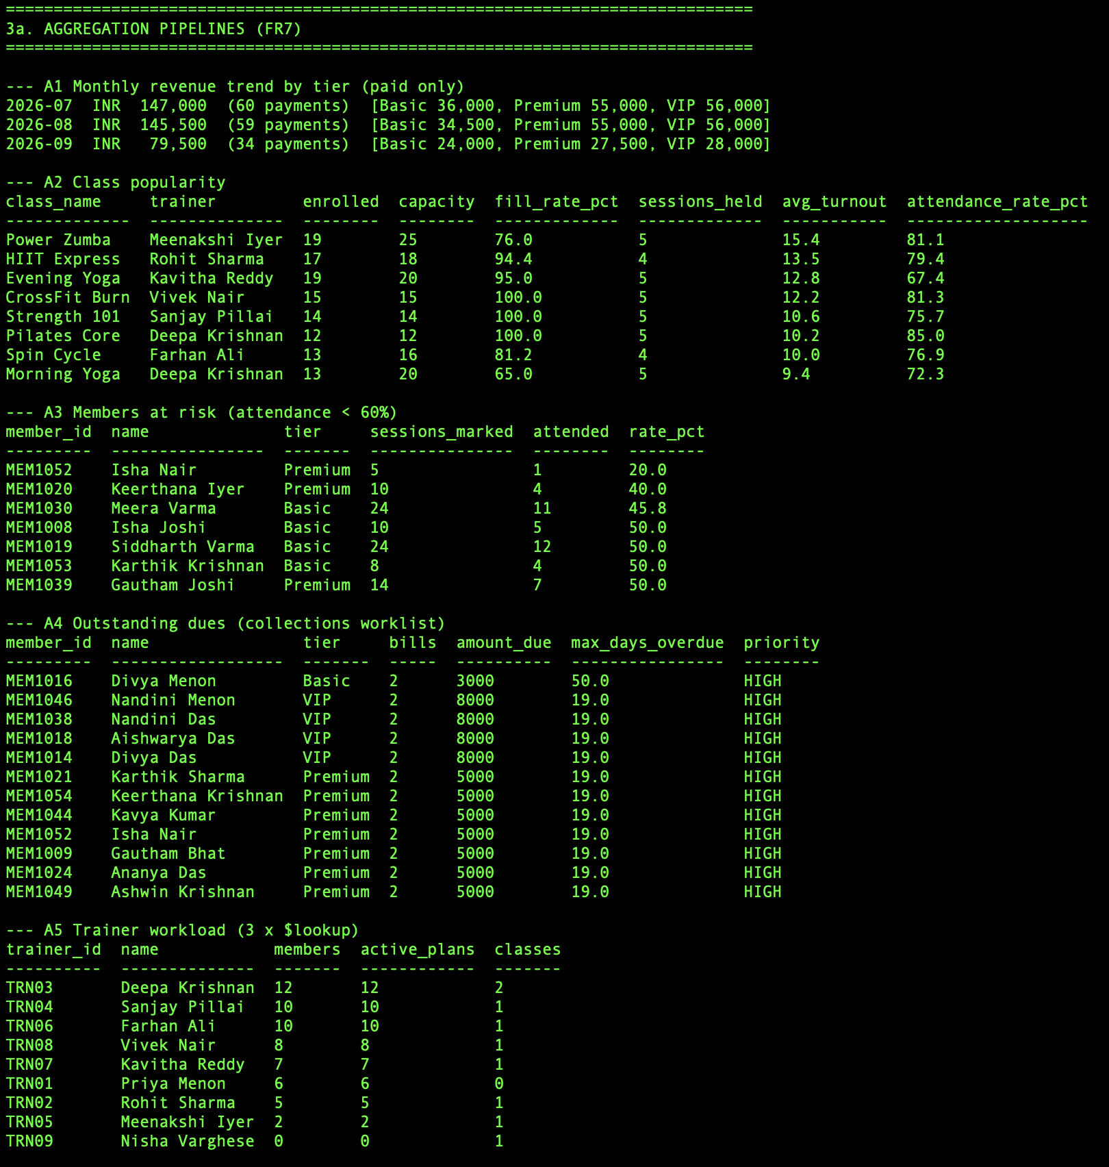
Figure F.5: Aggregation reports A1 to A5
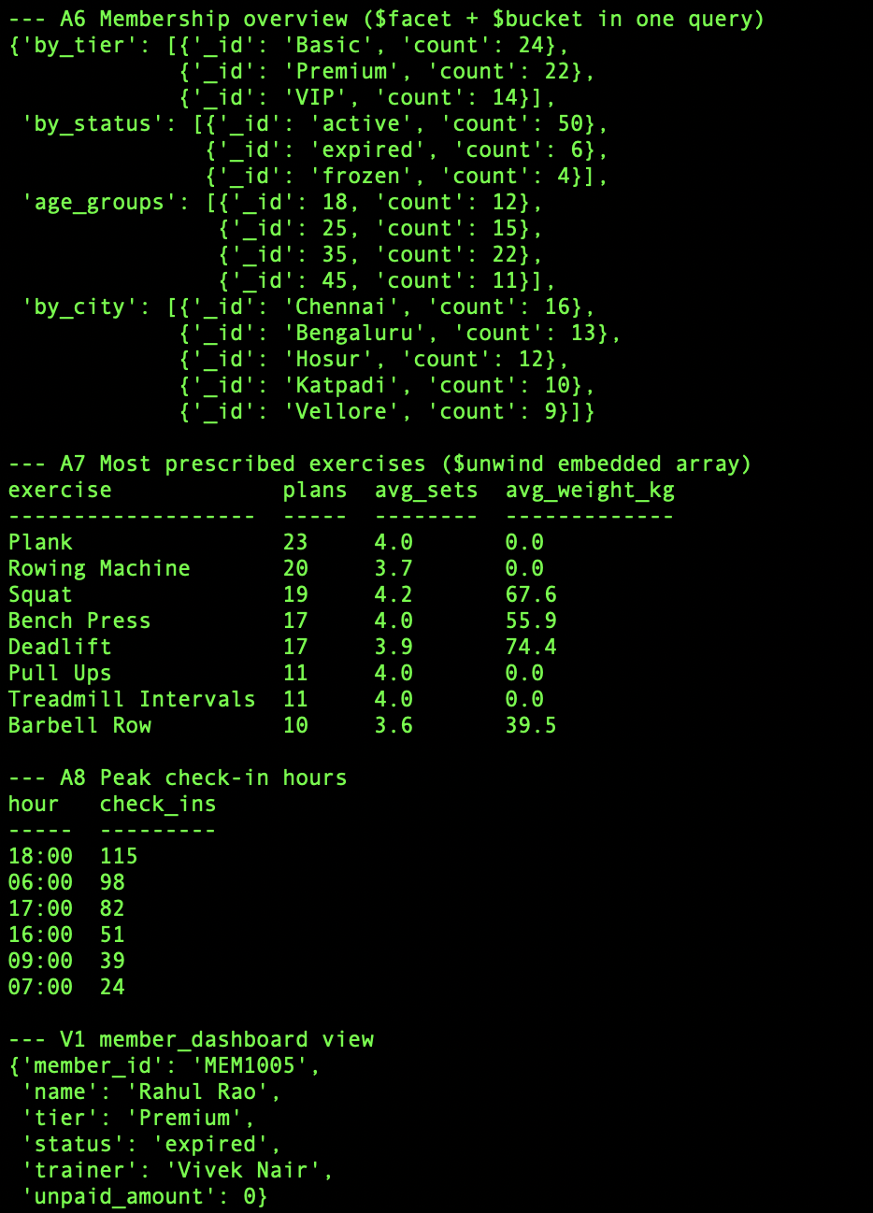
Figure F.6: Aggregation reports A6 to A8 and the member_dashboard view
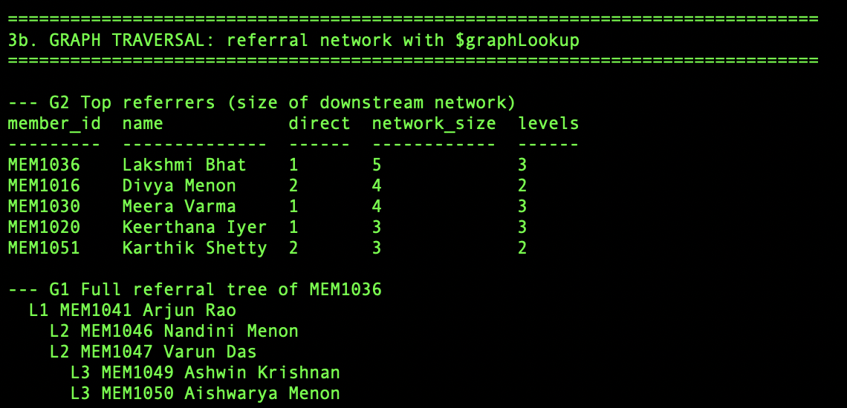
Figure F.7: Referral network with $graphLookup
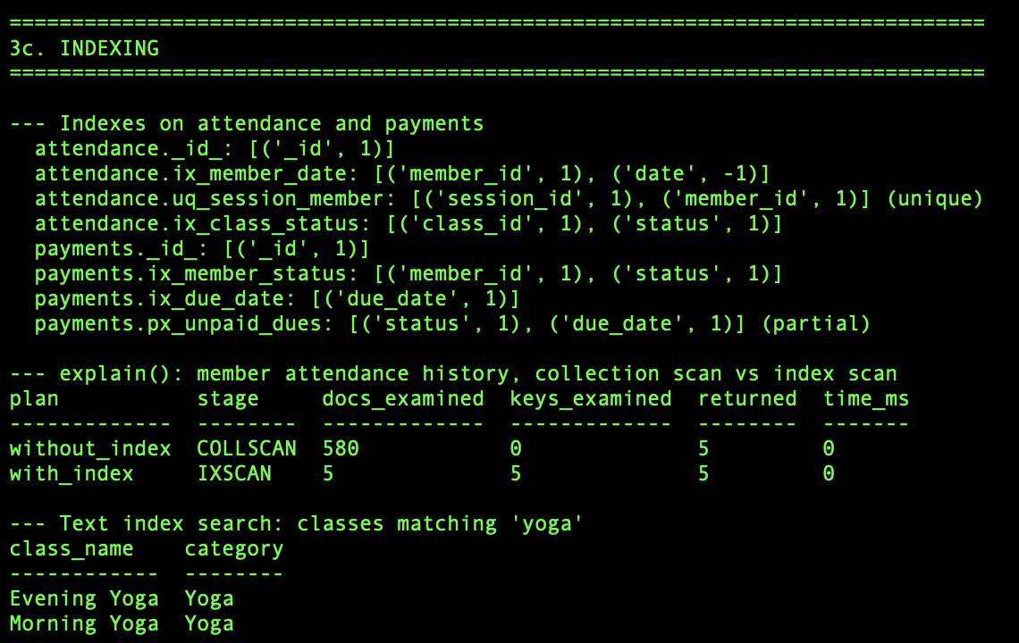
Figure F.8: Indexes, explain() comparison and text search
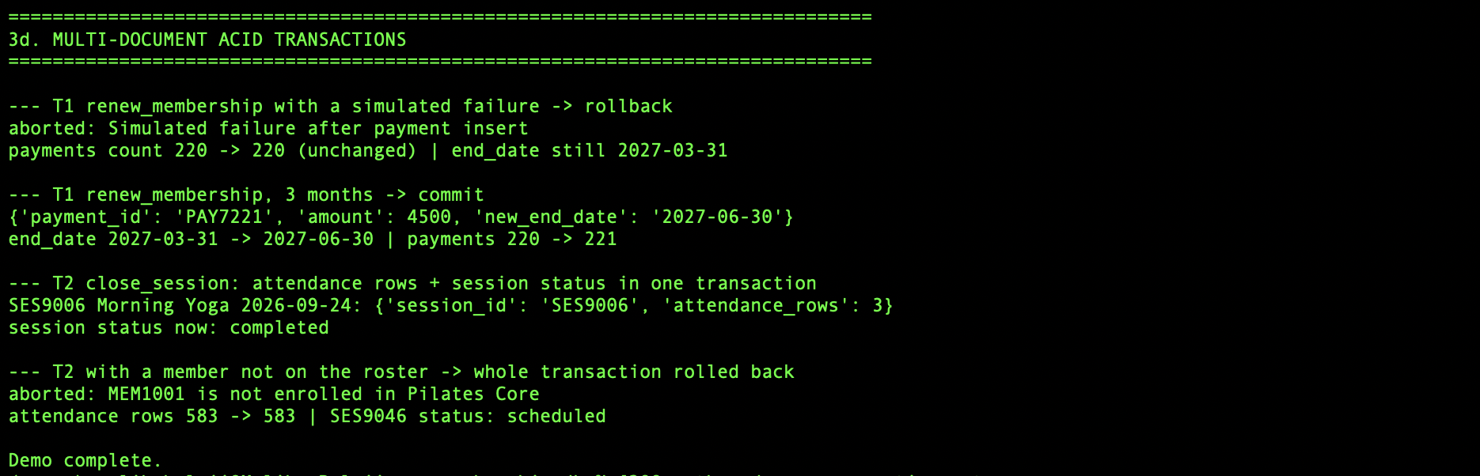
Figure F.9: Transactions T1 and T2, commit and rollback
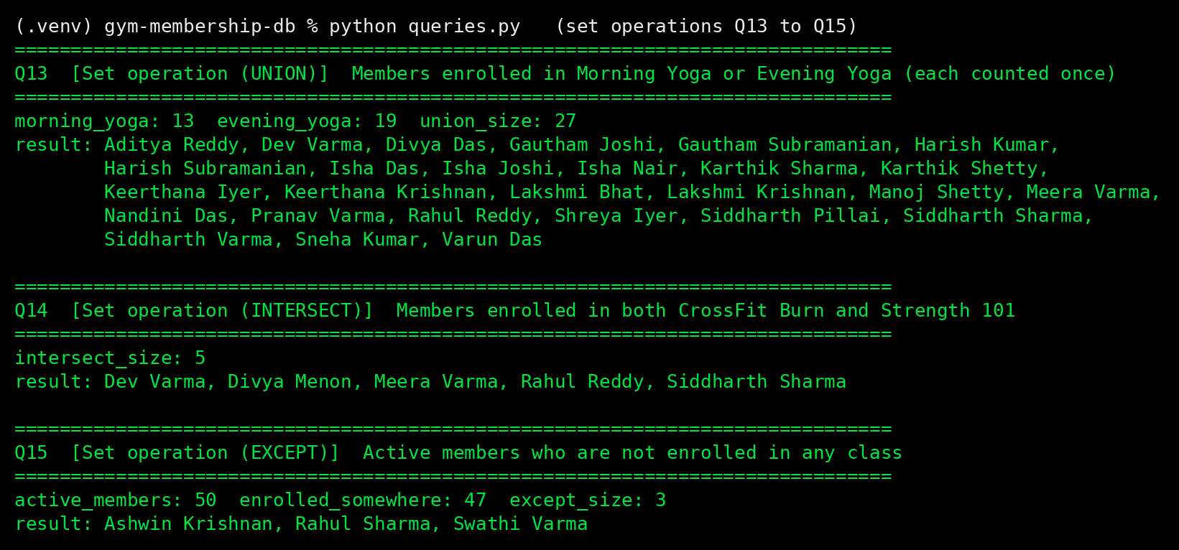
Figure F.10: Set operations Q13 to Q15
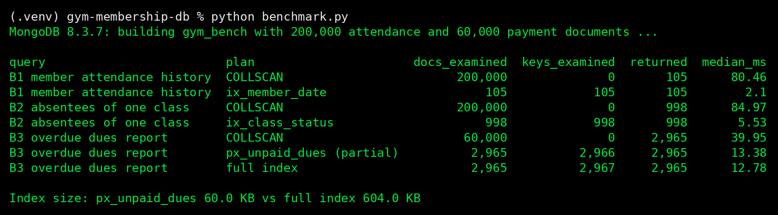
Figure F.11: Index benchmark at 200,000 documents
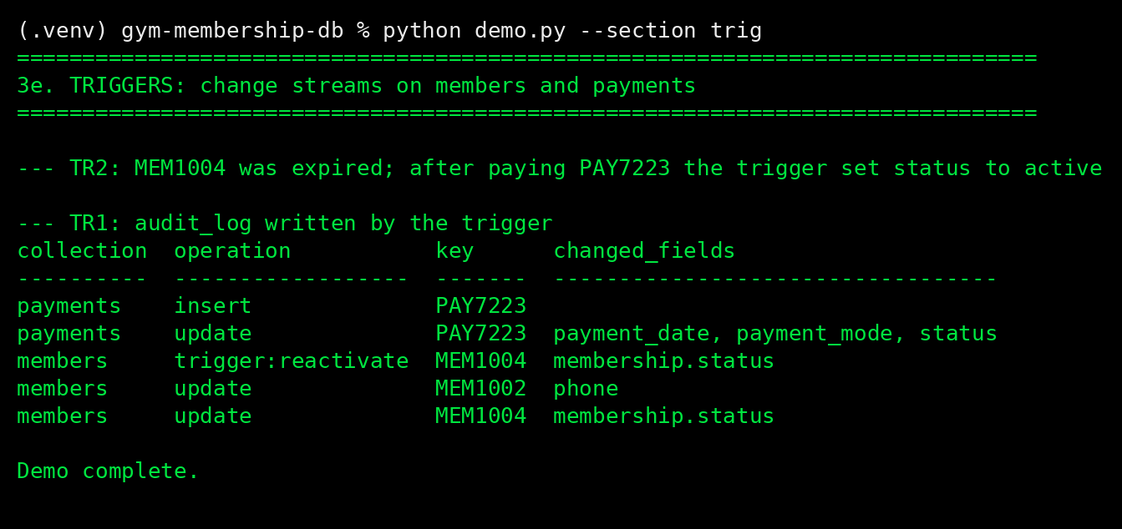
Figure F.12: Change-stream triggers TR1 and TR2

Appendix G: User Manual

G.1 Installation
- Install Python 3.10+, Git, MongoDB Community Server 8 and mongosh (macOS: brew tap mongodb/brew, brew trust mongodb/brew, brew install mongodb-community; Windows: MSI installers from mongodb.com).
- Enable the replica set: add replication: and replSetName: rs0 to mongod.conf (macOS /opt/homebrew/etc/mongod.conf; Windows C:\Program Files\MongoDB\Server\8.0\bin\mongod.cfg).
- Restart MongoDB and run mongosh --eval "rs.initiate()" once.
- Clone the repository, create a virtual environment and run pip install -r requirements.txt (Section 5.1).

G.2 Running the System
Table G.1: Commands
Command | What it does
python demo.py | Rebuilds gym_db and runs every section
python demo.py --section NAME | setup, crud, agg, graph, index, txn or trig
python queries.py [--only Q11] | The 15 queries (or one)
python benchmark.py | Index benchmark (about 10 s)
python -m pytest -q | Automated tests (no server needed)
python demo.py --mock | Demonstration without a server
mongosh mongosh/queries.js | Query set in the shell

G.3 Everyday Tasks
from datetime import datetime
from gym_db.config import get_db
from gym_db import crud as C, aggregations as A, transactions as T
db = get_db()
C.create_member(db, "Asha Rao", "asha.rao@example.com", "9876500000", datetime(2002, 5, 1),
"Female", "Secret@123", tier="Premium", trainer_id="TRN03")
C.enroll_member(db, "CLS01", "MEM1061") # book a class
C.mark_attendance(db, "SES9007", "MEM1061", "present", "07:02") # roll call
T.renew_membership(db, "MEM1061", months=3, mode="UPI") # renew and pay
C.flag_overdue(db); A.outstanding_dues(db) # dues worklist
Test logins: priya.menon@gym.com / Trainer@01; members use Member@<number>, for example Member@1001.

G.4 Backup and Restore
mongodump --db gym_db --out backup/ # backup
mongorestore --drop backup/ # restore
python export_data.py # JSON export to data/*.json

G.5 Troubleshooting
Table G.2: Common problems
Message | Fix
ServerSelectionTimeoutError | Start the MongoDB service
"Transaction numbers are only allowed on a replica set member" | Add replSetName: rs0 and run rs.initiate()
ModuleNotFoundError | Activate .venv and install requirements
Untrusted tap (Homebrew) | brew trust mongodb/brew
Document failed validation | The value breaks a rule in Table 4.7

