

Database Systems Project
Review 2
Database Implementation and Core Functionalities
Gym Membership Management System (MongoDB)
Submitted by: Liz Alex (24BCE2978)
Malika Balaji (24BAI0114)
Nehaa Prabhu (24BAI0130)
Submitted to: Prof. Lydia Jane G

Contents
1. Review 2 Summary 3
1.1 Coverage of the Review 2 Rubric 3
1.2 Expected Deliverables Checklist 3
2. Implementation Environment 3
3. Database Implementation 4
3.1 Collections and Schema Validation 4
3.2 Relationships Implemented 5
3.3 Sample Data 5
4. CRUD Operations 6
4.1 CRUD Coverage by Collection 6
4.2 Referential Integrity Rules 7
4.3 Key CRUD Implementations 7
4.4 CRUD Demonstration Results 8
5. Advanced NoSQL Features 10
5.1 Aggregation Pipelines 10
5.2 Graph Traversal: Referral Network 15
5.3 Indexing 16
5.4 Multi-Document ACID Transactions 17
6. Traceability to Review 1 Requirements 19
7. Testing 19
8. Intermediate Demonstration Plan 20
9. Source Code Repository 20
10. Plan for Review 3 21

1. Review 2 Summary
Review 1 defined the problem, requirements, NoSQL selection and the seven-collection MongoDB data model. Review 2 implements that design as a working database. The gym_db database now runs with schema validation, 1,016 sample documents, a complete CRUD layer for every collection, and a set of advanced MongoDB features: eight aggregation pipelines, recursive graph traversal with $graphLookup, nineteen purpose-built indexes, and multi-document ACID transactions.

1.1 Coverage of the Review 2 Rubric
Criterion | Marks | What was delivered | Section
Database implementation (collections, relationships, sample data) | 2 | 7 collections with $jsonSchema validators; 10 relationships using references and embedded arrays; 1,016 reproducible sample documents | 3
CRUD operations completed | 3 | 36 functions covering create, read, update and delete on all 7 collections, with 10 referential-integrity rules enforced | 4
Advanced NoSQL features | 5 | 8 aggregation pipelines and 1 view; $graphLookup referral network; 19 indexes (unique, compound, multikey, text, partial) with explain() proof; 2 ACID transactions with rollback | 5
Total | 10

1.2 Expected Deliverables Checklist
Deliverable | Status | Evidence
Database created | Done | gym_db with 7 validated collections, 19 secondary indexes and 1 view (Section 3.1)
Sample data loaded | Done | seed.py loads 1,016 documents; also exported to data/*.json for mongoimport (Section 3.3)
CRUD operations working | Done | gym_db/crud.py, exercised by demo.py and 6 automated tests (Sections 4 and 7)
Minimum 50 sample records | Done | 60 members alone; 1,016 documents in total
Intermediate demonstration | Ready | demo.py runs every rubric item in order; mongosh/demo_queries.js for live queries (Section 8)
Source code repository | Ready | gym-membership-db Git repository with README (Section 9)

2. Implementation Environment
All reports use a fixed reference date of 24 September 2026 (set in gym_db/config.py), and the seed script uses a fixed random seed. Every run therefore produces the same dataset and the same report figures, which keeps the demonstration repeatable.
Component | Choice | Reason
Database | MongoDB 8.3 (Homebrew, macOS), single-node replica set rs0 | A replica set is required for multi-document transactions
Language and driver | Python 3.12 with PyMongo 4 | Official driver; readable pipelines; easy to demonstrate
Password hashing | bcrypt | Salted adaptive hashing, as specified in NFR3
Shell | mongosh | Live ad-hoc queries during the review
Testing | pytest with mongomock (in-memory MongoDB) | Tests run on any laptop without a database server

3. Database Implementation

3.1 Collections and Schema Validation
MongoDB does not require a schema, but the project attaches a $jsonSchema validator to every collection with validationLevel: strict and validationAction: error. Invalid documents are rejected by the database itself, not only by application code. Each validator enforces required fields, BSON data types, allowed values, value ranges and formats.
Collection | Key rules enforced by the validator
members | member_id pattern MEM####; valid email; 10-digit phone; tier in Basic, Premium, VIP; status in active, expired, frozen; dates are BSON dates; trainer and referrer are ObjectIds
trainers | trainer_id pattern TRN##; role fixed to trainer; specialization is an array of strings; availability items need day, start and end time
workout_plans | member and trainer ObjectIds required; duration 1 to 52 weeks; at least one exercise; sets and reps at least 1
classes | trainer ObjectId required; capacity 1 to 50; schedule and roster are arrays
class_sessions | class ObjectId; date is a BSON date; status in scheduled, completed, cancelled
attendance | session and member ObjectIds; status in present, absent, late
payments | amount at least 0; currency INR; mode in cash, card, UPI; status in paid, pending, overdue

Validator for the members collection (gym_db/schema.py):
"members": {
"bsonType": "object",
"required": ["member_id", "name", "email", "password_hash", "role", "membership"],
"properties": {
"member_id": {"bsonType": "string", "pattern": "^MEM[0-9]{4}$"},
"name": {"bsonType": "string", "minLength": 2},
"email": {"bsonType": "string", "pattern": "^.+@.+\\..+$"},
"phone": {"bsonType": "string", "pattern": "^[0-9]{10}$"},
"gender": {"enum": ["Male", "Female", "Other"]},
"role": {"enum": ["member"]},
"membership": {
"bsonType": "object",
"required": ["type", "status", "start_date", "end_date"],
"properties": {
"type": {"enum": ["Basic", "Premium", "VIP"]},
"status": {"enum": ["active", "expired", "frozen"]},
"start_date": {"bsonType": "date"},
"end_date": {"bsonType": "date"},
},
},
"assigned_trainer_id": {"bsonType": [OID, "null"]},
"referred_by": {"bsonType": [OID, "null"]},
},
}
In the live run, inserting a member with the tier Gold was rejected by the server with error code 121, Document failed validation (Screenshot 1).
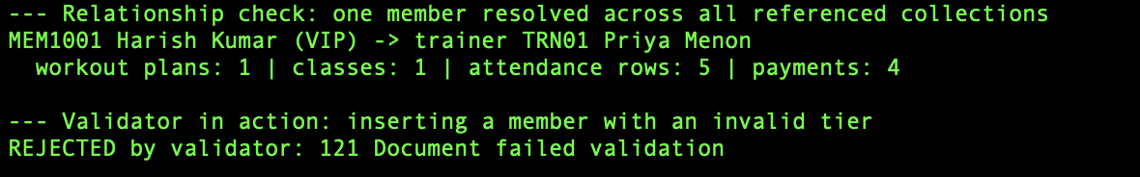
Screenshot 1: $jsonSchema validator rejecting an invalid membership tier (live MongoDB run)

3.2 Relationships Implemented
The relationships from the Review 1 data model are implemented as designed: bounded data that is always read with its parent is embedded; data that grows without limit or is queried independently is referenced by ObjectId, with frequently displayed names denormalized to avoid joins on dashboards.
Relationship | Cardinality | Implementation | Integrity enforced by
Trainer to Members | 1:N | members.assigned_trainer_id reference | create_member, assign_trainer
Member to Workout plans | 1:N | workout_plans.member_id reference + member_name copy | create_workout_plan
Trainer to Workout plans | 1:N | workout_plans.trainer_id reference + trainer_name copy | create_workout_plan
Plan to Exercises | 1:N | exercises[ ] embedded array | validator (minItems 1)
Trainer to Classes | 1:N | classes.trainer_id reference | create_class, delete_trainer
Class to Members (roster) | M:N | enrolled_members[ ] embedded, bounded by capacity | enroll_member (atomic)
Class to Sessions | 1:N | class_sessions.class_id reference | create_session, delete_class
Session and Member to Attendance | 1:N | attendance references both, unique pair | unique index + upsert
Member to Payments | 1:N | payments.member_id reference + member_name copy | create_invoice, delete_member
Member to Member (referral) | 1:N, recursive | members.referred_by self-reference (new) | create_member, delete_member

Change from Review 1. One nullable field, referred_by, was added to members to model the gym's referral programme. It makes the members collection a self-referencing graph and gives the graph traversal feature (Section 5.2) a real business purpose. No other schema changes were needed.

3.3 Sample Data
The seed script (gym_db/seed.py) generates realistic, internally consistent data: every reference points to an existing document, rosters never exceed capacity, attendance exists only for completed sessions of enrolled members, and each bill matches the member's tier fee (Basic INR 1,500, Premium INR 2,500, VIP INR 4,000 per month).
Collection | Documents | Contents
trainers | 8 | Specializations, certifications and weekly availability
members | 60 | 24 Basic, 22 Premium, 14 VIP; 50 active, 6 expired, 4 frozen; 5 cities; referral links
workout_plans | 76 | 60 active and 16 completed plans, 3 to 4 embedded exercises each
classes | 8 | Yoga, Zumba, CrossFit, HIIT, Spin, Pilates, Strength; 2 weekly slots each
class_sessions | 64 | Four weeks of dated sessions, 7 September to 4 October 2026
attendance | 580 | Present, late or absent for each enrolled member in each completed session
payments | 220 | July to October 2026 billing cycles: paid, pending and overdue
Total | 1,016 | The rubric minimum is 50

Passwords are stored as bcrypt hashes. Test logins follow the pattern Trainer@01 for TRN01 and Member@1001 for MEM1001. The full dataset is also exported as MongoDB Extended JSON in the repository's data/ folder and can be loaded with mongoimport --jsonArray.
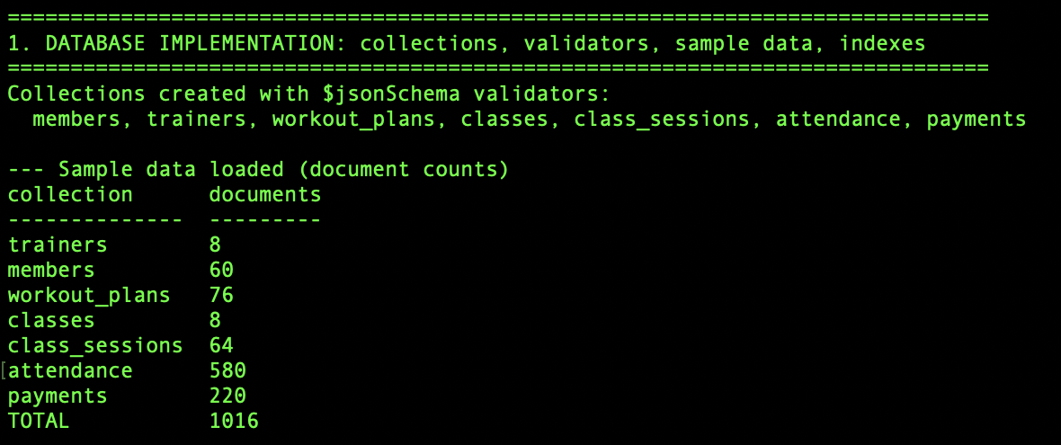
Screenshot 2: Collections created and 1,016 sample documents loaded (live MongoDB run)

4. CRUD Operations
All CRUD logic is in gym_db/crud.py: 36 functions across the seven collections. Because MongoDB has no foreign keys, this layer is also where referential integrity is enforced, as committed in NFR5 of Review 1.

4.1 CRUD Coverage by Collection
Collection | Create | Read | Update | Delete
members | create_member | get_member, list_members (filter, sort, paginate) | update_member, change_membership, assign_trainer | delete_member (guarded cascade)
trainers | create_trainer | get_trainer, find_trainers_by_skill | add_specialization ($addToSet), set_availability | delete_trainer (guarded)
workout_plans | create_workout_plan | get_active_plan | add_exercise ($push), progress_exercise (positional $inc) | remove_exercise ($pull), delete_workout_plan
classes | create_class | get_class, member_classes (multikey) | enroll_member (atomic), withdraw_member | delete_class
class_sessions | create_session | used by reports and T2 | cancel_session | via delete_class
attendance | mark_attendance (upsert) | attendance_history (sorted, indexed) | mark_attendance (corrects) | delete_attendance
payments | create_invoice | member_dues | record_payment, flag_overdue (bulk) | delete_payment (pending only)

Authentication (FR8) is provided by authenticate(email, password), which verifies the bcrypt hash and returns the user's role. Every read that returns a member or trainer excludes password_hash through a projection.

4.2 Referential Integrity Rules
Rule | Enforced in
A member's trainer, and a referrer, must exist | create_member, assign_trainer
A workout plan is issued by the member's assigned trainer; only one plan is active at a time | create_workout_plan
Only active members can enroll; roster never exceeds capacity; no duplicate enrollment | enroll_member (single atomic update)
A name change is copied to every denormalized copy (plans, attendance, payments, class rosters) | update_member
A member with unpaid bills cannot be deleted; otherwise plans, roster entries and referral links are cleaned up | delete_member
A trainer with assigned members or classes cannot be deleted | delete_trainer
Deleting a class removes its future sessions but keeps attendance history | delete_class
Paid bills are immutable; only a pending invoice raised in error can be deleted | record_payment, delete_payment
One attendance record per member per session | unique index uq_session_member + upsert
Pending bills past their due date become overdue | flag_overdue (bulk update)

4.3 Key CRUD Implementations

Atomic class enrollment (Update)
The capacity and duplicate checks sit inside the update filter using $expr and $size. MongoDB applies a single-document update atomically, so two members booking the last place at the same moment can never overbook the class, and no transaction is needed.
def enroll_member(db, class_id, member_id):
"""FR4. Atomic single-document update: the filter itself checks capacity and duplicates,
so two simultaneous requests can never overbook the class."""
m = db.members.find_one({"member_id": member_id, "membership.status": "active"})
if not m:
raise IntegrityError(f"{member_id} not found or membership not active")
res = db.classes.update_one(
{"class_id": class_id,
"enrolled_members.member_id": {"$ne": m["_id"]},
"$expr": {"$lt": [{"$size": "$enrolled_members"}, "$capacity"]}},
{"$push": {"enrolled_members": {"member_id": m["_id"], "member_name": m["name"],
"enrolled_on": REFERENCE_DATE}}})
if res.modified_count == 0:
raise IntegrityError(f"Cannot enroll {member_id} in {class_id}: class full or already enrolled")
return True

Propagating a name change to denormalized copies (Update)
def update_member(db, member_id, **fields):
"""Update profile fields. A name change is propagated to every denormalized copy."""
allowed = {"name", "phone", "email", "address", "emergency_contact"}
bad = set(fields) - allowed
if bad:
raise ValueError(f"Cannot update {bad} here")
doc = db.members.find_one_and_update({"member_id": member_id}, {"$set": fields},
projection=SAFE, return_document=ReturnDocument.AFTER)
if doc and "name" in fields:
oid, name = doc["_id"], fields["name"]
for coll in ("workout_plans", "attendance", "payments"):
db[coll].update_many({"member_id": oid}, {"$set": {"member_name": name}})
db.classes.update_many({"enrolled_members.member_id": oid},
{"$set": {"enrolled_members.$.member_name": name}}) # positional $
return doc

Guarded cascading delete (Delete)
def delete_member(db, member_id):
"""Blocked if dues are outstanding; otherwise cascades to plans and class rosters.
Attendance and payment history are kept as the gym's audit trail."""
oid = _member_oid(db, member_id)
dues = db.payments.count_documents({"member_id": oid, "status": {"$in": ["pending", "overdue"]}})
if dues:
raise IntegrityError(f"{member_id} has {dues} unpaid bill(s); settle before deleting")
plans = db.workout_plans.delete_many({"member_id": oid}).deleted_count
rosters = db.classes.update_many({}, {"$pull": {"enrolled_members": {"member_id": oid}}}).modified_count
db.members.update_many({"referred_by": oid}, {"$set": {"referred_by": None}})
db.members.delete_one({"_id": oid})
return {"plans_deleted": plans, "classes_updated": rosters}

Idempotent attendance marking with upsert (Create and Update)
def mark_attendance(db, session_id, member_id, status, check_in_time=None):
"""FR5. Upsert keyed on (session, member): re-marking corrects the record, never duplicates it."""
s = db.class_sessions.find_one({"session_id": session_id})
if not s:
raise IntegrityError(f"Session {session_id} not found")
m = db.members.find_one({"member_id": member_id})
if not m:
raise IntegrityError(f"Member {member_id} not found")
return db.attendance.update_one(
{"session_id": s["_id"], "member_id": m["_id"]},
{"$set": {"status": status, "check_in_time": check_in_time},
"$setOnInsert": {"class_id": s["class_id"], "member_name": m["name"], "date": s["date"]}},
upsert=True)

4.4 CRUD Demonstration Results
Results recorded from the live run of python demo.py (Screenshots 3 and 4):
Operation | Result
Create trainer, member, plan, class, session, invoice | TRN09, MEM1061 (referred by MEM1003), WP5077, CLS09 (capacity 2), SES9065, PAY7221
Create with a duplicate email | Rejected: DuplicateKeyError from unique index uq_email
Create a member for trainer TRN77 | Rejected: IntegrityError, Trainer TRN77 not found
Read active VIP members, page 1 | 11 matches; first 5 returned, sorted by member_id
Read trainers with specialization Yoga | TRN03 Deepa Krishnan, TRN07 Kavitha Reddy
Enroll 3 members into a class of capacity 2 | First two succeed; third rejected, class full
Push exercise, +5 kg on Squat, add a skill twice | Plan shows 3 exercises, Squat 30 to 35 kg; skill stored once ($addToSet)
Rename member | New name appears in members, workout_plans, payments and the class roster
Mark attendance late, then correct to present | Still exactly 1 attendance row, status present
Record payment; run overdue sweep | PAY7221 paid by UPI; 16 bills flagged overdue
Delete a member with unpaid bills | Blocked: MEM1008 has 2 unpaid bills
Delete MEM1061 | Member deleted, 1 plan cascaded, 0 orphan documents left
Delete trainer TRN01 | Blocked: still has 6 members; reassign first
Login with correct and wrong password | Returns role trainer for TRN01; wrong password returns None
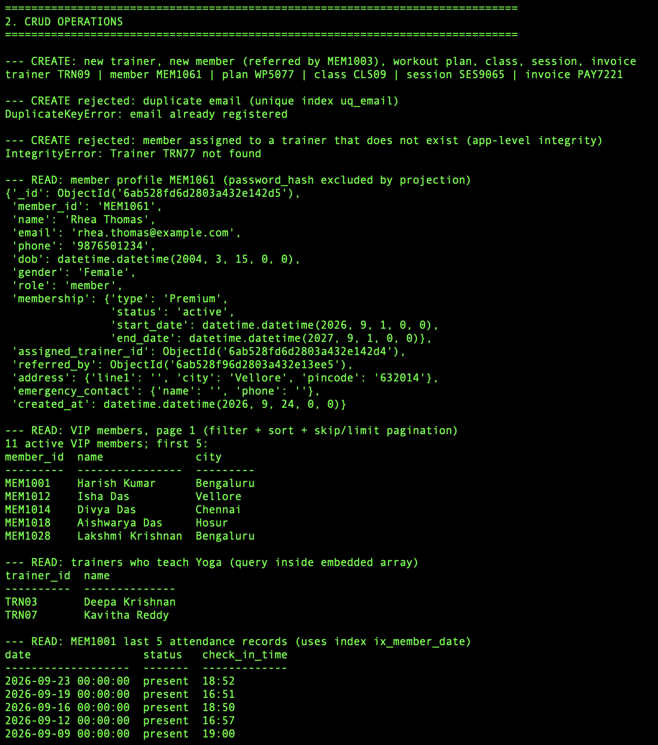
Screenshot 3: CRUD demonstration, create and read operations (live MongoDB run)
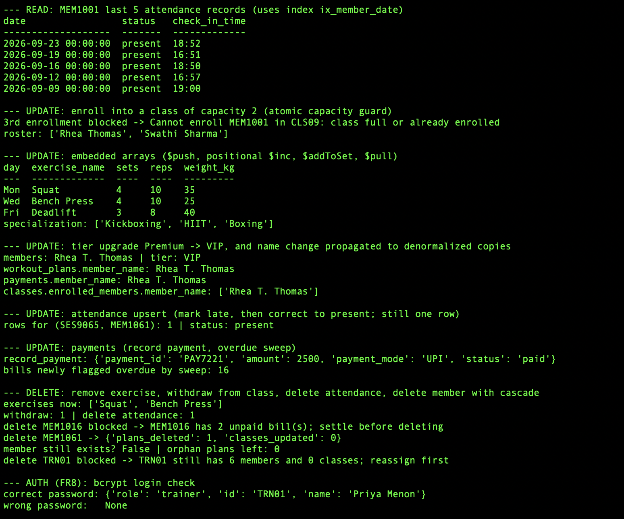
Screenshot 4: CRUD demonstration, update, delete and authentication (live MongoDB run)

5. Advanced NoSQL Features
This criterion carries 5 of the 10 marks. Four categories of advanced features are implemented, each tied to a requirement from Review 1.
Feature | Implemented | Requirement
Aggregation framework | 8 analytical pipelines and 1 read-only view | FR2, FR3, FR6, FR7
Graph traversal | $graphLookup over the member referral network (2 queries) | Referral programme
Indexing | 19 indexes of 6 kinds, verified with explain() | NFR1
Transactions | 2 multi-document ACID transactions with rollback | NFR5
Also used | $jsonSchema validation, atomic conditional updates, upserts, array update operators | NFR5

5.1 Aggregation Pipelines
ID | Report | Business question answered | Main stages and operators
A1 | Revenue trend | How much was collected each month, per tier? | $match, $lookup, $unwind, $group (twice), $dateToString, $push
A2 | Class popularity | Which classes are full, and which are actually attended? | $group, $cond, $addToSet, $lookup, $size, $divide, $round
A3 | At-risk members | Who attends less than 60% and may cancel? | $group, $addFields, $match, $lookup
A4 | Outstanding dues | Who owes money, how late, and in what priority? | $subtract on dates, $floor, $max, $group, nested $cond
A5 | Trainer workload | Is the load spread fairly across trainers? | 3 x $lookup, $filter, $size
A6 | Membership overview | Tier, status, age and city mix in one query | $facet, $bucket, $group
A7 | Top exercises | What do trainers prescribe most? | $unwind (embedded array), $group, $avg
A8 | Peak hours | When is the gym busiest? | $substr, $concat, $group, $sort
V1 | member_dashboard view | Everything a member sees on login | stored view: 2 x $lookup, $filter, $map, $first

A1: Monthly revenue by tier
def revenue_trend(db):
return list(db.payments.aggregate([
{"$match": {"status": "paid"}},
{"$lookup": {"from": "members", "localField": "member_id", "foreignField": "_id", "as": "m"}},
{"$unwind": "$m"},
{"$group": {
"_id": {"month": {"$dateToString": {"format": "%Y-%m", "date": "$billing_period_start"}},
"tier": "$m.membership.type"},
"revenue": {"$sum": "$amount"}, "payments": {"$sum": 1}}},
{"$group": {"_id": "$_id.month",
"total_revenue": {"$sum": "$revenue"},
"payments": {"$sum": "$payments"},
"by_tier": {"$push": {"tier": "$_id.tier", "revenue": "$revenue"}}}},
{"$sort": {"_id": 1}},
{"$project": {"_id": 0, "month": "$_id", "total_revenue": 1, "payments": 1, "by_tier": 1}},
]))
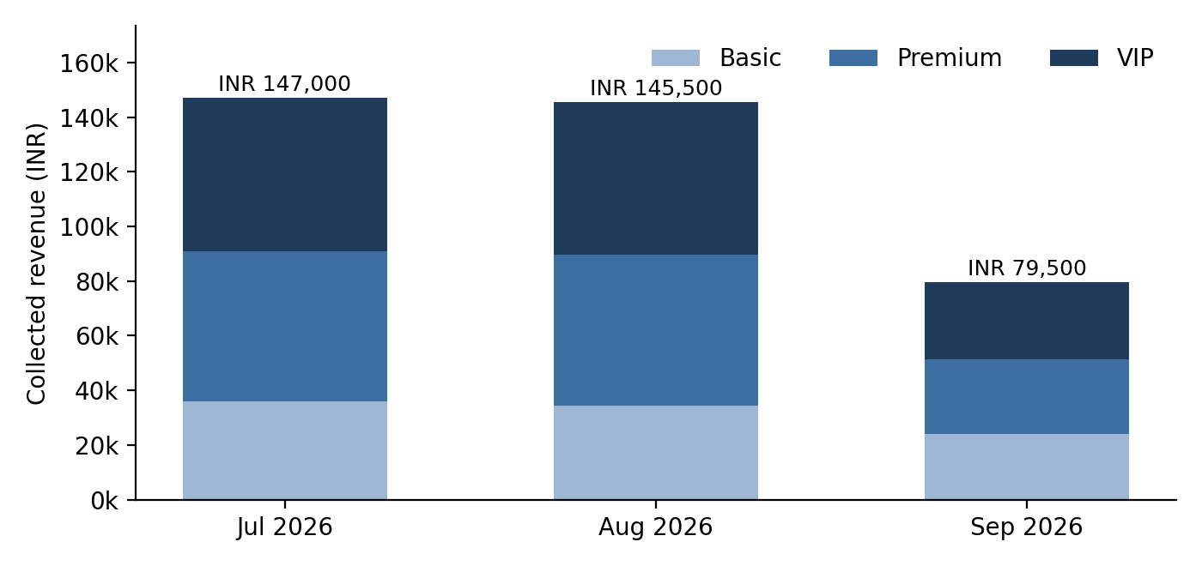
Figure 1: Output of pipeline A1, collected revenue by month and membership tier
Revenue was INR 1,47,000 in July and INR 1,45,500 in August, then fell to INR 79,500 in September. Pipelines A6 and A4 explain the drop: 6 memberships expired on 31 August, 4 are frozen, and 16 September bills are unpaid. VIP members are 14 of 60 but produced INR 56,000 of July revenue, 38% of the total.

A2: Class popularity
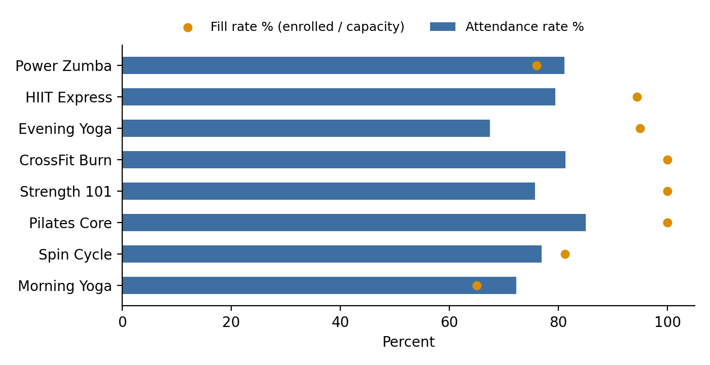
Figure 2: Output of pipeline A2, attendance rate and fill rate per class
Class | Trainer | Enrolled / capacity | Sessions held | Avg turnout | Attendance %
Power Zumba | Meenakshi Iyer | 19 / 25 | 5 | 15.4 | 81.1
HIIT Express | Rohit Sharma | 17 / 18 | 4 | 13.5 | 79.4
Evening Yoga | Kavitha Reddy | 19 / 20 | 5 | 12.8 | 67.4
CrossFit Burn | Vivek Nair | 15 / 15 | 5 | 12.2 | 81.3
Strength 101 | Sanjay Pillai | 14 / 14 | 5 | 10.6 | 75.7
Pilates Core | Deepa Krishnan | 12 / 12 | 5 | 10.2 | 85
Spin Cycle | Farhan Ali | 13 / 16 | 4 | 10 | 76.9
Morning Yoga | Deepa Krishnan | 13 / 20 | 5 | 9.4 | 72.3

Pilates Core, CrossFit Burn and Strength 101 are fully booked, and Pilates Core has the best attendance at 85%. Morning Yoga is weakest on both measures (65% full, 72.3% attendance), which makes it a candidate for a new time slot.

A3 and A4: Members at risk and outstanding dues
Member | Name | Tier | Sessions | Attended | Rate %
MEM1052 | Isha Nair | Premium | 5 | 1 | 20
MEM1020 | Keerthana Iyer | Premium | 10 | 4 | 40
MEM1030 | Meera Varma | Basic | 24 | 11 | 45.8
MEM1008 | Isha Joshi | Basic | 10 | 5 | 50
MEM1019 | Siddharth Varma | Basic | 24 | 12 | 50
MEM1039 | Gautham Joshi | Premium | 14 | 7 | 50
MEM1053 | Karthik Krishnan | Basic | 8 | 4 | 50
A3 output: members attending less than 60% of their sessions
Member | Name | Tier | Bills | Amount due | Days overdue | Priority
MEM1016 | Divya Menon | Basic | 2 | INR 3,000 | 50 | HIGH
MEM1014 | Divya Das | VIP | 2 | INR 8,000 | 19 | HIGH
MEM1018 | Aishwarya Das | VIP | 2 | INR 8,000 | 19 | HIGH
MEM1038 | Nandini Das | VIP | 2 | INR 8,000 | 19 | HIGH
MEM1046 | Nandini Menon | VIP | 2 | INR 8,000 | 19 | HIGH
MEM1009 | Gautham Bhat | Premium | 2 | INR 5,000 | 19 | HIGH
A4 output: first six rows of the collections worklist
A4 calculates days overdue from the dates inside the pipeline and then assigns a priority with nested $cond. MEM1016 holds the oldest debt at 50 days, with both August and September unpaid.

A5 to A8: Operational reports
Trainer | Name | Members | Active plans | Classes
TRN03 | Deepa Krishnan | 12 | 12 | 2
TRN04 | Sanjay Pillai | 10 | 10 | 1
TRN06 | Farhan Ali | 10 | 10 | 1
TRN08 | Vivek Nair | 8 | 8 | 1
TRN07 | Kavitha Reddy | 7 | 7 | 1
TRN01 | Priya Menon | 6 | 6 | 0
TRN02 | Rohit Sharma | 5 | 5 | 1
TRN05 | Meenakshi Iyer | 2 | 2 | 1
A5 output: trainer workload from three $lookup joins
A5 shows an uneven load: Deepa Krishnan handles 12 members and 2 classes, while Meenakshi Iyer has only 2 members. A6 returns four summaries from a single $facet query: by tier (Basic 24, Premium 22, VIP 14), by status (active 50, expired 6, frozen 4), by age band using $bucket (18 to 24: 12, 25 to 34: 15, 35 to 44: 22, 45 to 59: 11), and by city.
def membership_overview(db, today=REFERENCE_DATE):
res = list(db.members.aggregate([
{"$addFields": {"age": {"$floor": {"$divide": [{"$subtract": [today, "$dob"]}, 31557600000]}}}},
{"$facet": {
"by_tier": [{"$group": {"_id": "$membership.type", "count": {"$sum": 1}}}, {"$sort": {"_id": 1}}],
"by_status": [{"$group": {"_id": "$membership.status", "count": {"$sum": 1}}}, {"$sort": {"_id": 1}}],
"age_groups": [{"$bucket": {"groupBy": "$age", "boundaries": [18, 25, 35, 45, 60],
"default": "60+", "output": {"count": {"$sum": 1}}}}],
"by_city": [{"$group": {"_id": "$address.city", "count": {"$sum": 1}}}, {"$sort": {"count": -1}}],
}},
]))
return res[0]
A7 unwinds the embedded exercise arrays of all active plans. The most prescribed exercises are Plank (23 plans), Rowing Machine (20 plans), Squat (19 plans, average 67.6 kg), Bench Press (17 plans, average 55.9 kg), Deadlift (17 plans, average 74.4 kg). A8 finds the busiest check-in hours: 18:00 (115 check-ins), 06:00 (98 check-ins), 17:00 (82 check-ins).
V1 is stored in the database as a read-only view named member_dashboard. The member screen in Review 3 will query this view directly; it joins the trainer's name and totals unpaid bills while never exposing the password hash.
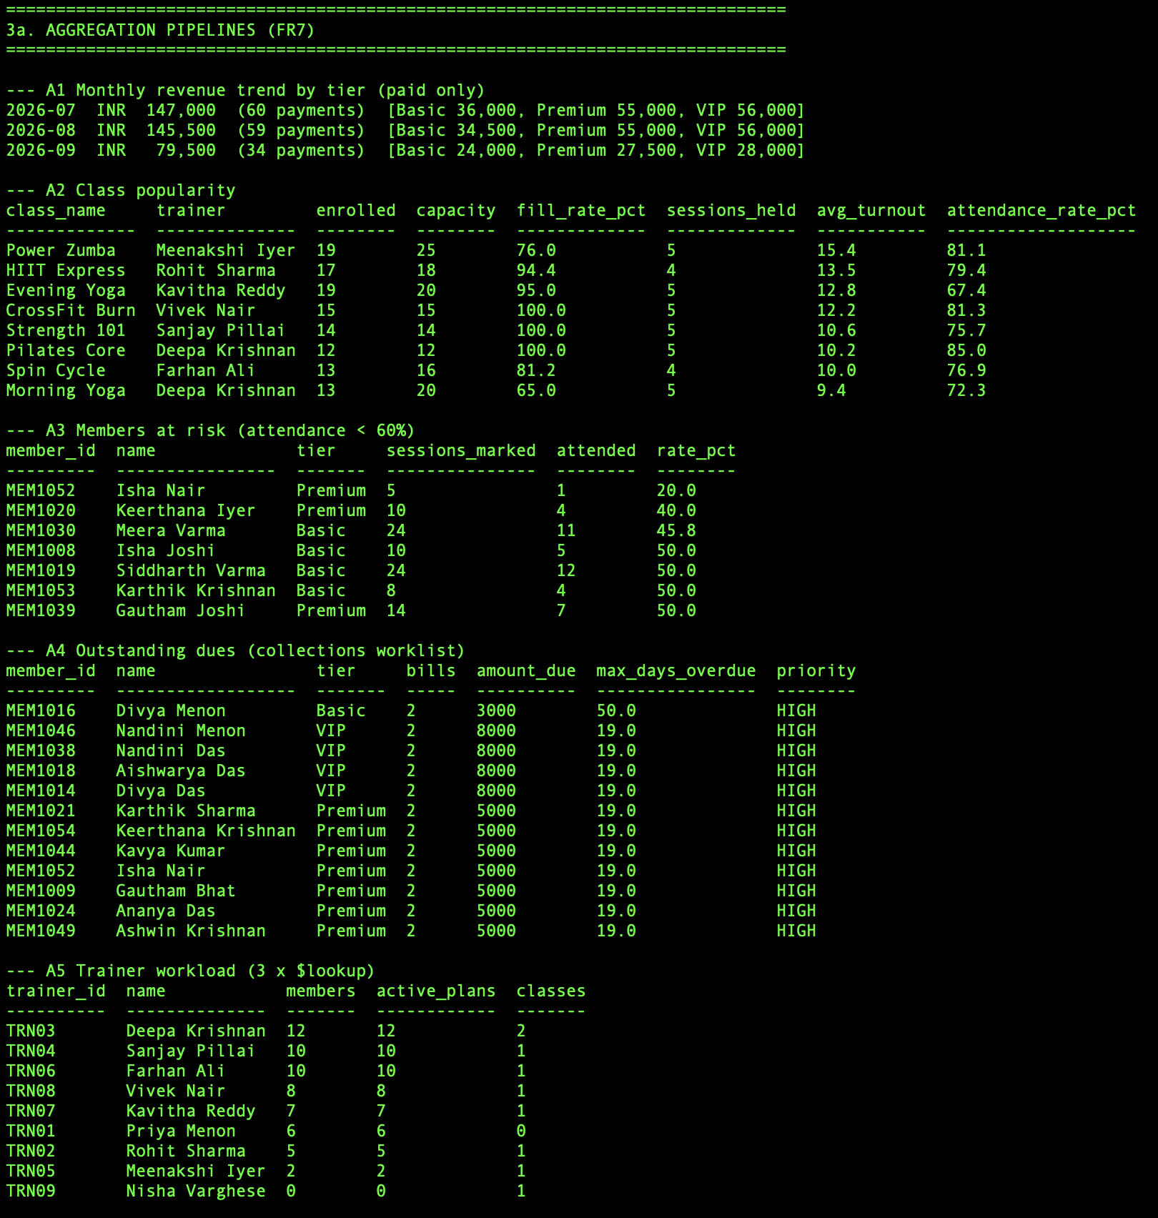
Screenshot 5: Aggregation pipelines A1 to A5 (live MongoDB run)
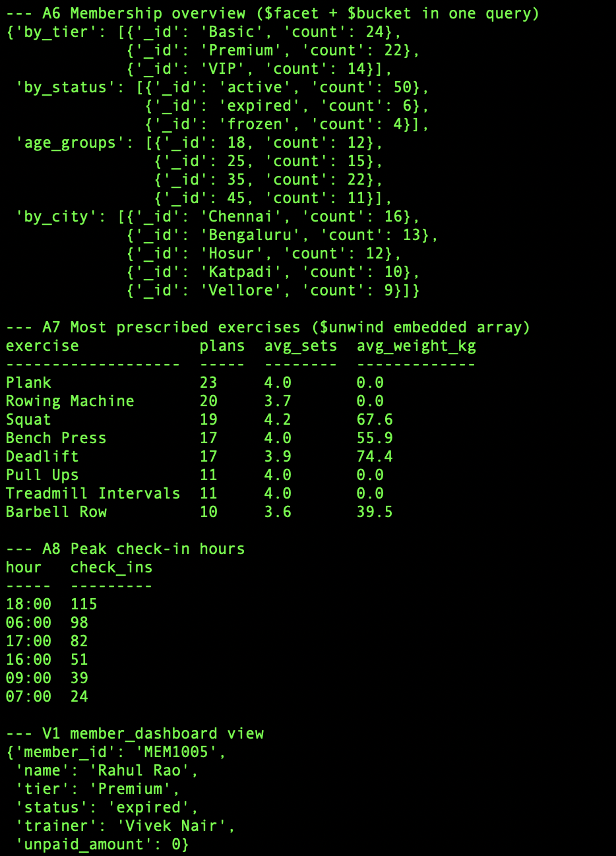
Screenshot 6: Aggregation pipelines A6 to A8 and the member_dashboard view (live MongoDB run)

5.2 Graph Traversal: Referral Network
Members can refer new members, who can refer others in turn, forming a tree of any depth. $graphLookup walks this tree recursively inside the database, which would otherwise need one query per level in application code. The depthField records each person's distance from the starting member, and maxDepth bounds the search. The ix_referred_by index supports each recursive step.
def referral_network(db, member_id):
res = list(db.members.aggregate([
{"$match": {"member_id": member_id}},
{"$graphLookup": {"from": "members", "startWith": "$_id", "connectFromField": "_id",
"connectToField": "referred_by", "as": "network",
"maxDepth": 5, "depthField": "level"}},
{"$project": {"_id": 0, "member_id": 1, "name": 1,
"network": {"$map": {"input": "$network", "as": "n",
"in": {"member_id": "$$n.member_id", "name": "$$n.name",
"level": {"$add": ["$$n.level", 1]}}}}}},
]))
Member | Name | Direct referrals | Network size | Levels
MEM1036 | Lakshmi Bhat | 1 | 5 | 3
MEM1016 | Divya Menon | 2 | 4 | 2
MEM1030 | Meera Varma | 1 | 4 | 3
MEM1020 | Keerthana Iyer | 1 | 3 | 3
MEM1051 | Karthik Shetty | 2 | 3 | 2
G2 output: top referrers ranked by the size of their whole downstream network
Referral tree of MEM1036 Lakshmi Bhat (G1 output):
Level 1: MEM1041 Arjun Rao
Level 2: MEM1046 Nandini Menon
Level 2: MEM1047 Varun Das
Level 3: MEM1049 Ashwin Krishnan
Level 3: MEM1050 Aishwarya Menon
Lakshmi Bhat referred only 1 member directly, yet the traversal shows 5 members across 3 levels joined through that referral. Counting direct referrals alone would miss this, which is why graph traversal is the right tool for rewarding referrers.
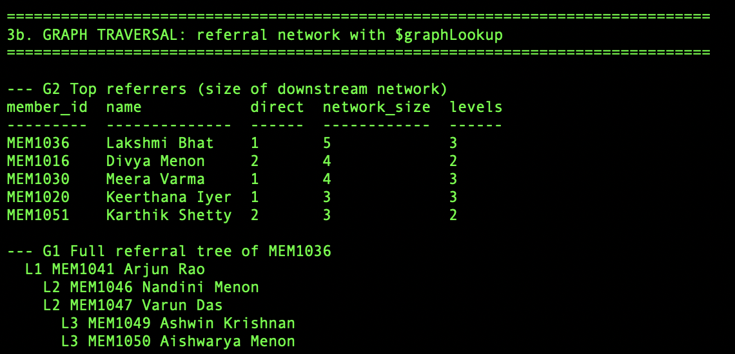
Screenshot 7: $graphLookup referral network (live MongoDB run)

5.3 Indexing
Nineteen secondary indexes implement and extend the indexing plan from Review 1 section 6.8. Each index exists to serve a specific query in the CRUD layer or the reports.
Collection | Index | Keys | Type | Serves
members | uq_email, uq_member_id | email; member_id | Unique | Login, lookups, no duplicate accounts
members | ix_trainer | assigned_trainer_id | Single | Trainer's member list, A5
members | ix_tier_status | membership.type, membership.status | Compound | list_members filters
members | ix_referred_by | referred_by | Single | $graphLookup connectToField
trainers | uq_email, uq_trainer_id | email; trainer_id | Unique | Login, lookups
workout_plans | ix_member_status | member_id, status | Compound | get_active_plan
workout_plans | ix_trainer | trainer_id | Single | Trainer's plans, A5
classes | ix_trainer | trainer_id | Single | A5, delete_trainer check
classes | ix_enrolled_member | enrolled_members.member_id | Multikey | member_classes, rename propagation
classes | tx_class_search | class_name, category | Text | Class search
class_sessions | ix_class_date | class_id, date | Compound | Class timetable
attendance | ix_member_date | member_id, date (descending) | Compound | Member attendance history
attendance | uq_session_member | session_id, member_id | Unique compound | One record per member per session
attendance | ix_class_status | class_id, status | Compound | A2 class popularity
payments | ix_member_status | member_id, status | Compound | member_dues
payments | ix_due_date | due_date | Single | Overdue sweep
payments | px_unpaid_dues | status, due_date (unpaid only) | Partial | Dues reports on a smaller index

Proof with explain(). The same dashboard query, one member's attendance history newest first, is run twice: once forced to scan the collection with hint({$natural: 1}), and once through ix_member_date.
Plan | Leaf stage | Documents examined | Index keys examined | Documents returned | In-memory sort
Without index | COLLSCAN | 580 | 0 | 5 | Yes
With ix_member_date | IXSCAN | 5 | 5 | 5 | No

Without the index, MongoDB reads all 580 attendance documents and sorts them in memory to return 5. With the index it reads exactly the 5 matching entries, already in date order because the index stores date descending. As attendance grows over the years the scan cost grows with it, while the indexed query stays flat, which is how the design meets NFR1. The partial index px_unpaid_dues holds only the 67 unpaid bills instead of all 221, so dues reports use a much smaller index.
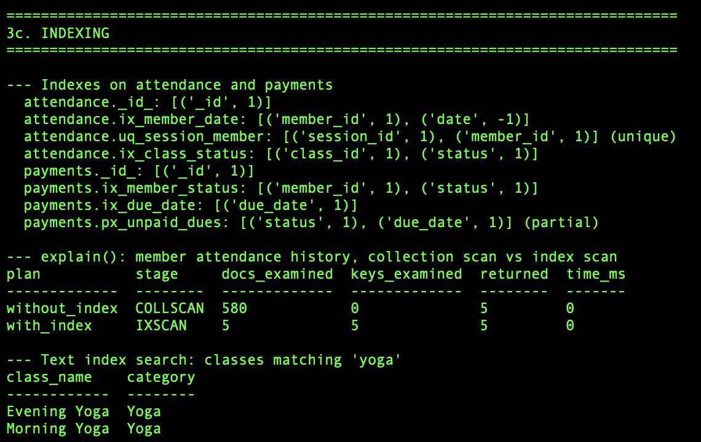
Screenshot 8: Indexes, explain() comparison and text search (live MongoDB run)

5.4 Multi-Document ACID Transactions
Two operations write to more than one collection and must never be left half done. They run inside a transaction with snapshot read concern and majority write concern. PyMongo's with_transaction retries transient errors automatically and aborts on any exception, so either every write commits or none does.
Transaction | Writes | Why it must be atomic
T1 renew_membership | Insert a paid bill in payments; extend end_date in members | A payment without an extension, or the reverse, is a billing error
T2 close_session | Mark the session completed; insert its attendance rows | Attendance must never exist for a session still marked open, and a failed roll call must not half-save

def _run(db, fn):
"""Run fn(session) inside a transaction, with automatic retry on transient errors.
Under mongomock (no transaction support) fn runs without a session."""
if is_mock():
return fn(None)
client = get_client()
with client.start_session() as s:
return s.with_transaction(
fn,
read_concern=ReadConcern("snapshot"),
write_concern=WriteConcern("majority"),
read_preference=ReadPreference.PRIMARY,
)
def renew_membership(db, member_id, months, mode="UPI", fail_midway=False):
"""T1. fail_midway=True raises after the payment insert to prove the rollback."""
def txn(s):
m = db.members.find_one({"member_id": member_id}, session=s)
if not m:
raise TransactionAborted(f"{member_id} not found")
fee = TIER_FEES[m["membership"]["type"]] * months
old_end = m["membership"]["end_date"]
start = max(old_end, REFERENCE_DATE) + timedelta(days=1)
new_end = start + timedelta(days=30 * months)
last = db.payments.find_one({}, sort=[("payment_id", -1)], projection={"payment_id": 1}, session=s)
pid = f"PAY{int(last['payment_id'][3:]) + 1}"
db.payments.insert_one({
"payment_id": pid, "member_id": m["_id"], "member_name": m["name"], "amount": fee,
"currency": "INR", "payment_mode": mode, "status": "paid",
"billing_period_start": start, "billing_period_end": new_end,
"payment_date": REFERENCE_DATE, "due_date": REFERENCE_DATE}, session=s)
if fail_midway:
raise TransactionAborted("Simulated failure after payment insert")
db.members.update_one({"_id": m["_id"]},
{"$set": {"membership.end_date": new_end, "membership.status": "active"}},
session=s)
return {"payment_id": pid, "amount": fee, "new_end_date": new_end.date().isoformat()}
return _run(db, txn)
Test | Result
T1 with a simulated failure after the payment insert | Aborted; payment count and end date unchanged (rolled back)
T1 renew MEM1010 for 3 months | Committed: new paid bill of INR 4,500; end date moved from 31 Mar 2027 to 30 Jun 2027
T2 close the next session with 3 roll-call marks | Committed: session completed, 3 attendance rows added
T2 with a member who is not on the roster | Aborted after the session update and first insert; both rolled back, session stays scheduled
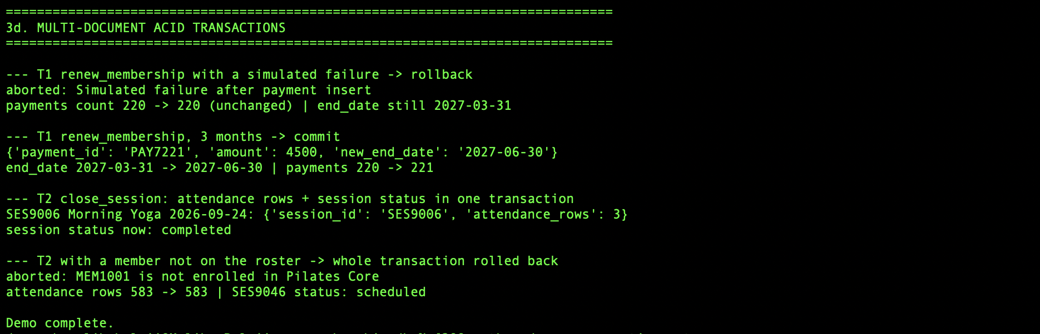
Screenshot 9: Transaction commits and rollbacks (live MongoDB run)

6. Traceability to Review 1 Requirements
ID | Requirement | Status in Review 2 | Where
FR1 | Admin CRUD on members, trainers, classes, payments | Done | crud.py
FR2 | Trainer manages workout plans | Done | plan functions; A5, A7
FR3 | Member views profile, plan, classes, attendance, payments | Done at data layer; screens in Review 3 | member_dashboard view, member_classes, attendance_history, member_dues
FR4 | Class scheduling with capacity and enrollment | Done | create_class, create_session, enroll_member, withdraw_member
FR5 | Attendance per member per session | Done | mark_attendance, T2 close_session
FR6 | Payment tracking and overdue flags | Done | create_invoice, record_payment, flag_overdue, A4
FR7 | Aggregated reports | Done | A1 to A8
FR8 | Authentication and role-based access | Authentication done; role-based screens in Review 3 | authenticate (bcrypt)
NFR1 | Performance | Done | 19 indexes, explain() comparison
NFR2 | Scalability | Done | Unbounded data referenced, bounded data embedded; indexed access paths
NFR3 | Security | Done | bcrypt hashes; projections hide password_hash
NFR4 | Usability | Review 3 | Responsive dashboard
NFR5 | Data consistency | Done | Validators, 10 integrity rules, atomic updates, transactions

7. Testing
Six automated tests in tests/test_gym_db.py run against an in-memory MongoDB (mongomock), so any team member or evaluator can verify the code without installing a server. All six pass.
Test | Checks
test_minimum_sample_records | At least 50 members and 1,000 documents are loaded
test_member_crud_and_cascade | Create, read, rename propagation, enrollment and cascading delete leave no orphans
test_integrity_guards | Unknown trainer rejected; a trainer with members cannot be deleted
test_capacity_guard | A class of capacity 1 rejects a second member and a duplicate enrollment
test_payments_flow | Overdue sweep flags bills; a payment is recorded once; a paid bill cannot be paid again
test_aggregations | Revenue report equals the sum of paid bills; facet totals equal the member count; graph sizes agree

In addition, all 1,016 seeded documents were checked against the seven $jsonSchema validators before submission, with zero violations. Finally, the complete demonstration was run against a live MongoDB 8.3 replica set: validators, explain(), text search and both transaction rollbacks behaved exactly as designed. Screenshots 1 to 9 are taken from that run.

8. Intermediate Demonstration Plan
The demonstration takes about ten minutes and follows the rubric order. demo.py recreates the database at the start, so the panel always sees the same state.
Step | Command | What the panel sees
1 | python demo.py --section setup | Collections with validators, 1,016 documents, 19 indexes, a validator rejecting bad data
2 | python demo.py --section crud | Every CRUD operation, including the blocked cases in Section 4.4
3 | python demo.py --section agg | Reports A1 to A8 and the member_dashboard view
4 | python demo.py --section graph | Top referrers and a full referral tree
5 | python demo.py --section index | Index list, COLLSCAN versus IXSCAN, text search
6 | python demo.py --section txn | Commit and rollback of both transactions
7 | mongosh ... mongosh/demo_queries.js | Any query re-run live in the shell or Compass on request

9. Source Code Repository
Repository: https://github.com/malikabalaji/gym-membership-db
The repository holds the complete source code, sample data, tests, the live demonstration output (demo_output.txt), the Review 1 and Review 2 reports, and the terminal screenshots from the live run.
gym-membership-db/
README.md setup, run commands, dataset summary
requirements.txt pymongo, bcrypt, mongomock, pytest
demo.py intermediate demonstration (6 sections)
export_data.py exports the dataset to data/*.json
gym_db/
config.py connection, reference date, tier fees
schema.py collections and $jsonSchema validators
seed.py reproducible sample data (1,016 documents)
indexes.py 19 indexes and the explain() comparison
crud.py 36 CRUD functions and integrity rules
aggregations.py A1 to A8, G1 and G2 ($graphLookup), view V1
transactions.py T1 and T2 ACID transactions
mockpatch.py offline test support
mongosh/demo_queries.js live shell queries
data/*.json exported sample data (Extended JSON)
tests/test_gym_db.py 6 automated tests
Running it:
pip install -r requirements.txt
docker run -d --name gymdb -p 27017:27017 mongo:8 --replSet rs0
docker exec gymdb mongosh --eval "rs.initiate()"
python demo.py # full demonstration
python demo.py --mock # same demonstration without a server
python -m pytest -q # automated tests

10. Plan for Review 3
- Web dashboard for the three roles (Admin, Trainer, Member), built on the CRUD layer and the member_dashboard view.
- Session-based login with role-based authorization, completing FR8.
- Admin dashboard charts fed directly by pipelines A1 to A8.
- Responsive layout for desktop and mobile, completing NFR4.

