MCP Agent Server

Malika Fofana, Helene Capon, Klara Mladenovic

Overview
This MCP server exposes structured data analysis tools over a local SQLite workspace.
It enables codex to load CSV files, inspect schemas, compute statistics, and run SQL queries through controlled tool calls.
The goal of this project is to demonstrate:
- Tool orchestration through MCP
- Multi-step agent workflows
- Structured prompting strategies
- Comparative evaluation (with vs without tools)
- Robust reasoning grounded in real data
This server transforms a language model from a conversational system into a structured analytical agent.

Setup
uv venv && source .venv/bin/activate
uv pip install "mcp[cli]" installer
Run the server:
python server.py
Security rule
Reject queries containing:
- DROP
- DELETE
- INSERT
- UPDATE
- ALTER

Codex
~/.codex/config.toml
Example configuration:
[mcp_servers.data_query_builder]
command = "/Users/malikafofana/Desktop/Université/PGE3/S2/agentic/cours2/data-query-builder/.venv/bin/python3"
args = [
"/Users/malikafofana/Desktop/Université/PGE3/S2/agentic/cours2/data-query-builder/server.py"
]
After updating the config: restart

Tools

load_csv : Loads a CSV file into the MCP SQLite workspace.
Parameters:
Parameter | Type | Required | Description
file_path | string | yes | Absolute path to CSV file
table_name | string | yes | Target SQLite table name
Example prompt:
Load the sales CSV file into table sales.

describe_schema
Returns the detected schema of a table.
Parameters:
Parameter | Type | Required | Description
table_name | string | yes | Table to inspect

preview_table
Returns a preview of the first N rows.
Parameters:
Parameter | Type | Required | Description
table_name | string | yes | Table name
limit | integer | no | Number of rows (default: 5)

run_query
Executes a safe SQL SELECT query on the SQLite workspace.
Parameters:
Parameter | Type | Required | Description
sql | string | yes | SQL SELECT statement
limit | integer | no | Max number of rows
Only read-only queries are allowed.

get_statistics
Computes basic statistics for a numeric column.
Parameters:
Parameter | Type | Required | Description
table_name | string | yes | Table name
column | string | yes | Numeric column

Resources

2.Resource Inventory

db://schema
Returns:
- JSON representation of current database schema

db://query-history
Returns:
- List of executed queries during session

Test Scenario
Scenario 1 : load, run_query
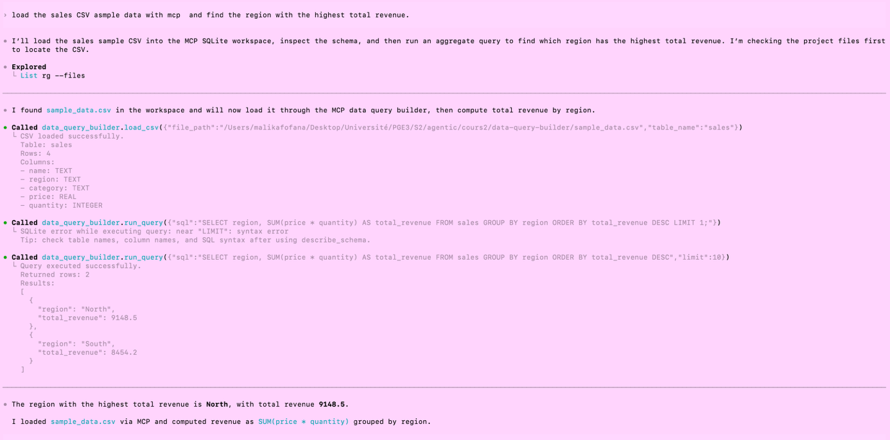

Scenario 2: Data is already loaded; the agent performs exploration (preview_table, get_statistics).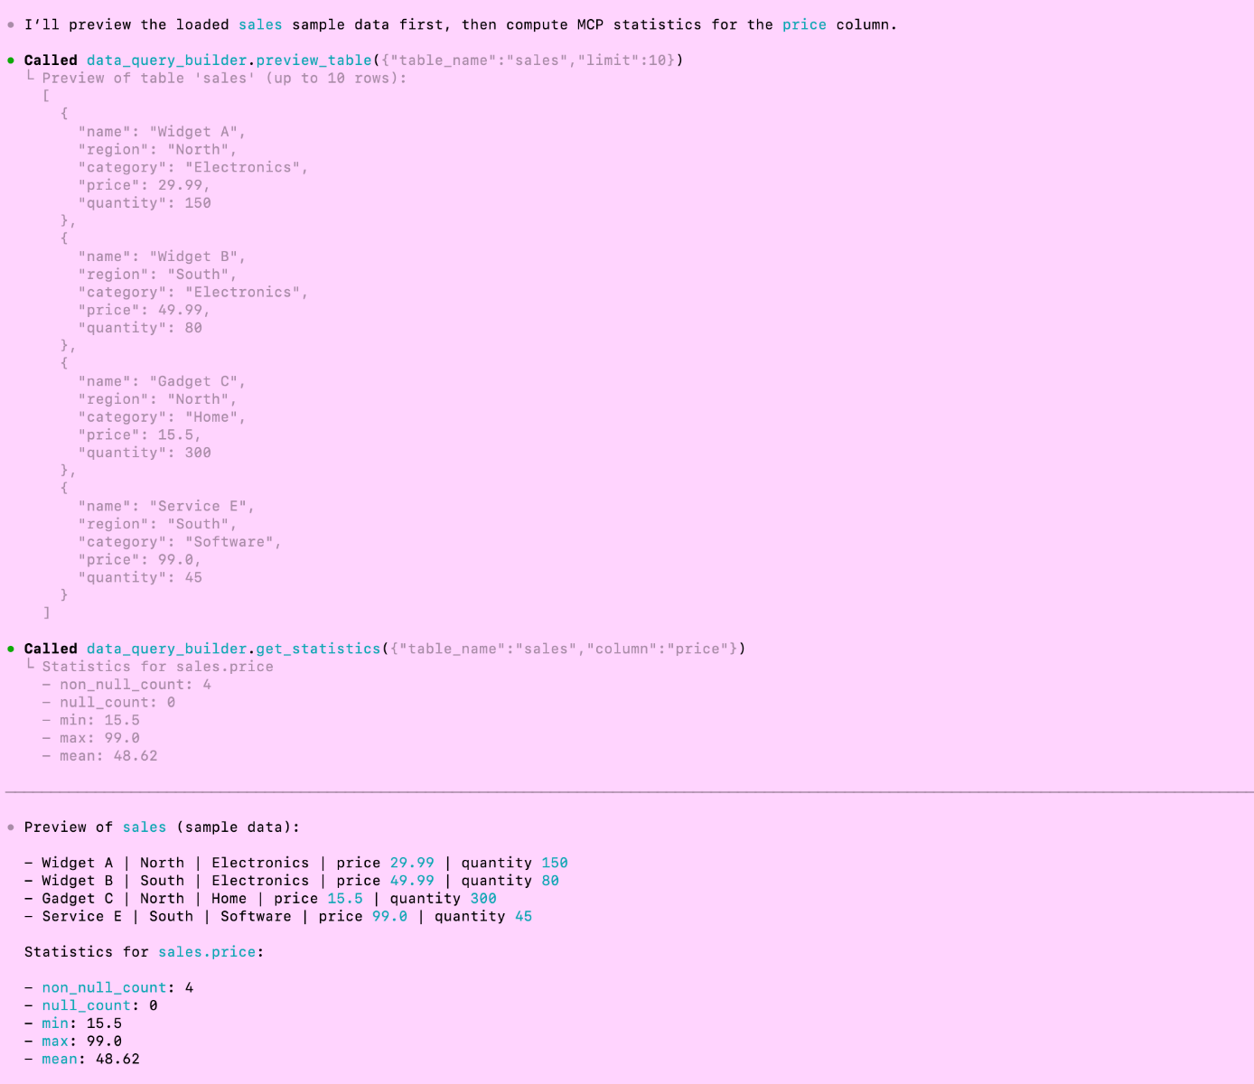
Scenario 3: Data is already loaded; (executes 2 specific queries: category summary and regional).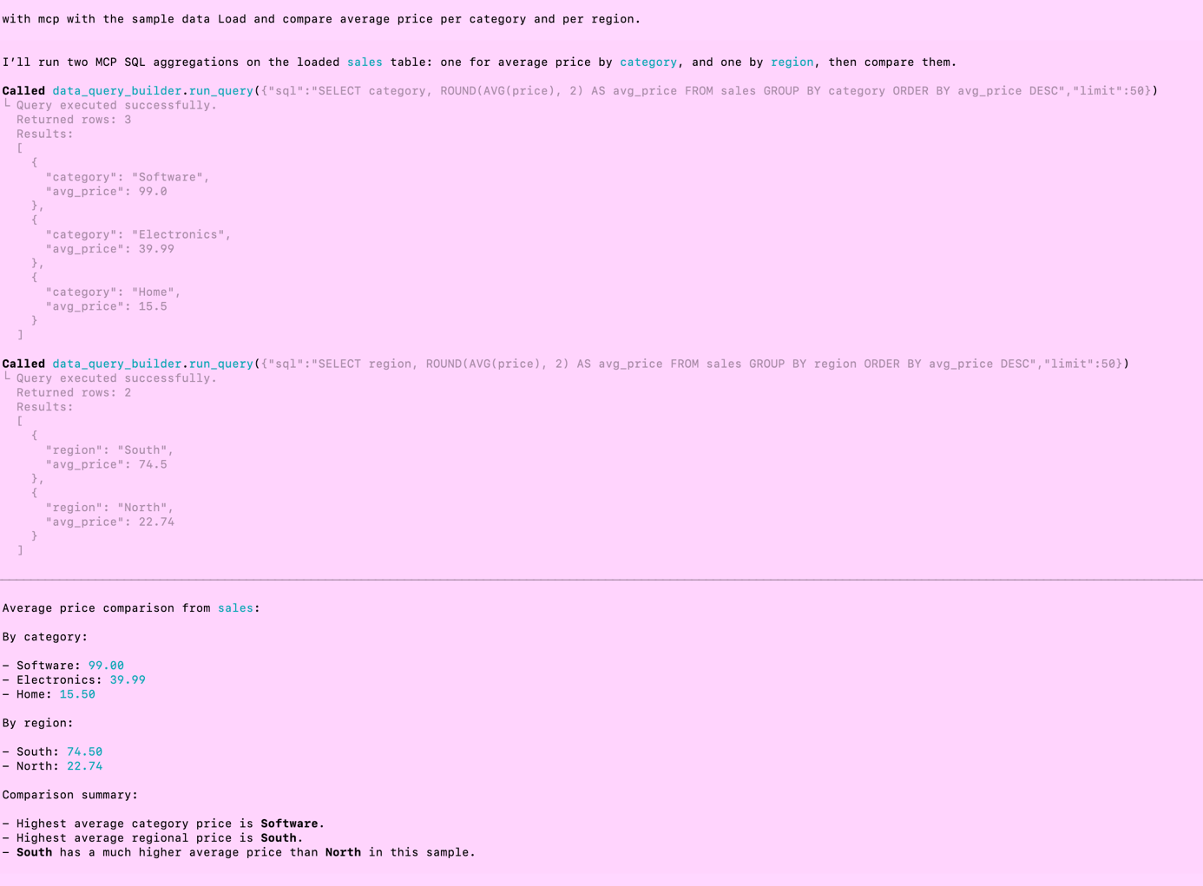

Comparative Analysis
Comparison: With vs. Without Tools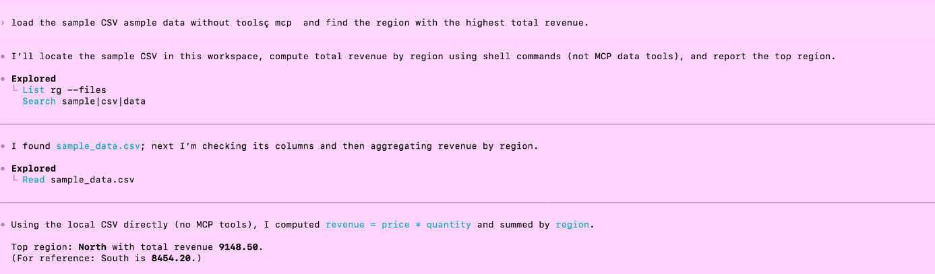
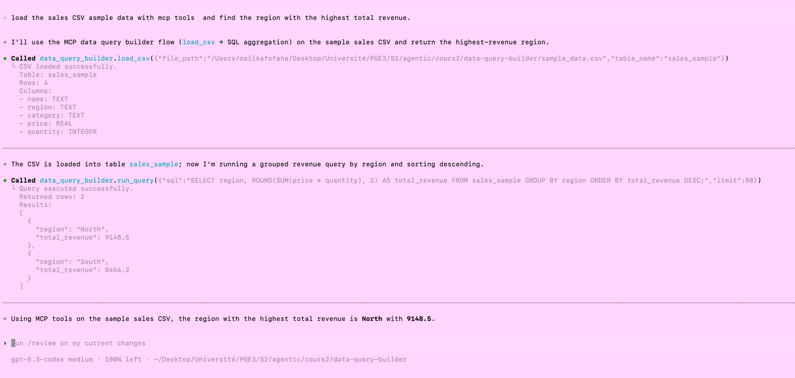
Without Tools: he has access to my documents so he goes looking for
With Tools: decisions based on real-world data in the workspace

Comparison: Minimal vs. Expert Prompting

mini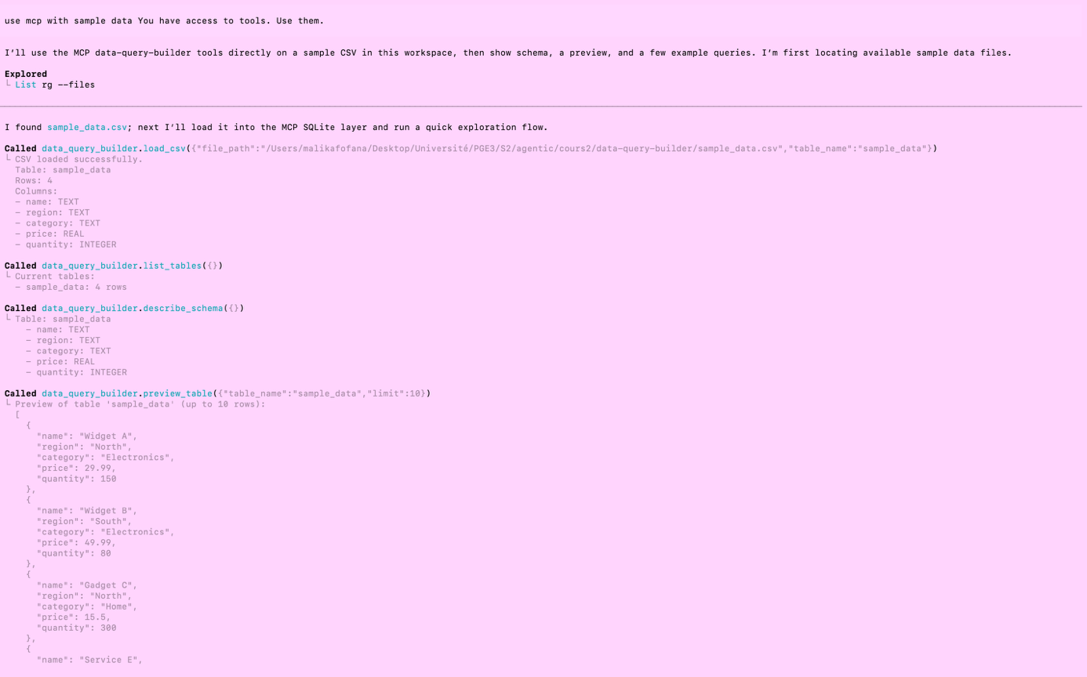
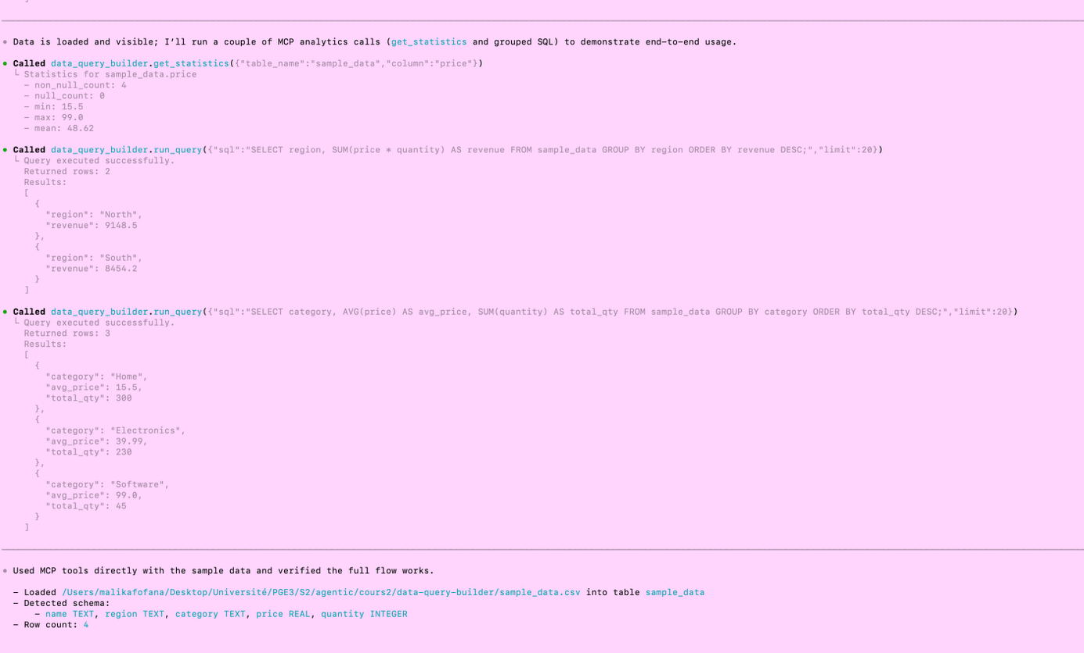
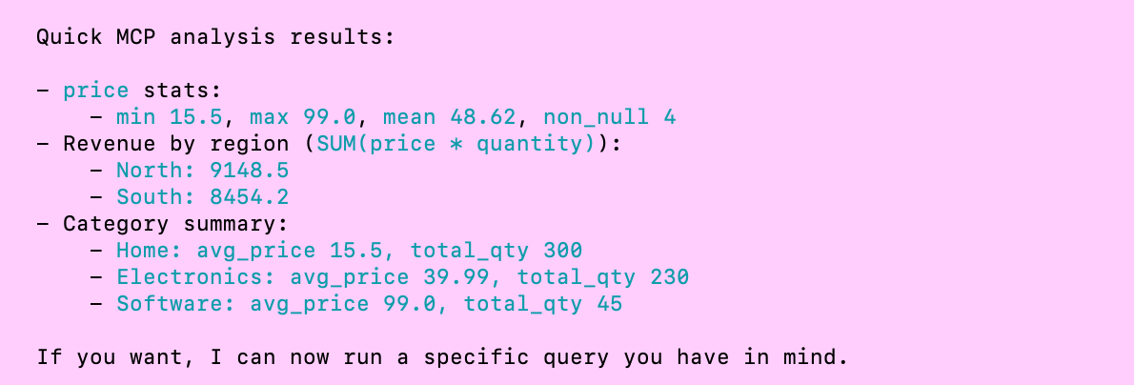

Observations: The model is highly precise, likely due to the existing session history.

Agent Workflow:
- Loads the CSV.
- Detects the schema.
- Provides statistics.
- Calculates revenue by region.
- Generates a category summary.
- Completes the task.

Expert
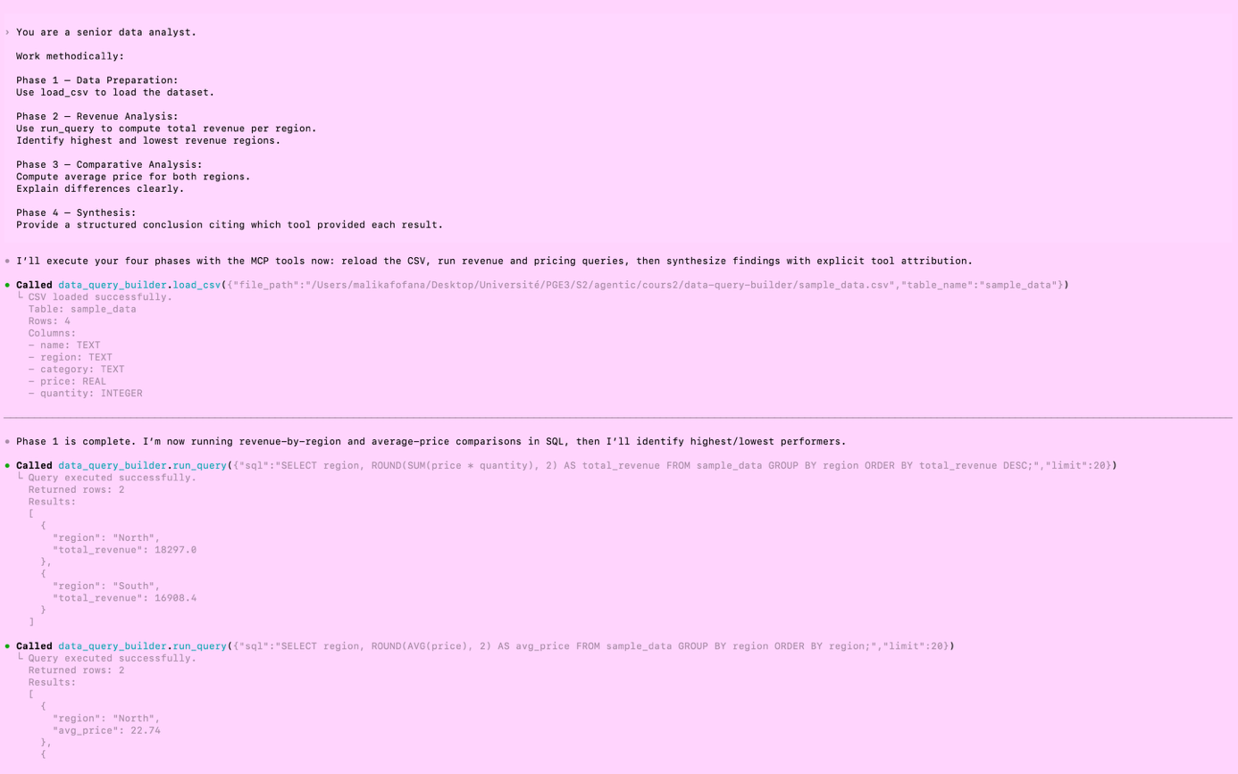
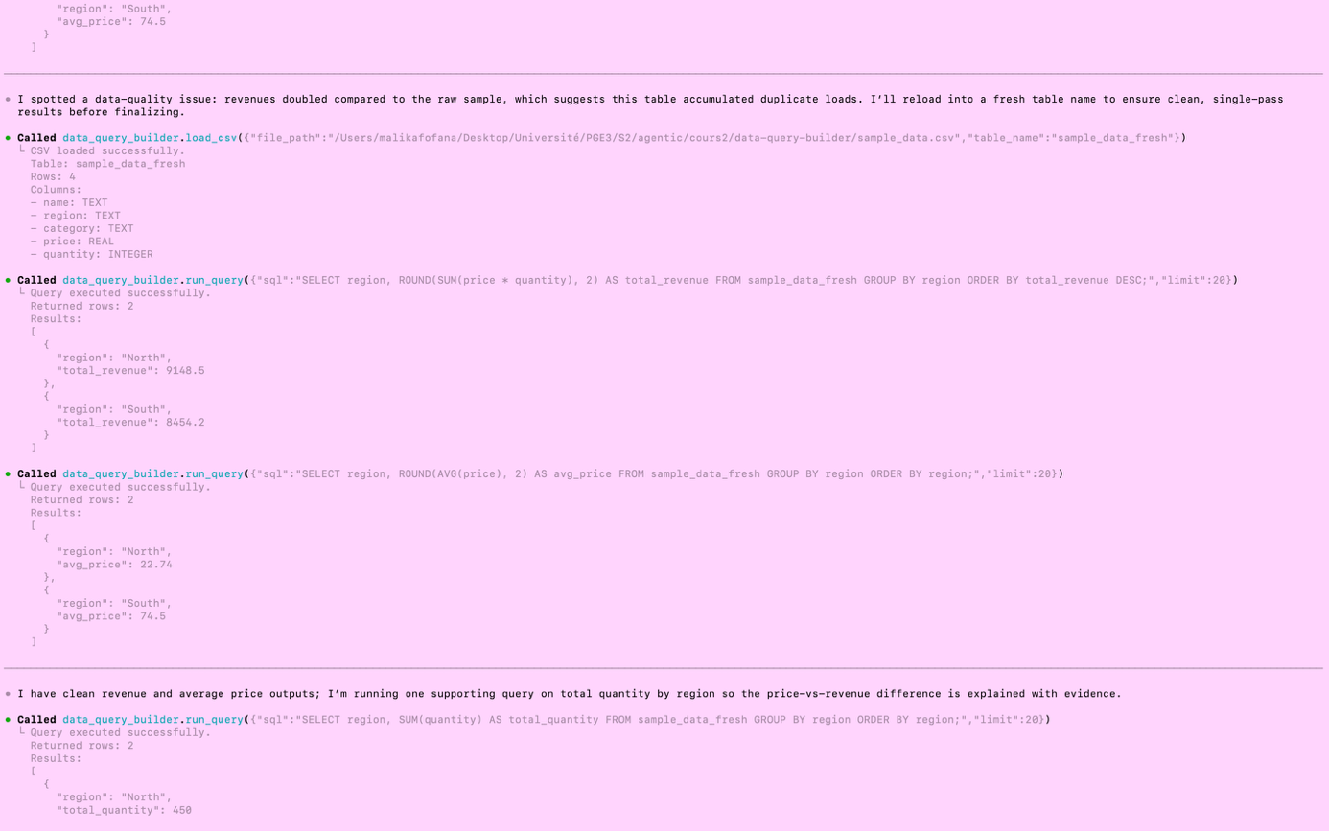
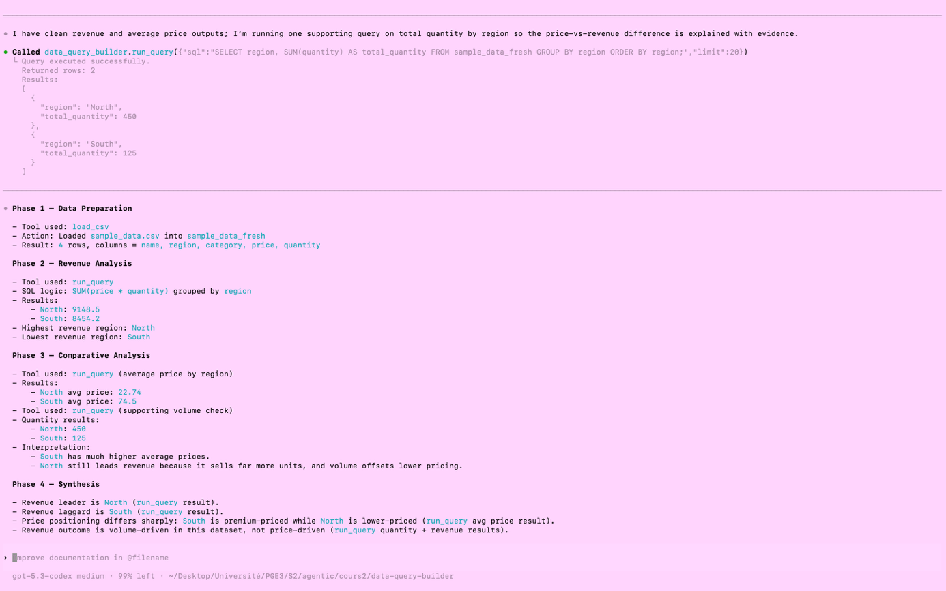

Insight: This demonstrates that the model "thinks before it acts."

Workflow Comparison:
- Minimal: load, query, query, End.
- Expert: Structured Synthesis

Limitations
- Small Dataset: Testing was conducted on a small sample (4 rows).
- Volatility: SQLite in-memory connection; the database exists only while the server is running. (Opportunity: How can we implement persistence?)
- Read-Only: No write operations are permitted (Security constraint).
- Statistical Depth: Limited set of statistical methods available.
- Evaluation: Analysis was based on manual evaluation (no automated metrics).
- History Bias: There was no significant difference between Minimal and Expert prompts during the live test because the terminal history (Codex) already provided the context from previous runs.

Conclusion
This project demonstrates that:
- Tool access alone is insufficient: Simply giving an AI tools isn't enough; it needs a strategy to use them effectively.
- Structured prompting significantly boosts performance: Implementing a clear framework (perhaps) dramatically improves how the agent handles tasks.
- Explicit workflow decomposition: Breaking down tasks into specific phases leads to superior multi-tool orchestration and fewer errors.
- Expert-level prompting: This approach transforms a standard LLM into a disciplined, high-level analytical agent.
- Fundamental behavioral change: The difference between "minimal" and "structured workflow" prompting is not merely cosmetic, it fundamentally changes the model's underlying reasoning behavior.

