**Task NO.1 : Open internet explorer & check CIIT Lahore Website:**

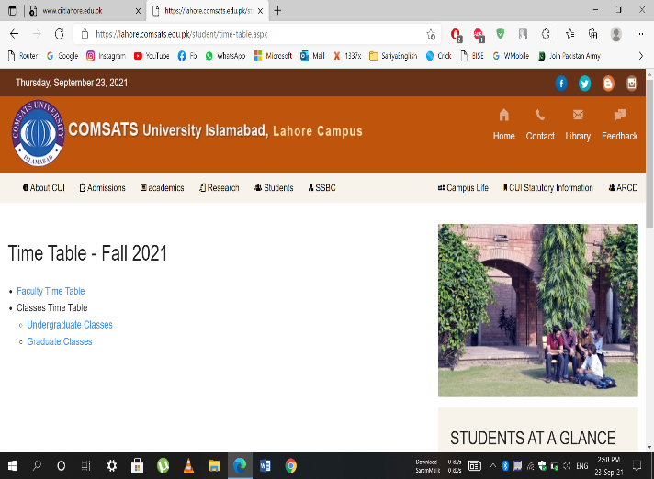

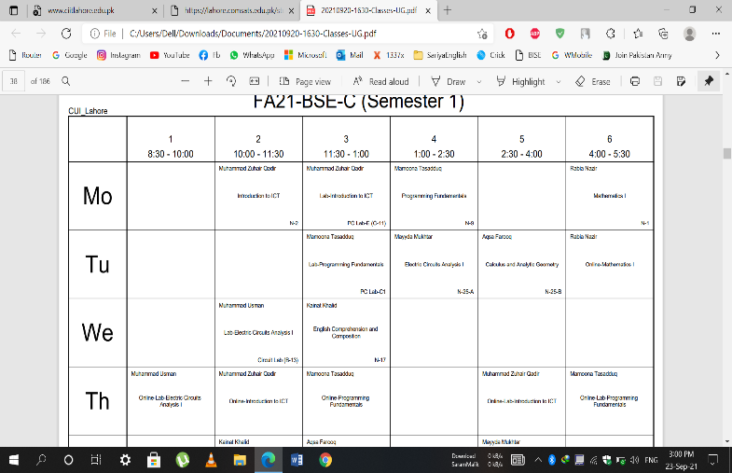

**Task NO. 2: Open CUOnline From CIIT Lahore Website:**

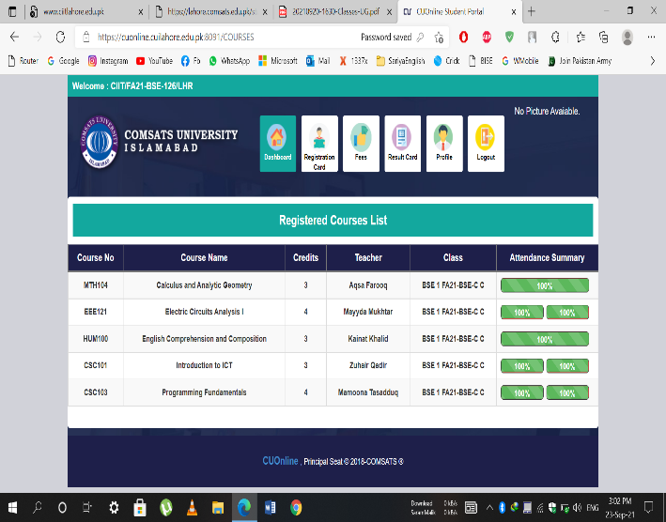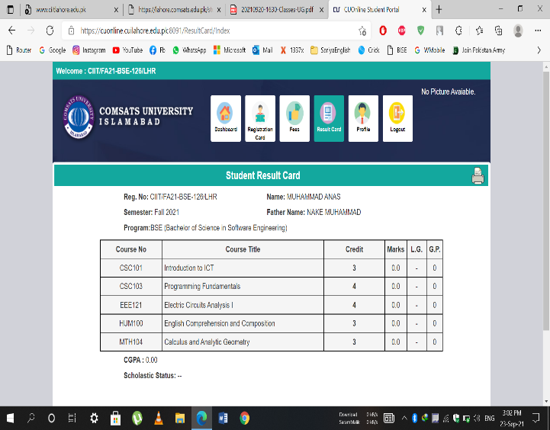

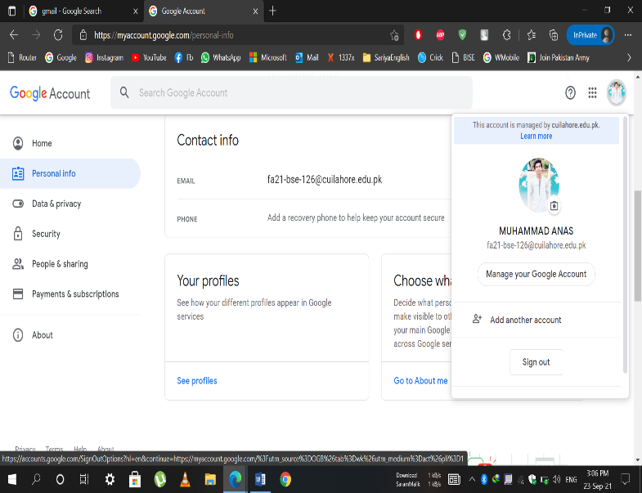**Task NO. 3: Open Internet Explorer & Check Your Email:**

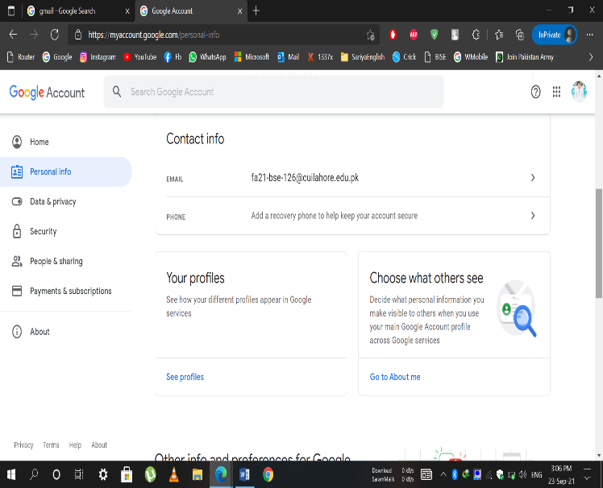

**Task NO. 4: Open MS word and Experiment with basics:**

**1.IntroductIOn:**

I am Muhammad Anns from Narang. My father is a Doctor. I done my ICS from Al-Noor Group of Colleges Shahdare. I choose BS-Software Engineering Because of my passion and Nowadays the scope of Computer science filed is better than other fields. I went to become a profession app designer. Thank You !

**2.Save file as :**

Save File with FA21-BSE-126/LHR-Lab1

**Done!**

**3. Copy ,Cut and Paste:**

|  |  |
| --- | --- |
| **Left Side** | **Right Side** |
| Copy this sentence and paste it in the box to the right. | Copy this sentence and paste it in the box to the right. |
|  | Cut this 2nd sentence and paste it in the box to the right. |
|  | Highlight 3rd sentence and drag it in the box to the right. |

**4. Aligning Text:**

Align this sentence to the right.

Align this sentence in the center.

Align this sentence to the left.

This is the first Paragraph. Change the spacing for this paragraph to 2.0. This is the first Paragraph. Change the spacing for this paragraph to 2.0. This is the first Paragraph. Change the spacing for this paragraph to 2.0. This is the first Paragraph. Change the spacing for this paragraph to 2.0. This is the first Paragraph. Change the spacing for this paragraph to 2.0.

This is the second Paragraph. Change the spacing for this paragraph to 1.0. This is the second Paragraph. Change the spacing for this paragraph to 1.0. This is the second Paragraph. Change the spacing for this paragraph to 2.0. This is the second Paragraph. Change the spacing for this paragraph to 1.0. This is the second Paragraph. Change the spacing for this paragraph to 1.0.

**5. Header and Footer**

**In the Header:**

Name:

Class:

Date:

**In the Footer:**

Write the name of your favorite food.

Use the ‘Alphabet’ style footer. Do not erase the phone number.

**6. Deleting Text:**

Delete above Table of Cut, Copy, Paste .

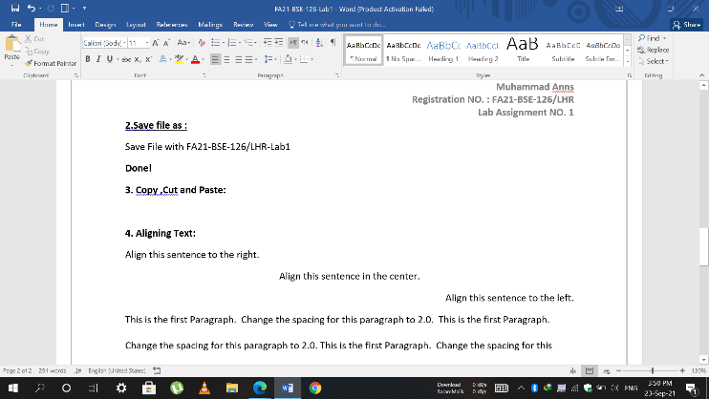

**7. Formats Borders & Shading:**

**Done!**

**8. Print Review:**

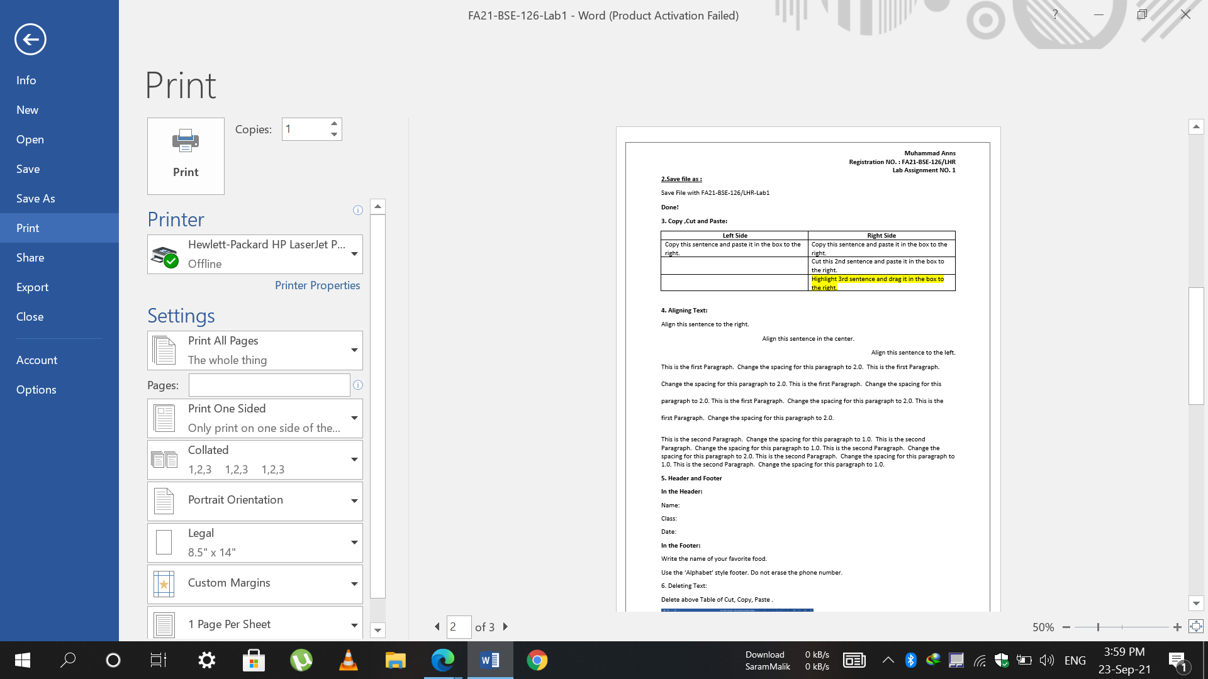

**Task No. 5: Open MS word and experiments with clip arts & pictures:**

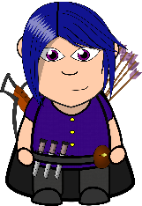

The weather is great!



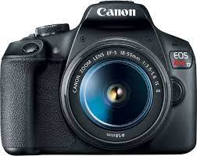

**Task No. 6: Create a Business Letter and then flyer or boarder:**

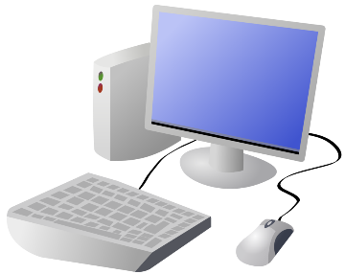**Computers Are Us**

**555 Main Street**

**Brighton, MI 48116**

**(810) 555-1212**

**Date:**22-Sep-21 4:39 PM

**Dear Sir,**

Hope you are fine. Thanks for your order on **September 20,2021**. We will be shipped your parts by Leopards Service.

Sincerely,

Muhammad Anns