THE ISLAMIA UNIVERSITY OF BAHAWALPUR
Department of Information Technology

SOFTWARE DESIGN DOCUMENT
(SDD)

Student Internship Portal (SIP)

Prepared By | M. Adnan
Roll Number | S23BINFT1M01110
Session | Spring/Fall 2023–2027
Supervisor | Mr. Munawar Ahmad
Document Version | 1.0
Date | 10 June 2026

Revision History

Version | Date | Author | Description | Status
1.0 | June 2025 | M. Adnan | Initial SDD creation based on approved SRS | Approved
1.1 | July 2025 | M. Adnan | Added detailed sequence diagrams and updated module design | Draft
1.2 | August 2025 | M. Adnan | Security and performance sections revised | Draft

Table of Contents

1. Introduction | 4
1.1 Purpose | 4
1.2 Scope | 4
1.3 Intended Audience | 5
1.4 Definitions and Acronyms | 5
1.5 References | 6
2. Design Considerations | 6
2.1 Assumptions | 6
2.2 Constraints | 7
2.3 Design Goals | 7
2.4 System Environment | 8
3. System Architecture | 8
4. Module Design | 10
4.1 Authentication Module | 10
4.2 Student Module | 11
4.3 Company Module | 12
4.4 Admin Module | 13
5. Database Design | 14
6. Class Design | 17
7. Use Case Design | 20
8. Sequence Diagrams | 22
9. Activity Diagrams | 27
10. Component Design | 30
11. Deployment Design | 31
12. User Interface Design | 32
13. Security Design | 35
14. Performance Design | 37
15. Maintainability Design | 38
16. Future Enhancements | 39
17. Conclusion | 40

1. Introduction

1.1 Purpose
This Software Design Document (SDD) presents the complete architectural and detailed design of the Student Internship Portal (SIP), a web-based application developed as a Final Year Project at the Department of Information Technology, The Islamia University of Bahawalpur. The purpose of this document is to translate the requirements specified in the Software Requirements Specification (SRS) into a concrete design blueprint that will guide the development team throughout the implementation phase.
The SDD describes the system architecture, module decomposition, database schema, class structure, user interface layouts, security mechanisms, and deployment topology. This document serves as the authoritative reference for all design decisions and ensures that the implemented system is traceable back to the stated requirements.

1.2 Scope
The Student Internship Portal (SIP) is a full-stack web application designed to bridge the gap between university students seeking internship opportunities and companies offering them. The portal automates the entire internship lifecycle, encompassing student registration and profile management, internship posting by companies, application submission and tracking, and administrative oversight.
The system is constrained to web-based access through modern browsers and is developed using the Django framework (Python) on the backend, HTML5/CSS3/Bootstrap 5/JavaScript on the frontend, and PostgreSQL as the production database. The scope of this SDD covers all functional and non-functional aspects of the SIP, including authentication, data management, business logic, security controls, and deployment infrastructure.

1.3 Intended Audience
This document is intended for the following stakeholders:
- Development Team: Developers and programmers responsible for implementing the SIP based on this design.
- Project Supervisor: Mr. Munawar Ahmad, who will evaluate the design against university project requirements.
- University Evaluators and Examiners: Academic personnel reviewing the FYP documentation for assessment.
- Quality Assurance Engineers: Testers responsible for verifying that the implementation conforms to the design.
- Future Maintainers: Engineers who may extend or maintain the system after initial deployment.

1.4 Definitions and Acronyms

Term / Acronym | Definition
SDD | Software Design Document
SRS | Software Requirements Specification
SIP | Student Internship Portal
FYP | Final Year Project
MVC | Model-View-Controller design pattern
MVT | Model-View-Template (Django's architectural pattern)
API | Application Programming Interface
CRUD | Create, Read, Update, Delete operations
ORM | Object-Relational Mapper (Django's database abstraction layer)
RBAC | Role-Based Access Control
CSRF | Cross-Site Request Forgery
HTTPS | HyperText Transfer Protocol Secure
UI | User Interface
ER | Entity-Relationship
CV | Curriculum Vitae (résumé document)
CGPA | Cumulative Grade Point Average
Nginx | High-performance HTTP and reverse proxy web server
Gunicorn | Python WSGI HTTP Server for UNIX
PostgreSQL | Open-source relational database management system
JWT | JSON Web Token (used for stateless authentication)

1.5 References
- IEEE Std 1016-2009 – IEEE Standard for Information Technology — Systems Design — Software Design Descriptions.
- Software Requirements Specification (SRS) – Student Internship Portal v1.0, M. Adnan, 2024.
- Django Documentation v4.x – https://docs.djangoproject.com/
- PostgreSQL 15 Documentation – https://www.postgresql.org/docs/
- Bootstrap 5 Documentation – https://getbootstrap.com/docs/5.0/
- OWASP Web Application Security Testing Guide v4.2.
- The Islamia University of Bahawalpur – FYP Guidelines and Submission Standards, Department of IT, 2024.

2. Design Considerations

2.1 Assumptions
The following assumptions have been made during the design phase of the Student Internship Portal:
- All end users (students, company representatives, and administrators) possess access to a modern web browser (Google Chrome 90+, Mozilla Firefox 88+, Microsoft Edge 90+, or Safari 14+) with JavaScript enabled.
- The server environment is a Linux-based operating system (Ubuntu 22.04 LTS or equivalent) capable of running Python 3.10+, Django 4.x, PostgreSQL 14+, Nginx, and Gunicorn.
- Students will self-register using their university email addresses. Email verification is not mandatory in Version 1.0 but is assumed to be available for future extensions.
- Company representatives registering on the portal are assumed to act in good faith; formal company verification (e.g., trade registration checks) is handled manually by the administrator.
- The CV upload feature supports only PDF format files up to a maximum size of 5 MB per upload.
- Internet connectivity is available to all users accessing the portal.
- The system will operate within a single university context; multi-tenancy for multiple universities is not within scope of Version 1.0.
- All monetary transactions (if any) are out of scope; the portal is a non-commercial educational platform.

2.2 Constraints
The design of the SIP is subject to the following technical and organizational constraints:
- Technology Stack Constraint: The backend must be implemented using Django (Python). Alternatives such as Node.js, Spring Boot, or Laravel are not permissible within the scope of this project.
- Database Constraint: PostgreSQL must be used in the production environment. SQLite may be used only during local development and testing.
- Frontend Constraint: The user interface must be built using HTML5, CSS3, Bootstrap 5, and vanilla JavaScript. Frontend frameworks such as React or Vue.js are not included in the current scope.
- Security Constraint: The application must comply with OWASP Top 10 security guidelines including protection against SQL injection, XSS, and CSRF attacks.
- Performance Constraint: The system must deliver a page response time of under 3 seconds for 95% of requests under normal load conditions (up to 100 concurrent users).
- Deployment Constraint: The production deployment stack consists of Nginx as the reverse proxy and Gunicorn as the WSGI application server.
- Academic Deadline Constraint: All primary features must be implemented and submitted by the university-specified FYP deadline.

2.3 Design Goals
The following design goals have been established to guide architectural and implementation decisions:
- Modularity: The system shall be decomposed into discrete, loosely-coupled Django applications (apps) including accounts, students, companies, internships, applications, and core, enabling independent development, testing, and maintenance.
- Scalability: The architecture shall support horizontal scaling through stateless request handling and database connection pooling, ensuring the system can accommodate a growing user base without major re-engineering.
- Security: All sensitive data, including user passwords and CV files, shall be protected through industry-standard mechanisms including PBKDF2 hashing, HTTPS enforcement, CSRF tokens, and role-based access control.
- Usability: The user interface shall adhere to responsive design principles using Bootstrap 5, ensuring accessibility across desktop and mobile devices.
- Maintainability: Code shall follow PEP 8 standards, include inline documentation and docstrings, and be managed through a Git version control workflow with feature branching.
- Reliability: The system shall implement transaction management, error handling, and input validation at both client and server levels to prevent data corruption and ensure graceful error recovery.

2.4 System Environment
The SIP operates within the following technical environment:

Operating System | Ubuntu 22.04 LTS (Production Server)
Programming Language | Python 3.10+
Web Framework | Django 4.2 LTS
Frontend Technologies | HTML5, CSS3, Bootstrap 5.3, JavaScript (ES6)
Database (Production) | PostgreSQL 15
Database (Development) | SQLite 3
Web Server | Nginx 1.24 (Reverse Proxy)
Application Server | Gunicorn 21.x (WSGI)
Version Control | Git 2.x with GitHub repository
Development IDE | VS Code / PyCharm
Package Manager | pip with requirements.txt
Deployment Environment | Virtual Private Server (VPS) or University Server

3. System Architecture

The Student Internship Portal is designed on a Three-Tier Architecture pattern, which separates the application into three distinct logical and physical layers: the Client Layer (Presentation Tier), the Application Layer (Logic Tier), and the Database Layer (Data Tier). This separation of concerns promotes maintainability, scalability, and security.

3.1 Three-Tier Architecture Overview
The three-tier architecture ensures that changes in one layer can be made independently of the others, provided that the interfaces between layers remain stable. Django's MVT (Model-View-Template) pattern maps naturally onto this architecture:
- Templates correspond to the Client/Presentation Layer.
- Views and business logic correspond to the Application Layer.
- Models and ORM correspond to the Data Layer.

3.2 Client Layer (Presentation Tier)
The Client Layer encompasses all components responsible for rendering the user interface and managing user interactions within the web browser. This layer consists of HTML5 templates rendered by the Django template engine, CSS3 stylesheets and Bootstrap 5 component library for responsive design, and JavaScript (ES6) for client-side form validation, AJAX calls, and dynamic interface updates.
The client layer communicates with the application layer exclusively through HTTP/HTTPS requests and responses. No business logic resides on the client side; all validation is duplicated server-side to ensure security.

3.3 Application Layer (Logic Tier)
The Application Layer is the core of the SIP and is implemented using the Django web framework. It is responsible for processing all incoming HTTP requests, executing business rules, coordinating between services, and constructing HTTP responses.
Key components of the Application Layer include:
- URL Dispatcher (urls.py): Routes incoming HTTP requests to the appropriate view functions or class-based views based on URL patterns.
- Views: Django view functions and class-based views that implement the business logic for each module (authentication, student, company, admin).
- Django ORM Models: Python class definitions that map to database tables and provide an abstracted interface for all database operations.
- Authentication Service: Manages user session creation, validation, password hashing, and role verification using Django's built-in authentication framework.
- File Storage Service: Handles the secure upload, storage, and retrieval of CV files (PDF), using Django's FileField with configurable MEDIA_ROOT.
- Notification Service: Manages in-portal notification creation and delivery for application status changes, new postings, and administrative alerts.
- Form Validators: Django Form and ModelForm classes that enforce server-side input validation and sanitization.

3.4 Database Layer (Data Tier)
The Database Layer stores all persistent application data including user accounts, student profiles, company information, internship postings, applications, CVs, and notifications. PostgreSQL is employed in the production environment for its ACID compliance, advanced indexing capabilities, JSON support, and robust concurrency handling. SQLite is used during local development for its zero-configuration setup.
Django's ORM provides a database-agnostic abstraction layer, meaning that switching between SQLite and PostgreSQL requires only a configuration change in settings.py without any modification to the model definitions or queries.

3.5 Architecture Diagram
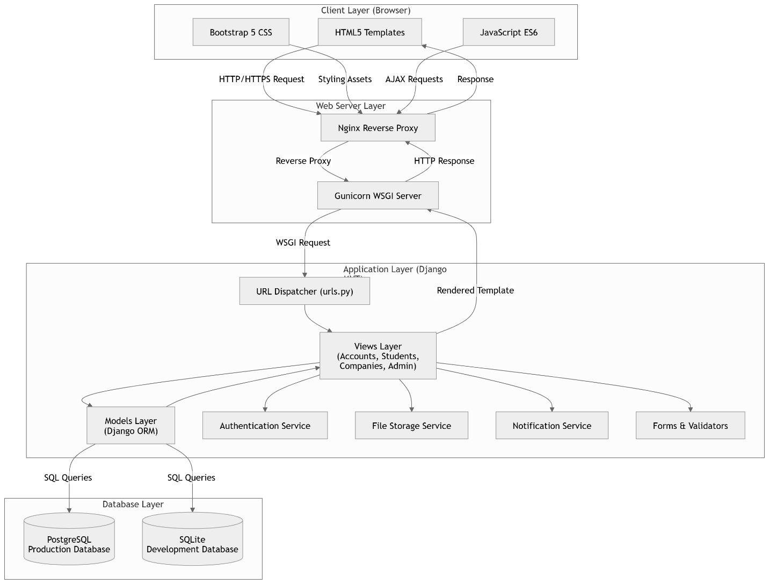

4. Module Design

The Student Internship Portal is decomposed into four primary functional modules, each implemented as a self-contained Django application. Each module encapsulates a cohesive set of features with well-defined interfaces to other modules.

4.1 Authentication Module

4.1.1 Purpose
The Authentication Module is responsible for all aspects of user identity management, including new user registration, credential-based login, session management, logout, and password recovery. It serves as the security gateway for all other modules and enforces role-based access control by assigning users a role (student, company, or admin) during registration.

4.1.2 Features
- Registration: New users may register as a student or company representative by providing a username, full name, email address, password, and role selection. Input validation ensures uniqueness of username and email.
- Login: Registered users authenticate using their username or email and password. Successful authentication creates a server-side session and redirects the user to their role-appropriate dashboard.
- Logout: Authenticated users can terminate their session securely, invalidating the session token.
- Forgot Password: Users can initiate a password reset by providing their registered email address. A secure, time-limited token is generated and dispatched to the provided email.

4.1.3 Inputs
- Registration: username, full_name, email, password, confirm_password, role
- Login: username/email, password
- Forgot Password: registered email address

4.1.4 Outputs
- Registration: New User record created; redirect to login or dashboard.
- Login: Session token created; role-based dashboard rendered.
- Logout: Session destroyed; redirect to login page.
- Forgot Password: Password reset email dispatched; confirmation message displayed.

4.1.5 Processing Logic
Upon registration, the system validates all input fields, hashes the provided password using PBKDF2-SHA256, creates a User record in the database, and depending on the selected role, creates a corresponding StudentProfile or Company record. Upon login, the system retrieves the user record, verifies the provided password against the stored hash using Django's check_password() function, and upon success, calls login() to create a session.

4.1.6 Dependencies
- Django's built-in django.contrib.auth module
- User model (accounts app)
- StudentProfile model (students app) and Company model (companies app) for post-registration record creation
- Email backend configuration (SMTP) for password reset

4.2 Student Module

4.2.1 Purpose
The Student Module provides all functionality required by student users to manage their academic profile, upload their curriculum vitae, discover available internship opportunities, submit applications, and monitor the status of submitted applications.

4.2.2 Features
- Profile Management: Students can create and update their academic profile, including CGPA, skills, department, and contact information.
- CV Upload: Students can upload their CV in PDF format (max 5 MB). The system validates the file type and size and stores it securely with a unique filename.
- Internship Search: Students can search available internship listings by keyword, industry, location, and deadline using a dynamic search interface.
- Internship Application: Students can apply for an internship by selecting a listing and confirming the application. The system validates that a CV is uploaded before permitting application.
- Application Tracking: Students can view a list of all their submitted applications with real-time status updates (Pending, Reviewed, Accepted, Rejected).

4.2.3 Inputs
- Profile: cgpa (float), skills (text), department (string), phone, bio
- CV Upload: PDF file (≤ 5 MB)
- Internship Search: keyword, industry, location, deadline filters
- Application: internship_id (selected internship), student_id (from session)

4.2.4 Outputs
- Updated StudentProfile record; success/error messages
- CV file stored; CV record updated with file_path
- Filtered internship listings rendered
- Application record created with status = 'Pending'
- Application status list rendered for the student

4.2.5 Processing Logic
The profile management view retrieves the student's existing profile (or creates one if absent) and populates a pre-filled form. Upon form submission, server-side validation is performed before saving the updated record. The CV upload view validates file extension and size, generates a unique filename, saves the file to the MEDIA_ROOT/cvs/ directory, and updates the CV model record. The application submission view first verifies that the student has an uploaded CV; if not, it redirects to the CV upload page with an appropriate warning message.

4.2.6 Dependencies
- StudentProfile model, CV model, Application model, Internship model
- Authentication Module (login_required decorator)
- File Storage Service

4.3 Company Module

4.3.1 Purpose
The Company Module provides functionality for company representatives to establish and manage their organizational profile, publish internship opportunities, and review and manage applications submitted by students for their posted internships.

4.3.2 Features
- Company Profile: Company representatives can create and update their company profile, including company name, industry sector, location, website URL, and a description.
- Post Internship: Companies can create new internship listings specifying the title, description, required skills, stipend details, application deadline, and available positions.
- Manage Applications: Companies can view all applications received for their internship postings and update the status of each application (Reviewed, Accepted, Rejected).

4.3.3 Inputs
- Company Profile: company_name, industry, location, website, description
- Post Internship: title, description, required_skills, stipend, deadline, positions, company_id (from session)
- Manage Applications: application_id, new_status

4.3.4 Outputs
- Updated Company record; confirmation message
- New Internship record created; listing visible to students immediately
- Application status updated; notification dispatched to the student

4.3.5 Processing Logic
When a company representative posts a new internship, the view validates all required fields including the deadline (must be a future date), saves the Internship record linked to the company's profile, and immediately makes it available in student search results. When an application status is updated, the system saves the new status to the Application record and triggers the Notification Service to create an in-portal notification for the concerned student.

4.3.6 Dependencies
- Company model, Internship model, Application model
- Authentication Module (login_required, company_required decorators)
- Notification Service

4.4 Admin Module

4.4.1 Purpose
The Admin Module provides the system administrator with comprehensive management and oversight capabilities for all user accounts, internship listings, and system-wide data. It also provides reporting functionality to generate insights about portal activity.

4.4.2 Features
- Manage Users: The administrator can view, search, activate, deactivate, and delete user accounts of any role.
- Manage Internships: The administrator can view, edit, approve, suspend, or delete any internship listing.
- Reports and Monitoring: The admin can generate statistical reports including total registered users by role, total internship postings by period, total applications by status, and company activity summaries.

4.4.3 Inputs
- User Management: user_id, action (activate/deactivate/delete)
- Internship Management: internship_id, action (approve/suspend/delete), optional edits
- Reports: date_range, report_type

4.4.4 Outputs
- Updated user account status; confirmation message
- Updated or deleted internship record; portal listing updated
- Statistical report rendered as HTML table or exportable CSV

4.4.5 Processing Logic
The Admin Module leverages Django's built-in admin capabilities extended with custom views. User management actions require the requesting user to have is_staff=True. All administrative actions are logged to the system's audit trail. Report generation queries aggregate database statistics using Django ORM annotations and annotations with Count() and Sum() functions, producing tabular summaries.

4.4.6 Dependencies
- User model, StudentProfile model, Company model, Internship model, Application model
- Authentication Module (admin_required decorator, is_staff check)
- Django's django.contrib.admin for base admin functionality

5. Database Design

The database design of the Student Internship Portal follows Third Normal Form (3NF) to eliminate data redundancy and ensure referential integrity. PostgreSQL is used as the production RDBMS with Django ORM managing all schema migrations. The following section details each entity, its attributes, keys, and relationships.

5.1 Entity Descriptions

5.1.1 USER Table
The USER table is the central identity table for all registered users regardless of role. It stores authentication credentials and role assignments.

Attribute | Data Type | Constraint | Description
user_id | INTEGER | PRIMARY KEY, AUTO_INCREMENT | Unique identifier for each user
username | VARCHAR(150) | UNIQUE, NOT NULL | Unique login username
full_name | VARCHAR(255) | NOT NULL | User's full name
email | VARCHAR(254) | UNIQUE, NOT NULL | User's email address
password_hash | VARCHAR(128) | NOT NULL | PBKDF2-SHA256 hashed password
role | VARCHAR(20) | NOT NULL, CHECK(IN 'student','company','admin') | User's system role
is_active | BOOLEAN | DEFAULT TRUE | Account activation status
created_at | DATETIME | AUTO_NOW_ADD | Account creation timestamp

5.1.2 STUDENT_PROFILE Table
The STUDENT_PROFILE table extends the USER table with academic profile information specific to students.

Attribute | Data Type | Constraint | Description
student_id | INTEGER | PRIMARY KEY, AUTO_INCREMENT | Unique student profile identifier
user_id | INTEGER | FOREIGN KEY → USER(user_id), UNIQUE | Reference to the parent user account
cgpa | DECIMAL(4,2) | NULLABLE, CHECK(0.00-4.00) | Student's cumulative GPA
skills | TEXT | NULLABLE | Comma-separated skill keywords
department | VARCHAR(100) | NULLABLE | Academic department name
phone | VARCHAR(20) | NULLABLE | Contact phone number
bio | TEXT | NULLABLE | Short personal biography

5.1.3 COMPANY Table
The COMPANY table stores organizational profile information for registered company representatives.

Attribute | Data Type | Constraint | Description
company_id | INTEGER | PRIMARY KEY, AUTO_INCREMENT | Unique company profile identifier
user_id | INTEGER | FOREIGN KEY → USER(user_id), UNIQUE | Reference to the parent user account
company_name | VARCHAR(255) | NOT NULL | Official company name
industry | VARCHAR(100) | NOT NULL | Industry sector (e.g., IT, Finance)
location | VARCHAR(255) | NOT NULL | Company city and country
website | URLField | NULLABLE | Company official website URL
description | TEXT | NULLABLE | Company description

5.1.4 INTERNSHIP Table
The INTERNSHIP table stores all internship postings created by registered company users.

Attribute | Data Type | Constraint | Description
internship_id | INTEGER | PRIMARY KEY, AUTO_INCREMENT | Unique internship identifier
company_id | INTEGER | FOREIGN KEY → COMPANY(company_id), NOT NULL | Owning company reference
title | VARCHAR(255) | NOT NULL | Internship position title
description | TEXT | NOT NULL | Detailed internship description
required_skills | TEXT | NULLABLE | Required technical/soft skills
stipend | VARCHAR(100) | NULLABLE | Stipend or compensation details
positions | INTEGER | DEFAULT 1 | Number of available positions
deadline | DATE | NOT NULL | Application deadline date
is_active | BOOLEAN | DEFAULT TRUE | Whether the listing is publicly visible
posted_at | DATETIME | AUTO_NOW_ADD | Creation timestamp

5.1.5 APPLICATION Table
The APPLICATION table records all internship applications submitted by students, forming a many-to-many relationship between STUDENT_PROFILE and INTERNSHIP with additional status metadata.

Attribute | Data Type | Constraint | Description
application_id | INTEGER | PRIMARY KEY, AUTO_INCREMENT | Unique application identifier
student_id | INTEGER | FOREIGN KEY → STUDENT_PROFILE(student_id) | Applying student reference
internship_id | INTEGER | FOREIGN KEY → INTERNSHIP(internship_id) | Applied internship reference
status | VARCHAR(20) | DEFAULT 'Pending' | Application status: Pending, Reviewed, Accepted, Rejected
applied_at | DATETIME | AUTO_NOW_ADD | Application submission timestamp
cover_letter | TEXT | NULLABLE | Optional cover letter from student
UNIQUE | (student_id, internship_id) | CONSTRAINT | Prevents duplicate applications

5.1.6 CV Table
The CV table maintains references to uploaded CV files and associates them with student profiles.

Attribute | Data Type | Constraint | Description
cv_id | INTEGER | PRIMARY KEY, AUTO_INCREMENT | Unique CV record identifier
student_id | INTEGER | FOREIGN KEY → STUDENT_PROFILE(student_id), UNIQUE | Owning student reference
file_path | VARCHAR(500) | NOT NULL | Relative path to stored PDF file
uploaded_at | DATETIME | AUTO_NOW | Last upload/update timestamp

5.1.7 NOTIFICATION Table
The NOTIFICATION table stores in-portal notification messages for users, primarily used to inform students of application status changes.

Attribute | Data Type | Constraint | Description
notification_id | INTEGER | PRIMARY KEY, AUTO_INCREMENT | Unique notification identifier
user_id | INTEGER | FOREIGN KEY → USER(user_id), NOT NULL | Recipient user reference
message | TEXT | NOT NULL | Notification message content
is_read | BOOLEAN | DEFAULT FALSE | Whether the user has read the notification
created_at | DATETIME | AUTO_NOW_ADD | Notification creation timestamp

5.2 Entity-Relationship Diagram
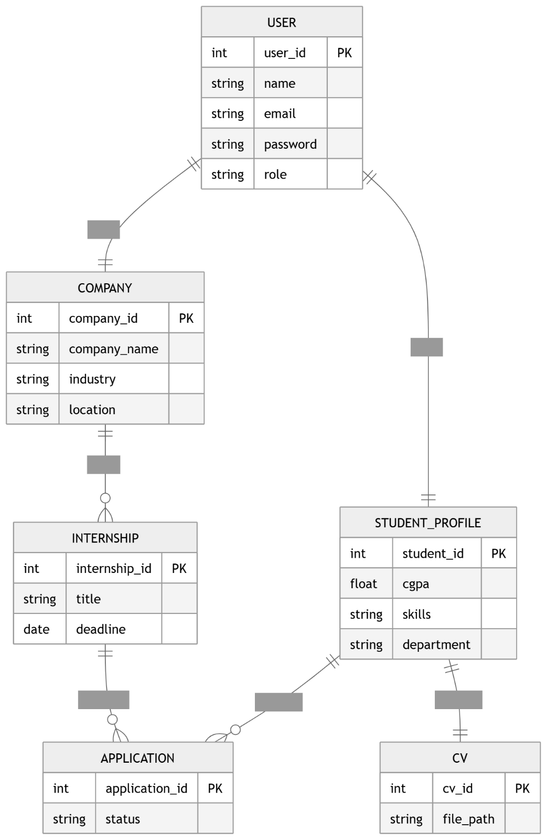

5.3 Relationship Summary

Relationship | Type | Description
USER — STUDENT_PROFILE | One-to-One | Each student user has exactly one academic profile
USER — COMPANY | One-to-One | Each company user has exactly one company profile
COMPANY — INTERNSHIP | One-to-Many | A company may post multiple internship listings
STUDENT_PROFILE — APPLICATION | One-to-Many | A student may submit multiple applications
INTERNSHIP — APPLICATION | One-to-Many | An internship may receive multiple applications
STUDENT_PROFILE — CV | One-to-One | Each student has at most one current CV on file
USER — NOTIFICATION | One-to-Many | A user may receive multiple notifications

6. Class Design

The class design of the SIP follows an object-oriented paradigm aligned with Django's Model-View-Template architecture. Each class corresponds directly to a Django Model that maps to a database table. The following descriptions provide attribute and method specifications for each major class.

6.1 Class: User
Purpose | Central authentication and identity class for all system users
Attributes | id, username, full_name, email, password_hash, role, is_active, created_at
Key Methods | register(), login(), logout(), changePassword(), deactivate()
Relationships | One-to-One with StudentProfile; One-to-One with Company; One-to-Many with Notification

6.2 Class: StudentProfile
Purpose | Stores academic and personal details of student users
Attributes | student_id, user_id (FK), cgpa, skills, department, phone, bio
Key Methods | updateProfile(), getApplications(), searchInternships()
Relationships | One-to-One with User; One-to-Many with Application; One-to-One with CV

6.3 Class: Company
Purpose | Stores organizational profile for company representatives
Attributes | company_id, user_id (FK), company_name, industry, location, website, description
Key Methods | updateProfile(), postInternship(), getPostedInternships()
Relationships | One-to-One with User; One-to-Many with Internship

6.4 Class: Internship
Purpose | Represents a single internship opportunity posted by a company
Attributes | internship_id, company_id (FK), title, description, required_skills, stipend, positions, deadline, is_active, posted_at
Key Methods | getApplications(), deactivate(), isOpen()
Relationships | Many-to-One with Company; One-to-Many with Application

6.5 Class: Application
Purpose | Records a student's application to a specific internship with current processing status
Attributes | application_id, student_id (FK), internship_id (FK), status, applied_at, cover_letter
Key Methods | updateStatus(), getStudent(), getInternship()
Relationships | Many-to-One with StudentProfile; Many-to-One with Internship

6.6 Class: CV
Purpose | Manages the stored CV document associated with a student profile
Attributes | cv_id, student_id (FK), file_path, uploaded_at
Key Methods | upload(), delete(), getFilePath()
Relationships | One-to-One with StudentProfile

6.7 Class: Notification
Purpose | Stores in-portal notifications for users regarding application and system events
Attributes | notification_id, user_id (FK), message, is_read, created_at
Key Methods | markAsRead(), create()
Relationships | Many-to-One with User

6.8 Class: Admin
Purpose | Represents the administrative role with elevated system management capabilities
Attributes | Inherits from User with is_staff=True flag
Key Methods | manageUsers(), manageInternships(), generateReports(), activateUser(), deactivateUser()
Relationships | Inherits User; operates on all model instances

6.9 Class Diagram

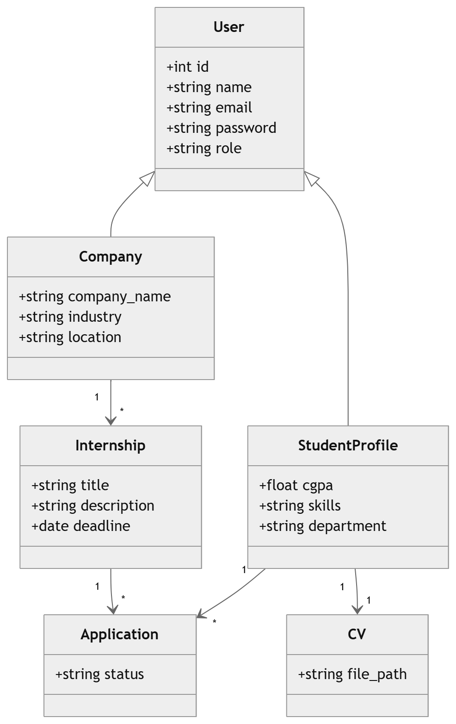

7. Use Case Design

7.1 Actor Descriptions

Actor | Type | Description
Student | Primary | A registered university student who uses the portal to search for internship opportunities, upload CVs, submit applications, and track their application status.
Company | Primary | A registered company representative who uses the portal to create a company profile, post internship listings, and manage applications received from students.
Admin | Primary | The system administrator responsible for overall portal management, user oversight, internship moderation, and report generation.
Email Server | Secondary | External SMTP server used to dispatch password reset emails and notification messages.

7.2 Use Case Descriptions

UC-01: User Registration
Actor | Student / Company
Precondition | User does not have an existing account
Description | The user provides registration details (username, email, password, role) and submits the form. The system validates input, creates a user account, and redirects to the dashboard.
Postcondition | New User record created; role-specific profile record created
Alternate Flow | If email or username already exists, the system displays a validation error.

UC-02: User Login
Actor | Student / Company / Admin
Precondition | User has a registered and active account
Description | The user submits their credentials. The system verifies the credentials and creates a session, redirecting the user to their role-appropriate dashboard.
Postcondition | Authenticated session created; user redirected to dashboard
Alternate Flow | Invalid credentials → error message; account inactive → appropriate message shown.

UC-03: Upload CV
Actor | Student
Precondition | Student is authenticated
Description | The student selects a PDF file (≤5 MB) and submits the upload form. The system validates the file and stores it, updating the CV record.
Postcondition | CV record created/updated; file stored in MEDIA_ROOT
Alternate Flow | Invalid file type or size → error message; file not replaced until upload is successful.

UC-04: Apply for Internship
Actor | Student
Precondition | Student is authenticated and has an uploaded CV
Description | The student selects an internship listing and submits an application with an optional cover letter. The system creates an Application record with status 'Pending'.
Postcondition | Application record created; student sees confirmation message
Alternate Flow | No CV uploaded → redirect to CV upload page; duplicate application → error message.

UC-05: Post Internship
Actor | Company
Precondition | Company representative is authenticated and has a company profile
Description | The company fills in the internship posting form and submits it. The system creates a new Internship record visible to students.
Postcondition | Internship record created; listing visible in student search results
Alternate Flow | Deadline in past → validation error; required fields missing → field-level error messages.

UC-06: Manage Applications (Company)
Actor | Company
Precondition | Company is authenticated; has received applications
Description | The company views application list for a posting and updates an application's status (Reviewed/Accepted/Rejected). The system saves the update and notifies the student.
Postcondition | Application status updated; notification dispatched to student
Alternate Flow | No applications exist → empty state message displayed.

UC-07: Generate Reports (Admin)
Actor | Admin
Precondition | Admin is authenticated
Description | The admin selects a report type and date range and submits the report request. The system queries aggregated data and renders statistical output.
Postcondition | Statistical report rendered; optionally exported as CSV
Alternate Flow | No data in selected range → empty report with appropriate message.

7.3 Use Case Diagram

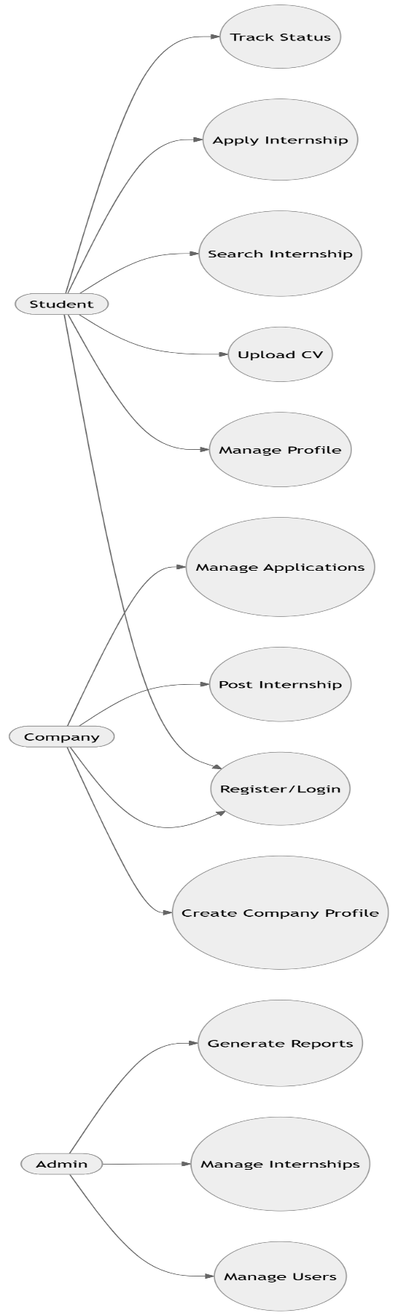

8. Sequence Diagrams

Sequence diagrams illustrate the dynamic interaction between system objects and actors over time for the key use cases of the Student Internship Portal.

8.1 User Registration

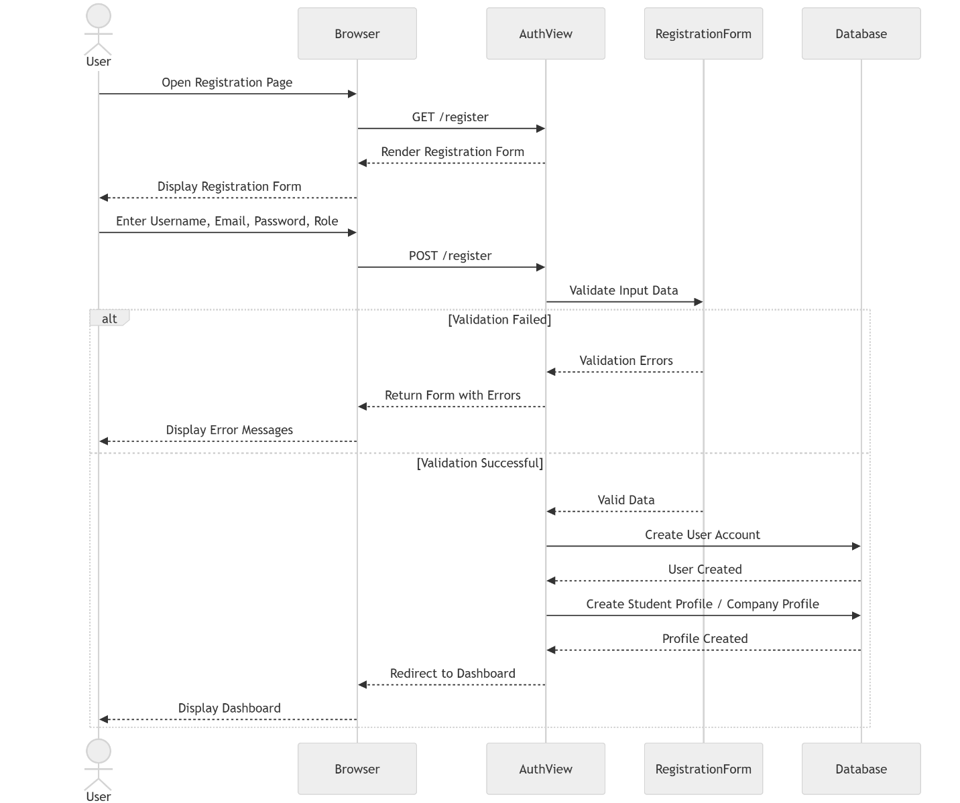

8.2 User Login

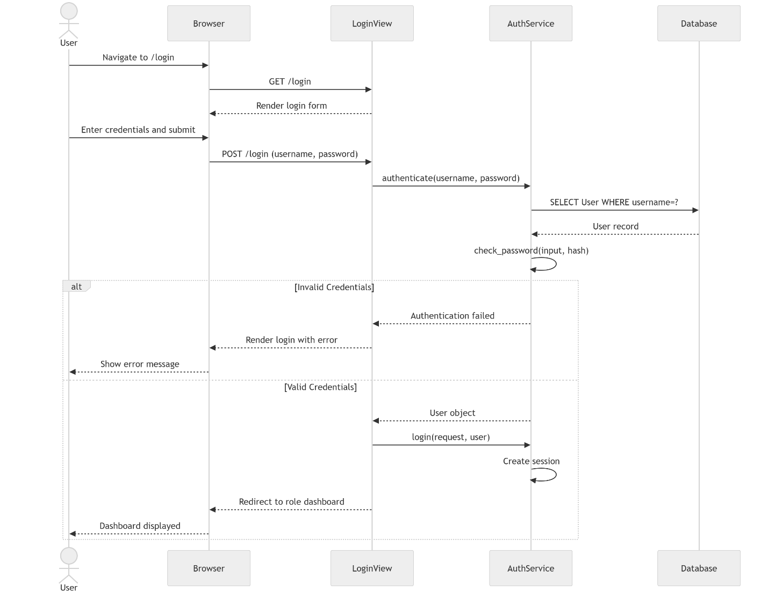

8.3 Upload CV
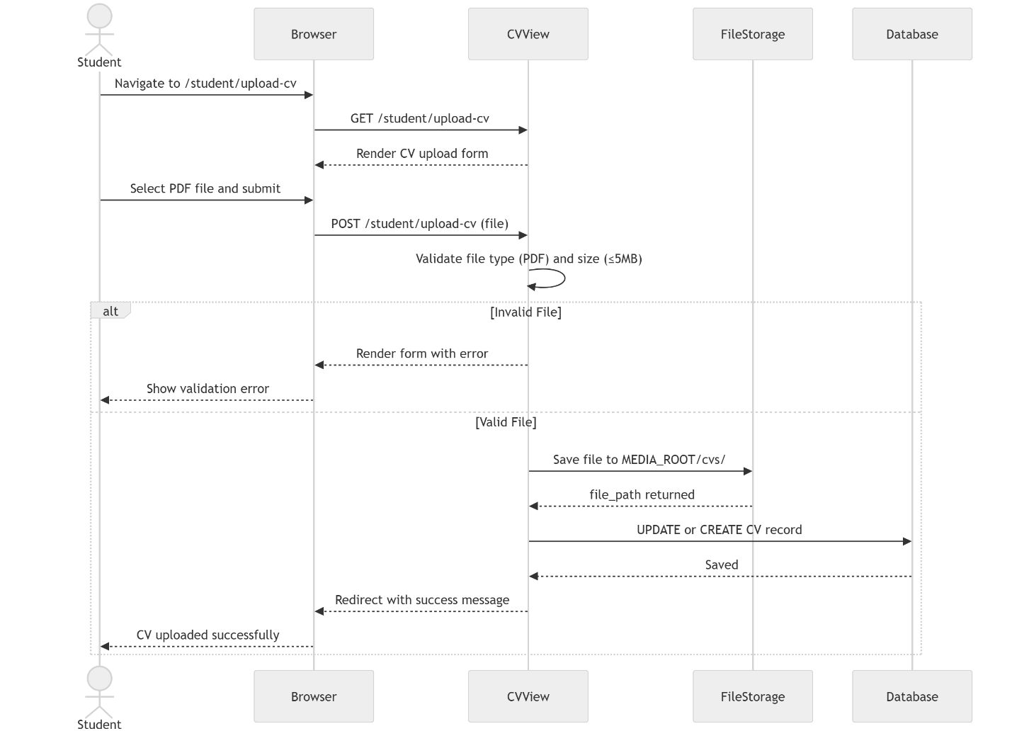

8.4 Apply for Internship

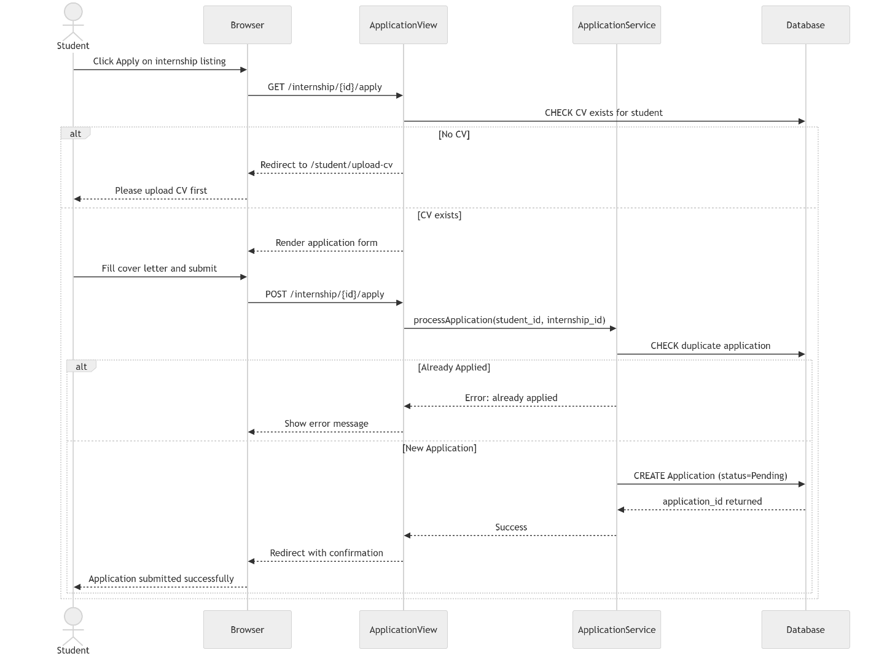

8.5 Manage Applications

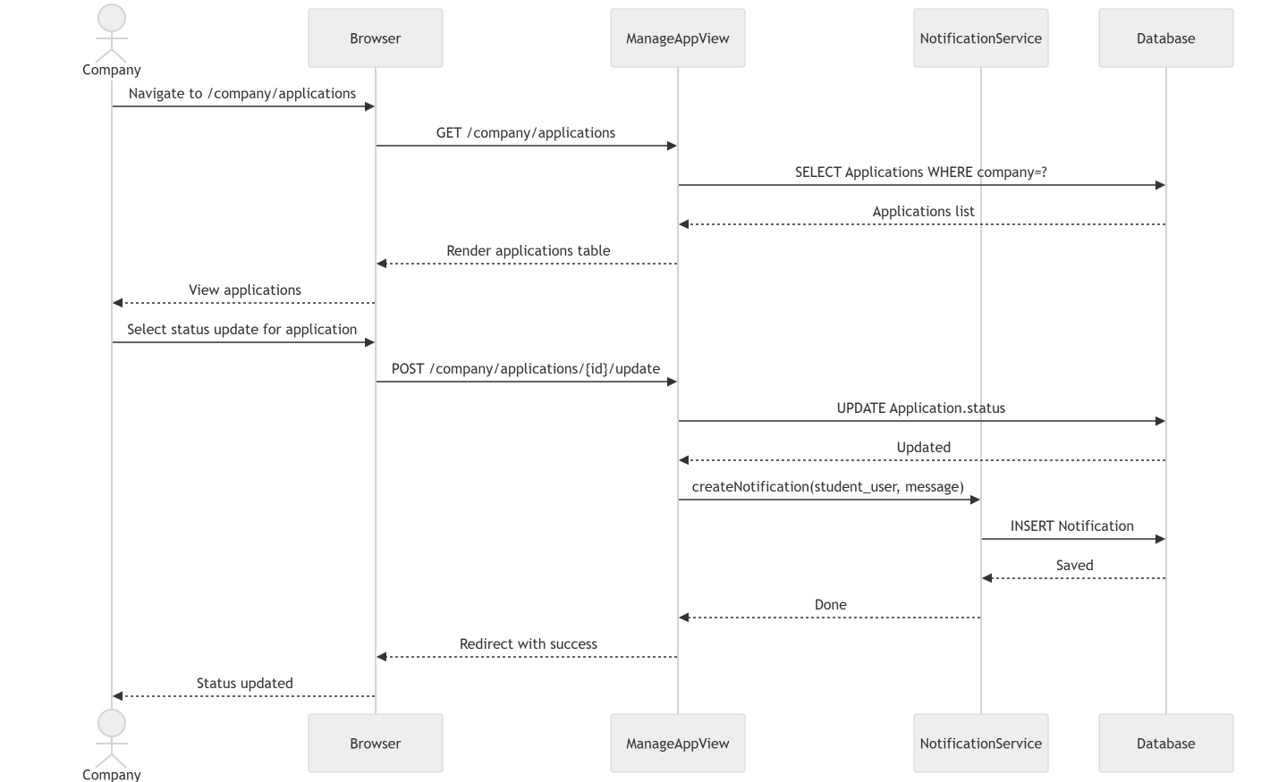

8.6 Generate Reports

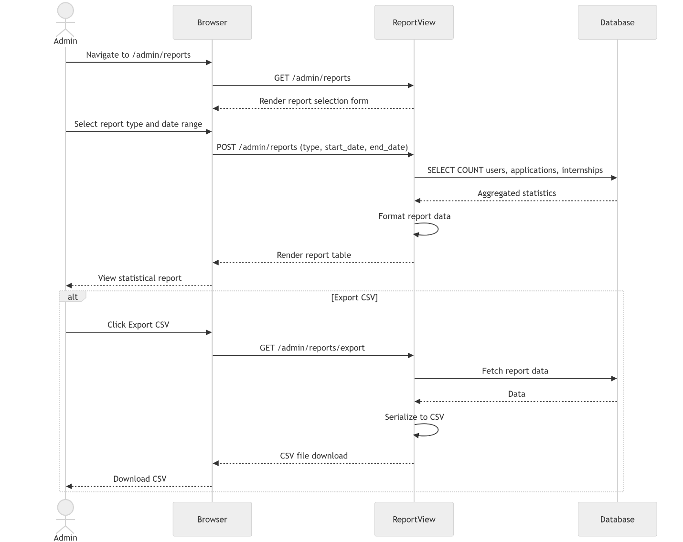

9. Activity Diagrams

Activity diagrams model the workflow and control flow within each primary actor's interaction with the Student Internship Portal, illustrating decision points, parallel processes, and action sequences.

9.1 Student Workflow Activity Diagram
The student workflow begins with authentication and proceeds through profile management, CV upload, internship discovery, application submission, and status tracking. The decision node for CV upload enforces a prerequisite before application submission can proceed.

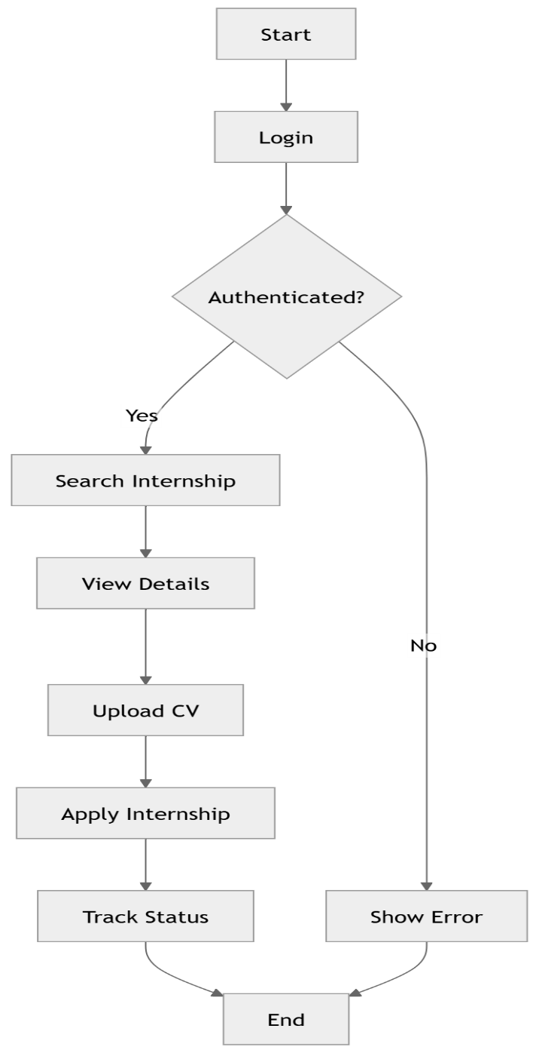

9.2 Company Workflow Activity Diagram
The company workflow begins with registration or login and proceeds through company profile creation, internship posting (with form validation), and application management including status updates and student notifications.

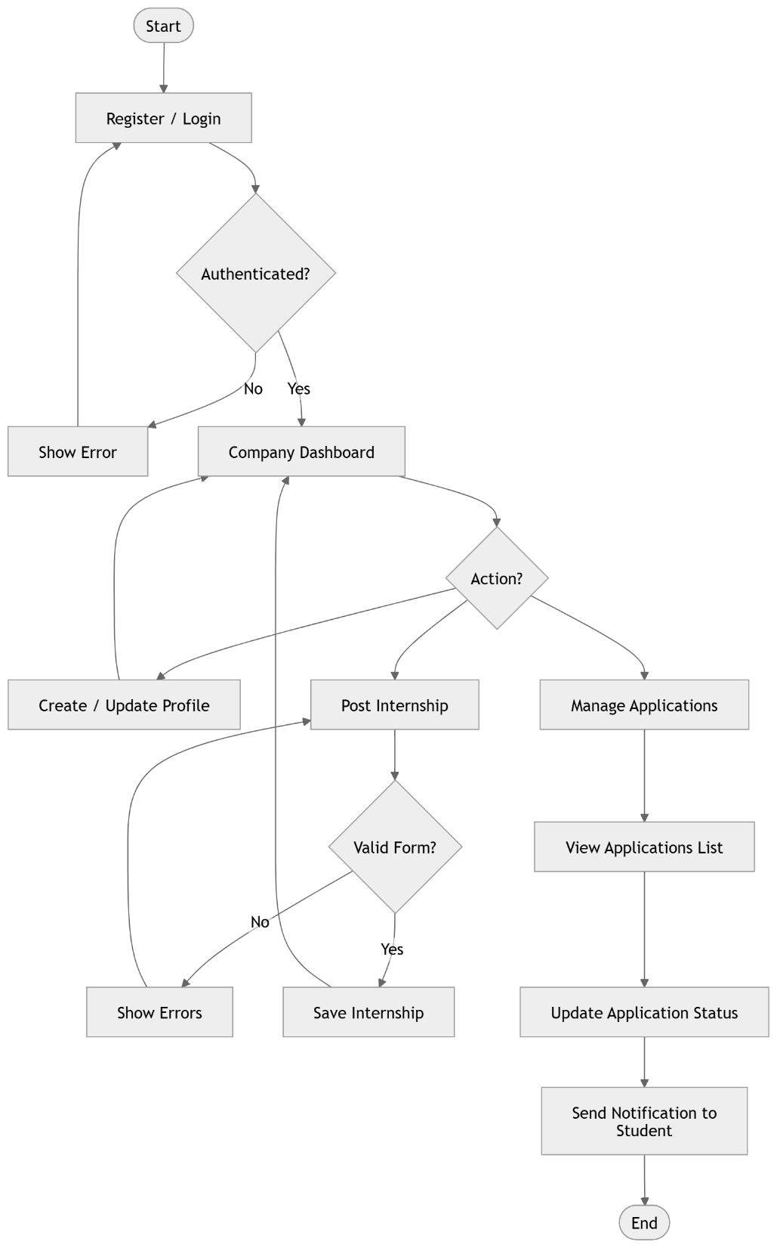

9.3 Admin Workflow Activity Diagram
The admin workflow encompasses system-wide management activities including user account control, internship moderation, and report generation with optional CSV export functionality.

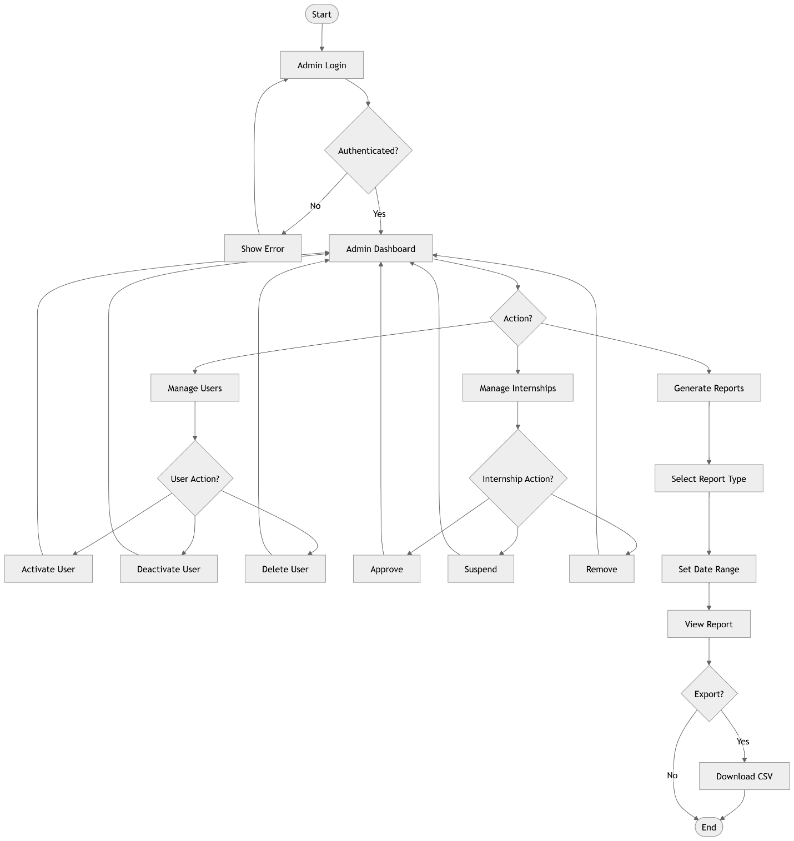

10. Component Design

The component diagram illustrates the high-level structural decomposition of the SIP into its major software components and their inter-dependencies. Each Django app is a self-contained component that communicates with others through well-defined interfaces and shared model references.

10.1 Component Descriptions

Component | Type | Responsibility
accounts app | Django App | Handles user registration, authentication, login, logout, and password management
students app | Django App | Manages student profiles, CV uploads, internship search, and application submission
companies app | Django App | Manages company profiles, internship posting, and application management
internships app | Django App | Provides internship listing views and shared internship data logic
admin app | Django App | Extends Django admin for user management, internship moderation, and reporting
Authentication Service | Service | Django's contrib.auth framework providing credential verification and session management
Notification Service | Service | Custom service creating and dispatching in-portal notifications to users
File Storage Service | Service | Django's FileField infrastructure managing CV file uploads and retrieval from MEDIA_ROOT
Report Generator | Service | Aggregation service computing statistical summaries using Django ORM annotations
Django ORM | Framework | Provides model-to-database mapping, query abstraction, and migration management
PostgreSQL | Database | Production RDBMS storing all persistent application data
SMTP Email Server | External | External mail server used for password reset and notification emails

10.2 Component Diagram

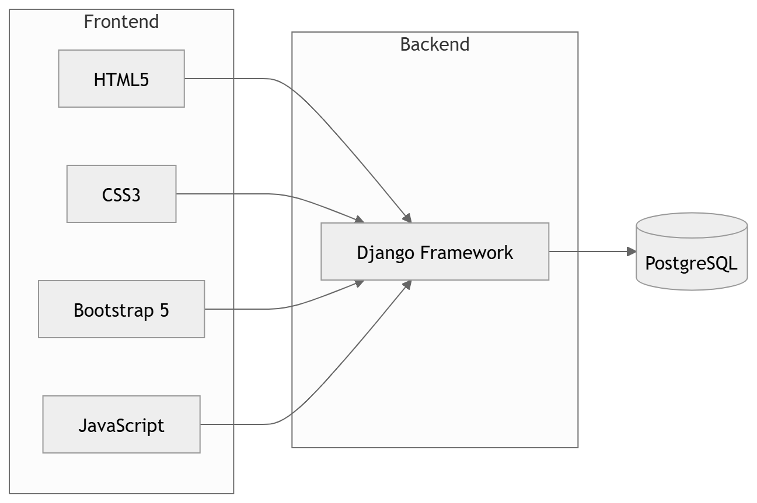

11. Deployment Design

The deployment design describes the physical and logical infrastructure on which the Student Internship Portal is deployed. The production architecture employs a single-server deployment model using Nginx as a reverse proxy and Gunicorn as the Python WSGI application server.

11.1 Deployment Topology

Node | Technology | Role
Client Browser | Chrome / Firefox / Edge 90+ | Renders the HTML/CSS/JS frontend and submits HTTP requests
Internet / CDN | HTTPS (TLS 1.3) | Encrypted communication channel between client and server
Nginx | Nginx 1.24 | Reverse proxy, SSL termination, static file serving, request load distribution
Gunicorn | Gunicorn 21.x | WSGI HTTP server bridging Nginx to the Django application
Django Application | Django 4.2 / Python 3.10 | Core application logic, view processing, ORM, and template rendering
PostgreSQL | PostgreSQL 15 | Relational database storing all application data
File System | Ubuntu ext4 FS | Stores uploaded media files (CVs) and static assets

11.2 Deployment Diagram

11.3 Nginx Configuration Overview
Nginx is configured to listen on ports 80 (HTTP) and 443 (HTTPS). All HTTP traffic is permanently redirected to HTTPS. Nginx serves static files (JS, CSS, images) directly from the STATIC_ROOT directory without passing them to Gunicorn, improving performance. All other requests are proxied to Gunicorn on 127.0.0.1:8000 with appropriate proxy headers (X-Forwarded-For, X-Real-IP) for correct request logging.

11.4 Gunicorn Configuration
Gunicorn is configured with a number of worker processes equal to (2 × CPU cores + 1) to maximize concurrency. Workers use the sync worker class for standard synchronous Django views. A systemd service unit manages Gunicorn's lifecycle (start, stop, restart, reload), ensuring automatic restart on failure.

12. User Interface Design

The User Interface design of the Student Internship Portal adheres to responsive design principles using Bootstrap 5. All pages share a common navigation bar, footer, and message notification area. The design prioritizes clarity, usability, and consistent visual hierarchy across all user roles.

12.1 Home Page
Purpose | Portal entry point; introduces SIP to visitors and provides navigation to Login/Register
Layout | Hero section with portal name and tagline; feature cards (Search, Apply, Track); Call-to-Action buttons
Key Components | Navbar with Login/Register links; Hero banner; Feature highlights section; Footer with university info
Responsive | Single-column stacking on mobile; 3-column feature grid on desktop

12.2 Login Page
Purpose | Credential entry form for all registered users
Layout | Centered card form with portal branding; username/email field; password field; Remember Me checkbox; Forgot Password link
Key Components | Form validation feedback (Bootstrap invalid-feedback); CSRF hidden token; Submit button; Registration redirect link
Validation | Client-side required field checks; server-side credential verification with error message display

12.3 Registration Page
Purpose | New user account creation for students and companies
Layout | Two-column form on desktop (single column mobile); role selection radio buttons toggling additional fields
Key Components | Full name, username, email, password, confirm password, role selector fields; terms acceptance checkbox; Submit button
Validation | Password strength indicator; email format check; username uniqueness checked via AJAX

12.4 Student Dashboard
Purpose | Central hub for student users to access all portal features
Layout | Sidebar navigation (Profile, Search, My Applications, Upload CV, Notifications); Main content area with summary cards
Key Components | Application count stats cards; Recent applications table; Quick-action buttons; Notification bell with unread count
Responsive | Sidebar collapses to hamburger menu on mobile; cards stack vertically

12.5 Company Dashboard
Purpose | Central hub for company representatives to manage internship postings and applications
Layout | Sidebar (Company Profile, Post Internship, My Postings, Applications, Notifications); Stats cards in main area
Key Components | Total postings count; Total applications received; Recent applications requiring review; Quick post button
Responsive | Collapsible sidebar on mobile; stacked card layout

12.6 Admin Dashboard
Purpose | System-wide administrative overview and management hub
Layout | Top navigation with Admin badge; Stats overview row (users, internships, applications); Management sections
Key Components | User count by role; Active internship count; Pending application count; Quick-access management links
Responsive | Full-width table views with horizontal scroll on mobile

12.7 Internship Listing Page
Purpose | Displays searchable, filterable list of active internship opportunities for students
Layout | Left filter panel (keyword, industry, location, deadline); Right results grid with card-per-internship layout
Key Components | Search bar; Filter dropdowns; Internship cards (title, company, location, deadline, Apply button); Pagination
Responsive | Filter panel collapses to top filter bar on mobile; single-column card list

12.8 Application Management Page
Purpose | Allows companies to view and update the status of all received applications
Layout | Filterable table with columns: Applicant Name, Internship, Applied Date, Status, Actions
Key Components | Status badge (color-coded: yellow=Pending, blue=Reviewed, green=Accepted, red=Rejected); Status update dropdown; View CV button
Responsive | Horizontally scrollable table on mobile with sticky first column

13. Security Design

Security is a foundational design requirement of the Student Internship Portal. The following security controls are implemented at multiple layers of the application to protect user data, prevent unauthorized access, and comply with OWASP security guidelines.

13.1 Authentication
All users must authenticate before accessing any protected resource. Django's built-in authentication framework (django.contrib.auth) is used to verify user credentials. The login_required decorator is applied to all views requiring an authenticated session, automatically redirecting unauthenticated requests to the login page.

13.2 Authorization and Role-Based Access Control (RBAC)
The SIP implements three distinct roles: Student, Company, and Admin. Custom decorators (student_required, company_required) are applied to role-specific views to verify that the authenticated user holds the appropriate role. Attempts to access a restricted URL from an unauthorized role result in an HTTP 403 Forbidden response or a redirect to an access-denied page. The Admin role additionally requires is_staff=True on the User model.

Role | Permitted Areas | Denied Areas
Student | Student dashboard, profile, CV, search, apply, track | Company dashboard, admin panel
Company | Company dashboard, profile, post internship, manage apps | Student private pages, admin panel
Admin | All areas including admin panel, user management, reports | None (full access)

13.3 CSRF Protection
Django's built-in CSRF middleware (django.middleware.csrf.CsrfViewMiddleware) is enabled and enforced on all POST, PUT, and DELETE requests. Every HTML form rendered by Django templates includes the {% csrf_token %} template tag, which embeds a unique, session-bound CSRF token. Requests without a valid CSRF token are rejected with an HTTP 403 Forbidden response.

13.4 Password Hashing
User passwords are never stored in plain text. Django's authentication framework uses PBKDF2 with the SHA-256 hashing algorithm and a random salt per password (100,000 iterations by default) to hash passwords before storage. This makes offline dictionary and brute-force attacks computationally infeasible. Password verification is performed using Django's check_password() function.

13.5 Session Management
Django stores session data server-side in the database (django.contrib.sessions.backends.db). Session IDs are transmitted only via secure, HttpOnly cookies with the SESSION_COOKIE_SECURE=True setting enforced in production, preventing JavaScript access to session cookies. Sessions are invalidated immediately upon logout through Django's logout() function.

13.6 Input Validation and Sanitization
All user-submitted data is validated and sanitized at two levels: client-side using HTML5 form validation attributes and JavaScript, and server-side using Django's Form and ModelForm validation framework. Django's template engine automatically escapes HTML characters (< > & " ') in all template variables, preventing Cross-Site Scripting (XSS) attacks. The Django ORM uses parameterized queries exclusively, eliminating the risk of SQL injection.

13.7 HTTPS Enforcement
In the production deployment, all HTTP traffic is permanently redirected to HTTPS by Nginx (HTTP 301 redirect). The Django settings SECURE_SSL_REDIRECT=True and SECURE_HSTS_SECONDS=31536000 are configured to enforce HTTPS and instruct browsers to only communicate with the portal over HTTPS for one year via the HTTP Strict Transport Security (HSTS) header.

13.8 File Upload Security
The CV upload functionality is restricted to PDF files only. Server-side validation checks both the file extension and MIME type. Uploaded files are stored in a non-publicly-accessible directory (outside the web root) and are served through a Django view that validates authorization before streaming the file, preventing unauthorized access to CV documents.

14. Performance Design

The performance design ensures that the Student Internship Portal delivers a satisfactory user experience under expected load conditions by optimizing database queries, implementing caching, and sizing the server infrastructure appropriately.

14.1 Response Time Requirements
The system is designed to achieve a page response time of under 3 seconds for 95% of requests under normal operating load (up to 100 concurrent users). Critical views including the dashboard and internship listing page are targeted for sub-1-second response times through query optimization and caching.

14.2 Concurrent Users
Gunicorn is configured with multiple synchronous worker processes to handle concurrent requests. The number of workers is set to (2 × CPU cores + 1). Each worker handles one request at a time, and Nginx distributes incoming requests across available workers, providing basic load distribution without requiring a separate load balancer for the expected user base.

14.3 Database Optimization
The following database optimization strategies are employed:
- Indexing: Database indexes are defined on all foreign key columns (user_id, company_id, student_id, internship_id) and on frequently queried fields including email, username, status, and is_active.
- Query Optimization: Django's select_related() and prefetch_related() ORM methods are used throughout views that traverse foreign key relationships to eliminate N+1 query problems.
- QuerySet Evaluation: QuerySets are evaluated lazily and only when necessary; count() is used instead of len() for counting records.
- Connection Pooling: PgBouncer or Django's persistent database connection (CONN_MAX_AGE setting) is used to reduce connection overhead.

14.4 Caching Strategy
Django's caching framework is configured with a memory-based cache (LocMemCache) for development and Redis (django-redis) for production. The following content is cached:
- Internship listings: The full internship listing query result is cached for 5 minutes using Django's cache_page decorator, significantly reducing database load from repeated browse requests.
- Statistics: Admin dashboard aggregate statistics are cached for 10 minutes.
- Template fragment caching: Navigation elements and header components are cached per-session using Django's {% cache %} template tag.

14.5 Static File Optimization
Static files (CSS, JavaScript, images) are collected to STATIC_ROOT using Django's collectstatic management command and served directly by Nginx, bypassing the Python application layer entirely. CSS and JavaScript files are minified during the build process to reduce payload sizes.

15. Maintainability Design

The maintainability design ensures that the Student Internship Portal codebase remains comprehensible, modifiable, and extensible throughout its lifecycle.

15.1 Modular Django App Structure
The project is organized into cohesive, independently deployable Django apps following the single-responsibility principle. The directory structure is:
sip_project/
├── config/ # Project settings, URLs, WSGI, ASGI
│ ├── settings/
│ │ ├── base.py # Common settings
│ │ ├── development.py # Development overrides
│ │ └── production.py # Production overrides
├── accounts/ # Authentication module
├── students/ # Student module
├── companies/ # Company module
├── internships/ # Internship listing module
├── notifications/ # Notification service
├── reports/ # Admin reporting module
├── templates/ # Global templates
│ ├── base.html
│ ├── accounts/
│ ├── students/
│ └── companies/
├── static/ # CSS, JS, Images
├── media/ # Uploaded files (CVs)
├── requirements.txt
└── manage.py

15.2 Documentation Standards
All Python modules, classes, and functions are documented using Google-style docstrings. Each Django model includes field-level comments explaining business rules. Django's built-in admin is configured with list_display, search_fields, and list_filter attributes for all models to facilitate administrative introspection.

15.3 Git Workflow
The project follows the GitHub Flow branching strategy:
- main branch: Contains only production-ready, tested code. Direct pushes are prohibited.
- develop branch: Integration branch for completed features before release.
- feature branches: Named feature/feature-name (e.g., feature/cv-upload). Created from develop and merged via Pull Request upon completion.
- hotfix branches: Named hotfix/issue-description for urgent production bug fixes.
- Commit messages follow the Conventional Commits specification (feat:, fix:, docs:, refactor:, test:).

15.4 Coding Standards
All Python code conforms to PEP 8 style guidelines, enforced using the Flake8 linting tool and Black auto-formatter. Template files follow a consistent indentation and naming convention. JavaScript code follows the Airbnb JavaScript Style Guide.

16. Future Enhancements

The following enhancements are identified as high-value extensions for post-Version-1.0 development phases of the Student Internship Portal:

16.1 Interview Scheduling Module
A dedicated interview scheduling subsystem would allow companies to invite shortlisted candidates for virtual or in-person interviews directly through the portal. The module would include a calendar integration, time-slot selection, confirmation workflow, and automated email reminders to both parties.

16.2 AI-Powered Recommendation Engine
An intelligent recommendation engine, based on machine learning (collaborative filtering or content-based filtering), would analyze a student's profile attributes (skills, CGPA, department) and past application behavior to suggest the most relevant internship opportunities. Similarly, companies could receive a ranked list of the most suitable student candidates for their listings.

16.3 Mobile Application
A cross-platform mobile application for Android and iOS (built using React Native or Flutter) would extend the portal's accessibility to mobile-first users, providing features including push notifications for application status updates, offline internship browsing, and mobile-optimized CV upload.

16.4 Enhanced Email Notification System
The current in-portal notification system would be extended with full transactional email notifications using a dedicated email service provider (e.g., SendGrid or Mailgun). Notification types would include welcome emails, application submission confirmation, status change alerts, deadline reminders, and administrative announcements.

16.5 Analytics Dashboard
An advanced analytics module would provide graphical, interactive dashboards for both the admin and company roles. Administrators would gain insights into registration trends, application conversion rates, and platform engagement metrics. Companies would receive visualizations of their posting performance, application funnel statistics, and candidate quality metrics using Chart.js or D3.js.

16.6 Internship Progress Tracking
A post-acceptance module would allow accepted students to log their internship progress, submit weekly reports, and receive supervisor feedback through the portal, providing the university with a comprehensive end-to-end internship management system.

17. Conclusion

This Software Design Document has presented a comprehensive and rigorous architectural and detailed design specification for the Student Internship Portal (SIP), developed as a Final Year Project at the Department of Information Technology, The Islamia University of Bahawalpur.

The SDD has systematically translated the requirements captured in the Software Requirements Specification into concrete, implementable design artifacts. The three-tier architecture, built upon the Django MVT framework with a PostgreSQL database and Nginx/Gunicorn deployment stack, provides a sound, industry-standard foundation that balances performance, security, and maintainability.

The modular decomposition into discrete Django applications (accounts, students, companies, internships, notifications, reports) ensures that each component can be independently developed, tested, and maintained. The comprehensive database design in Third Normal Form guarantees data integrity and eliminates redundancy. The class design provides a clear object-oriented blueprint aligned with the Django ORM, and the fifteen Mermaid-format UML diagrams — encompassing architecture, entity-relationship, class, use case, sequence, activity, component, and deployment views — collectively provide a complete multi-perspective representation of the system.

The security design addresses OWASP Top 10 concerns through layered defenses including PBKDF2 password hashing, CSRF protection, RBAC, input validation, XSS prevention through template escaping, and HTTPS enforcement. The performance design employs query optimization, caching, and static file serving strategies to meet the specified response time requirements.

The design described herein is complete, consistent, and traceable back to the SRS. It provides the development team, supervisor, and academic evaluators with the documentation necessary to verify that the implementation is faithful to the stated requirements and adheres to professional software engineering standards. The future enhancement roadmap further demonstrates the portal's potential for growth into a comprehensive, AI-augmented internship management ecosystem.

The Student Internship Portal, as designed in this document, represents a significant and practical contribution to the internship discovery and management process at The Islamia University of Bahawalpur, providing measurable benefit to students, industry partners, and the institution alike.

— End of Software Design Document —
Student Internship Portal (SIP) | Version 1.0 | The Islamia University of Bahawalpur

