1.Inner Join between Customer and Customer Account tables to find the balance of each customer:  
  
SELECT Customer.Name, Customer_Account.Balance

FROM Customer

INNER JOIN Customer Account

ON Customer.C_id = Customer_Account.Acc_number;  
  
  
  
  
2. Left Join between Branch and Manager tables to find all branches and the corresponding managers  
  
  
SELECT Employee.Name, Department.Name

FROM Employee

LEFT JOIN Department

ON Employee.Department = Department.D_id;

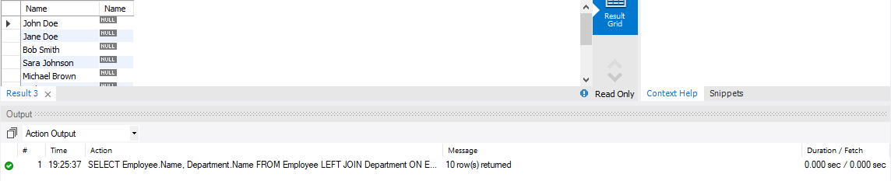  
  
  
  
  
  
  
  
  
  
  
  
3. Right Join between Transaction and Current Account tables to find all transactions and the corresponding current account balances  
  
ANS:  
 SELECT Transaction.details, currentaccount.Balance

FROM Transaction

RIGHT JOIN currentaccount

ON Transaction.Acc_number = currentaccount.Acc_id;  
  
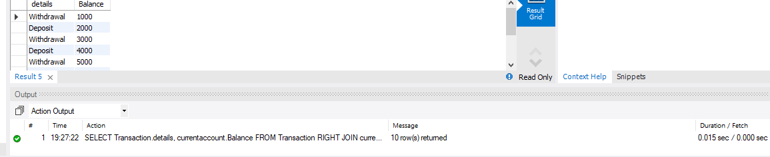  
  
  
  
  
  
4. Find the names of customers who have a current account balance greater than the average balance of all customers.  
ANS:  
select * from customer;

SELECT Customer.Name

FROM Customer

INNER JOIN CustomerAccount

ON Customer.C_id = CustomerAccount.Acc_number

INNER JOIN CurrentAccount

ON CustomerAccount.Acc_number = CurrentAccount.Acc_id

WHERE CurrentAccount.Balance > (SELECT AVG(Balance)

FROM CurrentAccount);  
  
  
  
  
  
5. Find the names of employees who work in the IT department and earn a salary greater than 30000:  
  
SELECT Name

FROM Employee

WHERE Department = 'IT' AND Salary > 30000;  
  
  
  
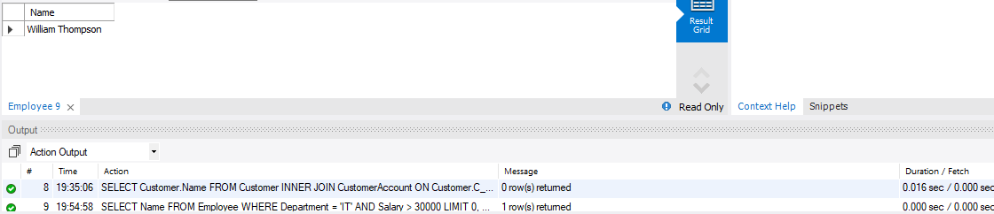  
  
  
6. Find the names of customers who live at the same address as an employee:  
  
SELECT Customer.Name

FROM Customer

JOIN Employee ON Customer.Address = Employee.Address;  
  
