Software Requirement Specifications

Intelligent Resume and Job Match Analyzer



Submitted by:

Muhammad Ramzan (S23BINFT1E02069)

Submitted to

Dr. Syed Ali Nawaz Shah

Department of Information Technology
Faculty of Computing

The Islamia University of Bahawalpur

Meeting Details
Sr No | Details | Date | Teacher Signature
01 | Discussion about Templates | 10/04/2026
02 | Design and Implementation | 20/04/2026
03 | Functional and NON-Functional Requirement | 30/04/2026

Summary

SkillScan AI is an intelligent web-based platform designed to bridge the gap between job seekers and employers by analyzing resumes against job descriptions using Artificial Intelligence. The system accepts a CV upload and a job description, then generates a compatibility match score, identifies missing skills, and provides personalized improvement suggestions. This document outlines the complete software requirements for SkillScan AI, including functional requirements, non-functional requirements, and use case specifications. The system is developed using Python, Django, Google Gemini API, and HTML/CSS/JavaScript.

Table of Contents

1. Introduction 6
1.1 Purpose 6
1.2 Document Conventions 6
1.3 Intended Audience and Reading Suggestions 6
1.4 Product Scope 7
1.5 References 7
2. Overall Description 8
2.1 Product Perspective 8
2.2 Product Functions 8
2.3 User Classes and Characteristics 8
2.3.1 Job Seeker (Registered User) 8
2.3.2 System Administrator 8
2.4 Operating Environment 9
2.5 Design and Implementation Constraints 9
2.6 User Documentation 9
2.7 Assumptions and Dependencies 9
3. External Interface Requirements 11
3.1 User Interfaces 11
3.2 Hardware Interfaces 11
3.3 Software Interfaces 11
3.4 Communications Interfaces 11
4. System Features / Use Cases 12
4.1 User Registration 12
4.1.1 Description and Priority 12
4.1.2 Stimulus / Response Sequences 12
4.1.3 Functional Requirements 12
4.2 User Login 13
4.2.1 Description and Priority 13
4.2.2 Stimulus / Response Sequences 13
4.2.3 Functional Requirements 13
4.3 CV Upload 13
4.3.1 Description and Priority 13
4.3.2 Stimulus / Response Sequences 13
4.3.3 Functional Requirements 14
4.4 Job Description Input 14
4.4.1 Description and Priority 14
4.4.2 Stimulus / Response Sequences 14
4.4.3 Functional Requirements 14
4.5 AI Analysis and Match Score Generation 15
4.5.1 Description and Priority 15
4.5.2 Stimulus / Response Sequences 15
4.5.3 Functional Requirements 15
4.6 System use case…………………………………………………………………………. ..16
4.7 Scan History 16
4.7.1 Description and Priority 16
4.7.2 Stimulus / Response Sequences 16
4.7.3 Functional Requirements 16
4.8 Admin Management Panel 17
4.8.1 Description and Priority 17
4.8.2 Stimulus / Response Sequences 17
4.8.3 Functional Requirements 17
5. Other Non-Functional Requirements 18
5.1 Performance Requirements 18
5.2 Safety Requirements 18
5.3 Security Requirements 18
5.4 Software Quality Attributes 18
5.5 Business Rules 19
6. Other Requirements 20
Appendix A: Glossary 21

1. Introduction
SkillScan AI is an intelligent web-based platform designed to help job seekers optimize their resumes by analyzing them against specific job descriptions using Artificial Intelligence. In today's highly competitive job market, most applicants submit generic resumes without knowing which skills are missing or how well their profile aligns with a given job posting. This results in high rejection rates, wasted effort, and missed career opportunities. SkillScan AI solves this problem by providing instant, AI-driven compatibility analysis, skill gap identification, and personalized improvement suggestions — completely free and accessible through any browser.

1.1 Purpose
The purpose of this document is to present a complete and detailed description of the requirements for SkillScan AI. It explains the purpose and features of the system, the interfaces, what the system will do, and the constraints under which it operates. This document will serve as the foundation for system design, development, and testing, and will be used as the primary reference for all future development stages of the project.

1.2 Document Conventions
This document is prepared using Times New Roman font throughout. Body text is typeset at 12pt and headings at 14pt. All headings are bold for clear distinction. Section references follow the IEEE 830-1998 standard numbering convention. Requirements are identified using the prefix REQ followed by a sequential number (e.g., REQ-1, REQ-2). Priority levels used are: High, Medium, and Low.

1.3 Intended Audience and Reading Suggestions
This document is intended for the following stakeholders:
- Developers — to identify functional and non-functional requirements for implementation
- Testers — to verify that the implemented system meets the specified requirements
- Project Supervisor (Dr. Syed Ali Nawaz Shah) — for academic evaluation and feedback
- System Designers — to design system architecture based on requirements

Readers are recommended to begin with Section 1 for an overview, proceed to Section 2 for the overall system description, review Section 3 for interface requirements, and study Section 4 for detailed system features.

1.4 Product Scope
SkillScan AI is a web-based application that automates the process of resume and job description matching using Artificial Intelligence. The system targets job seekers, fresh graduates, and career changers who wish to improve their chances of securing employment. The platform accepts a CV upload and a pasted job description, then generates a detailed compatibility report including a percentage match score, a list of missing skills, and actionable improvement suggestions. The system also maintains a scan history for each registered user. SkillScan AI is developed using Python, Django, and Google Gemini API, and is designed to be deployed on a standard web server accessible through any modern browser without requiring software installation.

1.5 References
1. IEEE Computer Society, "IEEE Std 830-1998: IEEE Recommended Practice for Software Requirements Specifications," 1998.
2. Google LLC, "Gemini API Documentation," Google AI for Developers, 2024. Available: https://ai.google.dev
3. Django Software Foundation, "Django Documentation v5.0," 2024. Available: https://docs.djangoproject.com
4. K. Wiegers and J. Beatty, Software Requirements, 3rd ed. Microsoft Press, 2013.

2. Overall Description

2.1 Product Perspective
SkillScan AI is a new, standalone web-based software product developed to overcome the limitations of generic resume submission practices. The system integrates with Google's Gemini AI API for natural language processing and analysis, and uses PyPDF2 for PDF text extraction. It follows a three-tier client-server architecture: an HTML/CSS/JavaScript frontend, a Python Django backend, and an SQLite database. The system is designed to be self-contained and does not depend on any external organizational system. Future versions may integrate with external job platforms such as LinkedIn or Indeed.

2.2 Product Functions
The following are the primary functions of SkillScan AI:
- User registration and secure login with hashed password authentication
- CV upload in PDF format with automatic text extraction using PyPDF2
- Job description input via text field supporting any job posting format
- AI-powered analysis generating a compatibility percentage match score
- Skill gap identification highlighting missing qualifications and skills
- Personalized improvement suggestions generated by Google Gemini API
- Scan history dashboard allowing users to view and compare past results
- Admin panel for user management via Django built-in administration

2.3 User Classes and Characteristics

2.3.1 Job Seeker (Registered User)
The primary user of SkillScan AI is a job seeker who registers and uses the platform to analyze their resume against job descriptions. This user is expected to have basic computer literacy, access to a web browser, and a CV in PDF format. The user does not require any technical background to use the system. Expected interaction frequency is moderate — users may run multiple scans when applying to different positions.

2.3.2 System Administrator
The admin user manages the SkillScan AI platform through Django's built-in administration panel. The admin can monitor registered users, view scan statistics, manage user accounts, and ensure platform integrity. The admin is expected to have intermediate technical knowledge of Django and web application management.

2.4 Operating Environment
SkillScan AI is a web application designed to operate in the following environment:

Category | Specification
Server OS | Linux (Ubuntu 22.04 LTS) or Windows Server
Programming Language | Python 3.10+
Web Framework | Django 4.2+
AI Integration | Google Gemini API (gemini-pro)
PDF Processing | PyPDF2 3.0+
Database | SQLite (default) — upgradeable to PostgreSQL
Frontend | HTML5, CSS3, JavaScript (Vanilla)
Browser Support | Chrome 90+, Firefox 88+, Edge 90+, Safari 14+
Internet | Constant internet connection required for Gemini API calls

2.5 Design and Implementation Constraints
- The system uses Google Gemini API which requires a valid API key and active internet connection
- CV uploads are restricted to PDF format only with a maximum file size of 5MB
- The server-side language used must be Python with Django framework
- Database must be SQLite for the initial deployment (upgradeable to PostgreSQL)
- The frontend must be compatible with all modern browsers without browser-specific plugins
- Job description input must be a minimum of 50 characters for meaningful AI analysis
- The system is limited to English language input for CV and job description analysis

2.6 User Documentation
The following user documentation will be provided with SkillScan AI:
- User Manual — step-by-step guide for registration, CV upload, and result interpretation
- In-app Tooltips — contextual hints on each form field explaining input requirements
- FAQ Section — answers to common questions about file formats, results, and scoring

2.7 Assumptions and Dependencies
- Users are assumed to have access to a valid CV in PDF format before using the system
- Google Gemini API is assumed to be available and operational during all analysis requests
- The system assumes users have a stable internet connection for API-dependent features
- It is assumed that job descriptions pasted by users are in English language
- Email verification for registration is not required in the initial version
- The system will operate correctly on standard shared hosting with Python/Django support

3. External Interface Requirements

3.1 User Interfaces
SkillScan AI features a clean, minimal web interface with the following pages:
- Landing Page — overview of features, call-to-action buttons for Register and Login
- Registration Page — form with fields for full name, email, password, and confirm password
- Login Page — email and password input with a "Forgot Password" option
- Dashboard — displays a welcome message, quick-start button, and recent scan summary
- New Scan Page — two-panel layout with CV upload area and job description text field
- Results Page — displays match score, skill gap list, and improvement suggestions
- Scan History Page — chronological list of past scans with scores and view buttons
- Admin Panel — Django built-in admin interface for user and data management

3.2 Hardware Interfaces
SkillScan AI is a web application and does not interact directly with any hardware beyond standard computing devices. The system requires a web server capable of running Python and Django. On the client side, any device with a modern web browser and internet connection is sufficient — including desktop computers, laptops, tablets, and smartphones.

3.3 Software Interfaces
The following software interfaces are used by SkillScan AI:
- Google Gemini API — provides AI-powered natural language processing for CV and job description analysis. Communication via HTTPS REST API using JSON payloads.
- PyPDF2 Library — used server-side to extract plain text from uploaded PDF files.
- Django ORM — interface between the application logic and the SQLite database.
- HTML/CSS/JavaScript — client-side rendering of the user interface in the browser.

3.4 Communications Interfaces
SkillScan AI uses HTTPS for all communications between the client browser and the Django web server, ensuring encrypted data transmission. Communication with the Google Gemini API is conducted over HTTPS using authenticated REST API calls with API key authorization. The underlying TCP/IP protocol stack manages all network communications transparently through the operating system.

4. System Features
SkillScan AI has two actor types: a Registered User (Job Seeker) and an Admin. All user data, scan records, and skill gap results are stored in the SQLite database managed by Django ORM. The system level use case diagram below illustrates the interactions between actors and system features.

4.1 User Registration

4.1.1 Description and Priority
This feature allows new users to create a SkillScan AI account. It is HIGH priority as it is the entry point for all other system features. Without a registered account, no user can access the CV analysis functionality.

4.1.2 Stimulus / Response Sequences
The user clicks the "Register" button on the landing page. The system displays the registration form. The user fills in their details and submits. The system validates input and creates the account.

4.1.3 Functional Requirements
Feature ID | SF-01
Priority | High
Description | Allow new users to create a secure account to access SkillScan AI.
Stimulus / Response | User clicks Register → fills form → system validates → account created.
Functional Requirements | - REQ-1: Registration form must include Full Name, Email Address, Password, and Confirm Password fields  - REQ-2: Email address must be unique in the system — duplicate emails must be rejected with an error message  - REQ-3: Password must be a minimum of 8 characters and include at least one number  - REQ-4: Confirm Password field must exactly match the Password field before submission  - REQ-5: On successful registration, user is automatically logged in and redirected to the Dashboard

4.2 User Login

4.2.1 Description and Priority
This feature allows registered users to securely authenticate and access their account. It is HIGH priority as all core features require authentication.

4.2.2 Stimulus / Response Sequences
User navigates to the Login page, enters email and password, and clicks Login. System verifies credentials against the database and grants or denies access.

4.2.3 Functional Requirements
Feature ID | SF-02
Priority | High
Description | Allow registered users to securely log in to their account.
Stimulus / Response | User enters credentials → system validates → redirects to Dashboard or shows error.
Functional Requirements | - REQ-6: Login form must include Email Address and Password fields  - REQ-7: System must verify credentials against hashed passwords stored in the database  - REQ-8: On failed login, system must display a generic error message without revealing which field is incorrect  - REQ-9: Successful login must redirect user to the Dashboard

4.3 CV Upload

4.3.1 Description and Priority
This feature allows registered users to upload their CV in PDF format for AI analysis. It is HIGH priority as it is the primary input for the core analysis functionality.

4.3.2 Stimulus / Response Sequences
User navigates to the New Scan page and selects a PDF file using the upload control. The system validates the file type and size, extracts text using PyPDF2, and confirms successful upload.

4.3.3 Functional Requirements
Feature ID | SF-03
Priority | High
Description | Allow users to upload a CV in PDF format for AI-powered analysis.
Stimulus / Response | User selects PDF file → system validates → extracts text → confirms upload.
Functional Requirements | - REQ-10: System must accept only PDF format files for CV upload  - REQ-11: Maximum allowed file size is 5MB — files exceeding this limit must be rejected with an error  - REQ-12: System must extract text from the uploaded PDF using PyPDF2 before analysis  - REQ-13: If the PDF is password-protected or corrupted, system must notify the user and reject the file  - REQ-14: User may optionally provide a label/title for the scan for easy identification in history

4.4 Job Description Input

4.4.1 Description and Priority
This feature allows users to paste any job description for comparison against their CV. It is HIGH priority as it is the second required input for the core AI analysis.

4.4.2 Stimulus / Response Sequences
User pastes job description text into the provided text area on the New Scan page. The system validates the minimum length and stores the input for analysis.

4.4.3 Functional Requirements
Feature ID | SF-04
Priority | High
Description | Allow users to input a job description for AI-powered CV matching.
Stimulus / Response | User pastes job description → system validates length → stores for analysis.
Functional Requirements | - REQ-15: Job description must be entered in a multi-line text area field  - REQ-16: Minimum job description length is 50 characters — shorter inputs must be rejected  - REQ-17: System must store the job description linked to the corresponding CV upload  - REQ-18: User may optionally enter a Job Title label to identify the position in scan history

4.5 AI Analysis and Match Score Generation

4.5.1 Description and Priority
This is the core feature of SkillScan AI. Once both CV and job description are submitted, the system calls the Google Gemini API to perform AI analysis and generate a comprehensive compatibility report. It is HIGH priority.

4.5.2 Stimulus / Response Sequences
User clicks the Analyze button. System sends CV text and job description to Gemini API. API returns analysis results. System parses and displays the full report to the user.

4.5.3 Functional Requirements
Feature ID | SF-05
Priority | High
Description | Analyze CV against job description using Gemini AI and generate a full compatibility report.
Stimulus / Response | User clicks Analyze → system calls Gemini API → parses response → displays report.
Functional Requirements | - REQ-19: System must send extracted CV text and job description to Google Gemini API for analysis  - REQ-20: Analysis result must include a numeric compatibility match score between 0 and 100 percent  - REQ-21: Analysis result must include a list of skills and qualifications missing from the CV  - REQ-22: Analysis result must include specific, actionable improvement suggestions for the CV  - REQ-23: Analysis must be completed and results displayed within 15 seconds under normal conditions  - REQ-24: If Gemini API is unavailable, system must display an appropriate error message and allow retry

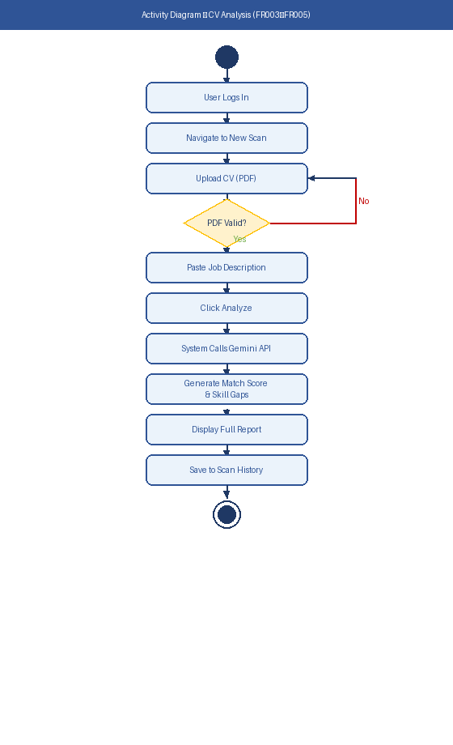
Figure 1: Activity Diagram — CV Analysis Process (SF-05)

4.6 System use case

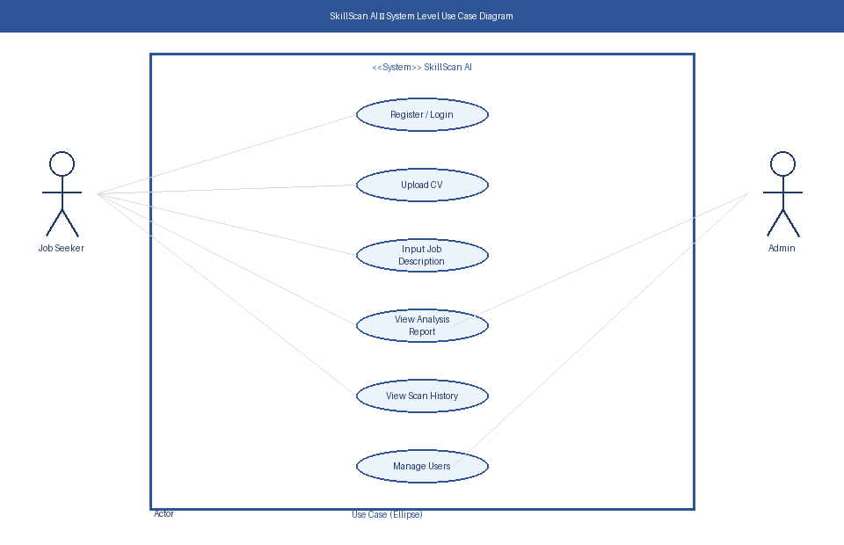
Figure 2: System Level Use Case Diagram — SkillScan AI

4.7 Scan History

4.7.1 Description and Priority
This feature allows registered users to view a chronological list of all their previous scan results. It is MEDIUM priority as it enhances usability and allows tracking of improvement over time.

4.7.2 Stimulus / Response Sequences
User navigates to the Scan History page. System retrieves all scans associated with the logged-in user from the database and displays them in reverse chronological order.

4.7.3 Functional Requirements
Feature ID | SF-06
Priority | Medium
Description | Allow registered users to view and manage their previous scan results.
Stimulus / Response | User visits History page → system retrieves scans → displays list with scores.
Functional Requirements | - REQ-25: History page must display all scans in reverse chronological order with date, job title, and match score  - REQ-26: User must be able to click any scan to view the full analysis report  - REQ-27: User must be able to delete any scan from their history  - REQ-28: If no scans exist, system must display an appropriate empty-state message

4.8 Admin Management Panel

4.8.1 Description and Priority
This feature provides the system administrator with access to the Django built-in admin panel for monitoring and managing users, scans, and platform data. It is MEDIUM priority.

4.8.2 Stimulus / Response Sequences
Admin navigates to /admin URL, enters admin credentials, and accesses the management dashboard with full access to all system data.

4.8.3 Functional Requirements
Feature ID | SF-07
Priority | Medium
Description | Provide system administrator with a management interface for user and data oversight.
Stimulus / Response | Admin accesses /admin → logs in → views and manages users, scans, and settings.
Functional Requirements | - REQ-29: Admin panel must be accessible only to users with superuser status in Django  - REQ-30: Admin must be able to view, search, and filter all registered user accounts  - REQ-31: Admin must be able to view all scan records and their associated results  - REQ-32: Admin must be able to deactivate or delete user accounts when necessary

5. Other Non-Functional Requirements

5.1 Performance Requirements
- The load time for all user interface pages shall not exceed 3 seconds on a standard broadband connection (10 Mbps+)
- AI analysis results (Gemini API response) shall be returned and displayed within 15 seconds under normal operating conditions
- PDF text extraction using PyPDF2 shall complete within 5 seconds for files up to 5MB
- Database queries for scan history retrieval shall return results within 2 seconds
- The system must support a minimum of 50 concurrent users without performance degradation

5.2 Safety Requirements
- All uploaded PDF files must be scanned for malicious content before processing
- User CV data and job descriptions must not be shared with any third party beyond the Google Gemini API for analysis purposes
- Gemini API calls must be made over HTTPS using encrypted connections at all times
- User session data must expire after 30 minutes of inactivity to prevent unauthorized access

5.3 Security Requirements
- All user passwords must be stored as hashed values using Django's built-in PBKDF2-SHA256 algorithm — plaintext passwords must never be stored
- All forms must implement CSRF (Cross-Site Request Forgery) protection using Django's built-in CSRF middleware
- User authentication must be enforced on all pages except the landing page, login, and registration pages
- API keys for Google Gemini must be stored as environment variables and never hardcoded in source code
- Database must be backed up daily to prevent data loss

5.4 Software Quality Attributes
- Usability: The interface must be intuitive and usable by any job seeker without training. Core tasks must be completable within 3 clicks from the dashboard.
- Reliability: The system must maintain 99% uptime during the academic evaluation period.
- Maintainability: All code must follow PEP8 Python standards with inline comments. Django best practices must be followed for models, views, and templates.
- Portability: The application must run on any OS supporting Python 3.10+ including Linux, Windows, and macOS.
- Scalability: The architecture must support migration from SQLite to PostgreSQL without significant code changes.

5.5 Business Rules
- A user must be registered and logged in to access any analysis or history feature
- Each registered user can only view their own scan history — no cross-user data access is permitted
- Only users with Django super user status can access the admin management panel
- The free tier allows unlimited scans with no daily restriction in the academic version
- Uploaded CV files are stored temporarily and processed server-side — no permanent file storage is required

6. Other Requirements
The SkillScan AI web interface must be visually clean, professional, and accessible on both desktop and mobile browsers through responsive design. The system must provide clear error messages for all invalid inputs and failed operations. A help tooltip or placeholder text must be provided on all form fields to guide users. The application must gracefully handle API errors and provide retry options rather than crashing or showing technical error messages to end users.

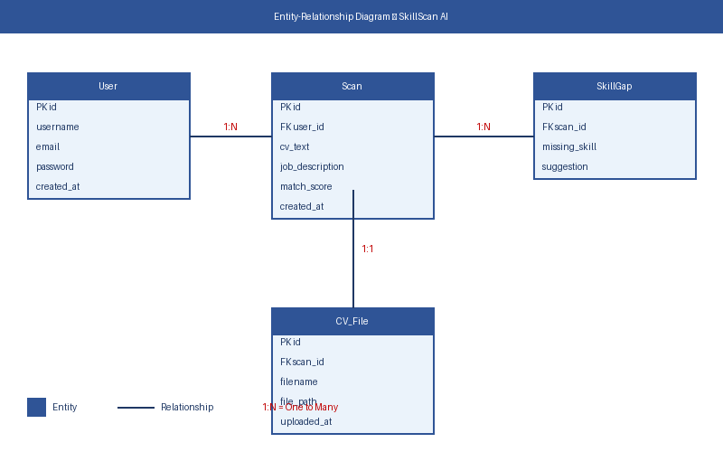
Figure 3: Entity-Relationship Diagram — SkillScan AI Database

Appendix A: Glossary
Term | Definition
AI | Artificial Intelligence — the simulation of human intelligence processes by computer systems
API | Application Programming Interface — a set of rules allowing software applications to communicate
CSRF | Cross-Site Request Forgery — a web security vulnerability protection mechanism
CV / Resume | Curriculum Vitae — a document summarizing a person's professional experience and qualifications
Django | A high-level Python web framework that encourages rapid development and clean design
ERD | Entity-Relationship Diagram — a visual representation of database structure and relationships
Gemini API | Google's large language model API used for AI-powered text analysis in this system
HTTPS | Hyper Text Transfer Protocol Secure — encrypted version of HTTP for secure data transfer
IEEE | Institute of Electrical and Electronics Engineers — standards organization
Match Score | A percentage value (0–100%) representing how well a CV matches a job description
NLP | Natural Language Processing — AI technique for understanding and processing human language
OS | Operating System — software that manages computer hardware and software resources
PBKDF2 | Password-Based Key Derivation Function 2 — Django's default secure password hashing algorithm
PDF | Portable Document Format — file format used for CV uploads in this system
PyPDF2 | A Python library used to extract text from PDF files
SRS | Software Requirements Specification — this document
SQLite | A lightweight, file-based relational database management system

