**Bank Management System:**

**Comprehensive Database Architecture & Implementation**

# 1. Introduction

This report presents the design and implementation approach for a comprehensive Bank Management System database. The system is designed to manage a banking environment including Banks, Branches, Employees, Customers, Accounts, Transactions, Loans, Cards, and ATMs. It ensures data accuracy, scalability, and referential integrity for real-world use.

# 2. Objectives

• To design a complete banking database structure using QuickDBD.  
• To establish Primary Keys (PK) and Foreign Keys (FK) for referential integrity.  
• To support key banking operations: deposits, withdrawals, fund transfers, loan servicing, and card issuance.  
• To export the database schema to MySQL for deployment and querying.

# 3. Tools and Technologies

• QuickDBD – For creating the Entity Relationship Diagram (ERD) and database schema.  
• MySQL – For deploying and running SQL queries on the designed database.  
• Microsoft Word – For documentation and report presentation.

# 4. Using QuickDBD to Design the Database

Step 1: Open QuickDBD and create a new project.  
Step 2: Define all entities with their attributes using QuickDBD syntax.  
Step 3: Set Primary Keys (PK) using the asterisk (*) notation.  
Step 4: Set Foreign Keys (FK) using references between entities.  
Step 5: Verify the ERD diagram for correctness and consistency.  
Step 6: Export the database schema from QuickDBD to SQL format.

# 5. System Entities and Attributes

The banking system includes the following main entities with their attributes:

**1. Bank:**

Bank_ID (PK), Bank_Name, Headquarters, Established_Date  
**2. Branch:**

Branch_ID (PK), Bank_ID (FK), Branch_Name, Address, City, State, Contact  
**3. Employee**:

Employee_ID (PK), Branch_ID (FK), Name, Position, Hire_Date, Salary  
**4. Customer:**

Customer_ID (PK), Name, Address, Phone, Email, Date_of_Birth  
**5. Account:**

Account_ID (PK), Customer_ID (FK), Branch_ID (FK), Account_Type, Balance, Date_Opened  
**6. Transaction:**

Transaction_ID (PK), Account_ID (FK), Transaction_Type, Amount, Date, Description

**7. Loan:**

Loan_ID (PK), Customer_ID (FK), Branch_ID (FK), Loan_Type, Amount, Interest_Rate, Start_Date, End_Date  
**8. Card:**

Card_ID (PK), Customer_ID (FK), Account_ID (FK), Card_Type, Issue_Date, Expiry_Date  
**9. ATM:**

ATM_ID (PK), Branch_ID (FK), Location, Status

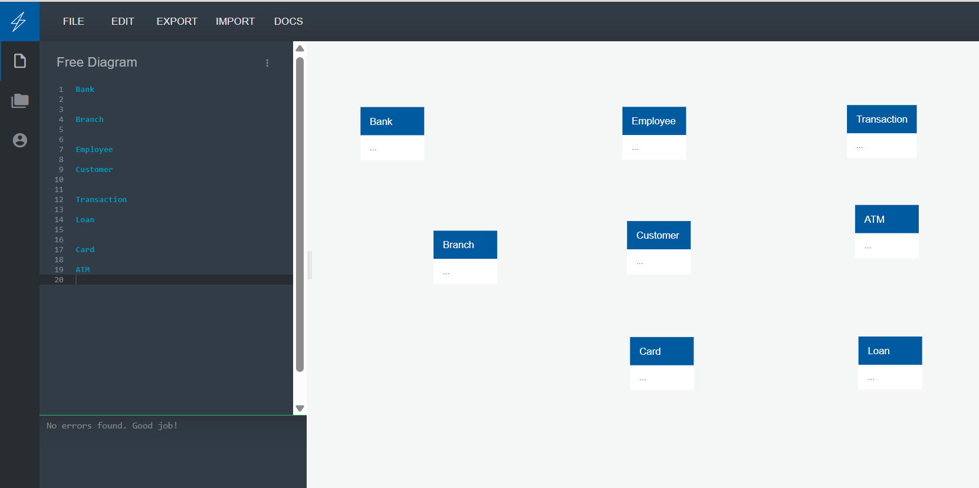

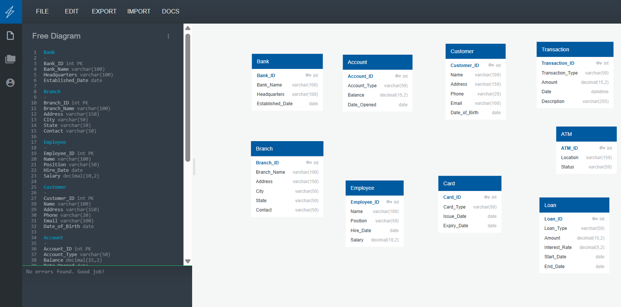

# 6. Relationships and Referential Integrity

• A Bank can have multiple Branches.  
• Each Branch employs multiple Employees.  
• A Customer can hold multiple Accounts and Loans.  
• Transactions are linked to specific Accounts.  
• Cards are issued for specific Accounts and Customers.  
• ATMs are associated with Branches.

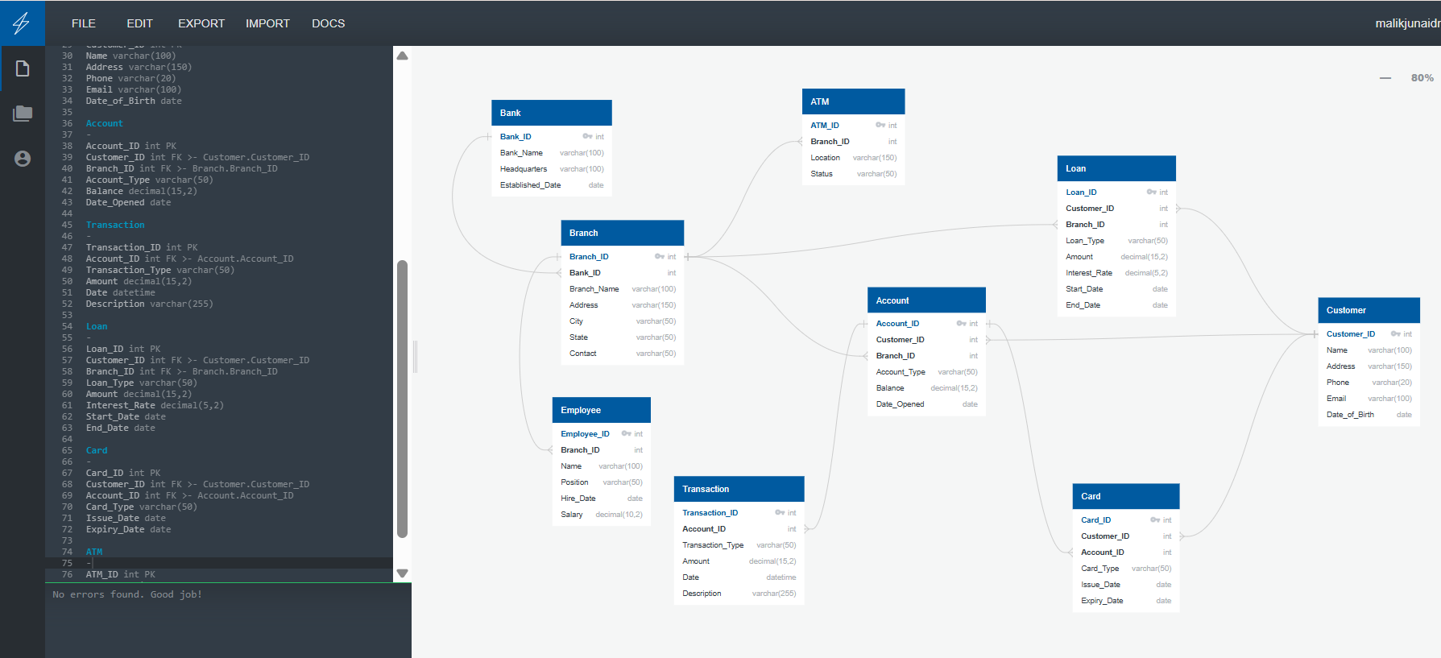

# 7. Exporting to MySQL

Step 1: Download the SQL script exported from QuickDBD.  
Step 2: Open MySQL Workbench or phpMyAdmin.  
Step 3: Create a new database for the Bank Management System.  
Step 4: Import the SQL script into the database.  
Step 5: Run sample queries to test database functionality.

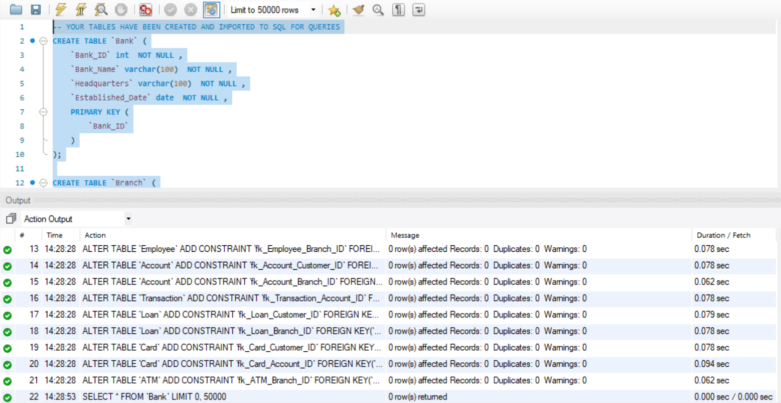

# 8. Example SQL Queries

Example queries include:  
  
• View all customers with their accounts.  
• Retrieve all transactions for a specific account.  
• Calculate total loans per branch.  
• List all employees working in a particular branch.  
• Show all active cards issued to a customer.

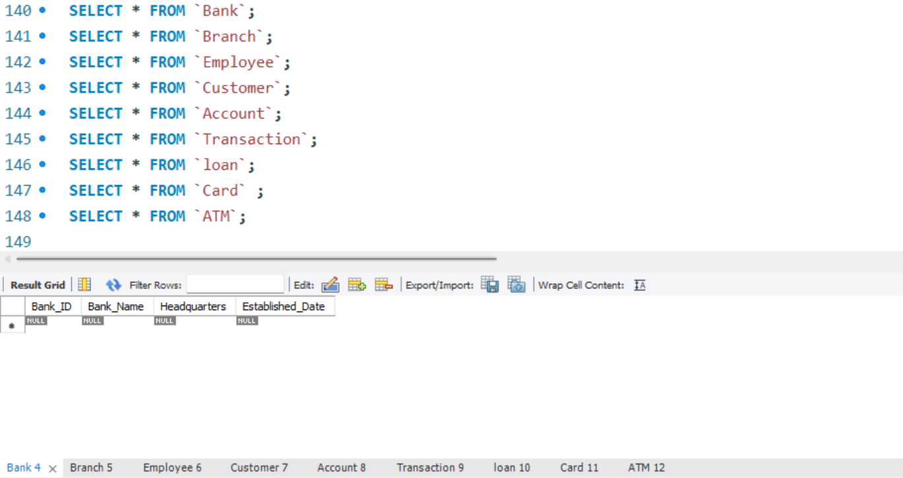

### ****9. Conclusion****

The Bank Management System (BMS) database, designed using QuickDBD and deployed on MySQL, delivers a robust, scalable, and secure foundation for modern banking operations. It integrates all critical components—banks, branches, employees, customers, accounts, transactions, loans, cards, and ATMs—while ensuring high standards of **data accuracy and referential integrity** through well-defined primary and foreign keys.

This design supports essential banking activities, including deposits, withdrawals, transfers, loan servicing, and card management, and is built to scale with growing transaction volumes and expanding digital services. The QuickDBD-to-MySQL workflow enabled efficient modeling and implementation, aligning with industry best practices for database lifecycle management.

Ultimately, this database not only meets current operational requirements but also provides a strong platform for **future growth, regulatory compliance, advanced analytics, and integration with emerging technologies** such as online banking and data visualization tools.

### ****10. Future Enhancements and Data Analytics Integration****

In the future, this Bank Management System database can be enhanced by implementing **advanced SQL queries and establishing additional relational mappings** to enable deeper analysis of banking operations. Complex queries such as customer behavior analytics, branch performance insights, and loan repayment trend analysis can be developed to support strategic decision-making.

Furthermore, integrating the database with **business intelligence tools like Microsoft Power BI** will enable dynamic data visualization, interactive dashboards, and real-time reporting. This will transform raw banking data into actionable insights, empowering management to monitor financial performance, detect anomalies, and forecast trends effectively.