SQL Data Cleaning & Exploratory Data Analysis (EDA)

# 1. Introduction

The objective of this project was to clean and analyze a dataset related to company layoffs. The dataset contained information about companies, industries, countries, and the number of employees laid off.

# 2. Data Cleaning Steps

The following steps were performed during data cleaning:

* - Removed duplicate rows
* - Standardized company names, industries, and country names
* - Handled missing/null values appropriately
* - Corrected date formats for consistency

# 3. Exploratory Data Analysis (EDA)

The following analyses were conducted:

* - Maximum layoffs observed in dataset
* - Companies with 100% layoffs
* - Top companies with most layoffs
* - Yearly layoff trends
* - Monthly layoff trends
* - Rolling total layoffs
* - Top companies by year

# 4. Key Insights & Findings

- Certain industries experienced significantly higher layoffs compared to others.  
- Some companies had 100% of their workforce laid off.  
- Layoffs showed clear yearly and monthly patterns, with spikes in specific periods.  
- Rolling totals highlighted long-term layoff trends.

# 5. Conclusion

This project highlighted the importance of proper data cleaning before conducting analysis. The exploratory data analysis provided insights into how layoffs have impacted companies over time, revealing key trends and industry-specific effects.

# 6. Appendix - SQL Queries

The project included SQL queries for data cleaning and EDA. Example queries:

SELECT company, SUM(total_laid_off) FROM layoffs GROUP BY company;

SELECT YEAR(date), SUM(total_laid_off) FROM layoffs GROUP BY YEAR(date);

**SQL Data Cleaning & Exploratory Data Analysis (EDA) – Layoffs Dataset:**

1. **Creating a Backup Table :**

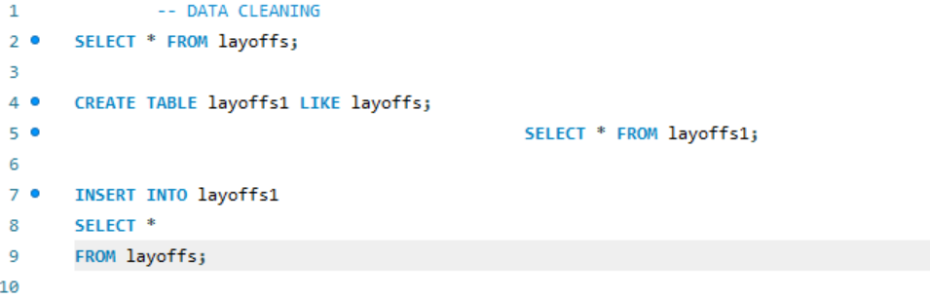

1. **Identifying and Removing Duplicates :**

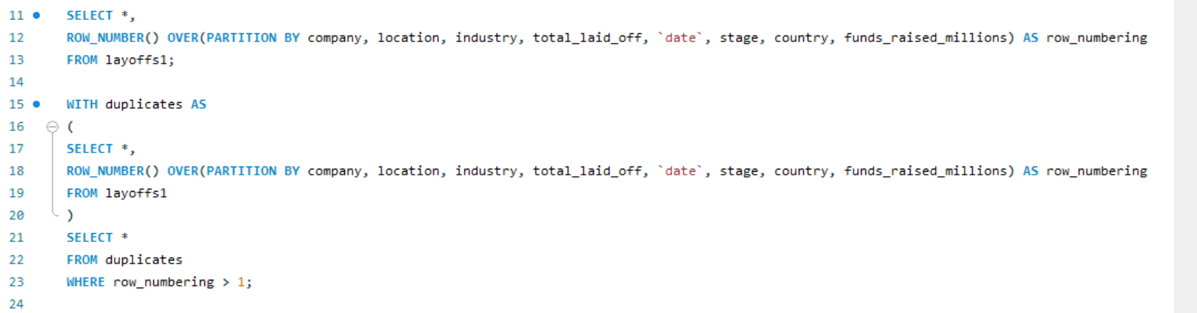

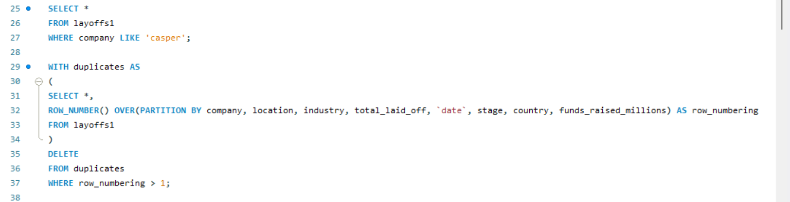

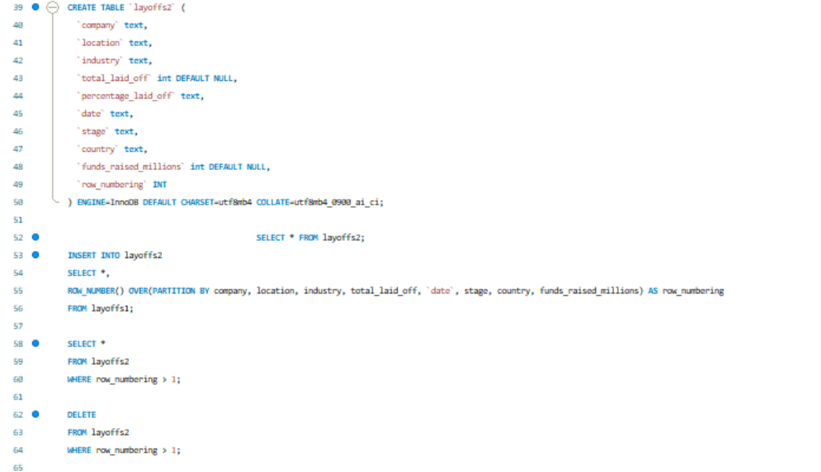

1. **Standardizing Text Data :**

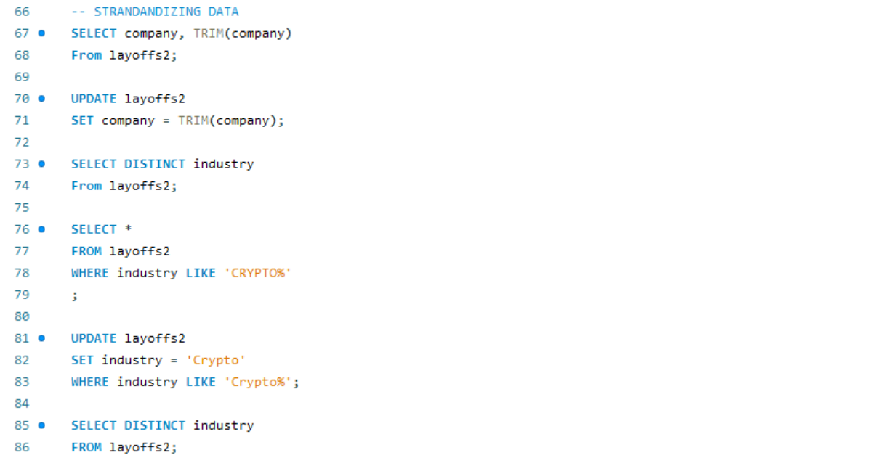

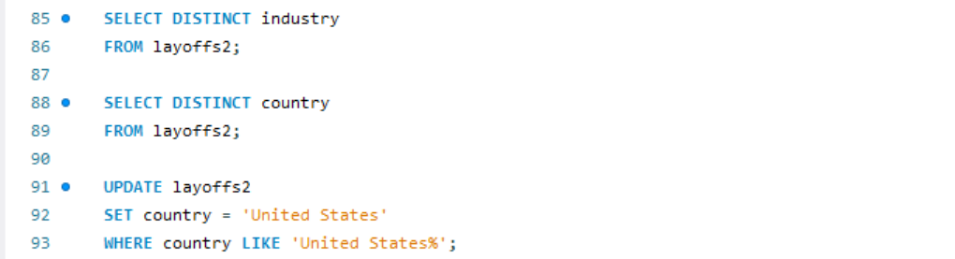

1. **Fixing Dates :**



1. **Handling Null & Missing Values :**



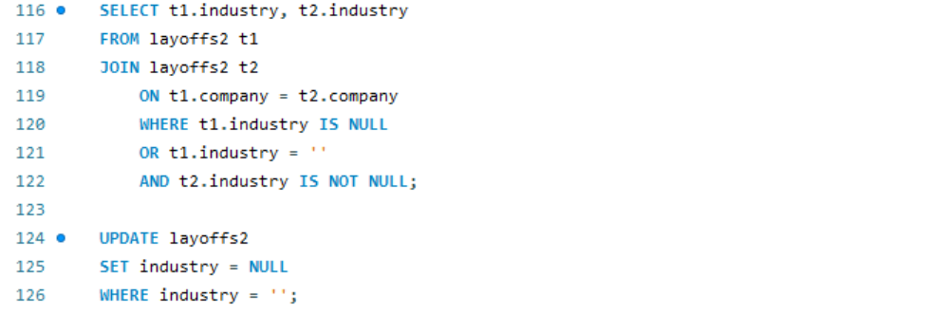



**Exploratory Data Analysis (EDA) :**

1. **Maximum layoffs :**



1. **Companies with 100% layoffs :**



1. **Companies with most layoffs :**



1. **Layoffs by Year :**

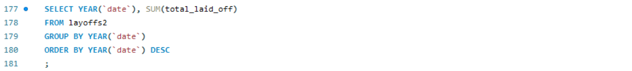

1. **Monthly Trends :**



1. **Rolling Total of Layoffs :**

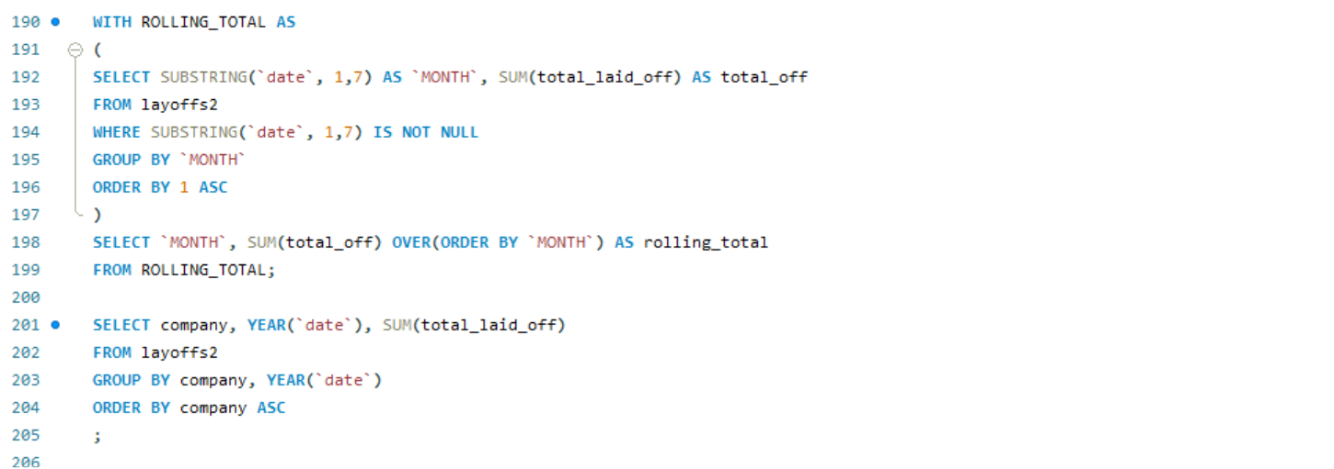

1. **Top Companies by Year :**

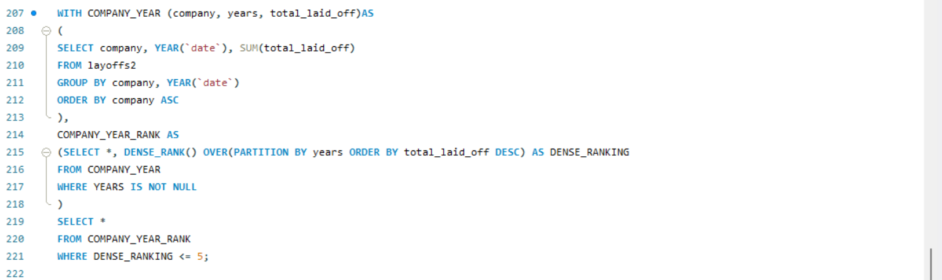

**Conclusion**:  
This project demonstrated the importance of structured data cleaning and exploratory analysis in deriving meaningful insights from raw datasets. By addressing duplicates, inconsistencies, and missing values, the data was transformed into a reliable foundation for analysis. The EDA highlighted key layoff patterns, industry impacts, and temporal trends, offering valuable perspectives for strategic decision-making. Overall, the study reinforces that clean, well-analyzed data is critical to driving informed business outcomes.

**----------------------------------------------------------------------------------------------------**