**AWS Machine learning Course: Basic Mathematics**

**Summary:**

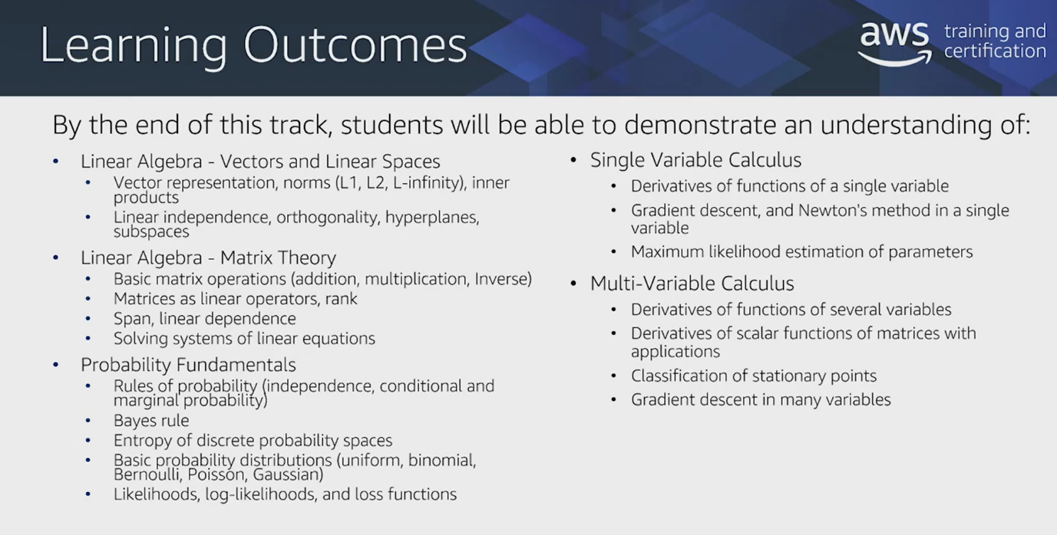

**Machine Learning in Theory**

1. It is a field of study that gives computers the ability to learn without being explicitly programmed. **(Arthur Samuel, 1959)**
2. It is a collection of methods that allow the extraction of rules or patterns from data rather than explicit construction from a programmer.

**The Machine Learning Pipeline in Mathematics:**

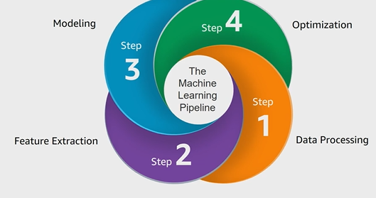

1. **Data Processing**  
   Data formatting (uses linear algebra) so Algorithms can ingest.
2. **Feature Engineering and Selection**  
   Transform Data (uses Vectors/Matrices) so Algorithms can understand
3. **Modeling**  
   Define problem(uses Geometry, **Loss Functions**(i.e. probability, norms and statistics) so Algorithm can optimize
4. **Optimization**  
   Iterate (uses vector calculus) until conditions are met and choose the best Model.  
   (**Vector Calculus**: Take *loss functions* and take ***derivatives*** of it, learn how to optimize based on these things)  
   Training phase, Data evaluation, Predictions (deploy in real world).

### What is ML-ready Data?

Data that is represented as

1. Vectors or
2. Matrices

**Vectors and Matrices**

1. Column Vectors:
2. Row vectors: [1 0 -1 2]
3. Matrix : 2D grid(rows * cols)
4. Geometry of Column vectors
   1. Vectors as direction: Vectors tells you which direction to move in starting from any point.

|  |
| --- |
|  |

* 1. Scalar Multiplication by a vector keeps the same direction but changes its magnitude.
  2. Subtraction of matrices as mapping:

|  |
| --- |
|  |

1. Measure of Magnitude
   1. Norm: Must be non-negative, scale with scalar multiplication, Triangle Inequality

|  |
| --- |
|  |

* 1. Euclidean Norm

|  |
| --- |
|  |

* 1. Lp – Norm  
     L1 – Norm (Lp – Norm when p=1) e.g. Measuring travel time between two cities.

|  |
| --- |
|  |

* 1. L∞ – Norm: It zooms onto the worst factors that effects the algorithm e.g. ML algorithm where it performs worst.

|  |
| --- |
|  |