**Docker create postgres database image**

docker ps

docker ps –a

docker images

**Docker run postgres database**

docker run -d --name monsmalik/mypostgresdb -p 54320:5432 -e "POSTGRES_PASSWORD=password" postgresdb

docker start postgresdb

docker stop postgresdb

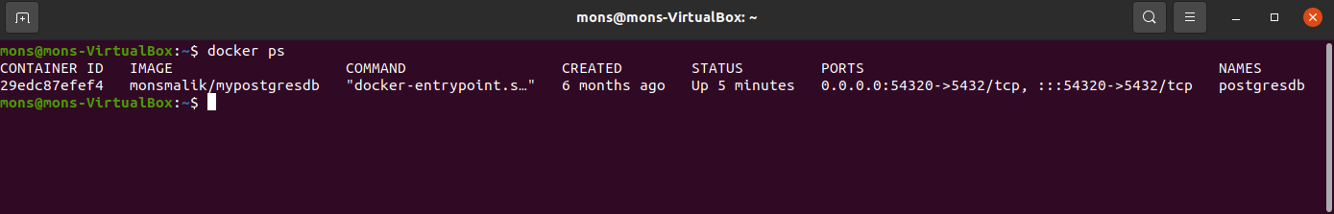

**Oracle VM**

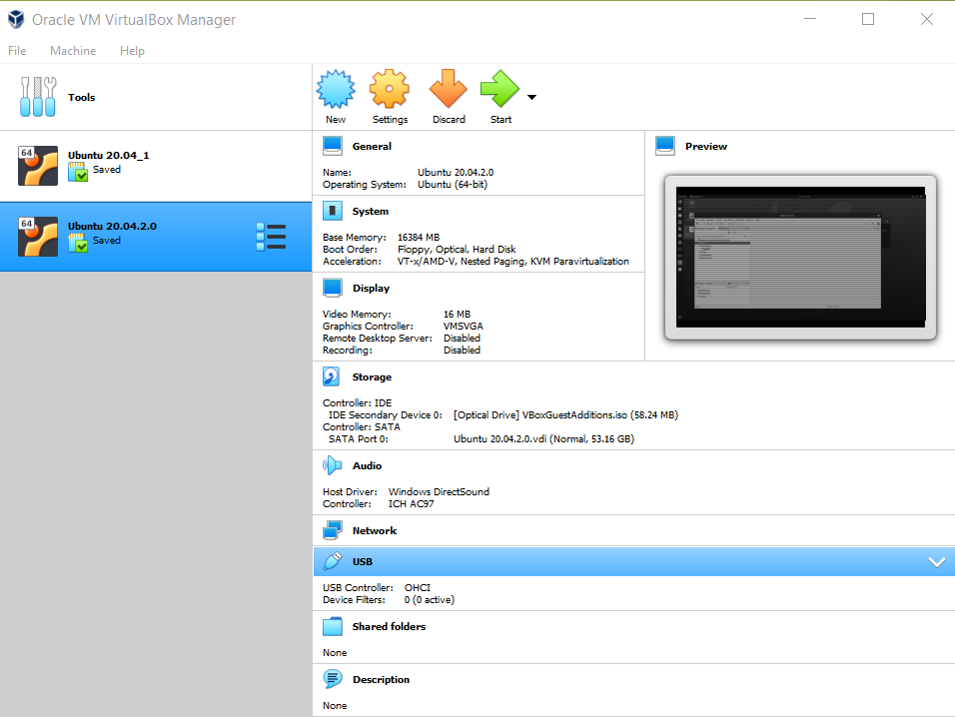

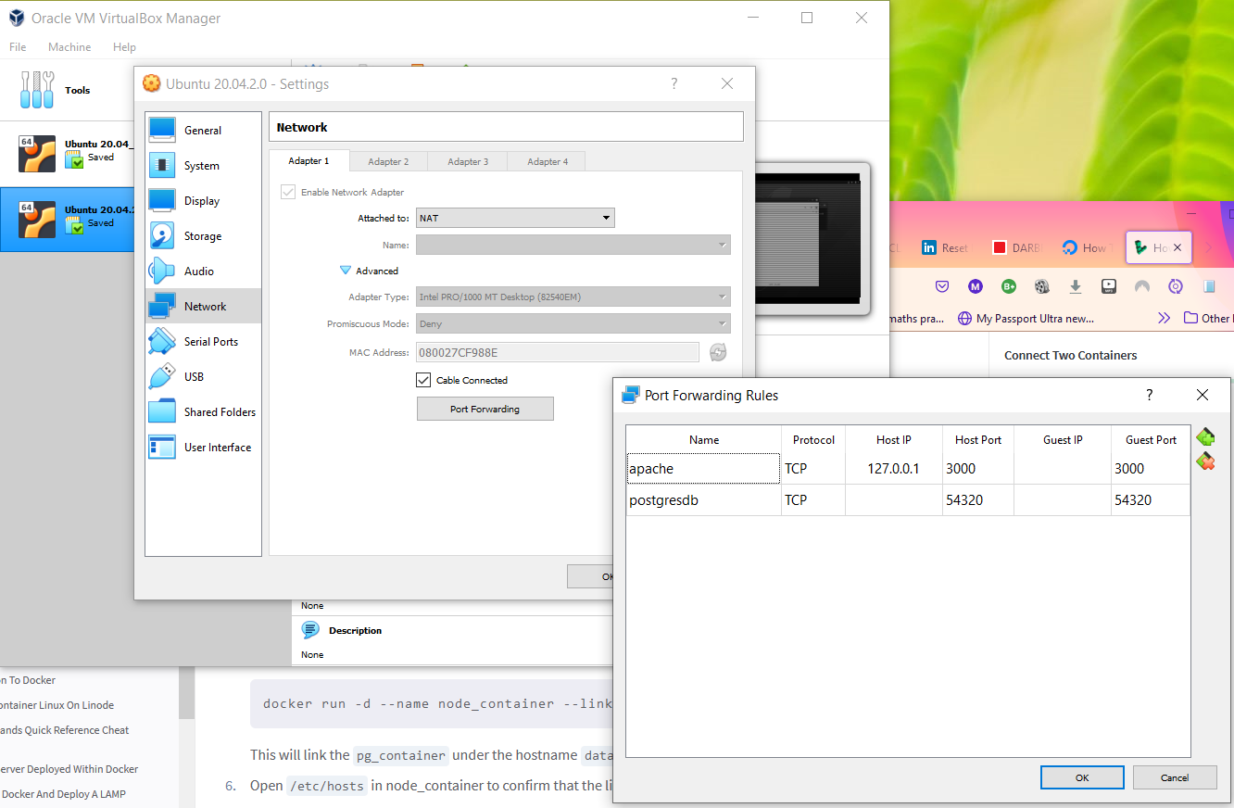

Start STS

**Create your own self signed SSL certificate**

<https://howtodoinjava.com/spring-boot/spring-boot-ssl-https-example/>

To get SSL digital certificate for our application we have two options –

1. to create a self-signed certificate
2. to obtain SSL certificate from certification authority(CA) we call it CA certificate.

For today’s demo purpose we will create self-signed certificate generated by java keytool command. We need to run the keytool -genkey command from command prompt.

Here is the exact command we will use –

keytool -genkey -alias selfsigned_localhost_sslserver -keyalg RSA -keysize 2048 -validity 700 -keypass changeit -storepass changeit -keystore ssl-server.jks

|  |
| --- |
| keytool -genkey -alias selfsigned_localhost_sslserver -keyalg RSA -keysize 2048 -validity 700 -keypass changeit -storepass changeit -keystore ssl-server.jks |

Let’s understand above command –

* -genkey – is the keytool command to generate the certificate, actually keytool is a multipurpose and robust tool which has several options
* -alias selfsigned_localhost_sslserver – indicates the alias of the certificate, which is used by SSL/TLS layer
* -keyalg RSA -keysize 2048 -validity 700 – are self descriptive parameters indicating the crypto algorithm, keysize and certificate validity.
* -keypass changeit -storepass changeit – are the passwords of our truststore and keystore
* -keystore ssl-server.jks – is the actual keystore where the certificate and public/private key will be stored. Here we are using [JKS](https://en.wikipedia.org/wiki/Keystore) fromat – Java Key Store, there are other formats as well for keystore.

Once we execute above command, it will ask for certain information and finally this will look like this.

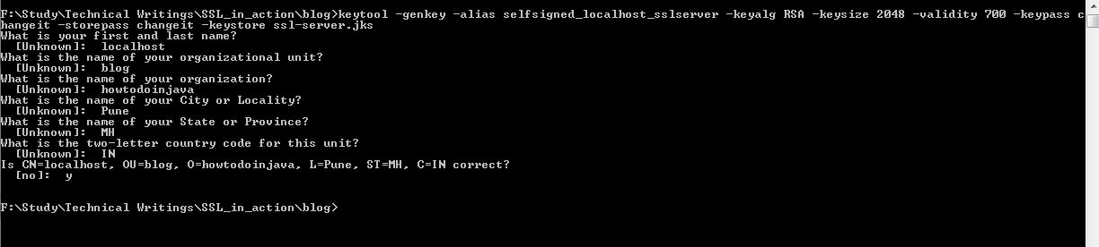keytool to generate the certificate

That’s all we need at this point regarding certification generation. This will generate the ssl-server.jks keystore file containing our self signed certificates in the directory from where keytool command has been executed.

To view what is inside this keystore we can again use the keytool -list command as bellow.

|  |
| --- |
| keytool -list -keystore ssl-server.jks |

Output will be something like –

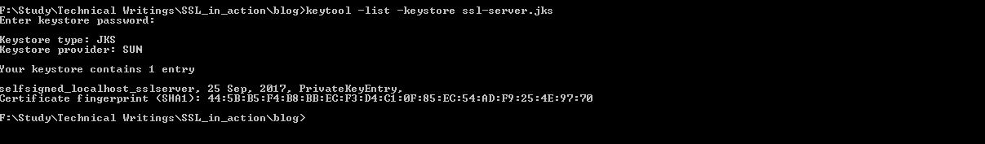keytool -list option

<https://mkyong.com/webservices/jax-ws/suncertpathbuilderexception-unable-to-find-valid-certification-path-to-requested-target/>

C:\Users\malikmo\Documents\workspace-spring-tool-suite-4-4.6.0.RELEASE\restproject\src\main\resources

# Create React App

C:\Users\malikmo\Documents\Projects\Personal\react

Microsoft Windows [Version 10.0.19042.1466]

(c) Microsoft Corporation. All rights reserved.

C:\Users\malikmo>cd C:\Users\malikmo\Documents\Projects\Personal\react

C:\Users\malikmo\Documents\Projects\Personal\react>npx -version

7.19.1

C:\Users\malikmo\Documents\Projects\Personal\react>npm -version

7.19.1

C:\Users\malikmo\Documents\Projects\Personal\react>npx create-react-app world-app

Need to install the following packages:

create-react-app

Ok to proceed? (y) y

You are running `create-react-app` 4.0.3, which is behind the latest release (5.0.0).

We no longer support global installation of Create React App.

Please remove any global installs with one of the following commands:

- npm uninstall -g create-react-app

- yarn global remove create-react-app

The latest instructions for creating a new app can be found here:

https://create-react-app.dev/docs/getting-started/

C:\Users\malikmo\Documents\Projects\Personal\react>dir

Volume in drive C is CGI

Volume Serial Number is 3A9C-FB51

Directory of C:\Users\malikmo\Documents\Projects\Personal\react

18/02/2022 15:33 <DIR> .

18/02/2022 15:33 <DIR> ..

18/02/2022 15:20 <DIR> myapi

18/02/2022 15:33 64 myapi.code-workspace

1 File(s) 64 bytes

3 Dir(s) 69,872,107,520 bytes free

C:\Users\malikmo\Documents\Projects\Personal\react>npm install react@latest react-dom@latest

added 6 packages, and audited 7 packages in 2s

found 0 vulnerabilities

C:\Users\malikmo\Documents\Projects\Personal\react>npm version

{

npm: '7.19.1',

node: '12.18.2',

v8: '7.8.279.23-node.39',

uv: '1.38.0',

zlib: '1.2.11',

brotli: '1.0.7',

ares: '1.16.0',

modules: '72',

nghttp2: '1.41.0',

napi: '6',

llhttp: '2.0.4',

http_parser: '2.9.3',

openssl: '1.1.1g',

cldr: '37.0',

icu: '67.1',

tz: '2019c',

unicode: '13.0'

}

C:\Users\malikmo\Documents\Projects\Personal\react>

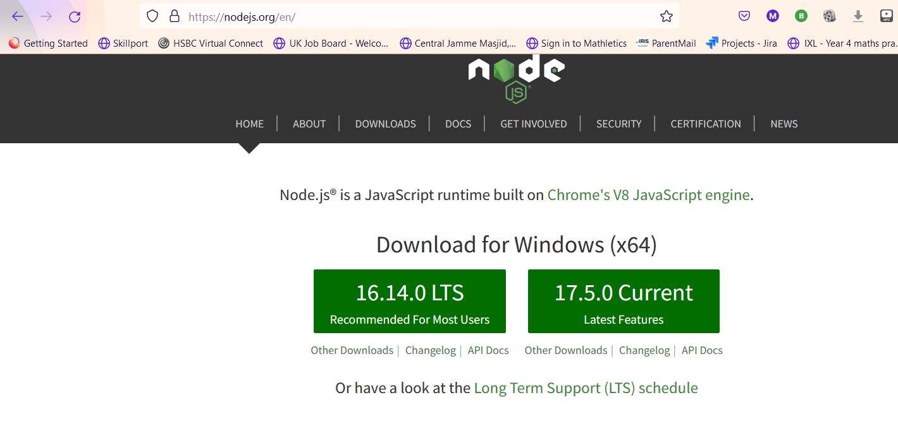

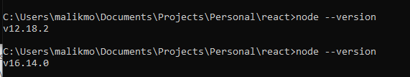

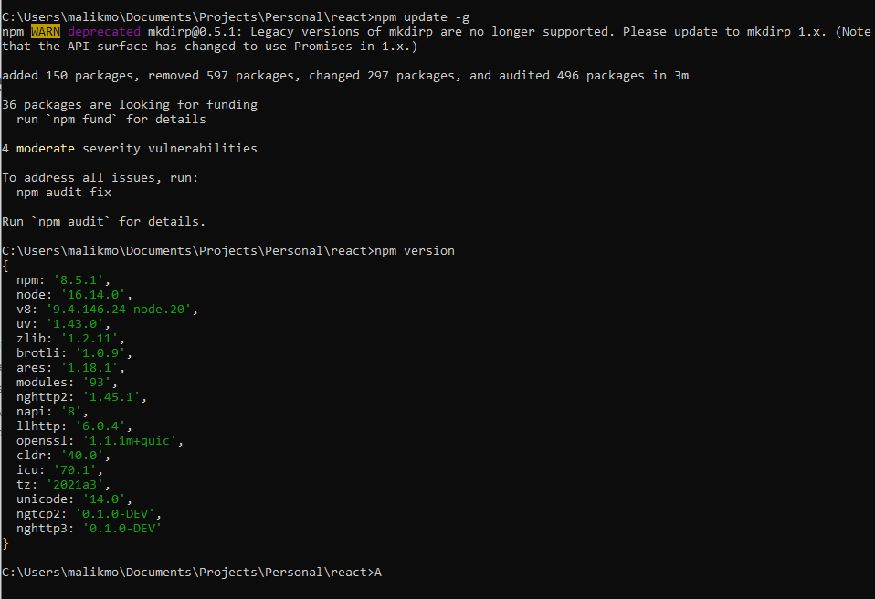

npm uninstall -g create-react-app

up to date, audited 1 package in 216ms

found 0 vulnerabilities

C:\Users\lg\Desktop>npx clear-npx-cache

Need to install the following packages:

clear-npx-cache

Ok to proceed? (y) y

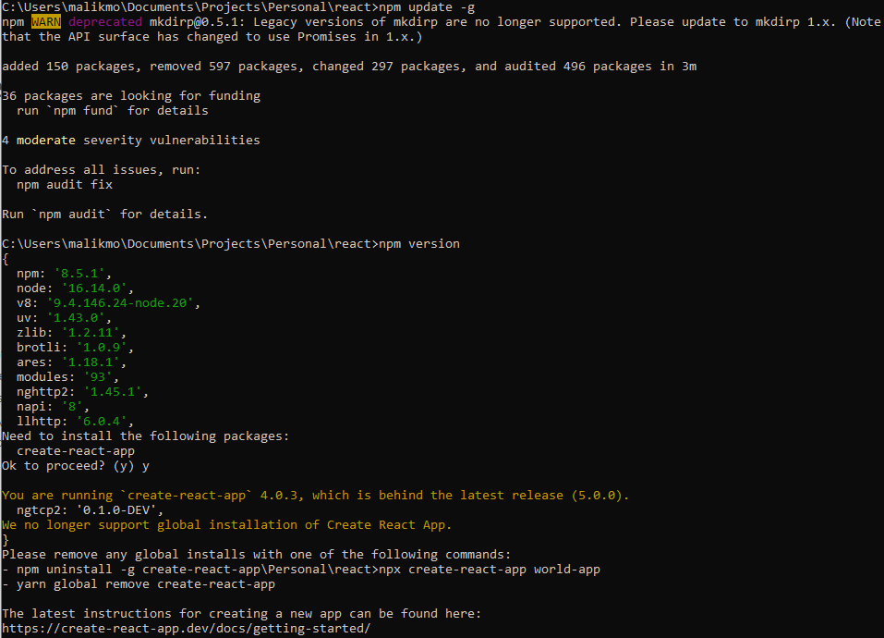

C:\Users\malikmo\Documents\Projects\Personal\react>npx clear-npx-cache

C:\Users\malikmo\Documents\Projects\Personal\react>npx create-react-app@5.0.0 world-app

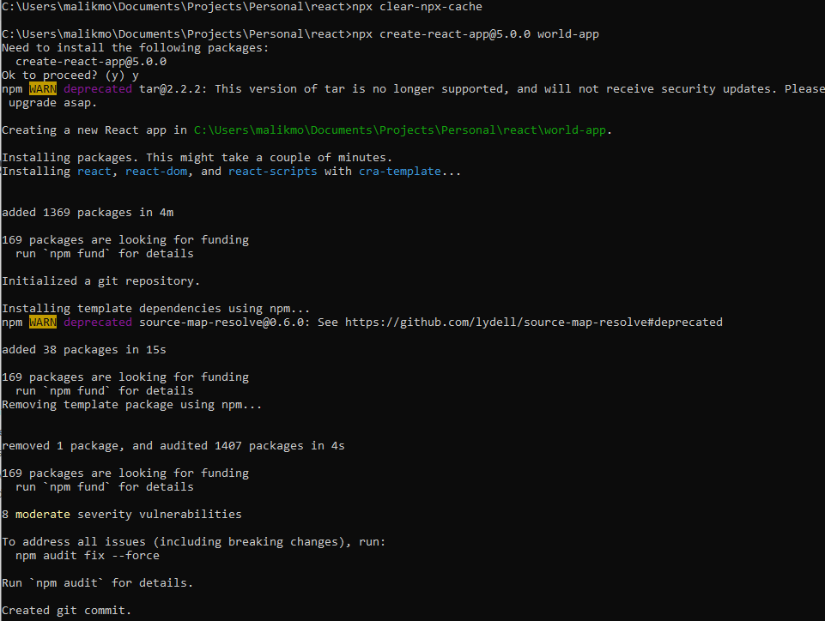

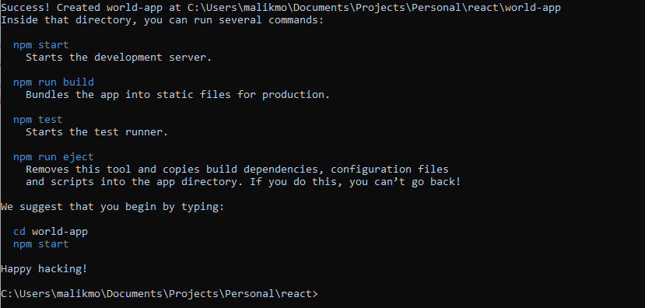

C:\Users\malikmo\Documents\Projects\Personal\react

VSCode open folder C:\Users\malikmo\Documents\Projects\Personal\react\world-app

**How to install bootstrap in React.js**

<https://www.geeksforgeeks.org/how-to-install-bootstrap-in-react-js/>

Shards React

<https://bestofreactjs.com/repo/designrevision-shards-react-react-templates>