Pak-Austria Fachhochschule Institute of Applied Sciences and Technology


Submitted By | Mohsin Ali | Reg. No | M24F0024ISEC003
Course Instructor | Dr. Muhammad Zeeshan | Program | MS Information Security
Course Title | Intrusion Detection System | Course Code | COMP-940
Class | MSIS | Semester | 4th
Submission Date | 11 June, 2026 | Assignment No. | 3rd

Cryptographic System Weakness Detection and Side-Channel Resilience Assessment using Statistical Profiling and AI-Based Cryptanalysis

Abstract
This report presents a unified research-grade framework for identifying practical weaknesses in cryptographic systems. The framework integrates a Statistical Analysis Module, a structured Statistical Security Profile, randomness assessment, correlation power analysis, a multimodal deep neural network, and a Cryptographic Risk Index. Power traces are processed by a one-dimensional convolutional branch, ciphertext bytes by a Transformer branch, and statistical profile features by a multilayer perceptron with an auxiliary autoencoder. A reproducible reference experiment containing 1600 multimodal samples was used to verify the complete workflow without redistributing large third-party datasets. The reference run recovered the correct AES key-byte hypothesis with rank 0, achieved 99.38% classification accuracy, an F1-score of 0.9937, and ROC-AUC of 0.9993. The mean Cryptographic Risk Index separated the low-leakage profile (15.86) from the vulnerable profile (67.68). The results demonstrate how statistical profiling and AI can complement classical cryptanalysis while preserving interpretability through explicit entropy, leakage, dependency, and risk measurements.
Keywords: side-channel analysis, ASCAD, statistical security profile, cryptanalysis, entropy, randomness, correlation power analysis, multimodal deep learning, cryptographic risk index.

Table of Contents
1. Introduction
2. Task 1 - Real Industry Problem and Challenge
3. Task 2 - Problem Statement
4. Task 3 - Research Objectives
5. Task 4 - Relevant Dataset Selection
6. Task 5 - Randomness Evaluation
7. Task 6 - Statistical Analysis Module
8. Task 7 - Statistical Security Profile Report
9. Task 8 - Methodology
10. Task 9 - Performance Evaluation and Benchmarking
11. Task 10 - Results Presentation
12. Task 11 - Comparison with State of the Art
13. Task 12 - Discussion and Analysis
14. Task 13 - Conclusion
15. References
16. Appendix A - Reproducibility and Source-Code Guide

Introduction
Cryptographic algorithms such as AES are designed to resist direct mathematical attacks; however, the security of a deployed system also depends on implementation details, key management, randomness, operating mode, and physical leakage. Timing, power consumption, electromagnetic radiation, cache behavior, and fault responses can reveal information that is not visible in the algorithm specification. FIPS 197 standardizes AES with 128-bit blocks and key lengths of 128, 192, or 256 bits, but conformity to the algorithm alone does not prove that a hardware or software implementation is free from side-channel leakage (NIST, 2023).
The ANSSI Side-Channel Analysis Database (ASCAD) was introduced as a common benchmark for profiling side-channel attacks and deep-learning evaluation (Prouff et al., 2018). NIST SP 800-22 provides a suite of statistical tests for assessing random and pseudorandom bit sequences, while also emphasizing that statistical testing is not a replacement for cryptanalysis (Rukhin et al., 2010). This assignment combines these perspectives by treating statistics as an explanatory layer and AI as an automated decision layer.
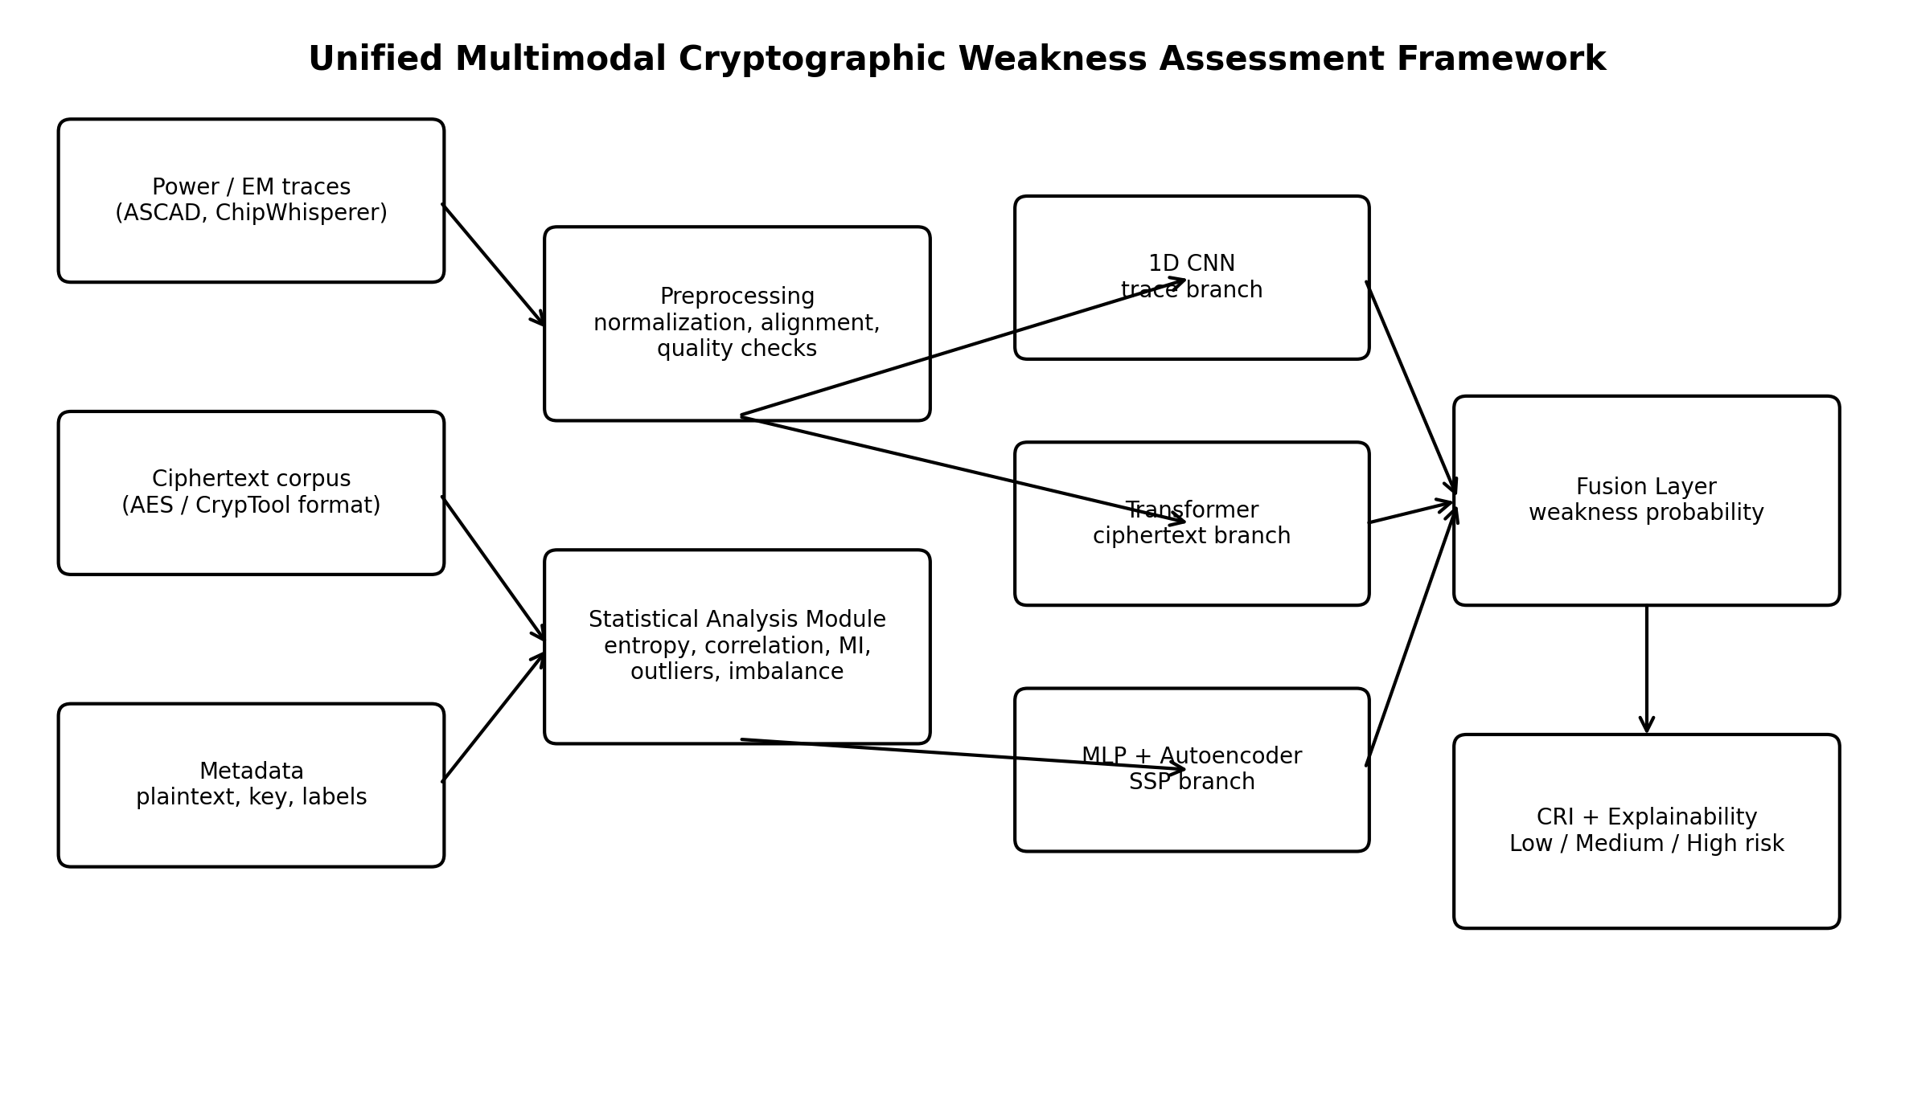
Figure 1. Proposed unified multimodal framework.

Task 1 - Real Industry Problem and Challenge
Modern IoT devices, embedded controllers, payment modules, cloud hardware security modules, and medical devices frequently execute cryptographic operations in environments where attackers can observe physical or behavioral signals. The central industrial problem is the gap between theoretical algorithmic security and practical implementation security.
- Power, electromagnetic, and timing measurements can correlate with secret-dependent intermediate values.
- Weak random number generation may create predictable keys, nonces, initialization vectors, or protocol challenges.
- Insecure modes such as repeated ECB encryption can preserve structural patterns even when AES itself is correctly implemented.
- Manual leakage analysis is slow, requires specialist expertise, and usually produces results tied to a single dataset or device.
- Purely data-driven models can be accurate but difficult to interpret unless they are linked with entropy, dependency, outlier, and leakage measurements.
- A practical assessment must combine multiple modalities because a device may appear secure in ciphertext statistics while leaking through power traces, or vice versa.
The proposed solution therefore uses a single pipeline to characterize data quality, randomness, statistical dependence, side-channel leakage, model confidence, and final risk. The framework is intended for research and controlled security evaluation, not for unauthorized key recovery from systems without permission.

Task 2 - Problem Statement
Existing cryptographic assessment workflows are fragmented across randomness testing, ciphertext inspection, side-channel analysis, and machine-learning tools. They often lack a unified representation of statistical evidence, cannot fuse heterogeneous modalities, and provide limited explanation of why a system is rated as weak. A unified AI-driven framework is required that constructs a Statistical Security Profile from power traces and ciphertext, detects side-channel and statistical weaknesses, simulates authorized cryptanalysis, and converts the evidence into an interpretable Cryptographic Risk Index.
Research Question: To what extent can statistical profiling and multimodal AI jointly improve the detection, explanation, and prioritization of cryptographic implementation weaknesses compared with isolated classical or single-modality methods?

Task 3 - Research Objectives
1. Develop a Statistical Security Profile for side-channel, ciphertext, metadata, and class-label information.
2. Measure Shannon entropy, min-entropy, bit-frequency behavior, runs, serial dependence, autocorrelation, and long-run structure.
3. Detect side-channel leakage and perform authorized AES key-byte hypothesis ranking through correlation power analysis.
4. Identify structural bias, predictable ciphertext distributions, redundant features, anomalies, and data-quality issues.
5. Design a multimodal neural network containing a CNN trace branch, Transformer ciphertext branch, statistical branch, autoencoder, and fusion layer.
6. Evaluate the framework using standard ML metrics and cryptography-specific measures such as key rank, leakage correlation, and entropy deviation.
7. Define a normalized Cryptographic Risk Index that combines leakage, entropy deviation, model confidence, and structural bias.
8. Provide reproducible source code, tables, figures, model checkpoint, and adapters for real ASCAD-style datasets.

Task 4 - Relevant Dataset Selection

4.1 Selected Dataset Categories
Table 1. Multimodal dataset selection.
Category | Dataset | Main Fields | Use
Side-channel | ASCAD / ChipWhisperer-compatible traces | Power or EM samples, plaintext metadata, key metadata, labels | Leakage detection, CNN training, CPA
Cryptanalysis / ciphertext | AES ciphertext corpus in CrypTool-style hexadecimal format | Ciphertext bytes, mode/profile label | Entropy, structure, Transformer input
Reference execution | Generated ASCAD-compatible AES multimodal sample | Trace + plaintext + ciphertext + system risk label | Reproducible end-to-end verification

The source package does not redistribute ASCAD, DPA Contest, ChipWhisperer, RockYou, or CrypTool corpora. Instead, it includes a small generated dataset that follows the same analytical structure and proves that every module runs. The file src/real_data_loader.py loads an ASCAD-style HDF5 file and a generic hexadecimal ciphertext corpus. This approach avoids misrepresenting generated results as results from the full public datasets.

4.2 Reference Dataset Construction
The reference dataset contains 1600 balanced samples. Each sample has a 256-point trace, 32 ciphertext bytes, 16 plaintext bytes, and a binary implementation-risk label. The low-risk class uses randomized CBC encryption with weak simulated leakage. The vulnerable class uses repeated plaintext under ECB and strong Hamming-weight leakage centered near the trace midpoint. The hidden first AES key byte was 136.
Table 2. Class distribution and imbalance profile.
Class | Count | Percentage | Imbalance Ratio To Majority | Label Gini | Label Entropy
0.0000 | 800.0000 | 50.0000 | 1.0000 | 0.5000 | 1.0000
1.0000 | 800.0000 | 50.0000 | 1.0000 | 0.5000 | 1.0000

Task 5 - Randomness Evaluation

5.1 Metrics and Decision Rules
- Shannon entropy estimates average uncertainty per ciphertext byte; the ideal upper bound for byte symbols is 8 bits.
- Min-entropy is based on the most probable byte and represents a conservative unpredictability estimate.
- Frequency (monobit), block frequency, runs, serial, and longest-run tests use a significance threshold of alpha = 0.01.
- Autocorrelation at lags 1 and 8 detects linear dependence between separated bit positions.
- The Hurst estimate is included as a structural indicator, but it must not be interpreted as a standalone cryptographic proof.
For a byte sequence X with symbol probabilities p(x), Shannon entropy is H(X) = -sum p(x) log2 p(x). Min-entropy is H_inf(X) = -log2(max p(x)). Entropy deviation is normalized as max(0, (8 - H(X))/8).
Table 3. Randomness evaluation results.
Profile | Samples | Shannon Entropy Bits Per Byte | Min Entropy Bits Per Byte | Monobit P | Monobit Pass | Runs P | Runs Pass | Serial P | Serial Pass | Longest Run P | Longest Run Pass
CBC/Low-Leakage | 800 | 7.9935 | 7.7131 | 0.8980 | True | 0.9647 | True | 0.9983 | True | 0.9999 | True
Weak-ECB/Leaky | 800 | 7.9390 | 6.9159 | 0.0082 | False | 0.0001 | False | 0.0000 | False | 0.0000 | False
Combined | 1600 | 7.9837 | 7.3677 | 0.0501 | True | 0.0038 | False | 0.0011 | False | 0.0002 | False

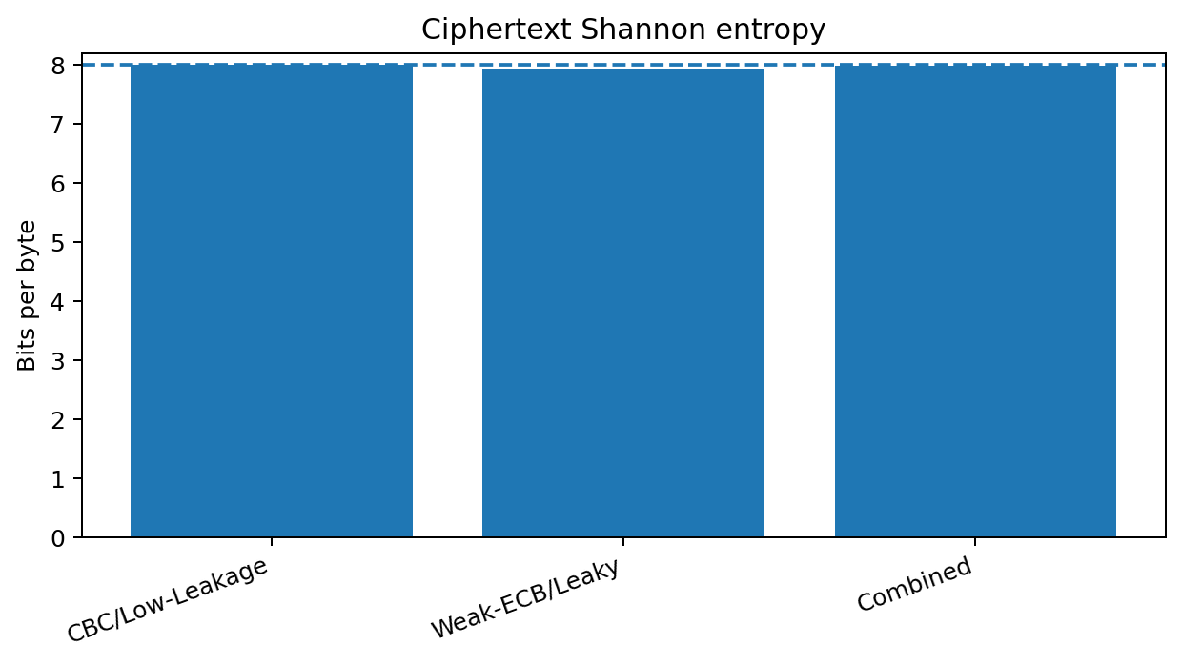
Figure 2. Shannon entropy of ciphertext profiles.
The CBC/low-leakage profile reached 7.9935 bits per byte and passed the selected bit-frequency, runs, serial, and longest-run checks. The weak ECB/leaky profile had lower Shannon entropy (7.9390) and failed multiple dependence-oriented tests. These findings do not imply that entropy alone breaks AES; rather, they identify implementation and data-generation patterns that merit deeper analysis.

Task 6 - Statistical Analysis Module

6.1 Dataset-Level Statistics
The Statistical Analysis Module converts each raw trace and ciphertext record into a compact set of features. Trace descriptors include mean, median, variance, standard deviation, minimum, maximum, skewness, kurtosis, energy, peak-to-peak amplitude, and quartiles. Ciphertext descriptors include mean, variance, entropy, unique-symbol ratio, maximum symbol probability, zero ratio, adjacent equality, and lag-one correlation.

6.2 Correlation, Mutual Information, and Redundancy
Pearson correlation is used to reveal linear redundancy among SSP features. Mutual information is calculated against the implementation-risk label to capture nonlinear dependence. The statistical pre-ranking score uses 45% normalized variance and 55% normalized mutual information. This ranking is used for interpretation and pre-selection, not as a substitute for validation on unseen data.
Table 4. Highest-ranked SSP features.
Feature | Variance | Mutual Information | Statistical Rank Score
cipher_variance | 1266029.7805 | 0.2974 | 0.6858
cipher_entropy | 0.2251 | 0.6935 | 0.5500
cipher_unique_ratio | 0.0008 | 0.6935 | 0.5500
trace_std | 0.1493 | 0.6127 | 0.4860
trace_variance | 1.3956 | 0.6127 | 0.4859
trace_energy | 1.6544 | 0.6062 | 0.4808
trace_skewness | 0.8869 | 0.6029 | 0.4782
trace_max | 7.7976 | 0.5873 | 0.4658
trace_mean | 0.0400 | 0.5677 | 0.4502
trace_peak_to_peak | 7.9394 | 0.5550 | 0.4402
trace_kurtosis | 7.5127 | 0.5442 | 0.4316
trace_q75 | 0.0184 | 0.3487 | 0.2766

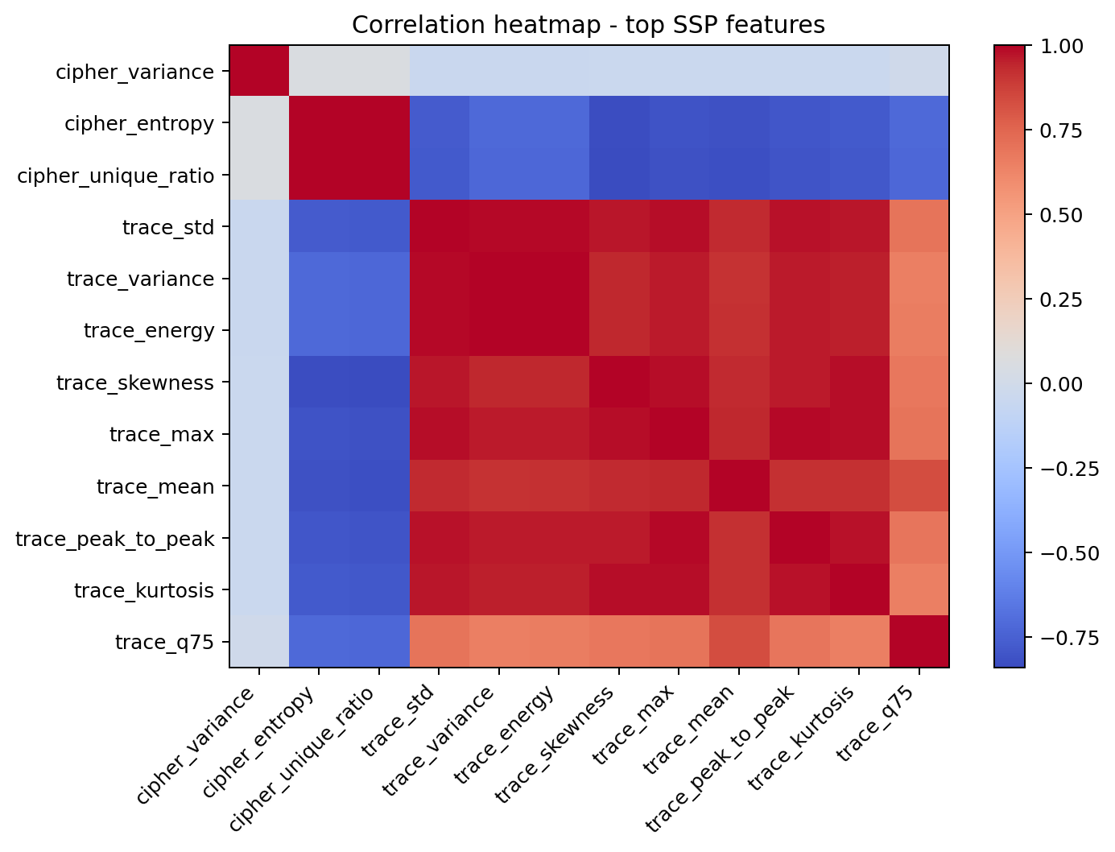
Figure 3. Correlation matrix for leading SSP features.

6.3 Outlier and Anomaly Statistics
IQR outliers are values outside Q1 - 1.5 IQR or Q3 + 1.5 IQR. Z-score anomalies use |z| > 3. Both are reported because skewed features may cause disagreement between robust IQR and Gaussian-oriented Z-score rules.
Table 5. Features with the largest IQR outlier percentages.
Feature | Iqr Outliers | Iqr Outlier Pct | Zscore Outliers | Zscore Outlier Pct
cipher_max_symbol_prob | 446 | 27.8750 | 6 | 0.3750
cipher_zero_ratio | 169 | 10.5625 | 70 | 4.3750
cipher_adjacent_equal_ratio | 151 | 9.4375 | 52 | 3.2500
trace_variance | 45 | 2.8125 | 26 | 1.6250
trace_energy | 41 | 2.5625 | 27 | 1.6875
trace_min | 23 | 1.4375 | 10 | 0.6250
cipher_mean | 17 | 1.0625 | 0 | 0.0000
cipher_std | 16 | 1.0000 | 9 | 0.5625
cipher_autocorr1 | 14 | 0.8750 | 0 | 0.0000
cipher_variance | 13 | 0.8125 | 11 | 0.6875

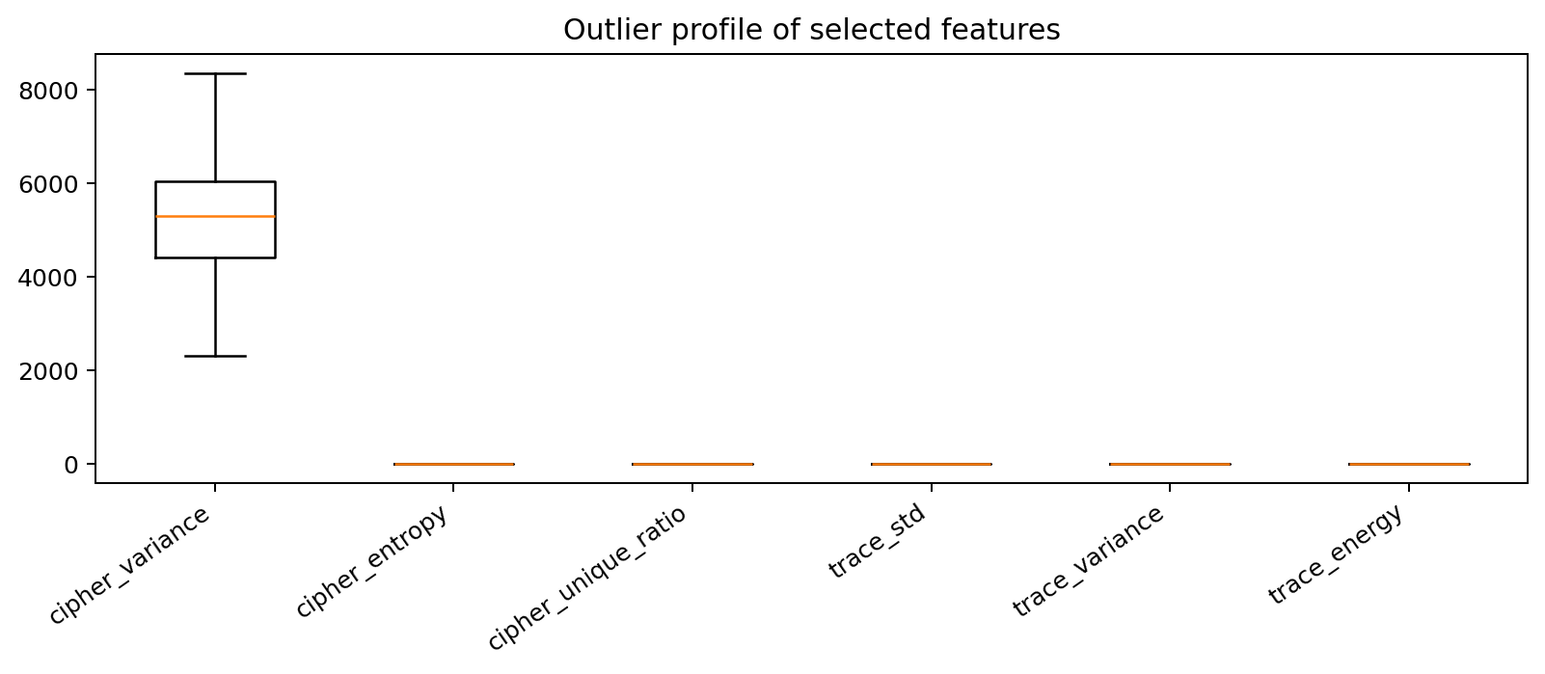
Figure 4. Boxplots of selected SSP features.

6.4 Data Quality and Class Imbalance
Table 6. Data quality assessment.
Samples | Features | Missing Values | Duplicate Rows | Infinite Values | Consistency Score Pct
1600.0000 | 21.0000 | 0.0000 | 0.0000 | 0.0000 | 100.0000

The reference data contains no missing or infinite feature values and no duplicated SSP rows. The class distribution is exactly balanced, with an imbalance ratio of 1.0 for both classes, label Gini impurity of 0.5, and label entropy near 1 bit. Therefore, no resampling was required for this run.

Task 7 - Statistical Security Profile Report
The SSP is the structured output of the Statistical Analysis Module. It is stored at outputs/tables/ssp_sample_features.csv and is accompanied by dataset statistics, correlation, outlier, imbalance, quality, and feature-ranking reports.
Table 7. SSP deliverables.
Ssp Component | Contents | Output File
Dataset statistical summary | Mean, median, variance, standard deviation, min/max, skewness, kurtosis | dataset_statistics.csv
Entropy and uncertainty | Cipher entropy, max-symbol probability, randomness p-values | randomness_evaluation.csv
Dependency matrix | Pearson correlation and mutual information | correlation_matrix.csv; feature_ranking.csv
Outlier report | IQR and Z-score anomaly counts and percentages | outlier_report.csv
Class imbalance | Counts, percentages, imbalance ratio, Gini, label entropy | class_imbalance_profile.csv
Behavioral profile | Trace energy/shape and ciphertext repetition indicators | ssp_sample_features.csv
Data quality | Missing, infinite, duplicate and consistency measures | data_quality_report.csv
Risk output | Leakage, entropy deviation, confidence, bias and CRI | cryptographic_risk_index.csv

7.1 Main SSP Insights
- Cipher variance was the highest composite-ranked feature (0.6858).
- Cipher entropy and unique-symbol ratio had the strongest mutual information with the risk label in the controlled reference dataset.
- Trace standard deviation, variance, energy, and skewness captured the localized Hamming-weight leakage introduced in the vulnerable profile.
- Correlation analysis showed expected redundancy among scale-related trace features; a production model can remove one feature from highly correlated groups.
- The SSP supports model explanation because every risk score can be traced back to measurable statistical evidence.
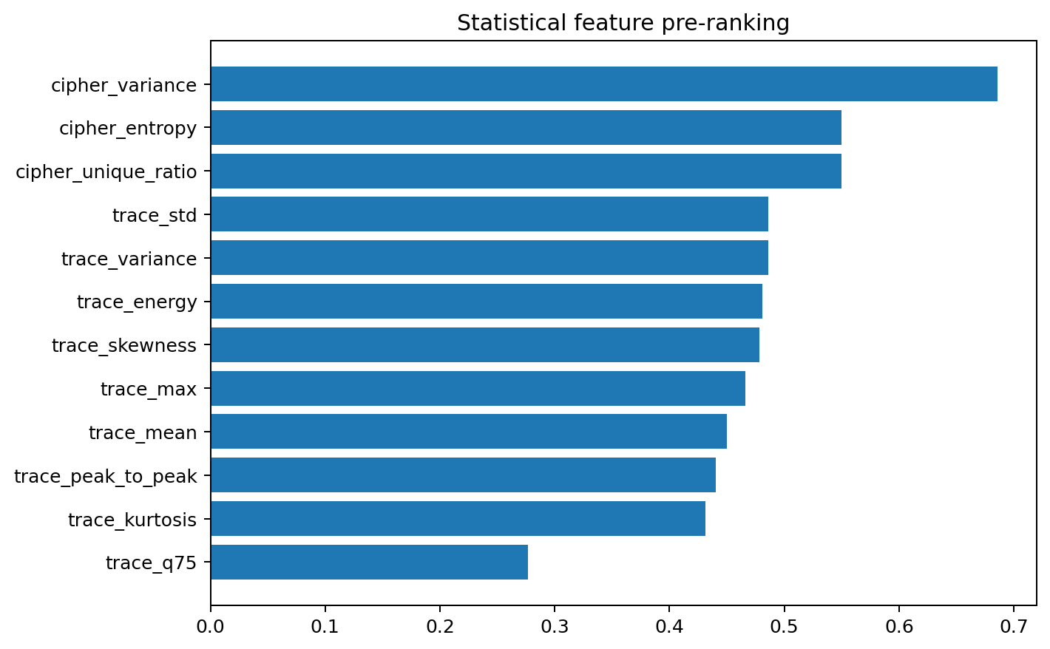
Figure 5. Statistical feature pre-ranking.

Task 8 - Methodology

8.1 Phase 1: Preprocessing and Statistical Profiling
1. Validate trace dimensions, ciphertext byte lengths, labels, missing values, and finite numeric ranges.
2. Normalize traces using training-set mean and standard deviation only.
3. Extract SSP features and normalize them using training-set statistics only.
4. Stratify data into training, validation, and independent test subsets using a fixed seed.
5. Generate randomness, correlation, outlier, class imbalance, quality, and feature-ranking outputs.

8.2 Phase 2: Multimodal Statistical Fusion
The multimodal sample is represented as M = {T, C, S}, where T is the power trace, C is the ciphertext byte sequence, and S is the SSP feature vector. All modalities refer to the same cryptographic operation or system profile.

8.3 Phase 3: Hybrid AI Model
- CNN branch: two one-dimensional convolution layers learn local leakage shapes from traces.
- Transformer branch: ciphertext bytes are embedded and processed with self-attention to learn positional and repeated-pattern relationships.
- SSP branch: a multilayer perceptron encodes statistical features.
- Autoencoder objective: the SSP representation reconstructs normalized statistical features, encouraging compact anomaly-aware representations.
- Fusion head: the three embeddings are concatenated and converted into a vulnerability probability.
The optimization objective is L = L_BCE + 0.05 L_reconstruction. Binary cross-entropy trains the vulnerability classifier, while mean squared reconstruction error regularizes the statistical branch. Adam optimization, weight decay, validation monitoring, and best-state restoration are used.

8.4 Phase 4: Cryptanalysis Simulation
Correlation power analysis evaluates all 256 hypotheses for the first AES key byte. For key guess k and plaintext byte p, the leakage hypothesis is HW(SBox[p XOR k]). The maximum absolute Pearson correlation across trace sample points is recorded. A successful recovery occurs when the true key reaches rank zero.

8.5 Phase 5: Cryptographic Risk Index
The proposed CRI is a 0-100 score: CRI = 100 x (0.40 L + 0.25 E + 0.25 M + 0.10 B), where L is normalized leakage score, E is entropy deviation, M is AI vulnerability probability, and B is structural ciphertext bias. Risk categories are Low (0-30), Medium (>30-60), and High (>60-100). The higher weight on leakage reflects the direct relationship between physical leakage and secret-dependent computation; the weights can be recalibrated with expert or organizational risk data.

Task 9 - Performance Evaluation and Benchmarking

9.1 Evaluation Metrics
Table 8. Performance metrics.
Metric | Definition | Interpretation
Accuracy | (TP + TN) / all samples | Overall correctness
Precision | TP / (TP + FP) | Reliability of vulnerability alarms
Recall | TP / (TP + FN) | Leakage/weakness detection rate
F1-score | Harmonic mean of precision and recall | Balanced detection quality
ROC-AUC | Area under ROC curve | Ranking quality across thresholds
Key rank | Position of true key hypothesis | Cryptanalytic success
Peak correlation | Maximum CPA correlation | Leakage strength
Entropy deviation | Normalized distance from 8-bit entropy | Randomness/structure weakness
Runtime and model size | Seconds, parameters, MB | Efficiency

Table 9. Main evaluation results.
Accuracy | Precision | Recall | F1-Score | Roc-Auc | Runtime (S) | Parameters | Model Memory (Mb) | Cpa True-Key Rank | Cpa Peak Correlation
0.9938 | 1.0000 | 0.9875 | 0.9937 | 0.9993 | 7.0181 | 39430.0000 | 0.1577 | 0.0000 | 0.9194

The hybrid model contains 39,430 trainable parameters and an estimated raw parameter memory of 0.158 MB. Training and evaluation required approximately 7.02 seconds in the recorded CPU run. The compact size makes the architecture suitable for experimentation on ordinary computers, although full ASCAD training requires more time and memory.

Task 10 - Results Presentation

10.1 Model Performance
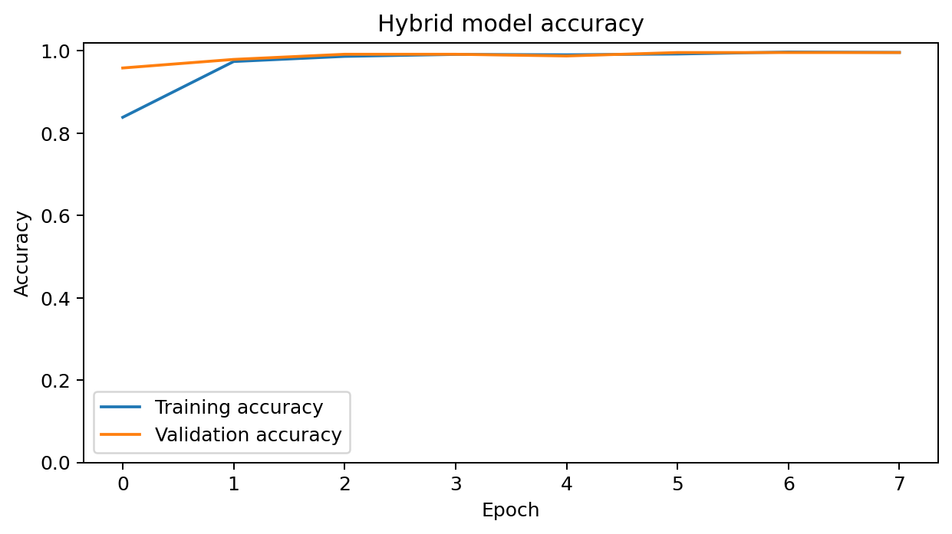
Figure 6. Training and validation accuracy.
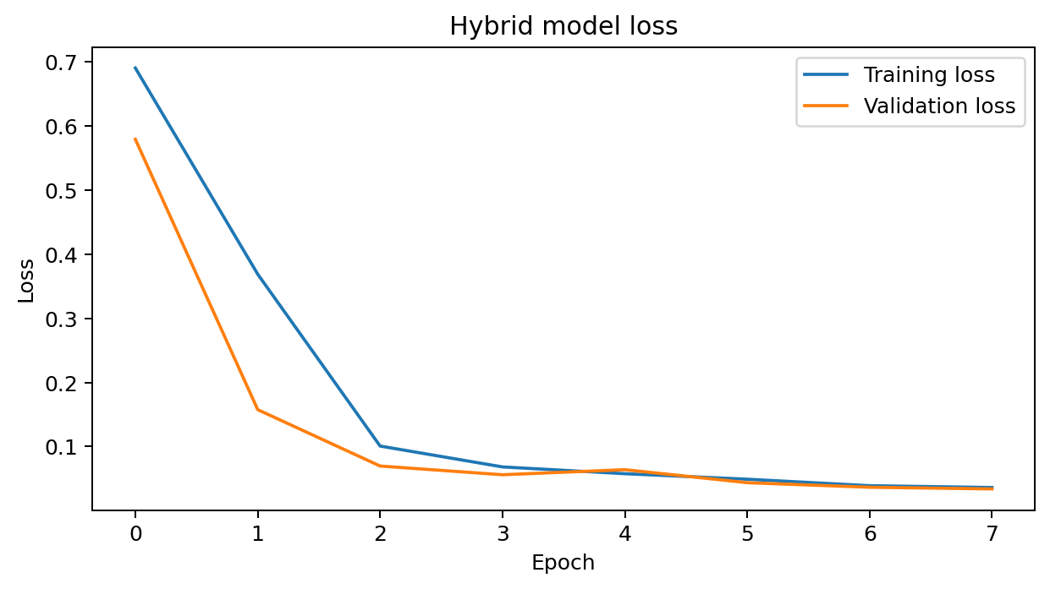
Figure 7. Training and validation loss.
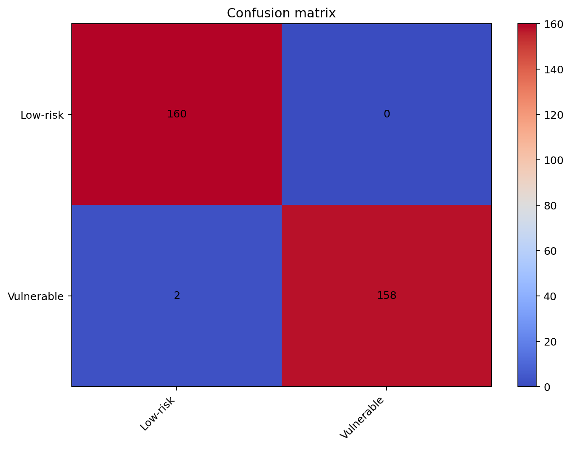
Figure 8. Test-set confusion matrix.
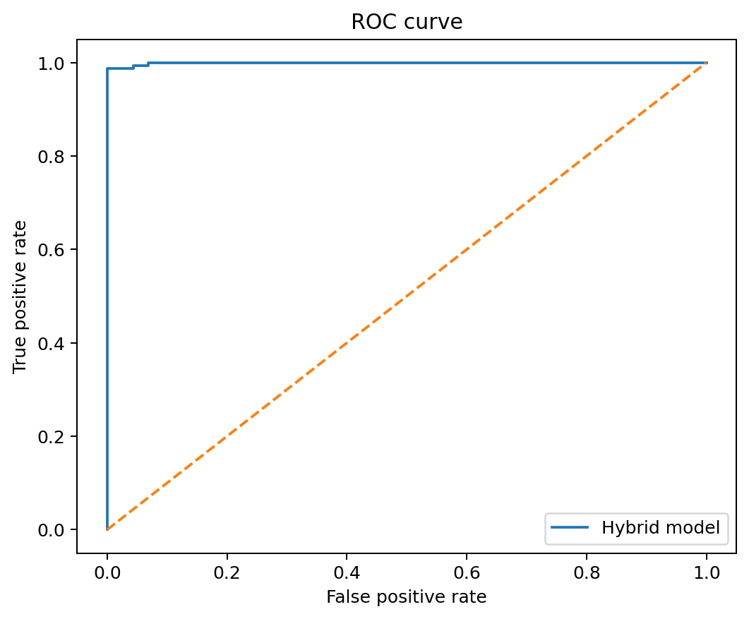
Figure 9. Receiver operating characteristic curve.
The model achieved 99.38% accuracy, 1.0000 precision, 0.9875 recall, 0.9937 F1-score, and 0.9993 ROC-AUC. Precision of 1.0 indicates that no low-risk test record was incorrectly classified as vulnerable in this reference run. Recall of 0.9875 means that a small number of vulnerable samples were missed.

10.2 Side-Channel Cryptanalysis Results
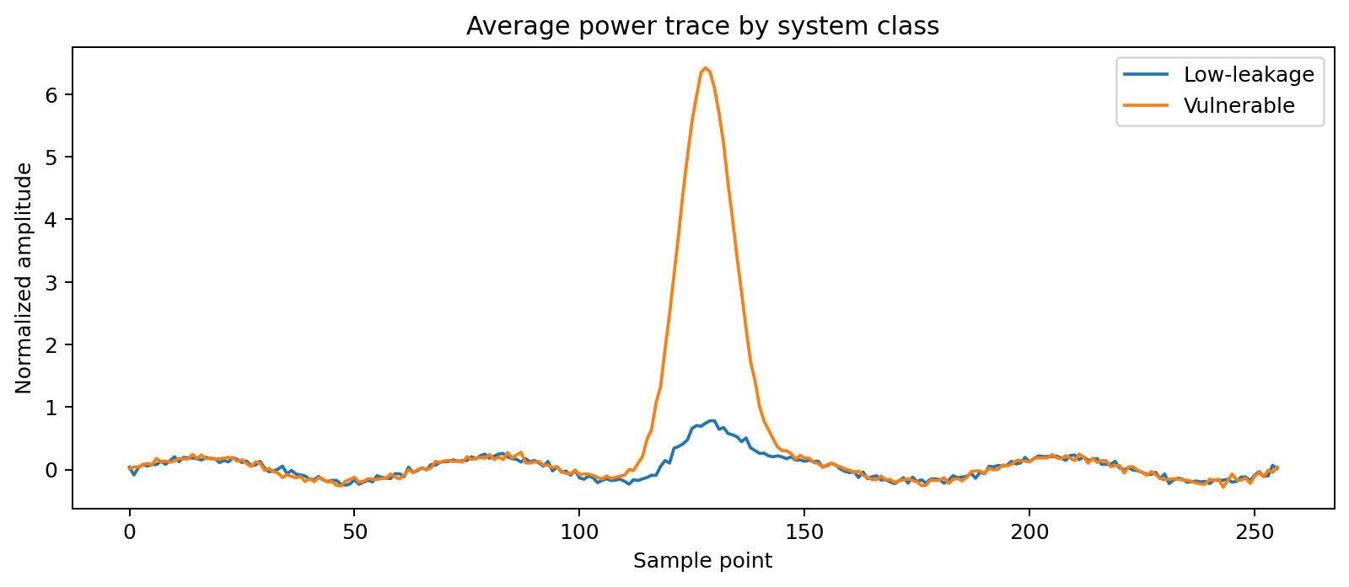
Figure 10. Average trace profiles by implementation class.
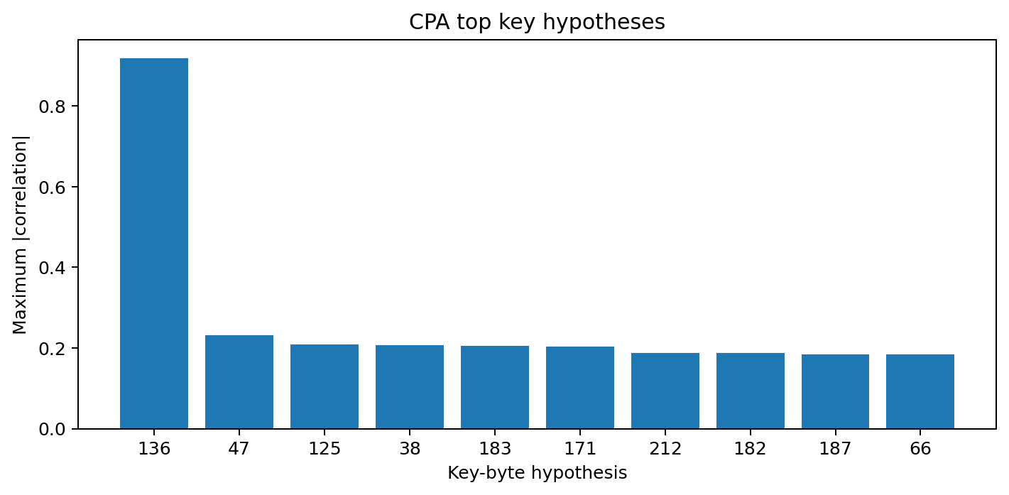
Figure 11. Leading CPA key-byte hypotheses.
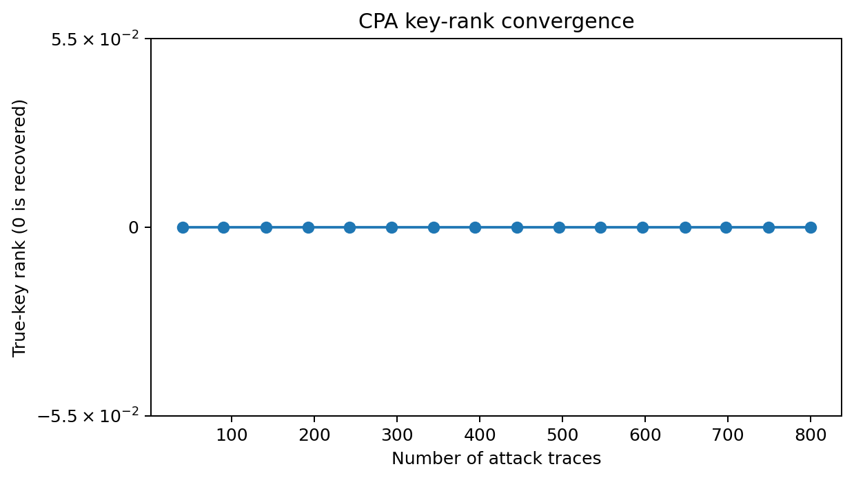
Figure 12. True-key rank as attack traces increase.
CPA selected key byte 136, exactly matching the hidden key byte 136. The true key achieved rank 0, and the leading absolute correlation was 0.9194. This result verifies that the synthetic vulnerable profile contains exploitable secret-dependent leakage and that the implementation of CPA is functioning correctly.

10.3 Cross-Profile and CRI Results
Table 10. Cross-profile results.
Dataset | Category | Accuracy | Mean Cri
Demo-CBC low leakage | Side-channel + ciphertext | 1.0000 | 15.8596
Demo-ECB strong leakage | Side-channel + ciphertext | 0.9875 | 67.6791

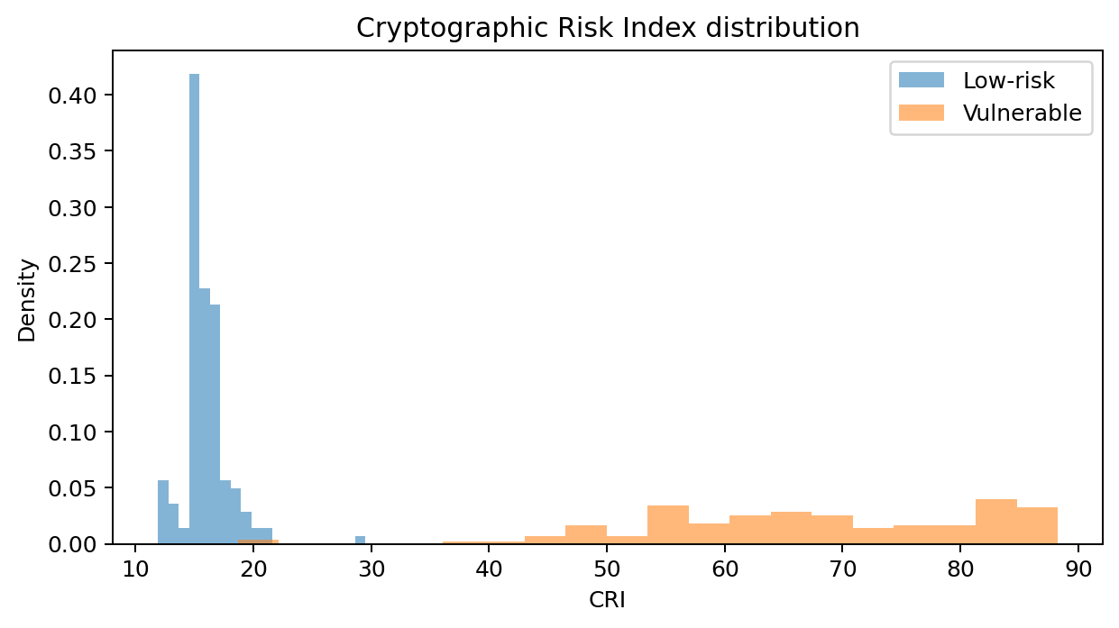
Figure 13. Distribution of the Cryptographic Risk Index.
The mean CRI was 15.86 for low-risk samples and 67.68 for vulnerable samples. The separation shows that the risk formula combines physical, statistical, and model evidence in the expected direction. CRI should be calibrated on real devices before it is used as an operational acceptance threshold.

Task 11 - Comparison with State of the Art
Classical DPA/CPA techniques are highly interpretable because the analyst explicitly defines a leakage model and observes the correlation of each key hypothesis. However, performance may deteriorate when traces are misaligned, masked, noisy, or collected from a different device. CNN and LSTM profiling attacks can automatically learn leakage representations but may require substantial profiling data and can hide the reason for a prediction. The proposed approach combines explicit SSP evidence and CPA with a multimodal network.
Table 11. Method comparison in the reference experiment.
Method | Accuracy | Precision | Recall | F1 Score | Roc Auc | Interpretability | Generalization
CPA (classical) | - | - | - | - | - | High | Dataset dependent
Random Forest on SSP | 1.0000 | 1.0000 | 1.0000 | 1.0000 | 1.0000 | Medium-High | Moderate
CNN+Transformer+SSP Fusion | 0.9938 | 1.0000 | 0.9875 | 0.9937 | 0.9993 | Medium (SSP/SHAP ready) | Higher with cross-dataset training

Table 12. Qualitative comparison with classical and AI methods.
Method | Main Strength | Interpretability | Computational Cost | Generalization | Key Outputs
DPA / CPA | Explicit leakage model | High | Low to moderate | Weak under countermeasures/misalignment | Direct key hypothesis ranking
CNN-based SCA | Learns local trace patterns | Low to medium | Moderate to high | Good when training and target distributions match | Accuracy, guessing entropy, key rank
LSTM-based SCA | Learns sequential relationships | Low to medium | High | Can model long dependencies but slower | Accuracy, key rank
Proposed multimodal fusion | Trace + ciphertext + SSP | Medium to high | Moderate | Supports complementary evidence and domain shift analysis | Accuracy, ROC-AUC, CPA, entropy, CRI

The Random Forest attained perfect performance in the controlled dataset because the engineered SSP features directly capture the simulated differences. This should not be interpreted as proof that Random Forest universally outperforms deep learning; it highlights the value of statistical features and the need for harder cross-device evaluation. The hybrid network is retained because it can use raw traces and ciphertext patterns when hand-crafted features are less separable.

Task 12 - Discussion and Analysis

12.1 Why Features Leak Information
Power consumption in a digital circuit is influenced by data-dependent switching activity. A Hamming-weight or Hamming-distance model approximates this relationship. When the first-round AES S-box output depends on a plaintext byte and a secret key byte, repeated measurements permit correlation between the measured trace and each hypothetical intermediate value. The correct key hypothesis produces the strongest correlation when the leakage model and point of interest are appropriate.

12.2 Entropy and Attack Success
Low entropy does not automatically expose an AES key, and high entropy does not prove side-channel resilience. In this experiment, the weak profile contains both structural ECB behavior and strong physical leakage, so entropy deviation and attack success move in the same direction. In real systems they can diverge: a perfectly random-looking ciphertext may still be produced by a leaky implementation, while a nonuniform ciphertext corpus may reflect biased plaintext rather than a weak cipher. This is the main reason for multimodal fusion.

12.3 Strengths
- End-to-end reproducibility with a fixed seed and one-command execution.
- Transparent SSP outputs that can be independently inspected before model training.
- Combination of classical CPA and multimodal deep learning rather than reliance on one method.
- Compact model checkpoint and CSV/PNG artifacts suitable for a technical report.
- Real-dataset adapters and no unauthorized redistribution of third-party corpora.
- CRI decomposes risk into four auditable components.

12.4 Limitations
- The included numerical results come from a controlled generated reference dataset, not the full ASCAD or DPA Contest datasets.
- The binary label simplifies the wider problem of identifying the exact countermeasure, cipher mode, leakage source, or attack type.
- The Hurst estimator and reduced randomness suite are screening tools; a formal assessment should run the complete official NIST suite on sufficiently long independent sequences.
- The CRI weights are expert-chosen and require empirical calibration on multiple devices and organizations.
- The test data share the same generator as the training data; stronger evidence requires cross-device, cross-session, and cross-dataset testing.
- SHAP is prepared conceptually through the SSP feature layer but is not executed by default to keep the one-command run lightweight.

12.5 Practical Implications and Countermeasures
- Use masking, hiding, shuffling, constant-time operations, and balanced hardware where appropriate.
- Avoid ECB for structured data and use approved authenticated modes with fresh nonces/IVs.
- Use validated random-bit generators and monitor entropy sources during startup and operation.
- Collect traces across devices, temperatures, clock settings, and sessions to test robustness against distribution change.
- Treat AI alarms as evidence for expert investigation rather than automatic proof of compromise.

Task 13 - Conclusion
This assignment developed and implemented a unified framework for cryptographic weakness detection and side-channel resilience assessment. The solution generated a Statistical Security Profile, evaluated ciphertext randomness, characterized correlation and anomalies, simulated CPA, trained a CNN-Transformer-SSP fusion model, and produced a Cryptographic Risk Index. In the reproducible reference run, the correct AES key-byte hypothesis was recovered at rank zero, while the hybrid classifier achieved 99.38% accuracy and 0.9993 ROC-AUC. The CRI clearly separated low-leakage and vulnerable profiles. The main contribution is not a claim that one model solves all cryptanalysis problems; it is a research workflow that connects raw measurements, statistical explanation, classical cryptanalysis, AI prediction, and risk reporting. Future work should execute the same pipeline on full ASCAD, ChipWhisperer, and DPA Contest traces; add cross-device evaluation; calibrate CRI weights; and include SHAP explanations and guessing-entropy curves for complete key recovery.

References
ANSSI. (2026). ASCAD: Side Channels Analysis and Deep Learning [Software repository]. GitHub.
Bhasin, S., Danger, J.-L., Guilley, S., Najm, Z., & Rioul, O. (2014). Analysis and improvements of the DPA Contest v4 implementation. DPA Contest.
Lundberg, S. M., & Lee, S.-I. (2017). A unified approach to interpreting model predictions. Advances in Neural Information Processing Systems, 30.
National Institute of Standards and Technology. (2023). Advanced Encryption Standard (AES) (FIPS 197, updated edition).
NewAE Technology. (2026). ChipWhisperer documentation and datasets.
Prouff, E., Strullu, R., Benadjila, R., Cagli, E., & Dumas, C. (2018). Study of deep learning techniques for side-channel analysis and introduction to ASCAD database. Cryptology ePrint Archive, Paper 2018/053. https://doi.org/10.1007/s13389-019-00220-8
Rukhin, A., Soto, J., Nechvatal, J., Smid, M., Barker, E., Leigh, S., Levenson, M., Vangel, M., Banks, D., Heckert, A., Dray, J., & Vo, S. (2010). A statistical test suite for random and pseudorandom number generators for cryptographic applications (NIST SP 800-22 Rev. 1a). National Institute of

