High-Level Data Warehouse Design
Movie Rental System
Course: Data Warehousing / Data Architecture
Assignment: From OLTP Schema to Dimensional Model and ETL Design

1. Introduction
This report presents a high-level data warehouse design for a movie rental business based on the existing OLTP Sakila database. The OLTP system handles daily operational transactions such as customer registration, film inventory management, rental processing, and payment recording. Although effective for these tasks, the OLTP schema is not optimised for analytical reporting — its normalised structure requires complex multi-table joins that make business queries slow and difficult to write.
A data warehouse reorganises this data into a structure optimised for analysis. Unlike OLTP, which minimises redundancy through normalisation, a data warehouse uses denormalisation to reduce join complexity at query time. The proposed warehouse — implemented in MySQL as film_dw — uses a star schema with two fact tables (fact_rental, fact_payment) and six dimension tables (dim_customer, dim_date, dim_film, dim_location, dim_staff, dim_store).

2. Business Questions

# | Business Question | Importance for Decision-Making
1 | Which films are rented most frequently? | Helps with inventory restocking and identifying titles to promote.
2 | Which stores generate the highest revenue? | Supports store performance evaluation and resource allocation.
3 | Which customers generate the highest revenue? | Enables loyalty programmes and VIP customer targeting.
4 | How does revenue change month by month? | Supports seasonal staffing decisions and financial forecasting.
5 | Which cities have the highest rental activity? | Informs decisions about new store locations.
6 | Which staff members generate the most sales? | Supports employee performance reviews and bonus decisions.

3. Dimensional Model Design

3.1 Selected Business Processes
- Film rental transactions — when a customer borrows a film from a store.
- Payment transactions — when a customer pays for a rental.

3.2 Fact Tables

Fact Table | Business Process | Grain | Measures | Foreign Keys
fact_rental | Film rental | One row per rental transaction | rental_count, rental_duration, late_return_days | date_key, customer_key, film_key, store_key, staff_key, location_key
fact_payment | Payment transaction | One row per payment | payment_amount, payment_count | payment_date_key, customer_key, film_key, store_key, staff_key, location_key

3.3 Dimension Tables

Dimension | Main Attributes | Source OLTP Tables | Purpose
dim_customer | customer_key, customer_id, full_name, email, active_status, create_date | customer, address | Customer profiling and top customer analysis.
dim_date | date_key, full_date, day, month, month_name, quarter_num, year, weekday_name, weekend_flag | Generated calendar | Time-based trend analysis by month, quarter, and year.
dim_film | film_key, film_id, title, description, release_year, rental_duration, rental_rate, length, rating, language_name, category_name | film, language, film_category, category | Film popularity analysis across rentals.
dim_location | location_key, city, country, district | address, city, country | City-level and country-level rental activity.
dim_staff | staff_key, staff_id, full_name, email, active_status, store_id | staff | Staff sales performance tracking.
dim_store | store_key, store_id, manager_name, address | store, staff, address | Store revenue comparison.

The design uses a star schema. All dimensions are fully denormalised and fact tables join directly to each dimension. A snowflake schema was not used as it would add unnecessary join complexity.

4. Dimensional Model Diagram

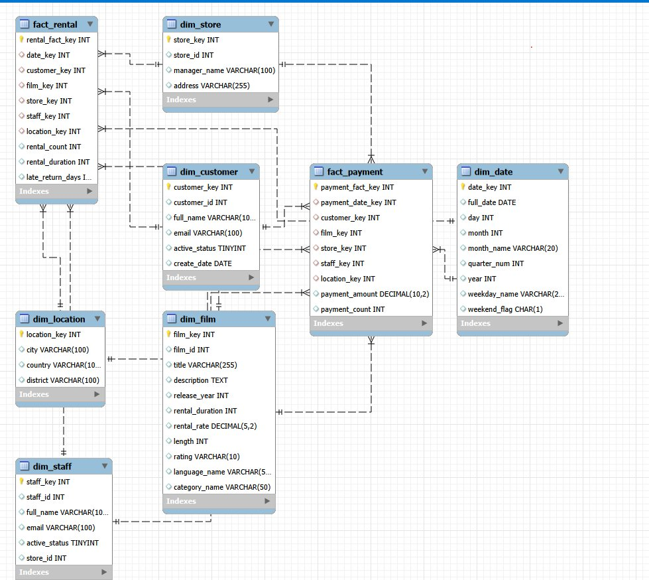
Figure 1: Star schema of film_dw — fact_rental, fact_payment and six dimension tables.

5. ETL Design

5.1 Extract

OLTP Table | Loads Into | Why It Is Needed
rental | fact_rental | Provides rental_date, return_date, customer_id, inventory_id, staff_id.
payment | fact_payment | Provides payment date, amount, customer_id, staff_id, rental_id.
customer | dim_customer | Provides customer_id, name, email, active status, create_date.
film | dim_film | Provides title, description, release_year, rental_duration, rental_rate, length, rating.
film_category | dim_film | Links films to categories (many-to-many resolved during transform).
category | dim_film | Provides category name text.
language | dim_film | Provides language name for each film.
inventory | fact_rental | Links each rental to the correct film and store.
store | dim_store | Provides store_id and address.
staff | dim_staff / dim_store | Builds staff dimension and supplies manager name to dim_store.
address | dim_location / dim_store | Provides address and location details.
city | dim_location | Provides city name.
country | dim_location | Provides country name.

5.2 Transform
1. Joining OLTP tables to build dimensions:
- dim_customer: customer joined with address.
- dim_film: film joined with language, film_category, and category.
- dim_location: distinct city and country combinations from address, city, and country.
- dim_store: store joined with staff (for manager name) and address.

2. Surrogate key generation:
Each dimension receives an auto-incremented surrogate key. The original OLTP natural key is retained for traceability.

3. Date key creation:
dim_date is pre-populated as a complete calendar. For each rental and payment date, the corresponding date_key is looked up and stored in the fact row.

4. Calculated measures:
- rental_duration = DATEDIFF(return_date, rental_date)
- late_return_days = MAX(0, DATEDIFF(return_date, rental_date) − film.rental_duration)
- rental_count = 1 per row; payment_count = 1 per row; payment_amount = payment.amount

5. Data cleaning:
- First and last name concatenated into full_name for dim_customer and dim_staff.
- Text values standardised to consistent casing.
- Duplicate location combinations removed before loading dim_location.

6. Many-to-many resolution (film–category):
One category per film is selected — the first alphabetically. Dropped categories are logged.

5.3 Load
Loading order:
- Step 1: dim_date
- Step 2: dim_location
- Step 3: dim_customer, dim_film, dim_store, dim_staff
- Step 4: fact_rental
- Step 5: fact_payment

Surrogate keys: Generated using MySQL AUTO_INCREMENT. Fact rows reference surrogate keys only.

Insert/update strategy:
- Dimensions: Type 1 SCD — overwrite on change.
- Facts: Insert-only — transactions are never modified once recorded.

6. Data Quality Considerations

Data Quality Issue | Handling Strategy
Missing return_date | Set to NULL; late_return_days defaults to 0.
Negative payment amounts | Rejected or set to 0 and logged.
Duplicate customer records | Keep the record with the most recent last_update.
Film with multiple categories | Pick first category alphabetically; dropped categories are logged.
Future rental dates | Reject or flag for manual review.
Orphaned fact foreign keys | Reject row or assign to a default Unknown dimension row.

7. Conclusion
The proposed data warehouse film_dw uses a star schema with two fact tables and six dimension tables to answer six key business questions covering rental frequency, store revenue, top customers, monthly revenue trends, city activity, and staff performance. The ETL pipeline extracts from thirteen Sakila OLTP tables, applies the necessary transformations, and loads dimensions before facts to maintain referential integrity. Data quality rules are enforced throughout the process.

GitHub Repository: https://github.com/maliknihad004/Datawarehouse

