

An - Najah National University
Computer science Department

Students:
Malik Hamdan
Abdallah Badrah

Supervisor:

Momin Abu Ghazaleh

Movie Rental Data Warehouse Report

1. Introduction
In this project, we designed a data warehouse for a movie rental business. The original database (called an OLTP system) is used for day-to-day tasks like adding new customers, managing films, recording rentals, taking payments, and managing stores and staff.
The problem is that an OLTP database is built for fast transactions, not for analysis. A data warehouse is a better choice when we want to answer questions like: which films are most popular, how much money each store makes, or how sales change over time.
Our data warehouse uses a dimensional model. This means we have fact tables that store numbers and events (like rentals and payments), and dimension tables that describe the details (like customers, films, and stores). This structure makes it easy to write reports and answer business questions.

2. Business Questions
- Which films are rented most frequently?
This helps the business know which films to keep in stock and which ones to advertise.
- Which stores generate the highest revenue?
This helps managers see which stores are doing well and decide where to focus resources.

- Which customers generate the highest revenue?
This helps the business reward top customers and offer them special deals.

- How does revenue change month by month?
This helps the business plan how many staff to hire each month and predict future income.

- Which cities have the highest rental activity?
This helps the business decide where to open new stores.

- Which staff members generate the most sales?.
This helps managers see which staff members are working the hardest and who deserves a bonus.
- Which films are returned late most often?
This helps the business identify which films are always returned late and think about better rental rules.
- Which film categories are rented the most?
This helps the business know which types of films to buy more of and which categories to promote.
- What is the average rental duration for different film ratings?
This helps the business decide how long each film should be available for rental based on its rating.
- Which films generate the highest revenue?
This helps the business know which films make the most money and should be kept available at all times.

3. Dimensional Model Design

3.1 Selected Business Processes
We chose two main business processes for our data warehouse: renting films and processing payments. The rental process helps us study which films are popular, how customers behave, and which returns are late. The payment process helps us track revenue and see how much money the business is making.

3.2 Fact Tables
The first fact table is called fact_rental. Each row in this table represents one rental. It stores numbers like how many times a film was rented, how long the rental lasted, and how many days it was returned late. This table is connected to the date, customer, film, store, staff, and location dimensions.
The second fact table is called fact_payment. Each row in this table represents one payment. It stores the payment amount and a count of payments. Like fact_rental, it is also connected to the date, customer, film, store, staff, and location dimensions.
fact_rental | Film Rental | One row per rental transaction | rental_count, rental_duration, late_return_days | dim_date, dim_customer, dim_film, dim_store, dim_staff, dim_location
fact_payment | Payment Processing | One row per payment transaction | payment_amount, payment_count | dim_date, dim_customer, dim_film, dim_store, dim_staff, dim_location

3.3 Dimension Tables
The dim_date table lets us look at rentals and payments by time. It stores information like the full date, the day number, month, month name, quarter, year, the name of the weekday, and whether it is a weekend.
The dim_customer table holds information about each customer, such as their full name, email, whether they are still active, and when they joined. We use this to see which customers rent the most or spend the most money.
The dim_film table holds information about each film, like the title, description, release year, how long people can rent it, the rental price, the film length, the rating, the language, and the category. We use this to find the most popular films and the highest-earning categories.
The dim_store table holds basic information about each store, like the store ID, the manager name, and the address. We use this to compare how well each store is doing.
The dim_staff table holds information about each staff member, like their full name, email, whether they are active, and which store they work at. We use this to measure how many rentals or payments each staff member handles.
The dim_location table holds location information like city, district, and country. We use this to see which cities or countries have the most rental activity.
Our model is called a galaxy schema (also known as a fact constellation schema). This is because we have two fact tables (fact_rental and fact_payment) that both share the same set of dimension tables. This design is simple and works well for business reporting.
dim_date | date_key, full_date, day, month, month_name, quarter, year, weekday_name, is_weekend | Generated (rental.rental_date, payment.payment_date) | Time-based analysis of rentals and payments
dim_customer | customer_key, customer_id, full_name, email, active, create_date | customer | Customer behaviour and revenue analysis
dim_film | film_key, film_id, title, description, release_year, rental_duration, rental_rate, length, rating, language_name, category_name | film, language, category, film_category | Film popularity and revenue by title, category, or rating
dim_store | store_key, store_id, manager_name, address | store, staff (manager), address, city, country | Store performance comparison by rentals and revenue
dim_staff | staff_key, staff_id, full_name, email, active, store_id | staff | Staff performance in rentals and payments
dim_location | location_key, city, district, country | address, city, country | Geographic analysis of rental activity and revenue

4. Dimensional Model Diagram
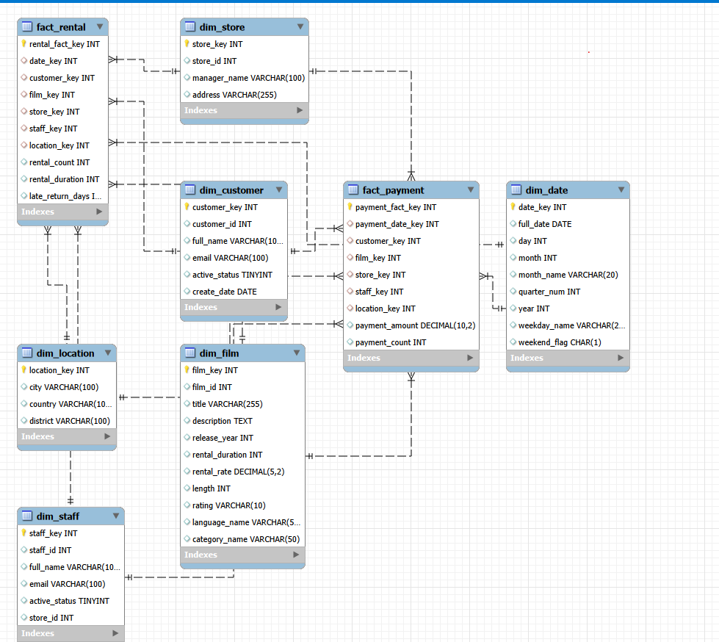
Proposed Movie Rental Data Warehouse Model

5. ETL Design

5.1 Extract
In the extract step, we copy data from the OLTP database. The tables we need are: rental, payment, customer, film, inventory, store, staff, address, city, country, language, category, and film_category. These tables contain all the raw data we need to fill the data warehouse.
We need the rental table because it is the main source for fact_rental. It gives us rental dates, return dates, and connects to customers, films, and staff. We need the payment table because it has the payment amounts and dates for fact_payment. We need the customer table to build dim_customer with names and emails. We need the film table to build dim_film with titles, ratings, and rental details. We need the inventory table to connect each rental to the right film and store. We need the store table to build dim_store with store and manager information. We need the staff table to build dim_staff and also to get the manager name for each store. We need the address, city, and country tables together to build dim_location with full location details. We need the language table to get the language name for each film. We need the category and film_category tables to find out which category each film belongs to.

5.2 Transform
In the transform step, we clean and prepare the data before loading it. We combine first name and last name into one full name field. We replace the original OLTP IDs with new surrogate keys (simple numbers that we generate in the data warehouse). We convert rental dates and payment dates into date keys that match the dim_date table. We also calculate the measures we need, like how long each rental lasted, how many days it was late, and the total payment amount.
We also join the film table with the language and category tables to get all film details in one place. We join the address, city, and country tables to build the full location information. We remove any duplicate records. If a return date is missing (the film has not been returned yet), we handle that carefully so it does not cause errors. We also make sure that text values like city names, country names, and category names are written in a consistent format.

5.3 Load
In the load step, we insert the cleaned data into the data warehouse. We always load the dimension tables first, because the fact tables need to look up the surrogate keys from the dimensions. Only after all dimensions are ready do we load fact_rental and fact_payment.
The correct loading order is: dim_date first, then dim_location, dim_customer, dim_film, dim_store, and dim_staff. After all dimensions are loaded, we load fact_rental and then fact_payment. This order makes sure that all the surrogate keys exist before we try to use them in the fact tables.
Each dimension table gets its own surrogate key, which is just a simple number that we create in the data warehouse (for example, 1, 2, 3...). These replace the original IDs from the OLTP system. Every row in a fact table uses these surrogate keys to point to the right dimension row. When new data comes in, we insert new rows. If a customer name or store detail changes, we update the existing row. Before we load anything, we check the data to make sure all keys are valid, no payment amounts are negative, and there are no duplicate records.

6. Data Quality Considerations
Data quality checks help us make sure the data in the warehouse is correct. Here are the rules we apply: payment amounts must not be negative. Rental dates and payment dates must not be empty. All foreign keys (customer, film, store, staff, and date) must already exist in their dimension tables before we load a fact record. Duplicate rental or payment records must be removed. If a return date is missing, we treat it as a film that has not been returned yet, not as an error. City, country, language, and category names must all use the same spelling and format. Late return days must be zero or a positive number, never negative.

7. Conclusion
In this report, we designed a data warehouse for a movie rental business. The design has two fact tables: fact_rental for tracking rentals, and fact_payment for tracking payments. Both fact tables share six dimension tables: date, customer, film, store, staff, and location.
This data warehouse can answer many useful business questions, such as which films are most popular, which stores earn the most, how revenue changes over time, and which customers spend the most. By moving from an OLTP system to a data warehouse, the business can make better and faster decisions based on organised data.

GitHub link : https://github.com/maliknihad004/Datawarehouse/tree/57f1952e93914b5e06dde9f6bf1333a18676158b

