

An - Najah National University
Computer science Department

Students:
Malik Hamdan
Abdallah Badrah

Supervisor:

Momin Abu Ghazaleh

Movie Rental Data Warehouse Report

1. Introduction
The purpose of this project is to design a simple data warehouse for a movie rental business. The original OLTP database is used for daily operations such as registering customers, managing films, recording rentals, processing payments, managing stores, and managing staff.
However, an OLTP system is not the best choice for analysis and reporting. A data warehouse is better for answering business questions about rental activity, revenue, customer behavior, film popularity, store performance, staff performance, and trends over time.
The proposed data warehouse uses a dimensional model. It contains fact tables for business transactions and dimension tables for descriptive information. This makes the design easier to understand and useful for reports.

2. Business Questions
- Which films are rented most frequently?
Helps with inventory restocking and identifying titles to promote.
- Which stores generate the highest revenue?
Supports store performance evaluation and resource allocation.

- Which customers generate the highest revenue?
Enables loyalty programmes and VIP customer targeting.

- How does revenue change month by month?
Supports seasonal staffing decisions and financial forecasting.

- Which cities have the highest rental activity?
Informs decisions about new store locations

- Which staff members generate the most sales?.
Supports employee performance reviews and bonus decisions.

3. Dimensional Model Design

3.1 Selected Business Processes
The main business processes selected for the data warehouse are rental transactions and payment transactions. Rental transactions are used to analyze rental activity, film popularity, customer behavior, and late returns. Payment transactions are used to analyze revenue and financial performance.

3.2 Fact Tables
The first fact table is fact_rental. This table stores information about each rental transaction. The grain of this table is one row for each rental. The main measures are rental_count, rental_duration, and late_return_days. This fact table connects to date, customer, film, store, staff, and location dimensions.
The second fact table is fact_payment. This table stores information about each payment transaction. The grain of this table is one row for each payment. The main measures are payment_amount and payment_count. This fact table connects to date, customer, film, store, staff, and location dimensions.

3.3 Dimension Tables
The dim_date table is used to analyze rentals and payments over time. It includes attributes such as full date, day, month, month name, quarter, year, weekday name, and weekend flag.
The dim_customer table stores customer information such as customer ID, full name, email, active status, and creation date. It helps analyze customer behavior and revenue by customer.
The dim_film table stores film information such as film ID, title, description, release year, rental duration, rental rate, length, rating, language name, and category name. It helps analyze film popularity and revenue by film or category.
The dim_store table stores store information such as store ID, manager name, and address. It helps compare the performance of different stores.
The dim_staff table stores staff information such as staff ID, full name, email, active status, and store ID. It helps measure staff performance in rentals and payments.
The dim_location table stores geographical information such as city, country, and district. It helps analyze activity and revenue by location.
The proposed model is a simple galaxy schema because there are two fact tables sharing the same dimension tables. This design is simple and suitable for reporting.

4. Dimensional Model Diagram
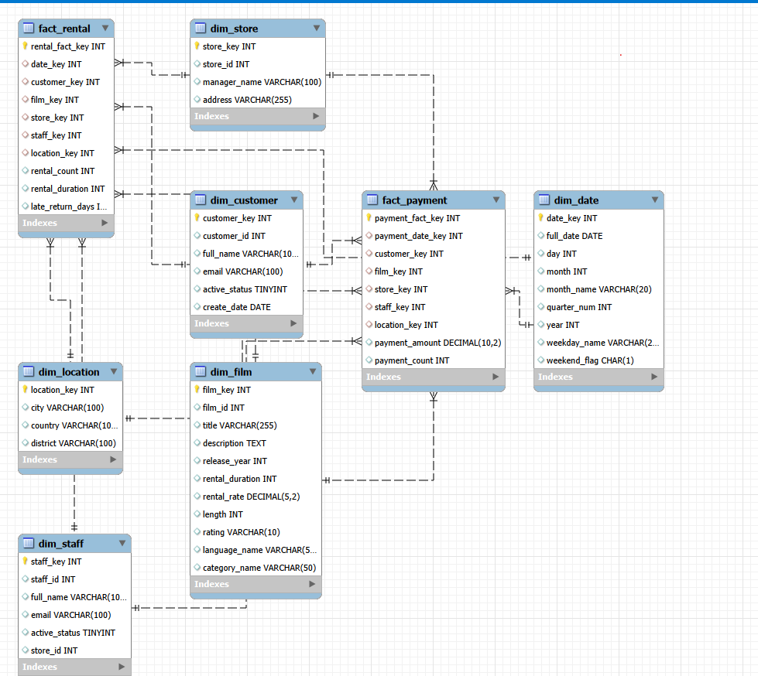
Proposed Movie Rental Data Warehouse Model

5. ETL Design

5.1 Extract
In the extract step, data is taken from the OLTP source tables. The main source tables are rental, payment, customer, film, inventory, store, staff, address, city, country, language, category, and film_category. These tables provide the data needed to build the fact and dimension tables.

5.2 Transform
In the transform step, the extracted data is cleaned and prepared for the data warehouse. First name and last name are combined into full name. Operational IDs are converted into warehouse surrogate keys. Rental dates and payment dates are converted into date keys. Measures such as rental duration, late return days, payment amount, rental count, and payment count are calculated.
Other transformations include joining film with language and category, joining address with city and country, removing duplicate records, handling missing return dates, and standardizing text values such as city, country, language, and category names.

5.3 Load
In the load step, the transformed data is inserted into the data warehouse. Dimension tables should be loaded first because fact tables need dimension surrogate keys. After loading the dimensions, the fact_rental and fact_payment tables are loaded.

6. Data Quality Considerations
Data quality checks are important to make sure that reports are correct and reliable. Payment amount should not be negative. Rental date and payment date should not be missing. Customer, film, store, staff, and date keys must exist before loading fact records. Duplicate rentals and payments should be removed. Missing return dates should be handled carefully. City, country, language, and category names should be standardized. Late return days should not be negative.

7. Conclusion
This report proposed a simple data warehouse design for a movie rental business. The design includes two fact tables: fact_rental and fact_payment. These fact tables share common dimensions such as date, customer, film, store, staff, and location.
The design supports analysis of rental trends, revenue, customer behavior, film popularity, store performance, staff performance, and location-based activity. This data warehouse can help managers make better decisions using organized and analytical data.

GitHub link : https://github.com/maliknihad004/Datawarehouse/tree/57f1952e93914b5e06dde9f6bf1333a18676158b

