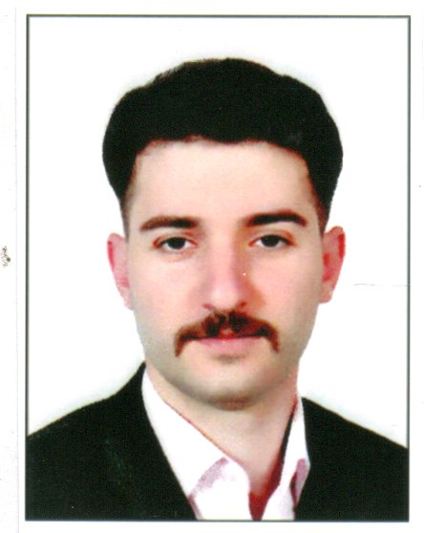
Thanoon Hani Dahaam
Iraq, Baghdad. Almansoor
07703840986
07516630995
Thanoonsawaf@gmail.com
Personal Information

Birth date :28/2/1992
Marital Status :Single
Gender : Male

Education

University :Mosul University
Faculty :Technical Engineering College
Department :Electrical Power Graduation Project :Parallel Operation of Synchronous Generator
Grade Of Project :Excellent
Termination year :June 2014

Objective

Apply for any related position to my academic studies , since I seek a position where my academic background and interpersonal skills can be approved , developed , challenged and motivated.

Training and Experiences
- Trained at Hadbaa substation in Mosul in( June –September) 2012 .
- Trained at Mosul Dam Power Station in(June-September) 2013.
- Worked at Foodstuff trading and marketing company
- Volunteer in Fazaa organization for 6 months
- Worked as a sales representative of medical devices for one year
- English Course ( Head Away-manarat Center-mosul)
- Certificate English Course from university of Mosul
- Certificate of computer course (MS programs)
Computer Skills
- Good Command of Microsoft Office
- Good Command of Matlab
- Excellent in use internet and email

Language Skills

- Arabic :Fluent writing and spoken
- English : good writing and spoken

