Curriculum Vitae

Safa adnan sadkhan |  |  | Name
Baghdad/Hay al_atbaa |  |  | Home Address
2/10/1994 | Birth Date | Baghdad/Hay al_atbaa | Place of Birth
Female | Gender | single | Marital status
Muslim | Religion | Arab/Iraqi | Nationality

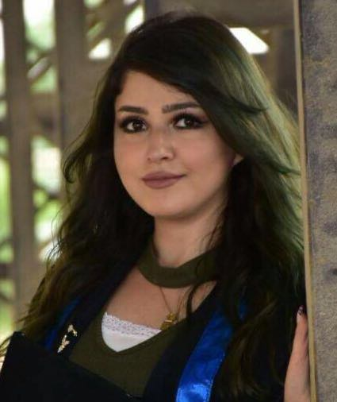

college of science | College or institute | Al nahrain Uni. | University Name
2017 | Graduation year | Physics dept. | Specialization
physicest |  |  | Specialty

 | 00964_07814357054 | Phone number
Sfoooshammar12@gmail.com |  | E.MAIL

1.speaking English very well  2.working on Microsoft office apps  3.photos/videos/audio editing designing programs  4.out look  5. computer skills |  |  |  | Skills
1- Working in alyarmouk hospital as a physicist .  2- I have a certificate in flight system and reservation system.  3- working in almerjan company for travel and tourism. |  |  |  | Experiences
Writing | Reading | Talk | Language | Languages
Very good | Very good | Very good | English | Languages
Very good | Very good | Very good | Arabic | Languages
 |  |  | Other language | Languages

