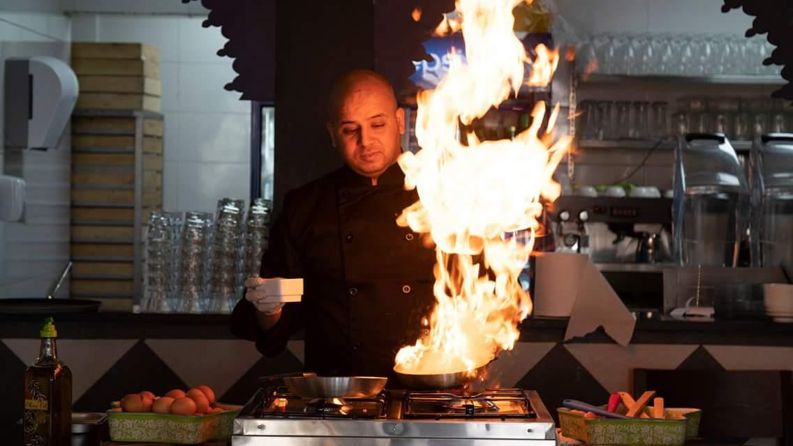
15/01/2019

Contact information
Name: Mohammad Zohdi
Mobile phone: 00962 797428960 Jordan /Amman
Email address: zohdi_mohammad@yahoo.com
PERSIONAL INFORMATION
Birth date: 10/04/1983 / Nationality: Jordanian / Marital status: married
Education
Ain Abasha Education career center food & beverage 2000/2002
Second secondary hotel 1998/2000
Practical experiences
Executive chef
Location : Iraq Baghdad food Eco company( Azkadnya Baghdad) from 20 /01/ 2018 tell 20/01/ 2019
Head chef
Location : Jordan fig tree company ( Hanin restaurant ) from 3/07/2016 tell 14/01/2018
SENIOUR SOUS CHEF
Mira Food Company (Riyadh ) (LUSIN RESTAURANT) February 2015 / February 2016
Head chef
Support services company Location: Saudi Arabia Company industry: catering
from 2007 until January 2015 many location & hospital
Child &Child Hospital Dammam / Bin Laden company / Aramco / Taif Hospital / Royal Hospital Jubal
King Abdul Aziz Hospital Jeddah / Gulf Contracting Company / Company for Saudi Electricity / Rani Juice factory / Management Institute Riyadh / Al-Aqeer village project .
Chef departi
Grand Hayat Amman Job role: none management 2002 tell 2007
Trainee Majestic hotel 2001
Specialties
Food policy food quality food safety menu designee food coast
Training & certifications
Food safety and general
Computer skills
Language Arabic / English / Hindi
Driving License Jordan / Saudi

