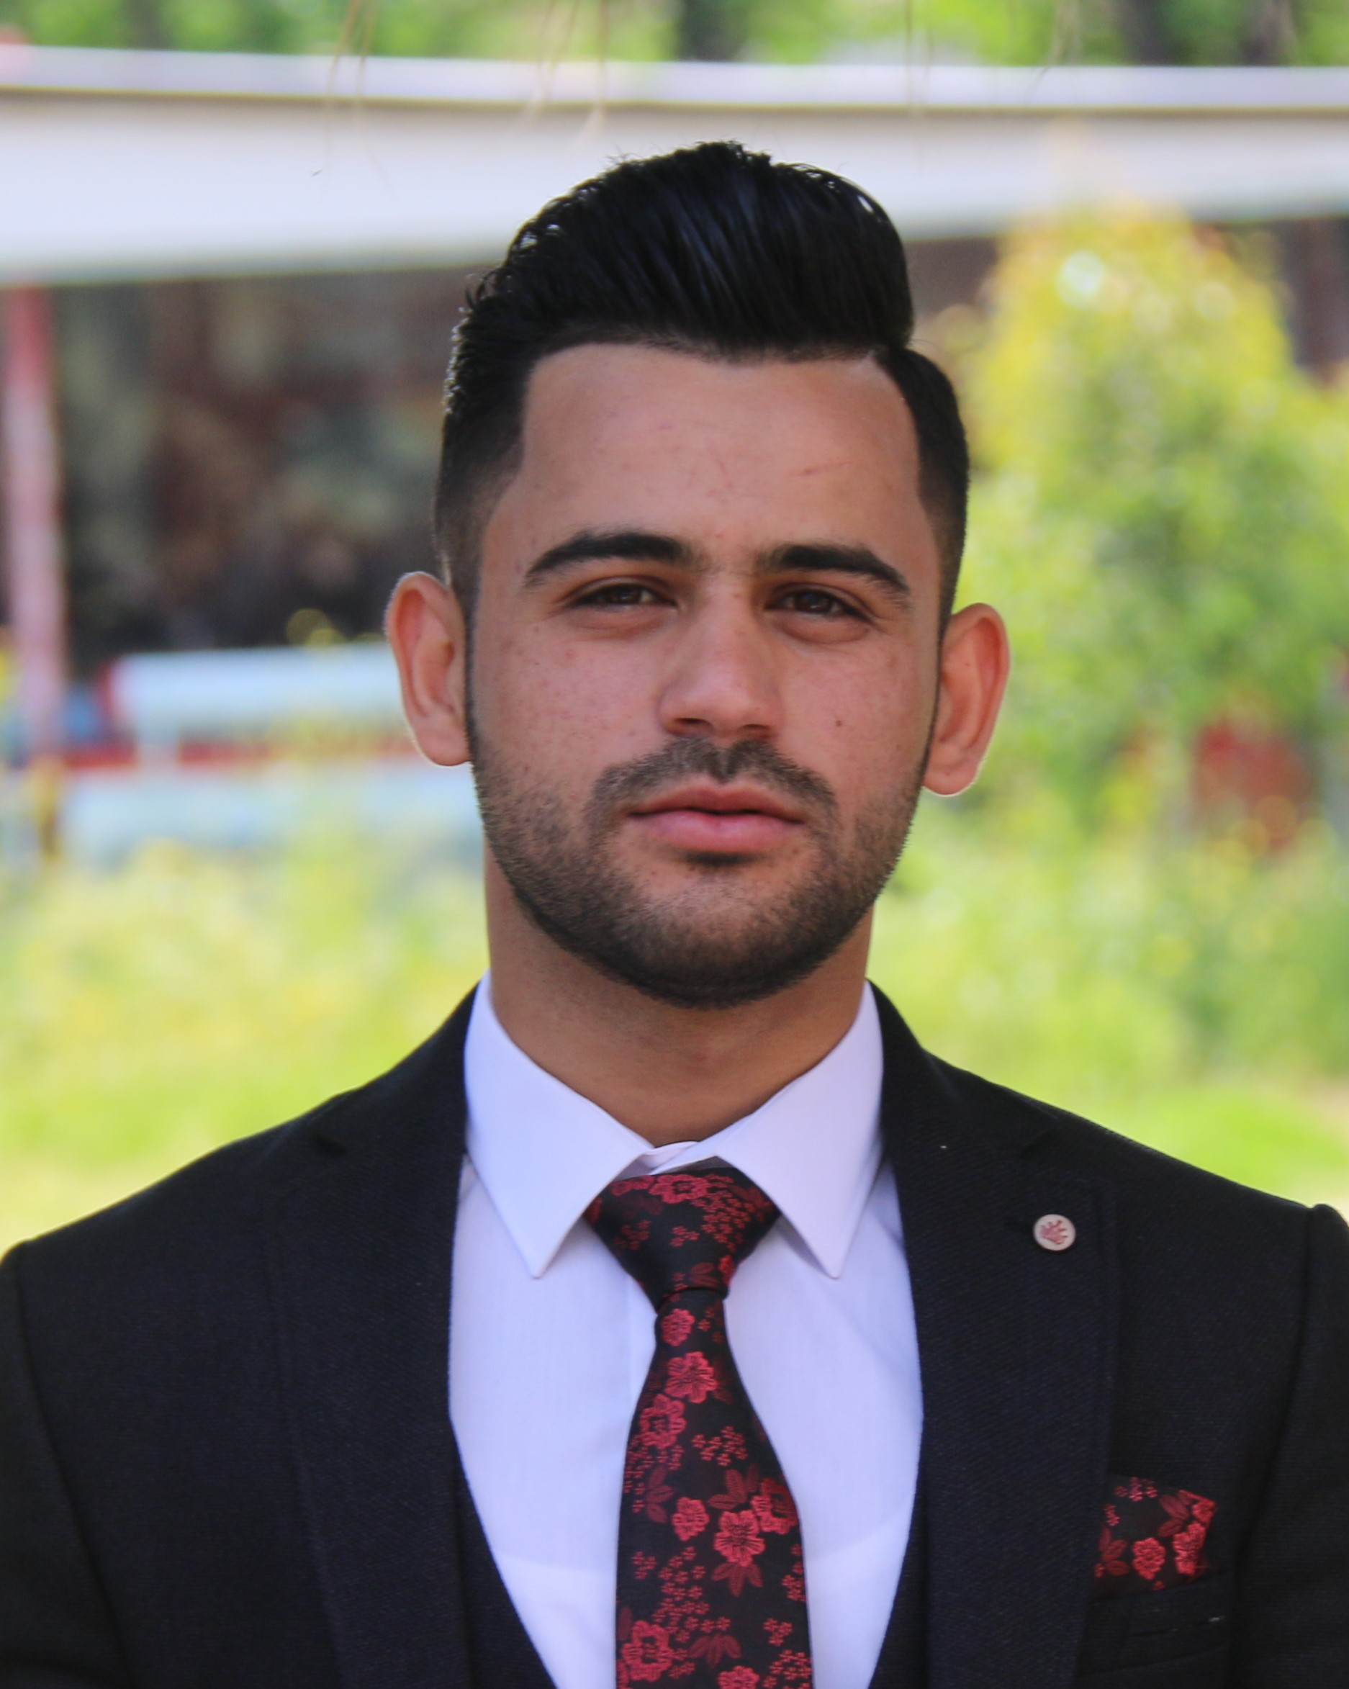

Muhammed Jabbar

Location: Erbil, Iraq
Education: Bachelor's degree, Financial & Banking
Experience: 4 Years

Contact

Location: Erbil, Iraq
Full Name: Muhammed Jabbar Omer

Mobile Phone: +964 7501948358
Country: Iraq

Email Address: Muhammed.jabar.98@gmail.com


Target Job

Target Job Title: Sale Manager, Marketing Manager, HR, Networking, Field, Teacher, Management, Office, Business
Career Level: Entry Level
Target Job Location: Erbil, Iraq
Employment Type: Full Time Employee; Internship; Part Time Employee

Personal Information

Birth Date: 15 January 1998 (Age: 21)
Gender: Male
Nationality: Iraq
Residence Country: Erbil, Iraq
Visa Status: Citizen

Name in Arabic: محمد جبار
Marital Status: Single

Driving License Issued From: Erbil

Education

Bachelor's degree, Financial & Banking

At Salahaddin university-college of Economic & Administrant/Financial & Banking
Location: Erbil, Iraq

Completion Date: June 2019

Specialties

- Graduation research on role of reinsurance in the performance of insurance company.

- Summer Trainin in Didawan Bank in Erbil for 3 months.

- One year experience in Ashti Market in Erbil in the following Jobs (Cashier,Organasing Foods, General enternal market jobs).

Microsoft office(word, exel, ppt)

Level: Expert | Last Used: 1 month or less

Social media

Level: Expert | Last Used: 3 years or less


Driving

Level: Exellent | Last Used: 2 Years or more

Presentation

Level: Good | Last Used: 1 month or less

Languages

English

Level: Good | Experience: Degree in Starter level of Dilman Institute

Arabic

Level: Good | Experience: None

Kurdish

Level: Fluent | Experience: Native

Hobbies and Interests

- Driving license

- Quick learner

- Fast typing

- Management

- Excellent team work skills
- attention to details
- Able to motivate and strongly influence others
- Sport

- Reading

- Traveling

- Video games

- Electronics

- Movies

- Music

