Personal
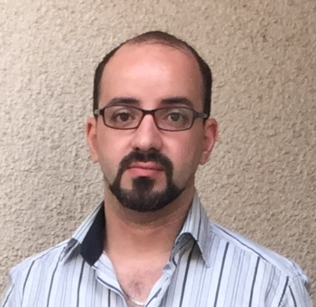
- Name : Zaid Nadir Jawad
- Gender : Male
- Birth Date : Oct. 30, 1982
- Nationality : Iraqi
- Address : Bagdad-Mansour
- Marital Status : Single
- E-mail Address : zaidjawad2010@yahoo.com
- Mobile No. : +964 7811561111

Languages

 | Read | Write | Speak
Arabic | ----- Mother Tongue -----
English | Good | Good | Good

Education

- B.Sc. in Business Management from Al. Turath University 2006 .

Skills

- Experience in Microsoft Office Tools.
- Emailing & Applications Experience ( marketing & warehouse ) .

Experience

- Delegate of AL-ZUMERD DRUGS SCIENTIFIC BUREAU ( 2004-2005)

- Accountant of AL-KAHIRA DRUGS SCIENTIFIC BUREAU ( 2006-2010).

- Delegates administrator for FASTLINK ( ZAIN sub. contract ) 2010-2014

- SIM store manager for FASTLINK ( ZAIN sub. contract ) 2014-2017 .

Certificates

- course in MS office from Al-Khalid institute .
- course in English language from Al-Khalid institute .

